GLOBAL BUSINESS CHALLENGES
Artificial Intelligence and Risk Management in a Multinational Context: A Strategic Analysis of Amazon in the United Kingdom and the European Union

Module Name: Global Business Challenges
Module Code: BMMB7006
Student Name:- KISHAN MAKVANA
STUDENT ID:- 2422722

Executive Summary
Amazon.com, Inc. is advised by this report produced by RFD Global on the strategic threats and opportunities that this technology known as AI poses in two of the company's key geographies Europe and the United Kingdom. Amazon's reliance on AI in logistics, personalisation, pricing, and even in its past recruitment screening processes creates significant risk of exposure to data governance failure, algorithmic bias and regulatory non-compliance, while playing out against the backdrop of differences between regulatory philosophies the principles-based flexible approach of the UK versus the EU's risk-t tiered approach to the AI Act.
The report builds on three theories: Institutional Theory, Brussels Effect, and Stakeholder Theory and the Resource-Based View, concluding that Amazon's capabilities based on AI are becoming more dependent on good governance than technology. Data Governance in the era of GDPR, algorithmic discrimination, discrepancies in compliance costs between the UK and EU and opacity of the system that erodes customer trust are identified as priority risks.
The report suggests the creation of a centralised AI Governance Board reported to the Risk Committee, compulsory ethical AI audits and a gradual harmonisation process to ensure UK-EU compliance which are both costed and time bound in the included implementation plan. Once these recommendations are put into practice, Amazon will have a way to transform regulatory stress into a long-term competitive advantage without exposing its brand and profits to litigation and reputational damage.
Contents

Executive Summary 2

1. Introduction 4

2. Main Findings 5
2.1 The International Business Environment: UK vs EU 5
2.2 Micro-Economic Implications for Amazon 9
2.3 AI Risk Management 12
2.3.1 Data Governance Risks 12
2.3.2 Ethical AI Challenges 14
2.3.3 Regulatory Compliance Risks 15
2.3.4 Customer Trust and Reputation 15
2.4 Cost Implications of AI Adoption 16
2.5 Strategic Recommendations and Implementation Plan 17

3. Conclusion 20

References 22

Figure 1: (Amazon is using AI in almost everything it does - Artificial Intelligence +, 2026).. 5
Figure 2: (Figure 4-Amazon.com Value Chain Analysis In Figure 4, technology stream..., 2026). 10
Figure 3: (AI lifecycle risk management: ISO/IEC 42001:2023 for AI governance | AWS Security Blog, 2026). 12
Figure 4: (Figure 4-Amazon.com Value Chain Analysis In Figure 4, technology stream..., 2026). 17
Figure 5: 20

Table 1: UK vs EU AI Regulatory Approaches, A Comparative Analysis for Amazon. 6

1. Introduction
RFD Global supports multinational clients as they go through the intersection of economics, policy, politics and regulation. This report addresses a brief to give a multinational business the facts about the ever-expanding world of artificial intelligence and its impact on enterprise risk management, specifically with respect to data governance, ethical use of AI, regulatory compliance and customer trust. Amazon.com, Inc. is chosen as the client organisation given the complexity, scope and depth of its AI deployment throughout the operating model, from prediction and recommendation shaping the customer experience, through to robotics and predictive analytics in fulfilment logistics, and prior to its termination, an automated tool in place to screen recruitment candidate (Chang, 2023). This wide reach of deployment puts the organisation at risk of being hit by aspects of consumer protection law, employment law, competition law and data protection law at the same time in each jurisdiction where they do business.
Two areas are really quite stark examples of the compliance problem. The UK regulatory stance is pro-innovation and principles-based with five non-statutory principles (Roberts et al., 2023); critics say that this has left the enforcement with no teeth (Charlesworth et al., 2023). By contrast, the European Union has been following a prescriptive, risk-based approach to AI regulation, on top of the General Data Protection Regulation (Bhouri, 2025). Given the sheer size of Amazon, this split is not an abstract legal curiosity; it can have a real impact on the costs of compliance, the speed at which AI-powered products can make their way to market, and the build-up of litigation and reputational risks over the long term.
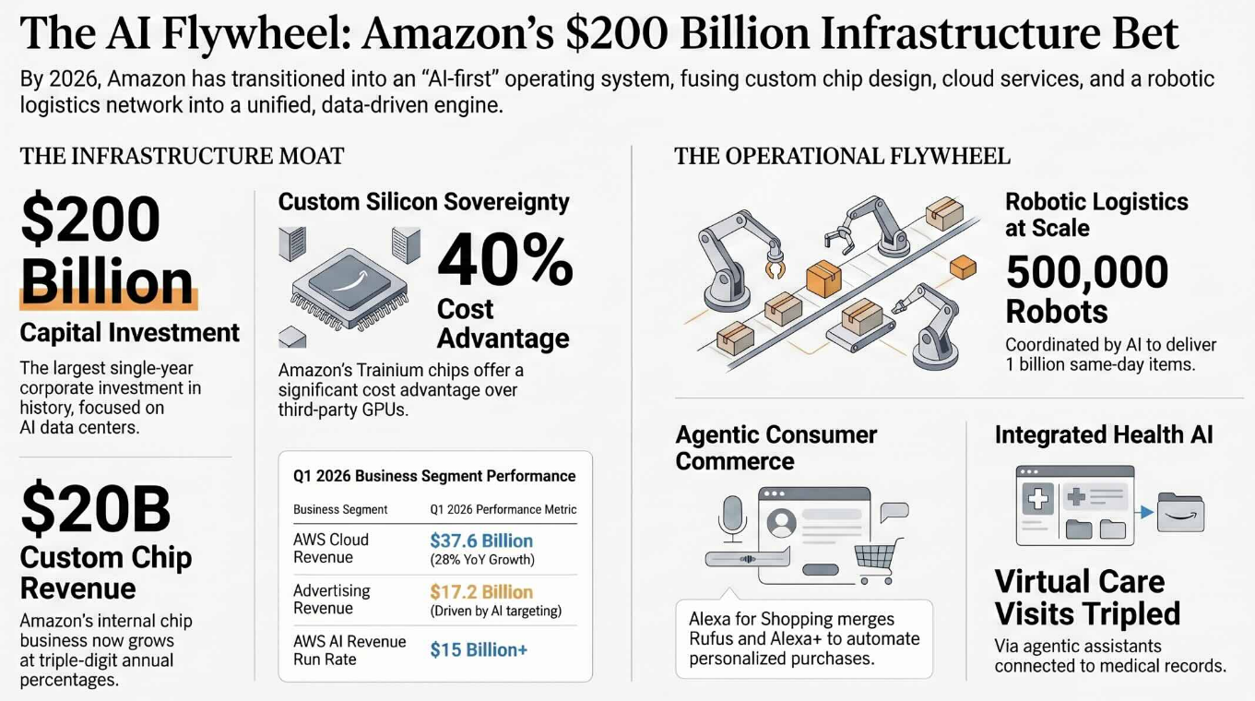
Figure 1: (Amazon is using AI in almost everything it does - Artificial Intelligence +, 2026)..
This report advises the client at a senior level on managing these dynamics to secure the best outcome, while demonstrating how macroeconomic policy shapes the performance of global businesses operating under divergent regulatory regimes. Section 2.1 examines the UK-EU regulatory and macroeconomic environment. Section 2.2 assesses the micro-economic implications of AI for Amazon's value chain and competitive position. Section 2.3 undertakes the core risk analysis across data governance, ethical AI, regulatory compliance and customer trust. Section 2.4 quantifies the cost implications of AI adoption, and Section 2.5 sets out costed, owned recommendations with an implementation roadmap. The Conclusion synthesises these findings into a future-proofing strategy for the client.

2. Main Findings

2.1 The International Business Environment: UK vs EU
Table 1: UK vs EU AI Regulatory Approaches, A Comparative Analysis for Amazon.
Amazon's AI strategy cannot be assessed independently of the institutional environments in which it operates, because regulatory divergence between the UK and EU actively shapes what AI applications are commercially viable in each market. The UK's post-Brexit position is deliberately permissive: rather than introducing dedicated AI statute, government policy asks existing sector regulators to apply five cross-cutting principles safety, transparency, fairness, accountability and contestability within their current remits (Roberts et al., 2023). The stated rationale is that this preserves the UK's attractiveness for AI investment and avoids the compliance drag associated with prescriptive regulation. However, this flexibility is not without cost to the client. Charlesworth et al. (2023) directly challenge the government's characterisation of the white paper as coherent, arguing that a “complex patchwork” of sector regulators, each applying the same five principles differently, in practice reduces certainty rather than increasing it. For Amazon, operating simultaneously in retail, cloud infrastructure (AWS), logistics and advertising, this means at least four separate UK regulators could reach different conclusions about the same underlying AI system, raising rather than lowering compliance risk relative to a single unified regime.
The European Union has taken the opposite approach. The AI Act defines risk tiers for systems and obligates high-risk applications which are those with documented risk assessments and human oversight and whose risks are considered high by imposing binding requirements, including transparency, human oversight and documented risk assessment, as well as fines of up to 7% of the global annual turnover for non-compliance. Adding to this is the General Data Protection Regulation that already regulates the personal data that enables most of Amazon's customer-facing artificial intelligence. EU member states are also making initial progress towards differentiating the rules of IP protection for AI-generated or AI-assisted outputs, which will introduce a new dimension of diversity among the countries within the EU one that Amazon, a pan-European retailer, will need to navigate along with the nuances of AI Act requirements. Bhouri (2025) describes the EU's strategy as a purposeful compromise: they believe that legal uncertainty will be a cost of entry for businesses willing to cover it and that this cost will not be a barrier to those businesses. This trade-off matters strategically for Amazon because EU compliance costs are not confined to EU operations. Institutional Theory offers the clearest explanation of why: Rudko et al. (2025) argue that AI functions simultaneously as a product of institutional pressure and as an institutional force in its own right, meaning organisations frequently adopt uniform internal standards not purely for legal necessity but to secure normative legitimacy across all the markets in which they operate. Put in practical terms, Amazon has commercial reasons to apply EU-grade data governance standards even to UK operations that are not directly bound by the AI Act, since maintaining two parallel compliance architectures is itself a cost and a source of operational risk.
This dynamic is reinforced by what Siegmann and Anderljung (2022) term the “Brussels Effect” in AI regulation: because the EU represents too large a market for most multinationals to abandon, and because EU rules are comparatively stringent, firms frequently find it cheaper to build one EU-compliant global standard than to maintain jurisdiction-specific variants. The authors distinguish a de facto effect, where firms voluntarily extend EU-standard products worldwide, from a de jure effect, where other jurisdictions copy EU legislative language directly. For Amazon, the de facto channel is the more immediately relevant: high-risk AI applications built to EU AI Act specification are more easily deployed unmodified into markets, including the UK, that lack an equivalent binding standard, than the reverse.
The economic dimension of this divergence is measurable rather than speculative. Frey and Presidente (2024) find that GDPR compliance produced a 2.1% decline in profitability for technology firms targeting European consumers, driven by increased operating expenditure and wage costs rather than lost sales, alongside earlier survey evidence indicating GDPR compliance costs ranging from $1.7 million for smaller enterprises to $70 million for large multinationals (Sharma and Sharma, 2025). For a firm of Amazon's scale, this is a material and recurring line item rather than a one-off transition cost, and it should be read as a direct illustration of how macroeconomic and regulatory policy shapes firm-level performance the connection the brief specifically asks this report to demonstrate. Technologically, the environment on both sides of the Channel is converging around a shared expectation of explainability: Panigutti et al. (2023) note that the AI Act neither mandates explainable AI (XAI) techniques nor bans opaque models outright, but does require documented human oversight for high-risk systems, creating technical design obligations that UK-based teams building for EU deployment must absorb regardless of the UK's own lighter-touch stance. Ethically and environmentally, both jurisdictions are moving toward mandatory sustainability disclosure for data-intensive AI operations; this is addressed directly in Section 2.3.1 and Table 1 below, given its direct relevance to Amazon Web Services' reported energy profile.
This divergence is well documented comparatively: regulatory philosophy, not technological capability, is consistently found to be the primary source of cross-border compliance complexity for multinational AI deployers (Akinola et al., 2022; Alfiani and Santiago, 2024; Montasari, 2023), rooted in differing state conceptions of responsibility for AI outcomes (Djeffal et al., 2022). Görentaş (2025) finds the UK's absence of binding legislation leaves wide interpretive latitude at enforcement, while Cyphert (2025) and Tsertsvadze (2025) both note that any AI regulator struggles to calibrate rules for a technology whose risk profile outpaces the legislative cycle. For Amazon, neither regime is a stable target; both are moving baselines the Governance Board proposed in Section 2.5 must track continuously.
The comparative position is summarised in Table 1, which extends a standard PESTLE analysis by adding a fourth column translating each factor into a specific strategic implication for Amazon, addressing the earlier assessment feedback that PESTLE factors were listed without being connected to firm-specific conclusions.

Factor | UK Position | EU Position | Strategic Implication for Amazon
Political / Legal | Principles-based; five non-statutory principles applied by existing sector regulators (Roberts et al., 2023) | Prescriptive AI Act; binding risk-tiered obligations with fines up to 7% of global turnover (Bhouri, 2025) | Amazon faces regulatory fragmentation in the UK (multiple regulators, one standard) and higher compliance certainty but higher cost in the EU
Economic / Macro-policy | Lighter compliance burden supports faster product launch cycles | GDPR compliance reduces tech-firm profitability by c. 2.1% via cost channel (Frey and Presidente, 2024) | EU-grade compliance cost should be budgeted as a recurring operating expense, not a one-off transition cost
Technological | No mandated explainability standard | AI Act requires documented human oversight for high-risk systems (Panigutti et al., 2023) | Human-oversight documentation should be built once to EU standard and reused across markets
Ethical / Environmental | Voluntary sustainability disclosure | Moving toward mandatory AI-linked environmental disclosure | AWS carbon intensity (~210 gCO2-eq/kWh) trails disclosed competitor figures (Hankendi et al., 2025); disclosure gap is a reputational risk
Table 1: PESTLE-informed comparative regulatory analysis, UK vs EU (Roberts et al., 2023; Bhouri, 2025)

2.2 Micro-Economic Implications for Amazon
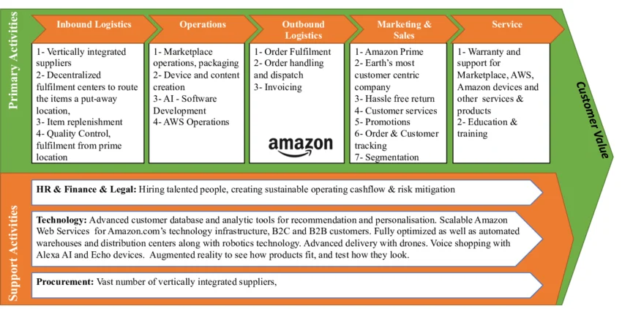
Figure 2: (Figure 4-Amazon.com Value Chain Analysis In Figure 4, technology stream..., 2026).
At the micro-economic level, AI functions as an embedded capability across Amazon's value chain rather than a discrete technology investment, and its strategic value is best explained through the interaction of the Resource-Based View and Stakeholder Theory rather than in isolation. The core to most of the activities like demand forecasting and warehouse robotics is Amazon's proprietary, historically gathered transaction data; the algorithms themselves have become increasingly commonplace, and the underlying advantage is not the code but the choice and unique body of data available for training AI models (Richey et al., 2023; Sharma et al., 2022). General assumptions from the wider logistics literature are: first, that AI benefit comes from end-to-end integration of forecasting, routing and inventory (Boute and Udenio, 2022); second, that AI impacts on the resilience of the system by reducing the time it takes to react to a disruption (Attah et al., 2024); and third, that the more systems incorporate Internet-of-Thing sensing across transport and warehouses, the more dependent they become on AI, confirming that Amazon's advantage is not one particular algorithm, but in systems. On the demand side, the logic continues on the conversion and retention benefits brought by personalisation, which is reflected in a decrease of the customer's search cost, but also on the marginal cost of support at scale, which is reflected in the use of a chatbot for customer service. Because these capabilities depend on data that is valuable, difficult to replicate and organisationally embedded, they satisfy the classic conditions for sustained competitive advantage – but this framing alone is incomplete, and the earlier assessment critique that Resource-Based View analysis stopped at description rather than strategic conclusion is worth addressing directly here.
Stakeholder Theory supplies the missing analytical layer. Matthews et al. (2025) argue that intelligent machines do not create uniform value for an organisation's stakeholders; instead, value is contingent on the specific stakeholder group and the characteristics of the AI system in question its autonomy, its learning capacity, its inscrutability and its materiality. Applied to Amazon, this means the same recommendation algorithm that raises value for shareholders through higher conversion simultaneously raises risk for regulators and consumer-rights stakeholders through opacity, and raises risk for employee stakeholders where AI is used in workforce management. This is not a peripheral observation: it explains why Amazon's AI-driven competitive advantage cannot be assessed purely through a shareholder-value lens, since regulatory and reputational stakeholders are empowered, under both UK and EU frameworks, to constrain or penalise exactly the systems that generate the firm's efficiency gains. The strategic implication is that Resource-Based View value creation and stakeholder-based risk exposure rise together, not independently meaning Amazon's sustainable competitive advantage depends on governance capability that can hold both in balance, rather than on the underlying algorithms alone.
A further implication follows for Amazon's competitive positioning over time. The issue is that the underpinning technology that Amazon uses is becoming more widely available from a host of commercial cloud vendors, in fact, even from one of its own competitors, AWS's outside customers, and the importance of the data and governance practices around the algorithms giving Amazon an edge is therefore increasingly growing. This is also in line with Kumar et al. (2022)'s discovery that in logistics-oriented industries, AI-based advantage is becoming more dependent on the extent of integration within logistics value chains, as opposed to any particular technical component; and with Mohsen (2023)'s finding that AI-related performance improvements in supply chain settings are heavily reliant on a range of organisational readiness factors that are much more difficult for other organizations to rapidly replicate than the algorithms themselves. For the client, this changes the strategic question of whether Amazon's AI capability is better when compared to the competition in isolation to whether their data governance and stakeholder-management infrastructure is better; something a competitor could potentially just buy off the shelf.
This affects directly the decisions and the costs. Ahdadou et al. (2024) conclude that, as in the UK and EU's shared regulatory emphasis on human oversight, the value of AI in the boardroom lies in complementing rather than supplanting the judgement of its members in making strategic decisions, where the power of AI is felt both in terms of speed and the evidentiary basis supporting the business decision. This augmentation logic is reflected in Amazon's own cost structure: automation lowers the marginal cost of labour (MCL) in routine tasks, but is significantly offset by the increased fixed costs (FC) of cloud infrastructure, specialist AI talent and, on the rise, governance overheads, as illustrated by a broader systematic review which correlates increased governance structures with higher, rather than lower, near-term reported costs, while also reducing tail-risk exposure (Ahdadou et al., 2025a). Amazon's own annual filings corroborate the scale of this exposure, disclosing AI-related investment across every reportable segment of the business (Amazon.com, Inc., 2025). For the client, the strategic conclusion is that Amazon's AI-driven cost advantage should be evaluated net of governance investment, not gross of it a distinction the implementation plan in Section 2.5 is designed to make explicit through owned, costed line items rather than aspirational statements.

2.3 AI Risk Management

2.3.1 Data Governance Risks
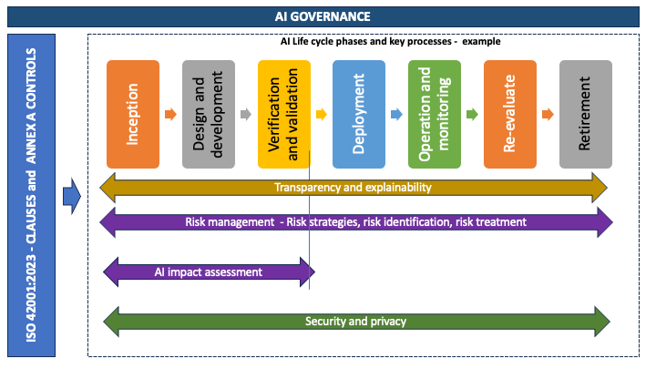
Figure 3: (AI lifecycle risk management: ISO/IEC 42001:2023 for AI governance | AWS Security Blog, 2026).
Amazon's data governance exposure is structural rather than incidental, because its AI systems are trained and operated on the same consumer transaction, browsing and biometric data that GDPR was designed to protect. Agarwal et al. (2024) frame effective AI-era data governance as requiring the integration of technical security controls with organisational accountability structures – a dual requirement that pure IT security investment cannot satisfy alone. This is consequential for Amazon specifically because its scale means a governance failure is not contained to a single business unit: data flows connect the retail marketplace, AWS cloud infrastructure, and Alexa voice services, so a control failure in one domain has cross-contamination potential across the group. Nookala (2024) argues that adaptive governance frameworks – capable of evolving alongside the data architecture itself are now a precondition for compliant AI-driven digital transformation, rather than a compliance formality layered on afterward; static, annually-reviewed policies are structurally unsuited to systems that are retrained and redeployed continuously. Gudepu and Eichler (2024) reach a compatible conclusion from a different angle, finding that organisations which embed data governance controls directly into the AI development pipeline, rather than applying them retrospectively at deployment, experience materially fewer compliance breaches. Mattews and Emma (2024) similarly find that automating governance procedures, rather than relying on periodic manual review, most reliably closes the gap between policy and practice, provided accountability for each data asset sits with a single named owner (Noor et al., 2025). In multi-tenant cloud environments such as AWS, this requires controls auditable at the level of individual workloads rather than the platform as a whole (Antiya, 2025), with compliance verification itself increasingly automated once an AI estate exceeds a certain scale (Ali et al., 2024). For Amazon, whose AI systems are updated on a near-continuous release cycle across multiple business units, this points toward a specific and actionable governance design choice: control points should sit inside the model development lifecycle itself, owned jointly by engineering and compliance functions, rather than being appended as a final sign-off step once a system is otherwise complete.
Amazon's own environmental data governance illustrates the reputational dimension of this risk. Hankendi, Coskun and Sovacool (2025) report that AWS operates at an average carbon intensity of approximately 210 gCO2-eq/kWh, materially higher than the disclosed figures for competing cloud providers, and argue more broadly that the absence of standardised, comparable operational disclosure across major cloud providers itself constrains external scrutiny and stakeholder trust. For Amazon, this is a governance risk in the strict sense used throughout this section: it is not that AWS is necessarily performing worse in absolute terms, but that comparative disclosure gaps leave the company unable to rebut competitor positioning on sustainability, which increasingly intersects with both EU AI Act documentation obligations and UK investor ESG expectations.

2.3.2 Ethical AI Challenges
The clearest illustration of ethical AI risk materialising into reputational cost is Amazon's own discontinued recruitment-screening tool. Chang (2023) documents how the system, trained on a decade of historical resumes from a male-dominated technical workforce, learned to systematically downgrade applications containing terms such as “women's”, reproducing rather than correcting the underlying labour-market bias in its training data. This is analytically significant beyond the recruitment context because it demonstrates a general property of Amazon's AI estate: any system trained on historical human decisions recruitment, pricing, content moderation inherits the biases embedded in that history, and does so at a scale and with an appearance of objectivity that makes the resulting discrimination harder to detect and contest than an equivalent human decision would be. Sison et al. (2023) frame this as a core business ethics challenge rather than a purely technical one, arguing that AI ethics in commercial deployment must be evaluated through its practical governance consequences rather than abstract principle-setting alone. Almeida et al. (2022) reach a parallel conclusion in their comparative US-EU-UK analysis of facial recognition and surveillance technologies: accountability failures in high-visibility AI applications typically stem less from technical inaccuracy than from an absence of clear regulatory ownership for redress a weakness Amazon's own recruitment case exemplifies.
The regulatory response to this class of risk is converging on explainability, but Panigutti et al. (2023) caution against treating explainable AI (XAI) techniques as a complete solution. Their interdisciplinary analysis of the EU AI Act finds that the Act imposes transparency and human-oversight obligations for high-risk systems without mandating any specific XAI technique, and that existing XAI methods carry real technical limitations they can produce plausible-looking explanations that do not accurately represent the model's actual decision process. The strategic implication for Amazon is that documentation and human-oversight process design, rather than any single explainability tool, should be treated as the primary compliance mechanism, with XAI techniques as a supporting rather than sufficient control.

2.3.3 Regulatory Compliance Risks
Amazon's regulatory compliance risk is compounded by its position across two governance philosophies simultaneously. Mirishli (2024) argues that legal frameworks for AI in corporate governance remain uneven internationally, and that firms operating across jurisdictions with differing enforcement maturity face a genuine strategic choice between calibrating compliance to the lowest common legal requirement or the highest, with the latter increasingly favoured by firms seeking to avoid regulatory arbitrage accusations from civil society and institutional investors. Given the Brussels Effect dynamic established in Section 2.1, and Amazon's public profile, the analytically defensible position is that the client should treat EU AI Act compliance as its effective internal floor across all markets, including the UK, rather than maintaining the UK's lighter formal requirement as the operative standard. This is reinforced by Charlesworth et al.'s (2023) finding that the UK's principles-based model currently lacks the enforcement clarity that would let a firm rely on UK compliance alone as a defensible position if challenged under a stricter external standard, such as EU market access rules or US regulatory scrutiny of AWS. Mahmud (2023) adds urgency to this analysis, noting that as jurisdictions explore criminal, not only civil, liability for serious AI-related harms, the cost of relying on the lighter of two available standards rises sharply.

2.3.4 Customer Trust and Reputation
Customer trust in Amazon's AI systems is not a downstream consequence of compliance but a distinct risk category that compliance alone does not resolve. When it comes to public trust in algorithmic decision making, Dunleavy and Margetts (2025) suggest that it should be understood as more about accountability of institutions than about the quality of the algorithms themselves; “a system can be statistically accurate and, at the same time, lack public trust because of opaque or unclear institutional accountability.” For the ecommerce sector, Atla (2024) has found platforms that proactively explain their AI systems to be measurably more trusted and satisfying platforms, as users have more meaningful control over AI features. Read together, these findings suggest that Amazon's trust exposure is a communication and governance-visibility problem as much as a technical one: the recommendation is therefore not only to reduce algorithmic error, but to make existing governance controls – audit committees, human oversight processes, data protection safeguards visible to the customer, converting compliance investment already made under Sections 2.3.1–2.3.3 into a trust-building asset rather than a purely defensive cost.

2.4 Cost Implications of AI Adoption
The financial profile of Amazon's AI adoption is best understood as a reallocation of cost rather than a straightforward reduction, and this distinction should inform how the client evaluates AI investment going forward. As the number of data pipelines that run upstream into an AI system increases the attack surface, regulators are becoming more focused on specific AI security tasks (e.g., providing a description of potential risks) than on overall IT posture ensuring cybersecurity is becoming more difficult and costlier than it was before of AI. First, cybersecurity compliance: As the amount of data pipelines increases in an organization feeding the AI models, so do the attack surfaces, and hence, the complexity and cost of cybersecurity compliance. And regulators are increasingly focusing on specific AI security functions (such as explaining possible risks) instead of overall IT security functions, complicating the process of complying with cybersecurity. Secondly, cloud infrastructure: Thangaraj (2024) has stated that AI security does not always consider the cost of cloud security, affected by various factors such as compliance tooling and redundancy costs, that continues to grow on top of the infrastructure cost. Third, Governance Overhead (mentioned explicitly above in section 2.2): As with misconfigured server infrastructure supporting AI workloads, the risk of misconfiguration is not a high-priced cost centre, but it highlights as soon as there is a breach (Ahdadou et al., 2025a). The fourth one (but topical now) is the security and rights problem of non-regulated or “shadow” AI: Puthal et al. (2025) talks about the rights and security issues of non-regulated or “shadow” AI and Balogun et al. (2025) about the risks of “shadow” AI at large.
This overall trend is best understood in terms of the evidence provided in Section 2.1 (Frey and Presidente, 2024) that shows measurable losses in profits as a result of compliance with the GDPR. The environmental dimension is for the same reason. Hankendi, Coskun and Sovacool (2025) note that improving data centre carbon transparency itself requires investment in measurement and reporting infrastructure that is not directly revenue-generating but is increasingly demanded by regulators and institutional investors as a precondition of continued market access. For Amazon, the analytically sound conclusion is that AI adoption should be assessed on a net-of-governance basis in all future investment appraisal, since the same features that generate the efficiency gains described in Section 2.2 are the features driving the recurring cost categories identified here. Treating governance spend as a discretionary or deferrable cost, rather than an integral cost of AI deployment, is the single clearest route by which the risks catalogued in Section 2.3 convert into realised financial loss.

2.5 Strategic Recommendations and Implementation Plan
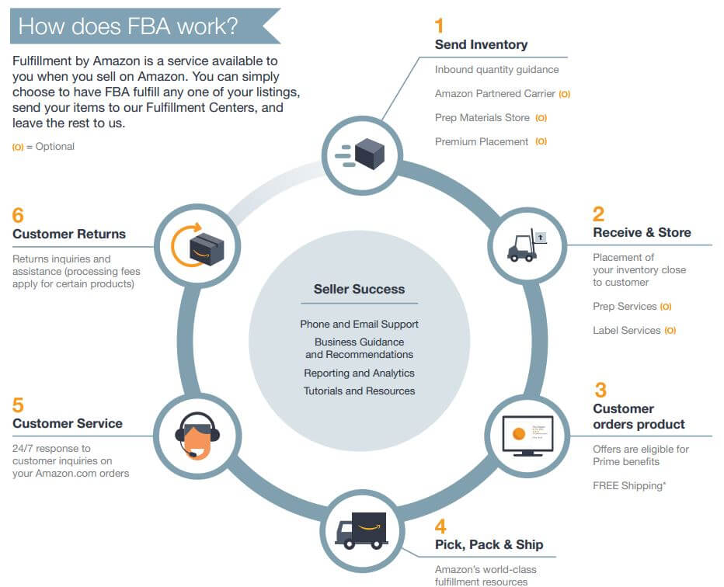
Figure 4: (Figure 4-Amazon.com Value Chain Analysis In Figure 4, technology stream..., 2026).
The recommendations below are structured to be company-specific rather than generic, addressing the Amazon business units and reporting lines directly, and each is paired with an implementation mechanism rather than presented as a standalone statement of intent.
Recommendation 1: Establish a unified AI Governance Board. Amazon should create a single AI Governance Board with authority across AWS, Retail AI and Alexa, reporting directly to the existing Risk Committee rather than operating as a parallel structure. Ahdadou et al. (2025a) find that dedicated AI governance committees with defined board-level reporting lines are consistently associated with stronger oversight outcomes than AI governance handled informally within existing audit or technology committees, because a dedicated body avoids AI oversight being treated as a subordinate item on an already-crowded agenda. Ahdadou et al. (2025b) add, in their dual-dimensional framework, that oversight is most effective where board, committee and individual-director engagement are treated as distinct governance layers rather than one generic policy, a distinction the Board's terms of reference should reflect; Tsai (2025) recommends building this directly on existing data governance architecture rather than as a parallel structure.
Recommendation 2: Adopt EU AI Act standards as the internal compliance floor across all markets. Building on the Brussels Effect analysis in Section 2.1 (Siegmann and Anderljung, 2022), Amazon should formally adopt EU AI Act documentation and human-oversight requirements as its minimum internal standard globally, including in the UK, rather than maintaining jurisdiction-specific variants. This converts a market-access cost into a single, de-risked global architecture.
Recommendation 3: Institute mandatory ethical AI audits with published summaries. Independent audits of high-risk systems – recruitment-adjacent tools, pricing algorithms and content-moderation systems should be conducted on a fixed cycle, with summary findings published to support the trust-building case set out in Section 2.3.4 (Owczarczuk, 2023; Mirishli, 2024).
Recommendation 4: Align internal principles to the OECD AI Principles as an external benchmark. Adopting the OECD's five values-based principles as a reporting benchmark (OECD, 2023) gives Amazon an internationally recognised reference point that is independent of any single jurisdiction's regulatory politics, useful given the current instability in the UK's own framework noted in Section 2.1.
Table 2 summarises how each theoretical lens used across this report translates into a specific strategic conclusion for the client, addressing directly the earlier assessment feedback that theory application should move beyond identification toward argued strategic use.
Theory | Core Premise | Application to Amazon | Key Source
Brussels Effect | Stringent EU rules diffuse globally as firms adopt one compliant global standard rather than multiple | Amazon should apply EU AI Act documentation standards as its internal global floor, including in the UK | Siegmann and Anderljung (2022)
Institutional Theory | Organisations adopt uniform practices to secure legitimacy, not only legal compliance | Explains why Amazon has commercial reasons to harmonise UK and EU governance beyond strict legal necessity | Rudko et al. (2025)
Stakeholder Theory | Value created by intelligent machines is contingent on the stakeholder group affected | The same AI systems that create shareholder value simultaneously create regulator and consumer risk exposure | Matthews et al. (2025)
Resource-Based View | Sustained advantage requires valuable, rare, inimitable resources | Competitive advantage is shifting from algorithms to proprietary data and governance infrastructure | Kumar et al. (2022); Mohsen (2023)
Table 2: Theoretical frameworks applied and their strategic application to Amazon
Table 3 sets out the implementation roadmap with named ownership, timeline, cost and KPI for each recommendation, replacing the unstructured bullet-point plan previously submitted.
Recommendation | Owner / Timeline | Cost & KPI | Risk Rating
Establish unified AI Governance Board reporting to Risk Committee | Chief Risk Officer / 0-6 months | £1.2m annual budget; KPI: 100% of high-risk AI systems reviewed by Board | Low
Adopt EU AI Act standard as global compliance floor (incl. UK) | Legal & Compliance / 6-18 months | £2.5m one-off harmonisation cost; KPI: single compliance architecture across all markets | Medium
Mandatory ethical AI audits with published summaries | Compliance Team / ongoing, 6-monthly cycle | £600k annually; KPI: zero unresolved high-risk audit findings | Medium
Adopt OECD AI Principles as external reporting benchmark | AI Governance Board / 12 months | £150k; KPI: annual public alignment statement published | Low
Table 3: Implementation roadmap (owner, timeline, cost and KPI)
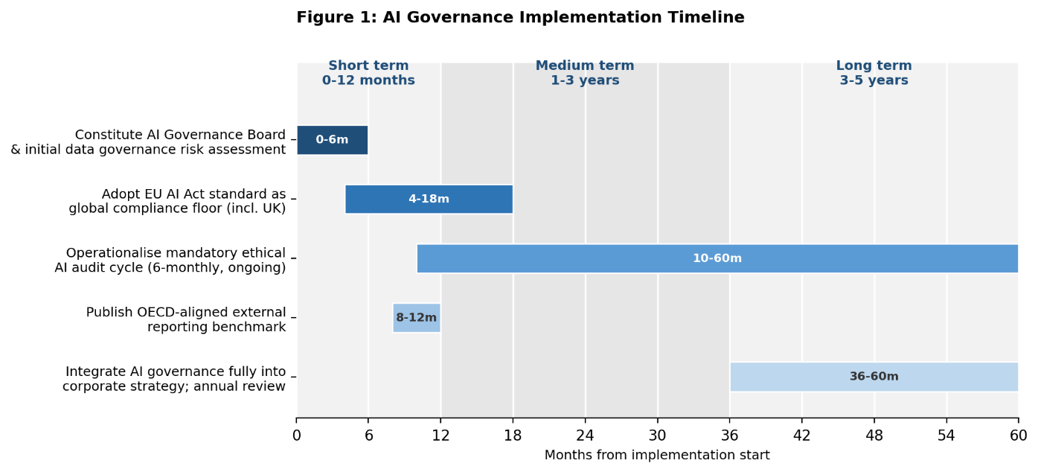
Figure 5:
Implementation should be phased over a five-year horizon. In the short term (0–12 months), the Governance Board should be constituted and an initial data governance risk assessment completed. In the medium term (1–3 years), the ethical AI audit cycle and EU-standard compliance harmonisation should be operationalised across all business units. In the long term (3–5 years), AI governance should be fully integrated into corporate strategy, with the OECD-aligned reporting benchmark reviewed annually against evolving UK and EU regulatory developments. Ownership sits jointly across the AI Governance Board, Compliance, Legal and HR functions, funded through existing risk-management budget lines rather than requiring a separate capital allocation, consistent with the net-of-governance investment logic established in Section 2.4.

3. Conclusion
This report has advised Amazon on the strategic risk implications of its AI deployment across the United Kingdom and European Union, applying Institutional Theory, the Brussels Effect, Stakeholder Theory and the Resource-Based View to move beyond description toward argued strategic conclusions. The analysis finds that Amazon's AI-driven competitive advantage and its regulatory risk exposure are two faces of the same underlying capability: the same data assets and algorithmic systems that generate efficiency and personalisation gains are precisely the systems that create data governance, ethical and regulatory exposure under both UK and EU frameworks.
The UK's principles-based flexibility and the EU's prescriptive AI Act represent genuinely different regulatory philosophies, but the Brussels Effect and Institutional Theory both point toward convergence in practice: a global organisation of Amazon's scale has stronger commercial reasons to adopt the more stringent EU-grade standard universally than to maintain parallel compliance architectures. Acted on together, the recommendations in Section 2.5 – a unified AI Governance Board, EU-standard compliance as the internal floor, mandatory ethical audits, and OECD-aligned external benchmarking – are designed to be future-proof in the specific sense the brief requires: they do not depend on any single jurisdiction's current regulatory settlement remaining static, and they convert governance investment from a defensive cost into the foundation of durable, trust-based competitive advantage.

References
Agarwal, A., Kumar, S., Chilakapati, P. and Abhichandani, S. (2024) ‘Artificial intelligence in data governance: Enhancing security and compliance in enterprise environments’, Nanotechnology Perceptions, 20(1), pp. 34–45.
Ahdadou, M., Aajly, A. and Tahrouch, M. (2024) ‘Unlocking the potential of augmented intelligence: A discussion on its role in boardroom decision-making’, International Journal of Disclosure and Governance, 21(3), pp. 433–446.
Ahdadou, M., Aajly, A. and Tahrouch, M. (2025a) ‘Enhancing corporate governance through AI: A systematic literature review’, Technology Analysis & Strategic Management, 37(11), pp. 1753–1766.
Ahdadou, M., Ahdadou, A., Aajly, A. and Tahrouch, M. (2025b) ‘Artificial intelligence in corporate boards: A dual-dimensional framework for integration across autonomy and structural levels’, Data Science and Management.
Akinola, O., Tunbosun, O.A. and Oladapo, B. (2022) ‘Comparative analysis regulatory of AI and algorithm in UK, EU and USA’. Available at: SSRN.
Alfiani, F.R.N. and Santiago, F. (2024) ‘A comparative analysis of artificial intelligence regulatory law in Asia, Europe, and America’, in SHS Web of Conferences. Vol. 204. Les Ulis: EDP Sciences, p. 07006.
Ali, S.M., Razzaque, A., Yousaf, M. and Shan, R.U. (2024) ‘An automated compliance framework for critical infrastructure security through artificial intelligence’, IEEE Access, 13, pp. 4436–4459.
Alii, H.M., Ugli, A.A.G., Mannonov, A. and Lalnunthari, L. (2025) ‘Artificial intelligence and IoT in logistics management for the intelligent supply chain management for the future era’, in 2025 International Conference on Computational Innovations and Engineering Sustainability (ICCIES). Piscataway, NJ: IEEE, pp. 1–6.
Almeida, D., Shmarko, K. and Lomas, E. (2022) ‘The ethics of facial recognition technologies, surveillance, and accountability in an age of artificial intelligence: A comparative analysis of US, EU, and UK regulatory frameworks’, AI and Ethics, 2(3), pp. 377–387.
Amazon.com, Inc. (2025) Annual reports, proxies and shareholder letters. Available at: https://www.amazon.com (Accessed: Day Month Year).
Antiya, D.S. (2025) ‘Harnessing AI for data-driven compliance and security in cloud environments: A blue-green infrastructure approach’, in Integrating Blue-Green Infrastructure into Urban Development. Hershey, PA: IGI Global Scientific Publishing, pp. 245–270.
Atla, V.K.R. (2024) ‘Navigating the digital marketplace: The role of AI transparency in building consumer trust in e-commerce’, International Journal of Research in Computer Applications and Information Technology, 7(2), pp. 2557–2566.
Attah, R.U., Garba, B.M.P., Gil-Ozoudeh, I. and Iwuanyanwu, O. (2024) ‘Enhancing supply chain resilience through artificial intelligence: Analyzing problem-solving approaches in logistics management’, International Journal of Management & Entrepreneurship Research, 5(12), pp. 3248–3265.
Balogun, A.Y., Metibemu, O.C., Olutimehin, A.T., Ajayi, A.J., Babarinde, D.C. and Olaniyi, O.O. (2025) ‘The ethical and legal implications of shadow AI in sensitive industries: A focus on healthcare, finance and education’. Available at: SSRN.
Bhouri, H. (2025) ‘Navigating data governance: A critical analysis of European regulatory framework for artificial intelligence’, Recent Advances in Public Sector Management, 171.
Boute, R.N. and Udenio, M. (2022) ‘AI in logistics and supply chain management’, in Global Logistics and Supply Chain Strategies for the 2020s: Vital Skills for the Next Generation. Cham: Springer International Publishing, pp. 49–65.
Chang, X. (2023) ‘Gender bias in hiring: An analysis of the impact of Amazon’s recruiting algorithm’, Advances in Economics, Management and Political Sciences, 23(1), pp. 134–140.
Charlesworth, A.J., Fotheringham, K., Gavaghan, C., Sanchez-Graells, A. and Torrible, C. (2023) Response to the UK's March 2023 White Paper "A Pro-Innovation Approach to AI Regulation". SSRN.
Cyphert, A.B. (2025) ‘Confronting the challenges of regulating artificial intelligence’, FIU Law Review, 20, p. 82.
Djeffal, C., Siewert, M.B. and Wurster, S. (2022) ‘Role of the state and responsibility in governing artificial intelligence: A comparative analysis of AI strategies’, Journal of European Public Policy, 29(11), pp. 1799–1821.
Dunleavy, P. and Margetts, H. (2025) ‘Data science, artificial intelligence and the third wave of digital era governance’, Public Policy and Administration, 40(2), pp. 185–214.
Dwivedi, D.N. (2024) ‘The use of artificial intelligence in supply chain management and logistics’, in Leveraging AI and Emotional Intelligence in Contemporary Business Organizations. Hershey, PA: IGI Global Scientific Publishing, pp. 306–313.
Folorunso, A., Adewa, A., Babalola, O. and Nwatu, C.E. (2024a) ‘A governance framework model for cloud computing: Role of AI, security, compliance, and management’, World Journal of Advanced Research and Reviews, 24(2), pp. 1969–1982.
Folorunso, A., Adewumi, T., Adewa, A., Okonkwo, R. and Olawumi, T.N. (2024b) ‘Impact of AI on cybersecurity and security compliance’, Global Journal of Engineering and Technology Advances, 21(1), pp. 167–184.
Frey, C.B. and Presidente, G. (2024) ‘Privacy regulation and firm performance: Estimating the GDPR effect globally’, Economic Inquiry, 62(3), pp. 1074–1089.
Görentaş, M.B. (2025) ‘Analysis and evaluation of the United Kingdom’s AI regulations using artificial intelligence methods’, Selçuk Üniversitesi Hukuk Fakültesi Dergisi, 33(3), pp. 2051–2082.
Gudepu, B.K. and Eichler, R. (2024) ‘The role of AI in enhancing data governance strategies’, International Journal of Acta Informatica, 3(1), pp. 169–186.
Hankendi, C., Coskun, A.K. and Sovacool, B.K. (2025) ‘Why transparency matters for sustainable data centers and carbon-neutral artificial intelligence (AI)’, iScience, 28(11), 113705.
Kumar, P.S., Petla, R.K., Elangovan, K. and Kuppusamy, P.G. (2022) ‘Artificial intelligence revolution in logistics and supply chain management’, in Artificial Intelligent Techniques for Wireless Communication and Networking, pp. 31–45.
Mahmud, A. (2023) ‘Application and criminalization of artificial intelligence in business: Recommendations to counter the regulatory challenges’, Journal of Applied Security Research, 18(4), pp. 689–699.
Marchenko, V., Dombrovska, A. and Prodaivoda, V. (2024) ‘Comparative analysis of regulatory acts of the EU countries on the protection of intellectual property in the conditions of the use of artificial intelligence’, Public Administration and Law Review, 3(19), pp. 44–66.
Mattews, A. and Emma, O. (2024) The Role of Artificial Intelligence in Automating Data Governance Procedures.
Matthews, M.J., Su, R., Yonish, L., McClean, S., Koopman, J. and Yam, K.C. (2025) ‘A review of artificial intelligence, algorithms, and robots through the lens of stakeholder theory’, Journal of Management, 51(6), pp. 2627–2676.
Mirishli, S. (2024) ‘The role of legal frameworks in shaping ethical artificial intelligence use in corporate governance’, International Law and Integration Problems, 1(68), pp. 52–65.
Mohsen, B.M. (2023) ‘Impact of artificial intelligence on supply chain management performance’, Journal of Service Science and Management, 16(1), pp. 44–58.
Montasari, R. (2023) ‘National artificial intelligence strategies: A comparison of the UK, EU and US approaches with those adopted by state adversaries’, in Countering Cyberterrorism. Cham: Springer International Publishing, pp. 139–164.
Nookala, G. (2024) ‘Adaptive data governance frameworks for data-driven digital transformations’, Journal of Computational Innovation, 4(1).
Noor, M., Baharom, F. and Mohd, H. (2025) ‘Big data governance framework: Current and future trends’, Journal of Research and Digital Innovation, 1(1), pp. 26–36.
OECD (2023) The State of Implementation of the OECD AI Principles Four Years On. OECD Artificial Intelligence Papers No. 3. Paris: OECD Publishing.
Owczarczuk, M. (2023) ‘Ethical and regulatory challenges amid artificial intelligence development: An outline of the issue’, Ekonomia i Prawo. Economics and Law, 22(2), pp. 295–310.
Panigutti, C. et al. (2023) ‘The role of explainable AI in the context of the AI Act’, in Proceedings of the 2023 ACM Conference on Fairness, Accountability, and Transparency, pp. 1139–1150.
Puthal, D., Mishra, A.K., Mohanty, S.P., Longo, A. and Yeun, C.Y. (2025) ‘Shadow AI: Cyber security implications, opportunities and challenges in the unseen frontier’, SN Computer Science, 6(5), p. 405.
Richey Jr, R.G., Chowdhury, S., Davis-Sramek, B., Giannakis, M. and Dwivedi, Y.K. (2023) ‘Artificial intelligence in logistics and supply chain management: A primer and roadmap for research’, Journal of Business Logistics, 44(4), pp. 532–549.
Roberts, H., Babuta, A., Morley, J., Thomas, C., Taddeo, M. and Floridi, L. (2023) ‘Artificial intelligence regulation in the United Kingdom: A path to good governance and global leadership?’, Internet Policy Review, 12(2), pp. 1–31.
Rudko, I., Bashirpour Bonab, A., Fedele, M. and Formisano, A.V. (2025) ‘New institutional theory and AI: Toward rethinking artificial intelligence in organizations’, Journal of Management History, 31(2), pp. 261–284.
Sharma, A.K. and Sharma, R. (2025) ‘Data governance in the age of artificial intelligence: Challenges, best practices and regulatory compliance’, Applied Marketing Analytics, 10(4), pp. 390–403.
Sharma, R., Shishodia, A., Gunasekaran, A., Min, H. and Munim, Z.H. (2022) ‘The role of artificial intelligence in supply chain management: Mapping the territory’, International Journal of Production Research, 60(24), pp. 7527–7550.
Siegmann, C. and Anderljung, M. (2022) ‘The Brussels Effect and artificial intelligence: How EU regulation will impact the global AI market’, arXiv preprint arXiv:2208.12645.
Sison, A.J.G., Ferrero, I., García Ruiz, P. and Kim, T.W. (2023) ‘Editorial: Artificial intelligence (AI) ethics in business’, Frontiers in Psychology, 14, 1258721.
Thangaraj, P. (2024) ‘The hidden costs of cloud security: Understanding financial implications for businesses’, Journal of Contemporary Education Theory and Artificial Intelligence.
Tsai, P. (2025) ‘How to build an AI governance framework with data governance’, in Humanism and Artificial Intelligence. Cham: Springer Nature Switzerland, pp. 171–186.
Tsertsvadze, L. (2025) ‘Regulation of artificial intelligence: Challenges and opportunities’, Legal Methods, p. 19.
Tutuncuoglu, B.T. (2023) ‘Invisible failures: How AI uncovers hidden server configuration risks before they break your infrastructure’. SSRN.
Vanoy, R.J.A. (2023) ‘Logistics 4.0: Exploring artificial intelligence trends in efficient supply chain management’, Data and Metadata, 2, pp. 145–145.
AI lifecycle risk management: ISO/IEC 42001:2023 for AI governance | AWS Security Blog (2026). Available at: https://aws.amazon.com/blogs/security/ai-lifecycle-risk-management-iso-iec-420012023-for-ai-governance/ (Accessed: July 23, 2026).
Amazon is using AI in almost everything it does - Artificial Intelligence + (2026). Available at: https://www.aiplusinfo.com/blog/amazon-is-using-ai-in-almost-everything-it-does/ (Accessed: July 23, 2026).
Figure 4-Amazon.com Value Chain Analysis In Figure 4, technology stream... (2026) ResearchGate. Available at: https://www.researchgate.net/figure/Amazoncom-Value-Chain-Analysis-In-Figure-4-technology-stream-has-important-role-to_fig3_326132044 (Accessed: July 23, 2026).

