Which digital tool is most commonly used for collaboration at UWTSD?

Dennis Brown

Student Number - 2026661

Lecturer name - Abdi Rahman

BMSW4003_BIRM

Digital skills and research methods

Content

1.Cover page

2.Contents page

3. Abstract & introduction

4. Research design & questions

5. Ethical considerations & results

6. Results

7. Results

8. Results

9. Results & Discussion

10. Discussion & Conclusion

11. Appendix

12. Appendix

13. References

Abstract

The purpose of this report is to find which digital tool is most commonly used to collaborate at university of wales trinity saint David.to determine this I used the results from my group task where we made a questionnaire on Microsoft forms. There were six participants that took part in my research questionnaire, and I found that Microsoft teams was most commonly used for collaboration at the university along with WhatsApp.

Introduction

In the new global economy, technology is a crucial part of everyday life, but it is a pivotal part for any business or educational institution to be able to function smoothly and communicate effectively, especially during and since the current pandemic. This research report comes at an ideal time due to the current circumstances and its aim it to research which digital tool is most commonly used for teams to collaborate easily together when producing work specifically aimed at UWTSD. Our aim was to work efficiently as a team on this research report to discover the popularity of a number of digital tools. We used a variety of digital tools to communicate with each other whilst working remotely and created a power point presentation based on literature, we had researched to provide a base for our research report. We then produced a questionnaire which was aimed at both tutors and students at UWTSD, this enabled us to gain a wider perspective on the desirability of various digital tools available. By using these two methods we were able to enhance our knowledge and investigate more thoroughly the positives and negatives of these digital tools and which had influenced our findings. This then led us to conclude which tool was the most popular amongst students and tutors.

Research design and question

My chosen research question was “Which digital tool is most commonly used for collaboration at the University of Wales Trinity Saint David? “. It has become apparent during the pandemic just how important technology is, and it is transparently clear that it is of great importance that as a nation individuals must keep up with these technology advances and as The NYU Dispatch (2018) stated ‘to stray as far away from it as possible will only hinder someone from advancing themselves in their learning abilities and in society overall.’ Businesses and education intuitions have relied heavily on these technology based tools to continue to function productively De, Pandey et el (2020) conducted their own research regarding the surge in use of digital technologies and investigating the pros and cons of a more technology driven working industry and the impact this could have on how we communicate or work effectively as a team and as a business, they found that during the pandemic ‘Video-conferencing services like Zoom have seen a ten times increase in usage’. However, technology pre-pandemic had already began to move at a faster pace and the pandemic only increased this speed of which workplaces and educational institutions relied on these tools, it is now an integral part of both businesses and places of learning deliver information and work smoothly. Emails have seemingly been around since the beginning of the internet, but Mohsin (2021) only affirmed how reliant in particular small businesses are on email as a source of communication noting that ‘and clearly shows that the use of email will be around for the foreseeable future. However, there many other digital tools which businesses and educational institutions should consider using for collaborating on projects on a more personal level and the freedom to work remotely.
Working remotely and to still have the ability of face-to-face communications with team members on collaborations is a priority as it allows for a more transparent way of communicating. This led to a desire to look at various digital tools available which we could then compare and have a better understanding of the popularity of these tools amongst both students and staff at UWSTD and how easy and confident they were at using them.
In order to gather the data required for our research, our team created a questionnaire using Microsoft Forms which was then forwarded to students and staff via email. Six people responded and completed the questionnaire which for ethical reasons was anonymously. I asked eight questions aiming to gather the information quickly, my reasoning behind a small number of questions was to encourage individuals to respond due to its simplicity and felt this was a sufficient enough amount of information to be able to analyse.
The questions that I asked in this questionnaire was -
- Which tool do you feel is most valuable to you to help with your work at university of wales trinity saint David when communicating?
- Do u feel training is needed to use these communication tools?
- What age group are you?
- What gender are you?
- Do u feel online communication helps in the times we are in with a pandemic etc?
- Which tool do you use more often?
- Which of these tools have been used more often during your time at university of wales trinity saint David?
- Are you confident in using these tools to communicate?

Ethical considerations

It is of upmost important to ensure all research is ethical in order for it to be unbiased. The World Health Organisation (2022) established that one reason for ethical standards is important when conducting research using human beings to be adhered to is to protect the dignity, rights and welfare of research participants. This was the forefront of my research, and I took every precaution to ensure the participants would not be harmed or hindered I ensured this by gathering the data anonymously from the participants. It was also of upmost important for the data I collected was collected fairly and respect fully. When asking for participants to complete my questionnaire I firstly made sure I had their full consent to use the data collected from them within my research report and since gathering this data I have been able to accurately analyse the data.

Results

1.
 |  | WHATTSAPP | 2
 | MS TEAMS |  | 2
 | EMAIL |  | 1
 | TELEPHONE |  | 0
 | SKYPE |  | 0
 | ASANA |  | 0
The results show me that both WhatsApp and MS teams when were the most valuable tool to help with work at UWTSD.

2.

DO U FEEL TRAINING IS NEEDED TO USE THESE COMMUNICATION TOOLS?
1 |  | YES | 2
2 |  | NO | 1
3 |  | MAYBE | 2
One person felt that training was needed, two felt that it wasn’t needed and three thought maybe training would be needed.

3.
WHAT AGE GROUP ARE YOU?
 | 18 – 29 |  | 2
 | 30 – 40 |  | 2
 | 40 – 50 |  | 1
 | 50 + |  | 0
Two of the participants was between the age of 18-29 and two was between 30-40 and only 1 was 40-50.

4.
WHAT GENDER ARE YOU?
Male | 3
Female | 2
Non - binary | 0
Prefer not to say | 0
The participants reply to gender shows there were two females and three males.

5.
DO U FEEL ONLINE COMMUNICATION HELPS IN THE TIMES WE ARE IN WITH A PANDEMIC ETC?
Yes | 5
No | 0
Maybe | 0
All participants agreed that online communication helps in the current economic times we are in.

6.
WHICH TOOL DO YOU USE MORE OFTEN?
 | WHATTSAPP | 2
 | MS TEAMS | 1
 | EMAIL | 2
 | TELEPHONE | 0
 | SKYPE | 0
 | ASANA | 0
Both WhatsApp and Email are used the most by the participants

7.
WHICH OF THESE TOOLS HAVE BEEN USED MORE DURING YOUR TIME AT UWTSD?
 | WHATTSASPP | 0
 | MS TEAMS | 3
 | EMAIL | 2
 | TELEPHONE | 0
 | SKYPE | 0
 | ASANA | 0

MS teams was chosen by three people as being used more at UWTSD and two people chose
emails.

8.
ARE YOU CONFIDENT IN USING THESE TOOLS TO COMMUNICATE?
 | Yes | 5
 | No | 0
 | Maybe | 0
All participants are confident in using these tools to communicate.

Discussion

Several reports had already suggested that Microsoft Teams was a popular tool and as I previously indicated there was a substantial increase in the usage of digital tools during the pandemic, this was cemented by Curry (2022) when confirming that Microsoft Teams had an unpresidential increase in usage from 44 million users in November 2019 pre-pandemic compared to 75 million users at the start of the pandemic in March 2020. Hence, it was no surprise to me that my research concluded that Microsoft Teams was the most popular tool to use within the university, this was an area which my team had already discussed and hypothesized this result.
More unexpectedly was the fact that the participants were confident in the use of this tool when collaborating on projects. Emails were also a popular tool for students to use as a means to communicate which supports
One of the initial objectives of the research was to find the most used means of communication despite the popularity of these technologies. WhatsApp was identified as the most general tool that was used to communicate despite it not being the most popular amongst the participants and despite Microsoft Teams being the most popular
It was no surprise to me that the results showed me that Microsoft teams was chosen as the tool that was used more often at university of wales trinity saint David with three participants choosing it, in fact I spoke about this with my group when making the Questionnaire. I was more shocked that everybody was confident in using these tools to Collaborate, emails weren’t far behind with two people choosing it as the tool used more often at the university. I also asked which tool was use more often in general and it wasn’t really a shock that more people use WhatsApp and email with two choosing each other Microsoft teams that only had one person choose it. another unanimous choice from my questionnaire was “Do you feel online communications helps with the times we are in with a pandemic? “, consequently, everybody agreed that it does help which I would also agree with.
It is important that when conducting research that researchers ensure that there is a mixture of both genders to participate this will help with both gender equality and more inclusive results (Inno Renew CoE, 2022). Three males and two females responded to the questionnaire which was even numbers considering they was only five participants. Another important factor to consider in research to ensure an all-inclusive report is that of age, Smart Survey (2022) explained the importance is that life experience can affect the needs and result of surveys. I think this is true considering younger people would be more adept at using technology compared to the older generation and would influence the results relating to training. This was founded in the results as there was mixed opinions on whether training was needed.
Two people felt that WhatsApp was most valuable for the work at university of wales trinity saint David and two felt that Microsoft teams was most valuable with only one person choosing email, which I can neither agree nor disagree with as I feel that all three of them are a valuable tool when it comes to online collaboration at the university.
When completing my research Microsoft teams was one of the most powerful and popular tools when it comes to collaboration, so I feel that the outcome of this questionnaire agrees with the research that I completed. My results did, however, differ in what tool is generally used and which tool is most popular at the university. The results revealed through the survey and research were not unsurprising to me as from the time at the university I already had a personal understanding of which tools I have found more beneficial in my studies.
It was also of little surprise that emails were also chosen as they have been around for a long time and will continue to be used for the foreseeable future as a means of communication. although they are not as popular to collaborate on projects as much as Microsoft teams, they are still an initial point for teams to share information. One reason why Microsoft teams is so popular as Works Sighted (2022) suggested it provides an all-in-one solution which teams con seamlessly move from one method to another with in the application and this has especially been highlighted to me through the literature I have read.

Conclusion

The study set out to find the most useful and most popular technological tools that students and tutors used within the university when collaborating on group work. The study found that Microsoft Teams was the most popular and as research suggested this is because it provides an all-in-one solution for students to use a variety of methods to communicate with.
It also concluded that age plays a part in terms of the comfortability and ease of the tools researched which students found easy to use and determined whether training was required. WhatsApp was also a popular tool and the findings will be highly important for how universities provide a variety of platforms for students to use in the future especially in terms of delivering lectures and if they need to look outside of the box when delivering lectures if we should ever experience a situation which we have over the last few years in order for the smooth and continuity of providing education to all.

References

Works Cited
Curry, D., 2022. Busineesofapps.com. [Online]
Available at: https://www.businessofapps.com/data/microsoft-teams-statistics/
[Accessed 11 04 2022].
Dispatch, 2018. The NYU Dispatch. [Online]
Available at: https://wp.nyu.edu/dispatch/2018/08/27/technology-has-the-ability-to-foster-better-communication-skills-not-hinder-them/
[Accessed 11 04 2022].
Inno Renew CoE, 2022. innorenew.eu. [Online]
Available at: https://innorenew.eu/2021/05/gender-dimension-research/
[Accessed 11 04 2022].
Mohsin, M., 2021. Oberlo.co.uk. [Online]
Available at: https://www.oberlo.co.uk/blog/email-marketing-statistics
[Accessed 11 04 2022].
Rahul De, N. P. a. A. P., 2020. Impact of digital surge during Covid-19 pandemic: A viewpoint on research and practice. PubMed Central, 102171(55).
SmartSurvey, 2022. Smartsurvey.co.uk. [Online]
Available at: https://www.smartsurvey.co.uk/blog/why-ask-for-survey-respondents-age
[Accessed 11 04 2022].
Worksighted.com, 2022. Four reasons Why Nicrosoft Teams Is the Best Colloboration Software for Businesses. [Online]
Available at: https://www.worksighted.com/microsoft/4-reasons-why-microsoft-teams-is-the-best-collaboration-software-for-businesses/
[Accessed 11 04 2022].
World Health Organisation, 2022. Ethical Principals. [Online]
Available at: https://www.who.int/about/ethics/ethical-principles
[Accessed 11 04 2022].

Appendix

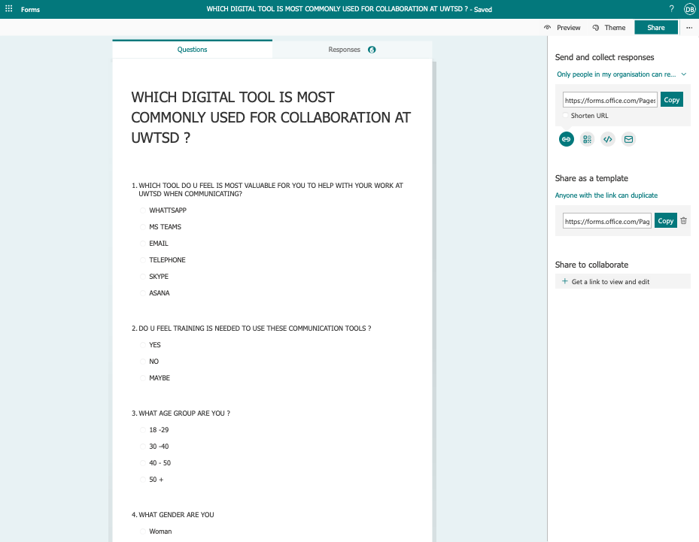
References

Works Cited
Curry, D., 2022. Busineesofapps.com. [Online]
Available at: https://www.businessofapps.com/data/microsoft-teams-statistics/
[Accessed 11 04 2022].
Dispatch, 2018. The NYU Dispatch. [Online]
Available at: https://wp.nyu.edu/dispatch/2018/08/27/technology-has-the-ability-to-foster-better-communication-skills-not-hinder-them/
[Accessed 11 04 2022].
Inno Renew CoE, 2022. innorenew.eu. [Online]
Available at: https://innorenew.eu/2021/05/gender-dimension-research/
[Accessed 11 04 2022].
Mohsin, M., 2021. Oberlo.co.uk. [Online]
Available at: https://www.oberlo.co.uk/blog/email-marketing-statistics
[Accessed 11 04 2022].
Rahul De, N. P. a. A. P., 2020. Impact of digital surge during Covid-19 pandemic: A viewpoint on research and practice. PubMed Central, 102171(55).
SmartSurvey, 2022. Smartsurvey.co.uk. [Online]
Available at: https://www.smartsurvey.co.uk/blog/why-ask-for-survey-respondents-age
[Accessed 11 04 2022].
Worksighted.com, 2022. Four reasons Why Nicrosoft Teams Is the Best Colloboration Software for Businesses. [Online]
Available at: https://www.worksighted.com/microsoft/4-reasons-why-microsoft-teams-is-the-best-collaboration-software-for-businesses/
[Accessed 11 04 2022].
World Health Organisation, 2022. Ethical Principals. [Online]
Available at: https://www.who.int/about/ethics/ethical-principles
[Accessed 11 04 2022].

