Qualification: CIPD Diploma in Applied Human Resources

Module Name: Contributing to the Resourcing and Talent Planning in the Organisation

Title: Resourcing and Talent Planning at MAWWFRS

Word Count: 3140 words

Student Name: Rachel Thomas
Student Number: 1201576
CIPD Membership Number: 55478540

By signing below, I confirm that the work/evidence presented is my own, unaided work. I understand the regulations pertaining to candidate malpractice and the action that may be taken as a result.

Signed: RMThomas
Date: 23/05/2021

Rachel Thomas

Resourcing & Talent Planning at MAWWFRS

Contents
Evidence Matrix 3
Organisational Approach to Workforce and Talent Planning 6
1.0 Background Information 6
1.1 Organisational Approach 6
1.2 Future People and Skills Needs 7
1.3 Addressing Service Needs 7
Reference List 8
Evidence – LO1 9
Recommendations to Improve Organisations Approach 14
Reference List 16
Evidence – LO2 17
Contributing to People Resourcing Activities 21
3.0 Recruitment of On-Call Firefighters 21
3.1 Roles and Responsibilities 21
3.2 Organisational Procedures and Legislative Requirements 21
3.3 Plan and Prepare 22
3.4 Implementation 22
3.5 Reflection 23
Reference List 23
Evidence – LO3 24

Evidence Matrix

Candidate name: Rachel Thomas |  |  |  |  | CIPD Membership/registration No.: 55478540
Qualification title: CIPD Diploma in Applied Human Resources (Level 5) |  |  |  |  | Student Number: 1201576
Unit code | Unit title |  | Assessment criteria no. | Evidence description | Evidence reference number |  | Assessor  initials | I/V initials if sampled
5ARTP | Contributing to the Resourcing and Talent Planning in the Organisation |  |  | Organisational Structure | EV01
 |  |  |  | KPI spreadsheet contents page | EV02
 |  |  |  | Re-Employment of Retired Firefighters Procedure (pages 1 – 2) | EV03
 |  |  |  | Transfer and Promotion Procedure (pages 1 – 2) | EV04
 |  |  |  | ADC guidance document (pages 1 – 2) | EV05
 |  |  |  | Application form for ADC process | EV06
 |  |  |  | Email from Head of HR regarding IDR process | EV07
 |  |  |  | IDR – Line manager meeting online document | EV08
 |  |  |  | Exit Interview Form | EV09
 |  |  |  | On-Call Firefighter Salary | EV10
 |  |  |  | Service Recognition Procedure | EV11
 |  |  |  | Employee Relations Update | EV12
 |  |  |  | Benefits Schemes available | EV13
 |  |  |  | HR KPI Tracker Spreadsheet  (01 April 2021 – 31 March 2021) | EV14
 |  |  |  | List of Fire Stations recruiting On-Call Firefighters – Service external website | EV15
 |  |  |  | Stakeholder Mapping | EV16
 |  |  |  | Recruitment and Selection procedure | EV17
 |  |  |  | Job Description | EV18
 |  |  |  | Email liaison with ED&I Officer regarding application form in line with Stonewall requirements | EV19
 |  |  |  | Records Management Procedure (pages 1 – 2) | EV20
 |  |  |  | Retention scheduled (Recruitment specific) | EV21
 |  |  |  | Email to Commands – Station Vacancies | EV22
 |  |  |  | Email from Training – On-Call & Wholetime Training Calendar | EV23
 |  |  |  | On-Call Training Calendar | EV24
 |  |  |  | Email to Commands – On-Call Training Calendar | EV25
 |  |  |  | Email to ICT – Upload of On-Call Training Calendar to @Work | EV26
 |  |  |  | @Work – On-Call Training Calendar Link | EV27
 |  |  |  | On-Call Recruitment process Gantt chart | EV28
 |  |  |  | CFO Memo | EV29
 |  |  |  | POEST Meeting Request | EV30
 |  |  |  | On-Call Recruitment Spreadsheet | EV31
 |  |  |  | Line manager approval – On-Call Recruitment Spreadsheet | EV32
 |  |  |  | Email to Fitness Team & Stores – Candidates for POEST | EV33
 |  |  |  | Email to Insync – Candidates & Optometric assessment forms | EV34
 |  |  |  | Email regarding On-Call Induction | EV35
 |  |  |  | Line Manager Statement | EV36
Candidate declaration:
- I confirm that the work/evidence presented for assessment is my own unaided work.
- I have read the assessment regulations and understand that if I am found to have ‘copied’ from published work without acknowledgement, or from other candidate’s work, this may be regarded as plagiarism which is an offence against the assessment regulations and leads to failure in the relevant unit and formal disciplinary action.
- I agree to this work being subjected to scrutiny by textual analysis software if required.
- I understand that my work may be used for future academic/quality assurance purposes in accordance with the provisions of the Data Protection Act 1998.
- I understand that the work/evidence submitted for assessment may not be returned to me and that I have retained a copy for my records.
- I understand that until such time as the assessment grade has been ratified through internal and external quality assurance processes it is not final.
Signature: |  |  |  |  |  | Date: | 23/05/2021

Organisational Approach to Workforce and Talent Planning

1.0 Background Information

Mid & West Wales Fire and Rescue Service (MWWFRS) operates 58 fire stations across 12000 square kilometres of Wales, employing around 1,300 employees. MWWFRS’s vision is “to be a World Leader in Emergency Response and Community Safety” (MAWWFire, 2020a). To do this, the aim is to deliver proactive and reactive fire and rescue services to the people of Mid and West Wales (MAWWFire, 2020b).

Employees of the Service are bound to differing conditions of service dependant on their role: Green Book and Grey Book. Green Book employees are those who provide admin assistance, whereas Grey Book employees are classed as ‘operational’ employees carrying out a firefighting role or are Control Room staff. The Conditions of Service are agreed by the National Firefighters Council and are therefore implemented within each Fire and Rescue Service in the UK.

1.1 Organisational Approach

For the Service to achieve its vision of providing emergency response and safety initiatives within the communities of Mid & West Wales, the main focal point for workforce and talent planning is the progression and development of its operational employees (those in a Wholetime or On-Call firefighting position).

According to Morgan (2015), MAWWFRS operates a traditional hierarchy structure with differing levels, whereby decisions are made at the highest level and transpired down to lower levels. Max Weber identified hierarchical structure as a central principle of a bureaucratic organisation (Kew and Stredwick, 2010). For such decisions to be made, departmental managers will feed information to the Corporate Heads and Directors, to make succession planning decisions (EV01).

The Human Resources department are responsible for recording KPI’s used within Service reports (EV02). Cambridge University Press (2020) define Key Performance Indicators as “a way of measuring a company’s progress towards the goals it is trying to achieve”. The use of KPI’s allows the HR department to provide statistical data to the Executive Leadership Team that outlines the following:

- Recruitment figures – across all four sectors
- Leaver information – across all four sectors
- The number of discipline and grievance cases currently active and processed
- Sickness absence – across all four sectors, broken down into sickness categories

To attract new talent to the organisation, job vacancies are published internally on the Service’s intranet, @Work, as well as the external website. Adverts are also posted on external sites such as Indeed, Gov.uk and People Exchange Cymru. Agreements are in place with various agencies that can also be utilised. There is however, a shortage of information available on the Service’s website in terms of the recruitment of Operational employees.

1.2 Future People and Skills Needs

The CIPD’s People Profession 2030 Report, looks at factors which could have impact on organisations in the future. For example, technology. According to the Annual Equality Report 2020-21 (MAWWFire, 2020d), the majority of the Service’s workforce are aged 35 – 64 years old, whereby, today, this age group would be perceived to have limited technological understanding.

Marr (2019) agrees with this, suggesting that in years to come, advances in technology could replace the need for people in an organisation, instead, systems become automated. He also goes onto mention the importance of encouraging and understanding diversity and cultural differences. According to the Annual Equality Report, 1.6% of Service employees class themselves as something other than ‘White British’.

Based on such research, the need to be flexible to adapt to change is something that needs to be considered. The demographic of the Service, along with their length of service, may bring about a sense of reluctance to chance, and reluctance to share their knowledge with others, and not willing to learn new things.

1.3 Addressing Service Needs

Winthrop (2021) highlights that it is no longer lawful for organisations to compulsorily retire employees when they reach retirement age. The use of KPI’s enables the organisation to predict the number of potential leavers based on retirement age, along with putting the necessary provisions in place 1) should they choose to leave, and 2) should they wish to remain in employment but change their working arrangements.

The Service recognises that a loss of skills, expertise, and knowledge of those voluntarily retiring from firefighting roles, may impact on Service performance, so has therefore introduced processes for the re-employment of retired firefighters (EV03).

The Service utilises a ‘Transfer & Promotion Panel’ whereby the decisions relating to workforce promotion and progression for operational employees are made, and are based on an “objective, transparent and fair criteria” (MAWWFire, 2020c). Operational employees are offered the opportunity to submit regular requests to be considered for transfers within the organisations providing a sense of job rotation (EV04).

Operational employees are urged to undertake the ‘Assessment Development Centre’ process to encourage promotion to Supervisory Manager, Middle Manager and Senior Manager positions (EV05). Employees are required to submit an application form to take part in this process (EV06). This process is carried out in partnership with South Wales Fire and Rescue Service, and North Wales Fire and Rescue Service.

Non-uniformed employees are recruited into roles based on their specific skills set and knowledge, therefore the same approach cannot be used for this sector of the organisation. Instead, non-uniformed employees are encouraged to further their development by undertaking further qualifications and courses to broaden their knowledge. This can be requested via their IDR.

CareerSmart (2020) explain the purpose of an IDR from an organisation’s perspective is to “assess an individual’s performance and to reinforce the connection to the aims and objectives of the organisation”. The IDR is made up of several questions in line with the Service’s strategic aims and objections (EV07) whereby individual development requirements can be highlighted in line with career pathways established by the People & Organisational Development Department (EV08).

Reference List

Cambridge University Press (2020) Definition of ‘KPI’. Available at: https://dictionary.cambridge.org/dictionary/english/kpi [Accessed: 21 September 2020]

CareerSmart (2020) Personal Development Review. Available at: https://careersmart.org.uk/your-career/appraisals-evaluations-reviews/personal-development-review [Accessed: 14 September 2020]

Kew, J and Stredwick, J. (2010) Human Resource Management in a Business Context. London: Chartered Institute of Personnel and Development.

Marr, B. (2019) ‘The 10 vital skills you will need for the future of work’. Forbes. 29 April. [Online] Available at: https://www.forbes.com/sites/bernardmarr/2019/04/29/the-10-vital-skills-you-will-need-for-the-future-of-work/?sh=723bf1663f5b [Accessed: 20 May 2021]

MAWWFire (2020a) Corporate Plan 2020 – 2025. Available at: https://www.mawwfire.gov.uk/media/1892/corporate_plan_2020_25_eng.pdf [Accessed: 01 June 2020]

MAWWFire (2020b) Fire Authority. Available at: http://www.mawwfire.gov.uk/English/FireAuthority/Committees/Pages/Fire-Authority.aspx [Accessed: 02 May 2020]

MAWWFire (2020c) Transfer and Promotion Procedure. Internal Publication. Available at: http://atwork/Library/Policies-and-Procedures/ServicePolicies/Transfer%20and%20Promotion%20Procedure(Grey%20Book%20employees%20excluding%20Control).pdf [Accessed: 13 May 2021]

MAWWFire (2020d) Annual Equality Report 2020-21. Available at: https://www.mawwfire.gov.uk/media/4839/jr1297-annual-equality-report-20-21_eng_jp.pdf [Accessed: 15 April 2021]

Morgan, J. (2015) ‘The 5 Types of Organisational Structures: Part 1, The Hierarchy’. Forbes Magazine. 06 July. [Online] Available at: https://www.forbes.com/sites/jacobmorgan/2015/07/06/the-5-types-of-organizational-structures-part-1-the-hierarchy/#6c4482315252 [Accessed: 15 March 2020]

Winthrop, M. (2021) ‘Retirement’. XpertHR. Available at: https://www.xperthr.co.uk/employment-law-manual/retirement/69658/#:~:text=An%20employer-justified%20retirement%20age%20will%20apply%20if%20the,expectations%20of%20the%20employee%27s%20performance%20and%20future%20plans. [Accessed: 05 May 2021]

Evidence – LO1

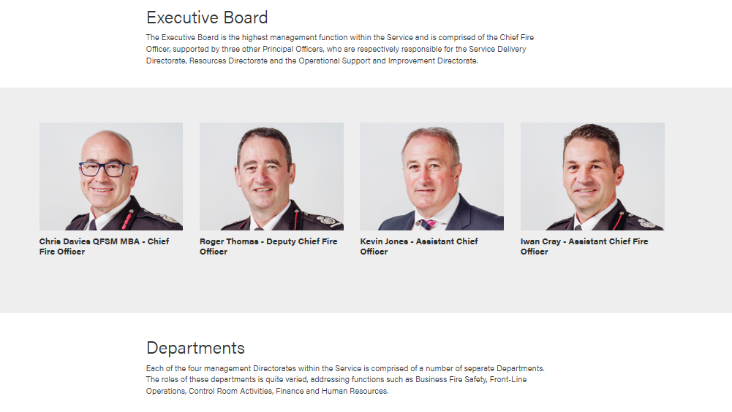
EV01

EV02
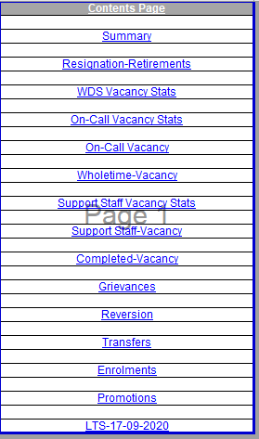

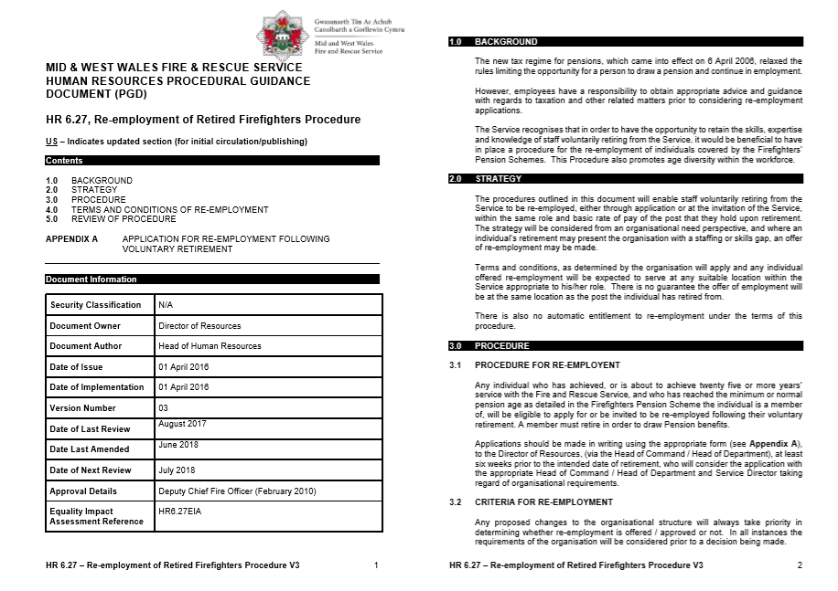
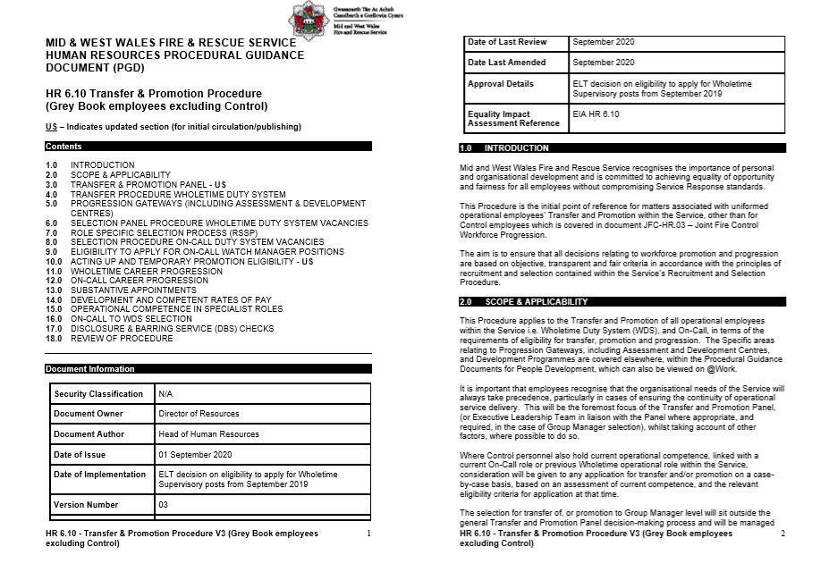
EV03
EV04
EV05
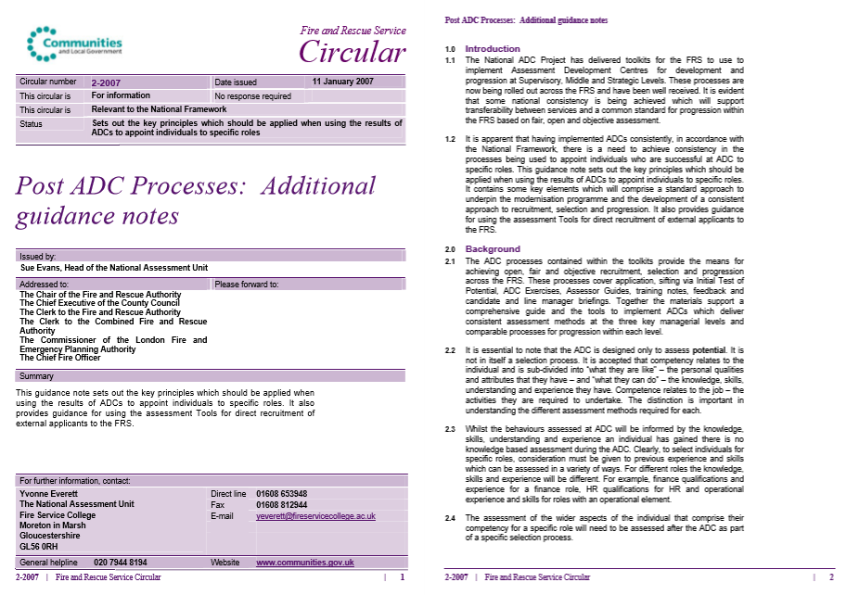

EV06
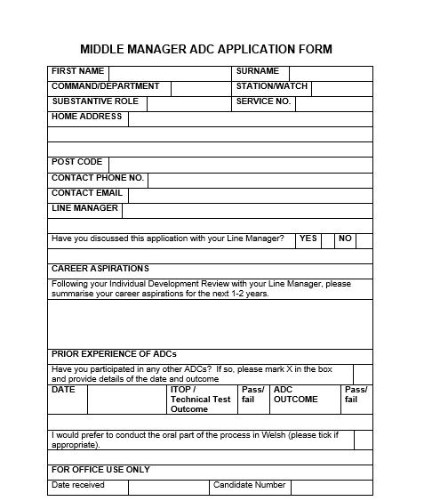
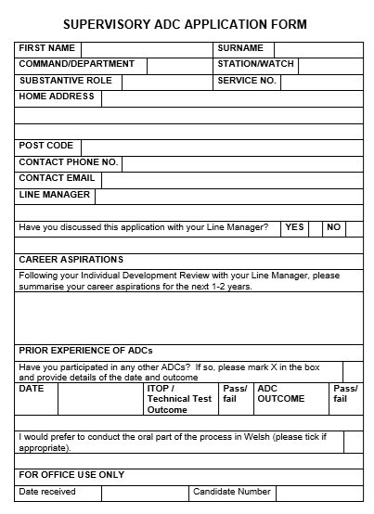

EV07

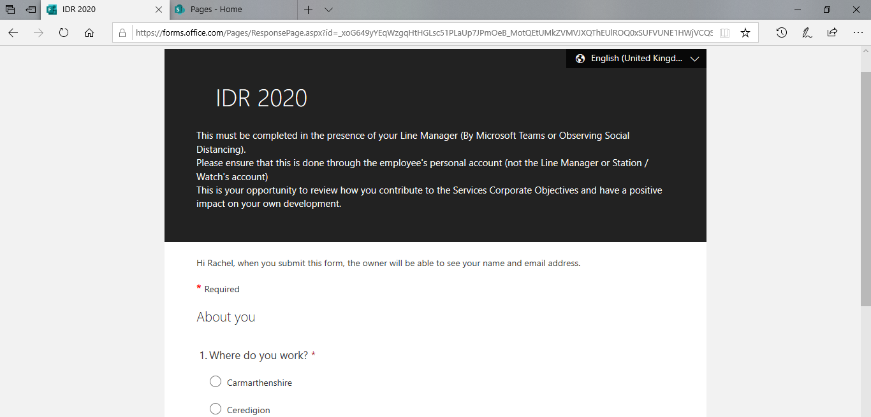
EV08

Recommendations to Improve Organisations Approach

Based on these findings and discussions with various employees within the Service, the following recommendations can be made:

- Mindtools (2021) suggests that the view of having more knowledge from experience, is often not the case. Reverse mentoring is the relationship between a junior team member, sharing skills, knowledge and understanding, to those more senior. Reverse mentoring can help to bridge the gap between the varying generations within the workforce. This is something that could be beneficial when looking at technological changes.

- Statistics suggest that the ‘On-Call’ sector has the highest annual turnover rate, in this regard and by using ‘Exit Interview Forms’ (EV09) the Service can monitor the reasons why employees in this sector are leaving to monitor and adapt engagement methods. Muller (2020) suggests that employees are more forthcoming with their feedback when leaving the organisation and can often provide constructive criticism for the organisation to consider in the future.

On-Call employees are required to provide 90 – 120 hours per week to fulfil their contracts. Employees are offered two types of contract, a 75% contract (providing between 90 – 119 hours a week) or 100% contract (providing 120 hours and above), this is sometimes not sustainable, and therefore the Service loses valuable employees. Many County Commands will decline new applications should they not be able to provide the 90 hours cover expected of them, instead of considering the requirements of the Stations. Therefore, by offering employees the option to reduce their contracts, the Service can look to retain employees in this sector. I propose that it is broken down as follows:
- Up to 30 hours a week = 25% contract
- Up to 60 hours a week = 50% contract
- Up to 90 hours a week = 75% contract
- Up to 120 hours a week = 100% contract

- Following on from this, feedback suggests that employees feel aggrieved with the salary they receive for carrying out such roles. As a Government funded organisation, salaries are agreed by the National Joint Council for Local Authority Fire and Rescue Services and are therefore standard in all Fire and Rescue Services and non-negotiable. On-Call Firefighters are paid an annual salary, an hourly salary for any additional training they take part in, along with a disturbance fee for every call-out they attend (EV10).

In this regard, it is apparent that those who are employed in a Station whereby there is a high level of callouts, these individuals receive a higher monthly salary. Having been in discussions with South Wales Fire and Rescue Service, it appears that the salary they pay their employees is equal per Station and is made up of an average of annual callouts. This is something the Service could utilise.

- It is apparent from the information available on succession planning, that emphasis is placed on the operational sectors of the organisation, and that a different approach is taken towards those in a ‘support’ role. The Service needs to pay more attention to the development and progression of employees providing a ‘support’ role.

Due to the rigid departmental structures within this sector, there is limited opportunity for progression or development for such employees, and this has been highlighted as a reason for departure. When advertising for job vacancies, the organisation could consider those currently employed with the Service in the first instance to gauge for interest. Should there be no interest, vacancies could then be advertised externally.

- Even though the procedures and processes are in place within the organisation for coaching and mentoring to take place, these learning initiatives are not actively promoted and consequently, uptake is low. Therefore, by utilising the Services communication department, this could be promoted on the Service’s internal website @Work, and via global emails/memos, and be utilised to share knowledge amongst employees.
Following on from the above, information regarding these learning initiatives can be provided to employees as part of their inductions packs when they start with the Service. This will not only show that the organisation is keen for employee development and improvement but will also start to change the culture within the organisation.

- The CIPD (2019) highlights the importance of developing people newly appointed into a line manager role. Line manager training is provided on a quarterly basis, whereby policies and procedures are explained. All the necessary information required to carry out such role, is accessible to line managers via the Service’s intranet. Where responsibility has devolved from HR to line managers, training is essential in ensuring the correct decisions are made. Unfortunately, due to the current Coronavirus pandemic, sessions have been postponed as working arrangements for employees have changed and will therefore continue when suitable to do so.

- As addressed by Maslow and Herzberg, recognition is a form of motivation for employees. It has already been highlighted that processes are not seen as equal within different departments; therefore, amendments have been made to the Reward and Recognition procedure to ensure equality from line management (EV11 & EV12). Additionally, work has been carried out to provide ‘incentives’ for employees, such as: Cycle to Work working in partnership with Halfords, Vectis Cards, Let’s Connect for technology and Salary Plan for vehicles (EV13).
The costs of making such changes will have an impact at first, however it is thought that over time this will outweigh the negatives through the increase in productivity and engagement of employees.
- Current processes require individuals to contact the Human Resources Department should they wish to express an interest in the role of an On-Call Firefighter. By liaising with the Corporate Communications and Business Development department, an ‘expressions of interest’ form could be created. This would allow candidates to provide their information in specific fields (rather than sending an email to the HR mailbox, which is the current process) and pass onto the HR Department. Not only does this reduce the number of emails being sent through to HR but allows for this information to be shared more efficiently with County Commands.

Reference List

CIPD (2019) Line managers' role in supporting the people profession. Factsheet. 16 October. Available at: https://www.cipd.co.uk/knowledge/fundamentals/people/hr/line-managers-factsheet (Accessed: 12 November 2020)

Mindtools (2021) Reverse Mentoring. Available at: https://www.mindtools.com/pages/article/reverse-mentoring.htm#:~:text=What%20Is%20Reverse%20Mentoring%3F,exchange%20skills%2C%20knowledge%20and%20understanding.&text=Usually%2C%20a%20mentor%20is%20expected,than%20his%20or%20her%20mentee. [Accessed: 23 February 2021]

Muller, D. (2020) The Importance of Exit Interviews. Available at: https://www.hracuity.com/blog/importance-of-exit-interviews [Accessed: 23 May 2021]

Evidence – LO2

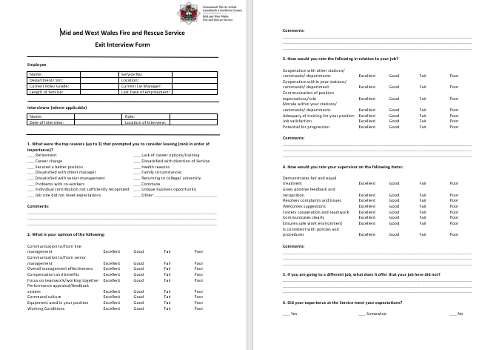
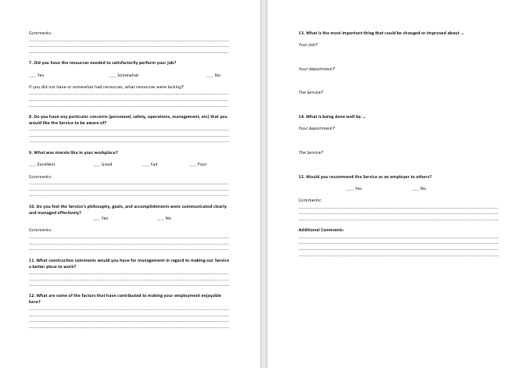
EV09
EV10
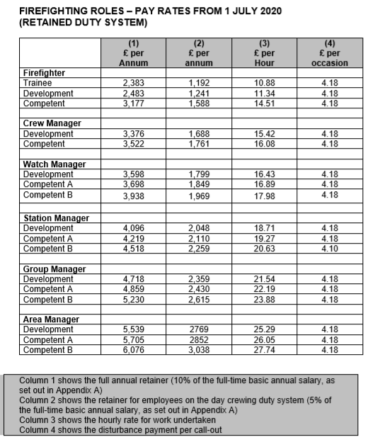

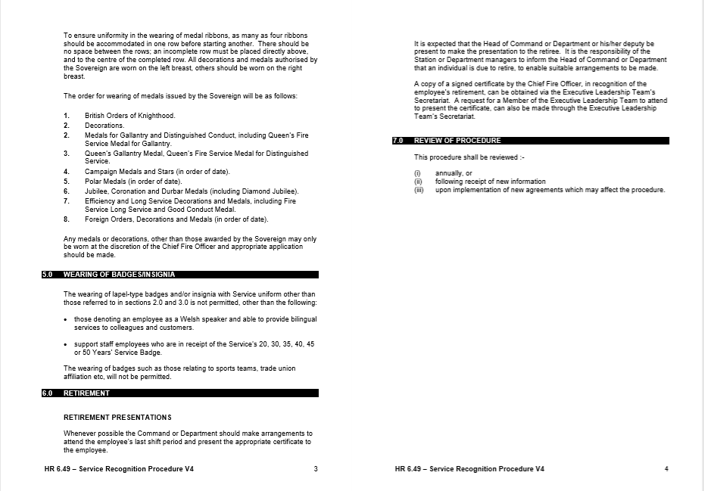
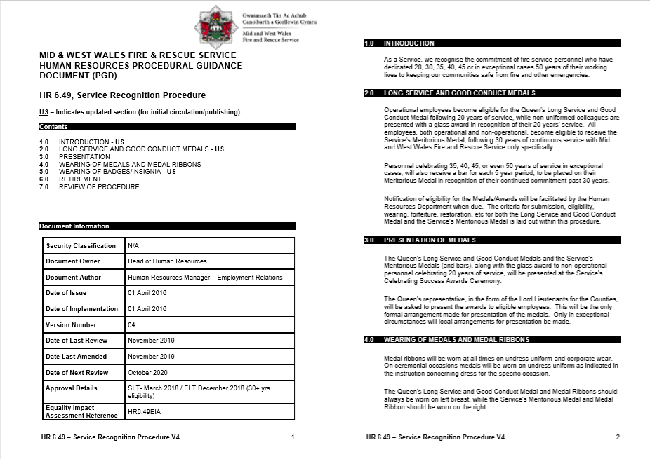
EV11

EV12

EV13

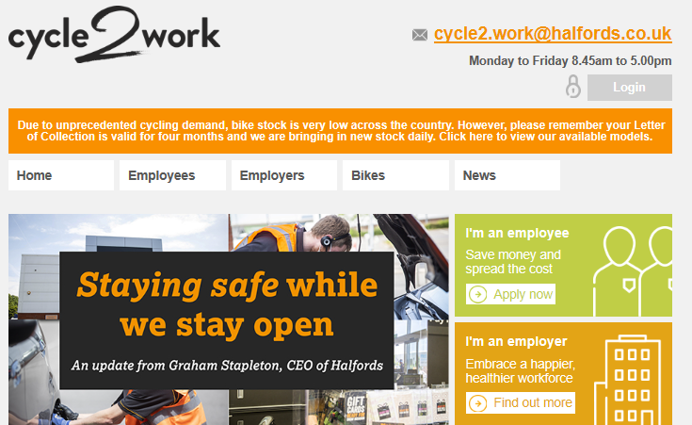


Contributing to People Resourcing Activities

3.0 Recruitment of On-Call Firefighters

Service statistics suggest a loss of around 120 employees between the period 01 April 2020 – 31 March 2021, across all four sectors: Wholetime, Control, On-Call and Support Staff (MWWFS, 2020). Out of the 120 employees that left in this period, the most significant findings are that 80 out of 120 of these employees, resigned from their position for various reasons, and 22 employees retired (EV14). Out of the four sectors of the organisation, the On-Call sector has the highest turnover rate.

Due to the number of On-Call leavers departing the Service, recruitment within this sector is constant, with vacancies remaining open-ended until Station requirements have been met (EV15).

3.1 Roles and Responsibilities

I am responsible for the issuing and collation of application documentation, and processing candidates through to the necessary stages of the recruitment process. Recruitment of On-Call Firefighters is constant, in line with the demand for resources in the Service’s 52 Fire Stations.

The On-Call recruitment process involves and requires the cooperation of several Departments/Roles to be successful. Project Manager (2021) defines a stakeholder as “an individual, group or organisation that is impacted by the outcome of a project”.

EV16 addresses that the Human Resources Department, Training Delivery, and County Command Officers are key players in the recruitment process. It was identified that the Executive Leadership and Trade Unions should be ‘kept informed’ of the outcomes of the recruitment process. Even though the Purchasing & Supplies team, Occupational Health, and the Fitness Team, are required to assist in the Point of Entry process, it was identified that they needed to be ‘kept informed’ of their requirements, for example, dates of testing and courses.

3.2 Organisational Procedures and Legislative Requirements

The Service’s ‘Recruitment and Selection’ procedure clearly outlines the variation in recruitment processes for Operational personnel and Support Staff employees (EV17). When a job is advertised, a job description and person specification is developed in line with the requirement of the role as shown in EV18.

Taylor (2019) suggests that carrying out job analysis is an essential foundation of any ‘good practice’ approach to recruitment and selection. A job analysis allows the organisation to determine the job duties and responsibilities, performance expectations and necessary skills and experiences required to carry out the role.

Under the Equality Act 2010, employers have a legal responsibility to make sure that they do unlawfully discriminate against someone, based on grounds of the nine protected characteristics. Working alongside the Equality, Diversity & Inclusion Officer, I have developed the Service application forms to reflect the requirements of Stonewall (EV19).

In accordance with the ‘General Data Protection Regulation’ (GDPR) and the Service’s Records Management Procedure (EV20), the Service must keep their records in line with the created retention schedule (EV21). In this regard, application documentation must only be kept for a period of 6 months, at which point it will be securely disposed of.

3.3 Plan and Prepare

Negotiations between all stakeholders were required to reach a common understanding of the process and the course of action need to be taken. I was involved in discussions with County Commanders located in each of the Service areas to address how many new recruits were required and in what areas they were needed (EV22), along with the Training Department to attain their availability as they would be heavily involved in aspects of the process (EV23). A training calendar was created (EV24) and issued to all Command Officers to understand the timings of the recruitment process (EV25), and I arranged for this to be published on the Service’s intranet for ease of access (EV26 & EV27).

Horn (2009) explains that the Gantt chart is used for planning and communicating the timeline of a project. The Gantt chart is representative of the tasks and amount of time each task should take. I have learnt that as an individual, I work best through visuals, therefore decided to develop a Gantt chart to reflect the recruitment process and the duration of each task (EV28).

3.4 Implementation

Due to the coronavirus pandemic and the subsequent Government guidance, unfortunately we were unable to follow the proposed timeline of events. As a result, all activities proposed after 23 March 2020, were placed on hold until advised that it was safe for individuals to return to the workplace, and for such activities to continue. Guidance was regularly issued by the Chief Fire Officer (EV29), listing the necessary adjustments the Service would be required to make.

A meeting was arranged by Head of Service Delivery, Group Manager Sean Lloyd on 15 July 2020 (EV30) who clearly outlined how the On-Call recruitment process would continue during such time. Meetings with candidates would now be conducted via telephone or Microsoft Teams, and the requirement to wear appropriate personal protective equipment (PPE) would be essential during physical testing where social distancing could not be achieved.

I developed a spreadsheet that would assist in collating the received applications and monitoring where in the recruitment process everyone was (EV31), which was approved by my line manager (EV32). I was also responsible for issuing the necessary correspondence to candidates to acknowledge their application documents, invite to testing, completion of pre-employment checks, and provide enrolment details.

I am required to liaise with County Command Officers, the Training Department and Fitness Team to ensure that they attended the scheduled testing sessions (EV33) and required to send candidates details to the Service’s Occupational Health provider, Insync, in readiness for pre-employment medicals (EV34).

I am also responsible for arranging the necessary induction day for On-Call new starters to attend. I am therefore required to liaise with the Executive Leadership Team, Training Delivery department, Human Resources Advisors, Fitness Team, Corporate Risk, Purchasing & Supplies, the FBU (Fire Brigades Union) and Firefighters Charity representatives, to ensure their attendance on the day (EV35). Marchington et al (2016) highlights the importance of an employee induction in creating the right cultural expectations for all new recruits.

3.5 Reflection

Looking back at the recruitment process for On-Call firefighters, my contributions play a huge part in ensuring that everything runs smoothly. I am the go-between for different elements of the process, and therefore must ensure that I meet all the deadlines and ensure that communication is clear to all.

I need to ensure that I follow the ‘Recruitment & Selection’ procedure, and that all involved in the recruitment process understand their roles and responsibilities. As such, I feel that I have built a good relationship with all parties involved, which could be of benefit moving forward.

In line with the 2013 CIPD Profession Map (2020a), for my role, I should be working at Band 1 or 2, and feel that I am on the way to achieving Band 2 in this field. On the other hand, I feel that this is not the case in many of the other professional areas due to the narrowness of my current role.

To broaden my knowledge of the Service’s retention processes within the organisation, it has been agreed with line management that over the next 12 months, I will shadow my colleagues who are working in a HR Advisor role to further understand and learn about the contractual elements of the employment contract (EV36).

Reference List

CIPD (2020) The 2013 Profession Map. Available at: https://www.cipd.co.uk/learn/profession-map/2013-profession-map (Accessed: 14 September 2020)

Horn, R. (2009). The Business Skills Handbook. London: Chartered Institute of Personnel and Development.

Marchington, M., Wilkinson, A., Donnelly, R. and Kyhighou, A. (2016) Human Resource Management at Work. 6th ed. London: Chartered Institute of Personnel and Development.

MWWFS (2020) KPI Tracker – All Spreadsheets. Internal Publication.

Project Manager (2021) Definition of ‘Stakeholder’. Available at: https://www.projectmanager.com/stakeholder-management [Accessed: 15 January 2021]

Taylor, S. (2019) Resourcing and Talent Management. 7th ed. London: Kogan Page Limited

Evidence – LO3

EV14

EV

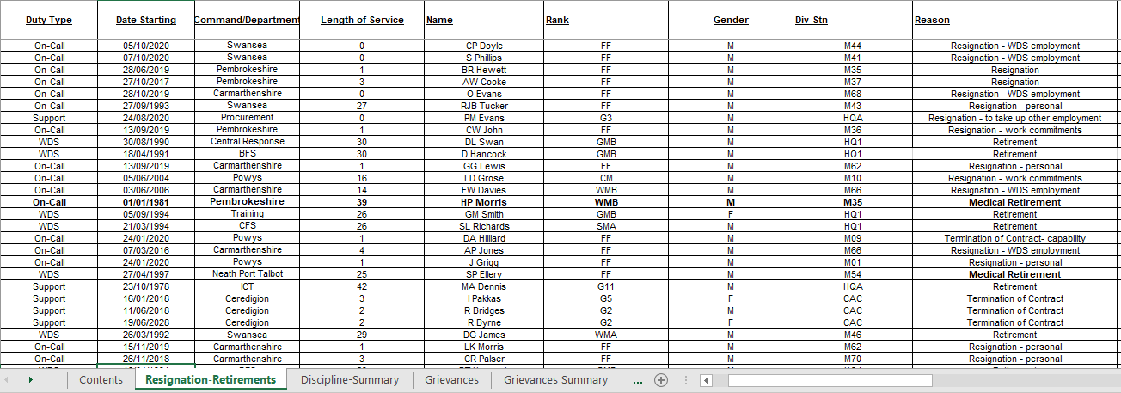

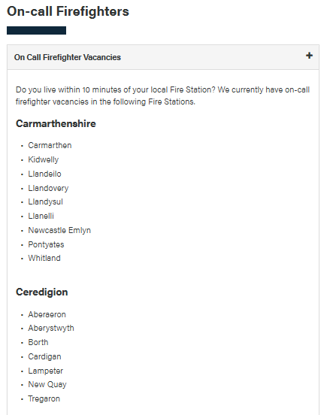
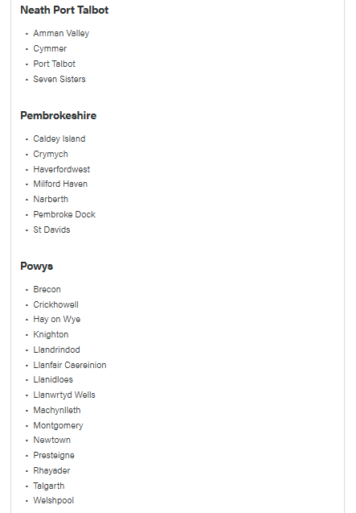
EV15

EV16
Stakeholder Influence/Interest Matrix
For each key stakeholder, characterize them using the following stakeholder influence grid.
Influence | High | Keep Satisfied | Key Players
Influence | Low | Minimal Effort | Keep Informed
 |  | Low | High
 |  | Level of Interest

Stakeholder Grouping
Using the Stakeholder Influence/Interest Matrix, complete the table below. This will help determine stakeholder’s grouping for communications.
Stakeholder Name | Influence Level | Level of Interest | Stakeholder Grouping
Human Resources | High | High | Key Players
Training Delivery Department | High | High | Key Players
Purchasing & Supplies | Low | Low | Minimal Effort
Fitness Team | Low | High | Keep Informed
Occupational Health Provider | Low | High | Keep Informed
County Command Officers | High | High | Key Players
Executive Leadership Team | High | Low | Keep Satisfied
Trade Unions | High | Low | Keep Satisfied
External Candidates | Low | High | Keep Informed

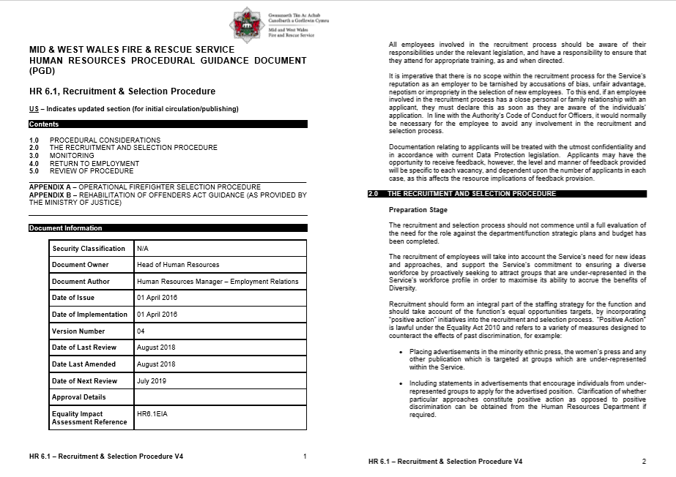
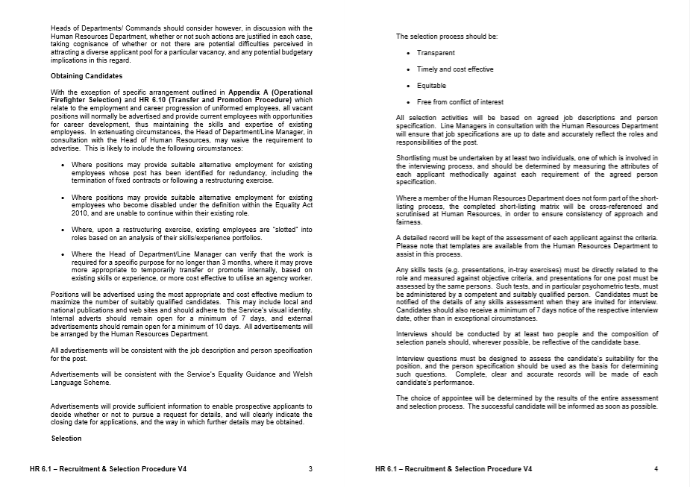
EV17
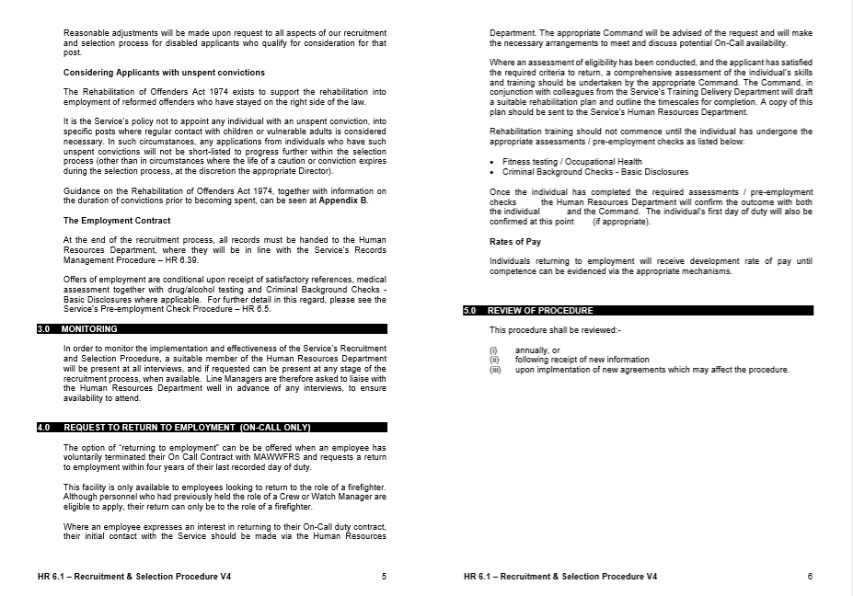
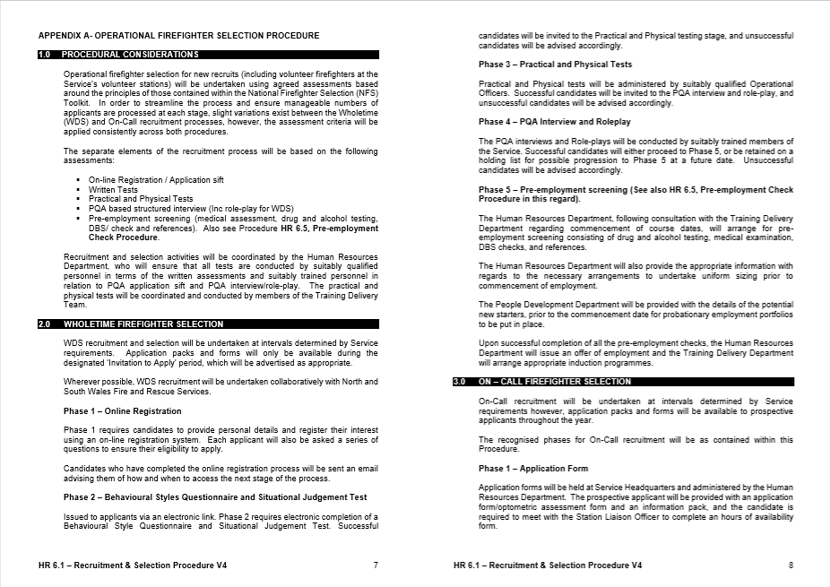
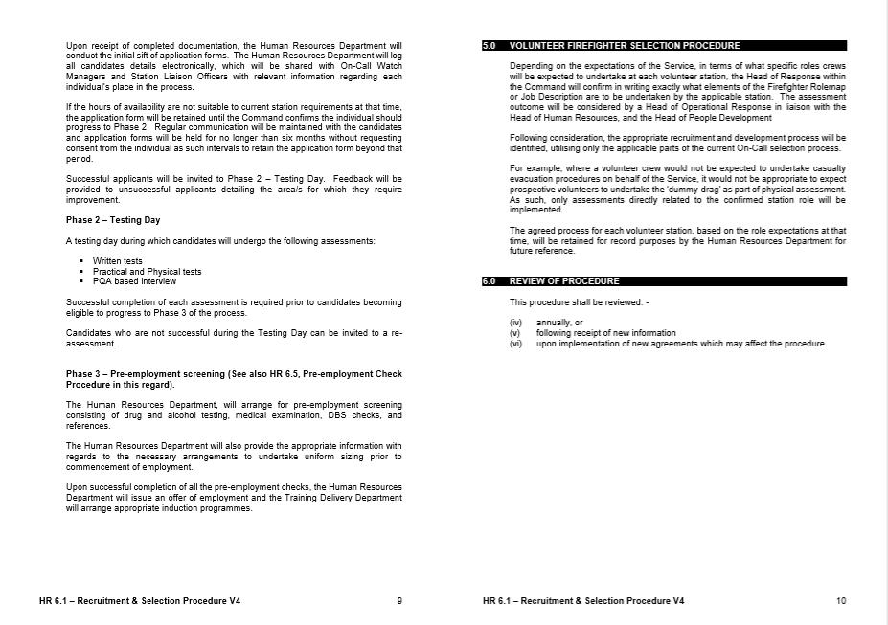

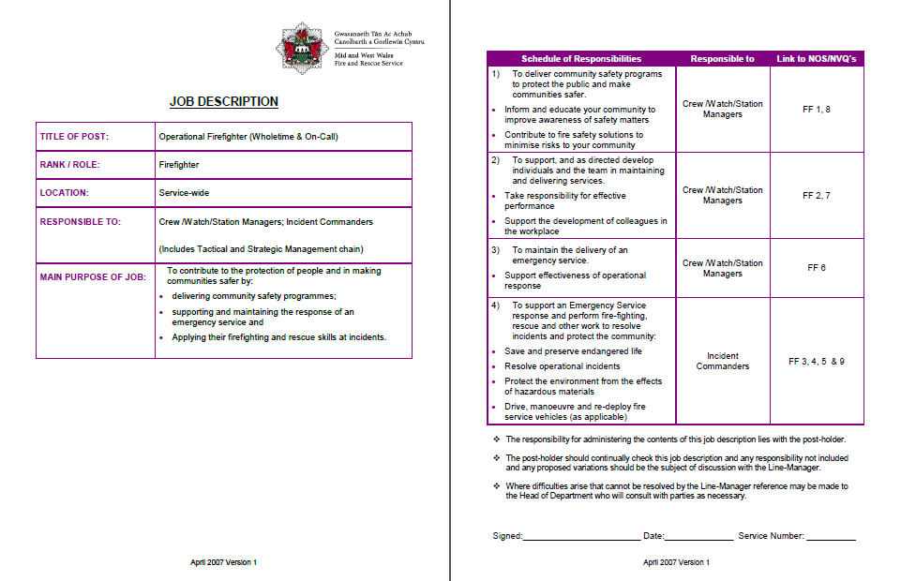
EV18

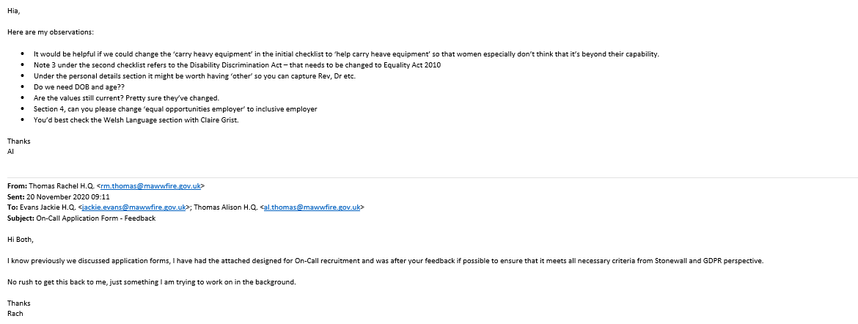
EV19

EV20
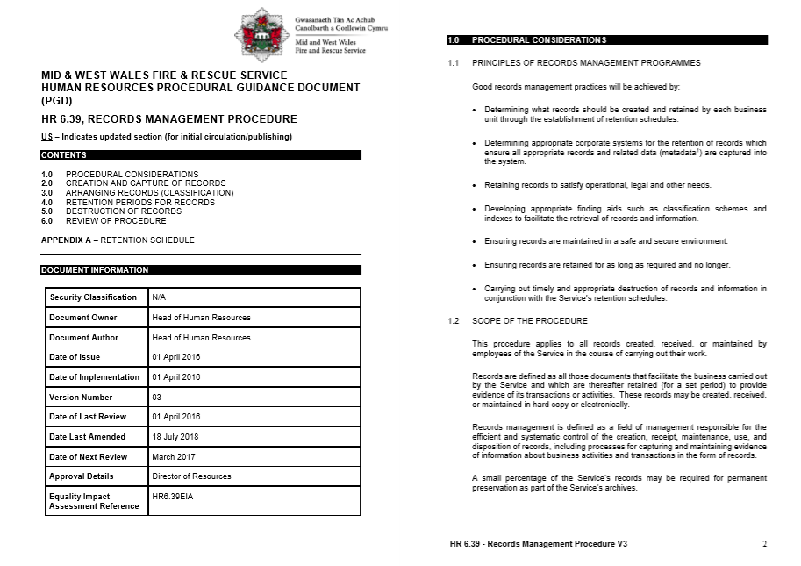
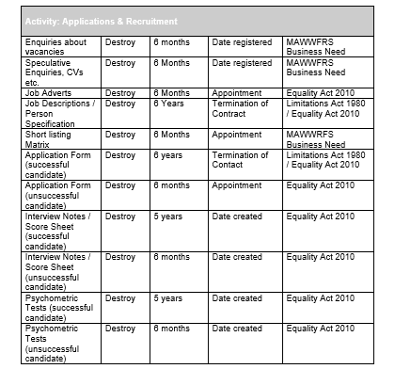
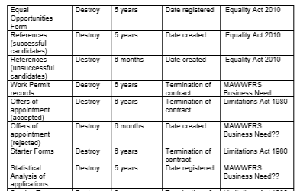
EV21

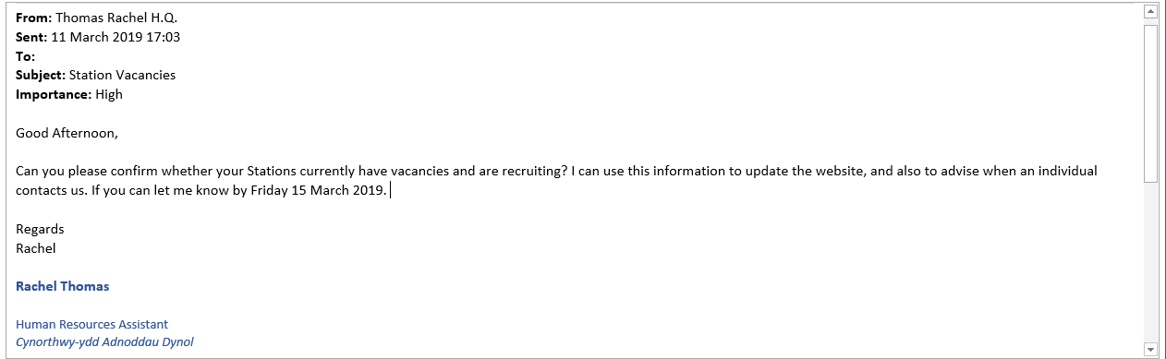
EV22

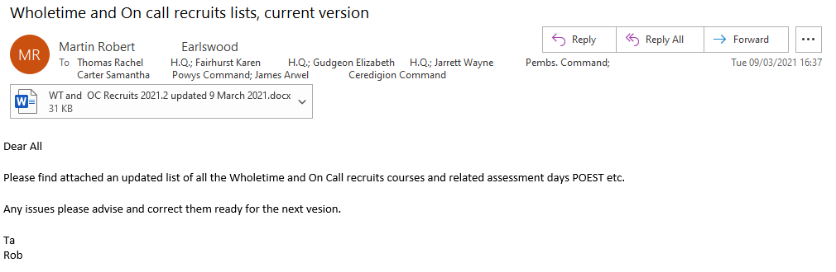
EV23

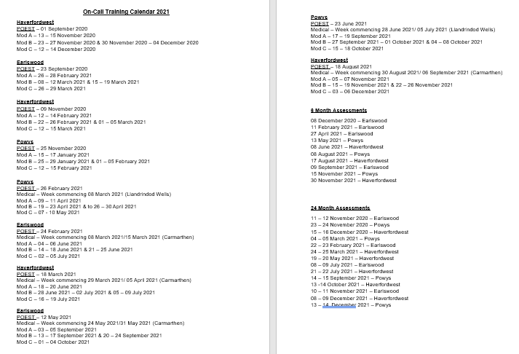
EV24

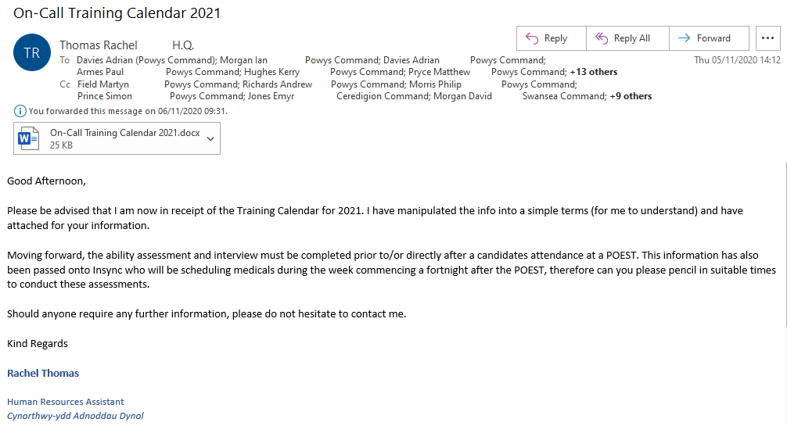
EV25

EV26
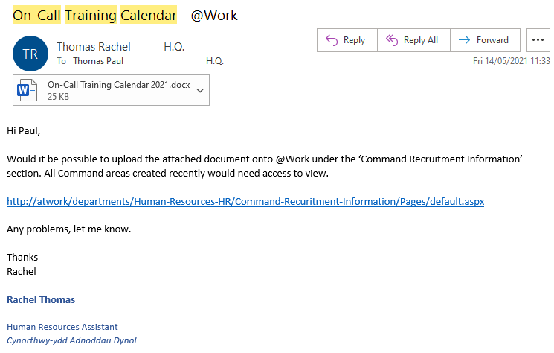

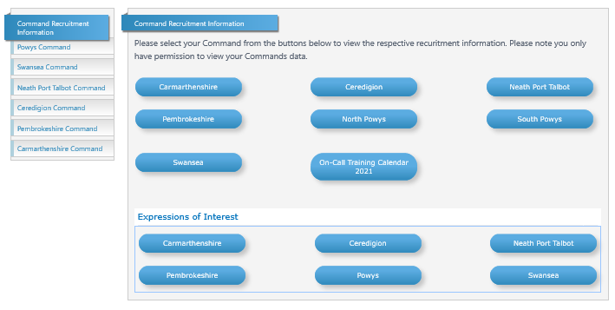
EV27

EV28

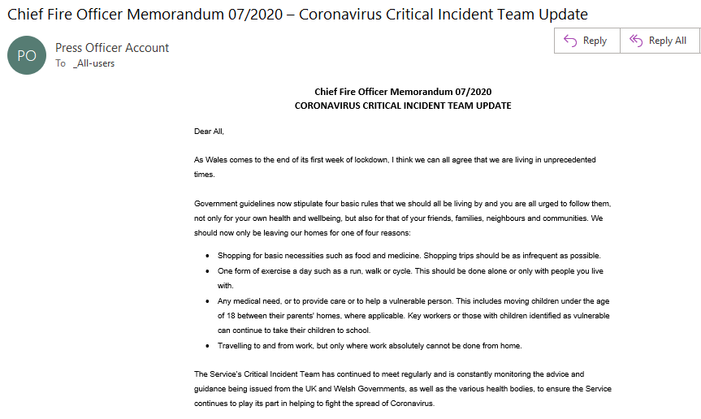
EV29

EV30
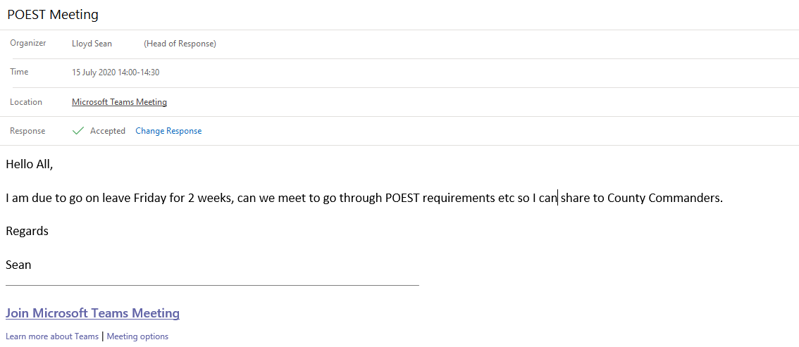

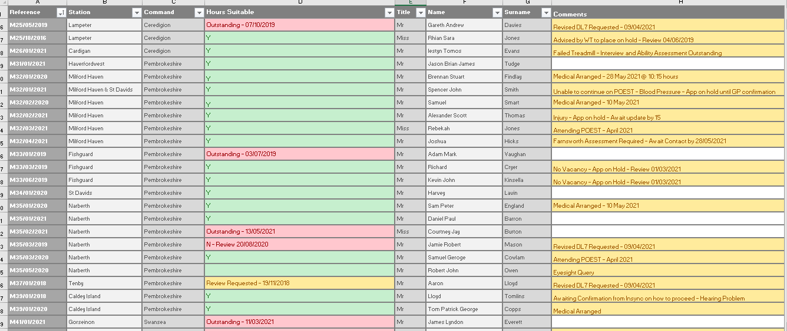
EV31

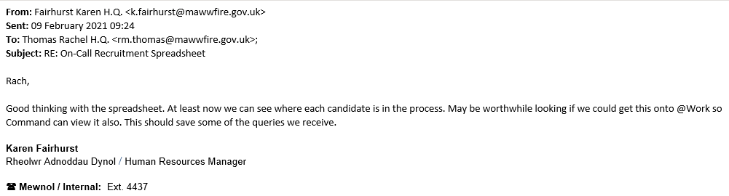
EV32

EV33
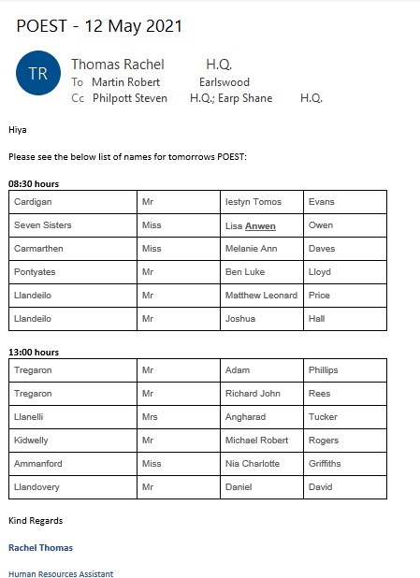

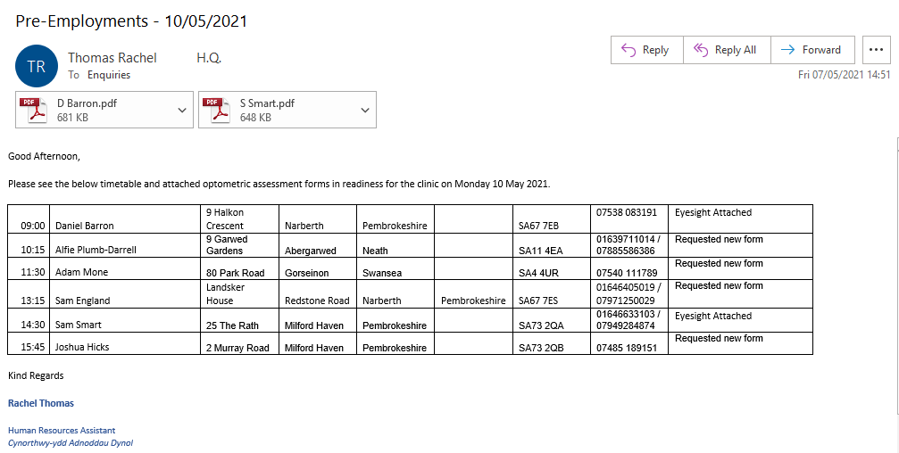
EV34

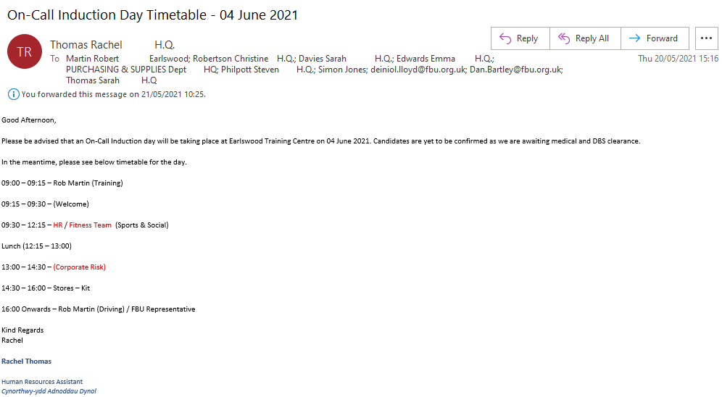
EV35

EV36


