4/3/2026
University of Wales Trinity Saint David
London campus
Module Name: Learning In the Digital Era
Module Code: ACCA 4025

Student Name: Cesar Cepero
Student ID: 2237352
Group: 1

Lecturer’s Name: Koushik Modak

E-Portfolio Link: https://2237352.wixsite.com/cesar
LDE Assignment 1
E-Portfolio
Table of Contents
Introduction 2
Task 1 (a): Report on Essential Academic and Employment Skills 3
Task 1 (b): Evaluation of Task 1 (a) based on Similarity report 4
Task 2: Collaborative Mind Map and Individual Poster 6
Mind Map (Collaborative) 6
Poster (Individual) 7
Task 3: Virtual Collaboration and RefWorks 8
Report on Virtual Collaboration 8
Step-by-step process of using RefWorks with visuals 10
Task 4: E-Portfolio Creation and Evaluation 14
Task 4 (a): E-Portfolio Creation 14
Task 4 (b): Illustrative Review of E-Portfolio tool Selection 14
Conclusion 15
Task 3 References: 16

Introduction

Nowadays we live in a world where technology has become essential in the daily life of many people, it is necessary to learn and be informed of the new digital era in which we are entering. In this module called Learning in the Digital Era, we are going to learn how to get along in this area, for that we will see .In each task we will learn different things such as Report on Essential Academic and Employment Skills; in which we will divide it into two sections, Essential Academic Skills y Essential Employment Skills, Also about Collaborative Mind Map and Individual Poster, here we will learn how to make a mind map with MindMester and the poster with Canva y Virtual Collaboration and RefWorks we will see teamwork and use the RefWorks tool that will be very useful On the other hand, let's not forget E-Portfolio Creation and Evaluation we will learn how to use Wix to create the portfolio .Thanks to all this knowledge we will be better in this subject and we will understand and know how to use new applications improving our skills

Task 1 (a): Report on Essential Academic and Employment Skills

Essential Academic Skills
Some of Employment Skills that we need for Academic are:
Emotional intelligence: It is important for any student to develop their intelligence to recognize, ask, understand, manage their emotions, yours and those of others to handle any situation no matter how difficult it may be [1].
Time Management: It is good for a student to know how to organize their time well for any situation in their life, it is about dividing large jobs into smaller steps. [2]
Research: it is about knowing how and where to look for information about a topic and getting references of the topics researched

Essential Employment Skills
Some of Employment Skills that we need for Business are:
Adaptability: we have to develop this type of skill because it is very necessary when they have to work in a team, when they have to work in different places, different positions, different companies, changing situations and to be able to relate to all the people who are meeting with him or her, face each situation and feel comfortable managing these types of uncertainties [3].
Attitude: This type of skill is the way to be mentally and emotionally prepared that help you react in a good way to people and some situations and ideas mostly in a positive or neutral way [4].
Teamwork: This is based on collaboration with other people, combining their efforts or skills to achieve a common goal or objectives in a faster and more effective way
Communication skill: All people should be able to communicate effectively, verbally and also in writing, this means expressing themselves, listening, also asking questions when they see the moment necessary.
Problem solving: It is the process of resolving problematic situations between the employees of a company that affect the correct development of their way of working and this must be solved in an appropriate way so as not to affect the productivity of a company.

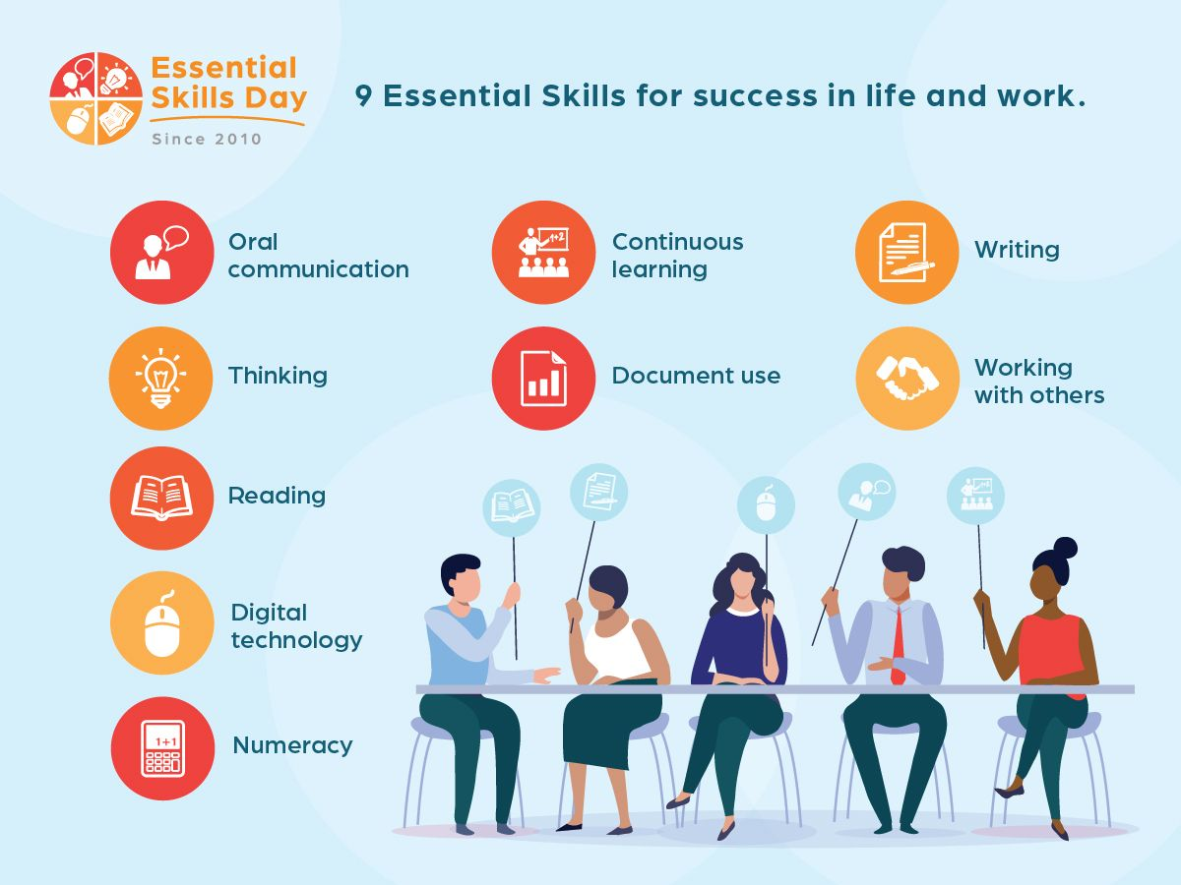
Figure 1: 9 Essential skills for success in life and work [5].

Task 1 (b): Evaluation of Task 1 (a) based on Similarity report

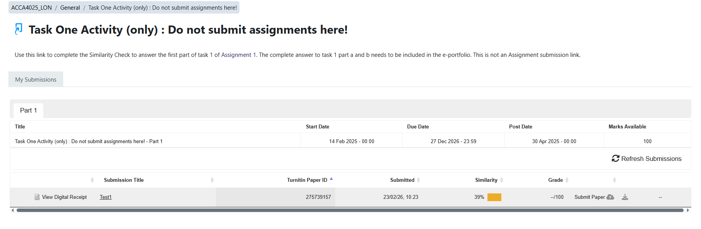This is my Similarity from my first test I've ever done, at 39%.I have learned to use the Turnitin, uploading my portfolio to the web, following the steps that the teacher has taught me to review and be able to modify the things I did wrong, as well as upload and reupload as many times as necessary to achieve a better Project.

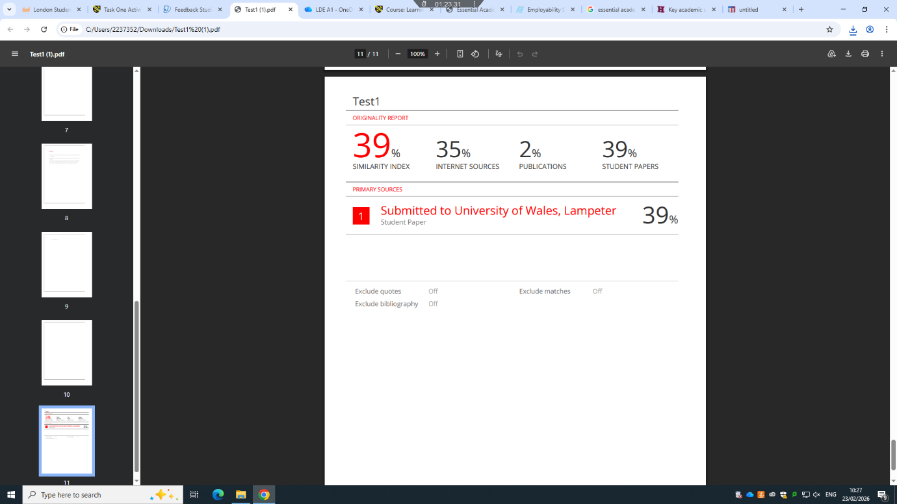
Here I took a screenshot with my data and my results .Here you can look at the pages that I was researching to get the information, as legal proof that I was striving for: 39% is because I have left the questions that I will later eliminate, no problem, but I know how it works and how to do it. It's interesting to know these things because I'll need to do it many times later 35% Internet Sources found on the web 2% Publications Similar Found. These scores can be improved by explaining everything in my own words correctly, although I use some phrases that I used from other pages for my portfolio I consider that I should have a better score, maybe a 20% of similarity I would give myself but no way, I will accept the evaluation grade that the University of Wales has given me, I'm learning to do better, I'm sure I'll get better every day

Task 2: Collaborative Mind Map and Individual Poster

Mind Map (Collaborative)
Mind Map Link: https://mm.tt/map/3952548205?t=ErfleLKTrz
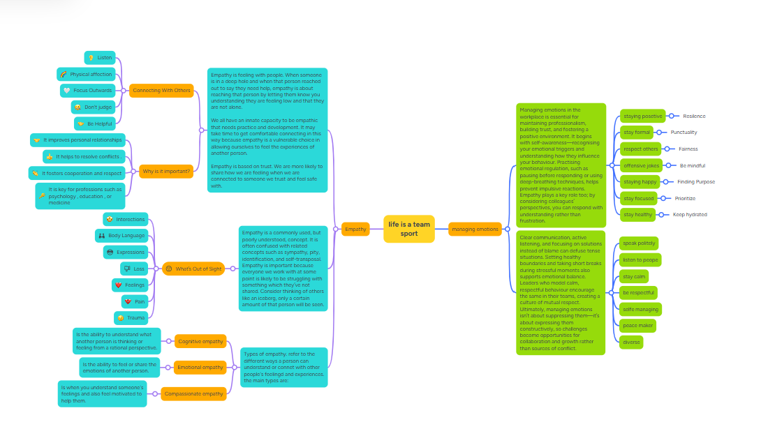

Team Member Names:
- Hamid
- Hamed
- Ena
- Cesar

Tools we used:
- MindMeister

Poster (Individual)
https://www.canva.com/design/DAHDY047wHU/OpLvBK9KtjflcGKo2aATOA/edit?utm_content=DAHDY047wHU&utm_campaign=designshare&utm_medium=link2&utm_source=sharebutton
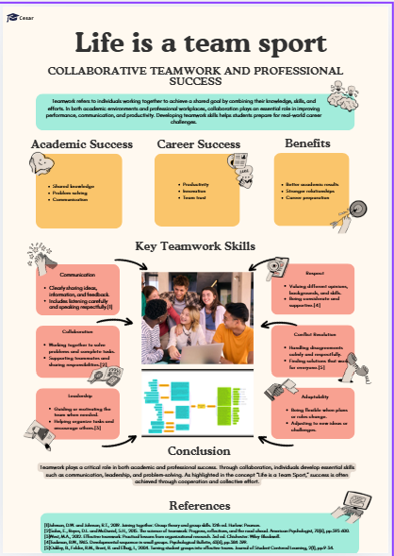

Task 3: Virtual Collaboration and RefWorks

Report on Virtual Collaboration
Unit 3 Topic 1: Forming a team
We have it divided into 3 sections:
Trust in me
In this section we can demonstrate a deeper way of understanding the importance of trust that can greatly improve a team's formation and development. [1]
When you comply with something you say you are going to do you clearly generate trust, but it is not quite enough, for a team to be productive and function in a correct way, all team members must do their part of the work as well and be responsible for their own. Because when a person trusts their team, it is more common for them to agree on solutions faster and the team is more productive. [2]
In this topic I have been able to see a video in which an expert in team management Patrick Lencioni analyses Five Dysfunctions of a Team:
Lack of trust is the first sign of a dysfunctional team. On a team, trust is essential because it is the cornerstone of cooperation. To build trust, members must be open and vulnerable with one another, sharing their identities, strengths, weaknesses, and mistakes. We cannot form a team without trust.
The dread of conflict is the second dysfunction. When we have trust, disagreement is reduced to the fervent search for the truth or the best solution.[3]
Lack of commitment is a team's third dysfunction. When everyone genuinely buys in after considering a decision and realising that's what they're all going to stick with, that's commitment.[4]
The Fourth Team Dysfunction On a team, accountability is crucial because when members have made a commitment, they will be more willing to approach each other about behavioural and performance issues.
and last problem, if we want to concentrate on the team's overall performance, we must have mutual trust, participate in constructive dispute, make commitments to one another, hold each other responsible for those decisions, and attain genuine collaborative outcomes. These are a team's five dysfunctions.

Getting to know your team members
Here it is about being aware of showing your image virtually, in how you present yourself and meet your work team, being authentic, being honest and transparent
and create a CV that reflects the best person you are to work in a team
We are Forming
Is about to drive team engagement, Members ought to establish quick goals.
- Frequently discussed
- Ambitious
- Specific
- Transparent
Fast goals help teams improve along multiple dimensions

Step-by-step process of using RefWorks with visuals

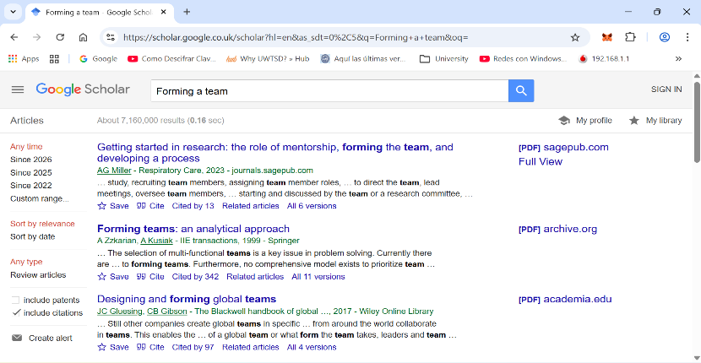
We'll start by searching for something in our Google scholar like Forming a team

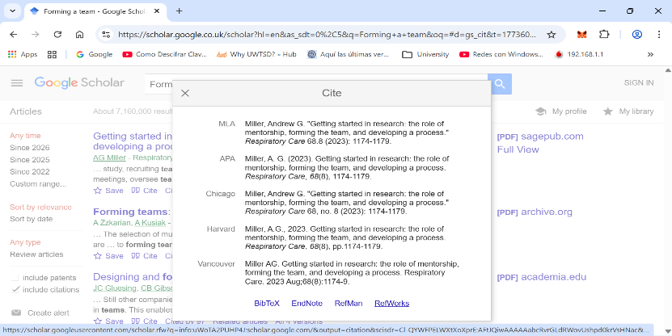

Then click on cite to go to the RefWorks option

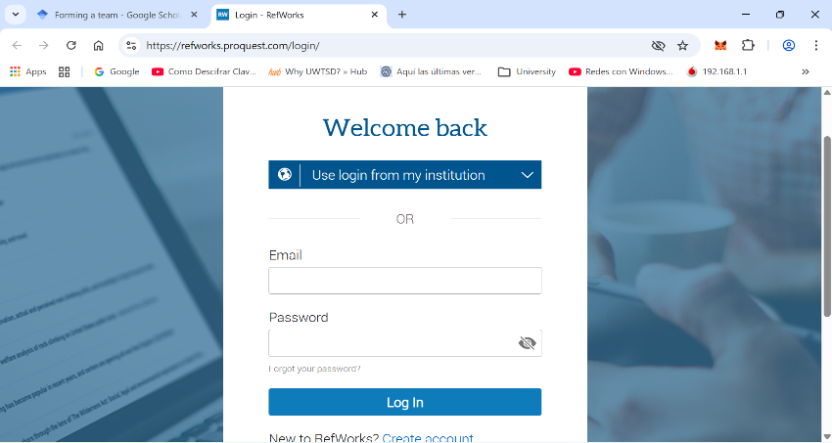

Click on RefWorks and this window will appear to start a section in our account

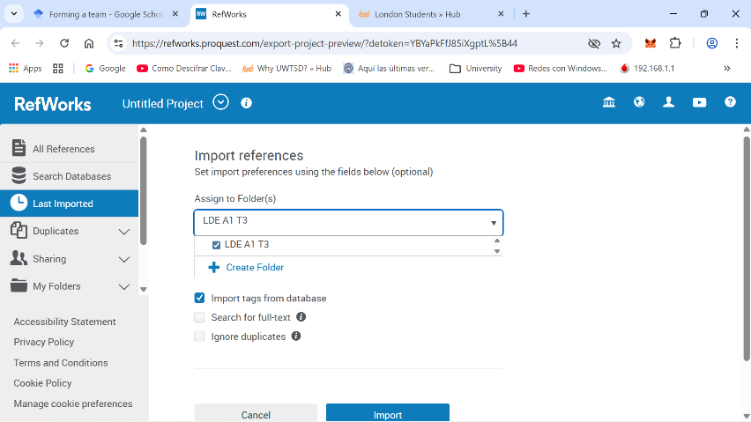

Once inside the application we will create a folder with the name I want, in this case I put LDE A1 T3 and I will click on import so that my link is saved

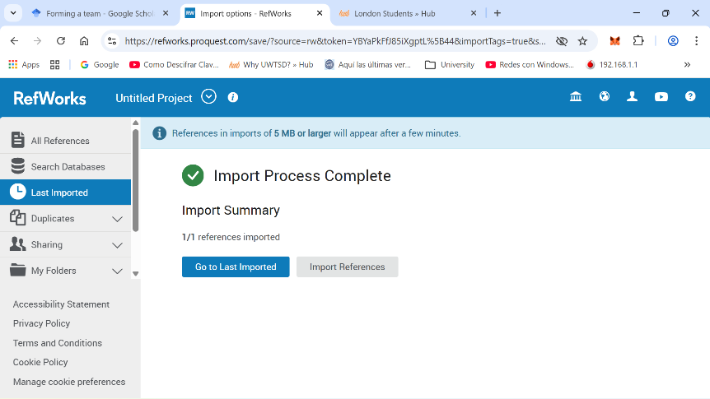

Here it was successfully imported

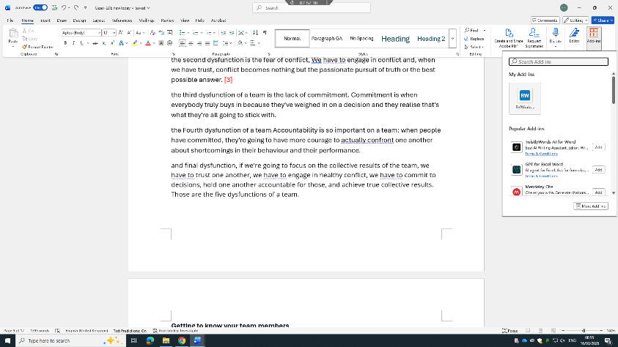
Once this is done, we will go to our Word toolbar and click on the Add-ins option and there we will look for our RefWorks application

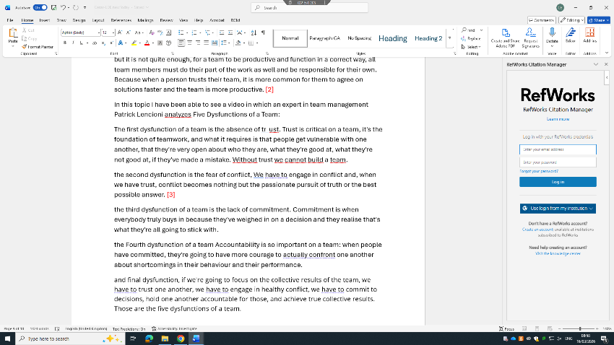

Then we will log into our RefWorks account to connect them to each other

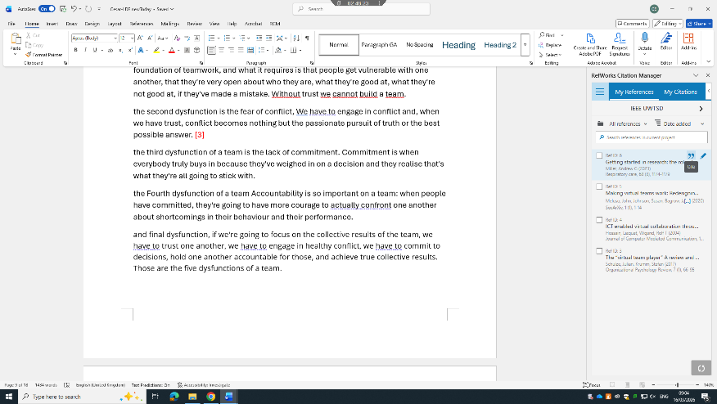

And now once we're connected to each other, we'll go to the two-quotation mark symbol and click there to insert my citation to our topic.

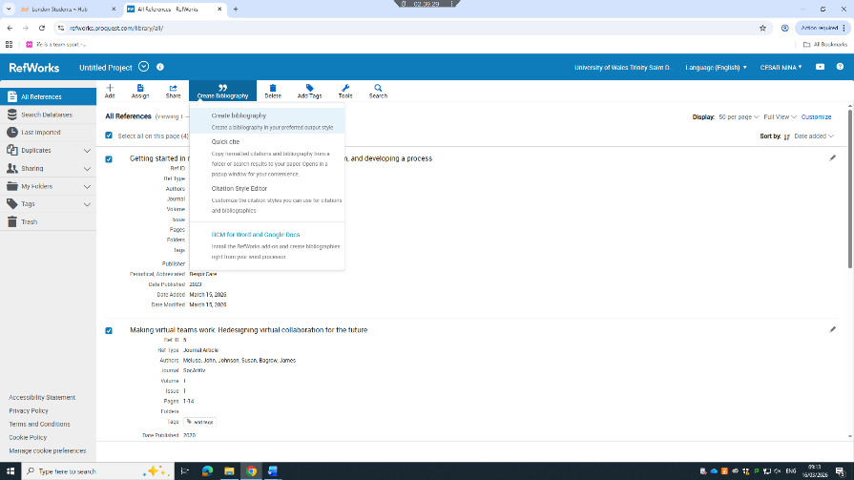
Now we will look for how to insert our references, for this we will go to our Refworks account, there we will select the references we want to add and choose the Create Bibliography option and there we will select the first option as seen in the image

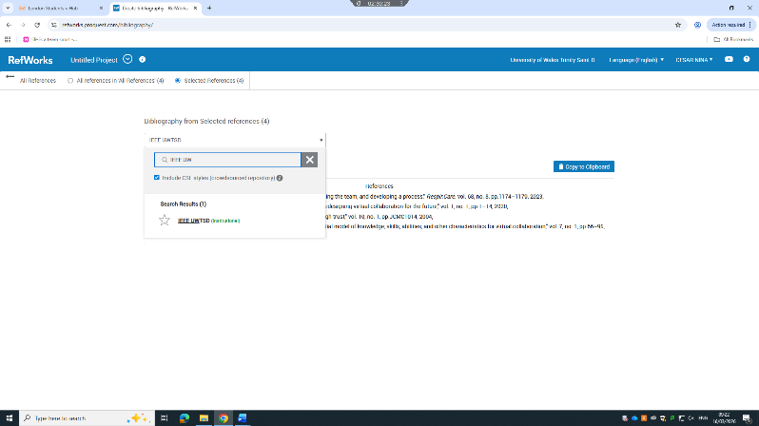

Now we'll look for IEEE UWTSD to create the references to the style we want and choose it

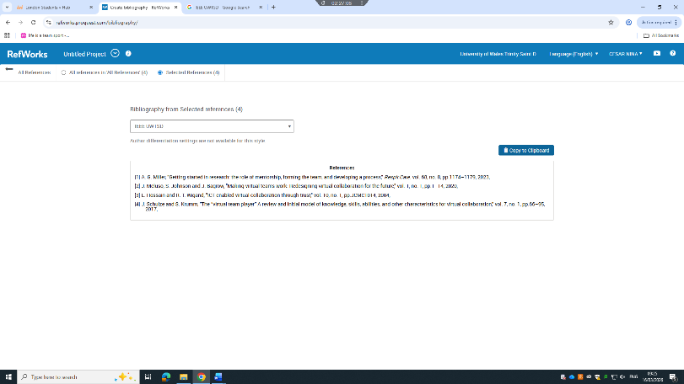

Once chosen, the references will be automatically created and now we will copy it from there to our created document.

Task 4: E-Portfolio Creation and Evaluation

Task 4 (a): E-Portfolio Creation
E-portfolio Link: https://2237352.wixsite.com/cesar
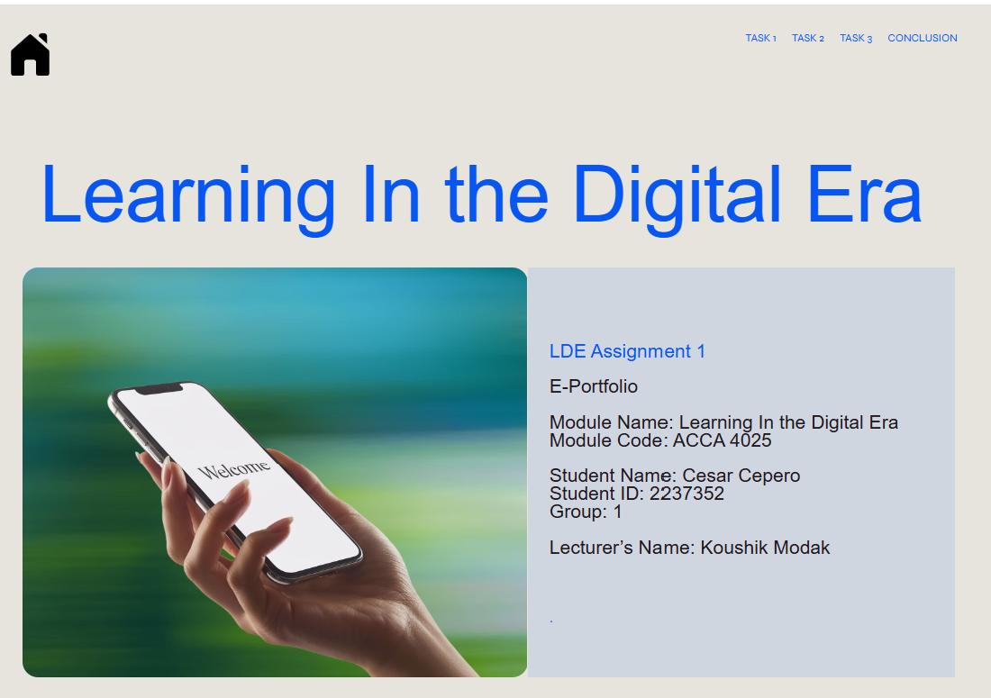
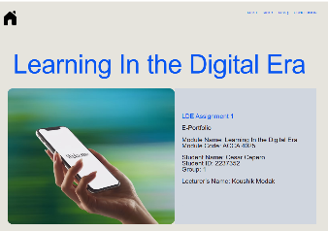 | 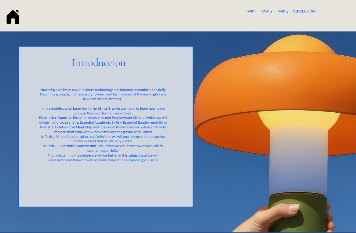 | 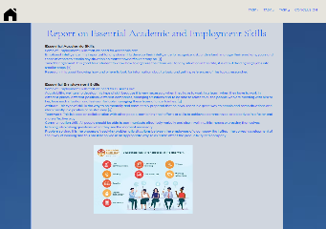
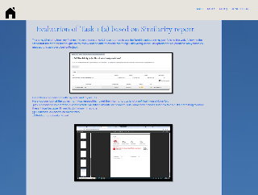 | 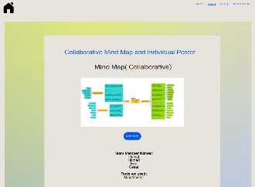 | 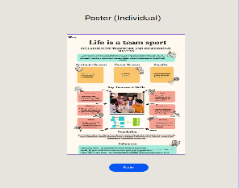
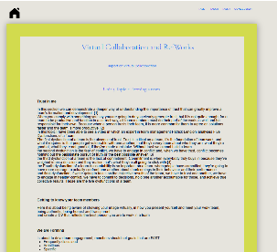 | 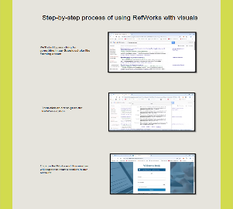 | 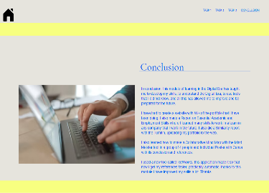

Task 4 (b): Illustrative Review of E-Portfolio tool Selection
The tool I used is called Wix, I used it because it is free, I had never used it, so it was the first time for me, so I also learn to use it, good experience, I recommend it. Here are some screenshots of my portfolio with Wix

This is the cover that I created, the truth is that I found it difficult at first, but as I did it I understood how each part of the Wix page worked, including how to put the image, the text boxes, the font size, the colour, the truth is very intuitive while you continue creating the page.

This is the introduction that I created, this part was simpler because I already had the text written in my portfolio, so it was just copy and paste.
This is where Task 1 began where I had to accommodate many word formats
As you can see here, I am in the part of task 2 where I have already put a button with a link to my Mind Map
I created the poster with Canva, and I had to put the image of my poster, I had already learned how to insert images
This is task 3, here was the longest part, because I had to put a lot of image captures, position them, change the borders and I practically had to create the page from 0
Here I ended with the conclusion of my portfolio the truth is very good the Wix application to make this type of content and be able to share it with other people for free on the web, I give it 5 stars. | 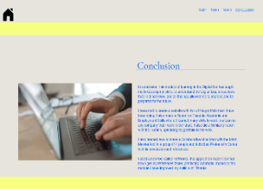

Conclusion

In conclusion, this module of learning in the Digital Era has taught me to develop my skills, to understand the Digital Era, to use tools that I did not know, and all this has allowed me to improve and be prepared for the future. I have had to create a website with Wix of the portfolio that I have been doing, I also made a Report on Essential Academic and Employment Skills where I learned many skills to work in a team in any company that I work in the future, I also did a Similarity report with the Turnitin, uploading my portfolio to the web. I also learned how to make a Collaborative Mind Map with the Mind Meister tool in a group of 4 people and Individual Poster with Canva with its conclusion and references. I used a new tool called RefWorks, this application made it so that now I get my references faster, practically automatic, thanks to this module I have improved my skills a lot. Thanks

References

Task 1 References:

[1] | R. Knott, “Essential Academic Skills to Help You Succeed at Uni,” Hannah Bowles, UK, 2020.
[2] | M. Pennington, Essential Study Skills, United States of America: El Dorado Hills, CA, 2009.
[3] | E.-S. Prince, 7 Skills for the Future: Adaptability, Critical Thinking, Empathy, Integrity, UK: Lisa Day, 2019.
[4] | A. Wilson, “Employability Skills: Essential Skills for the Future,” Parents, UK, 2026.
[5] | N. Jackson, Essential Skills:Essential Confusion, Canada: Mike Kelly, 2005.

Task 3 References:

[1] A. G. Miller, "Getting started in research: the role of mentorship, forming the team, and developing a process," Respir.Care. vol. 68, no. 8, pp.1174–1179, 2023,
[2] J. Meluso, S. Johnson and J. Bagrow, "Making virtual teams work: Redesigning virtual collaboration for the future," vol. 1, no. 1, pp.1–14, 2020,
[3] L. Hossain and R. T. Wigand, "ICT enabled virtual collaboration through trust," vol. 10, no. 1, pp.JCMC1014, 2004,
[4] J. Schulze and S. Krumm, "The “virtual team player” A review and initial model of knowledge, skills, abilities, and other characteristics for virtual collaboration," vol. 7, no. 1, pp.66–95, 2017,

