Developing innovation and creativity for business advantage
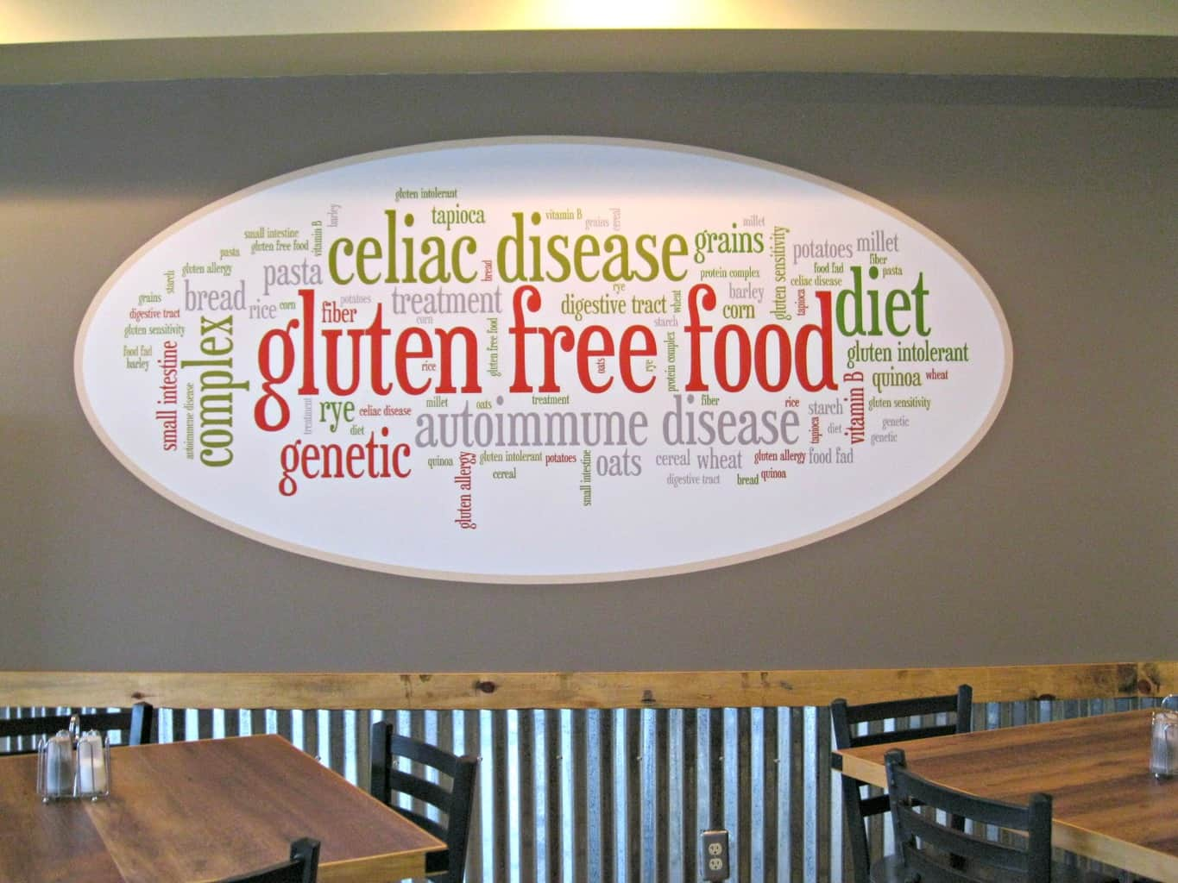

Assignment Type: Report
Student Name: Andreea Ciorascu
Student ID:2121532

Contents
INTRODUCTION 3
MAIN BODY 3
The innovative product OR unique service proposition: 3
E- Commerce 4
Marketing 5
Privacy and Data Protection: 7
CONCLUSION 8
REFERENCES 9
APPENDIX………………………………………………………………………………………10

INTRODUCTION
Creativity in the business is majorly around the original thoughts, knowledge and the unleash potential which highly supports to developing effective business idea which as an integral part in providing unique service to the people. With the development in the business there is major changes in working of a business organisation. Technology not only brings innovation but create a culture of working in which problem solving takes place (Alencar, et al., 2021). This report evaluate the business idea of a Glutton free restaurant which provides food made of organic products and glutton free products. The name of the restaurant is Cremica Restaurant. The aim of the report is to highlight the value proposition of the product and its importance towards customers. Then there is evaluation of the E commerce aspect of the restaurant with evaluation of the complete marketing aspects. Added to that there is explanation of the privacy and the data protection aspects of the Restaurant.
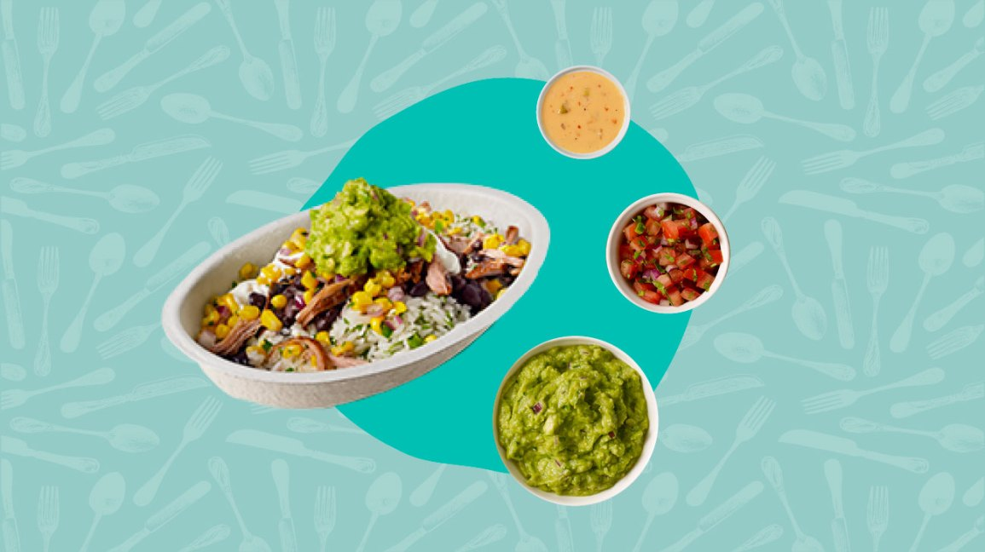

MAIN BODY

The innovative product OR unique service proposition:
What innovative product will you sell OR what unique service will you provide?
The service which Cremica Restaurant is providing to their customers is Glutton Free food and the organic food which is heathier for the people and gives more energy to them. This food is different from the usual food as it is being made with a purpose of enhancing health of the people with better taste.
Who are your customers?
The customers which is being targeted by the Cremica Restaurant is youngsters and the middle aged group who are more health conscious and wanted to explore good places with good environment. People got tired with their college and offices, thus, Cremica Restaurant will provide hen right ambiance with quality food.
Where and how will you sell your product OR provide your services?
The services of Cremica Restaurant will be provided on two ways one is they will be providing it on their location and the other one is they will provide their services through online portals by delivery agents.
Do you have a name for your venture?
Yes, the name of the venture is Cremica Restaurant because of their smooth services and working.
How do you intend to sustain your innovative business proposition?
With the knowledge and technology people are getting more aware about the more healthy options in eating and organic and Glutton free food are more healthier option which works for the betterment of the skin and the reducing fat as well.

Are there any competitors in this area?
Yes, there are multiple restaurant which are good in providing Glutton free food and the organic food in UK such as Niche Gluten free Dining, Indigo at one Aldwych Restaurant, Plant club and many more. These restaurant provides dine in services to the customers and there is only few options in the dishes. With that the rates of the food dishes are also very high.

E- Commerce
In order to provide online food to the customers there is website of the Cremica Restaurant from which customers can order food online and the delivery agent of the organisation delivers the food to the people. With personalised website this innovative business idea is also work in registering themselves from different online portals, so that customers can order the food from different platforms effectively (Woomer and Adedeji, 2021). This website will give all the information about the food, ingredients, prices and the response of the customers over the same, which helps in giving an idea to the customers about the Glutton free and organic dishes.
Cremica Restaurant is using software as a services in which they allow user to connect with the organisation and also implement cloud based apps. Such as they have to register themselves on shopify so that sales of the company becomes more effective. Shopify is a well-known sales platform through which customers can purchase anything.
In order to make the potential customer aware about their service it is crucial that right content is being used to influence customers. In order to do so blogs, articles and questionnaire will be used so that people get an idea of working of the company. The blogs and articles will be develop with the images of the food that restaurant is being providing to their customers with information of ingredients as well.
Providing services in the hospitality market clearly indicates that an organisation has to develop their position on online platforms and using online payment service for different types of customers. Cremica Restaurant need to take help of Paypal so that the people who are ordering food online can also pay for the same on a real time basis. But using such online platforms develop major issue for the organisation as well in terms of safety of data and from any mal practice. Also the restaurant is also providing on place services as well and at that time payment can be made with cards, through apps and in cash as well. In order to develop this payment systems in the organisation Cremica Restaurant should work as per the PCI compliance so that any sort of fines for the agreements can be avoided in future.

Marketing
How will you promote your product OR service?
In order to make the potential customers aware about the services of the restaurant it is important to facilitate effective marketing services which not only make people aware but attract the right of customers in the business as well. In context to Cremica Restaurant, the promotion will be take place with the help of digital marketing as youth and the people aged between 15- 40 are more active on different online platforms (Dabas, Sharm and Manaktola, 2021). The promotion will be developed with social media marketing, content marketing, and social media campaigning and with multiple other aspects online marketing.
Who are your target customers? How will you reach them?
The targeted customers and the most potential customers are the college students and the people who are working. This organisation provides healthy food with right set of ambiance to the people so that they can relax and chill with the peace. On order to reach out to the targeted people it is important to adopt digital marketing and innovative techniques as this will highly influence the customers because they are much active with their phones and more technically inclined. There are aspects in Google ads and Facebook ads which specifically target people with different aspect as per the demand of the people. Such ads and campaigning will appeared in their feed which automatically influence them with videos, images and text. Also influencers marketing is much useful as people get influence with local influencers who promotes the restaurants and their services by tasting their food and the experiencing the services of the restaurant as well. This will helps in better targeting to the potential customers.
Consider the use of social media.
Cremica Restaurant is being made for the youth especially as their food and ambiance are much suitable for them, implementing more tech friendly strategies will attract the people who like unique and different services from hospitality sector. Also for such people social media marketing is the most suitable aspect such as Instagram, Facebook, Snapchat, Pinterest and many other (Bryan Endres, Endres and Nižić, 2021). For effective promotion social media is considered as the best tool to influence people thus, which posts, videos, reels and images marketing aspect of restaurant is being established for targeting people. Facebook and Instagram is being used to promote Cremica Restaurant with videos and images and for influencers marketing Instagram reels are the most suitable platform.
Consider the use of paid search engines e.g. Google
Sponsored ads and the paid ads appear on top of the search engines whenever customers search about the restaurant on google and on other platform. Thus, in context to Cremica Restaurant it is important to implement paid search ads for more convince to the customers in generating information about the organisation (Gorach, Oksana and Rezvykh, 2024). Appearing on top will likely to generate more chances for the Cremica Restaurant to generate more customers in the restaurant and highlight their working among their competitors.
Understand the role of customer journeys
Generating the more understanding about the customers will highly help in giving positive customer experience which is crucial for building trust on customers and mastering in serving them effectively. In context to Cremica Restaurant understanding the role of customer journey will evaluate the information about customers which helps in building better relations with the customers. This can be generated by the Cremica Restaurant by mapping out the whole journey of the customers with list of scenarios which they will encounter in ordering food from online and offline platforms. The five main aspects of customer journey is awareness, consideration, decision, retention and advocacy. First customer will get to know about the brand by different platforms, then in consideration stage Cremica Restaurant will highlight their working in terms of generating competitive advantage, by the consideration stage customers decide to buy or not buying the goods and services of the restaurant, retention stage works on retaining customers by effective set of marketing and in advocacy Cremica Restaurant should work on proposing value that truly satisfy the customers. All these aspect is being developed with healthy and tasty food which needs to present on table within appropriate time.
Consider the use of email marketing;
In providing online vouchers, discounts and dine in email marketing is the most considerable type of marketing which gives personalised experience to the targeted audience. This will highly help the Cremica Restaurant in promoting their different services which they are offering to their different type of customers. In this type of marketing email is being prepared with the name of the registered customers and important information is being presented to them through highlighted text. This promotional technique provide complete information about the services of the company.

Privacy and Data Protection:
GDPR/Data Protection Act 2018
By the coming up of digitalisation within the society there has been the opening up of the infinite possibilities. Within the sector of hospitality it must be the responsibility to ensure the compliance of data in the restaurants bars and the hotels. In case of Cremica Restaurant it is important to establish good relationship which must be based on trust. Therefore all the data which are been exchanged at the time of taking up of the orders must be kept confidential and should not be misused (Andrew and Baker, 2021). Cremica takes into consideration to protect the personal information like the customer contact details collected during reservations, visits to establishment websites, newsletters sent out, payments, etc. of their customers (Andrew and Baker, 2021). There has been also the conducting up of the training programs for the employees to see that they do the compliance of Data protection laws during their busy days of working.
For the smooth operation of the restaurant the primary thing that have to be understood in compliance of the privacy laws is dealing with the concept of consent. As per the definition of consent it means there must not be the any kind of the detrimental behaviour form the side of the restaurant in case the consumers are not giving there information and it must be made very clear that what is the required information in which the consumer is giving the consent (Paal, 2021). The restaurant must also provide the right to the individuals to remove all the personal data from the record of the restaurant under special circumstances.
There is also the need of providing the security to the cloud provider in different ways like it is very important to have the proper understanding regarding the model of shared responsibility in case of the private data the whole responsibility come son the enterprises for the security but in the case of public cloud there has been the coming up of the different kinds of the complexity (Jia Jin and Wagman, 2021). There has been certain providers like the AWS and Microsoft Azure to clearly make the identification of role in various kinds of deployment situations.
Within the restaurant all the data are been always exposed to the risk in the state of transit and at rest which needs the protection in all the states (Jia, Jin and Wagman, 2021). There has been the very important role of Encryption for the purpose of protecting up of the data. For this purpose there has been the use made of the different encrypted connections like HTTPS, SSL, TLS, FTPS, etc for the purpose of protecting the content provided by the individuals. In case of the protection of data at rest Cremica Restaurant can simply do the encryption of the sensitive files before it is been stored or there has been the choosing up of the encrypt storage drive itself.

CONCLUSION
From the above report this is being concluded that innovation and creativity plays a major role in establishing an organisation in the respective market sector. This report is being developed in context a business idea in which a restaurant provide glutton free food and organic food to the customers. This report explains about the business idea with the marketing techniques and e-commerce. Then there is evaluation of evaluation of the privacy and data protection measures in the organisation. This report summarises about the digital marketing aspects on which Cremica Restaurant will focus on in order to facilitate their services effectively to the customers and make them aware about the working. There is evaluation of the how website of the company will help in informing customers.

REFERENCES
Books and Journals
Alencar, N.M.M., de Araújo, V.A., Faggian, L., da Silveira Araújo, M.B. and Capriles, V.D., 2021. What about gluten‐free products? An insight on celiac consumers' opinions and expectations. Journal of Sensory Studies, 36(4), p.e12664.
Andrew, J. and Baker, M., 2021. The general data protection regulation in the age of surveillance capitalism. Journal of Business Ethics, 168, pp.565-578.
Bryan Endres, A., Endres, R. and Nižić, M.K., 2021. Restaurant disclosure of food allergens: Analysis and economic implications. Tourism and Hospitality Research, 21(2), pp.202-215.
Cassar, M.L., Caruana, A. and Konietzny, J., 2020. Wine and satisfaction with fine dining restaurants: an analysis of tourist experiences from user generated content on TripAdvisor. Journal of Wine Research, 31(2), pp.85-100.
Dabas, S., Sharma, S. and Manaktola, K., 2021. Adoption of digital marketing tools in independent businesses: experiences of restaurant entrepreneurs in India and United Kingdom. Worldwide Hospitality and Tourism Themes, 13(2), pp.214-235.
Gorach, O., Oksana, D. and Rezvykh, N., 2024. Innovative Technology for the Production of Gluten-free Food Products of a New Generation. Current Nutrition & Food Science, 20(6), pp.734-744.
Jia, J., Jin, G.Z. and Wagman, L., 2021. The short-run effects of the general data protection
Kim, B., Yoo, M. and Yang, W., 2020. Online engagement among restaurant customers: The importance of enhancing flow for social media users. Journal of hospitality & tourism research, 44(2), pp.252-277.
Lee, Y.M. and Wei, C., 2024. Consumer visual attention to food allergen information on restaurant menus: an eye-tracking study. British Food Journal. Chawla, R.N. and Goyal, P., 2022. Emerging trends in digital transformation: a bibliometric analysis. Benchmarking: An International Journal, 29(4), pp.1069-1112.
Paal, B.P., 2021. Market Power in Data (Protection) Law. Global Privacy Law Review, 2(1).
Woomer, J.S. and Adedeji, A.A., 2021. Current applications of gluten-free grains–a review. Critical reviews in food science and nutrition, 61(1), pp.14-24.

APPENDIX




