Developing Workplace Critical Thinking

Student Name:
Student ID:

Contents
Introduction 3
Concept of Critical Thinking 4
The Difference between Beliefs, Attitudes and Values 6
Beliefs 7
Values 7
Attitudes 8
The Impact of Workplace Attitude and Behavior 9
Customer Satisfaction 9
Organization Performance 9
Interpersonal Skills 9
Cooperate Image 10
Critically Assess the Impact of Beliefs, Attitudes and Values in Own Workplace Behaviors. 10
Identify a Management Theory Relevant to Your Role and critically assess its Impact on Attitudes, Beliefs and values 13
My Role in the Workplace 13
Different Management Theories 14
System Theories 14
Contingency Theory 14
Bureaucratic Theory 15
Scientific Management Theory 16
Behavioural/Human relation Approach 16
Management Theories Relevant to My Role in the Workplace 16
Behavioral/ Human Relation Theory 16
Contingency Management Theory 17
Systems Theory 17
How Management Theories Impact My Own Beliefs Attitudes and Values in the Workplace 18
Conclusion 19
References 20

Introduction
I am currently an assistant manager working at one of the most famous food chains in the world, McDonald's, which is mostly famous for its quality food supply in about 100 nations globally. The company has about 35 000 outlets of fresh foods that exist in the 21st century. The company’s headquarters is based in Oak Brook in the U.S. the company was initially started by two brothers Maurice and Richard McDonald in California 1984. Its popularity has grown over the years as it is now the 8th largest company in the U.S with 375, 000 workers. However, the success of the company brought about a few unexpected increases in criticism for its popularity in different parts of the world. The paper aims at evaluating the concept of critical thinking by assessing the beliefs, values and attitudes in the workplace.

Concept of Critical Thinking
Critical thinking is defined as the approach that most managers take to find solutions to various challenges by applying to synthesize and conceptualizing. In some cases, managers use the concept of critical thinking to generate via observation, experience and good communication as a belief to actions on the various challenges that are present in the organization (Michael Scriven, Richard Paul, 1987). Critical thinking involves the evaluation of various structures generated specifically for coming up with causes of problems, purposes and assumptions to instantly find solutions to different challenges. Critical thinking involves analytical thinking, scientific thinking, technical thinking, technological thinking and economic thinking. Also, rational and moral thinking towards the organization to try and solve any form of misunderstanding that exists between workers and their employees.

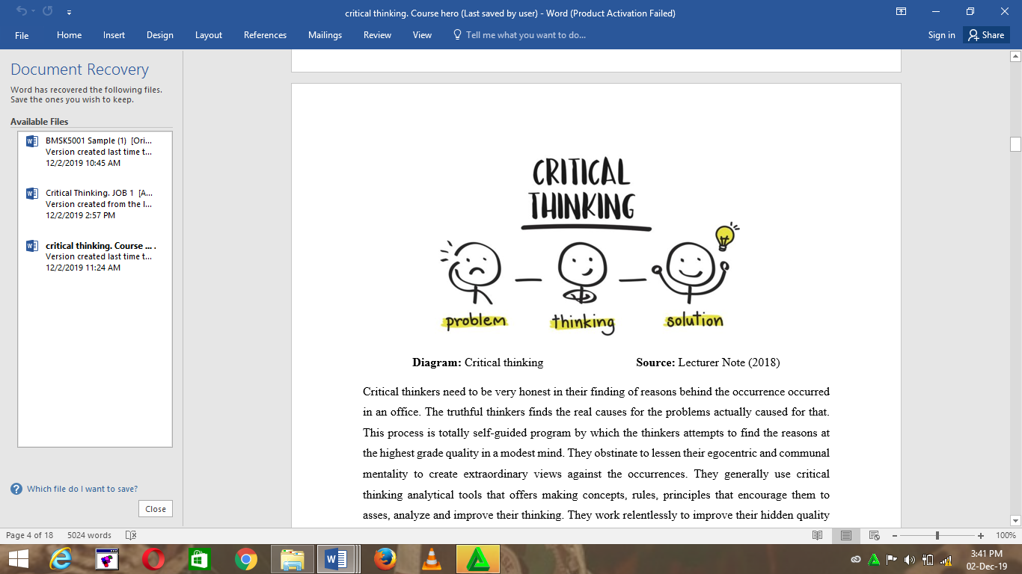Critical thinkers are expected to be honest in their reasons and findings behind any incident that may have occurred in the office. Thinkers who are truthful find the key causes of the challenges and their causes. The process of critical thinking is a self-motivated activity where the thinkers in the organization try to find ways as to why the greatest quality can be achieved in a modest manner. In most cases, they tend to obstinate in order to find lessen their communal and egocentric mentality that will create an extraordinary view against the happenings. They use the analytical tools of critical thinking to offer and make principles, rules, concepts and offers that enable them to analyze, assess and improve their critical thinking skills. Furthermore, critical thinkers work hard to develop hidden qualities via intellectual integrity, values, empathy, civility as well as intellectual judgments and thoughts for the right reasons (Linda Elder, 2007). Critical thinkers regard themselves to be devoted personnel’s that assist in realizing that thinking how skilled one is as a critical thinker does not necessarily matter. The only thing that matters the most is improving a person’s ability to reason rationality and make mistakes in, reasoning, prejudice, biases and vested intentions. Critical thinkers hardly practice cross-cultural reasoning as they are fair-minded and their intentions clear.

The Difference between Beliefs, Attitudes and Values
Beliefs are defined as a combination of convictions and miraculous thoughts, rules and views that have no specific visual evidence on the expense of measure of beliefs. One Milton Rokeach came up with a theory on values, attitudes and beliefs that conceptualized the persuasion of the general services of a consumer or rather obey definite life rules that people apply in their lives daily. Rokeach further explained that these values attitudes and beliefs are similarly based on manners, religion and legacy. To understand the above topic, more, beliefs, values and attitudes are described below in details.

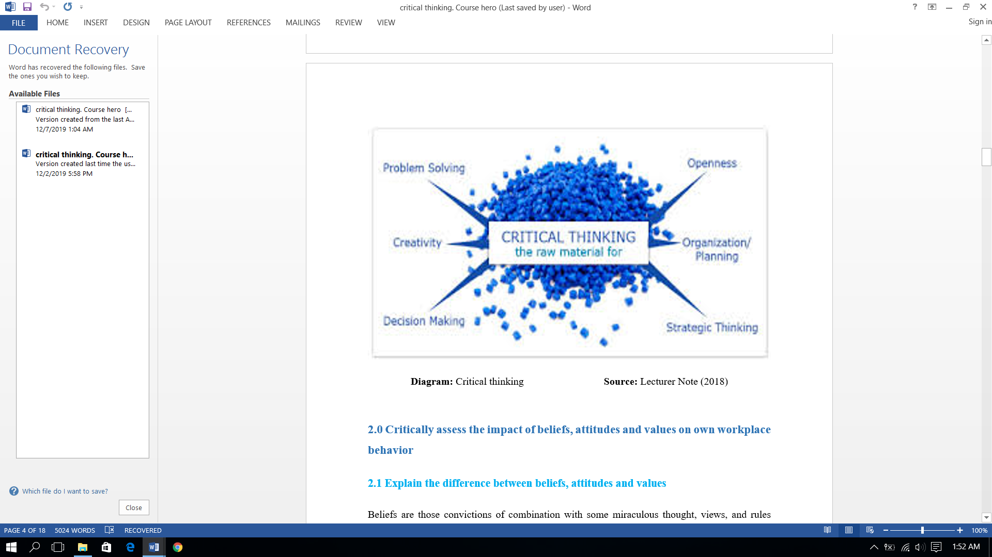

Beliefs
The beliefs contained by an individual persuade one to maintain a stable life balance that has various rules varied depending on the people in the community. A person applies various theories that are miraculous as they are not proven scientifically. Beliefs are what encourage people to see the difference between what is right and what is wrong as well as the kind of beliefs that an individual holds. For example, superstition beliefs, religious beliefs, self-realizations, soul beliefs, and assuming beliefs that one obtains either traditionally or hierarchically (Raymond Boudon, 2013).. Each belief that existed in men is due to the advancements that happen in life from day to day, continuous and dedicated experience doing jobs that are helpful for customer care. A good example of a belief that I have is that there exists there is a life that exists after death. I have a belief that God is the sole creator of heaven and earth. In this case, beliefs can be categorized to two primary categories. One key belief that cannot be altered and the other is peripheral beliefs that are changed according to the needs of a person.

Values
Values are, in most cases, considered to encourage critical thinking in the workplace and find solutions to various challenges that have taken place. Values can be described as a combination of different beliefs that are generated gradually in a person’s life. Values are a combination of different beliefs that are contained in the life of a person and shows their attitudes and their values and attitudes. Values can also be regarded to be psychological hearings, doings and attributes as well as other activities that individuals apply in their daily lives. There exist two key concepts that explain values, one in instrumental and the other is terminal values. Instrumental values are the ones which encourage people to work consciously while terminal ones are the ones that lead to various activities. For example, violence against women is wrong, and it is always my wish that all women get free from gender-based violence. Values that are highly by members who are related in business based firms consist of extraordinary qualities such as dictate mentality that solve challenges with clients, dedicating mentality and smiley faces to clients. Also, sweet-talking clients who hesitate to purchase goods. These values automatically confirm the development and enhancement of different institutions.

Attitudes
Attitudes are defined as the emergences that most people use in the day to day activities, manners, behaviors, and courtesy maintain ace and customs. People are regarded to be good or bad based on their attitudes. If one expresses themselves to be right or wrong and if they are to be trusted or not. Attitudes are the different qualities that define a person. Besides, it can also be described as the expression of what a person’s values and beliefs contained in mind (Anderson and De Silva, 2009). Most people express their values, views and thoughts within the attitudes of the ones that they hold in mind. Values are, in most cases, reflected through attitudes to humankind and the daily activities in either real or virtual life. Every person needs great full attitudes in their lives with generous experiences. It is important for every employer who has a multinational business organization or company to uphold the best possible attitudes and support clients in large numbers.
Even so, attitudes believe, and values are a combination of many qualities among individuals who are comprised of the entire character. This specific character plays an essential role in developing workplace critical thinking, mostly in solving problems. People who pose the concept of being in good behaviors have existed modest behavior. Indiscipline in behavior creates punishment. For example, crying for a toy in front of the parent’s children holds a belief that one can acquire the tot by crying, and if they don't, they can instead receive punishment for anonymously crying.

The Impact of Workplace Attitude and Behavior

Customer Satisfaction
The consumers of any given company are, in most cases considered to be the key stakeholders as they may be contented with the best services provided. McDonald's plc. Always ensures that the well-being of the stakeholders is their main priority. The organization provides great discounts to consumers from time to time. It is important for the authority of any company to have in mind that the satisfaction of the consumers is the key perspective of the activities if the business is to be developed (Raymond Boudon, 2013). Development of any successful business depends solely on the relationships that exist between the company and its customers. Consumers are expected to be able to get help from the workers in the company. Once the consumers get proper response from the workers, they are most likely to depend on the products and services and be certain of the best possible products that are within the setting. As a worker at the McDonalds, I would suggest that the new corner worker to acquire the necessary skills needed for proper services and sales to the consumers.

Organization Performance
Attitudes in the workplace refer to the organizational performance by the workers in the setting in various ways, such as satisfying consumers with the best possible trial. Also coming up with new innovations that will attract new customers and help the organization to promote its services and products. As an assistant manager of a global organization, I would suggest a new activity in the company to play an important action in ranking the business operations in a higher level by providing and serving their very best to the customers. This way, it will help the organization build a brighter future businesswise and make it more reliable to the customers.

Interpersonal Skills
An extraordinary pe4rformance and interactive quality with consumers improve the position of the respective sectors of the employees. In most cases, interpersonal skills involve behaviours such as sincerity, generosity, a dedicated mind of helping, problem-solving and innovative performance. Quality requires all the worker's attention, not only for promotion and salary but also for making sure that the business is making ranks at higher levels. An experienced and skilled worker is more important than the managers in the organization as they go through each experience and occurrence in the setting every decade.

Cooperate Image
Every member linked to a global company has to remember that they are the key representatives in the company. They are expected to attend every conference and advertising activities that aim to develop the products and services as well as exhibit the products for the consumers to test. The individual who is considered the sales representative in McDonald's plc. Is expected to perform as cooperate and brand image of the organization (McCurry, 2018). Presenting to the consumers that the company serves. A sales person is a reflection of the brand image of the company as well as popularity that exists around different locations.

Critically Assess the Impact of Beliefs, Attitudes and Values in Own Workplace Behaviors.
The behaviors in the setting involves an environment that is disciplined, safe, upholds performances, serving workers the best you can, employer and employee better relationships, security and safety management mostly for women workers. Also ensuring that employees get privileges, are self-motivated both mentality and for consumer services.
According to Kolb’s cycle of learning, most of the knowledge that is gained by working in a person’s life cannot be effective until knowledge is imposed on the individual’s life in a manner that is practical. If such things are implemented perfectly in the setting, the one who fulfilled them can be remembered for their good performance. As an assistant manager in a multinational organization, I can suggest that the newly employed people be true to their performance, their words and seek to build their communication skills. The marketer needs to enhance their skills in real-life first if they are going to contribute to the promotion of the business positively. They need to cherish the thoughts and beliefs for the sake of the society’s welfare they serve and make more profits for the company. Challenges come to me every time, sometimes through the customers and sometimes through the employees. There was one time when a family member who was a client wanted to be faithful at collecting products at the bean. However, the daughter refused, and the wife realized. At such a situation, I recognized that the parents had trust issues among themselves, but I never underestimated the child. I only manage him to be honest in his daily life. Some people believe that everything that happens is tied to God while others claim their misdeed in the life of suffering indeed.
Values, beliefs and attitudes are the three primary terms as well as special entities that can exist in a person’s life. These three things can be seen in a person’s life when the individual I trying to convince a customer to purchase a product, interact with stakeholders and while managing employees. The office manager considers all the other factors to be workers in the industry, representatives of trade union, and engineers of the technological sector and developers of sites. As an assistant manager, I have managed to gain experience with most of the incidents that have happened with me treating the consumers. It is always my duty to ensure that I treat my customers as family members as they are valuable to the success of the business. One needs to treat others with dignity to obtain respect.
There is a limitation when it comes to implementing a person’s values and beliefs all the time. The views of the customer need to be superior at all times to ensure customer satisfaction. As an assistant manager, it is my duty to listen to the views regarding various issues that are related to the business I performing the setting (Lumen, 2018). Also, to ensure that the behavior in the workplace is positive, it is good to interact with both employees and customers gently and positively. There is a significance in allowing the workers to opine any crucial decision making or policy-making that aims to develop the business. The beliefs and values of the customer are important and should always be upheld.
An environment where employees feel satisfied plays an important role in the company. A positive and satisfying working environment is encouraged by the nourishing values, beliefs and attitudes that are held by the employers and their staff. Every deed that is performed by the workers in the organization is impacted by attitudes, values and beliefs. For an instant, if an employee has a belief that every deed and performance fulfilled in the organization is observed by God, then the person is most likely to perform better. This is mainly because of the beliefs of such an individual act as an encouragement that promotes better performance. Such beliefs reform a person’s values with kindness, generosity as well as a big-hearted mentality among other great personalities. Appreciating good values and behaviours and showing kindness to customers and employees is my greatest priority while at work. However, the challenges come in when some employees chose to tell lies regarding certain situations instead of being honest. Lying is not good, and anytime an employee lies, my attitude towards them changes automatically. When a person’s lies, it is hard to rely on them again. Therefore, attitudes and values uphold a person dignity, value as well as respect. The devoted and honest employees in the workplace are treated with great respect, while the misguided and untrustworthy ones are treated unusually. Sometimes there are information gaps with the subordinates in the office. A reasonable excuse to evade responsibilities, especially when there is a pretence of not having a piece of certain information. Poor mentality causes other factors related to the business such as hierarchical subordinates and suppliers to suffer. Such challenges cannot be eradicated overnight. The best thing to do is to approach them with a soft mentality if they are to be reformed in an honest performance and revert their duties in a manner that will support the existence of the business.

Identify a Management Theory Relevant to Your Role and critically assess its Impact on Attitudes, Beliefs and values

My Role in the Workplace
I am lucky to be the assistant manager of the biggest restaurant business in the world. My greatest role is to ensure that I serve the customers at the higher service expectation from the service center. I am passionate in caring about consumers. I am obstinate to serve the customers with the facilities that can easily be handed out without creating losses to the company. My staff are devoted and dedicated mentally to ensure that the customers receive the best possible services. Besides, I am responsible for making sure that the working environment is secure and safe so that employees can be satisfied in their respective working areas. As the assistant manager, my key responsibilities in the office is demonstrated in different ways, such as:
- I am responsible in guiding subordinates employees towards the right path so they can be able to guide the customers in the right direction.
- To arrange learning events for the new employees so they can be at purr with the rest of the team
- To ensure there is fresh air in the shopping complex areas.
- To check important emails for suppliers and buyers
- To ensure that the surrounding is clean and neat thus ensuring a healthy environment

Different Management Theories

System Theories
The term system theory is established out of the marketing necessity and management with the objective to analyze the existing relationship that exists between companies and their respective environments. Systems theory are in most cases associated with nursing knowledge-based theory in regard to the nature in the society and various scientific domains. With such a framework, it is easier to investigate the phenomena from a more holistic approach. Systems theory has been derived in a total of two half attentions. In regards to the open aspect of realism as the interacting unicorn of the phenomena that are directly associated with nursing includes the properties and person elements which sometimes become uncertain. In contracts, the connection that exists between these elements and events produce vital ones with measures of system square that is rationally connected.
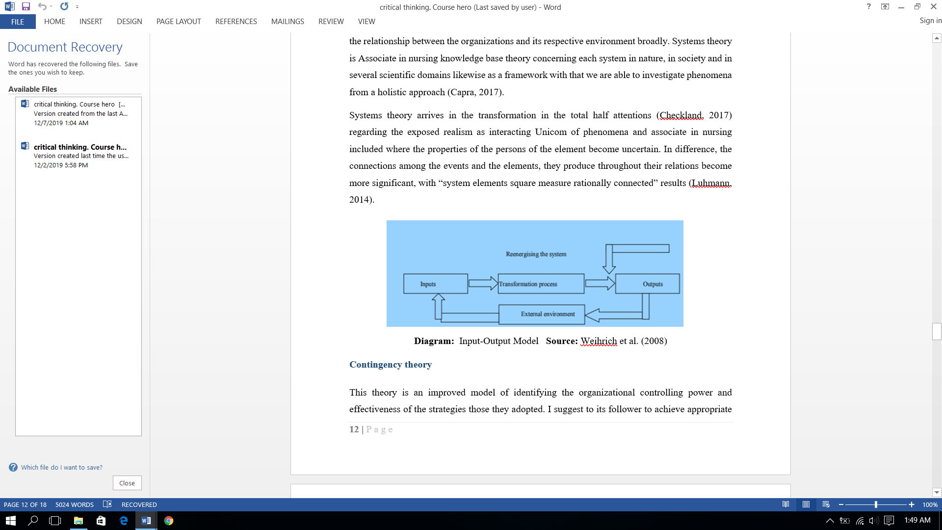
Diagram: Input-Output Model. Source Weihrich et al. (2008)

Contingency Theory
Contingency theory is described to be an improved model that identifies and controls the power of an organization together with the effectiveness of the adopted strategies. This management model collects an effective formula that assists managers in making the right decisions for the company. Managers try all they can to acquire all the resources they can of marketing and management as well as allow employees from different sectors to collectively establish so that they can attain their objectives and goals. This theory uses the concept of organizational systems and structures to control both the internal and external environment of a company. According to one Derner (1971), this theory puts much emphasis on controlling, planning and designing systems that determine the situation of the organization. The primary aim of this theory is to account the management of the organization.
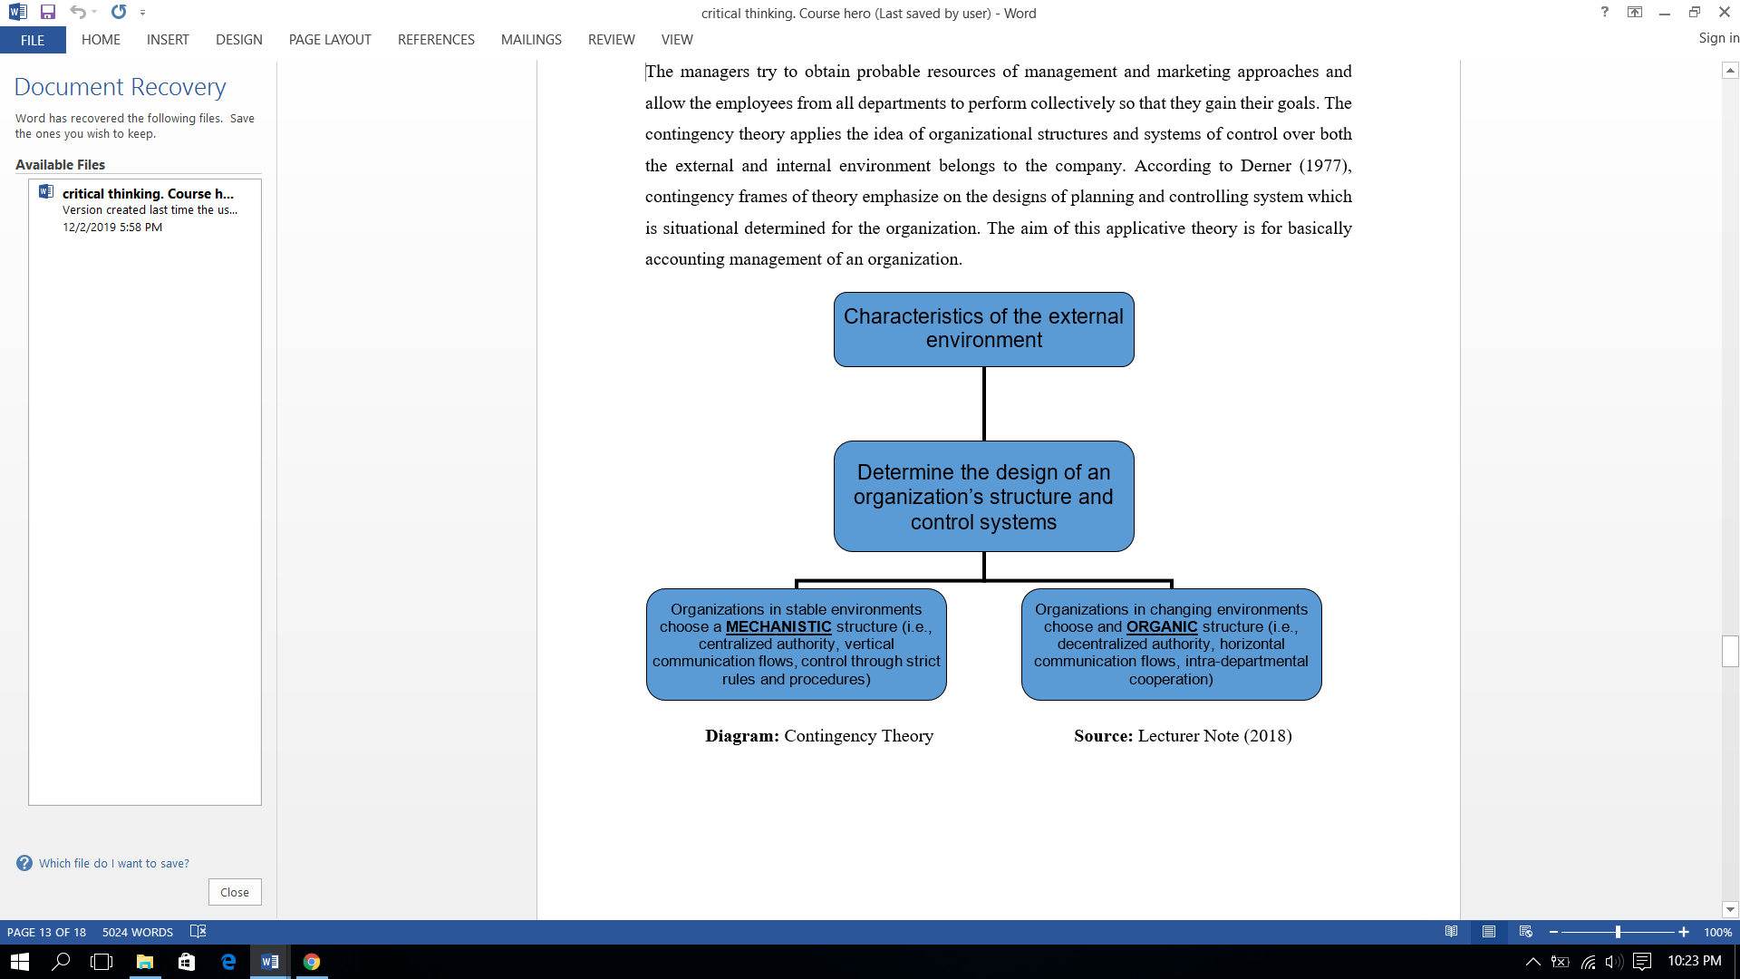

Bureaucratic Theory
The above theory was invented by Max EBER, who happens to be the father of bureaucracy. Max is a sociologist from German who published this theory with the aim to ensure the structure is patterned of both private and government-based system. Two primary types of methodologies have been analyzed as they describe the internal administrative structure in the setting. Weber has explained the hierarchal structure and governmental rules to conceptualize the actual; structure of management. Also, much emphasis has been put to the necessity of the organization to operate in a setting that is full of rational minds.

Scientific Management Theory
Before industrial revolution, business and firms were run via the willingness of the owners to recruit staff who are temporary. However, the existence industrial revolution, things have changed especially workplace dynamics. Workers need to evaluate their performances and ensure their target of selling is full filled. Managers work relentlessly as well as keep tabs on the activities of the workers. This has ensured that employees are paid for their works and inputs and not by their times. The key objective of this scientific model is to ascertain the maximum prosperity of the company by every worker related responsibilities.
Behavioral/Human relation Approach
This theory is considered a human relation management model as it discusses the level of performance as well as the activities performed by employees in the setting. Two primary branches evolved through this era is referred to as behavioral theorist and human relations as belongings to same dimensions focused on individual performances instead of the post. Human relations describe different ways in which the managers in the company cooperate and interact with subordinate employees in the workplace.

Management Theories Relevant to My Role in the Workplace

Behavioral/ Human Relation Theory
As an assistant manager, this method is most preferable, especially when interacting with subordinate workers, encourage meaningful relationships with workers and evaluating their performances. This management theory helps ensure a safe working environment whereby workers enjoy working in the company and give higher interests to the tasks delegated to them. This theory also helps me cooperate with different workers by motivating a large portion. Besides, Maslow’s hierarchical structural theory has played a vital role in communicating the bottom member of the structure. This way, it is easier to identify the actual conditions of the organization as well as take effective measures in case of challenges. Last but not least, the above model helps workers and their employers to practice unique potential facilities that they require at the moment.

Contingency Management Theory
I prefer this management theory as it helps evaluate the available ways by which a marketer is able to test their products. I will take actions that are acceptable and supported ones that are vital to the current state of affairs. I need to try and utilize a leadership approach that has participation from staff. It is our responsibility to possess managers who effectively and expeditiously agitate challenges and maintain a rising and stable level of development and productivity. For example, in the company’s previous gift manager was a lax, especially in managing the staffs in the care home as they did not seem to be motivated. However, this manager constantly asked the employees what the main issue in supply information regarding cooperate as a result of good communication which is very crucial in a care home setting was.

Systems Theory
I would love to put system theory into action in my sphere area of responsibility. When many system theories are combined, there are various factors that interrelate with one another such policies, manager, employees and the company strategies. Besides, these theories also help to identify the respective factors that have an effect on the abilities of workers and how to alter the values, attitudes and beliefs of working sites. I love to arrange all these factors in a scientifically based line of control by which one can examine the workers and their performance. System theories are important to evaluate the workers correctly as they do their best to achieve the aims and objectives of the company.

How Management Theories Impact My Own Beliefs Attitudes and Values in the Workplace
Considering McDonald's plc. is one of the world’s largest food chain, it is important to confirm with the customers regarding its best policy of serving healthy foods. Food is important as it determines whether a person’s health will be good or bad. Providing good quality dishes ensures good health for the consumers. Management system have mostly been developed with aims of making sure customers receive proper services (Luhmann, 2014).
. In this regards, my beliefs, attitudes and values are there to ascertain the needs of customers. Personal believes values and attitudes are also impacted by the management theories.
My attitudes, values and beliefs are constantly interfacing with our peers, family, friends and others. I seem like individual unconsciously, especially the ones that share my core beliefs and values, such as positive attitudes to the workers and consumers who promote the company’s frames as the leading business company global. Values are mostly created via regular practices of the thoughts of beliefs and views of the employees and managers. Also, it is important for me to consider the belief of consumers to be able to communicate and interact with them. This attempt confirms the velocity of the company.

Conclusion
To conclude, the circumstances that have been stated in the report assessed the values, attitudes and beliefs in a framework of management within a company that determined the decision making and achievement of the organization. This is the era of technology and science and the primary reason as to why most marketers apply technical, technological and scientific approaches to promote their business in a global context. I have shared my responsibilities and experiences as the assistant manager in McDonalds Company which is the largest food chain shop globally. It is vital for marketers to consider increasing the usage of management tools to maintain and uphold good communication among staff members. The very first steps kept much emphasis on technical aspects of work on the expense of personal aspects. It is clearer that coming into harmony with my value systems is what creates a successful relationship, whether it’s professional or personal. Before the industrial revolution, most organizations were run by the willingness of the owners who recruited workers temporarily. However, with the industrial revolution, things changed especially the dynamics that exist in the workplace. The success of the company lies in providing critical thinking in decision making.

References
Boudon, Raymond. (2018). Origin of values. 2nd Ed. Transaction Publishers. New Jersey.
Caramela, S. (2018) The management theory of Max Weber. Available at: https://www.business.com/articles/management-theory-of-max-weber/. [Accessed on April 12 2018]
Critical Thinking, (2018) Concept of critical thinking. Available at:
David, T. O. (2010) The contingency theory of management accounting: achievement and prognosis. New York:Pergamon Press Ltd
http://www.criticalthinking.org/pages/defining-critical-thinking/766. [Accessed on: April 18, 2018]
Lumen (2018) Scientific Management. Available at: https://courses.lumenlearning.com/wm-principlesofmanagement/chapter/scientific-management/. [Accessed on: April 19, 2018]
McQuerry, L. (20180 How Do Negative & Positive Attitudes Affect the Workplace? Available at: http://smallbusiness.chron.com/negative-positive-attitudes-affect-workplace-21287.html. [Accessed on April 19 2018]
Mele, C. (2009) A Brief Review of Systems Theories and Their Managerial Applications. Boston: Sage Publication
Perry, G.L. (2018) Human Relations Management Theory Basics. Available at: https://www.business.com/articles/human-relations-management-theory-basics/. [Accessed on April 19 2018]

