Qualification: CIPD Diploma in Applied Human Resources

Module Name:

Understanding the business context of Human Resources.

Word Count: 3885

Student Name: Sarah Mason
Student Number: 2005783
CIPD Membership Number: 55991280

By signing below, I confirm that the work/evidence presented is my own, unaided work. I understand the regulations pertaining to candidate malpractice and the action that may be taken as a result.

Signed: Sarah Mason
Date: 18th February 2021

Activity one
‘A business context’ is a context in which a specialized vocabulary is employed, this may be on an individual organisation, a larger business or single project (CIPD 2020).
Organisational structure can define the way a company arranges its people and jobs to achieve its goals.
A small business can operate with less formal structure and can take advantage of face-to-face communication to solve issues. Larger organisations need more specific definition and assignment of work tasks to establish responsibility and accountability (Business case study).
The most appropriate structure depends on the type of work it does, the number of employees, the company revenue, the location, and the degree of diversification of different types of business.
The British Army is in the public sector. The public sector provides goods and services for the benefit of the community. The police, NHS, public transport, public roads, and public education are also included in the public sector. The importance of organisational structure in British Army is key. According to Drucker 1989, he stated that structure is the correct design which most significantly determines the organisational performance. However good structure does not by itself produce good performance, but poor organisation makes good performance impossible no matter how good an individual manager may be.
The Army structure is made of divisions and brigades responsible for small groups. The Army’s operating environment is more complex than ever before, and the purpose of the military has shifted significantly. In the field, the army is agile and flexible in its operation being prepared for volatile and uncertain situations. The British Army has had to adopt agile working practises and approaches. The army has a directorate of personnel made up of 250 civilians and uniformed employees responsible for the design and delivery of strategy and policy. This increases the intake, minimises the leavers and maximises the talent, to enhance the operation of the army. The Army is traditionally a hierarchical organisation; due to the world we live in being volatile and forever changing they need to be more dynamic. This means they are able to react to the many changes and priorities from the government and global events. A HR specialist in the Army helps soldiers develop their Army careers, which includes promotion and future training. It also includes personnel support and assistance for transfers, travel orders and salary in all divisions (balancecareers).
Tesco is the 3rd largest retail shop in the world based on gross revenue. It is a well-known British multisite retailer. The organisation believes it is especially important to have a proper leadership process designed and used effectively. This helps Tesco’s set goals and objectives. Suitable leadership helps the organisation align its mission and vision with the process of selection and leading the employees towards goal fulfilment. Within Tesco it is one of the most discussed and researched topics to understand the process of managing people for a better leadership attitude. Different kinds of traits, behaviour and contingency approaches are necessary to understand and learn leadership for business purposes. The HR team at Tesco instructs and directs its employees towards organisational goals. They focus on redirecting HR goals from transactional to strategic assuring the effective path of innovation and forward-thinking business ideas (locusassignments)
Andrews Property Group is a medium sector business, founded by Cecil Jackson, who is also the founder of Oxfam and Age UK. He set up Andrews charitable trust and Andrews Property Group, working side by side as a business minded charity and a charity minded business (Andrews). The business is run by a board, which makes the decisions for the company. They work very closely with ACT trust; however, we are still a profitable making company. Due to the culture of the business, change is extremely hard to implement and they are renowned for being very set in their ways. The seniors and business managers are lacking leadership skills and the tolerance level within the business is exceptionally low. The norm would be to put a body on a seat, rather than leave the gap and wait and fill with the right person at the right time doing the right thing. A clear strategy and vision of progressing the leaders and leadership and focusing on people more than figures (Andrews).
The HR function and the professionals that work within it helps the organisation deliver its strategy and objectives by effectively recruiting and developing people and managing their performance. HR oversees the most important part of any organisation, the people (CIPD). This requires viewing them as human assets and not costs to the organisations, as with all assets they can be used strategically to add value. The HR objectives are to suggest to the management how to strategically manage people and resources. This is recruiting and hiring employees with the required skill set to meet the company’s current and future goals (Bianca). They are responsible for developing skills for the future, building loyalty and commitment, building talent pipelines, and staying current and competitive.
The HR function is unique to a specific organisation. The studies of organisational contingency and management practice have shown that every company has a unique functional structure (Taylor and Woodham). Some companies will combine the roles to save on payroll, others will create departments that suit their type of business. As the HR function evolves into a more strategic contributor, organisations customise the function to suit. The size of the organisation will determine the roles played in the HR function (Russ eft). Larger firms have hierarchical structure, and the HR manager may oversee other line managers. Small organisations do not have the vast array of people, so the owner could also be the HR manager.

rbn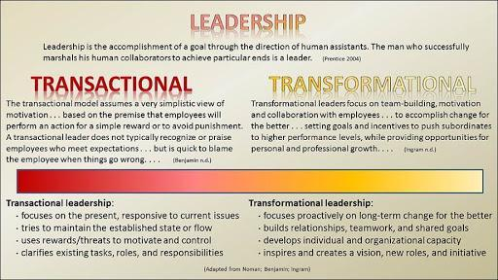

Traditional and transactional HR is involved in everyday running of an organisation, it involves a lot of repetitive and administrative tasks. Transactional HR incorporates all the HR functions and is reactive.
Transformational involves HR supporting and having proactive roles helping define the strategy goals, it expands the traditional HR role to develop the business needs and growth. In the modern business world things have changed, such as technology, more informed customers, global competition, culture, social purpose or for financial reasons and HR can play a key part in this.
Transformational and Transactional are not mutually exclusive. A successful HR department should have transfunctional functions to support transactional goals, this will align with the strategy goals of the organisation (LinkedIn).
Internal factors that can affect the HR function could be corporate objectives, this could be the need for redundancies or restructuring the business. Operational strategy could mean the introduction of new systems, which may require retraining or reducing staff levels. Market strategies could mean recruitment of new staff. Financial strategy could mean the decision on to reduce costs and maybe outsource which could result in loss of staff or a new training programme. External factors also play apart, and these can include market changes, economic changes, social changes or political or legal changes.
HR and line managers should work together as they both have a vested interest in the business. If a working relationship is formed the line manager is way more proficient in HR tasks and that allows the HR professional to devote more time to the strategic HR functions (Mayhew). In business workplace conflicts or training and development is key, any conflict between the line manager and HR could prevent this from being a focus. Holding a workshop for example would not be an easy way to resolve this. It is critical that a business create a model that considers the product, services, structure and expertise of the operation managers and the HR managers. The model should clearly lay out the roles of the HR versus the operation and have a clear focus of the strategy and goals (Mayhew).
Line managers have an especially important part to play within an organisation, they not only manage people and operations daily, but they also implement HR policies and support their team’s development. This is more the case in organisations that delegate these activities to line managers. It is important to think about how line managers are appointed and developed so they are successful in their roles (CIPD).
Organisations invest a lot of money and time into formulating strategies, they often bring in outside sources to develop action plans designed to move the business forward. However, by doing this the human factor tends to be overlooked (Bullivant).
The key to successful delivery and implementation lies with the people, which is led by the HR function. An organisation cannot deliver and sustain its goals and strategies without the right people, in the right place, with the right skills to be the best they can be. This is the reason the executive team needs to understand the value of the HR function.
To achieve great things an organisation must have visions and values, with everyone pulling in the same direction. HR communicates the vision and values of the company, so that employees are strategically focused and understand what the business is trying to achieve.
The strategy is what needs to be done, the culture is the ‘how’ HR has the skills to help the business bring strategy to life through its people.
For a business to trade successfully it needs the right skillset. HR needs to understand how to strategically manage HR in line with the business directors, ensuring the business has the right knowledge, attitude and skills underpins the success.
Productivity and quality are critical issues in an organisation and employee engagement. HR understands what drives someone to feel engaged and motivated. Understanding the employees’ journey is the same as understanding a customer’s journey.
Performance and productivity are so much more than bonus or appraisal systems. A bonus scheme will not improve performance, as wont completing an annual review. Ongoing coaching, feedback, supporting goals and trust will.
If an organisation invests in learning and training and development, they have the edge on the competition. It is about learning on the job, stretching tasks, coaching, and mentoring.
As an organisation evolves ‘What got us here, may not get us there’. There needs to be a plan for what gaps will need filling and what skills and capabilities will be required. HR will need to build a succession to fill these potential gaps and future proof the business.
Data analytics could be used to improve HR decisions, this can be a huge potential, especially for larger organisations. However, it seems to be a low priority, mainly because people in HR do not understand how to use it, also it can have a multiple issue, for example there are data privacy concerns, and the cost can be considerable. If an organisation were to use it, it would give benefits to understanding issues much earlier and improving HR strategy.
Defining a forward-looking workforce, in every organisation there is a risk of being overwhelmed by the operation and losing sight of the long-term goal. This can be risky on demographic change and the importance of a diverse workforce requires planning. Diversity management tends to be low on the priority list. Diversity seems to be deemed as not affecting the bottom line. However, it can have a massive effect on corporate culture and productivity and if managed correctly it can have a positive effect on creativity and productivity. Interaction among executive leadership is a test of the relationship between HR leaders and the business strategy. Often HR leaders are refused access to the boardroom, and they feel that organisations do not appreciate the value of human resources. The main way to improve the relationship is to prove the return on investment in HR activities. This could be a reduction in employee turnover or an improvement in satisfaction that improves bottom line (Mayhew).
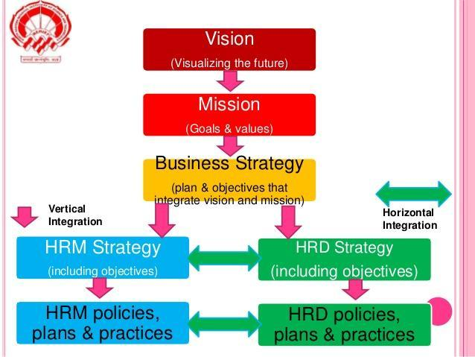
Vertical integration is about the effectiveness of HR, it is the way the HR role, practice and contributions are aligned with the strategy management process of a business and how they contribute to the vision and objectives.
Horizontal integration is about the effectiveness of HR and is the consequence between policies, practises, and implementation of these, in order to optimize the development of people.
A resourced based view is a model that sees resources as key to business performance. This model is used to determine the strategic resources a business can export to achieve sustainable competitive advantage.

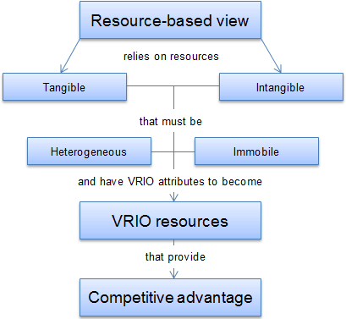

The resource-based view (RBV) of the organisation is a strategy for achieving competitive advantages that emerged through the 80’s and 90’s.
The core idea of the theory is rather than looking at a competitive business environment to look for an edge over others, instead, look from within for resources and potential that is already available. It is more beneficial and easier to use the potential in what you have, rather than acquiring new skills, traits, or function for each opportunity.
Within the RBV model there are two main resource assets. Tangible assets, these are physical things, for example, property, land, products, and capital. These are resources which can be bought easily on the market. Intangible assets refer to items and concepts that have no physical value but still claim to be owned by the organisation. This may refer to any reputation, trademarks or property which may be possessed. Reputation is built over time and it is something competitors cannot buy on the market.
There are two significant assumptions of resource-based view. Heterogeneous- this first major assumption is that resource, skills, and capability must vary from one organisation to another. If these organisations had the same set of individuals, they would not be able to employ varying strategies to compete with one another. This is known as a ‘Perfect competition’. Perfect competition does not exist in the real world, organisations may be exposed to the same competition, but they are still able to form different strategies to compete.
Immobile- the second assumption is that resources are immobile and are unable to move freely from organisation to organisation. Due to these organisations, they are unable to replicate the resources to the competition and therefore implement the same strategies. Intangible assets, knowledge, and processes are more likely to be 100% immobile than tangible assets (businessballs).
Although heterogeneous and immobile is crucial to a business success, it is not alone if they wish to sustain it. Barney created a framework for examining key priorities of resources and organisations called the VRIO framework. The VRIO framework stands for:
Valuable- Resources are valuable if they can help increase the value of the service or the products supplied to the customers. This can be improved by increasing differentiation, decreasing the cost of production, or other modifications to improve the quality. Any resources that do not meet this may lead to a competitive disadvantage.
Rare- Any resources, both tangible and intangible, which can be acquired by one or very few organisations, may be considered rare. If organisations have the same resources or capabilities, this can result in a competitive party.
Low imitability- If an organisation holds resources that are valuable or rare, they can achieve an advantage in the short term. However, to sustain this the resource would be costly to substitute, or rivals could close the gap and obtain similar.
Organized to capture value- Resources do not necessarily convey an advantage. If the organisation, systems, or processes are not designed to exploit the resources to the fullest, then it cannot hope to gain a competitive advantage. This could be referred to not utilising the talent in the correct department or role (businessballs).

Activity Two
PESTLE

A Pestle analysis is a framework to analyse key factors. They are political, economic, sociological, technological, legal, and environmental, these influence an organisation from the outside. It aids the HR function and the business to have insights into external factors that are impacting them. The analysis is flexible, so it can be used in a range of different scenarios, and the results can be used to guide strategic decisions (CIPD).

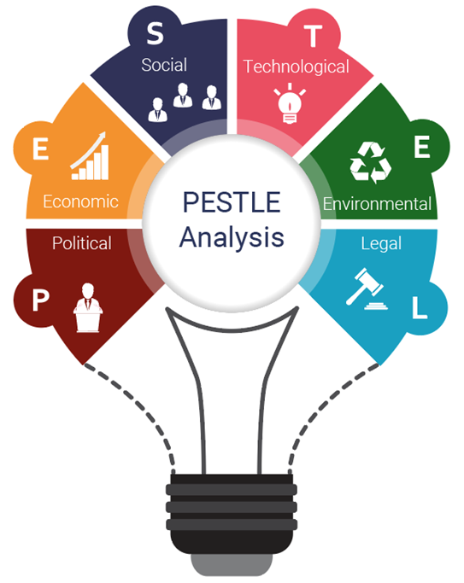
PepsiCo is the largest selling beverage in the world, after its rival Coca Cola. It accounts for a 37% share of the global market; therefore, they need to understand each and every country's market.
Pepsi is a large brand and is 23rd in the Interbrand report of the world’s leading brands. The advertisement features major celebrities such as David Beckham, Robbie Williams, and Britney Spears. The market reach is also remarkably diverse as they are represented from the US to New Zealand (MBA).
Political
Pepsi is a non-alcoholic beverage; it is regulated by the Food and Drug Administration (FDA). Also, many different countries across the world have different sets of regulations that are either more stringent or relaxed. Competitive pricing by their competitors is a factor that must be kept in mind. The HR function is important for the diverse market reach. Different nationalities have different beliefs and working practises. They must as a business ensure these are considered at all times.
Economic
As economics can take downturns, PepsiCo has had to look at their sales and marketing campaigns. Also, negative profits have impacted, and they have had to look at restructuring internally. Economic conditions have the highest influence on an organisation. Pepsi have profited from recent downturns due to people not being in work, therefore spending time at home. This has seen an increase in sales. The HR function supports the business with strategic restructure analysis and execution. They would also have a robust recruitment process to support driving sales.
Social
Due to the fact that Pepsi is a beverage it has to remain in line with different cultures. They also have to consider their image and how this is communicated across the world. Social implications are seen in marketing campaigns, for example certain countries have religious festivals, Pepsi will need to keep up to date with these, so that they can understand the market and how they can cash in on this. HR would be required for any diverse situation from recruitment to policies and procedures, they need to ensure that things are completed correctly, to prevent tribunals and a bad reputation as a poor employer.
Technological
With the new age in technology, organisations have integrated themselves with all the newest technology processes. Social media is key to every business, this has allowed Pepsi to stay ahead by engaging with consumers, this will enable them to reach out to increase the brand engagement. The HR function can utilise the social media explosion, from Facebook to LinkedIn, it can be utilised for in house communication or advertising vacancies.
Legal
There can be many legal implications upon the food and beverage industry. A famous Pepsi incident took place when Pepsi was accused of using contaminated water in India. Products needed to be recalled, this cost the business billions. HR plays a big part in potential disciplinaries based on legal issues.
Environmental
These factors can affect Pepsi, but it affects the agricultural business more directly. It does not alter trade or profits (MBA).
SWOT
A SWOT analysis is a planning tool which identifies the Strengths, Weaknesses, Opportunities and Threats in a project or an organisation. It is a model for matching an organisation's goals, programmed to the environment in which it operates (CIPD).

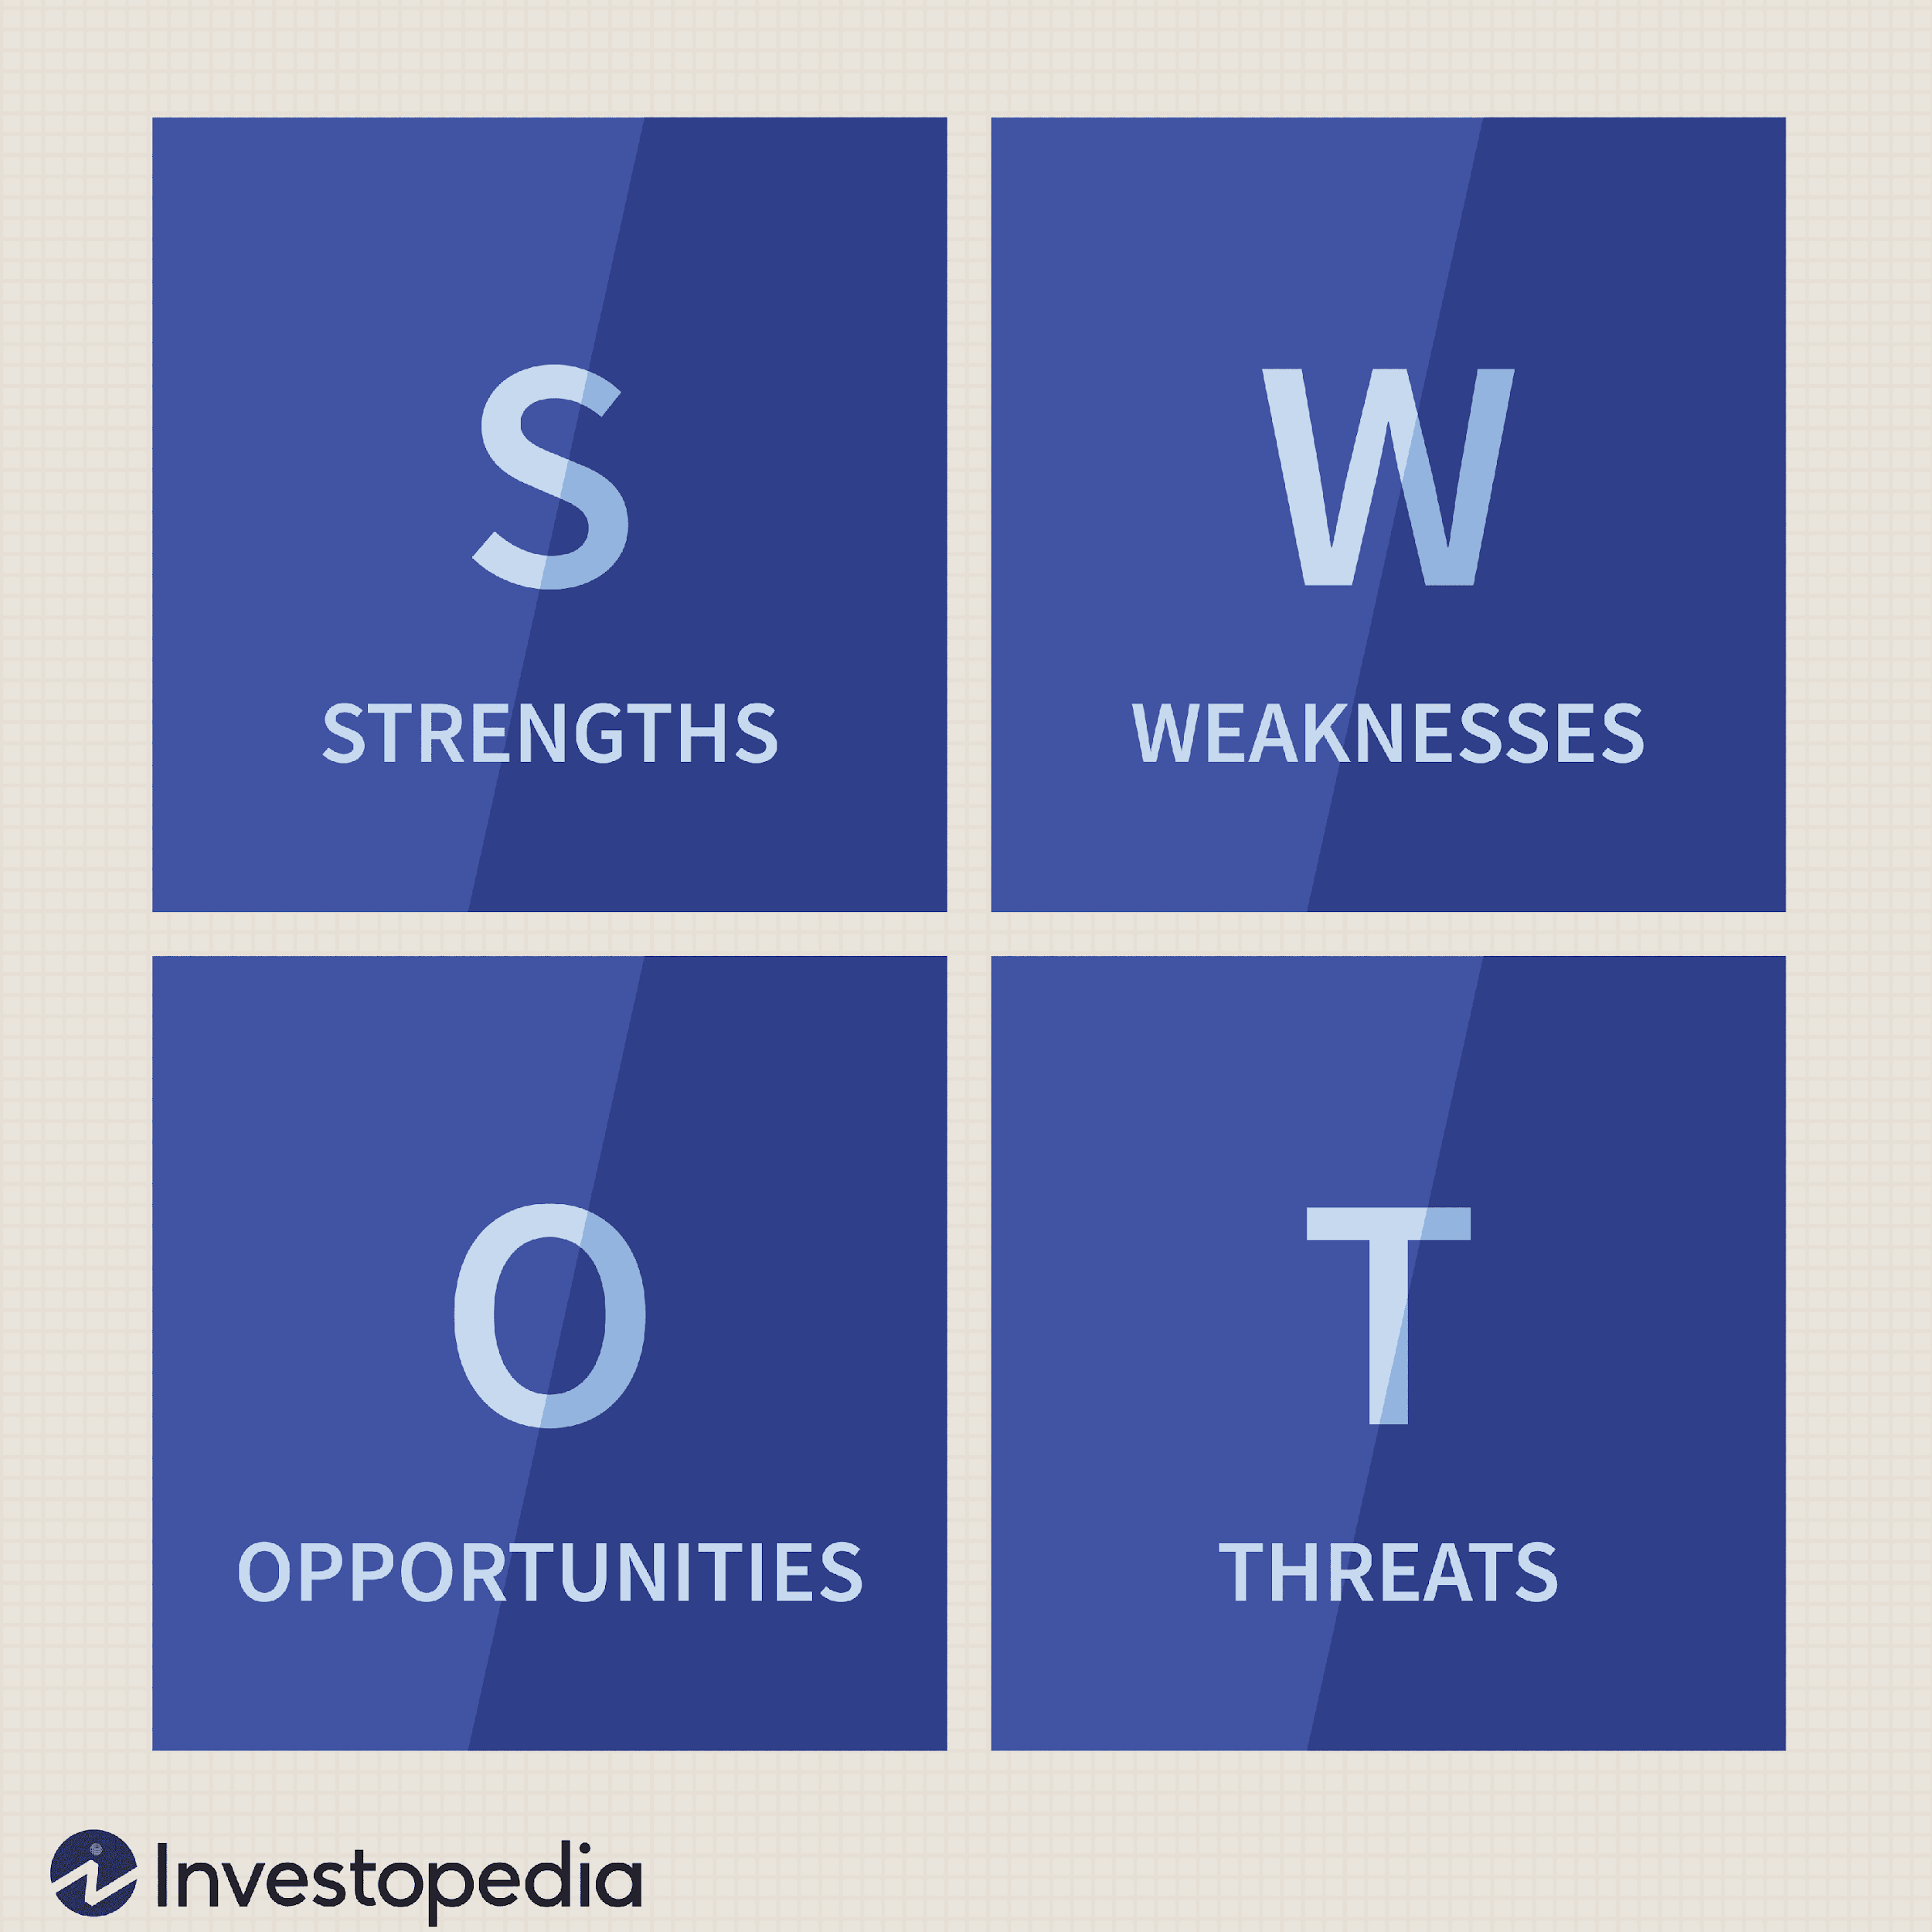

Strengths
PepsiCo, according to Forbes 2019, is the best global brand. It has the power of selling one strategy, by selling food, snacks, and beverages under one umbrella. This makes it a strong diversified business. PepsiCo has a highly diversified portfolio, with a large number of brands, such as Pepsi, Pepsi Max, Lay crisps etc. It participates in a strong global presence in more than 200 countries, this allows it to go head-to-head with its competitors. PepsiCo uses direct distribution, which ensures faster delivery, great promotions, and maximum visibility. PepsiCo understands the importance of marketing, this is evident in sponsoring the Super Bowl. PepsiCo is an iconic youthful brand; they have targeted fun elements such as music. It has an effective supply chain, with different markets across the world which cuts costs. It has a strong corporate responsibility and works with hundreds of international, national, and community-based organisations to enhance.
Weaknesses
Over dependence on carbonated soft drinks and packaged foods undermines the flexibility in case of turmoil; they have decided to put all its eggs into one basket. PepsiCo products are perceived to be unhealthy; they contain high sugar levels with chemical additives and flavour, in a health-conscious market this is a major weakness. Controversial advertisements have impacted them, in 2017 Pepsi had to pull an advert, after just one day; it featured Kendall Jenner and it was criticised for trivialising black lives matter.

Opportunities
PepsiCo has an opportunity to diversify different segments. Due to owning 22 brands it could diversify beyond the food and beverage umbrella, such as sportswear. This could attain stability, expanding E-commerce by taking advantage of online shopping and expanding mobile apps to grow sales and by increasing healthy options. PepsiCo could enhance its social responsibility by focusing on sustainability and the use of renewable sources which strengthens loyalty.
Threats
PepsiCo has stiff competition and profitability is threatened by competition from Coca Cola, Nestle and Dr Pepper etc. The competition also threatens long term profitability and sustainability, even though the food and beverage industry are strong, there could still be a recession. They could incur losses, as its products are amongst the ones that consumers give up first. If PepsiCo’s competitors were to have the edge on them in the technology world this could see them having the advantage. Government laws and regulations have to be taken into consideration, governments have adopted pro healthy regulations to reduce lifestyle diseases and illnesses attributed to junk food. This could affect profitability as most of their products mainly consist of unhealthy snacks and drinks.

Recruitment and selection can be ever changing in a flexible working environment. Hiring the right person is key, as this will have an impact on productivity and performance. This requires planning and organising. Performance management is an essential tool for PepsiCo’s success, due to productivity, performance management is an ongoing function. Training and development are a must in any organisation and PepsiCo must also adopt this. A clear plan should be in place to develop the people, therefore allowing succession from within. All HR strategies within PepsiCo and any organisations, need to be reviewed and evaluated to ensure that the strategy is still relevant, due to the constantly changing external factors (UKessays).

References

CIPD 2020 https://www.cipd.co.uk/
MBA 2020 https://www.mbaskool.com/
Business Balls 2019 https://www.businessballs.com/
UK Essay 2017 https://www.ukessays.com/
Forbes 2019 https://www.forbes.com/
Ruth Mayhew https://smallbusiness.chron.com/
LinkedIn https://www.linkedin.com/
Andrews property group https://www.andrewsonline.co.uk/
Business case study https://businesscasestudies.co.uk/
Balance careers https://www.thebalancecareers.com/
Lucus assignments https://www.locusassignments.com/
Taylor, S., & Woodhams, C. (2013). Managing people and organizations. London: Chartered Institute of Personnel and Development.
Russ-Eft, D. (2014). Human resource development, evaluation, and sustainability: what are the relationships?. Human Resource Development International
Russ-Eft, D. (2014). Human resource development, evaluation, and sustainability: what are the relationships?. Human Resource Development International

