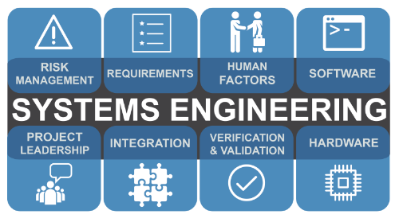

Development and Evaluation of a Test, Trial, Project using Systems Engineering Approaches
  - The Problem of ‘wonky’ sd4’s
Alexander Dand 1810440 | L4 Principles of Systems Engineering | 2019/20
Contents
Introduction 2
Systems Thinking 2
State the Problem 3
State the Problem - Projects 3
Limitations – Projects 5
Goals/Requirements – Projects 6
State the Problem – User/Process Owner 7
Interview analysis – User/Process Owner 8
Goals/Requirements – User/Process Owner 8
State the Problem – Quality Inspector (QI) 9
Goals/Requirements – QI 9
Investigate Alternatives – Evaluating different options to solve a specific problem 10
Foil Flyer 10
Barrel 10
Supporting Jig 10
Stripline 10
Model the System 10
Integrate 11
The New Process 11
Launch the System 12
Assess Performance 12
Re-evaluate 13
Table of Figures 14
References 15
Appendix 17

Introduction
The author has been tasked with the production of a report regarding the development and process of a work-based test, trial or project with respect to the principles of Systems Engineering.
Regarding this brief, contact was made with the Projects team within the Explosive Tech Centre (XTC) to identify the problem. As expected, multiple options were presented, however due to time constraints, and to the level of this assignment, a minor project has been identified that would be suitable; that of optimising ‘Wonky’ SD4 detonator manufacture.

Systems Thinking
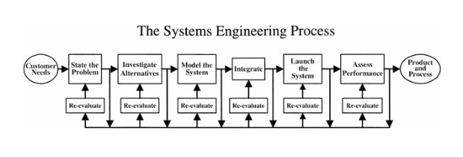
Figure 1 - The SIMILAR process [1]
‘Systems Engineering is a transdisciplinary and integrative approach to enable the successful realization, use, and retirement of engineered systems, using systems principles and concepts, and scientific, technological, and management methods.’ [2]
The key message to be taken from the model displayed in Figure 1, and the statement taken from the INCOSE website is that the mainstay of keeping oversight of the goal is constant verification against the desired outcome (‘Are we still on track?’) This will be challenging, as there will be different voices giving input to the project. The voice of the owner, the voice of the user, the voice of the operator, all stakeholders within the process, each with different ideas of what the outcome will look like. As this is an existing problem, there will have been some work put in, and it can be assumed that the systems engineering input is starting somewhere in the middle of the project. This will affect how the process is applied compared to if it was applied from the start of the process. This can be shown in Figure 2.
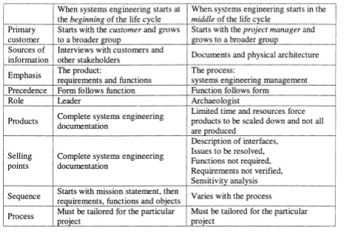
Figure 2 - Preliminary Comparison of Systems Engineering Processes [3]
Other problem solving models could be used, such as the 8 Disciplines (8D) model [4], but it was felt that the SIMILAR model would be a better fit for this project.

State the Problem

State the Problem - Projects
Upon identification of the project, the problem was stated from the perspective of the Projects/Manufacturing Engineering office. The process for SD4 manufacture has historically been under the purview of the science teams within XTC, and was only used for ad-hoc manufacture, with no requirement for mass production. Due to a change in requirements within the Tech Centre, it was identified that the process would need to be scaled up from one off to full production, with a requirement for 200-300 assemblies. This change in requirements has meant that there is now a shortfall in stock of SD4 assemblies. Once full-scale manufacture had started, it was identified that there were weaknesses within the process (See Figure 8).
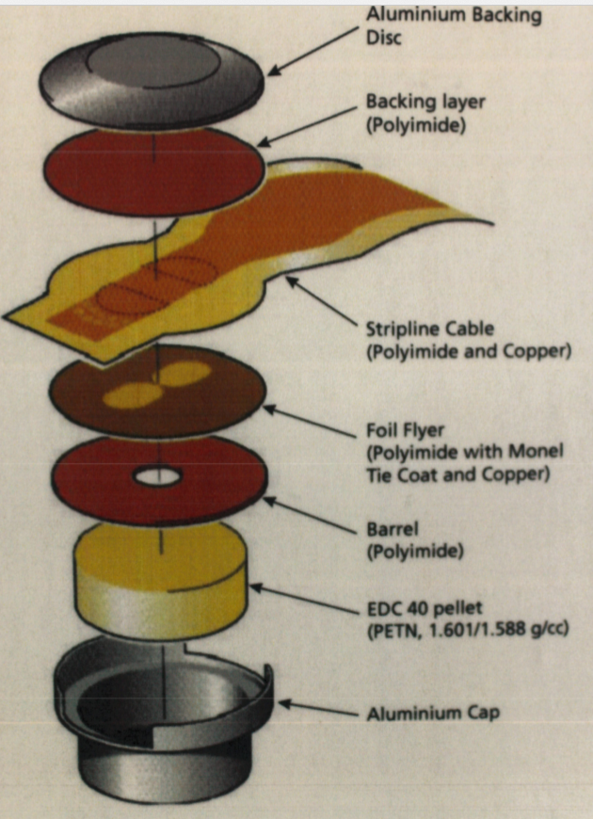
Figure 3 - SD4 manufacture [5]
The identified issue was as follows:
Once manufactured, the center point of the Foil Flyer (Foil Bridge) must be centralized to the assembly in order to gain certification for use. Centralisation has a positional tolerance of 400µm as per Certification Drawing. Fitting the Foil Flyer into the assembly does not allow for repositioning if the Foil Bridge is out of tolerance as the tooling currently in use is not adjustable (see Figure 4).
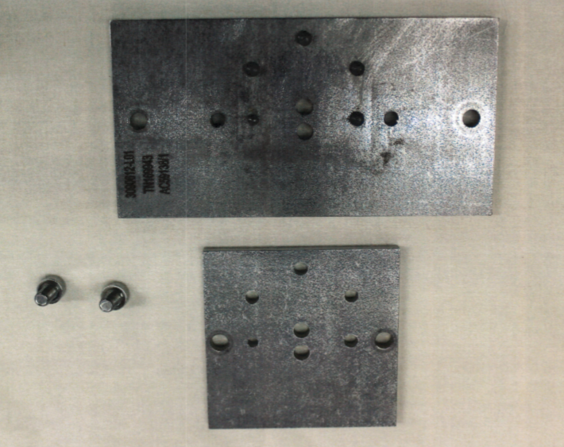
3
2
1
Figure 4 - Tooling for assembling Foil Flyer into SD4 assembly
Further referencing Figure 4, the plates stack and are secured by cap head screws (1). The plate is held in position by 5x fixed lugs (2). Some consideration for design for assembly can be seen as the left lug (3) is smaller than the right, so the top plate can only be installed in one orientation (‘poka-yoke’ or ‘mistake proofing’) [6] [7].
The current process is that there is only one incoming quality check for preassembled component parts of the assembly, that of copper thickness of the foil flyer. A further issue is that the Foil Bridge positioning is not checked until after the flyer has been bonded onto the strip line cable. After that point, the layers cannot be separated, and the job must be restarted. The net effect of these issues is that there is approximately a 5% success rate for certified manufacture.

Limitations – Projects
The master drawing cannot be changed, and neither can the specification. To do so would involve a lengthy recertification process, and the company has time-sensitive financial milestones attached to this process.

Goals/Requirements – Projects
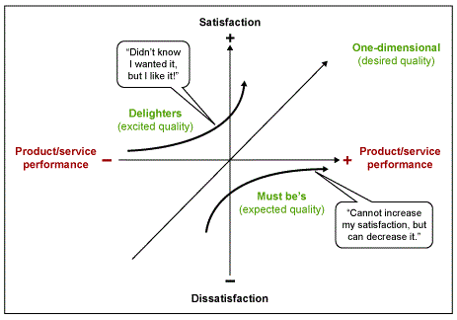
Figure 5 - The Kano Model illustrated [8]
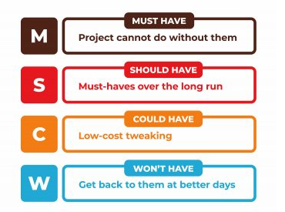
Figure 6 - MoSCoW model illustrated [9]
Customer requirements are not always clearly stated, nor are they potentially fully understood by the customer themselves. To this end, several tools can be used to analyse requirements such as the Kano model or MoSCoW model. As the process is currently working (in whatever capacity), the Kano model would likely be more suitable in this case as it deals with more quantitative goals. At this early stage, there is insufficient data to accurately assess requirements, so the requirements are as follows:
Stated:
- Improve certified manufacture success rate in order to increase stock of SD4 assemblies.
Minimum:
- Comply with limitations and address issues with Foil Flyer displacement.

State the Problem – User/Process Owner
As stated, more data would be required to progress. The Projects/ME team have an overview of the process, but to fully understand the process a visit to the ‘coalface’ and interviews with the actual process user and/or owner as their understanding of requirement will be different (also referred to as a ‘Gemba Walk’ in Lean Management philosophy [10].
On interview, the process is as follows:
- Foil flyers manufactured by external company. AWE supply raw materials and specification. Required thickness of copper 4.4-5.0 µm. Manufacturer has stated unable to guarantee this specification.
- Flyers supplied with Certificate of Conformity (CofC). No quality checks on receipt as CofC sufficient for receipt despite no guarantee meets specification.
- Process startup. Operator measures thickness of copper against spec. No positional checks, only thickness (20-80% rejection rate.)
- Layers of SD4 placed on jig. Adhesive applied to secure layers. Flyer bonded to copper strip through heat/pressure. Three jigs are available for use, all created to the same drawing.
- Position of Foil Bridge checked against drawing. If out of spec, reject and start process again. Bridge and stripline are unable to be separated. Entire process up to this point is zero value add.
- If Bridge position is within drawing spec, barrel is attached and laminated. Same jig used, no positional checks for barrel, no movement possible due to jig.
- Assembly sent for laser cutting. Drawing states laser program to centralise on foil bridge and cut set program (set by drawing so unable to change). If the barrel is not centralized, excess material is left extended on one side (see Figure 7)
- If excess material present, prevents flush placement within the aluminium cap, assembly is rejected and process needs to restart. Entire process up to this point is zero value add.
- Last 9 Work Orders, totaling 216 assemblies, 30 certified to drawing (14% pass rate).
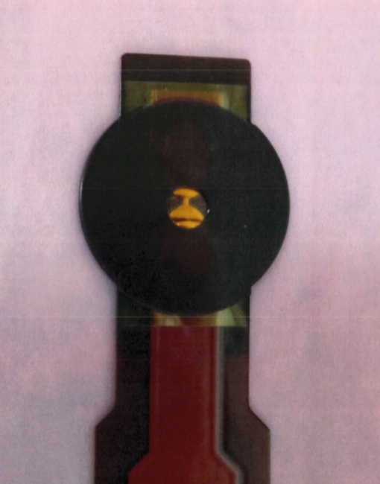
- As can be clearly seen, barrel is severely displaced. The lip present at the bottom prevents the assembly fitting flush within the cap
- The Foil Bridge is not centralised within the barrel hole. This suggests that there is a further positional tolerance not allowed for within the process spec.
2
1
Figure 7 - Rejected SD4

Interview analysis – User/Process Owner
Several weak signals stand out from this interview. First and foremost is that AWE’s chosen supplier delivers items as conforming to spec when this is not the case. There is no check for the positional specification at goods in. There is no check for conformity until after the first lamination has taken place, meaning a high potential for non-value adding work. There is no ability to move the layers during the process. There are no positional checks on the barrel, meaning if there is a positional tolerance on the central void, the potential for stacking multiple tolerances arises. Some of these issues are not strictly regarding the initial requirement but could be addressed to increase the customer’s satisfaction [8].

Goals/Requirements – User/Process Owner
With further data supplied by another stakeholder of the process, further requirements have been identified.
Stated (User):
- Wants to make a ‘good’ product. Satisfaction in the process is low.
Stated (Process Owner):
- Financial milestones have been imposed on the company, and output of SD4 assemblies will directly impact one of these milestones. Future-proofing the process will assist this.
Minimum:
- If any changes are made to the Master Drawing/Specification, all work from the last 3 years will be scrapped as no longer certified as ‘to drawing’. This extends to all certified assemblies that include the SD4 sub-assembly within them.

State the Problem – Quality Inspector (QI)
The next interview would proceed with the embedded QI for the section. Questions were asked as to their input to the process (incoming quality procedures, points of measurement, tolerances of said measurements) and further learning points were obtained:
- Width of the foil bridge has a drawing spec of 380µm ±200µm (see Figure 9).
- The acceptance measurement for the positioning of the foil bridge is taken from the centre of the copper strip in the stripline cable which has a drawing spec tolerance of 5.1mm ±500µm with a central latitudinal tolerance to the cable of 400µm. The other reference points are stamped holes with no positional tolerance due to the generic stamp, however they have a size tolerance of 4mm ±100µm and 3mm ±100µm respectively (see Figures 9 & 11).
- Barrels are also received CofC with no goods in inspection with a positional tolerance on all cutouts of 500µm, meaning that the central hole is also in all probability out of position (see Figure 10)
As can be seen in Figure 7, should multiple tolerances stack up in one direction, the barrel can conform to the drawing, but still have a comparatively large divergence from the intended design.

Goals/Requirements – QI
Stated (QI):
- Tighten all design tolerances to improve positional accuracy
- Change the position of the laser cutout datum to mirror QI positional check
- More checks of incoming components (position of bridge on flyer, not just thickness of copper; positional checks of barrel cutout)
Given unlimited resource, the first two would be optimal changes, however these would require changes to the Master Drawing, which has previously been identified as being unable to change.

Investigate Alternatives – Evaluating different options to solve a specific problem
From the interviews there have been four areas identified as potential targets for improvement. These are the Foil Flyer, the Barrel, the supporting jig and the stripline. Options for improvement are as follows:

Foil Flyer
- Investigate possibility of other manufacturing methods to improve acceptance rate (3D printing, Laser ablation)
- Implementing new goods in checks on the flyers to identify positional location (ideal position marked on jig and checked against each flyer, lens filter on microscope to indicate ideal position)

Barrel
- Implement new goods in checks to identify positional location
- Investigate alternative manufacturing methods to decrease positional tolerances (laser cutting)
- Investigate possibility of pairing barrels to flyers prior to operations to mitigate against barrel overhang

Supporting Jig
- Investigate possibility of new tooling to allow adjustment prior to bonding ops
- Mark jig to indicate ideal position for an ‘at a glance’ check

Stripline
- Implement new goods in checks to identify stripline positioning with a view to matching stripline/barrel/flyer in sets to mitigate against tolerance stacking

Model the System
At this point in the project, it was decided to prioritize issues. The use of Failure Mode and Effects Analysis (FMEA) was selected as the most appropriate tool for this aim [11] [12]. The completed FMEA can be found in the Appendix, but it was found that the signals with the highest RPNs were:
- Final laser cut of barrel cuts off centre resulting in barrel overhang (RPN 720)
- Securing holes off centre on barrel/stripline/foil flyer resulting in stacked tolerances meaning that each stage can be to drawing, but the completed assembly is substantially out of specification (RPN 490)
- Foil Bridge off centre resulting in non-value-added work and rejected assemblies (RPN 200)
During the formation of this document, various actions were discussed. As part of a previous uncompleted investigation into the SD4 process, a digital image capture has been taken for various parts of the process. It was posited that if an enlarged image of a suitable flyer was taken, and one of a barrel, these images could be superimposed over each other to attempt to match barrels to flyers. Other suggestions such as ‘dry-fitting’ flyers onto a pre-marked jig to obtain ‘at a glance’ inspection were considered, but due to the size of the bridge, it would need to be inspected under a microscope. Unnecessary handling of the flyer would also increase the risk of scratching or creasing the copper, which would cause the flyer to be rejected. A discussion was had with a subject matter expert (SME) for laser manufacturing about the current state of manufacturing technology, and whether it would be possible that the company could be able to manufacture the components on site. SME’s response was that he was unaware of capability that existed to manufacture the flyer with any degree of certainty (hence why the company has accepted the rejection rate of supposedly conforming flyers). 3D printing can at best achieve 10-25µm tolerances [13], and laser ablation can only get down to 5-10µm [14]. However, he advised that his laser cutter was accurate down to 10-20µm. When asked if he could potentially cut the barrels to these tolerances, he responded in the affirmative. This would potentially eliminate up to 480µm of tolerance stacking and mitigate against the two highest RPN issues.

Integrate
Please note: Due to social distancing and COVID-19 disruption, integration of measures is not possible within the timescale of this report’s submission deadline. To this end, the remainder of the report will be based on a forward plan to introduce the required amendments into the process.

The New Process
To obtain the highest possible acceptance rate for SD4 manufacture, there will by necessity be additional work. Firstly, new checks will be performed on the incoming flyers and barrels. When the flyers are checked for the copper thickness, they will then be transferred for digital image capture. This will be incredibly labour intensive, due to the number of flyers received in a batch. However, this can be somewhat alleviated by setting batch amounts. Each production route card calls for 24 ‘good’ flyers. Further checks can be carried out during the production run by other staff not required for the process in order to prepare for the next work order. It was suggested that another possibility for reduction in workload would be interval sampling (calculate Average Outgoing Quality Limit and sample those [15]) rather than continuous sampling. However due to the wide range of ‘good’ flyers accepted on thickness alone, this would not be an effective sampling regime [16].
The current contractor used to supply the barrels should be instructed to supply a section of the material for AWE to prove out the laser cutting of the barrels. If sufficient material is supplied to cut 10 barrels, and a program is written that conforms to the master drawing but has tighter tolerances written into the code, a number of barrels can be produced on site. These barrels can then be measured, and should the relevant dimensions (specifically the securing voids and the central void compared to the master drawing) be found to be within 50µm of all the others, this process should be written into the work instruction as it will provide a large mitigation. This will also potentially negate the need to match the barrels to flyers as the barrels will be supplied CofC and will have minimal tolerances to stack. If this process does not work, then similar goods in checks to the flyers will need to be performed on receipt of the barrels. Once the barrel images have been captured, the process of matching flyers to barrels can be performed.

Launch the System
As this aspect of the process is currently theoretical, we cannot predict how successful these amendments will be. However, if the historical data in Figure 8 – ‘Sample Manufacturing breakdown of Production Route Card’ is inspected, it can be seen how many SD4s were rejected for the ‘wonky’ issue. As indicated by the data collected by the User, it will not completely eliminate rejections (the items marked in red were rejected for resistance values being out of spec), and there is currently no recorded data to indicate the number of assemblies rejected at the initial flyer/stripline bonding stage. If these amendments to the process resolve the ‘wonky’ issue, the evidence suggests that it will be reversing the acceptance/rejection ratio from 14/86% to 88/12% at the completion of the Route Card. At the very least, it should identify other areas that may not have been detected without this resolution.

Assess Performance
As previously stated, the new process steps will need to be tested as to how much extra work it will be in order to complete these. If the new barrel cutting process is successful, it will negate a large quantity of work, as the customer can check the foil flyers without the additional task of pairing them to the barrels. The new barrel cutting process should be tested before anything else, to see if a large portion of work can be eliminated.
To assess the amount of extra work, time modelling may be introduced to the process. The current process timing can be indicated by historical Route Cards as each process step is date stamped. The author recommends implementing a Gantt chart [17] to model the new process, as whilst the initial Work Order will be by necessity running a single operation at a time, it can easily be identified where gaps in the process occur, and where additional operations can occur in parallel to the main process (ie once the flyers/barrels have been identified and entered into the process for the first work order, can a second operator be responsible for continuing to check the batches for upcoming Work Orders?).

Re-evaluate
At each stage completed so far, re-evaluation and ‘course correction’ has occurred regularly with the various stakeholders. As there is a close business focus on this process, Integrati0n and Launch will happen almost simultaneously. Once a sample of barrel material has been obtained, and a laser program has been written, this part of the new way of working can be proved out quite rapidly (it is suggested that 10 barrels be cut ‘to drawing’ but with tighter tolerances and then sent for inspection). From this point, the process can be implemented as soon as the next batch of flyers is received. Depending on the quality of the batch, it may be that a sufficient quantity of flyers will be identified for the complete order amount. Once the process has been run to completion once, it can be assessed for effectiveness (via Route Card analysis) and the decision can be made whether to carry on in this vein, or whether further work is required.

Table of Figures
Figure 1 - The SIMILAR process [1] 2
Figure 2 - Preliminary Comparison of Systems Engineering Processes [3] 3
Figure 3 - SD4 manufacture [5] 4
Figure 4 - Tooling for assembling Foil Flyer into SD4 assembly 5
Figure 5 - The Kano Model illustrated [8] 6
Figure 6 - MoSCoW model illustrated [9] 6
Figure 7 - Rejected SD4 8
Figure 8 - Sample Manufacturing breakdown of Production Route Card 17
Figure 9 - Drawing - Foil Flyer 18
Figure 10 - Drawing - SD4 Barrel 19
Figure 11 - Drawing - SD4 Stripline 20
Figure 12 - SD4 FMEA section 1 21
Figure 13 - SD4 FMEA section 2 22
Figure 14 - SD4 FMEA section 3 23

References

[1] | B. G. A. Terry Bahill, "Re-evaluating Systems Engineering Concepts Using Systems Thinking," IEEE TRANSACTIONS ON SYSTEMS, MAN, AND CYBERNETICS—PART C: APPLICATIONS AND REVIEWS, pp. 516-527, 1998.
[2] | INCOSE - International Council on Systems Engineering, "INCOSE - Systems Engineering," INCOSE, [Online]. Available: https://www.incose.org/systems-engineering. [Accessed 22 04 2020].
[3] | A. T. B. &. C. Briggs, "The Systems Engineering Started in the Middle Process: A Consensus of Systems Engineers and Project Manager," Systems Engineering, vol. 4, no. 2, pp. 156-167, 2001.
[4] | ASQ, "What Are the 8 Disciplines (8D)?," ASQ, [Online]. Available: https://asq.org/quality-resources/eight-disciplines-8d. [Accessed 06 07 2020].
[5] | C. Singleton, SD4 Manufacture Overview, Aldermaston: AWE, 2012.
[6] | G. Boothroyd and P. Dewhurst, Design for Assembly pts 1-4, Cleveland: Penton/IPC Inc., 1984.
[7] | Kanbanize, "What is the Poka Yoke Technique?," Kanbanize, [Online]. Available: https://kanbanize.com/lean-management/improvement/what-is-poka-yoke. [Accessed 03 07 2020].
[8] | J. D. Stroud, "The Kano Analysis: Customer Needs Are Ever Changing," iSixSigma, [Online]. Available: https://www.isixsigma.com/tools-templates/kano-analysis/kano-analysis-customer-needs-are-ever-changing/. [Accessed 23 04 2020].
[9] | S. Korolev, "MoSCoW Method: How to Make the Best of Prioritization," Railsware Solutions, 06 03 2019. [Online]. Available: https://railsware.com/blog/moscow-prioritization/. [Accessed 23 04 2020].
[10] | Kanbanize, "Gemba Walk: Where the Real Work Happens," Kanbanize, [Online]. Available: https://kanbanize.com/lean-management/improvement/gemba-walk. [Accessed 03 07 2020].
[11] | M. L. George, D. Rowlands, M. Price and J. Maxey, The Lean Six Sigma Pocket Toolbook, New York: McGraw-Hill, 2005.
[12] | Quality-One International, "Failure Mode and Effects Analysis (FMEA)," Quality-One International, [Online]. Available: https://quality-one.com/fmea/. [Accessed 06 07 2020].
[13] | M. Hatch, "Making the Impossible Possible – Copper 3D Printing," Proto Labs Ltd., 03 04 2019. [Online]. Available: https://www.protolabs.co.uk/resources/blog/making-the-impossible-possible-copper-3d-printing/. [Accessed 06 07 2020].
[14] | EDM Department Inc., "Laser Ablation," EDM Department Inc., [Online]. Available: https://www.edmdept.com/machining-manufacturing/laser-ablation/. [Accessed 06 07 2020].
[15] | S. Z. Khan, M. K. Pervaiz and M.-u.-D. Azad, "Selection of Single Sampling Plan on the Basis of AQL, AOQL, ATI and LTPD: A Case-Study on Haleeb Foods Ltd., Lahore," Journal of Statistics, vol. 12, no. 1, pp. 17-21, 2005.
[16] | Y. Cao and V. Subramaniam, "Improving the performance of manufacturing systems with continuous sampling plans," IIE Transactions, vol. 45, no. 6, pp. 575-590, 2013.
[17] | M. Rouse, "Search Software Quality - Gantt Chart," 05 2007. [Online]. Available: https://searchsoftwarequality.techtarget.com/definition/Gantt-chart. [Accessed 11 07 2020].

Appendix
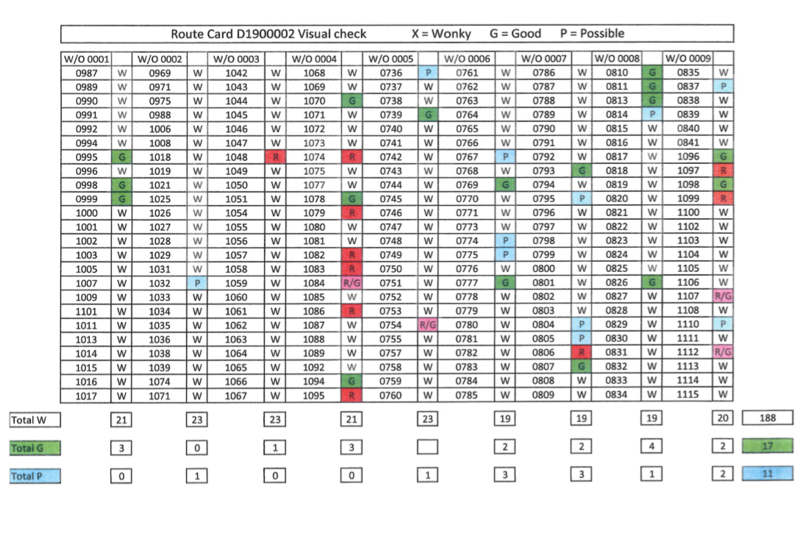
Figure 8 - Sample Manufacturing breakdown of Production Route Card
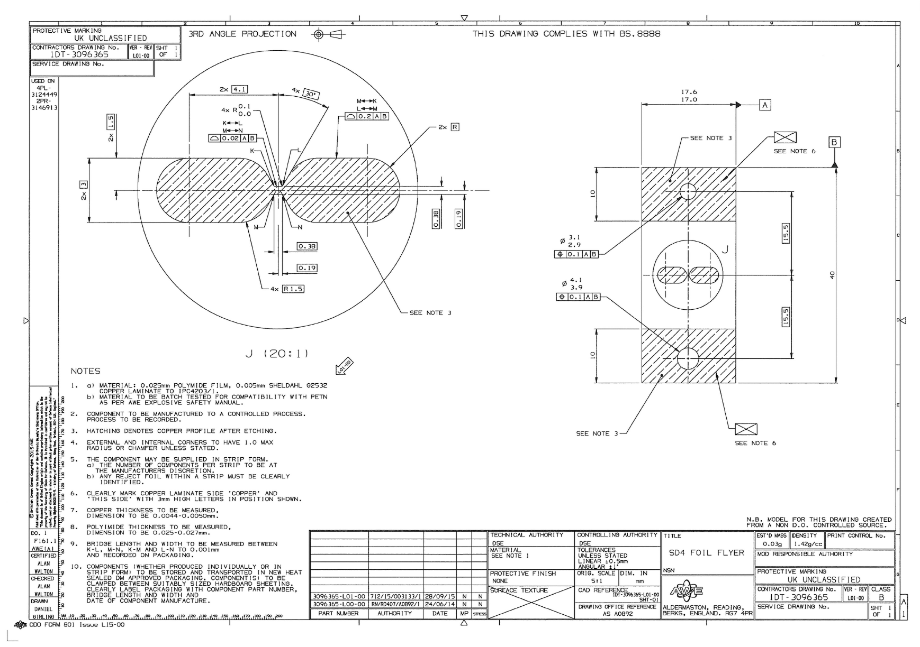
Figure 9 - Drawing - Foil Flyer
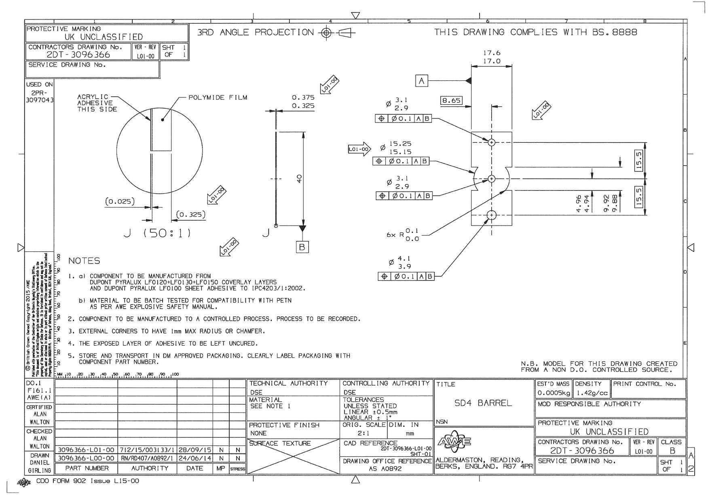
Figure 10 - Drawing - SD4 Barrel
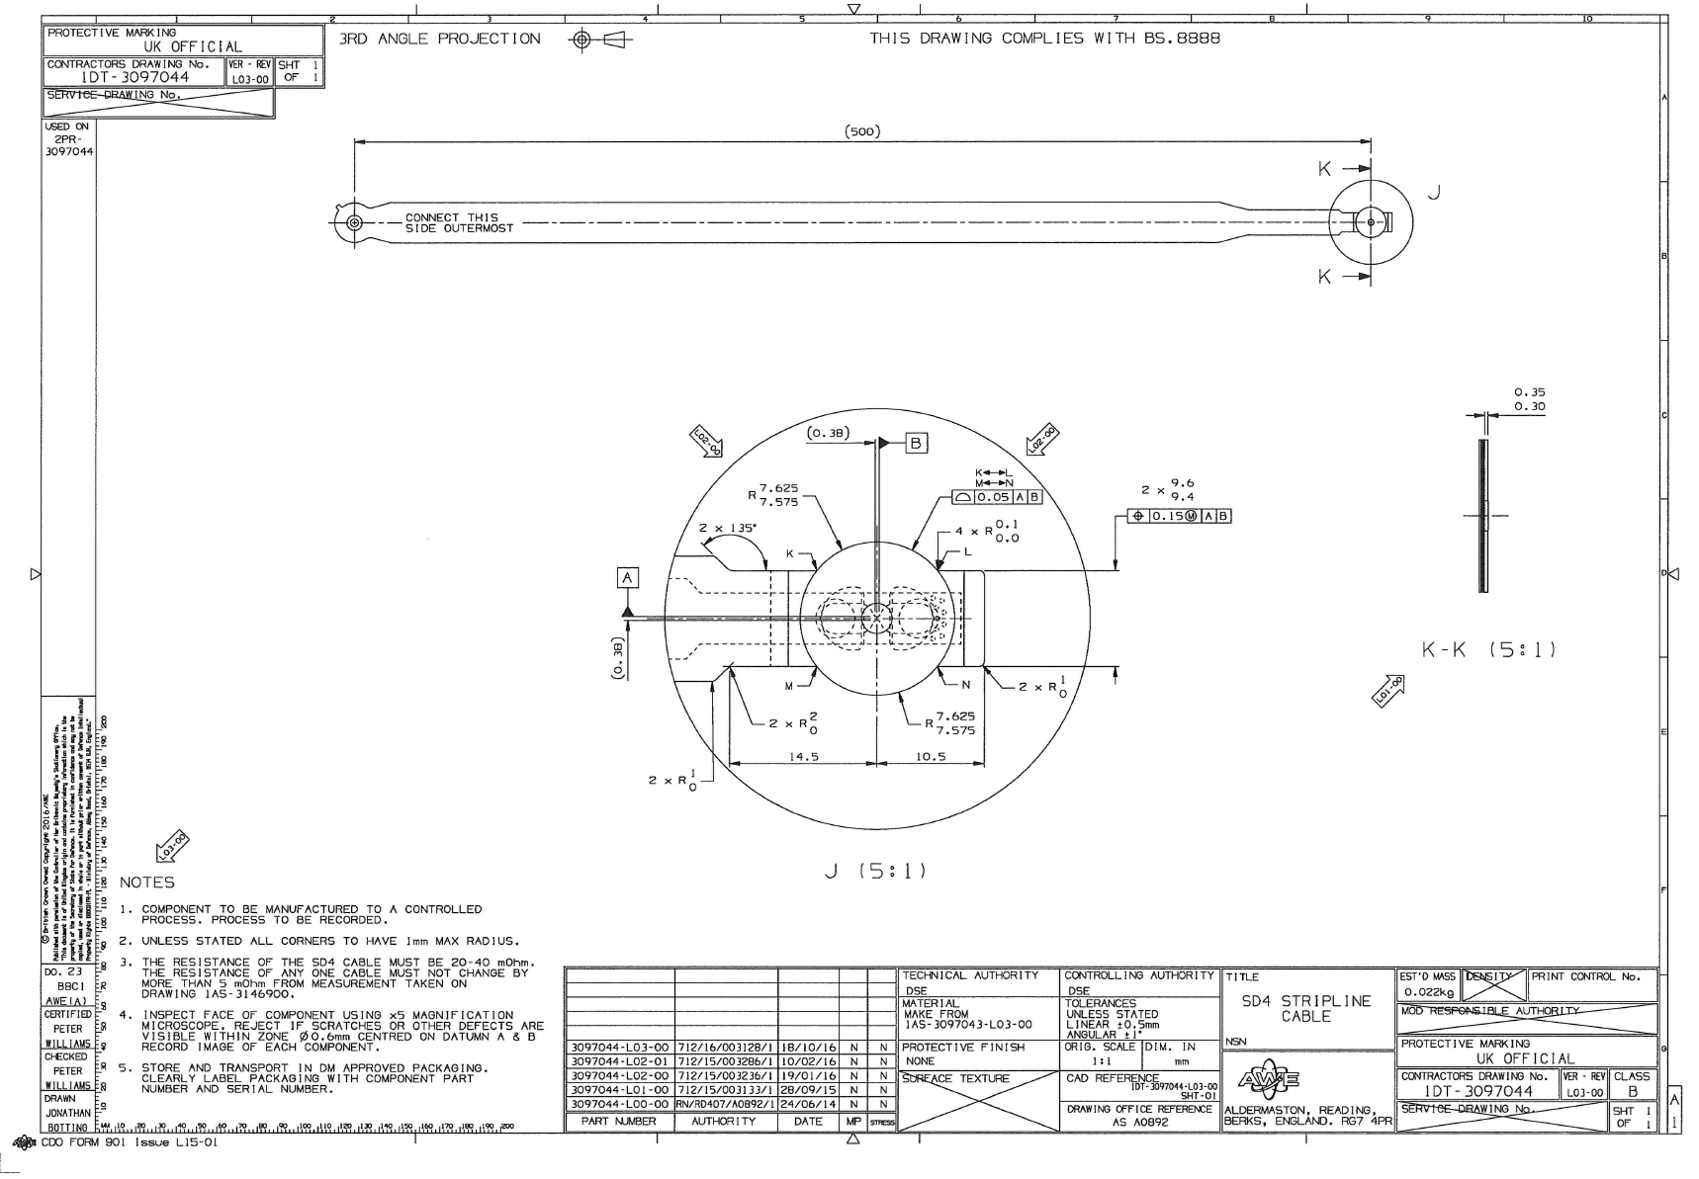
Figure 11 - Drawing - SD4 Stripline
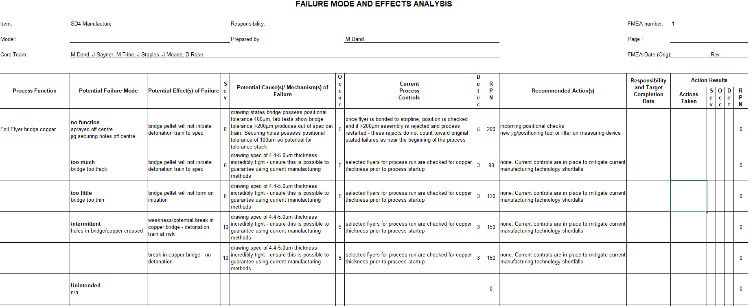
Figure 12 - SD4 FMEA section 1
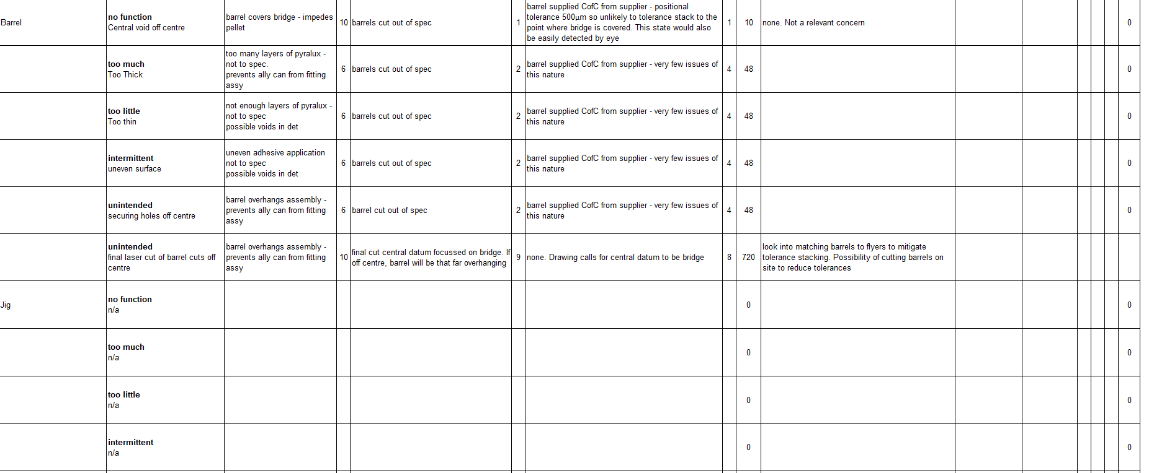
Figure 13 - SD4 FMEA section 2
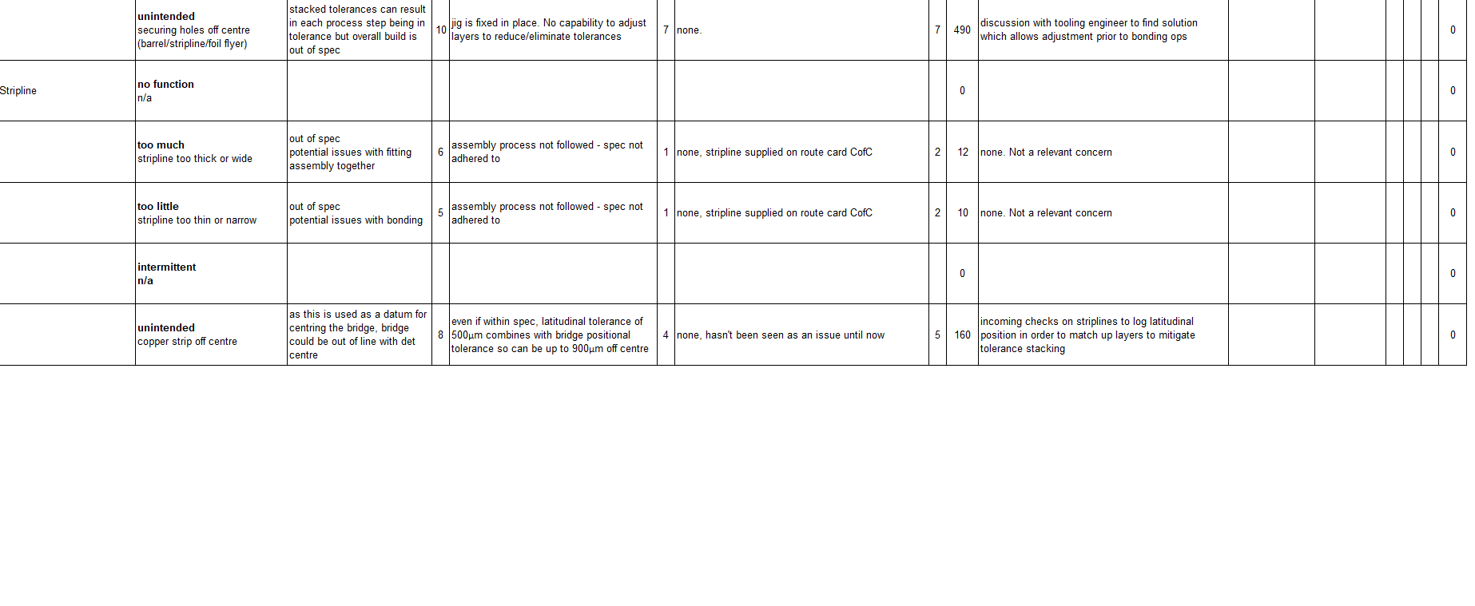
Figure 14 - SD4 FMEA section 3

