

Student Name: NEELKUMAR PATEL

Student ID: 2530038

Module Name: International Business Concepts

Module Code: LCMB7034

Lecturer’s Name: CHARLES OHAM

Work Count: 5326

Term 2

Table of Contents
Section 1: International Market Entry Analysis 5
1. Introduction 5
1.1 Background to Britvic PLC 5
1.2 Purpose and Scope of the Report 5
2. Organisational Classification and Global Strategy 6
2.1 International Strategy Classification 6
2.1.1 Application of Bartlett and Ghoshal's International Strategy Framework 6
2.1.2 Critical Evaluation of Britvic's International Strategy 8
2.2 Global Configuration and Competitive Advantage 8
2.2.1 Geographic Footprint of Britvic 8
2.2.2 Contribution to Competitive Advantage and Value Creation 9
3. Macro-Environmental Appraisal and Market Attractiveness 10
3.1 Host Country Analysis: Japan 10
3.1.1 Political Environment 10
3.1.2 Economic Environment 12
3.1.3 Legal and Regulatory Environment 14
3.1.4 Cultural Environment 17
3.2 Market Attractiveness Assessment 19
3.2.1 Strategic Opportunities 19
3.2.2 Strategic Challenges and Risks 20
3.3 Application of Dunning's Eclectic (OLI) Paradigm 21
3.3.1 Ownership Advantages (O) 21
3.3.2 Location Advantages (L) 23
3.3.3 Internalisation Advantages (I) 24
3.3.4 Strategic Synthesis of the OLI Framework 24
4. Entry Mode Strategy and Strategic Synthesis 25
4.1 Historical International Expansion Pattern 25
4.2 Critical Evaluation of Entry Mode Alternatives 27
4.2.1 Evaluation of Alternative Entry Modes 27
4.2.2 Recommended Entry Mode for Japan 29
4.3 Strategic Recommendations and Conclusion 31
4.3.1 Strategic Recommendations 31
4.3.2 Conclusion 31
Section 2: Reflective Account 31
5.1 Reflection Using Gibbs' Reflective Cycle 31
5.2 Description 32
5.3 Feelings 32
5.4 Evaluation 33
5.4.1 Effective Research Strategies 33
5.4.2 Challenges Encountered 33
5.5 Analysis 34
5.5.1 Application of International Business Theory 34
5.5.2 Development of Critical Thinking 34
5.6 Conclusion 35
5.7 Action Plan 35
References 36

List of Tables
Table 1: Critical Evaluation of Alternative Market Entry Modes 29
Table 2: Personal Action Plan for Future Academic and Professional Development 35

List of Figures
Figure 1: Britvic PLC Corporate Logo 5
Figure 2: Bartlett and Ghoshal's International Strategy Framework 6
Figure 3: Britvic PLC Brand Portfolio 7
Figure 4: Britvic PLC's Global Operational Presence 9
Figure 5: Member Countries of the CPTPP 10
Figure 6: Japan's Regulatory Framework for Imported Food and Beverage Products 11
Figure 7: Japan's Real Effective Exchange Rate 12
Figure 8: Online Consumer Expenditure by Product Category in Japan 13
Figure 9: Japan's Imported Food Monitoring and Inspection System 14
Figure 10: Example of a Japanese Food Compliance Label 15
Figure 11: Forecast of Japan's Health Drinks Market 16
Figure 12: Britvic PLC Sustainable Value Chain Framework 18
Figure 13: PET Bottle Collection and Recycling Rates in Japan 19
Figure 14: Japan Food Safety Management (JFS) Standards 21
Figure 15: Dunning’s Eclectic Paradigm (OLI Framework) 21
Figure 16: Britvic’s Drench Relaunch with Reduced-Sugar Formulation 22
Figure 17: Japan’s Strong Labour Market Position in 2026 23
Figure 18: Britvic PLC’s Acquisition of ebba in Brazil 25
Figure 19: Britvic’s Long-Term Franchise Bottling Partnership with PepsiCo 26
Figure 20: Joint Venture Structure 30

Section 1: International Market Entry Analysis

1. Introduction

1.1 Background to Britvic PLC

Figure 1: Britvic PLC Corporate Logo
Source: Britvic PLC (2024)
Britvic PLC is one of the United Kingdom's largest soft drinks manufacturers with owned brands including Robinsons, Tango, J2O and Fruit Shoot as well as licensed brands including Pepsi MAX, 7UP and Lipton Ice Tea in certain markets. With manufacturing, distribution, and strategic partnerships that provide competitive advantage in the international beverage market, the company is operating in Great Britain, Ireland, France and Brazil (Britvic PLC, 2024). Britvic has built up its reputation in several countries and continues to innovate on its products, incorporate sustainability measures and promote healthier beverage choices for long-term value creation and expansion in the international market (Azam et al., 2026; Britvic PLC, 2024).

1.2 Purpose and Scope of the Report
This report is an assessment of the strategic viability of Britvic's expansion into the Japanese market, where the company did not have a considerable operational presence, subsidiaries or production facilities as of June 2026 (Britvic PLC, 2024). The Japanese beverage market is appealing and competitive, with high-quality consumers, high standards of regulation, and developed retail infrastructure. Bartlett and Ghoshal's international strategy framework, macro-environmental analysis, Dunning's OLI paradigm and market entry mode theory are used in the analysis and critically assessed the suitability of Japan as Britvic's next international expansion destination (Cruz et al., 2020; Baena et al., 2015).

2. Organisational Classification and Global Strategy

2.1 International Strategy Classification

2.1.1 Application of Bartlett and Ghoshal's International Strategy Framework
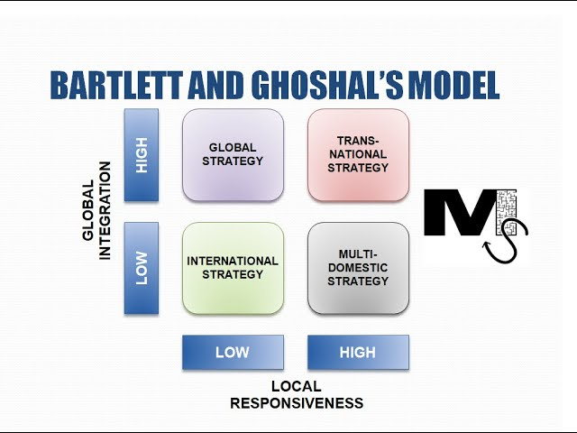
Figure 2: Bartlett and Ghoshal's International Strategy Framework
Source: Harvard Business School Press (2026)
From Bartlett and Ghoshal's perspective, Britvic's international approach could be broadly described as a transnational approach, since the company is seeking both global integration and product and operational adaptation to the needs of particular markets. The company's centralised research and development, procurement, brand management and sustainability functions bring operational advantages and ensure standardized quality in all markets. Concurrently, Britvic also provides significant autonomy to local businesses to adapt product offerings, marketing and distribution solutions to the preferences and requirements of their target market (Britvic PLC, 2024).
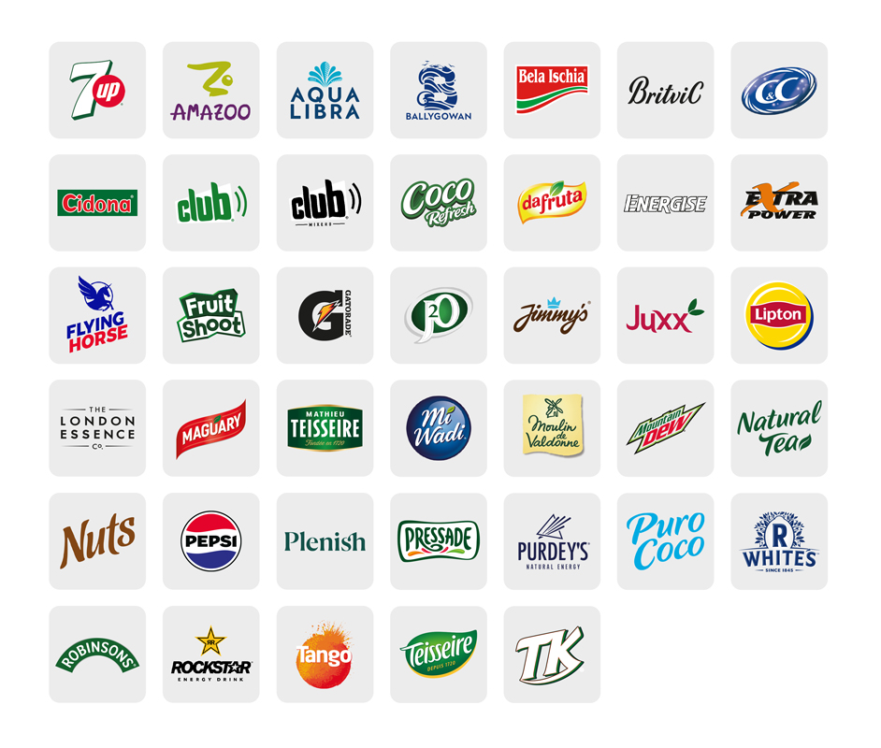
Figure 3: Britvic PLC Brand Portfolio
Source: Britvic – Year in Review: Our Brands (2026)
For example, the company manages distinct brand portfolio across Great Britain, Ireland, France and Brazil, reflecting differences in consumer tastes, purchasing behaviour and competitive dynamics. This mix of standardisation and localisation can help Britvic to take advantage of global resources and yet be local and responsive to the different market conditions. This is in line with the increasing value of flexibility in organisations when these operate in increasingly complex and dynamic international environments (Macro and Ott, 2024; Vrontis et al., 2024). Thus, Britvic's approach is not just a global or multidomestic but one that creates efficiencies globally while simultaneously being responsive to the local market to help maintain a competitive edge.

2.1.2 Critical Evaluation of Britvic's International Strategy
The transnational approach of Britvic has a number of strategic benefits. Shared procurement systems, innovation capabilities and sustainability initiatives create economies of scale and enable the introduction of innovative products to meet regional consumer preferences and regulatory requirements by local subsidiaries (Britvic PLC, 2024). This flexibility creates more customer relevance and helps sustain competitiveness on the international market (Swoboda et al., 2018). Incorporating local adaptation into a globally coordinated organisation adds complexity, demanding proper knowledge sharing and robust management practices in geographically dispersed operations (Macro and Ott, 2024). In addition, brand and product formulation changes can drive up costs and make supply chain management difficult. However, in the competitive beverage sector, where consumer tastes and cultural preferences and health laws differ widely from market to market, Britvic's international strategy offers a good balance of efficiency, innovation and market responsiveness.

2.2 Global Configuration and Competitive Advantage

2.2.1 Geographic Footprint of Britvic
With its manufacturing plants, distribution channels, and strategic licensing partnerships with global beverage giants like PepsiCo, Britvic has made significant strides in expanding its regional footprint across Great Britain, Ireland, France and Brazil (Britvic PLC, 2024). Its business model includes the use of both own brands and internationally recognised licensed products, which provides the company with a diversified revenue model and helps to reinforce its market penetration. While Britvic's international presence is mainly in Europe and in selected international markets, its experience in operations clearly shows its ability to manage cross border supply chain and strategic partnerships and multi-brand portfolios for future international expansion opportunities.
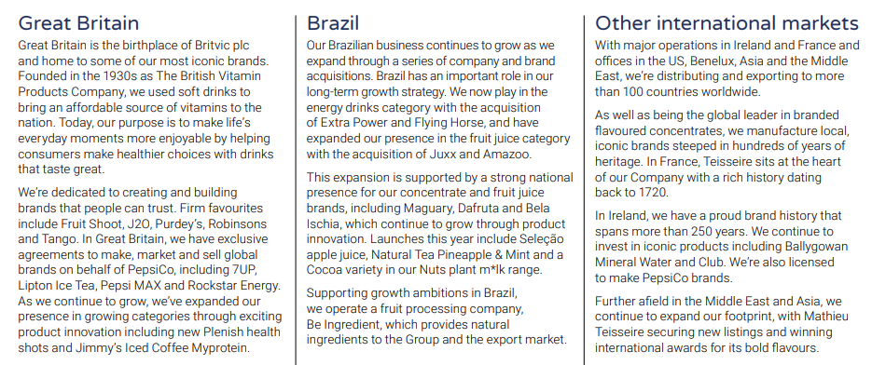
Figure 4: Britvic PLC's Global Operational Presence
Source: Britvic PLC (2024)

2.2.2 Contribution to Competitive Advantage and Value Creation
Britvic's international set up is important for establishing economies of scale, purchasing materials from a single source and achieving other efficiencies in manufacturing and coordinating innovation efforts in various markets (Britvic PLC, 2024). It has multiple brands, allowing for the effective segmentation of the market, and diminishing its reliance on a specific product or region. Cross-market knowledge sharing is useful for product innovation, beverage development and sustainability efforts, which can enhance long-term competitiveness (Oncioiu et al., 2026). Additionally, strategic licensing agreements and integrated supply chain management ensure operational efficiency, strengthen distribution networks, and bolster Britvic's agility in adapting to changing consumer trends, fostering sustainable value in the highly competitive global beverage landscape (Azam et al., 2026).

3. Macro-Environmental Appraisal and Market Attractiveness

3.1 Host Country Analysis: Japan

3.1.1 Political Environment
Japan provides a politically stable, transparent and business-friendly environment, making it an attractive destination for foreign direct investment (FDI). Investor confidence has been bolstered by strong institutions, predictable policy and regulatory changes, and most sectors are still open to foreign investment, although some screening is required for strategically sensitive industries per the Foreign Exchange and Foreign Trade Act (OECD, 2026; International Monetary Fund, 2026; ICLG, 2026). As a result, Britvic would find fairly low political barriers in getting in place or in strategic partnerships in Japan.
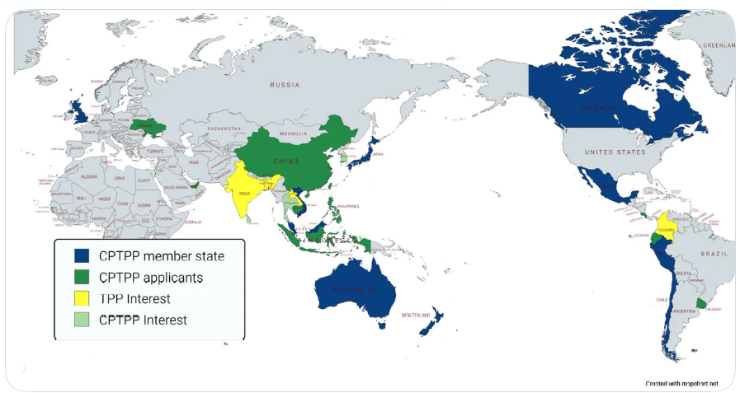
Figure 5: Member Countries of the CPTPP
Source: Wikimedia Commons (2025)
Consequently, the Japanese government has many extensive trade agreements, such as the Comprehensive and Progressive Agreement for Trans-Pacific Partnership (CPTPP) and the EU – Japan Economic Partnership Agreement, which allow the country to access imported ingredients and efficient regional supply chains (OECD, 2026). However, geopolitical tensions and global supply chain disruptions show the necessity for Britvic to diversify sourcing strategies and enhance supply chain resilience to reduce operational risks (Jawadi et al., 2024).
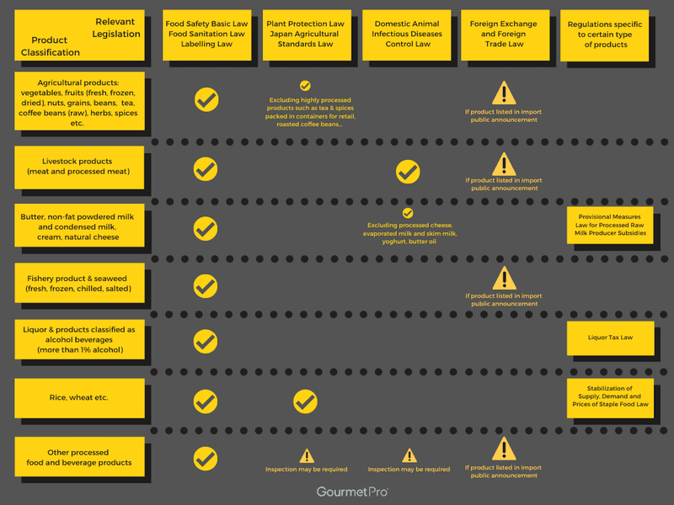
Figure 6: Japan's Regulatory Framework for Imported Food and Beverage Products
Source: GourmetPro (2024)
In addition, food and beverage companies are subject to strict food safety and product labelling and consumer protection laws and ordinances issued by the Ministry of Health, Labour and Welfare (MHLW, 2026). Furthermore, the Japanese government's dedication to sustainability promotes environmentally-friendly packaging by incentivizing carbon reduction, aligning with Britvic's sustainability initiatives, and packaging innovation strategy (Britvic PLC, 2024). Japan's political climate is overall stable, and its investment policies are favourable, as long as Britvic can effectively handle compliance with regulations and expectations of sustainability.

3.1.2 Economic Environment
Despite being one of the world's largest economies, Japan's purchasing power remains high, as do its well-developed retail infrastructure and demand for premium consumer goods (International Monetary Fund, 2026). While economic growth has slowed in response to demographic pressures, wages and sustained consumer spending are driving demand for high-quality, healthier and value-added beverages (OECD, 2026). This opens the door for Britvic to offer premium soft drinks, functional drinks and reduced sugar options to align with consumer trends.
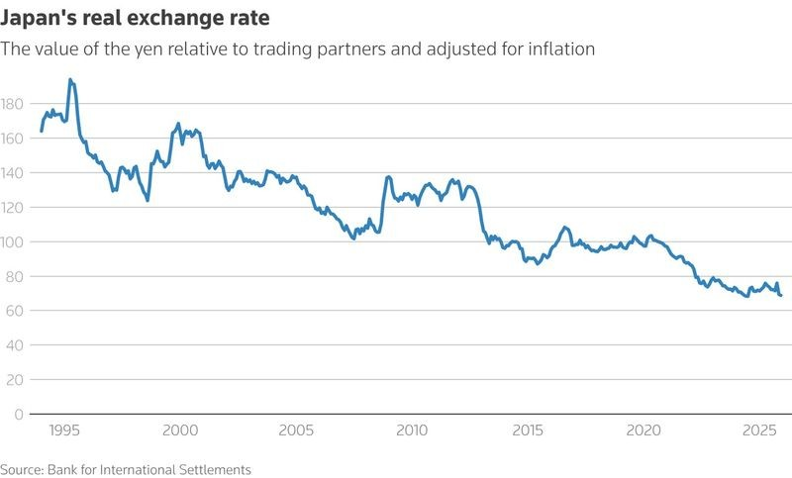
Figure 7: Japan's Real Effective Exchange Rate
Source: Reuters (2026)
Moderate inflation and Japanese yen fluctuations could raise production and import costs, which could impact Britvic's profitability in the event that the products are exported exclusively (OECD, 2026). Local production or partnering with local entities could minimize exchange rate risks and enhance the efficiency and responsiveness of operation to market demands.
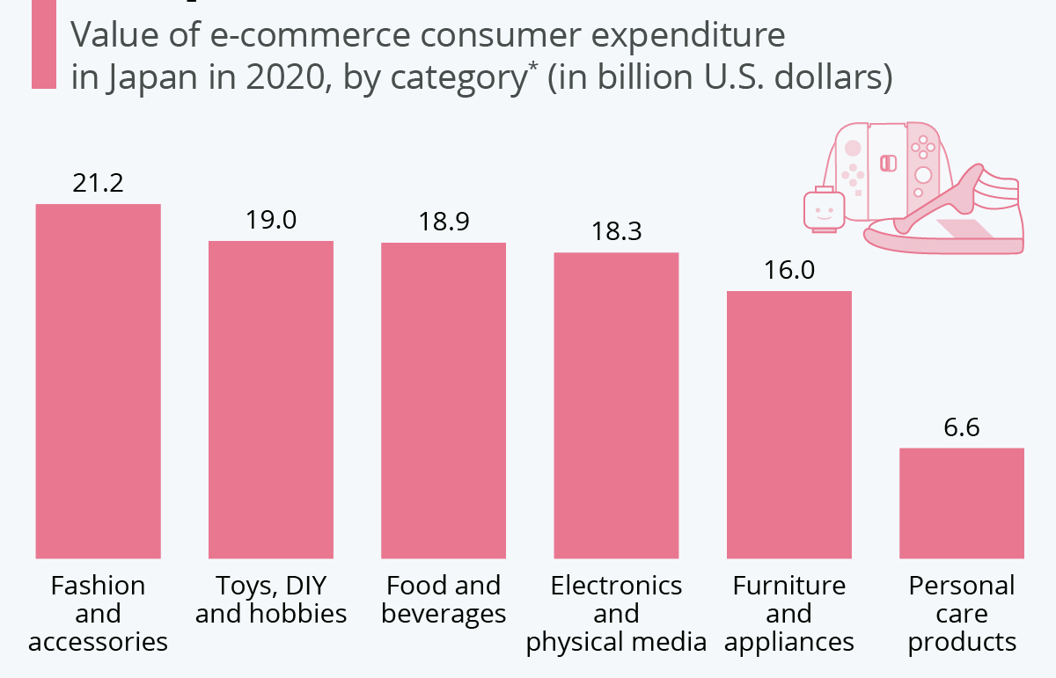
Figure 8: Online Consumer Expenditure by Product Category in Japan
Source: Statista (2020)
Japan has a highly developed retail network, featuring convenience stores, supermarkets, vending machines, and a growing e-commerce marketplace, which provides ample distribution opportunities. However, with competition being fierce, it is necessary to build strong relationships with local retailers and distributors to access the broader market.
The premiumisation and the promotion of healthy lifestyles and sustainable consumption are increasingly preferred consumption patterns of consumers. The interest in natural products for drinks with reduced sugar consumption as well as packaging options that are environmentally friendly is ever increasing (Lange et al., 2024; Barrahmoune et al., 2026). These trends align with Britvic's strategic objective of developing healthier product innovations and sustainable packaging practices (Britvic PLC, 2024). But sustained success will require some tweaking of flavours, product formulation and marketing concepts to the Japanese market, which is saturated and competitive. Overall, Japan's economic environment offers substantial growth potential, but Britvic must balance premium positioning with operational efficiency and effective local market adaptation.

3.1.3 Legal and Regulatory Environment
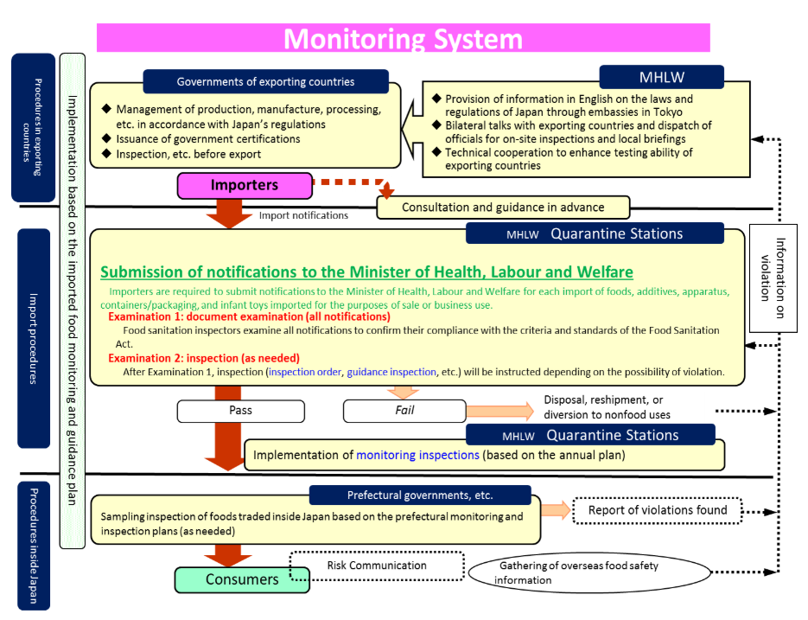
Figure 9: Japan's Imported Food Monitoring and Inspection System
Source: Ministry of Health, Labour and Welfare (MHLW) (2026)
The Japanese legal and regulatory environment for the food and beverage market is very complex, with foreign companies having to meet high standards before they can enter the market. The Regulation of Food Safety is handled in accordance with the Food Sanitation Act and other related laws under the jurisdiction of the Ministry of Health, Labour and Welfare (MHLW), with regards to ingredients, additives, manufacturing processes and quality assurance (QA) (MHLW, 2026). Britvic would have to implement comprehensive quality management systems, along with strict supplier selection and ongoing quality monitoring throughout the supply chain to ensure product safety and regulatory compliance.
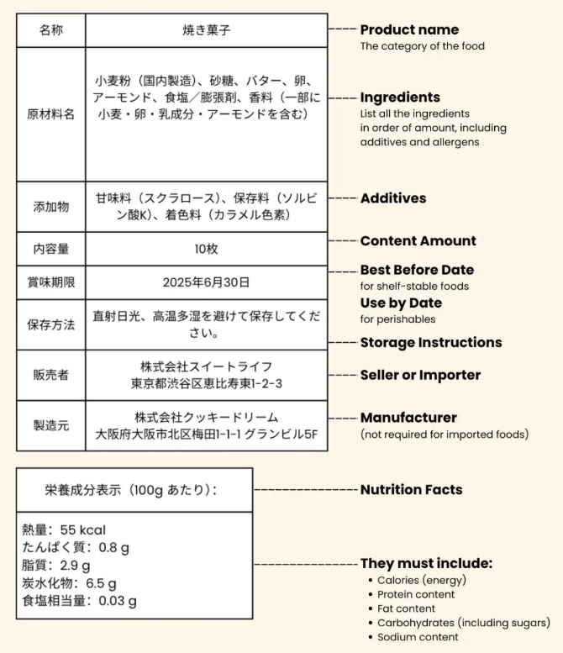
Figure 10: Example of a Japanese Food Compliance Label
Source: COVUE (2025)
The regulations for product labelling are also strict. Beverage manufacturers are required to give precise information on ingredients, allergens, nutritional information, expiration date, and country of origin in Japanese (MHLW, 2026). Britvic would therefore have to change packaging of their products to ensure consistency of the brand. Imported beverages also undergo customs checks and documentation verification, adding to compliance and administrative burdens (ICLG, 2026). Local production or collaboration with local manufacturers might therefore be helpful to enhance operational efficiency and reduce the delays involved in imports.
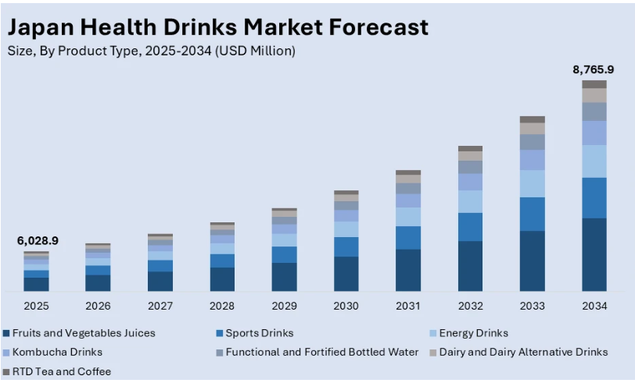
Figure 11: Forecast of Japan's Health Drinks Market
Source: IMARC Group (2026)
Though at present there is no sugar tax in Japan, the increasing concern for public health has spurred a demand for low-sugar drinks and healthier product lines (Lange et al., 2024). This development dovetails with Britvic's current emphasis on low and no sugar beverage offerings, and therefore lessens the risk of future regulations and improves the company's competitiveness. Advertising laws also need to ensure claims are accurate and not misleads, especially claims for health. Moreover, Japan offers robust protection for trademarks and brands, and competition law encourages good faith conduct and deters anti-competitive practices (Węgrzak, 2022; ICLG, 2026). Overall, whilst there is an extra cost of compliance, Japan offers a clear legal environment with a certainty of law that helps to facilitate investment and safeguard Britvic's brand assets.

3.1.4 Cultural Environment
Understanding the role of culture in Japanese consumer behaviour is of critical importance and adaptation of the product and marketing are necessary for successful entry into the Japanese beverage market. Japanese consumers tend to value quality, safety, authenticity and brand reputation more than low costs. Consumer Culture Theory proposes that consumer buying is an expression of common values shared by the members of the culture, so Britvic should take note that it needs to adapt its brand and products to fit the local life, and not just transcribe the successful European strategies (Dhiman et al., 2026). Therefore, positioning products around premium quality, health and reliability would enhance the market acceptance.
Japan is a country where people often buy drinks at a convenience store, supermarket and vending machine. Regular product innovation, seasonal flavours and premium experiences are also expected by consumers. The company's beverage innovation and expertise offer a competitive advantage; however, the company will need to adapt beverage flavours and concepts to local preferences, not just rely on existing beverages to make it a success (Britvic PLC, 2024).
Health and wellness have become major purchasing drivers as consumers increasingly prefer beverages containing natural ingredients, reduced sugar and functional benefits (Lange et al., 2024). Britvic's strategic emphasis on healthy product development is a close match to the above trends. Japanese consumers, however, have a preference for less sweetness and less pronounced flavors, so product reformulation is necessary to meet consumer expectations.
Japan's relatively high levels of uncertainty avoidance and long-term orientation, as per Hofstede's cultural dimensions, suggest that people prioritize loyal brands and consistent quality, along with sustainable business practices (Sari, 2025). Moreover, according to the High-Context Communication theory by Hall, marketing should emphasize subtler communication, symbolism, and authentic storytelling that appeals to emotions and feelings, rather than overt promotional messages (Dhiman et al., 2026). In this regard, Britvic should focus on communication through the brand heritage, product quality and trust of its consumers in its products.
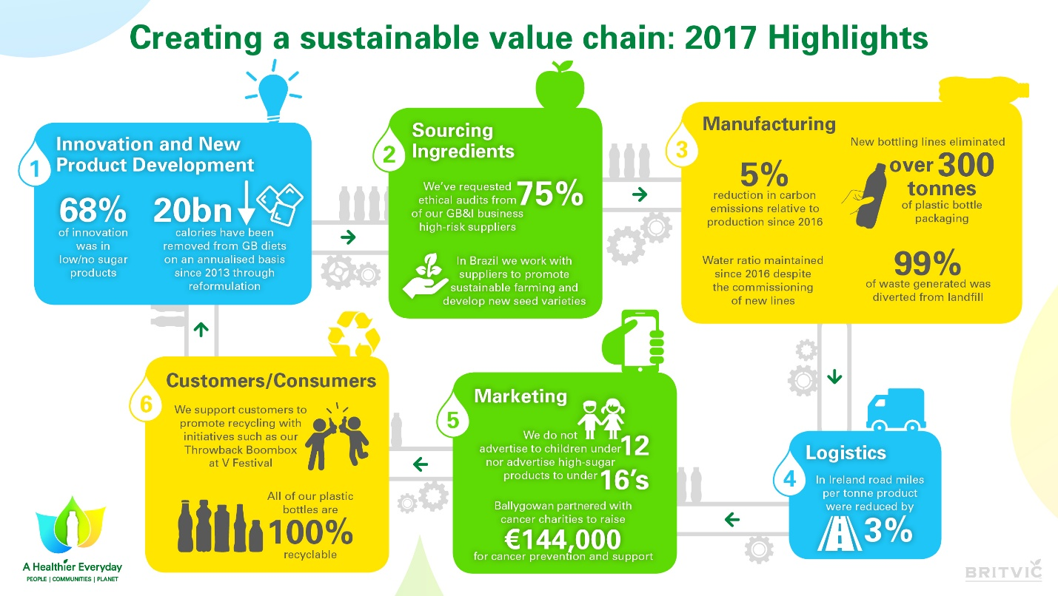
Figure 12: Britvic PLC Sustainable Value Chain Framework
Source: Britvic PLC (2018)
Sustainability has gained significant importance, as consumers demand environmentally friendly packaging and businesses are dedicated to reducing waste (Barrahmoune et al., 2026). The sustainability measures implemented by Britvic, such as recyclable packaging, align with these expectations (Britvic PLC, 2024). Furthermore, Japan's culture of gift giving opens up opportunities for high-end packaging as well as seasonal product editions, and the convenient shopping habits of the Japanese people indicates the need for reliable retailing relations. As a whole, these cultural traits suggest that Britvic's success requires a mix of global brand-building and local customization of its products, marketing and distribution.

3.2 Market Attractiveness Assessment

3.2.1 Strategic Opportunities
Japan presents several attractive growth opportunities for Britvic despite its mature beverage market. Britvic is seeing a sharp demand from consumers for premium soft drinks as well as also healthier alternatives and functional beverages, and this mirrors strongly with the company's focus of premium product innovation and on low and no sugar (Britvic PLC, 2024). The rising awareness of health and wellness among consumers has prompted them to look for drinks with a more comprehensive mix of natural nutrients and enhanced health benefits, which has paved the way for Britvic's diversified product portfolio (Lange et al., 2024).
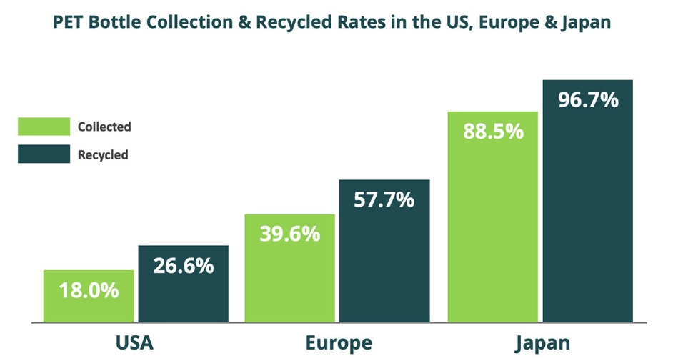
Figure 13: PET Bottle Collection and Recycling Rates in Japan
Source: WPIC Marketing + Technologies (2024)
In addition, Japan's dedication to sustainability allows for the potential to differentiate Britvic's range by incorporating recyclable packaging and a more sustainable approach. Market acceptance can be further improved with continuous product innovation such as limited-edition flavours, adaption of the products to the local market. Moreover, the well-established digital retail ecosystem in Japan, including e-commerce, convenience stores, and omnichannel retailing, provides efficient distribution and customer engagement possibilities and facilitates data-driven marketing and expanded market access (Oncioiu et al., 2026).

3.2.2 Strategic Challenges and Risks
However, Japan has a number of issues that may impact on Britvic's successful market entry. Soft drinks industry is a competitive market, mainly controlled by the large, domestic firms with a long distribution network and a well-known and trusted brand. The level of market saturation also affects the possibilities for a quick market penetration and demands a continuous product differentiation. Distributing is also challenging, because good relationships with wholesalers, retailers and convenience store chains are needed to get good shelf space and to have a nationwide market presence. Consumers in Japan are generally loyal to familiar local brands, and it can be challenging for new foreign brands to build brand awareness and repeat purchases (Sari, 2025). In addition, the complexity of rules and regulations regarding food safety and the requirements for product labelling and compliance add to the cost of market entry (MHLW, 2026).
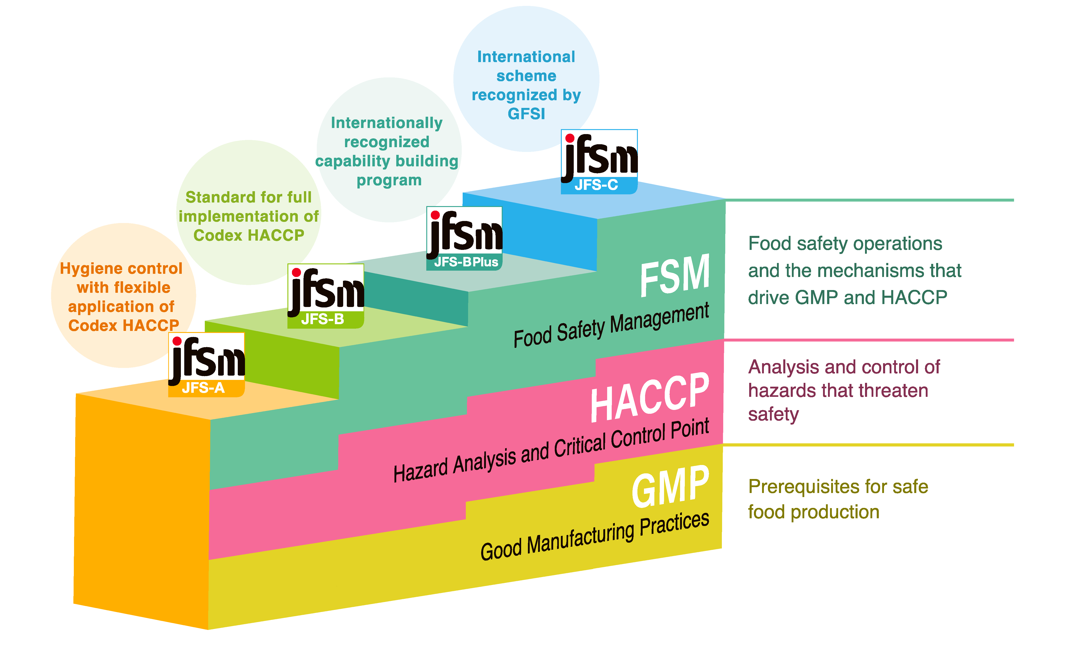
Figure 14: Japan Food Safety Management (JFS) Standards
Source: Japan Food Safety Management Association (JFSM) (2026)
Profitability can also be impacted by exchange rate movements, increases in production costs and general inflationary pressures, which Britvic will need to manage closely, as they will require careful pricing, efficiency and investment decisions from the company to stay competitive (OECD, 2026; International Monetary Fund, 2026).

3.3 Application of Dunning's Eclectic (OLI) Paradigm
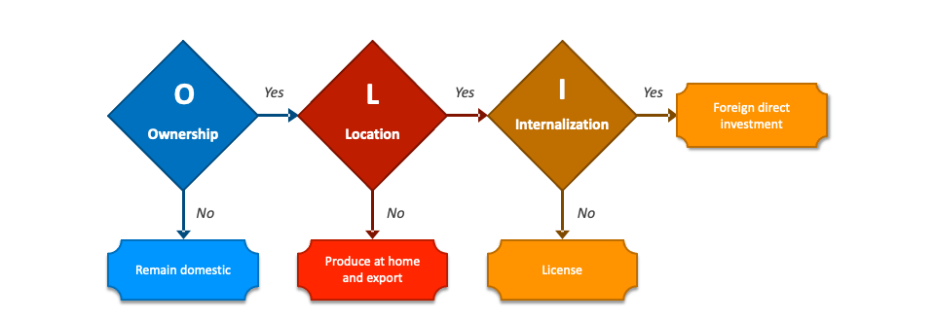
Figure 15: Dunning’s Eclectic Paradigm (OLI Framework)
Source: Collidu (2025)

3.3.1 Ownership Advantages (O)
Ownership advantages, according to Dunning's OLI paradigm, are firm-specific resources which give competitive advantage in international markets (Cruz et al., 2020). Britvic has a few company specific strengths or merits for expansion in Japan. The company has a diversified portfolio of well-known brands such as Robinsons, Tango, J2O and Fruit Shoot, among others, as well as licensed brands including Pepsi MAX and 7UP in selected markets to effectively segment the market which consists of various consumer groups (Britvic PLC, 2024). Britvic's ability to bring healthier drinks, lower sugar levels and innovative packaging to meet consumer tastes has been bolstered by investments in research and development (Global Legal Insights, 2026).
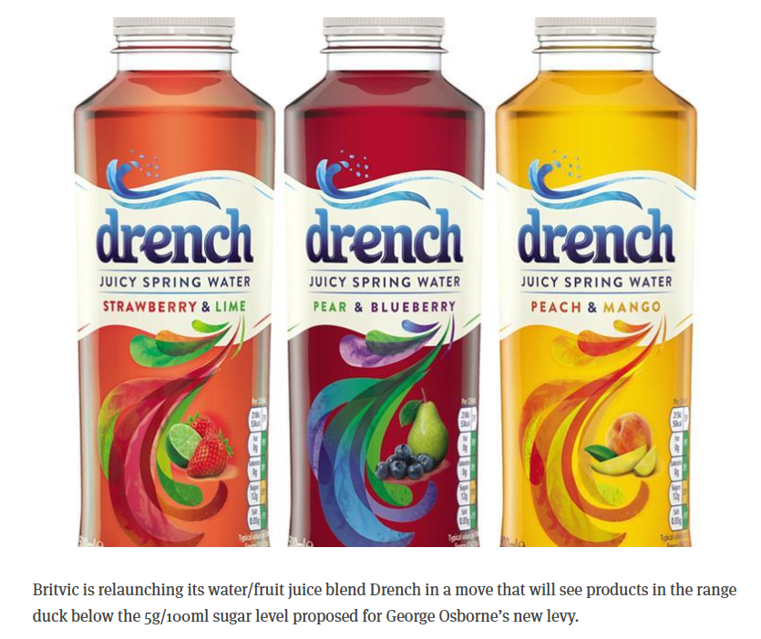
Figure 16: Britvic’s Drench Relaunch with Reduced-Sugar Formulation
Source: The Grocer (2016)
In addition, its considerable marketing experience and skills in dealing with owned and licensed brands augment its ability to gain brand equity in dynamic markets. Viability through integrated manufacturing and procurement, with sustainability programmes, and operational capabilities bring efficiencies for international expansion and long-term competitiveness (Azam et al., 2026).

3.3.2 Location Advantages (L)
Significant location specific advantages that make Japan attractive for Britvic's international expansion. Japan is one of the world's largest economies and offers a significant consumer market with a relatively high purchasing power, and demand for high quality and premium beverages (IMF, 2026). It has a sophisticated logistics network and a wide network of retail outlets, which enables efficient distribution and a broad countrywide reach (Karagkouni ett al., 2025).
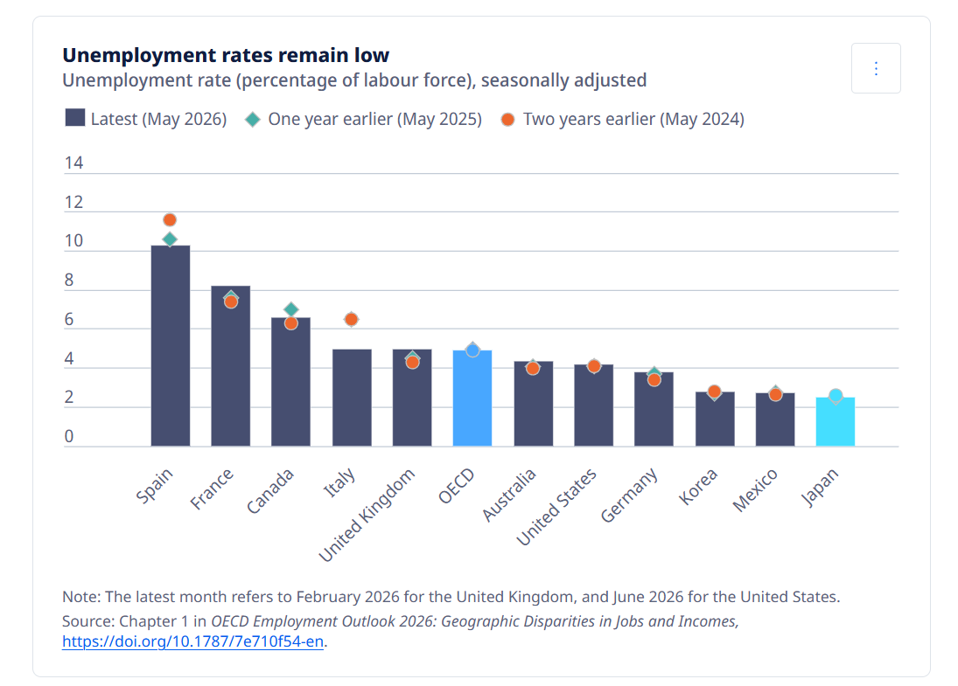
Figure 17: Japan’s Strong Labour Market Position in 2026
Source: OECD (2026)
The country is also blessed with a well-trained labor force, which is able to staff sophisticated manufacturing and product development and quality control. Moreover, technological leadership facilitates the transition to digital retailing and digital marketing strategies, as well as supply chain management, for achieving operational excellence (Oncioiu et al., 2026). Furthermore, the stable political systems, transparency of the legal system, and supportive investment climate in Japan minimize institutional uncertainty and promote long-term commitment of business investment (ICLG, 2026; OECD, 2026). All of these benefits create an external environment that is favourable to the sustainable growth of Britvic's business and competitiveness.

3.3.3 Internalisation Advantages (I)
The concept of internalisation advantages implies that the firm can derive more value from foreign operations than from only licensing or exporting (Cruz et al., 2020). Britvic would also gain greater control over product quality, manufacturing standards and brand uniformity from the move, all significant considerations for a consumer-driven Japanese market where there are food safety enforcements. It also would eliminate the risk of inconsistent product quality levels or reputational damage from third-party licensees, and facilitate greater operational involvement would also be expected to improve brand protection (Kostyuchenko et al., 2019). In addition, better access to procurement, production and distribution would mean better integration of the supply chain and increase the responsiveness of supply chain to shifting consumer preferences. It would also help to enhance the customer experience by being able to engage with customers more closely with locally adapted product development, marketing, and after-sales support. This is more expensive than exporting or licensing but provides better strategic control, preservation of valuable intangible assets and long-term value creation (Britvic PLC, 2024; Baena et al., 2015).

3.3.4 Strategic Synthesis of the OLI Framework
The OLI analysis has shown that Japan is an interesting market for the expansion of Britvic internationally. The ownership advantages of the company, such as recognised brands, innovation capabilities, operational expertise, and sustainability initiatives, offer valuable resources that can be leveraged in the Japanese market (Britvic PLC, 2024). At the same time, Japan provides significant location advantages with a large population of consumers, cutting-edge infrastructure, technological sophistication, stable institutions, and high purchasing power, while encountering growing demographic pressures (OECD, 2026; International Monetary Fund, 2026). Internalisation advantages further support maintaining greater operational control to ensure product quality, protect intellectual property, strengthen customer relationships and improve supply chain efficiency. However, significant product adaptation, regulatory clearance and investment will be needed to enter the market successfully and to compete with the well-established Japanese beverage market. Overall, the joint ownership, location and internalisation advantages meet the requirements of Dunning's eclectic paradigm, indicating that the conditions for Britvic's expansion in Japan are favourable, albeit with a modified entry strategy that maximises operational control while also leveraging Japanese market knowledge and commitment (Liu, 2024; Lingham et al., 2025).

4. Entry Mode Strategy and Strategic Synthesis

4.1 Historical International Expansion Pattern
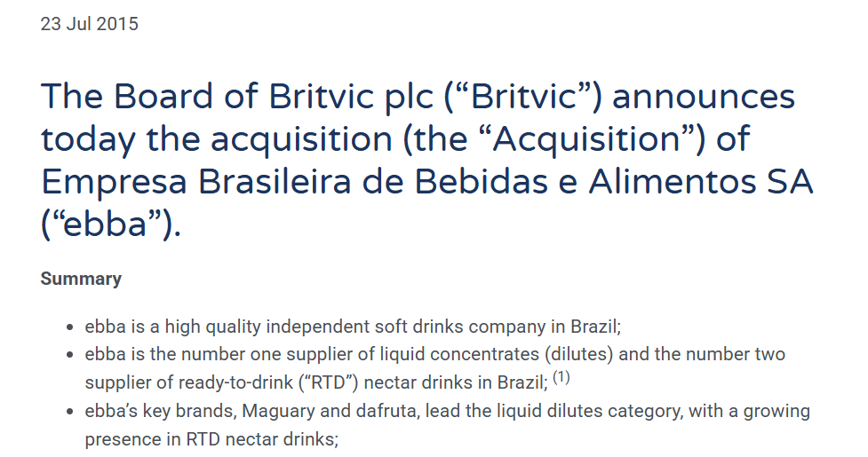
Figure 18: Britvic PLC’s Acquisition of ebba in Brazil
Source: Britvic PLC (2015)
Britvic's international expansion has been largely by means of acquisitions, strategic partnerships, licensing and distribution alliances as opposed to fully-owned greenfield investments. The company has bolstered its market standing by acquiring businesses, particularly the one in Brazil which it bought through Empresa Brasileira de Bebidas e Alimentos (EBBA) where it gained instant access to local production capacity, distribution channels and popular brands (Britvic PLC, 2024). Britvic has also grown on a strategic basis with licensing deals, most specifically with PepsiCo which it makes, markets and sells PepsiCo brands in Great Britain and Ireland. The firm has adopted this licensing scheme which has enabled it to gain international brands and local operational skills (Nosova, 2023).
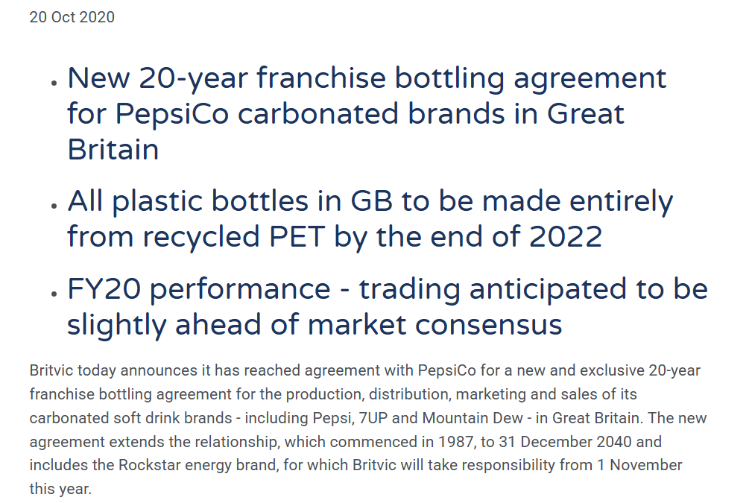
Figure 19: Britvic’s Long-Term Franchise Bottling Partnership with PepsiCo
Source: Britvic PLC (2020)
Distribution alliances have also been a key factor in Britvic's international expansion as it is able to expand markets without a large capital investment. Rather than relying on wholly owned subsidiaries, the company has generally preferred collaborative approaches that balance operational control with market flexibility. As per these historical trends, the Britvic seems to prefer acquisition deals, which involve moderate investment and local market insight and effectiveness. These partnership strategies help mitigate market uncertainty for the company and contribute to its long-term competitiveness in highly regulated and culturally diverse international markets (Baena et al., 2015; Britvic PLC, 2024).

4.2 Critical Evaluation of Entry Mode Alternatives

4.2.1 Evaluation of Alternative Entry Modes
Entry Mode | Risk | Control | Investment | Flexibility | Speed | Strategic Fit for Japan
Exporting | Low | Low | Low | High | Fast | Suitable for market testing but limited customer responsiveness and higher logistics costs.
Licensing | Low | Low | Low | High | Fast | Rapid entry but risks reduced quality control and weaker brand protection.
Franchising | Medium | Medium | Medium | Moderate | Moderate | Less suitable because beverage manufacturing depends more on production and distribution than retail franchising.
Strategic Alliance | Medium | Medium | Medium | High | Moderate | Enables access to local expertise, distribution channels and shared resources with relatively low risk.
Joint Venture | Medium | High | Medium-High | Moderate | Moderate | Combines local market knowledge with operational control and reduces market entry risk.
Acquisition | High | High | High | Low | Fast | Provides immediate market presence but requires substantial investment and integration capabilities.
Wholly-owned Subsidiary | High | Very High | Very High | Low | Slow | Maximum control but exposes Britvic to significant financial and operational risks during initial market entry.
Table 1: Critical Evaluation of Alternative Market Entry Modes
Source: Author (20206)

4.2.2 Recommended Entry Mode for Japan
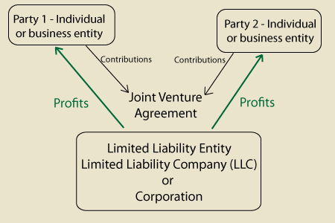
Figure 20: Joint Venture Structure
Source: Board Infinity (2020)
Britvic's expansion into Japan is most suitable with a joint venture as it will allow them to have a balance of strategic control and local market expertise, while minimizing investment risk. This can be explained by Dunning's OLI paradigm that suggests strong ownership advantages for Britvic, such as recognised brands, innovation capabilities and operational expertise, and strong location advantages in Japan, such as stable institutions, sophisticated infrastructure and high consumer purchasing power (Cruz et al., 2020). With a partner who has the experience and market knowledge to leverage existing distribution networks, a joint venture allows Britvic to in-source key business aspects.
Political risks are relatively low due to stable governance and transparent investment regulations, allowing long-term partnerships to be viable (ICLG, 2026). The sharing of resources, infrastructure and operating expenses with a local partner can help minimise financial risks that accompany significant capital investments. Working with a recognised domestic company also helps to manage operational risks such as compliance with food safety standards, product labelling requirements and complex distribution systems to the retail market (MHLW, 2026). Moreover, common cultural risks related to consumer preferences, communication and buying behaviours are greatly minimized when consumer-based knowledge is combined during product development and marketing decisions (Sari, 2025).
Acquisitions or wholly-owned subsidiaries would thus allow a higher degree of operational control but would involve significant financial outlay and integration and market entry risks for Britvic. Exporting and licensing, on the other hand, offer little control over product quality, customer experience and positioning of the brand in the very competitive Japanese beverage market. Hence, a joint venture provides an optimal level of control, flexibility, and competitiveness, contributing to Britvic's strategy of collaboration in international expansion, as evidenced in previous overseas markets (Britvic PLC, 2024; Baena et al., 2015).

4.3 Strategic Recommendations and Conclusion

4.3.1 Strategic Recommendations
- Britvic should establish a joint venture with an experienced Japanese beverage or distribution company to combine local market expertise with its international capabilities.
- The company should adapt product formulations, flavours and packaging to meet Japanese consumer preferences and health-conscious purchasing behaviour.
- Britvic should strengthen its presence through convenience stores, supermarkets and digital retail platforms to maximise market coverage.
- Continuous investment in sustainable packaging and product innovation should be maintained to enhance long-term competitiveness and regulatory compliance.

4.3.2 Conclusion
Britvic has a solid international capability and is able to expand in Japan. Despite significant competition and regulation, long-term opportunities are favourable due to economic conditions, sophisticated consumers and stable institutions. A joint venture provides the right mix of control, local knowledge and ongoing development and is the most appropriate approach to successful market entry.

Section 2: Reflective Account

5.1 Reflection Using Gibbs' Reflective Cycle
This reflection assesses the learning process experienced during the research and preparation of the international market entry analysis for Britvic PLC's expansion into Japan. Gibbs' Reflective Cycle offers a systematic process of looking at experiences, assessing learning outcomes and determining what can be done next. Reflective learning is especially important in international business as it promotes critical thinking and learning from evidence and extends the theoretical knowledge to the business context. As a result of reflection, I gained a better understanding of the process that multi-national companies use to assess international opportunities, as well as risks involved in entering a market and making strategic decisions using suitable analytical tools.

5.2 Description
When initially tasked with the assignment, I knew that the main challenge was not just to describe a company or country, but to critically evaluate an international market entry opportunity. Upon consideration of various multinational organisations, I decided to choose Britvic PLC due to its proven international operations and current growth strategy. Japan was selected as the target market because as of June 2026 it was a high-income country with no real presence for Britvic but held the potential for large opportunities in the premium drink market.
In order to ensure the systematic gathering of information, a structured research plan was developed. Academic Journal articles were initially studied to gain insight into relevant international business theories and Britvic's annual report and reputable sources of information, such as economic, government and industry publications, were analysed. The gathered information was subsequently analyzed based on the assessment needs and then theoretical approaches were applied to form critical analysis and evidence-based recommendations.

5.3 Feelings
When I started, I was confident to analyse an international expansion strategy as I had already learned some theories related to international business. I found, however, that to make a critical report it was necessary to go rather deeper than I had thought. One of the issues was to ensure that there was no significant operational presence by Britvic in Japan, and that the evidence was the latest available.
I felt more confident in the research as I went along as I got to know how to incorporate company evidence, academic literature and country-specific information. I also understood that for analysing a market more successfully abroad, opportunities and risks should be discussed in parallel and not just the favorable characteristics of the market. This experience helped build the confidence to analyze and to make decisions based on evidence.

5.4 Evaluation

5.4.1 Effective Research Strategies
Over the course of this assignment, several research strategies were found to be fruitful. International strategy, foreign market selection and entry mode decisions were analysed using the theoretical foundations of peer-reviewed academic literature. Britvic's annual report provided accurate data on its business model, international operations and strategic focus. The sources of credible information on Japanese government and economy were the OECD and IMF publications, the MHLW and ICLG documents, and industry reports, which provided details of consumer behaviour and market trends. Using a mix of multiple and quality sources was helpful in strengthening findings and mitigating reliance on a single viewpoint.

5.4.2 Challenges Encountered
The biggest hurdle was locating more recent, sound evidence that would support Britvic's comparatively small footprint in Japan. A further challenge was that of trying to combine a number of theories without repeating analysis. There was also a need for careful organisation in distinguishing between political, economic, legal and cultural influences as several factors were connected. These challenges were addressed by cross-checking information across multiple authoritative sources and ensuring that each theoretical framework addressed a distinct aspect of the market entry decision.

5.5 Analysis

5.5.1 Application of International Business Theory
This assignment proved to be a practical application of a number of international business theories. Bartlett and Ghoshal's framework enabled a systematic evaluation of Britvic's international strategy by distinguishing between global integration and local responsiveness. The Dunning's OLI Paradigm offered a detailed overview of ownership, location and internalisation advantages, which in turn illustrated the potential of Japan as a good host country for foreign investment. Market entry theories allowed to compare different entry modes based on the risk of investments, degree of control and level of commitment of resources. Political, financial, operational and cultural uncertainties were identified as important factors that need to be assessed before choosing an entry strategy, through risk analysis. Moreover, cultural concepts such as Hofstede's dimensions and Hall's High-Context Communication theory were explained and how they affect product adaptation and marketing decisions, consumer behaviour and communication styles. Together these theories have changed the nature of the assignment from description to strategic business analysis.

5.5.2 Development of Critical Thinking
The assignment helped me develop my critical thinking skills and to think more synthetically rather than descriptively. Rather than summarising information from other sources, I learned how to compare evidence, establish relationship between various environmental components, and objectively assess strategic options that would need to be taken. The formulation of evidence-based recommendations involved the need to consider both theoretical principles and business aspects, and to acknowledge that there is no one-size-fits-all approach to entry. This process has helped me enhance the practice of giving solid arguments and backing up decisions strategically with credible academical and industrial evidence.

5.6 Conclusion
This assignment helped me to better understand international market entry strategy, strategic analysis and multinational business decision-making. I acquired enhanced research, analytical and critical evaluation skills and the opportunities to apply international business theories to real life business issues. Overall, the experience added to my professional knowledge of the benefits of evidence-based analysis to inform the decision making when expanding overseas.

5.7 Action Plan
Development Area | Action Plan | Expected Outcome
International market analysis | Analyse additional international market entry case studies using real multinational companies. | Improve global strategic analysis and market evaluation skills.
Critical evaluation | Apply multiple theoretical perspectives when assessing strategic business decisions. | Strengthen analytical reasoning and evidence-based judgement.
Application of international business theories | Practise applying international business frameworks to real organisational scenarios and emerging global markets. | Enhance practical decision-making and professional competence in international business strategy.
Table 2: Personal Action Plan for Future Academic and Professional Development
Source: Author (2026)

References
Azam, I., Naseer, M.M., Guo, Y. and Brahim, M. (2026) ‘Does international expansion create shareholder value? Evidence from European multinational enterprises’, International Review of Economics & Finance, 106, 105052. Available at: https://doi.org/10.1016/j.iref.2026.105052
Baena, V. and Cerviño, J. (2015) ‘New criteria to select foreign entry mode choice of global franchise chains into emerging markets’, Procedia - Social and Behavioral Sciences, 175, pp. 506–512. Available at: https://doi.org/10.1016/j.sbspro.2015.01.1199
Barrahmoune, A. and Matanle, P. (2026) ‘Changes in Japan's food consumption footprints under human depopulation’, Cleaner and Responsible Consumption, 21, 100418. Available at: https://doi.org/10.1016/j.clrc.2026.100418
Cruz, C., Floriani, D. and Amal, M. (2020) ‘The OLI paradigm as a comprehensive model of FDI determinants: A sub-national approach’, International Journal of Emerging Markets, 17(1), pp. 145–176. Available at: https://doi.org/10.1108/IJOEM-07-2019-0517
Dhiman, A. and Singh, T. (2026) ‘Evolution of cross-cultural brand adaptation: A review and future directions’, Communication and Change, 2, 12. Available at: https://doi.org/10.1007/s44382-026-00031-6
Global Legal Insights (2026) Employment and Labour Laws and Regulations – Japan. Available at: https://www.globallegalinsights.com/practice-areas/employment-and-labour-laws-and-regulations/japan/
ICLG (2026) Foreign Direct Investment Regimes 2026 – Japan. Available at: https://iclg.com/practice-areas/foreign-direct-investment-regimes-laws-and-regulations/japan/
IMARC Group (2026) Japan Quick Service Restaurants Market. Available at: https://www.imarcgroup.com/japan-quick-service-restaurants-market
International Monetary Fund (2026) Japan: 2026 Article IV Consultation. Available at: https://www.elibrary.imf.org/view/journals/002/2026/075/article-A001-en.xml
Jawadi, F., Rozin, P., Gnegne, Y. and Idi Cheffou, A. (2024) ‘Geopolitical risks and business fluctuations in Europe: A sectorial analysis’, European Journal of Political Economy, 85, 102585. Available at: https://doi.org/10.1016/j.ejpoleco.2024.102585
Karagkouni, A. and Dimitriou, D. (2025) ‘Barriers and initiatives to access international market for European cross-border regions’, Economies, 13(6), 154. Available at: https://doi.org/10.3390/economies13060154
Kostyuchenko, M.N., Kosovan, A.P., Shaposhnikov, I. and Martirosyan, V.V. (2019) ‘The bakery products market in the globalization economy conditions: Institutional changes and trends in the development of consumer behavior and competitive strategies’, in Social and Cultural Innovations in the Context of Modern Industrial Relations. Available at: https://doi.org/10.2991/sicni-18.2019.101
Lange, K. and Nakamura, Y. (2024) ‘Japanese food culture and human health – What we can learn from Japan’, Journal of Digital Public Health Practice, 8, pp. 9–12. Available at: https://doi.org/10.5283/jdphp.50
Lingham, S., Kowalska, A., Kowalski, J., Maye, D. and Manning, L. (2025) ‘The impact of Brexit on UK food standards and food security: Perspectives on the repositioning of neoliberal food policy’, Foods, 14(9), 1474. Available at: https://doi.org/10.3390/foods14091474
Liu, Y. (2024) ‘Marketing plan and research report of Greggs’, Advances in Economics, Management and Political Sciences, 105, pp. 32–39. Available at: https://doi.org/10.54254/2754-1169/105/20241953
Macro, S. and Ott, U.F. (2024) ‘The evolution of the ability to effectively innovate in a transnational organization – A configurational analysis’, Journal of International Management, 30(6), 101200. Available at: https://doi.org/10.1016/j.intman.2024.101200
MHLW (2026) Food Labelling and Food Safety Standards in Japan. Available at: https://www.mhlw.go.jp/content/001711310.pdf
Nosova, O. (2023) ‘Strategies for achieving global competitiveness of transnational companies’, Proceedings of London International Conferences, pp. 66–81. Available at: https://doi.org/10.31039/plic.2023.8.170
OECD (2026) OECD Economic Outlook, Volume 2026 Issue 1: Japan. Available at: https://www.oecd.org/en/publications/2026/06/oecd-economic-outlook-volume-2026-issue-1_d6df5896/full-report/japan_d6df5896.html
Oncioiu, I. and Ifrim, A.-M. (2026) ‘Perceived sustainable digital transformation adoption in retail: A capability-mediated technology–organization–environment perspective’, Sustainability, 18(15), 7531. Available at: https://doi.org/10.3390/su18157531
Sari, I. (2025) ‘Japanese work culture from Hofstede's perspective: An analysis of workers' experiences through social media channels’, Penelitian Ilmu Pengetahuan Sosial, 2(2), pp. 146–160. Available at: https://doi.org/10.61511/pips.v2i2.2025.2270
Swoboda, B., Morbe, L. and Hirschmann, J. (2018) ‘International strategy’s effects on retailers’ local implementation and performance’, International Business Review, 27(3), pp. 642–653. Available at: https://doi.org/10.1016/j.ibusrev.2017.11.001
Britvic PLC (2024) Annual Report and Accounts 2024. Available at: https://www.annualreports.com/HostedData/AnnualReports/PDF/LSE_BVIC_2024.pdf
Vrontis, D., Shams, R., Thrassou, A. and Kafouros, M. (2024) ‘Global strategy evolution, devolution or revolution: Disruptions to globalization and international business introversion’, Journal of International Management, 30(5), 101188. Available at: https://doi.org/10.1016/j.intman.2024.101188
Węgrzak, M. (2022) ‘Intellectual property law in Japan: Contemporary trends and challenges’, Gdańskie Studia Azji Wschodniej, pp. 27–40. Available at: https://doi.org/10.4467/23538724GS.22.020.16136

