Name: Ifaz Faruki
Student number: 2305668
Module code: BMCP4001
Lecturer: Mike Durke
Submission date: Friday 3rd of May 2024

From Learning to Earning: Future Career Planning

Contents

Success in the Workplace 3
Introduction 3
Communication 3
Problem-solving 4
Teamwork 5
Conclusion 5
CV 7
Cover Letter 8
LinkedIn 10
References 11

Success in the Workplace

Introduction

In order for an individual to be successful in the workplace, they must have the relevant and correct skillset so that they can succeed in the job that they are applying for (Harris and Clayton, 2018). Being successful in the workplace is beneficial because it gives the employee the opportunity to get a promotion within their area of employment (Coun et al., 2021). This report will discuss some skills that are important and lead to success in the workplace.

Communication

People use communication skills in multiple of ways such as social interactions, social media, written communication, emails, presentations and much more (Harris and Clayton, 2018). Communication skills are important for success in the workplace because they can boost an Individual's relationship with their colleagues and manager, which improves the work that they produce in the workplace (Bailey, 1953; LaGree et al., 2023; McKeown and Ayoko, 2020; Verhoeven and Madsen, 2022). Another way that communication skills are important for success in the workplace is that it encourages workers to be open-minded and actively listen to their colleagues regarding anything that is work-related, as this will increase employee satisfaction and reduction in alienation (Gander, 2019; Saari and Judge, 2004). This can be beneficial for organisations regarding being successful in the workplace because it promotes innovation, as employees are able to freely communicate their plans and suggestions to work colleagues without the fear of being ridiculed (Gander, 2019). Poor communication skills within a workplace will cause members of staff to lose confidence in the work that they do, and this will have a negative impact on the organisation (Coun et al., 2021). From the above, it is clear that communication skills are crucial to become successful in the workplace.

Problem-solving
Problem-solving skills are important for success in the workplace because they help workers strategise the work that they do, such as finding effective solutions to handle difficult tasks and situations within the workplace (Rausch et al., 2015). Problem-solving skills help workers to identify the strengths and weaknesses of their colleagues which can highlight the areas their colleagues are most efficient in the workplace and what areas they need help improving on. This is good for success in the workplace because it can find a solution for workers to focus on so that they can become more efficient (Rios et al., 2020). Problem-solving is a transferrable skill, which means that it can be used and applied in any type of job setting, which is important for success in the workplace because it can be used in different situations (Rios et al., 2020; Urhahne, 2021). For example, the police service has a whole system dedicated to problem-solving which is called problem-solving policing or problem-oriented policing, and it is about determining what are the best resources and approaches to use and implement in order to increase public safety and trust (College of Policing, 2024). From the above, it is clear to see that problem-solving skills are effective regarding being successful in the workplace.

Teamwork
Teamwork is important for success in the workplace because it encourages workers to have a common goal, which is necessary when it comes to prioritising tasks in the workplace (Kozlowski, 2018). With multiple colleagues working on different jobs, a common goal ensures that the tasks are completed effectively, and objectives are achieved (Johnson, 2021). Another reason why teamwork is a crucial skill for success in the workplace is that it improves brainstorming (Johnson, 2021). Having good teamwork would allow colleagues to openly communicate any ideas or suggestions to further boost the organisation’s reputation and abilities (Sundstrom et al.,1990). This can include services, processes, products, plans, and campaigns (Katzenbach and Smith, 1993). Teamwork can be used in any job setting that highly emphasises working together to achieve aims and objectives that are expected from them. For example, during a major incident, the police service will have to work together with other public services such as the ambulance and fire and rescue, so that they can carry out the tasks that are required for them to complete in the most efficient way possible. In summary, teamwork is crucial for being successful in the workplace because it produces the most effective result.

Conclusion
It is clear that the skills mentioned above contribute to success in the workplace. Skills such as communication, problem-solving and teamwork are just three skills that are necessary for being outstanding and exceptional in a professional setting by improving relationships with colleagues and being able to deal with difficult situations and circumstances.

CV

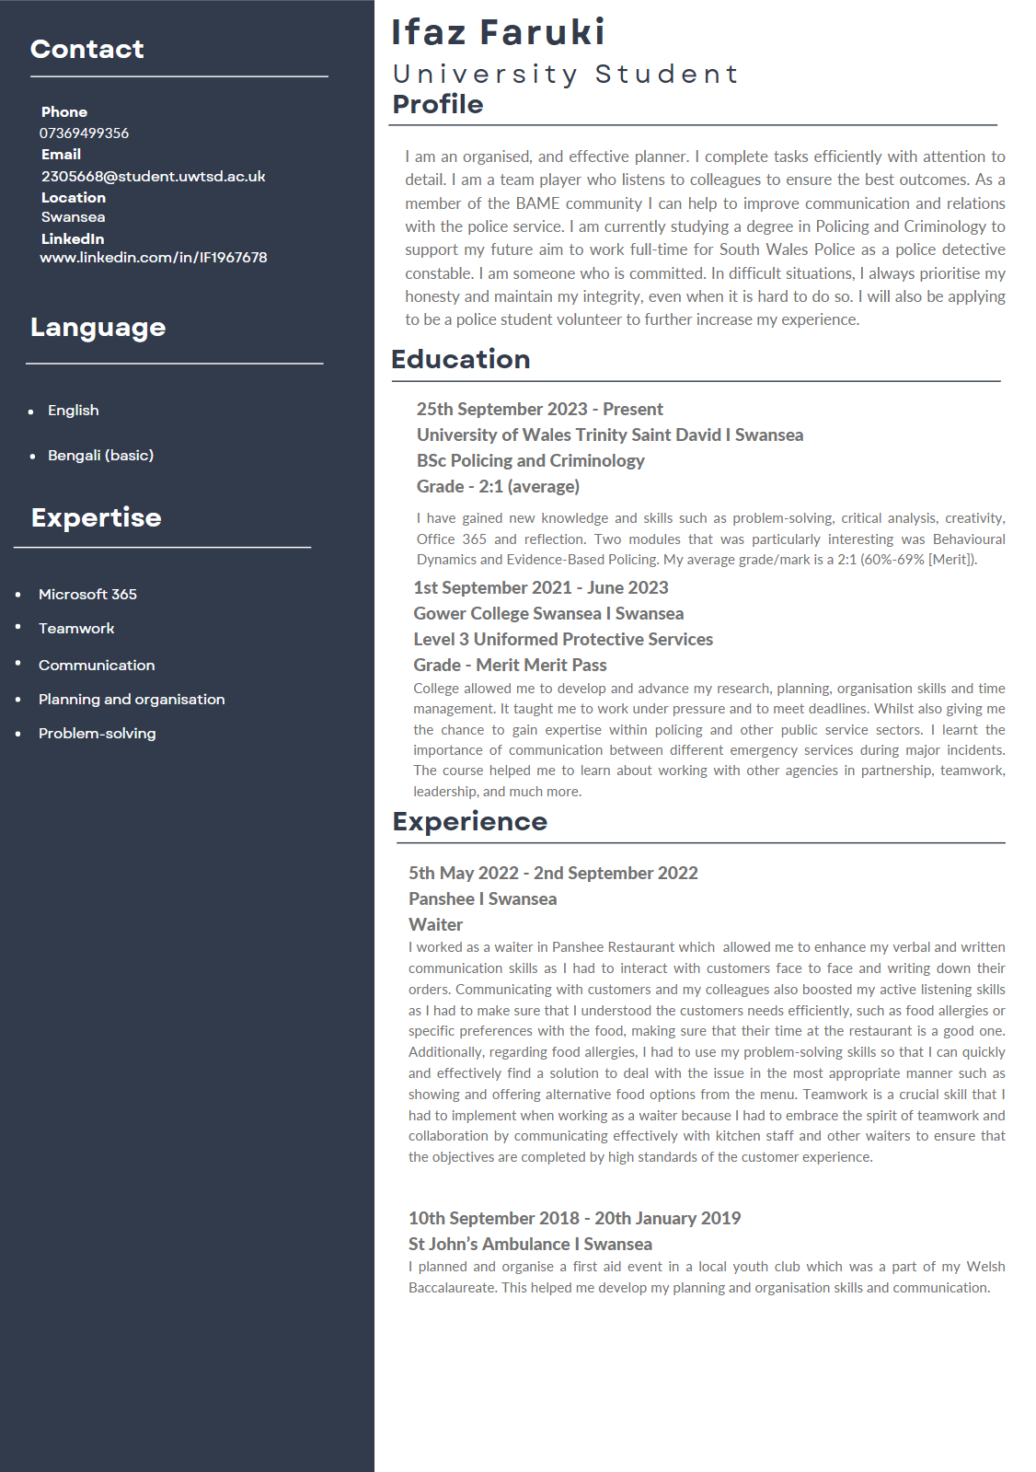

Cover Letter

16/03/2024
Hiring Manager
Seargent
South Wales Police
Cowbridge Road
Bridgend, CF31 3SU

Dear Hiring Manager,

Dear Sir or Madam,

I am currently studying for a degree in Criminology and Policing from the University of Wales Trinity Saint David. This degree course allows me to learn and become accomplished in the relevant skills and knowledge required to be able to achieve success in the workplace as a Police Detective.
I am excited to apply for the position through the fast-track detective program with South Wales Police as I am passionate about helping people from all walks of life and want to ensure that they are safe and protected. I believe that I have the attributes to perform to the highest of standards that are essential for the role.

I am proficient with academic writing, essays and reports, this can be evidenced by the requirements from both college and university assignments criteria, these are skills I have developed which can be applied directly to police procedures such as incident reporting.

I have developed strong communication, time management, planning, and organisation skills, these have been essential to build upon to successfully complete my college and university work to high standards. I continue to develop and improve upon existing skills and endeavour gaining and learning new skills which will enable me to become the most effective Police Detective that I can. I am good at working both independently and as team member, which is essential when working with my colleagues or the members of the public.

Health and fitness are important in my everyday life, I exercise by jogging and running so that I can stay physically fit and healthy. Fitness is a crucial part of policing, and I believe I can achieve the fitness standards and requirements to become a Police Detective.

Thank you very much for your time and consideration to read my application, I have attached my Curriculum Vitae for your attention.
I look forward to hearing from you soon.

Yours faithfully,
Ifaz

LinkedIn
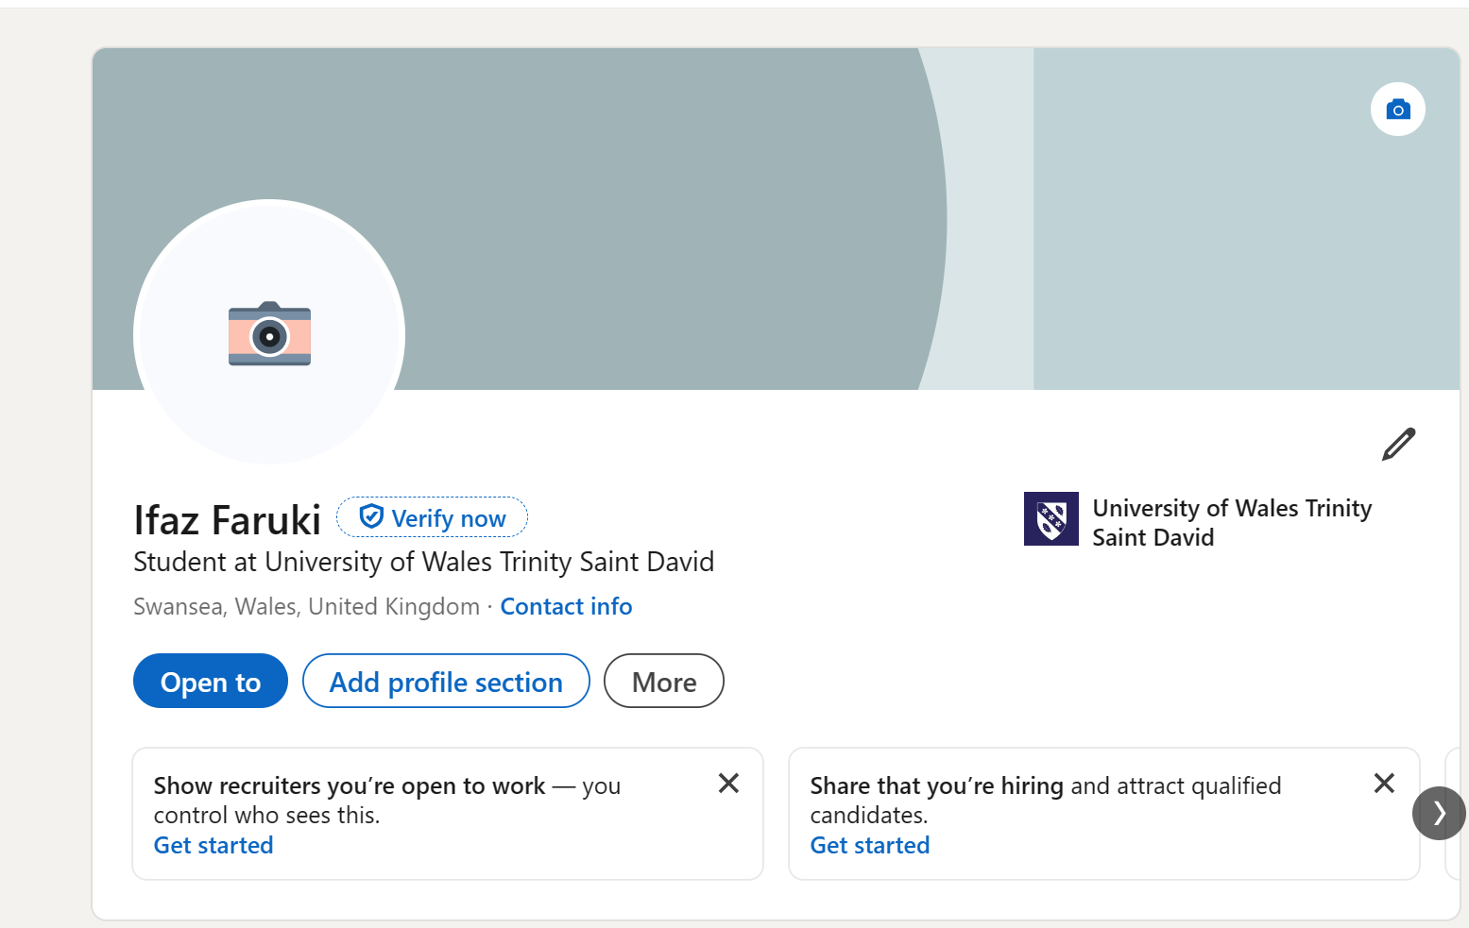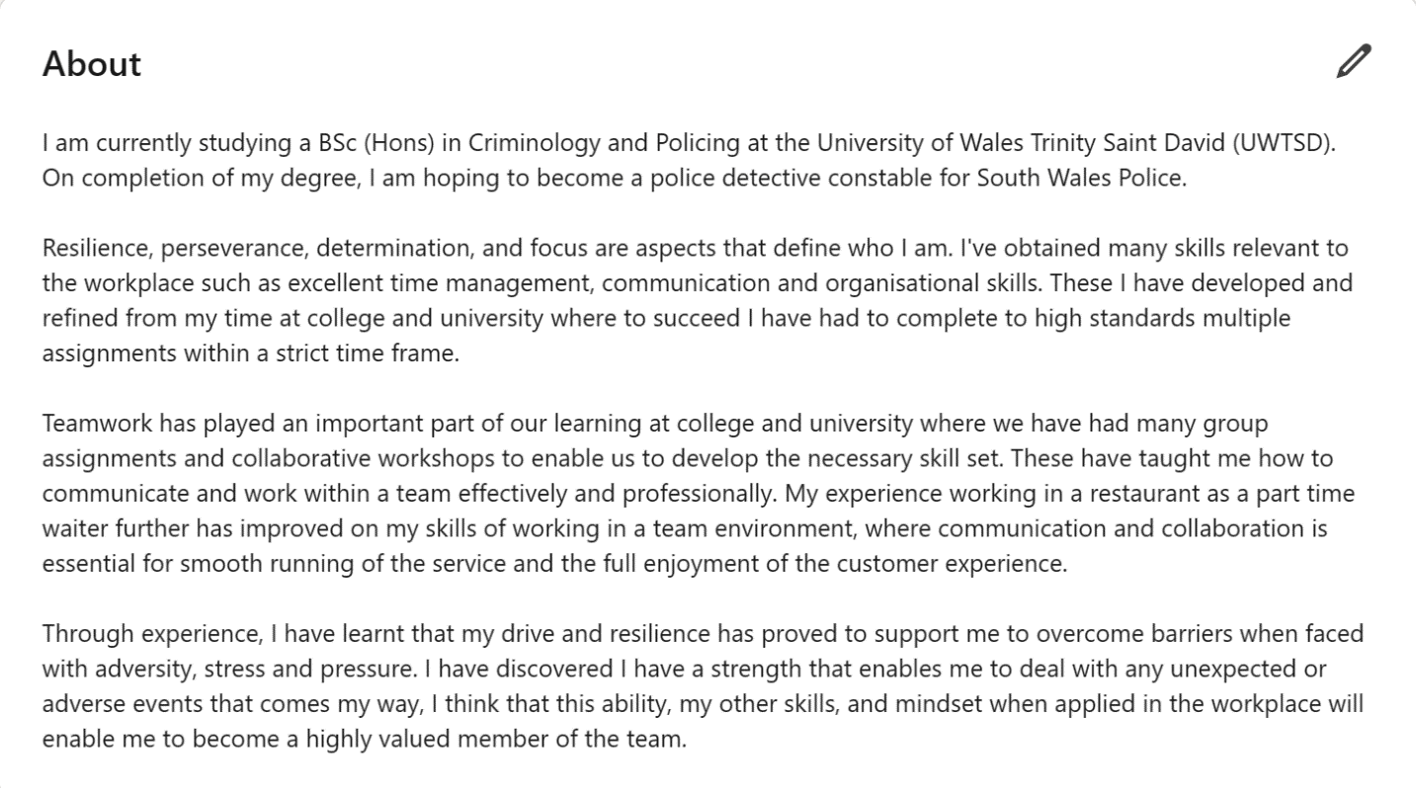

References

- Bailey, W.K. (1953) ‘The Importance of Communication for Advancement in Industry’, College Composition and Communication, 4(1), pp. 11-13. Available at: https://doi.org/10.2307/355546
- Coun, M., Peters, Pascale., Blomme, R., and Schaveling, J. (2021) ‘To empower or not empower, that’s the question. Using an empowerment process approach to explain employees’ workplace proactivity’, The International Journal of Human Resource Management, 33(14), pp. 2829-2855. Available at: https://doi.org/10.1080/09585192.2021.1879204
- College of Policing (2024) Problem-solving policing. Available at: Problem-solving policing | College of Policing (Accessed at: 17 March 2024)
- Dierdorff, E.C., Fisher, D.M., and Rubin, R.S. (2019) ‘The Power of Percipience: Consequences of Self-Awareness in Teams on Team-Level Functioning and performance’, Journal of Management, 45(7), pp. 2891-2919. Available at: https://doi.org/10.1177/0149206318774622
- Gander, M (2019) ‘Improving employee satisfaction through human resource management’, Perspectives: Policy and Practice in Higher Education, 23(2), pp. 37-38. Available at: https://doi.org/10.1080/13603108.2019.1579507
- Harris, R. and Clayton, B. (2018) ‘Editorial: the importance of skills – but which skills?’, International Journal of Training Research, 16(3), pp. 195-199. Available at: https://doi.org/10.1080/14480220.2018.1576330
- Johnson, S.S. (2021) ‘The Science of Teamwork’, American Journal of Health, 35(5), pp. 730-732. Available at: https://doi.org/10.1177/08901171211007955a Available at: https://doi.org/10.1177/1745691617697078
- Katzenbach, J., and Smith, D. (1993) The wisdom of teams: Creating the high performance organization. Boston, Massachusetts: Harvard Business School Press.
- Kozlowski, S.W.J. (2018) ‘Enhancing the Effectiveness of Work Groups and Teams: A Reflection. Perspective on Psychological Science, 13(2), pp. 205-212.
- LaGree, D., Houston, B., Duffy, M., and Shin, H. (2023) ‘The Effect of Respect: Respectful Communication at Work Drives Resiliency, Engagement, and Job Satisfaction among Early Career Employees, International Journal of Business Communication, 60(30), pp. 844-864. Available at: https://doi.org/10.1177/23294884211016529
- McKeown, T., and Ayoko, O.B. (2020) ‘Relationship at work – why do they matter so much?’, Journal of Management and Organization, 26(2), pp. 133-134. Available at: https://doi:10.1017/jmo.2020.3
- Rausch, A., Schley, T., and Warwas, J. (2015) ‘Problem solving in everyday office work- a diary study on differences between expert and novices’, International Journal of Lifelong Education, 34(4), pp. 448-467. Available at: https://doi.org/10.1080/02601370.2015.1060023
- Rios, J.A., Ling, G., Pugh, R., Becker, D., and Bacall, A. (2020) ‘Identifying Critical 21st-Century Skills for Workplace Success: A Content Analysis of Job Advertisements’, Educational Researcher, 49(2), pp. 80-89. Available at: https://doi.org/10.3102/0013189X19890600
- Sundstrom, E., Demuse, K., and Futrell, D. (1990) ‘Work Teams – Applications and Effectiveness, American Psychologist, 45(2), pp. 120-133. Avaiabale at: https://doi.org/10.1037/0003-066X.45.2.120
- Saari, L.M., and Judge, T.A. (2004) ‘Employee attitudes and job satisfaction’, Human Resource Management, 43(4), pp. 395-407. Available at: https://doi.org/10.1002/hrm.20032
- Urhahne, D. (2021) ‘Motivation to learn and problem solving’, Educational Psychology, 41(9), pp. 1079-1081. pp. 1079-1081. Available at: https://doi.org/10.1080/01443410.2021.1998304
- Verhoeven, J., and Madsen, V.T. (2022) ‘Active Employee Communication Roles in Organizations: A Framework for Understanding and Discussing Communication Role Expectations’, International Journal of Strategic Communication, 16(1), pp. 91-110. Available at: https://doi.org/10.1080/1553118X.2021.2014503

