
A comparation of two Buildings In European Modernism
History & Theory Module
Module Code: M4X01975
Coursework Assessment 2
(April 2019)


Saihaan R iSLAM-aHMED
UWTSD Student (No. 1707809)
For BSc Architecture (RIBA Part 1)

Introduction
This essay aims to outline and comprehend, certain features, commonly assumed and assessed in reference to the architectural styles of European modernism, in this case, with specific regards to Gerrit Rietveld’s ‘Schroder House commissioned by Truus Schroder-Schrader and Ludwig Mies Van der Rohe’s Barcelona Pavilion for the 1929 German Exhibition International Exposition. The design’s Historical context, Technical and material aspects, presented and employed, will also be established, further exploring the philosophies applied. In essence, I intend to present and compare how both structures display exemplary ideals in the theologies of European modernism.
Historical Context
Barcelona Pavilion
In 1929 for the Exhibition pre-mentioned, Mies Van der Rohe had designed & constructed the Barcelona Pavilion expressing commonalities with the Dutch originated De Stijl movement. He’d aimed to introduce this to a struggling, almost third-world Germany suffering at the hands of the American ‘Great depression’, as a way of promoting a more liberal & free-thinking Germany. Mies Van der Rohe attempted this often in Berlin, becoming a prominent figure in the ‘Werkbund’ also leading ‘Bauhaus’. “Less is more” a saying gaining momentum, highlights minimalistic principles for the Architectural world, fundamentally designs need non-embellishment redefining structures to the barest elements. It doesn’t need condensing, on the contrary, such builds could implement grander or expensive resources. Intending to display extensive minimalism, all aesthetically pleasing characteristics synonymously fulfilled practical necessities. Monetary adversities during this era would arise, questioning construction finalisation, in time for the Exposition. Opportunely, with later, improving, economic times, optimisms would shortly follow. This construct would personify Germany’s progression to socialism, left-wing thoughts in a creatively physical solution.
A free plan structure, with an open plan interior was enabled using non-load-bearing walls, functionally dividing the internal space, consequently imparting the responsibilities of load bearing to independent pillars. Masses of exposure and glass divisions would further express free plan elements. Partitions not reaching the full height, promoted ideas of a floating roof obtaining much adulation from individual and presenting encouraging feelings of the enlightening Weimar Germany.
Schroder House
Similarly, in Utrecht, Netherlands, 1924, some years previous to the pavilion Gerrit Rietveld designed Schroder House in a De Stijl style, like the pavilion, yet, where one construct represented more modern philosophies and politics, the other ensured the personification of an individuals desire for exposure and freedom. A method of rebelling against common concepts inviting repression and strictness into people’s lives. Mrs Schroder had somewhat opposed the traditional senses bought into her previous life whilst residing with her late husband, present with the expanse of wood carved furniture and classical nature of architecture, finding it to be all the restrictive nuances I’d detailed before, so a forward-thinking, progressive way of life was adopted.. This was the purpose of the house, however in the initial stages of design the client stated displeasure with the absence of external linking’s to the internal atmosphere without direct correlation to any other surrounding structures but it was quickly rectified to solve this by having certain planes and colours flowing through the house to the outside.
Plan and Section
Barcelona Pavilion
The Pavilion’s plan shows almost randomly placed walls with non-sensical logic as to the structural requirements needed, however, this portrays in full essence a free plan. The plan drawing image of the building defines free plan with eight columns appropriately placed into the design to sustain a roof permitting open planning, non-inhibiting an individual’s freedom of circulation opposed by conventionally designed builds. Walls are present, with only the directives to subtly encourage exploration of floorspace, whilst articulating a contrast to the horizontal planes with some verticality but the prime intention of organic direction for visitors, is to signal the path taken is still a naturalistic one. Illustrated by the secondary drawing. This had proven the De Stijl features that Mies Van der Rohe often designed in.
There remains no reservation that it’s not meant as accommodating but more a progressive journey to the succeeding village. The expansive openness demonstrates no insulating materials or weathering protection therefore the structure must be explorative stop on this journey, focusing a visitor’s routes through the pavilion. Through the use of these sliding planes facade an individual’s common desire for a direct straight-line journey is challenged, the circulation shown in the images below address that any route taken offers the chance to observe much more than the direct path.
De Stijl portrays ideas extending planes beyond other generally restrictive ones or uniformity with geometric forms, which the pavilion embodies, verified by the Axis, Geometry and Additive drawings below, as squares and rectangles seem centralized towards the heart of the form, some contracting in whilst others push beyond with a few overlapping features, confirming the De Stijl emobodiment with the pavilion.
Schroder House
Paralleling Barcelona pavilion, the Schroder house also displayed notes of a De Stijl-like Mondrian painting with planes, extending inside to outside, overlapping, flowing through and beyond others. Essentially the line between the macro and micro climates becomes much thinner. It was the openness the Mrs Schroder had always favoured.
Usual placements of rooms and conventionally thought plans were combatted with the dynamic wall systems allowing connections of spaces within the house, which, most of the time, were left in an open plan situation to allow for a large youthful recreation area and partitioning available for the secluded needs of a family.
One specific attribute attended to, was the untarnished vertical and horizontal linings with block primary colours throughout the house further representing the synonymities with Piet Mondrian’s paintings.
The upper floor windows needs consideration, observe and understand how throughout the entire design process of the house the predominant theme was sheer continuity and flow of spaces, which rendered the windows no stranger to these ideals where the large and small window open to 90 degrees outwards achieving an somewhat collapsed corner allowing one to experience presence with the external and natural environment.
Materials
Barcelona Pavilion
The resource variations that the individual perceives, further renders them querying this built existence by Mies van der Rohe. Onyx, Marble, Travertine, Glass, Steel, the core elements utilised, assuming these are the only physical feature present, contrarily, the water pool as further resource as it furthers the accentuations and sensory experience of the design. The Onyx, a golden hue and one of the vertical plane, Mies van der Rohe had sketched these planes to have the Onyx revered as a feature piece for the rest of the structure to focus around. The large block, measured over three metres, setting the ideal height for the design. Integrations of Intensely coloured marble enhanced with fractal veins contrasted through transparent glass and reflective material, would limit and emphasise natural lighting through the vertical partitions within the pavilion, a promotion of this inside/outside dynamic exposure intended, progressing a pleasing spatial experience for the visitor. The largest slabs and blocks of material are centred around the roof and floor an expensive marble known as Italian travertine. A highly reflective, bright material starts introducing luminance almost independently, and outshining the aesthetics of the other materials. As the two vertical travertine planes connected the horizontal ones, suddenly a series of independent planes merge to form a unified, harmonious design. The dark materialled basin of the pool, furthers enlightenment of oneself as a direct sight seems to illicit a reflecting image of the statue and an individual looking at it. The slab of green marble, portraying organic patterning becomes apparent in illustrating the natural surroundings and greenery quite heavily present.
Schroder House
With a desire for an entirely concrete house, defied by the financial limitations that it’s use would ensure, Rietveld was forced to only utilise this for the essential structural components i.e. the foundations and balconies, consequently leaving him with the plaster and brick walls, door, window framing and floors with wooden beams as the alternatives with structural components dictated by steel for meshes and girder, unusual, however, is the rubber flooring and the cork/beaver boarding for the dividers, but had a minimal to ineffective soundproofing attribute. Unlike the Barcelona pavilion, it is apparent that the Schroder House does not pay as much attention to the aesthetical truth of these materials but rather the function of their respective implemented components and the physical properties they need perform for the visitors, such as the compartmentalising features it achieves and the painted block coloured materials so it becomes the architectural embodiment of artworks by Theo Van Doesburg or Piet Mondrian
Ideas & Theories
The German government used the 1929 Exposition to market their progressive-thinking ‘Weimar’s Republic’, a representation of successive ideologies and liberalities through acceptance of worldwide culture, creativity and philosophy of a new-age, after the regressive outlook that Germany attained not long before. Germany’s assuming of modernist ideals, often coincided with aims of evolution in the Western-world with regards to these fields, which was seen as a solution to forging good and beneficial relations for all. With Germany undergoing a financial grace period, a sigh of breath presenting freedom was acknowledged and quickly acted on where reinvestments were made in small businesses, the education sector, general quality of life improved shortly followed by major leaps in mechanical with technological advancements and explorations of experimental creativity. Whilst both structures tried to embody the principles of the De Stijl movement, the Schroder House was considered during this era to be the most exemplar of the style, not plainly down the form but also what the form had come to symbolise. Mrs Schroder, had wanted to target and destroy the classical thinking of; set rooms being in allocated spaces, instituting uniformity, and regular division as she believed it idealised constriction, restriction, repression, regression, etc. Features not just displayed through conventional buildings but also in life, so the resolution became the open plan design. An ability for individuals to truly respire and relax through uninhibition of flow, being out in the open anywhere within the house as one would desire.
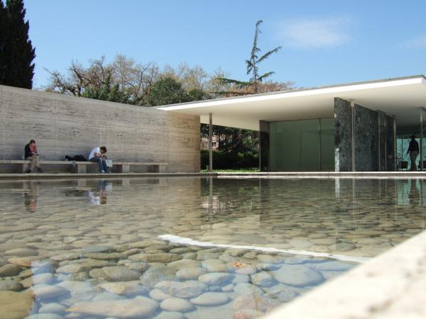
Barcelona Pavilion (Open University, 2001)
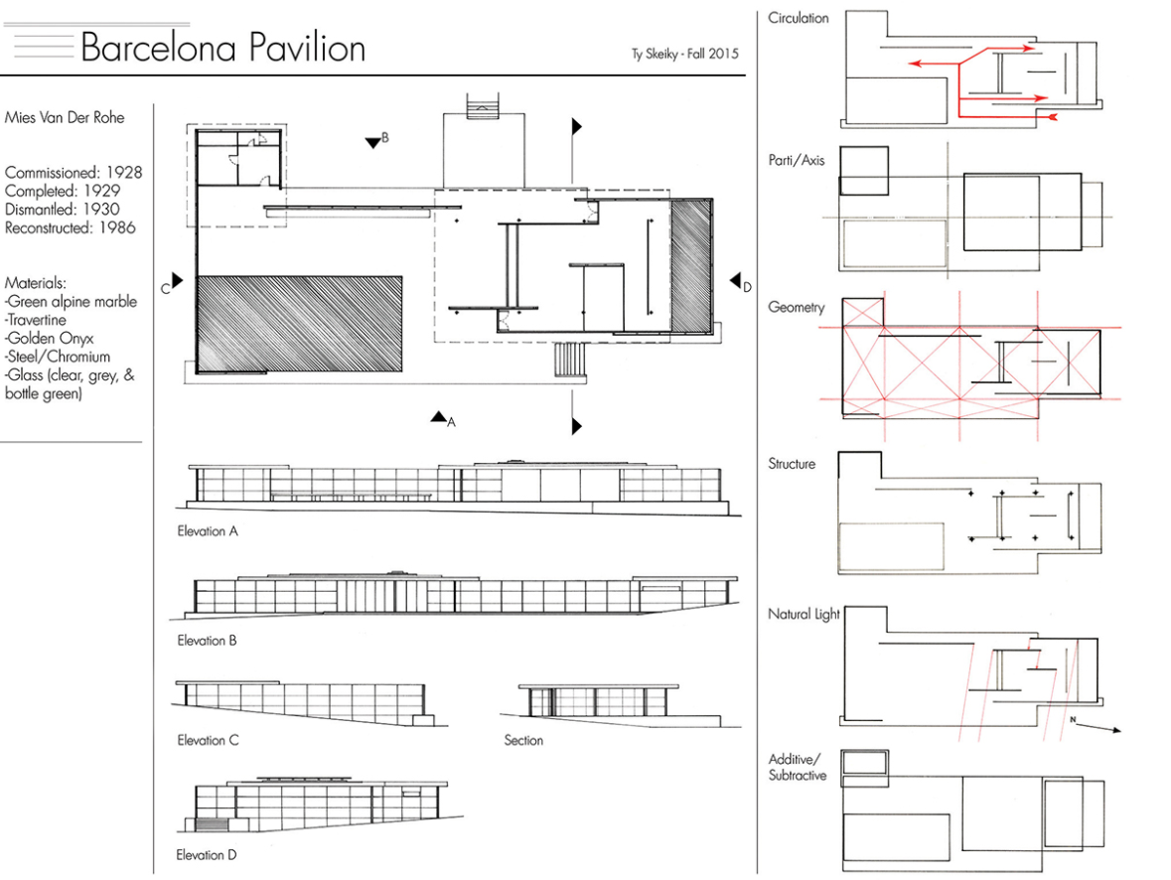
Plan and Section, Barcelona Pavilion
(Sheiky, 2016)
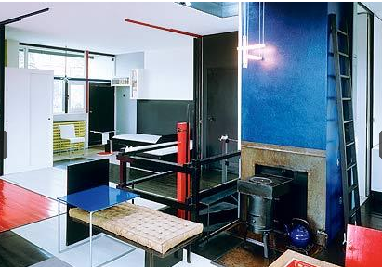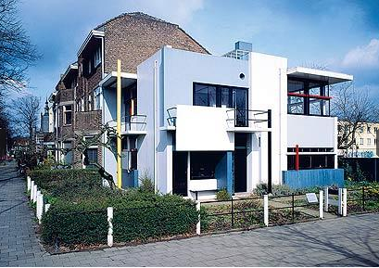
Schroder House (Moritz, 2010)
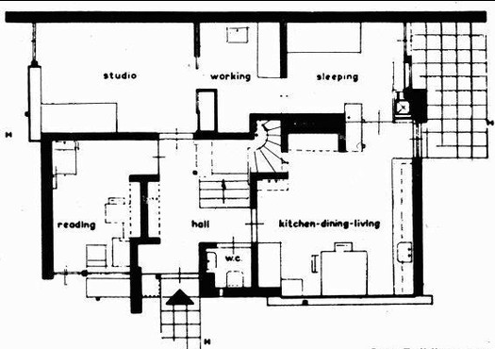
Schroder House, Plan (Rietveld, 1924)
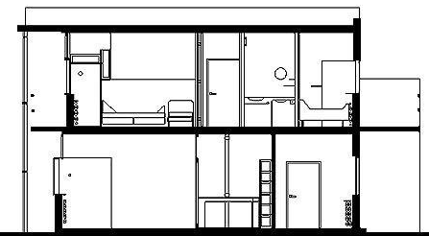
Schroder House, Section through Elevation (Great Buildings online, Date: N/A)
References

- Arch 120. (2014). Precedence Study, Barcelona Pavilion (Journal)

- Berger, Ursel (2007). Barcelona Pavilion. Berlin: Jovis

Church, B. (2016). Schroder House – Materiality. Schroderhouse. Available at: https://schroderhouse.wordpress.com/2016/10/15/schroder-house-materiality/ [Accessed 30 Apr. 2019]

- Campbell, Katie (2007). Icons of Twentieth-Century Landscape Design. London: Frances Lincoln. pp. 38–42

- Dodds, George (2005). Building Desire. New York: Routledge

Friedman, A.T. (2007). Women and the Making of the Modern House: A Social and Architectural History. New Haven. Yale University Press. p. 68-69

Hill, A. (2010). Interior design: The Schröder House in Utrecht. The Telegraph. [Online]. Available at: https://www.telegraph.co.uk/lifestyle/interiors/7036984/Interior-design-The-Schroder-House-in-Utrecht.html [Accessed 30 Apr. 2019]

Lisa, A. (2012). Supermodern 1920’s Rietveld Schröder House in Utrecht is a Simple, Elegant and Completely Transformable Home. Inhabitat. Available at: https://inhabitat.com/1920s-rietveld-schroder-house-in-utrecht-is-a-simple-elegant-and-completely-transformable-home/ [Accessed 30 Apr. 2019]

Moritz, E. (2010). Schroder House [image] Available at: https://www.telegraph.co.uk/lifestyle/interiors/7036984/Interior-design-The-Schroder-House-in-Utrecht.html [Accessed 30 Apr. 2019]

- Open University. (2001). Barcelona Pavilion. [image] Available at: https://www.open.edu/openlearn/history-the-arts/history/heritage/the-barcelona-german-pavilion [Accessed 29 Apr. 2019]

Overy, P. (1988). The Rietveld Schröder House. Netherlands. De Haan

Rietveld, G. (1992). The Schroder House, Utrecht, The Netherlands. Volume 68 of GA. Utrecht .A.D.A. Edita

- Rubio, Ignasi (1993). Mies Van Der Rohe : Barcelona Pavilion. New York: Watson-Guptill Publications

www.rietveldschroderhuis.nl, (2010). Welcome to the Rietveld Schröder House. [online] Available at: https://www.rietveldschroderhuis.nl/en/rietveld-schroder-house [Accessed 28 Apr. 2019]

- Skeiky, Ty. (2016). Barcelona Pavilion. [image] Available at: http://portfolios.mica.edu/gallery/32450807/Precedent-Study-Barcelona-Pavilion [Accessed 30 Apr. 2019]

Sveien, M. (2010). AD Classics: Rietveld Schroder House / Gerrit Rietveld. [online]. ArchDaily. Available at: https://www.archdaily.com/99698/ad-classics-rietveld-schroder-house-gerrit-rietveld [Accessed 30 Apr. 2019]

- Weston, Richard (2004). Key Building of the Twentieth Century. W.W. Norton and Company

- Wikipedia, (2018). Barcelona Pavilion. [online] Available at: https://en.wikipedia.org/wiki/Barcelona_Pavilion [Accessed 30 Apr. 2019]

- Wikipedia, (2018). Modern Architecture. [online] Available at: https://en.wikipedia.org/wiki/Modern_architecture#Early_modernism_in_Europe_(1900%E2%80%931914) [Accessed 30 Apr. 2019]

- Zimmerman, Claire (2006). Mies van der Rohe. Hong Kong: Taschen

Word Count: 1599

