Slide 1

Slide 2

Slide 3

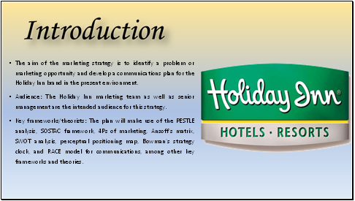

The marketing strategy for Holiday Inn is the subject of this presentation, which focuses on problem-solving and developing a communications plan for the current environment. In order to improve their marketing initiatives, Holiday Inn's top management and marketing staff will get feedback on this strategy. SOSTAC, the 4Ps of marketing, Ansoff's matrix, SWOT analysis, perceptual positioning map, Bowman's strategy clock, PESTLE analysis, and the RACE model for communications are just a few of the frameworks and ideas will be employing during this presentation. Examine the main factors that will influence company’s marketing approach as excavation into the contextual evaluation of Holiday Inn.

Slide 4

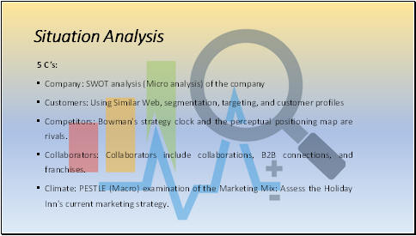

The 5 'C's'—Company, Customers, Competitors, Collaborators, as well as Climate—will be taken into account when we do a thorough scenario analysis for Holiday Inn in this section. In order to better understand company’s target audience, company will then excavation into the customer segmentations as well as targeting techniques (Que et al., 2019). Customer profiles will also be made utilising data from SimilarWeb. In order to determine our position in relation to rivals and assess strategic choices, we will now analyse the competitive environment using that perceptual positioning map along with Bowman's strategy clock. The company will also look at their B2B connections, alliances, and franchises as significant contributors to business ecosystem (Vallaster et al., 2023).

Slide 5

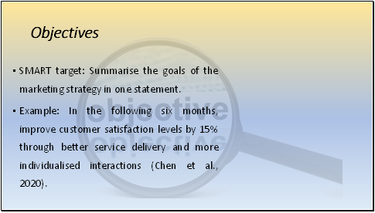

Any marketing plan must have certain goals in mind. In this part, we will create a SMART objective that succinctly expresses the main points of our marketing strategy (Marcucci et al., 2020). The objective will be clear, quantifiable, reachable, pertinent, and time-bound, giving our marketing activities a focus. For instance, companies could want to improve service delivery and personalise experiences in order to boost customer satisfaction levels by 15% over the course of the following six months (Luque et al., 2022). This goal is in line with the company's larger marketing objectives and enables us to concentrate on enhancing the entire client experience.

Slide 6

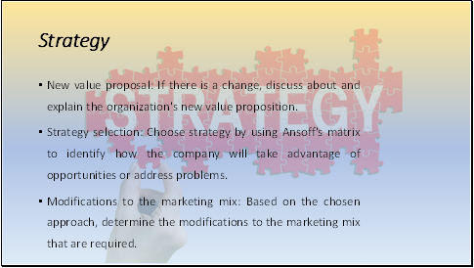

To properly direct the marketing activities, must have a well defined plan (Foris et al., 2020). If any adjustments are necessary, the company will talk about the revised value proposition for Holiday Inn in this area. Additionally, the company will make use of Ansoff's matrix to choose the best method for achieving our goals (Fedushko et al., 2021). The company may assess market penetration, product development, market development, and diversification initiatives with the use of this matrix.

Slide 7

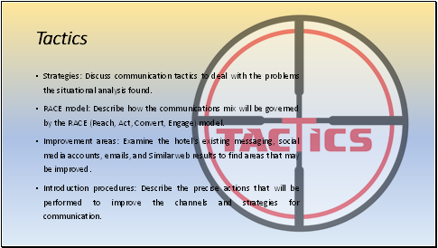

In order to solve the challenges indicated in the situational analysis including accomplishing the company’s goals, the company will investigate the particular tactics and communication techniques in this section (Madhavan et al., 2023). The RACE methodology (Reach, Act, Convert, Engage) will be used to direct our communications mix and guarantee a thorough strategy.

Slide 8

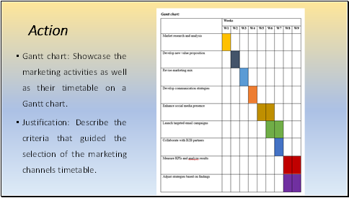

A Gantt chart outlining the marketing activities and their scheduling is presented in this section. We can better comprehend each task's requirements and timetable according to this visual depiction. The target audience's tastes, market trends, and available resources are only a few of the things that influence the marketing channel’s timetable. On the basis of data analysis as well as market research, the company will give priority to channels that have a track record of success (Krizanova et al., 2019). The company can properly manage resources, monitor development, and guarantee the prompt implementation of our marketing campaigns according to the Gantt chart. It acts as a road map for employees to follow while the developers carry out the process of the execution phase.

Slide 9

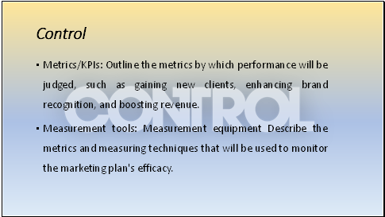

It is critical to evaluate the efficacy and success of Holiday Inn’s marketing strategy (Calisto et al., 2021). It's up to discuss the metrics including key performance indicators (KPIs) company will to gauge its success in this section. The measurement techniques may involve monitoring social media interaction, keeping tabs on customer satisfaction ratings, analysing website data, and tracking new client acquisition (Susanto et al., 2021). The company can evaluate the results of our marketing efforts, pinpoint areas for development, as well as make decisions based on data to enhance our tactics by keeping a focus on these KPIs. In the end, the control phase enables us to evaluate the ROI of our marketing initiatives and make any modifications to guarantee company is meeting those objectives (Bubenik et al., 2022).

Slide 10

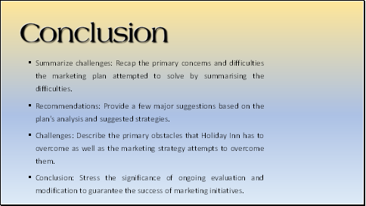

Finally, this Holiday Inn marketing strategy takes into account the main possibilities and problems presented by the current environment. The company wants to improve the brand's reputation, raise customer happiness, and spur revenue development through thorough scenario analysis, clear targets, defined plans, and focused approaches. The company is aware that there may be difficulties, and that ongoing evaluation and modification will be essential to the plan's success. They advise maintaining agility, embracing new technology, encouraging strategic alliances, and emphasising the customer experience.

Slide 11

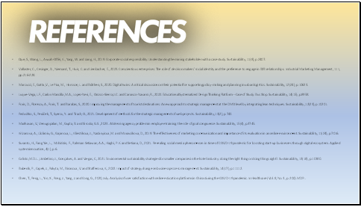

Slide 12



