Assignment 1
Essential skills for study and Employment
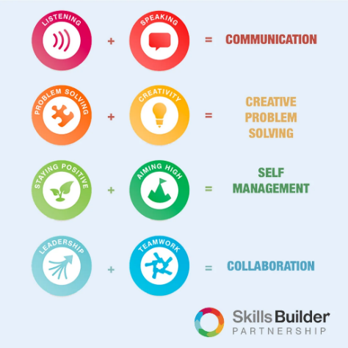
Essential skills are skills that are beneficial in both my studies and as I progress onto my career. It is “highly transferrable skills” that is the foundation enabling personal and professional development for these technical and job-specific skills required [Ferguson, 2020].

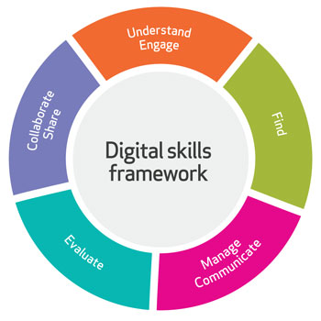
My first essential skill that I will be discussing is digital skills. Digital literacy is highlighted as the “ability to use information effectively, in all formats, in a largely digital information environment” in which certain competencies such as knowledge, skills and attitudes is required to be able to do so [Bawden and Robinson, 2012]. I develop myself professionally on this skill through using digital applications in my studies to enable me to understand the importance of this in this digital economy as well as my career once I graduate as this is highlighted as being needed in future work environments due to it being a “major driver of changing skill” [Cedefop, 2018].
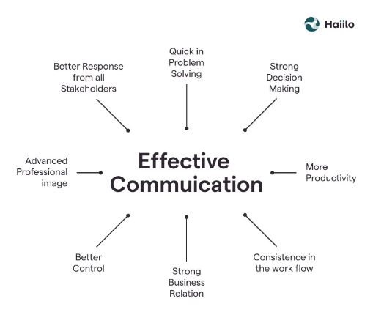
Alongside this, effective communication is indicated as an important skill due to its many benefits in developing individual and team success and reducing conflict in the workplace [Indeed, 2021]. I utilize this skill in my studies through conducting presentations using multiple skills and developing my skill and also in the workplace in which I would be using this skill in my day to day life and in my career with my team members in board meetings, group projects etc. achieving productivity and success as an effective skills can result in impactful results which employers would be keen to see in this skill with clients negotiation and persuasion [Page, 2023).

1b)

Reference list:
Bawden, D. and Robinson, L. (2012). Digital literacy. [online] Cambridge University Press. Available at: https://www.cambridge.org/core/books/abs/introduction-to-information-science/digital-literacy/0E7D24731A6D30ECF017F8D9B2621F1C [Accessed 27 Feb. 2023].
Blackburn, J. (2022). Learning Resources: Employability Skills: Persuading, Influencing & Negotiation. [online] libguides.wigan-leigh.ac.uk. Available at: https://libguides.wigan-leigh.ac.uk/c.php?g=667800&p=4736456 [Accessed 27 Feb. 2023].
Carlisle, S., Ivanov, S. and Digkmans, C. (2021). The digital skills divide: evidence from the European tourism industry. [online] doi:https://doi.org/10.1108/JTF-07-2020-0114.
Cedefop (2018). Insights into skill shortages and skill mismatch: learning from Cedefop’s European skills and jobs survey. Publications Office of the European Union. [online] Available at: https://op.europa.eu/en/publication-detail/-/publication/8d1a7959-2284-11e8-ac73-01aa75ed71a1/language-en [Accessed 27 Feb. 2023].
Ferguson, H. (2020). Essential skills need to be recognised and developed by education providers and employers. [online] CIPD. Available at: https://www.cipd.co.uk/news-views/news-articles/essential-skills-framework#gref [Accessed 27 Feb. 2023].
Indeed Editorial Team (2021). Why Is Communication Important? (And How To Improve It). [online] Indeed Career Guide. Available at: https://uk.indeed.com/career-advice/career-development/why-is-communication-important [Accessed 27 Feb. 2023].
Page, M. (2023). The importance of good communication in the workplace | Michael Page UK. [online] Michael Page. Available at: https://www.michaelpage.co.uk/advice/management-advice/development-and-retention/importance-good-communication-workplace [Accessed 27 Feb. 2023].

Task 2: eportfolio
Link: https://sway.office.com/E4ApdfrGMEbsHWp0

Task 3: Referencing Guide
Step 1: 1. Google: The first step is to type “download Mendeley” on Google Search and click on download once on the Mendeley.com website.
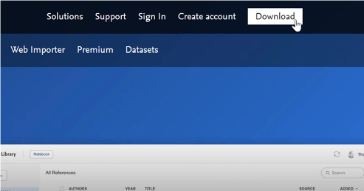
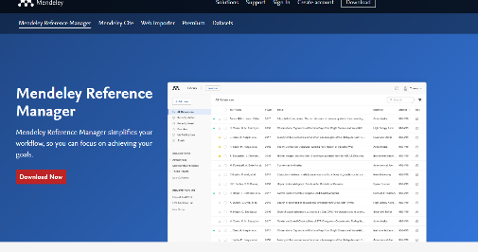
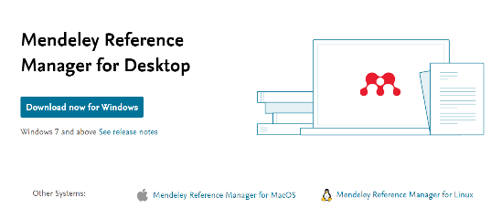



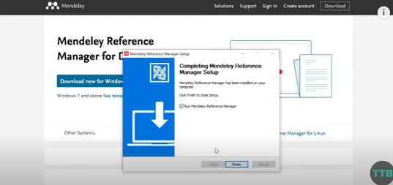
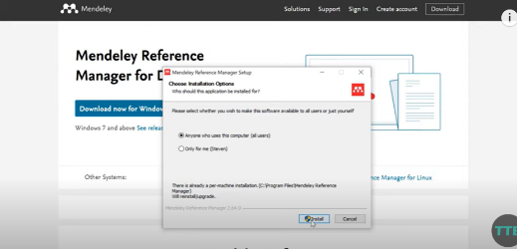
2. Install the application once download has finished

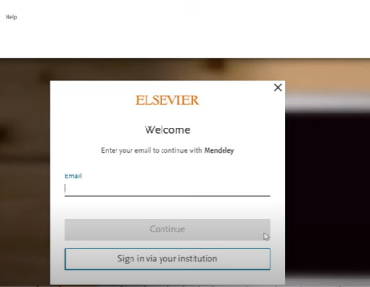
3.Create an account and then register an account
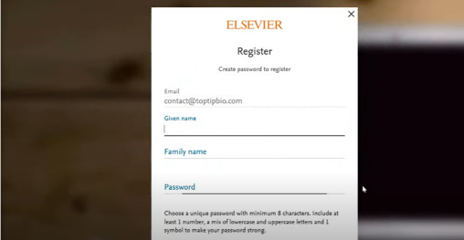
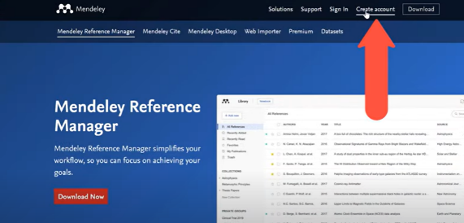

4.Then, on the top left icon- click on “Add new” and then “Add entry manually” which will enable you to provide the details for your individual references
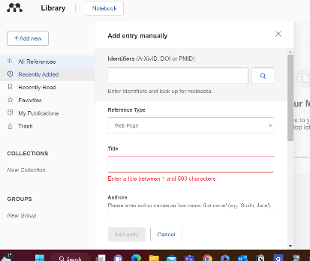
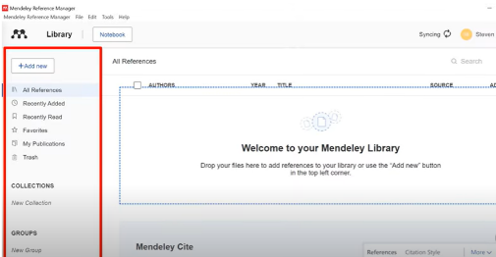
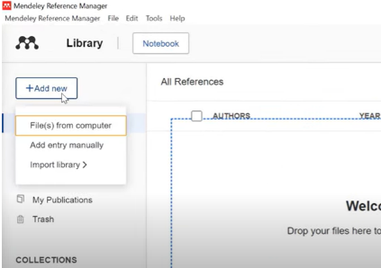

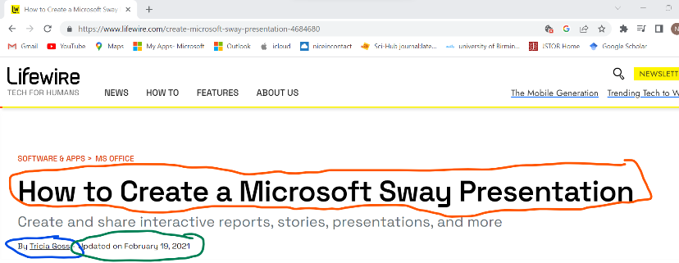
- Find website author, and date of publishing which is usually on the top of the website of on the bottom
Key:
Title
Author
Date it was published

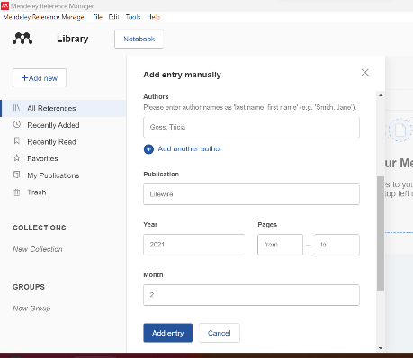
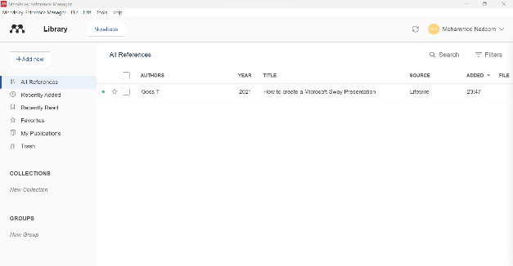
- Insert findings on Mendeley to create the reference and continue this process for further references.

