Report
Sustainable Hospitality & Tourism Management
Student Name: ZakiaShirinNishai
Student Number: 2208336
Module number: BMIH5006
Lecturer’s Name: Scott James

Table of Contents
1.0 Introduction 1
2.0 Requirements of hotels to execute and comply to be granted sustainable accreditation 1
2.1 Waste reduction 1
2.2 Provide rooms endurable 1
2.3 Ensure an eco-friendly guest service 2
2.4 Green Key Theory 3
3.0 Challenges and benefits linked with integrating sustainability into their regular operations 4
3.1 Challenges in integrating sustainability into daily operations 5
3.2 Benefits of integrating sustainability into regular operations 5
4.0 Future of the hospitality and hotel industry 6
5.0 Conclusion 7
6.0 References 9

1.0 Introduction
The main motive of this assignment is to elevate the different strategies in which the hospital and tourism industry can integrate sustainability towards the global market. The study will emphasise the requirements of hotels that help to execute a sustainable duration towards the existing market. Different strategies will be described in the following part of this report. Essentially it will analyse the challenges along with the advantages of integrating sustainability towards regular operations in the hospitality industry. In the father section of the study, a future recommendation will be provided for providing a better performance in the global market.

2.0 Requirements of hotels to execute and comply to be granted sustainable accreditation
Several strategies are supposed to increase sustainability towards the hospitality industry. The factors are discussed briefly in the following section of this assignment.

2.1 Waste reduction

The hospitality industry needs to cut down the wastage during events. Waste reduction is one of the crucial for achieving sustainability towards the hospitality industry and based on research it can be comprehended that the hospitality industry has needed to implement different types of recycling programs for plastic paper glass as well as needs to compose organic waste from kitchens (Lima Santos et al., 2020). The Greenhouse Hotel in Bournemouth, UK has followed the waste reduction policy for eliminating the disposable kits and it helps to achieve better sustainability towards the hospitality industry.

2.2 Provide rooms endurable
The hospital industry has adopted smart technology to enhance the guest experience by providing an endurable room with sustainable materials. The hotel can equip reusable coffee mugs and other utensils rather than use plasticware or paper (Sigala et al., 2021). In this way, the customer has enhanced their experience by adopting an innovative service. Apart from this, the industry has provided organic soap and shampoo from the Green Manufactures in biodegradable packaging. The renowned Marriott Hotel has provided this type of unique experience towards its customers and this feature helps to integrate the customer number (Marriott, 2024).

2.3 Ensure an eco-friendly guest service
This healthcare industry values customer service, thus it must improve transportation sustainability. Hospitality can support sustainable transportation by renting e-bikes or scooters (Ntouniset al., 2022). Many modern technology methods allow hotels to automate room service. The hotel can use room sensors to assess light levels, bulb brightness, and other things, as well as an AC thermostat to regulate room temperature and provide excellent service.
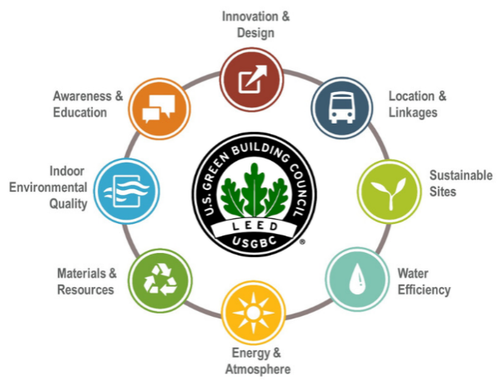
Figure 1: Sustainable practices in the hospitality industry
(Source: Modica et al., 2020)
The hospitality industry needs to create a green team that helps to enhance sustainability by providing eco-friendly practices towards customers. One of the most advantages of this strategy is that it helps to provide more commitment and it is a long-lasting strategy (Modica et al., 2020). Apart from that several hotels can uplift their eco-friendly programs to gain a comparative advantage along with sustainability towards the global market. The program must contain the awareness of reducing of uses plastic bottle containers and despite these plastic containers they can use biodegradable containers. To provide a better performance the hotels can hire a team for training sessions and it helps to provide several sustainable strategies towards employees. Apart from this, the hotel can hire employees through Skype or direct interview procedures. In that case, it also helps to cut down the fuel cost (Su and Chen, 2020). Reducing the carbon footprint is one of the core factors in achieving sustainability in the hospitality industry. Based on the research it can be comprehended that Marriott is one of the renowned hotels in the hospitality industry and its carbon footprint per room is 17.64 kg which helps to provide sustainable strategies towards this industry (Marriott, 2024). It has had a positive impact on the production of the company in the global market. All of these features helps to drive an enhanced sustainability towards the hospitality industry.

2.4 Green Key Theory
The Green key theory helps to assure the guest for providing a comfortable visit with a green key establishment. Essentially, the hospital industry has used this green key theory for sustainability as well as it helps to provide a better accommodation restaurant and a lot of attractions that help to grab the customers (Eid et al., 2021). The main motive of this green key theory is to curtail the environmental impact by increasing and efficient uses of the resources in the project. The key component of these sustainable projects is to enhance the different types of guest amenities that help to increase guest experience. For example, Marriott Hotel has achieved the Green Key award for providing a premium service with the help of the Green Keys sustainable practice (Kuo et al., 2022). Based on some research it can be exemplified that various hotels in the UN have joined more than 3200 green key awarded associations to provide a premium service towards its delicate guest.
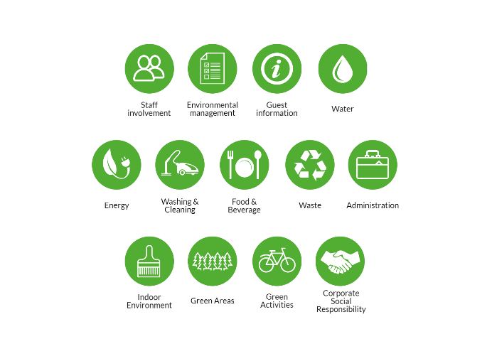
Figure 2: Green Key in the hospitality industry
(Source: Kuo et al., 2022)
Corporate social responsibility is one of the other sustainable management concepts that helps to provide different strategies for sustainable practice towards the hospitality and tourism industry. The hospitality industry has faced several challenges and with the help of a proper CSR theory implementation, it can attain a significant profit from the global market. A triple bottom line is one of the popular CSR theories that helps to provide a better understanding in economic terms as well as social and environmental terms (Alsawafiet al., 2021). According to this theory the hospitality industry as well as it helps to strain then the supply chain and financial performance of the organisation.
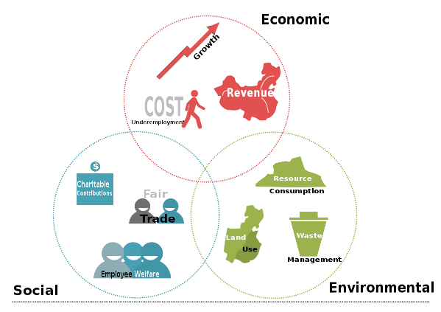
Figure 3: The triple bottom line
(Source: Alsawafiet al., 2021)
The hospitality industry has chosen these theories for providing a better sustainability in the global market and it helps to integrate the competitive advantages.

3.0 Challenges and benefits linked with integrating sustainability into their regular operations
It has been seen that in the current ever-developing business landscape, sustainability has appeared as a significant force pushing competitiveness, innovation and change. While bigger companies have usually carried the lead in embracing sustainability approaches, the limelight is increasingly moving towards a dynamic and powerful segment of the company world (Inkson and Minnaert, 2018). There is a need to explore the benefits and challenges to hotel and hospitality business operations when connected with sustainability.

3.1 Challenges in integrating sustainability into daily operations
One of the major challenges with integrating sustainability into regular operations is not understanding sustainability strategies. There is an interlude in comprehending what sustainability signifies for hotel and hospitality businesses. Hotels and businesses are required to understand how to facilitate reporting to decrease monotony, solve inconsistencies and create an optimistic influence by optimising their operation procedure and evolving their individual demanded sustainability-building aptitudes (Cooper, 2021). Failure to alter the business model can also be seen as a challenge in integrating sustainability. Hospitality businesses and hotels are required to comprehend how to classify major and market-supportable services and products in a manner that neglects to greenwash and favourably impact customer behaviour. Another major challenge can be seen as a shortage of pursuing new sustainability associates in an extensive ecosystem.
Some argue significant sustainability issues require systemic change and stakeholder cooperation. Sustainability and supply chain partner shortages endanger Premier Inn (Haski-Leventhal, 2018). Governance, law, technologies, organisations, and personal beliefs and actions might hinder sustainability. Lack of sustainability tracking tools is a major concern (Sloan et al., 2017). Knowing if sustainable methods affect greenwashing is vital. These tactics may make hotel and hospitality organisations appear concerned in the concerns, but they may be a short-term profit strategy or a result of misinterpretation and a lack of holistic operating participation.

3.2 Benefits of integrating sustainability into regular operations
Hospitality businesses and hotels that embraced sustainability approaches have experienced multiple advantages from decreased threats to possibilities for creation and greater functional efficiency (Gursoy et al., 2022). One of the major advantages of integrating sustainability is attracting and retaining talents as engaging workers in sustainability can even advance productivity and motivation.
Another major advantage that can be seen is decreased costs, innovation and creating value. It can entice investors and customers leading to prolonged term profitability and growth. Innovation has assisted Marriott International in giving inventive manner to serve its consumers and deliver possibilities for its partners. Another major benefit of integrating sustainability in regular operations is the enhancement of brand reputation and customer demand as multiple businesses such as Premier Inn, Whitbread, Marriott International, IHG and others have enhanced their brand reputation and image and it has also influenced their consumers' purchasing decisions (Page and Connel, 2020). All the hospitality businesses and hotels have significantly dedicated themselves to sustainability. It has been seen that the International Hotel Group have embraced sustainability approaches to advance their possibilities of winning repeat or new commerce, as they illustrate a dedication to decreasing their environmental influence and enhancing their social activities (Tandon et al., 2023). One of the major advantages of integrating sustainability is the competitive edge as sustainable activities have even confirmed that hotels and other hospital businesses such as Marriott International integrated sustainability across their value chain and reduced weather-related threats helping them gain a competitive edge. others follow rules and regulations and concede with appropriate legislation. It has also assisted them in enhancing business resilience and service/product availability. This advantage does not just contribute to the hotel and hospitality business’s bottom line but even plays a significant role in determining global issues such as resource depletion, climate change and social inequality.

4.0 Future of the hospitality and hotel industry
It can be seen that the future of the hotels and hospitality businesses is something that all individuals regard after an international pandemic that changed the manner they travel and live (Ahirwaret al., 2020). However, there are topmost trends that can shape the future of hotels and hospitality businesses.
The rise of eco-friendly and sustainable practices
Many consistent tourists will choose hotels that prioritise eco-friendly and sustainability practices as climate change is speeding up. It will be done through supportable amenities, conveying more regarding what the hotel is doing to be eco-friendlier (Abdou et al., 2022). It will be essential for hospitality industry businesses to partake in this movement.
Advanced highlight on health and safety
It is essential to know that safety and health have become a more conscious topic for individuals and travellers in the hospitality industry. Travellers in the future will look for hotels that provide complete health and safety such as antibacterial gel, complementary masks and others. However, executing hygiene approaches will be an essential component of taking the hotel business into the future such as Marriott International. The business will highlight safety and health for its associates and guests by personally inspecting guest space for cleanliness.
Increased usage of technology
Technology will be helpful for hotels and hospitality businesses in a significant manner. It will also assist in reducing the workload of employees and also decrease the time for doing any work. Companies such as Marriott International, and Whitbread are currently using cloud-based PMS systems for using the reception space for more welcoming and homely than a reserved desk. Technology can also be advantageous for guests by providing more personalised facilities and better supervision, conveying key details so that consumers always exit happily.
Augmented Reality (AR) and Virtual Reality (VR)
Augmented reality and virtual reality add one of the premium technologies which are needed in the hospitality industry for providing a better service. This method generates a virtual tour with site navigation and attractions (Sobaihet al., 2021). AR and VR can promote locations, engage tourists, and integrate hospitality booking. Additionally, this technology streamlines business. Most importantly, this technology integrates the hospitality industry's growing pace and improves competitive advantage to sustain its global market position.
Implementation of IoT technology
Rising IoT technology makes hospitality smarter. This technology will automate room services including lighting, temperature, and fan speed. This smart sensor system enhances hotel services and visitor satisfaction (Ülker et al., 2023). Cost savings and a seamless, personalised customer experience are key. It's one way hospitals can apply sustainability ideas globally.

5.0 Conclusion
The report has discussed the challenges and benefits of respective hotels and hospitality businesses in integrating sustainability into their regular operations. Examples can be seen as Premier Inn, Marriot International, IHG and others. The report has also looked at the forthcoming hospitality businesses including the topmost trends such as the rise of eco-friendly and sustainable practices, usage of technology and others. It can be concluded that tourists can capitalise on these tendencies by embracing their facilities to fulfil these changing requirements.

6.0 References
Abdou, A.H., Shehata, H.S., Mahmoud, H.M.E., Albakhit, A.I. and Almakhayitah, M.Y., 2022. The effect of environmentally sustainable practices on customer citizenship behavior in eco-friendly hotels: does the green perceived value matter?.Sustainability, 14(12), p.7167.
Ahirwar, N.K., Singh, R., Chaurasia, S., Chandra, R. and Ramana, S., 2020. Effective role of beneficial microbes in achieving the sustainable agriculture and eco-friendly environment development goals: a review. Front. Microbiol, 5, pp.111-123.
Alsawafi, A., Lemke, F. and Yang, Y., 2021. The impacts of internal quality management relations on the triple bottom line: A dynamic capability perspective. International Journal of Production Economics, 232, p.107927.
Cooper, C. 2021, Essentials of tourism. Third edition. London: SAGE.
Eid, R., Agag, G. and Shehawy, Y.M., 2021. Understanding guests’ intention to visit green hotels. Journal of hospitality & tourism research, 45(3), pp.494-528.
Gursoy, D., Buttle, F. and Bowie, D., 2022. Hospitality Marketing: Principles and Practices. Routledge.
Haski-Leventhal, D. 2018, Strategic corporate social responsibility: tools & theories for responsible management. London: SAGE.
Inkson, C. and Minnaert, L. 2018, Tourism management: an introduction. 2nd ed. London: SAGE.
Kuo, F.I., Fang, W.T. and LePage, B.A., 2022. Proactive environmental strategies in the hotel industry: Eco-innovation, green competitive advantage, and green core competence. Journal of Sustainable Tourism, 30(6), pp.1240-1261.
Lima Santos, L., Cardoso, L., Araújo-Vila, N. and Fraiz-Brea, J.A., 2020. Sustainability perceptions in tourism and hospitality: A mixed-method bibliometric approach. Sustainability, 12(21), p.8852.
Marriott, 2024. About hotels. [Online]. Available at:<https://www.marriott.com/default.mi?nst=paid&cid=PAI_GLB00050CK_GLE000BLSZ_GLF000ONTS&ppc=ppc&pId=intbppc&gad_source=1&gclid=CjwKCAjwgdayBhBQEiwAXhMxtuTwcZcY8uy2j8B1E5x9M6Z5ZccjYdKGYhntiuoB4KuWiu1sL1ysrxoCNDIQAvD_BwE&gclsrc=aw.ds> (Accessed on: 28th May).
Modica, P.D., Altinay, L., Farmaki, A., Gursoy, D. and Zenga, M., 2020. Consumer perceptions towards sustainable supply chain practices in the hospitality industry. Current Issues in Tourism, 23(3), pp.358-375.
Ntounis, N., Parker, C., Skinner, H., Steadman, C. and Warnaby, G., 2022. Tourism and Hospitality industry resilience during the Covid-19 pandemic: Evidence from England. Current Issues in Tourism, 25(1), pp.46-59.
Page, S.J. and Connell, J., 2020. Tourism accommodation and hospitality services. In Tourism (pp. 216-241). Routledge.
Sigala, M., Kumar, S., Donthu, N., Sureka, R. and Joshi, Y., 2021. A bibliometric overview of the Journal of Hospitality and Tourism Management: Research contributions and influence. Journal of Hospitality and Tourism Management, 47, pp.273-288.
Sloan, P., Legrand, W. and Chen, J.S. 2017, Sustainability in the hospitality industry: principles of sustainable operations. 3rd edn. London: Butterworth-Heinemann.
Sobaih, A.E.E., Elshaer, I., Hasanein, A.M. and Abdelaziz, A.S., 2021. Responses to COVID-19: The role of performance in the relationship between small hospitality enterprises’ resilience and sustainable tourism development. International Journal of Hospital
Su, C.H.J. and Chen, C.D., 2020. Does sustainability index matter to the hospitality industry?.Tourism Management, 81, p.104158.
Tandon, A., Dhir, A., Madan, P., Srivastava, S. and Nicolau, J.L., 2023. Green and non-green outcomes of green human resource management (GHRM) in the tourism context. Tourism Management, 98, p.104765.
Ülker, P., Ülker, M. and Karamustafa, K., 2023. Bibliometric analysis of bibliometric studies in the field of tourism and hospitality. Journal of Hospitality and Tourism Insights, 6(2), pp.797-818.

