Student Name: Chloe Rees

Student Number: 2104305

Course: Fine Art: Studio, Site and Context

Module: Research in Practice (ADAD5004)

Lecturer: Paul Duerinckx

Word Count: 2666 (Including all in-site text and references. Excluding list of figures and bibliography.)

List of Figures:

Fig. 3:
Chicago, J. (1979). The Dinner Party. Available at: https://www.google.co.uk/url?sa=t&rct=j&q=&esrc=s&source=web&cd=&ved=2ahUKEwjdtei_ge3-AhXSN8AKHaIaBUUQFnoECA0QAQ&url=https%3A%2F%2Fwww.brooklynmuseum.org%2Fexhibitions%2Fdinner_party%2F&usg=AOvVaw2SiLd_L5tb-d1lvIq6whwI [Accessed 6 May 2023].

Fig. 2:
Lucas, S. (1996). Self Portrait with Fried Eggs. Available at: https://www.google.co.uk/url?sa=t&rct=j&q=&esrc=s&source=web&cd=&ved=2ahUKEwi-kPHWge3-AhUPbsAKHQBtAEIQFnoECBEQAQ&url=https%3A%2F%2Fwww.tate.org.uk%2Fart%2Fartworks%2Flucas-self-portrait-with-fried-eggs-p78447&usg=AOvVaw3YG9uMIv3JCGP2iDXA-dBR [Accessed 5 May 2023].

Fig. 1:
Sherman, C. (1980). Untitled Film Stills. [Photography] Available at: https://www.google.co.uk/url?sa=t&rct=j&q=&esrc=s&source=web&cd=&ved=2ahUKEwiy5v6Bgu3-AhUJIsAKHXUXAS4QFnoECAwQAQ&url=https%3A%2F%2Fwww.moma.org%2Flearn%2Fmoma_learning%2Fcindy-sherman-untitled-film-stills-1977-80%2F&usg=AOvVaw1teM_0fosmbA7PpwVJfTEz [Accessed 4 May 2023].

‌‌

Research Proposal
This research proposal will explore three key words and their influence on, and relation to, the art world in order to develop a question for an independent research project. The connections between the words ‘identity’, ‘femininity’, and ‘patriarchy’ will be analysed through a feminist lens, aided by the writings of Katy Hessel, Helen Gorrill and Laura Mulvey. This will focus on the 1970-2000’s, known as the ‘Era of Feminism’. Basing around this time period brought out certain artists related to the key words.The three artists and their work this proposal will centre on: Cindy Sherman (identity), Sarah Lucas (femininity) and Judy Chicago (patriarchy). The ideas from the writings and the art-work will be studied in harmony, forming a well-rounded base of research before moving onto an independent research project on the subject.

“The fundamental paradox of identity is inherent in the term itself. From the Latin root idem, meaning “the same,” the term nevertheless implies both similarity and difference” (Buckingham, 2008).
The question of what makes up identity has always been a controversial conversation, from race and nationality to sexuality and gender. In today’s society this topic is more prominent than ever before as a result of the ongoing debate surrounding the rights and “safety of transgender and gender non-conforming individuals” (Witt and Medina-Martinez, 2021). This fight for the ability to express identity, and safely at that, has been going on amongst different minority groups for decades.
David Buckingham states that identity “distinguishes us from other people” (Buckingham, 2008) implying that we each have our own unique identity. Why, then, do women characters often have such formulated traits in the media and film? It demonstrates the misogyny prevalent in the art world and gives some context to the concept of identity in this setting. It shows that women are stripped of a ‘unique identity’. This idea can be researched further in the independent research document. Therefore, this research will analyse the way in which identity manifests itself within art and consider its prominence. Identity can be expressed from the artist’s perspective or from the viewer’s, but most often from both. The identity of a subject in a piece of artwork can be very subjective and depends on the way an audience perceives a piece of work. We must always bear this in mind when analysing art-work.
In this research proposal, it will demonstrate how identity presents itself within Cindy Sherman’s photography work in relation to gender, film and femininity. It will specifically be discussed through the ideologies of her Untitled Film Stills series (1977-1980). In this, Sherman uses photography to flip the narrative. She takes on characters that are typically based on patriarchal ideals and the “male gaze” (Mulvey 1975) and “brings [them] to life” (Hessel, 2022). She gives women back their identity by photographing them in their own right. Known to illustrate her exasperations with society’s view and treatment of women through photography and, as a result, a comparison could be made between her Untitled Film Still series and the “Bechdel Test” (Hopkins, 2015).
The series comprises 69 black and white photographs of “familiar (and disturbing) filmic characters” (Hessel, 2022). Hessel’s description raises the questions: What makes such recognisable characters of woman representation in film so disturbing? Was it the intent that they were disturbing for the viewer in the first place? Is it the recreation of such characters that makes it disturbing? Or, Is it knowing that the character is an accumulation of voyeuristic perspectives of the male gaze in the film industry that makes it uncomfortable? Nonetheless, Sherman simultaneously captures the essence of a woman, as the actress, being trapped under the power of a male director as well as the helplessness of the woman as the character. This is the aspect of her work which resonates so perfectly with the viewer. These characters' identities inspired by the male gaze were the reality for what many women of that era identified with.

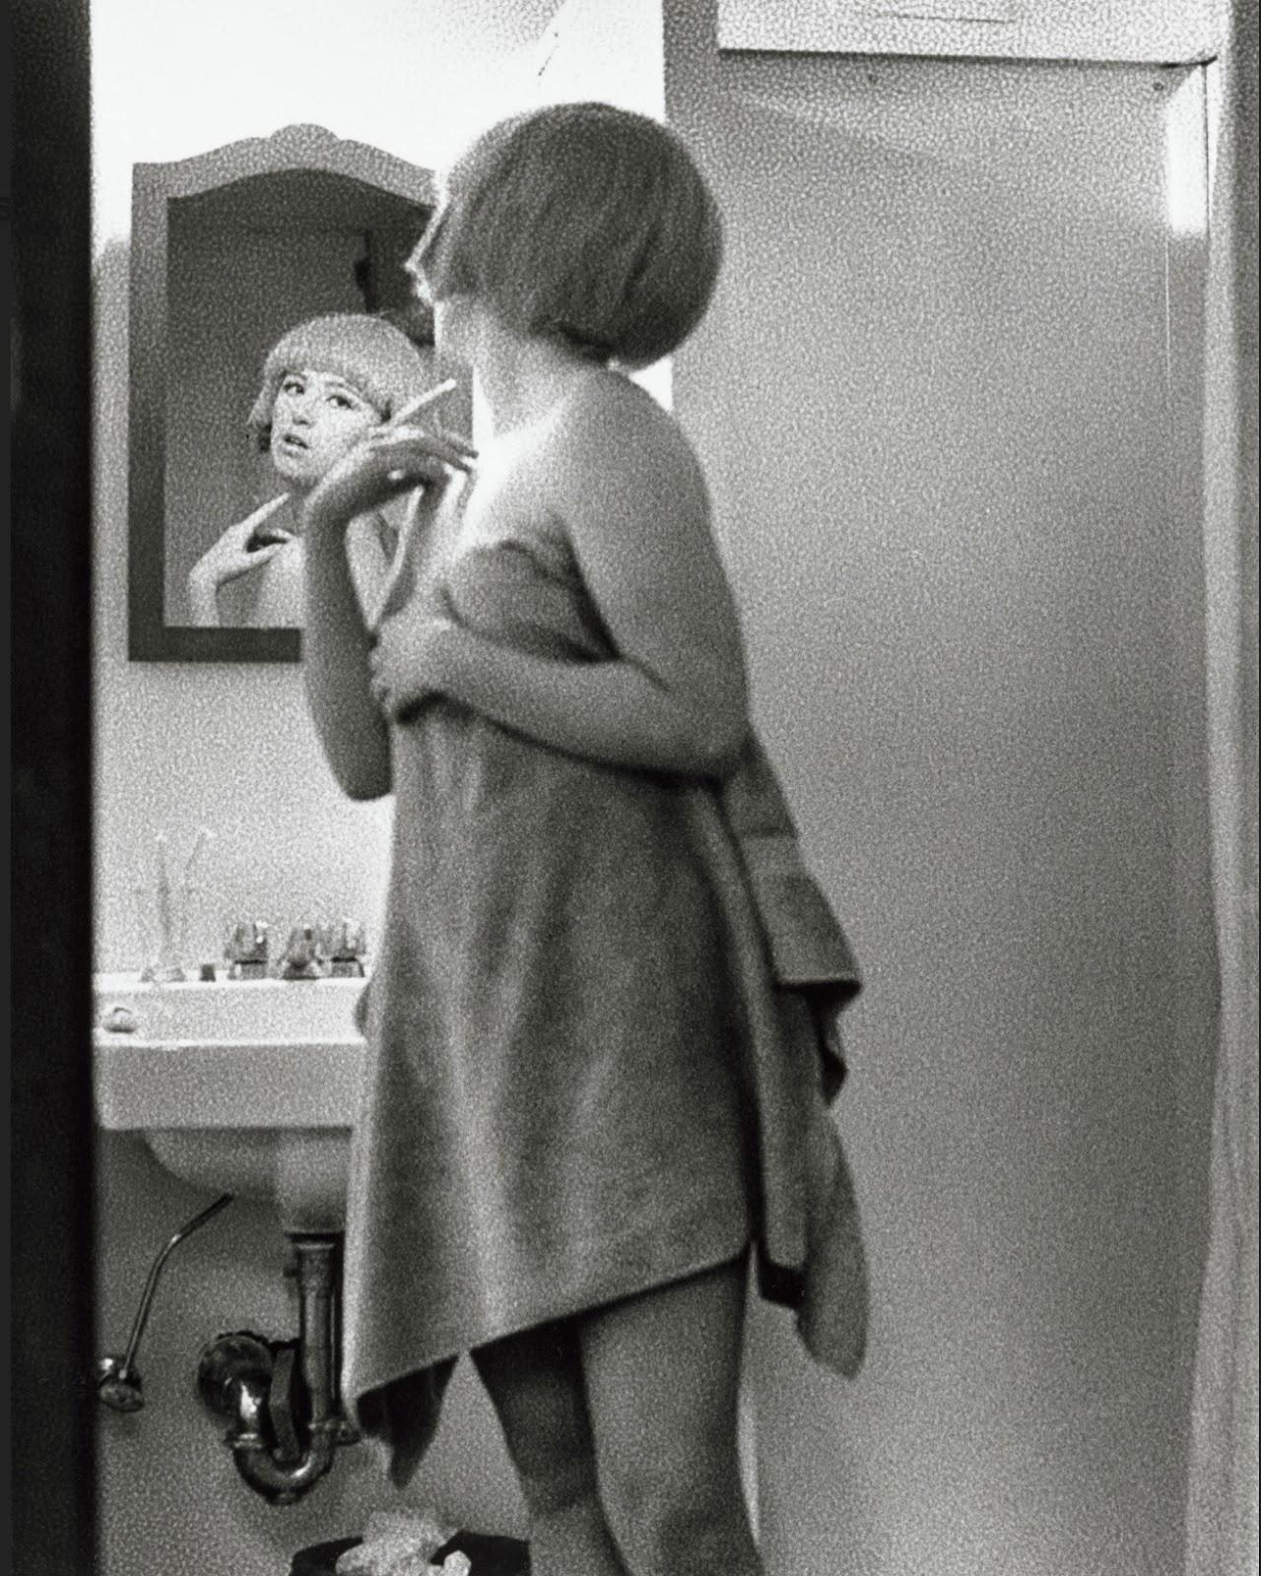

Fig. 1:
Cindy Sherman. Untitled Film Still #2. 1977.

Film Still #2 conveys the blonde pin-up, readily presentable, innocent sex symbol that was so often portrayed in film. It bears a resemblance to Dolly Parton's marginalised character, Doralee Rhodes in the feminist iconic film, 9 to 5. Rhodes’ character foundations were famously built upon simultaneously attracting unwanted attention from her boss, Mr Franklin, as well as ostracising her from her coworkers due to a rumoured affair with him (Baughan, 2018). Rhodes’ entire identity before Jane Fonda and Lily Tomlin’s characters came together with her was constructed around a male gaze perspective of her appearance. It is this essence of prejudice and identity perceiving that Sherman is trying to emulate, while also fighting against it, through her Untitled Film Series. The idea of identity being a prominent aspect to art is evidently undeniable. This research has led to a varied amount of questions through the lense of identity that will be interesting to research further, especially when considered with the context of the other keywords, femininity and patriarchy.
“Femininity does not invoke any empirically experienced notion of women” (Pollock, 2015). Femininity as a whole should be defined by each individual. As femininity can be a strong part of some people’s identity, it is completely subjective. The idea that femininity has a direct correlation to womanhood seems obvious. Nevertheless, this does not mean femininity and womanhood are one and the same. For this reason, it is important to emphasise that this portion of the proposal is based on the word femininity. Unfortunately, considering the vast gender binary, like gender, femininity hasn’t always been viewed in such a liberal way. While feminist author, Helen Gorrill was discussing art collector’s biases, the comparison was made between the “femininity of silver” and the “masculinity of the most desirable and expensive metal gold” (Gorrill, 2018). This demeaning, metaphorical outlook on femininity being viewed as inferior to masculinity demonstrates the attitude and disrespect of the art world towards women. It is bringing the patriarchal prejudices of mysongny into language.
In more recent decades femininity is starting not to just be seen as an identifier for women, but as more of an inclusive word in the LGBTQ+ community. The social construct of femininity is built upon many things. It is born out of the male gaze, internalised misogyny, expression or suppression of gender or sexuality, and as an opposition to masculinity. All of these aspects have been held to different levels when discussed around the context of femininity depending on the era and political environment in question.
According to Clare Johnson, femininity has had a political impact and has been “instrumental in the construct of feminist art history” (Johnson, 2013). The concept of a term being a significant road to political history within art marks the importance of language. It has the ability to change the perspective of people and create stereotypes surrounding their prejudices. Identifying something or someone as masculine or feminine could completely change the context in which the art or subject was implied. When looking at the political environment and decade debated, the effects on femininity as a concept are shown to be ever-changing. Throughout the 1990s, was seeing “the battle against the AIDS epidemic persisted” (Hessel, 2022), and with that stigmas surrounding gay men. This particularly hit the more ‘feminine’ presenting gay men, profiled as AIDS careers. This is an example which shows that men have also fallen victim to patriarchal terminology. Despite this, the 1990s are often viewed as a turning point, especially concerning British art. There was a growing change of attitudes from the art world regarding artists who were non-white, queer and women. “It was also a decade that saw them constantly pose questions about inequality, identity, migration and multiculturalism - subjects that artists are still actively dealing with today” (Hessel, 2022). This leads onto British feminist artist, Sarah Lucas. The main themes she tackles in her work revolve around identity, femininity and gender, openly critiquing “expectations of how society wanted women to behave” (Hessel, 2022). Femininity can be contextualised by using the concepts of identity and gender. With this in mind, Lucas would challenge the ideology of traditional female nudes which were more often than not painted by men, and created female form in a way not seen before. Lucas created a defiance against the notion of femininity being heavily based upon how society wanted women to behave and made her own identification with femininity instead. This can be seen in most of her works, one of the most recognisable being Self-Portrait with Fried Eggs, 1996.

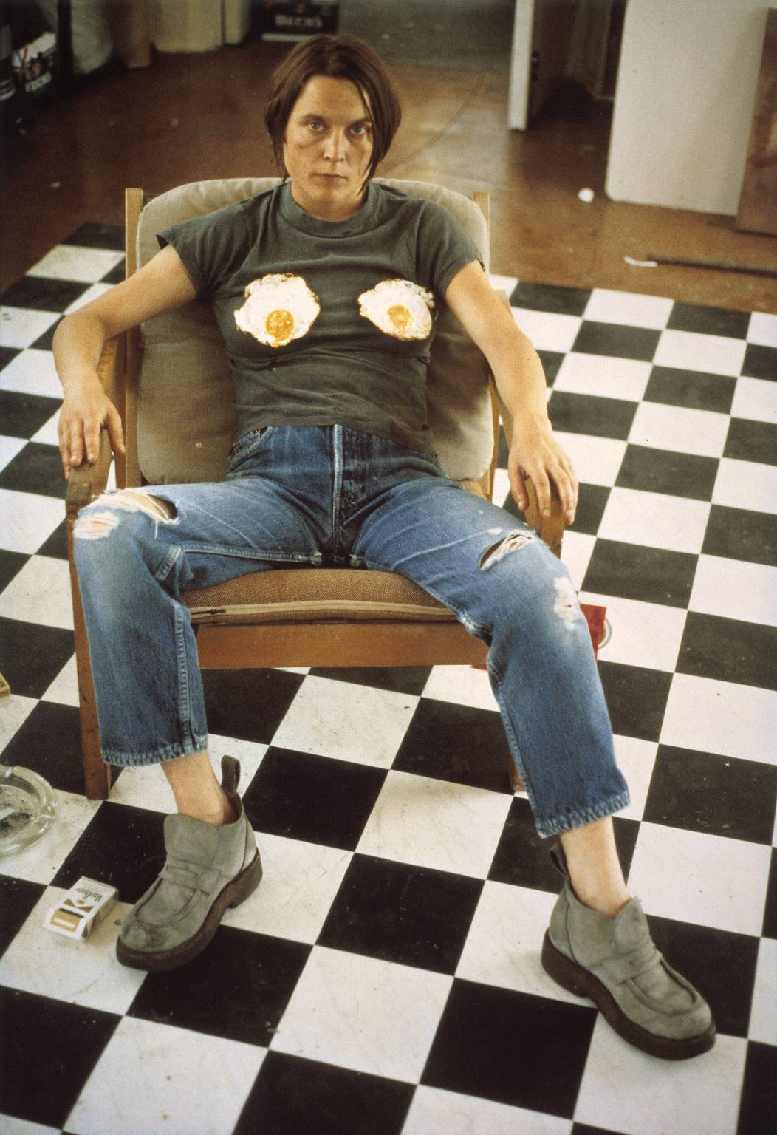

Fig. 2:
Sarah Lucas. Self-Portrait with Fried Eggs. 1996.
This image acts like the perfect representation for how attitudes towards the word femininity in particular were questioned. Lucas took a notorious form of art, the female nude, and spun it into a humorous narrative while simultaneously making a feminist stand for the offensive treatment of women. During the 1990’s it became a trend among artists to experiment with non-traditional media (Hessel, 2022). Lucas displayed this by taking the female nude out of the classically known painted medium and into the performance/comedy-photography medium. This is her take on feminine provocative intimacy that men artists have profited from for centuries. This beginning exploration into the key word femininity, through the artwork of Sarah Lucas and thoughts of Katy Hessel and Helen Gorrill, has generated many questions which value answers. Has the term or concept of femininity gained more power now that the perspective is coming from the person in debate instead of the built up societal construction? Is femininity a feminist outlook? Does femininity equal womanhood? Did femininity hold more of an importance to someone’s identity in the 1990’s climate of gender and sexuality issues than it does today?

Patriarchy is defined as ​“a society, system or country that is ruled or controlled by men” (Oxford Dictionary, 2022). More specifically, it could be said, by the white, straight men.
The 1970’s saw the implementation of change and, as a result, feminist art scenes transformed across the world. Following the June 1969 Stonewall Uprising and the1972 Equal Rights Amendment in the USA, being able to see oppression starting to lift ignited women to fight back against the patriarchy. Women came together and traditional art began collapsing. Art was a primary form of protest. For example, drag artists led the Stonewall Uprising and all-women exhibitions were staged to display feminist art. As a result, the feminist and artistic expression against the patriarchy was loud. When speaking of the effects women were having in the art scene, Hessel remarks on the “monumental progress” made by women in the art scene at the time. She emphasised that this progress made the white male-dominated industry take notice of women and their work (Hessel, 2022). This ‘establishment’, the patriarchy, has had the longest reign of power over women and human rights than anything else. The 1970’s is when it started to be dethroned.
A great example of a key feminist artist and teacher during this time is Judy Chicago. She created pioneering feminist art in an era made for it. When being interviewed about her art and reasoning behind her teaching methods, Chicago explained that the majority of her art knowledge was based on male artists and “male ideas” and found that it was evident to “feel a tremendous need for identifying with women” (Chicago, 1971). In 1972, Chicago co-founded the Feminist Art Program (FAP) with Miriam Shapiro. This brought women together for an educational purpose to create strength and empower each other. The education and collaboration of women’s minds is an element of the patriarchy that had been a battle for centuries. It was exactly this defiance against this patriarchal norm which fuelled Chicago’s work, showing her exploration into heavily male dominated fields of art like Minimalism in the early 1970’s. However, Chicago’s “‘icon of the decade: The Dinner Party” (Hessel, 2022) showed the most powerful rebellion against the patriarchy, with representation for 1038 women. This piece was full of feminist iconography. From the use of classically ‘feminine’ mediums, to the mathematical elements of the layout, it is an incredible piece of feminist art which will always go down in history. In fact, it now has a permanent place in the Brooklyn Museum.
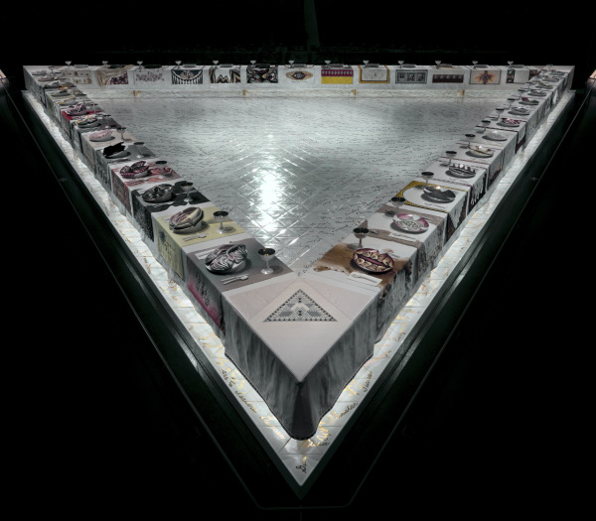

Fig. 3:
Judy Chicago, The Dinner Party. 1974-79.

As shown above, the table is built in a triangular form. This is a symbol of equality. The aspect of this piece that most viewers are fascinated by is the fact she has incorporated “yonic-shaped ceramic plate and hand-embroidered cloth” (Hessel, 2022) at each of the 39 women’s place settings. This is often portrayed as a nod to her earlier works in 1966-1971 where she “switched up her aesthetic to reflect vulva-like forms” (Hessel, 2022). This could be viewed as a humorous take from Chicago, or as a more intentionally defiant mark towards the patriarchy, saying in every sense that women are finally invited to the table. The table metaphor as a whole resembles that of The Last Supper, Leonardo De Vinci. Where Da Vinci’s painting illustrates 13 men at the table, at each side of Chicago’s table, there are sat 13 women. However, this piece was created in the peak of second-wave feminism, which has been criticised for privileging white, straight women. The piece is a product of its time and does not show representation for Spanish or Latin-American women. Chicago’s response to these criticisms seems slightly dismissive. She justifies the lack of representation of non-white women in The Dinner Party by explaining that, ‘At the time […], in the mid-1970s, there was little or no knowledge about any of these women” (Chicago, 2018). This begs the question: Is Chicago to blame for not participating in intersectional feminism, or is it the fault of the patriarchy? This is relevant to other questions raised: Why does the patriarchy have such a hold on the art world? Does the patriarchy still have such influence over the art world? Are these women feminists before artists, or artists before feminists? Can the ideas and solutions presented in feminist theory remedy the effects of a patriarchal system? These are all deep questions that would form great research towards a forthcoming independent research document.

Overall, the research into the key words patriarchy, identity and femininity has given this research proposal an overarching theme of feminism. Through each section of this research proposal, all three words were relevant contributors. It was illustrated how the three key words are always interlinked with each other through societal factors mentioned in each section. From womanhood to expression, they continue to be used in similar paths. When looking at feminist art these words will always be at bay. As a woman who creates art, with the outlook of activism, it would be extremely beneficial to read this research proposal, and go on to read the more in-depth independent research project. When looking into a more personal route of this research, it brings up a question: Can a woman create art without it being feminist art?
This beginning exploration into the key words of Identity, Femininity and Patriarchy has shown great strength from women artists over the years 1970-2000. This demonstrates a continued and not weakened fight. This proposal covers a time span of thirty years in which the world and opinions in society went through a great deal of change. Consequently, art reflected this change. Although these thirty years saw a change of attitude towards women, this research signifies how the feminist women in question have always carried a strong sense of self with their work. The overarching theme, feminism, developed out of admiration for and an interest in these strong female artists. Whilst exploring the concepts behind the three key words, identity, femininity and patriarchy, it was found that these words could be extended to include: gender, womanhood, expression, sexuality, provocative, society, character, perception, rebellion, intersectional. It is the intention to research, analyse and include all the concepts discussed in order to support the independent research project.

Reference list

9 to 5. (1980). 20th Century Studios.

Baughan, N. (2018). Yes, 9 to 5 really is a feminist movie. [online] BFI. Available at: https://www.bfi.org.uk/features/nine-five-feminism-jane-fonda [Accessed 6 May 2023].

Brooklyn Museum (2007). Brooklyn Museum: The Dinner Party by Judy Chicago. [online] www.brooklynmuseum.org. Available at: https://www.brooklynmuseum.org/exhibitions/dinner_party/ [Accessed 8 May 2023].

Buckingham, D. (2008). Introducing Identity. Foundation Series on Digital Media and Learning, [online] pp.1–24. doi:https://doi.org/10.1162/dmal.9780262524834.001.

Butler, J. (1999). Gender Trouble: Feminism and the Subversion of Identity. London: Routledge.

Frieze (2018). Judy Chicago Hits Back at ‘Dinner Party’ Criticism | Frieze. [online] Frieze. Available at: https://www.frieze.com/article/judy-chicago-hits-back-dinner-party-criticism [Accessed 8 May 2023].

Gørrill, H. (2020). Women Can’t Paint. Bloomsbury Publishing USA, pp.3–183.

Hessel, K. (2022). The Story of Art without Men. London: Penguin Random House, pp.327–414.

History (2023). Feminism’s Long History. [online] HISTORY. Available at: https://www.history.com/topics/womens-history/feminism-womens-history# [Accessed 7 May 2023].

Johnson, C. (2013). Femininity, Time and Feminist Art. [online] Google Books, Springer, pp.1–173. Available at: https://books.google.co.uk/books?hl=en&lr=&id=WXOYAAAAQBAJ&oi=fnd&pg=PP1&dq=femininity+in+art&ots=S-bAwIabfl&sig=wWf9oqzp-hfrH6_-UggJcfg_0BQ&redir_esc=y#v=onepage&q=femininity%20in%20art&f=false [Accessed 7 May 2023].

Lapine, C.-L. (2023). We Stand for Ourselves: The Non-Cisnormative Origins of the Stonewall Riots. Undergraduate Research Conference. [online] Available at: https://digitalcommons.usf.edu/usf_ourconference/2023/social_sciences/1/ [Accessed 7 May 2023].

Manchester, E. (2001). ‘Self Portrait with Fried Eggs’, Sarah Lucas, 1996. [online] Tate. Available at: https://www.tate.org.uk/art/artworks/lucas-self-portrait-with-fried-eggs-p78447 [Accessed 7 May 2023].

Milan Museum (2019). Milan-Museum.com. [online] Milan-museum.com. Available at: https://www.milan-museum.com/leonardo-last-supper-cenacolo.php [Accessed 8 May 2023].

MoMA (2023). Cindy Sherman. Untitled Film Still #2. 1977 | MoMA. [online] The Museum of Modern Art. Available at: https://www.moma.org/collection/works/56515 [Accessed 6 May 2023].

Mulvey, L. (1975). Visual Pleasure and Narrative Cinema. Screen, [online] 16(3), pp.14–26. Available at: https://ia802801.us.archive.org/4/items/visual-pleasure-and-narrative-cinema/Laura-mulvey-visual-pleasure-and-narrative-cinema.pdf [Accessed 6 May 2023].

NationalMuseum of Women in the Arts (2023). Women House | Exhibition. [online] NMWA. Available at: https://nmwa.org/exhibitions/women-house/ [Accessed 7 May 2023].

Oxford Learner’s Dictionaries (2022). patriarchy noun - Definition, pictures, pronunciation and usage notes | Oxford Advanced Learner’s Dictionary at OxfordLearnersDictionaries.com. [online] Oxfordlearnersdictionaries.com. Available at: https://www.oxfordlearnersdictionaries.com/definition/english/patriarchy#:~:text=%2F%CB%88pe%C9%AAtri%C9%91%CB%90rki%2F [Accessed 7 May 2023].

Pollock, G. (2015). Vision and difference : feminism, femininity and the histories of art. [online] London New York Routledge. Available at: https://www.google.co.uk/books/edition/Vision_and_Difference/alV9L5DF9dMC?hl=en&gbpv=0 [Accessed 7 May 2023].

Public Delivery (2019). Cindy Sherman’s Untitled Film Stills – Her Groundbreaking Self Portraits. [online] Public Delivery. Available at: https://publicdelivery.org/cindy-sherman-untitled-film-stills/ [Accessed 6 May 2023].

Schapiro, M. (1971). A Feminist Art Program. Art Journal, 31(1), pp.48–49. doi:https://doi.org/10.2307/775636.

Selisker, S. (2015). The Bechdel Test and the Social Form of Character Networks. New Literary History, 46(3), pp.505–523. doi:https://doi.org/10.1353/nlh.2015.0024.

Witt, H. and Medina-Martinez, K. (2021). Transgender Rights & the Urgent Need for Social Work Advocacy. Social Work in Public Health, 37(1), pp.1–5. doi:https://doi.org/10.1080/19371918.2021.1970685.

‌

