Jodie Thomas
2129540
Health, Wellbeing and Sustainable Development
Component 2- Written Assignment
BMHP6030
Lecturer- Parese Ahmed
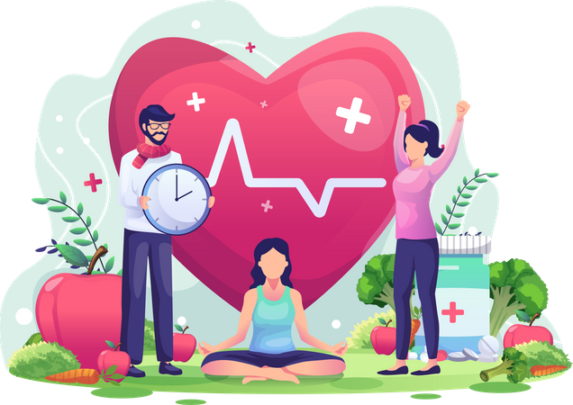

Introduction
Within this report I will be conducting an analysis of how Sustainable Development Goal (SDG) Goal 3 ‘Good Health and Wellbeing’ and SDG Goal 1: ‘No Poverty’ Impacts the health and wellbeing of citizens. I will also compile an evaluation into the effectiveness of national and local health, wellbeing and sustainable development initiatives. I will be critically examining the ubiquitous nature of health, wellbeing and sustainable development within present health and care sectors. By analysing secondary data, I intend to provide recommendations for improvement to current Health, Wellbeing and Sustainable Development policies and initiatives on a local, and national level.
In 2015, all 193 United Nations member states adopted the 2030 Agenda for sustainable Development, which sets out 17 goals and include 169 targets (WHO,2025). SDG’s aim is to transform the world, they are a call to action to end poverty and inequality, protect the planet, and ensure that all people enjoy health, justice and prosperity (Fonseca et al). The Sustainable Development Goals (SDGs) are important as they provide a universal roadmap to end poverty, protect the planet, and ensure prosperity and peace for all people. The are critical for addressing global challenges like climate change, inequality and health. They promote a sustainable future for both current and future generations. The SDG’s interconnected nature means that progress in one area contributes to progress in others, creating a holistic framework for transformation. “They represent a new coherent way of thinking about ecological, social, and economic issues, and address all the critical and major global challenges that threat the future, including those related to poverty, inequality, climate change environmental degradation and peace and justice” (NIH, 2020).
The structure of this report will be as follows:
- SGD3- Good Health and Wellbeing
- SDG1- No Poverty
- Conclusion
- Reference list
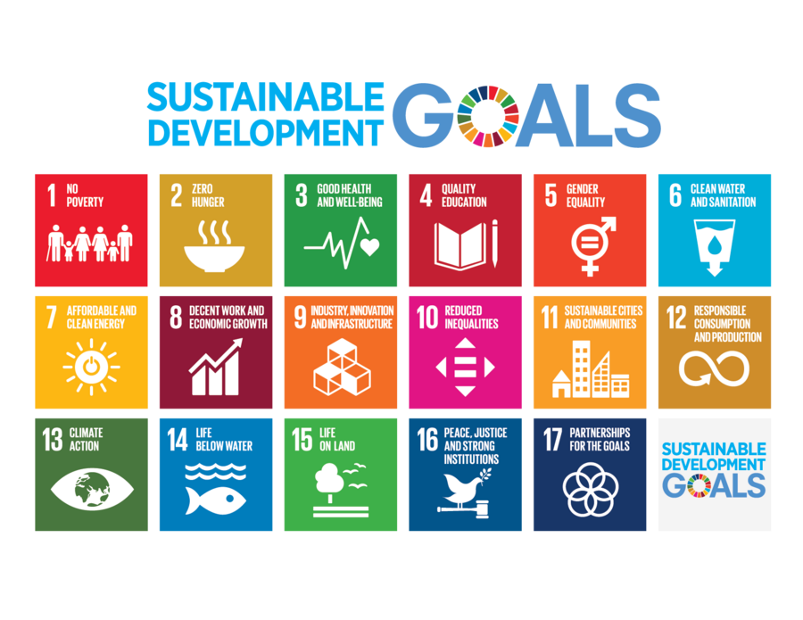
SDG 3-Good Health and Wellbeing
Overview
Sustainable Development goal 3 aims to ensure healthy lives and promote the wellbeing of all people at all ages (WHO, 2025). “SDG3 aims to prevent needless suffering from preventable diseases and premature death by focusing on key targets that boost the health of a countries overall population” (UNICEF, 2025).
These targets are:
- Maternal and child mortality: Reduce the global maternal mortality rate.
- Ending Epidemics.
- Non-communicable diseases: Reduce premature mortality from non-communicable diseases (like heart disease, cancer and diabetes).
- Universal health coverage: Achieve universal health coverage.
- Other health risks: Reduce deaths and illnesses from hazardous chemicals, air, water, and soil pollution and contamination.
- Health and well-being: Promote mental health and well-being and ensure everyone has access to sexual and reproductive healthcare services.

“Goal 3 also calls for deeper investments in research and development, health financing and health risk reduction and management”. (UNICEF, 2025). SDG3 strives to create a world where everyone can live a healthy and fulfilling life (WHO,2025).
Local Policies and initiatives- Ladywood
Local health initiatives often involve partnerships between NHS services, local councils, and community groups to create tailored solutions within the local area.
Examples include:
- Flourish Health: open group of third sector organisations working with health providers to reduce health disparities in Ladywood and perry Barr.
- Integrated neighbourhood teams: GP led teams of health and social care professionals who coordinate care for people with complex needs within the community.
- BCC: Local churches/Food banks
- Birmingham settlement Nature and Wellbeing Centre: Located in Ladywood, this centre offers nature-based activities to improve health and wellbeing, including Tai Chi, yoga and social walk and talk groups.
- Ladywood Community Project: Provides essential community support including Food assistance through the “Holiday Hunger Scheme” for families reliant on free school meals during breaks, help with fuel poverty, assistance with ills and benefits queries, financial help with school uniforms and trips for families on a low income.
- “Best Start in life program”: This initiative aims to educate young people about maternal and infant health to reduce the risk of poor maternal health and infant mortality rates.

National Policies and initiatives UK
The UK has various policies and initiatives aimed at promoting health, wellbeing and sustainable development. Such examples are:
- The NHS’s commitment to net-zero emissions (NHS Long Term Plan)
- The NHS 10-year health plan
- Health and Wellbeing boards: established by the Health and Care Act 2022, focusing on integrating health and social care services, promoting preventative care and person-centered approaches
- Mental health and wellbeing plan: A plan to improve mental health services and support.
- Health in all policies: Encourages collaboration across different government departments to consider the health impacts of all policies, promoting a holistic view of wellbeing.
- Greener NHS Program: launched in 2020, this sets specific goals for reducing the NHS’s carbon footprint and achieving net-zero emissions by 2040.
By recognizing the interconnectedness of health, environment, and the economy, there’s a push for greater collaboration across different government sectors and departments. Sustainable development requires long-term planning to avoid unintended consequences of short-term focused policies.

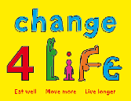

A Uk public health campaign launched in 2009, to help families eat better, move more and live longer, mainly focusing on reducing childhood obesity (GOV.UK, 2017).

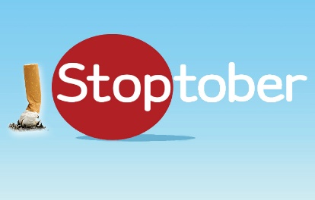
An Annual Public Health campaign organised by the NHS and the department of health and social care, which encourages smokers in the UK to quit smoking for 28 days in October (GOV.UK,2022).
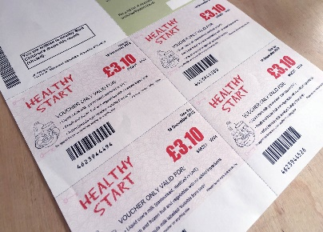
Healthy Start is an NHS scheme launched in 2006 to provide a nutritional safety net for low-income families. Helping women who are pregnant or have young children and are receiving benefits to purchase healthy foods, such as milk or fruit plus get free vitamins (BMC Medicine, 2024).

These programmes are linked to achieving sustainable development goal 3 by promoting healthier lifestyles, reducing health inequalities, preventing non-communicable diseases, improving maternal and child health and reducing health disparities through behavioural change and direct support.
Global Policies and Initiatives
- Non-communicable diseases (NCDs) and mental health are addressed through initiatives like the global Health4Life fund and the EU’s “Healthier Together” policy (WHO,2021).
- Health Emergency Preparedness and Response (HERA) who ensure that the EU and member States are ready to act in the face of cross-border health threats (Public Health, no. date).
- Gavi, the vaccine alliance: to improve access to new and underused vaccines for children living in the world’s poorest countries. (Gavi, 2024).
- The Global Initiative on Digital Health which uses digital technology to improve health outcomes.
- Global Breast Cancer initiative (WHO,2025)
- The global Diabetes Compact (Gregg et al, 2023)

Theories
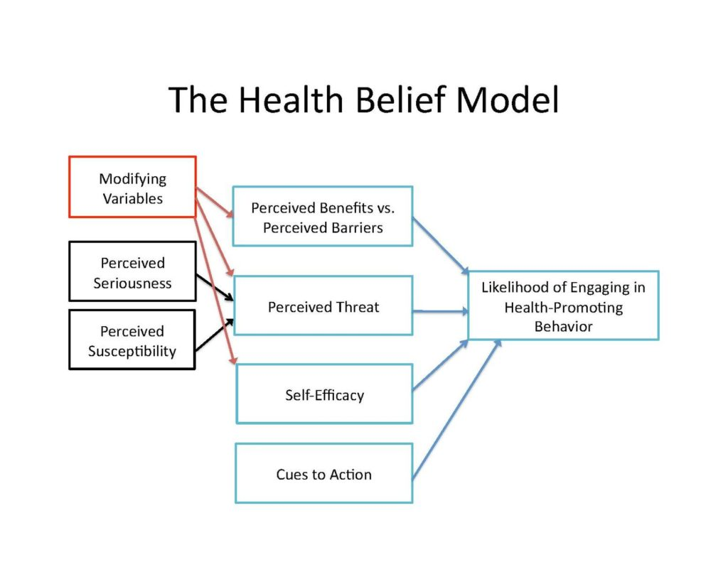
(Rosenstock,1990)
The Health Belief Model is a theoretical model that can be used to guide health promotion and disease prevention programs. It is used to explain and predict individual changes in health behaviours. The model focuses on how individuals perceive health threats and decide to act, based on the value the individuals place on a particular goal and the likelihood that actions taken towards that goal will be successful (NIH, 2024).
By making people aware of problems affecting their overall health and wellbeing and the threats associated with worsening health and wellbeing and giving them viable solutions and readily available pathways to achieve a healthier lifestyle, increases the likelihood of individuals engaging in health promoting behaviour.

Evaluation
As of 2023 133 countries have met the SDG3 target on under 5 mortality, and effective HIV treatment has cut global AIDS-related deaths by half since 2010, however overall progress towards meeting sdg3 targets is off course, with less than 15% of targets on track to be met by 2030. Evaluations of sustainable Development Goal 3 initiatives show mixed progress globally, with notable problems caused by COVID-19 pandemic, which severely disrupted health services, affected routine immunizations and increased prevalence of anxiety and depression rates globally(United Nations, No.date) The UK’s work towards SDG3 has been criticized for lacking overall coherence due to the absence of a dedicated public health strategy since 2015. Also, significant cuts to UK Official Development Assistance have “reversed, disrupted and delayed progress” in global health initiatives (GOV.UK, 2023)
Recommendations
Achieving SDG3 requires a comprehensive, integrated approach that addresses social, economic and environmental determinants of health. While there have been technological advances (e.g. AI in healthcare/Healthcare Apps) and some areas of progress, the current pace is insufficient to meet 2030 targets. Stronger political commitment, coherent national strategies, and improved international cooperation incentives are crucial to get progress back on track (Asadikia, 2024). Progress needs to be accessed and there needs to be a plan put in place to identify what can be done to radically accelerate progress on SDG3 implementation in the next five years.

SDG1: No Poverty: Calls for an end in poverty in all forms everywhere
Targets include:
- Eradicating extreme poverty
- Reducing all poverty
- Implementing social protection systems
- Ensuring equal rights
- Build resilience: Reduce the exposure of the poor and vulnerable to climate-related, economic, social and environmental shocks and disasters.
- Mobilize resources
- Create policy frameworks

According to World Bank Group, 2025, as of today almost 700 million people (8.5% of the global population) live in extreme poverty-on less than $2.15 per day. Poverty rates in low-income countries are higher than before the Covid-19 pandemic. “We have made almost no progress in the fight against poverty since 2019, In a world without the pandemic, poverty today would probably be significantly lower” (Yonzan et al, 2023).

Other reasons for global poverty include:

- Systemic inequality: Barriers based on gender, race, ethnicity, or social status can leave groups without equal access to resources.
- Conflict: War, destruction of infrastructure, disrupted economies, displaced populations and diverted resources.
- Lack of education/jobs
- Poor healthcare systems
- Debt: national debts can prevent countries from investing in essential services like education and healthcare for their own people.
- Climate change and natural disasters: Impoverished communities rely on agriculture whilst living in areas vulnerable to severe weather events. These disasters can destroy harvests, contaminate water, and push vulnerable families into deeper poverty.
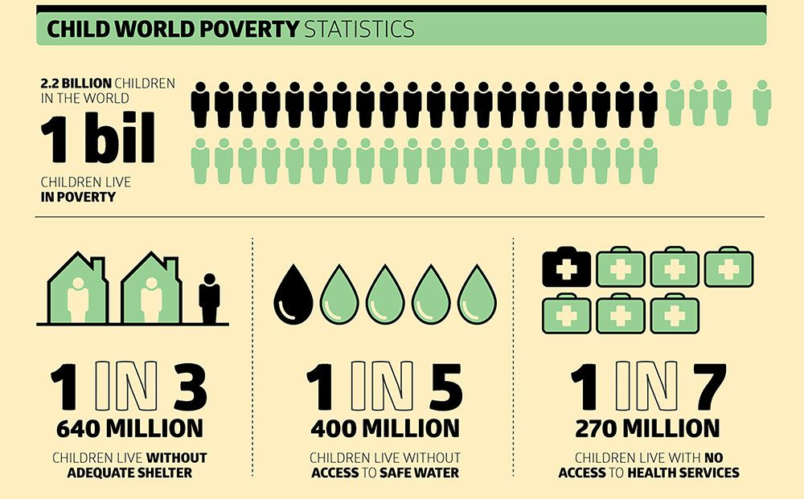
Jamaica’s poverty rate dropped significantly reaching an estimated 8.2% in 2023, a decline caused by the COVID-19 pandemic. Around 1.5 million Jamaicans have recently been impacted by hurricane Melissa, the worst climate disaster in the Caribbean nation’s history, 36,000 people urgently require food assistance, and more than 100,000 housing structures have been affected UN News, 2025). Their homes, livelihoods and communities are in ruin and are without basic food and water. The UN world food programme is airlifting food to support 6,000 households, but will this country recover, the burden of poverty prevalence will only increase.
21% of the UK population live in poverty, equivalent to 14 million people (The Health Foundation, 2024). Leading factors of UK poverty rates include unemployment, low wages, rising food costs, and insecure work (Wages have not kept pace with the rise in cost of living). Other factors include high housing costs, disabilities (which can create both higher costs and barriers to employment), and demographic factors like family type e.g. (larger or single-parent families) and barriers for ethnic groups accessing support and pathways into employment.

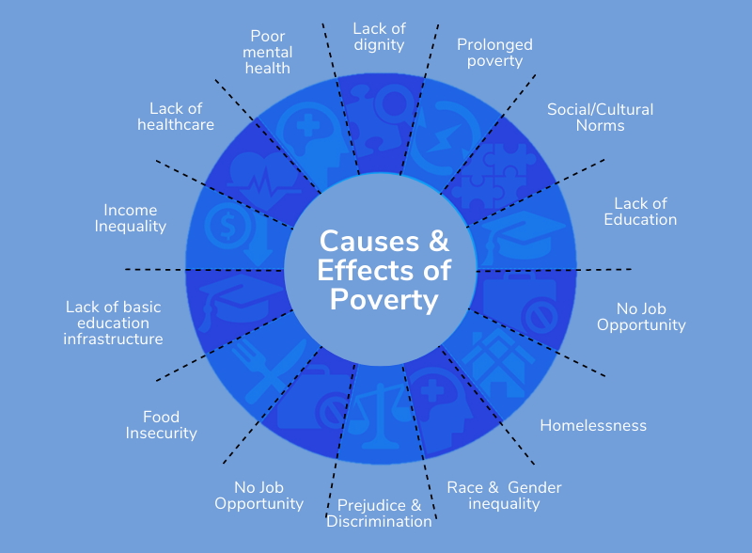

Global, national & Local policies and initiatives
Global
- FABLE: A global network of national research organisations developing national-scale food and land-use strategies aligned with global goals (FABLE, No. date).
- United Nations World Food Programme: Lead agency to respond to food emergencies worldwide
- UNICEF: Prevent malnutrition through community programmes and access to nutritious food, provide emergency aid, strengthen food systems through government partnerships and support for social protection programmes. Also provide solutions to accessing clean water and health services to combat disease.
National
- Tackling Child Poverty: Developing Our Strategy (GOV.UK, 2025)
- Poverty strategy commission
- Poverty in the UK: Government Policy
- Free School Meals
- Charities: e.g., Oxfam, Trussel Trust, Age UK and Action for children
- Shelters
- Food Banks
- State Benefits
- NHS (Free Healthcare)
- Household support fund
- Jobcentre plus

Local
- Community led support services- Financial and welfare advice
- Food banks
- A major housing regeneration project
- Soup kitchens
- Community fridges
- Too good to go (reduced price food apps)
- Food cycle community meals

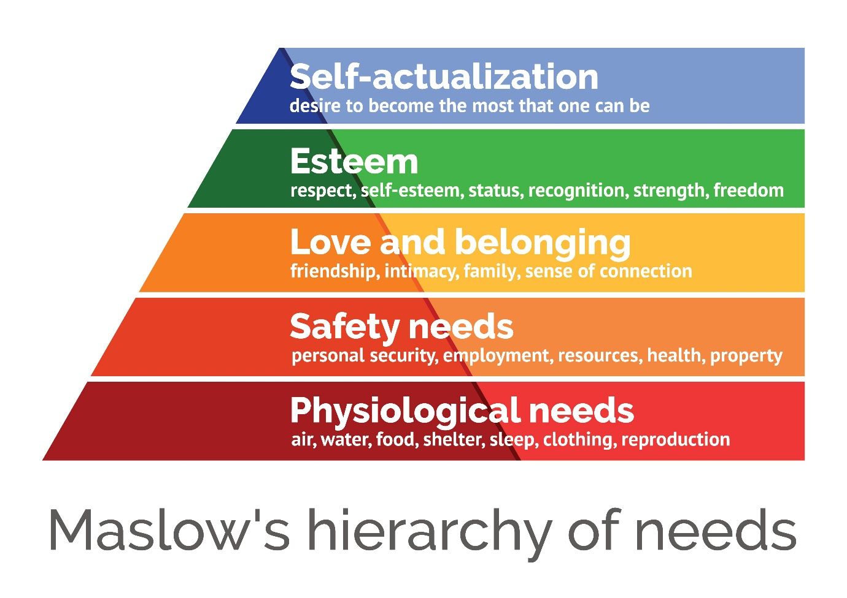
When people’s basic needs are not met, they experience a range of negative physical and psychological effects, including stress, anxiety, depression and conflict. Unmet needs like food, water and shelter can lead to diminished physical functioning. Over time unmet needs can lead to significant distress and a reduced ability to thrive (Psychology Today, 2022).

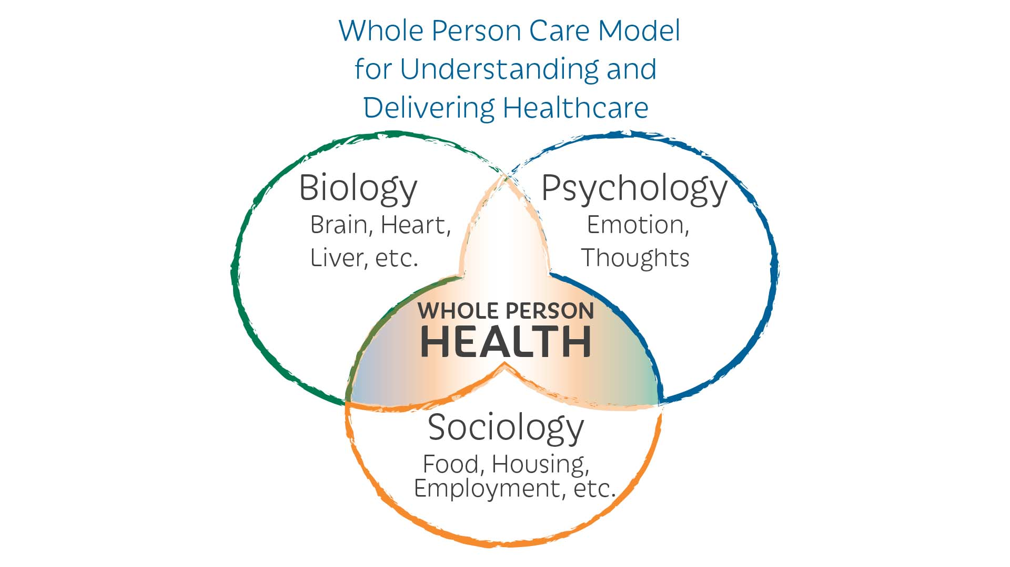
(Engel, 1977)
The above model addresses the social, economic, and environmental factors that drive poor health outcomes and exacerbate poverty.
Conclusion
Understanding poverty from a whole-person perspective requires moving beyond simple income metrics to consider the interconnected impacts on an individual’s material, social, psychological and physical well-being, while also recognizing that people are not just “poor”, but are often forced to live in poverty due to intersecting failures of social and economic systems. SDG1(No Poverty) and SDG3 (Good Health and Well-being) are deeply interconnected through a cycle where poverty impacts health, and poor health can trap people in poverty. Poverty can be difficult to escape, without access to essentials people living in poverty have few opportunities to change their circumstances, creating a cycle that persists for generations.
Recommendations
- Expand social protection
- Promote inclusive economic growth
- Strengthen financial support
- Enhance food security
- Improve healthcare access and quality
- Strengthen public health systems
- Reduce health inequalities
- Promote individual action
- Recognise the linkage between SDG’s: Recognize that poverty is a major determinant of health, so addressing one goal directly benefits the other.

References

- Asadikia, A et al (2024) ‘Navigating sustainability: Key factors in prioritising sustainable development goals’ Available at https://www.link.springer.com/article/10.1007/s11625-024-01561-9 (Accessed:14/11/2025)
- BMC Medicine, (2024) ‘The Healthy start scheme in England is a lifeline for families but many are missing out’: A rapid qualitative analysis. Millie Barrett, Mark Spines & Christina Vogel, BMC medicine.
- Edward, W. Gregg et al (2023) ‘Improving health outcomes of people with diabetes: target setting for the WHO Global Diabetes Compact’ Available at https://www.pubmed.ncbi.nlm.nig.gov/36931289/ (Accessed on 14/11/2015)
- Fable, (No. date) ‘A network for modelling food systems at national and global scales’ Available at https://www.fableconsortium.org/ (Accessed: 14/11/2025)
- Gavi, (2024) ‘Gavi Progress Report’ Available at https://www.gavi.org (Accessed on 15/11/2025)
- GOV.UK, (2025) ‘Tackling child poverty: Developing our strategy’ (Accessed 12/11/2025)
- GOV.UK, (2022) ‘Stoptober Launches to give smokers the confidence to quit’. Available at https://www.gov.uk/government/news/stoptober-launches-to-give-smokers-the-confidence-to-quit Department of Health and Social Care (accessed: 11/11/2025)
- GOV.UK, (2023) ‘The UK is committed to promoting the health and well-being of all to advance the sustainable development goals: UK statement at the UN general assembly’ Available at https://www.gov.uk/government/speeches/ (Accessed:14/11/2025)
- GOV.UK, (2017) ‘New Change 4 Life Campaign encourages parents to be food smart’ Public Health England. (Accessed: 51/11/2025)
- MDPI, (2020) ‘Mapping the sustainable Development Goals relationships’, Luis Migel Fonseca, Jose Pedro Domingues & Alina Michaela Dima, Volume 12, Issue 8. Available at https://www.mdpi.com/2071-1050/12/8/3359 (Accessed: 13/11/2025)
- NHS Providers, (2025) ‘The NHS 10-year Health plan: Conditions for success’, Saffron Cordery. Available at https://www.nhsproviders.org (Accessed:13/11/2025)
- NIH, (2024) ‘Health Belief Model of Behavioural Change’ Alyafei A, Easton & Carr R. Available at https://w.ncbi.nlm.nih.gov/books/NBK606120# (Accessed: June 2025)
- NIH, (2020) ‘Heading towards an unsustainable world: some of the implications of not achieving the SDG’s’, Walter Leal Filho, Franziska Wolf, Amanda Lange. Sept 4;1(1):2
- Nishant Yonzan, Daniel Gerson Mahler & Christoph Lakner, (2023) ‘Poverty is back to pre-covid levels globally, but not for low-income countries’ Available at https://www.blogs.worldbank.org/en/opendata/poverty-back-pre-covid-levels-globally-not-low-income-countries (Accessed:15/11/2025)
- Psychology Today, (2022) ‘3 unmet basic needs and their effects on relationships’ Available at https://www.psychologytoday.com/us/blog/understanding-ptsd/202212/3-unmet-basic-needs-and-their-effects-on-relationships (Accessed:16/11/2025)
- Public Health (No. date) ‘Health Emergency Preparedness and Response(HERA)’ Available at https://www.health.ec.europa.eu/health-emergency-preparedness-and-response-hera-en (Accessed on 16/11/2025)
- Rosenstock. (1990) ‘The health belief model: Explaining health behaviour through expectancies’ Health behaviour and health education: Theory, research, and practice (pp.39-62)
- The Health Foundation, (2024) ‘Trends in Poverty’ Available at https://www.health.org.uk/evidence-hub/money-and-resources/poverty/trend-in-poverty (Accessed:14/11/2025)
- UNICEY, (2025) ‘Goal 3: Good Health and Well-being’. Available at https://www.data.unicef.org/sdgs/goal-3-good-health-wellbeing/ (Accessed:14/11/2025)
- UN News, (2025) ‘Tackling child poverty: Developing our strategy(HTML)’, GOV.UK Available at https://www.uk/government/publ;ication/tackling-child-povertydeveloping our-strategy/tackling-child-poverty-developing-our-strategy-html (Accessed:12/11/2025)
- United Nations, (No.date) ‘Goal 3: ensure healthy lives and promote well-being for all at all ages’ Available at https://www.un.org/sustainabledevelopment/health/ (Accessed:14/11/2025)
- WHO, (2025) ‘The Global Breast Cancer Initiative, Empowering women, building capacity, providing care for all’ Available at https://www.who.int/initiatives-global-breast-cancer-initiative (Accessed 14/11/2025)
- WHO, (2025) ‘Sustainable Development Goals’ Available at https://who.int/europe/about-us/our-work/sustainable-development-goals (Accessed:13/11/2025)
- World Bank Group, (2025) ‘Poverty, Prosperity and Planet Report: Pathways out of the Poly-crisis’ Available at https://www.worldbank.org/en/publication/poverty-prosperity-and-planet (Accessed:16/11/2025)
- WHO, (2025) ‘Targets of sustainable Development Goal 3’ Available at https://www.who.intEurope/about-us/our-work/sustainable-development-goals/targets-ofsustainable-development-goal-3
- WHO, (2021) ‘Health4life fund UN multi-partner Trust fund to Catalyse country action for non-communicable diseases and mental health’ Available at https://www.cdn.who.int/media/docs/default-source/unitaf/uniatf-mptf-flyer-071021-final.pdf

