KHA16828994 Faiz Khan

assignment 1

Contents
Introduction 2
Task 1 2
Type 1 hypervisor 2
VM-Ware type 2 Hypervisor 2
Oracle VirtualBox type 2 Hypervisor 3
Hypervisor chosen 3
Setting up system 4
Administrator account 5
What is IP Address 6
IPv4 and IPv6 6
Setting up IP address for the servers 7
8
Setting up IP address for the workstations 9
Setting up the names for workstation 10
10
Setting up network cards 11
11
Testing connections 12
Conclusion 13
Bibliography 14

Introduction

Noss, a multinational corporation assigned the IT -professional to make a network in Swansea and London by connecting their servers and networks together with their own separate workstation. One workstation should be located in Swansea and the other will be located in London. The job they have given to the IT professional is to make an administrator account to set up a strong password for the account and then assign the system with IP addresses. It also needs a good network connection and also to make sure the connection is working correctly by testing the system.

Task 1

Type 1 hypervisor

The type one hypervisor runs directly on the computer’s physical hardware. It will interact directly with the CPU memory and the physical storage on the computer hardware. The one hypervisor is also a bare metal hypervisor which is directly installed in the host machine’s physical hardware but it won’t be installed through the operating system. The type one hypervisor will also be embedded in the machine’s firmware.

VM-Ware type 2 Hypervisor

The VMware hypervisor is a directly installed on the hardware which will run on a pc. It has good features like high performance, resource optimization, centralized management. It has relatively low hardware requirements. But the visualization specific processors can enhance its performance by better speed and faster load time. The advantages of the VM ware hypervisor are that it is a widely used system used by many originations. It also has a very good scalability. The other advantages of VM-Ware hypervisor are that it has a good range of security as you can set up strong password. [1] “As stated by VM-Ware they say VM-Ware security solutions turn points of vulnerability into points of security control. Endpoint VMWare offers a cloud-native endpoint protection platform, delivered as a SaaS offering, that prevents, detects and responds to advanced attacks.” So, the VM-Ware software offers a wide range of security which can help protect businesses from attacks.

Oracle VirtualBox type 2 Hypervisor

The Oracle VirtualBox hypervisor is a versatile and user-friendly, supporting wide range of guests in the operating system. The Oracle VirtualBox also has a great hardware support as if you have high performance hardware on the system you can set up as much hardware do you want to get used. The other ability Oracle Virtual box has that it is able to manage VMs through a graphical user interface. The other benefits of this Oracle Virtual Box are that it is a free to use software and supports a variety of hosts and guests. [2] “As stated by Hossein Ashtari he says, Oracle VM VirtualBox is a tool for virtualizing x86 and AMD64/intel64 computing architecture, enabling users to deploy desktops, server, and operating systems as virtual machines. You can this solution to deploy as many virtual machines as the host architecture has the resources for.” So, this shows the oracle VirtualBox can run a virtual desktops servers and other operating systems. It is also a free to use software which can do the same jobs like the other Hypervisors.

Hypervisor chosen

The Hypervisor which IT-professional chose is the VM Ware. The reason why he chooses this hypervisor is because it has a wide range of features like you can customise the hardware on the system. As you can choose the amount of hardware you would like the system to use. For example, if you have 32 Gb of RAM you can make your VM Ware hypervisor and you can choose to use 8GB of RAM as this will give the hypervisor a good speed and efficiency for its working.
The other thing which is good about the VM Ware hypervisor is that it has a good amount of security in the system. This will help protect their users from other attacks. The other reason why IT-professional should be using this Hypervisor is because it is widely used by many other users and it has a good system. [3] “As stated by Red Switches they say, VMware provides better disaster recovery, cost savings, greater resource utilization, scalability, security, and flexibility. It facilitates development and testing, permits support for legacy applications, and helps with resource managements” So, the VM ware hypervisor also has a disaster recovery as if there are any natural disasters or any other problems, the VM Ware can back up the data. So, your important data won’t be lost.

Setting up system

This is where IT-professional set up all the system shown from the following topology diagram. First, he sets up the Swansea Domain server. When he Sets up the Swansea workstation PC then he sets up the London Domain server and he also sets up the London workstation PC shown from the diagram. The other task he will be doing is setting up the IP address for the sever domains for Swansea and London servers. IT-professional will also be doing the same job for the pc where he will set up the IP and connect the PCs to their own located servers.
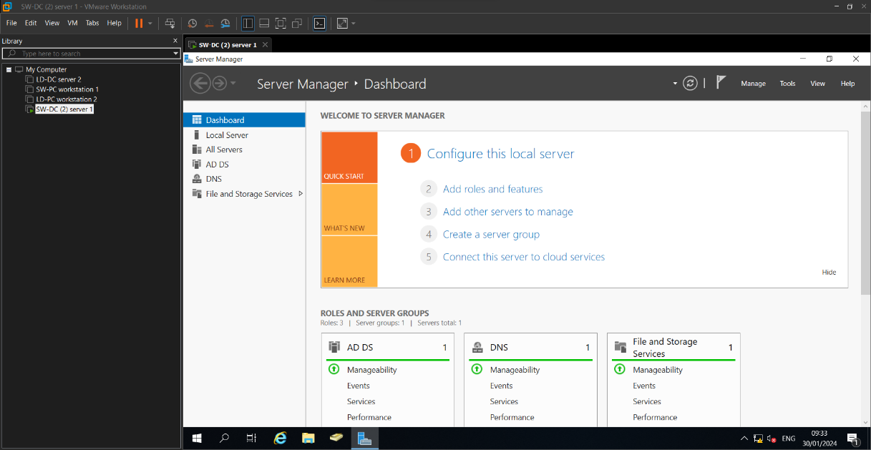

Administrator account

This is where IT-professional created the administrator user account which is the passwords and the login usernames which he named as Administrator. He also created administrator account in two workstations which are SW-PC and LD-PC IT-professional also made an administrator account for the LD-domain. He also gives all the systems the same passwords which are given in the topology diagram. [4] “As stated by Emily Matzelle she says, a server administrator configures and maintains servers and makes sure IT infrastructure runs smoothly in the following ways: Creates new user accounts, recovers lost passwords and keeps data secure. Develops and implements network maintenance standard operating procedures.” So, the administrator role is to keep a good system where they control networks and make user’s accounts for companies. They also help users for their accounts to recover their lost passwords and make new accounts.
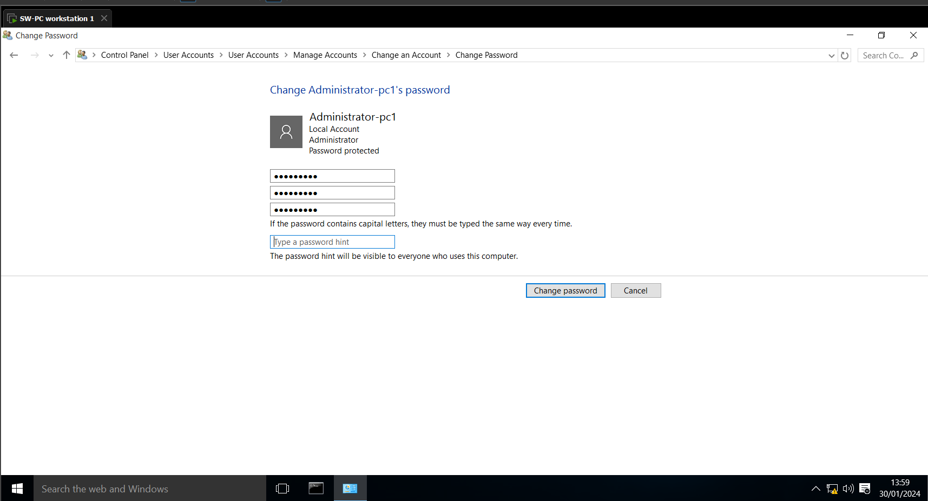
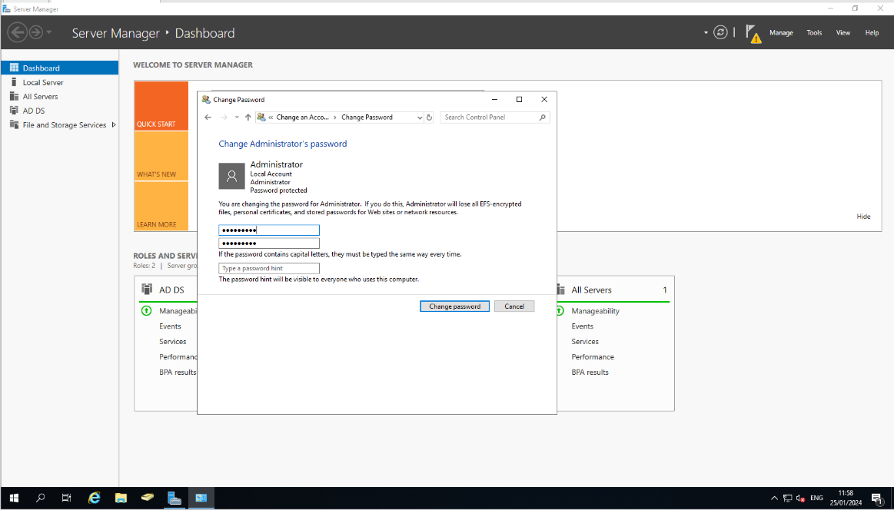

What is IP Address

An Internet Protocol short for IP is a unique identifying number assigned to every device connected to the internet. An IP address has been given to the device when they will be connected to the network. The network will give the users device a set of numbers that will only be given to that user. A lot of devices have an IP Address like Routes, mobile phone, laptops and etc. The devices that will give other system an IP address will be routers and Switchers as these devices will be running the network.
So, when these devices will be connected with the system, they will have an IP address that will be given from the Routers or Switches. The other role of the IP address is when devices will connect to the network it can send packets to other devices that will be connected to the network. [5] “As stated by Kai Hoffman he says, An IP packet is a unit of data in a network that contains information about the source and destination addresses and other control information need to transport the packet over a network.” So, this shows when devices will be connected to the network, they can send packets to other devices that will be connected to the system.

IPv4 and IPv6

The internet protocol version 4 which stands for IPv4 is a 32-bit system which identifies a network interface on a machine. The other internet protocol version 6 which is IPv6. This is the next generation internet protocol which has the 128- bit system. This is the latest IP address system and it is used by many more companies these days. The IPv6 also allows more users to join the network as it has a wide range of IP address to use.

Setting up IP address for the servers

These are the servers IP address that the administrator made the first IP address he made was the Swansea domain IP address which was 192.1.1.1. This server domain will control the Swansea workstation group that will be connected to the server. The administrator also made the IP address on the London domain which was 192.1.1.2, this domain server will control the London server group which will be connected to the servers.
[6] “As stated by Paessler they say, a sever is a computer or system that provides resources, data, services, or programs to other computers, known as clients, over a network. In theory, whenever computers share resources with client machines, they are considered servers.” So, this shows that a server is a system that handle people data and give users access to use the network on other devices.
So, when the administrator made the IP address for both of the servers. The system is running with Ipv6 which is the latest internet protocol which is running in many companies. [7] “As stated by Linksys they say, the internet Protocol version 6 (IPv6) is more advanced and has better features compared to IPv4. It has the capability to provide an infinite number of addresses. It is replacing IPv4 to accommodate the growing number of networks worldwide and help solve the IP address exhaustion problem.” So, IPv6 has a lot of benefits as it has the latest internet protocol and it also provides more IP addresses than the IPv4 internet protocol.

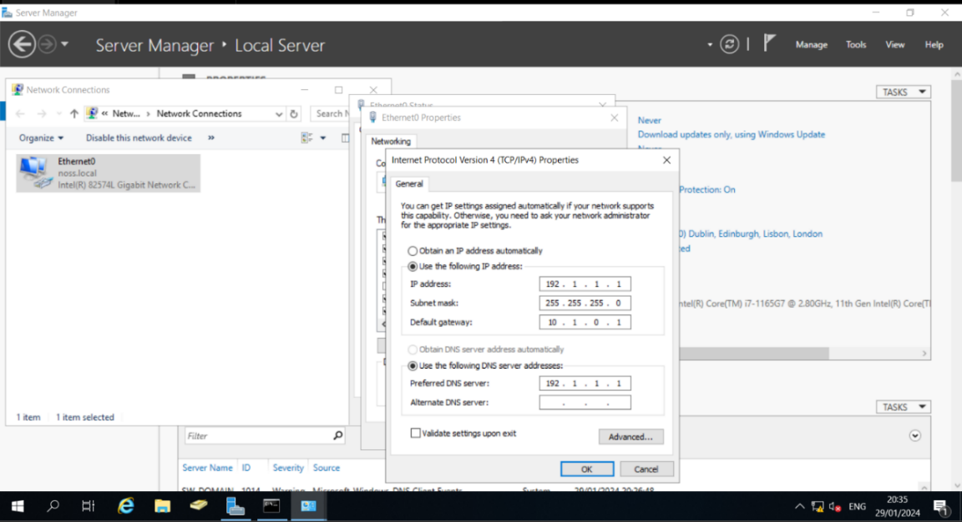
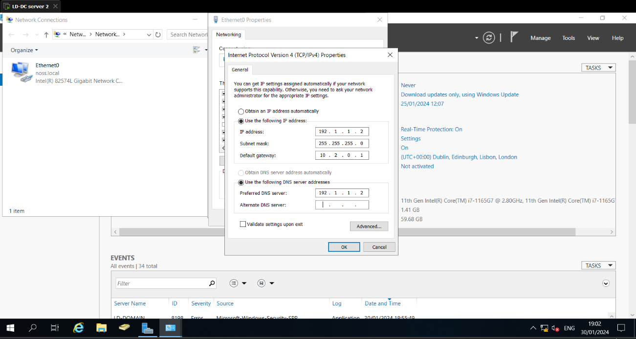

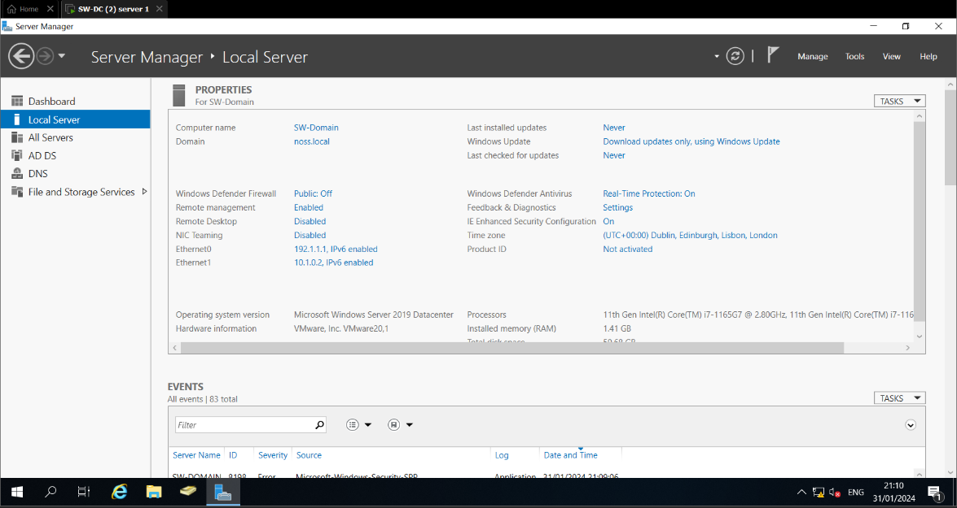

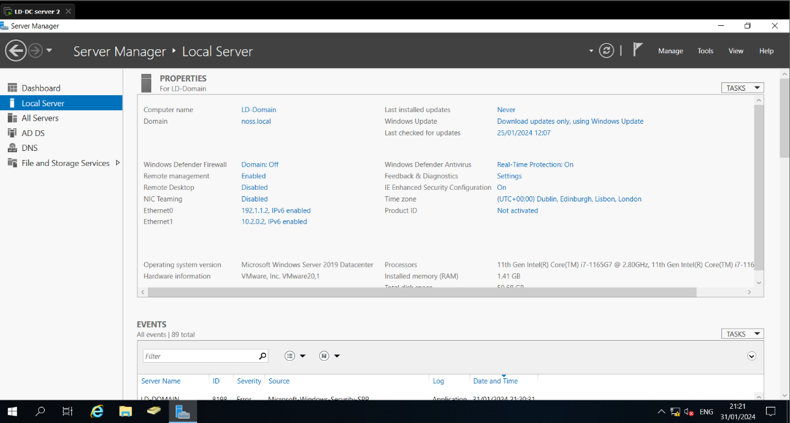

Setting up IP address for the workstations

This is where the administrator made the IP addresses for the workstations. The first workstation he made was the Swansea workstation. The IP address for this workstation was 10.1.0.2. So, he connected this workstation to the Swansea domain as the DNS IP address was 192.1.1.1. Therefore, this workstation was now connected to the Swansea domain server. So, the next thing he did is that he set up the London workstations. The IP address for this workstation was 10.2.0.2. So, the administrator connected this workstation to the London Domain IP Address which was 192.1.1.2. So, now this workstation was connected to each of their Domain servers.
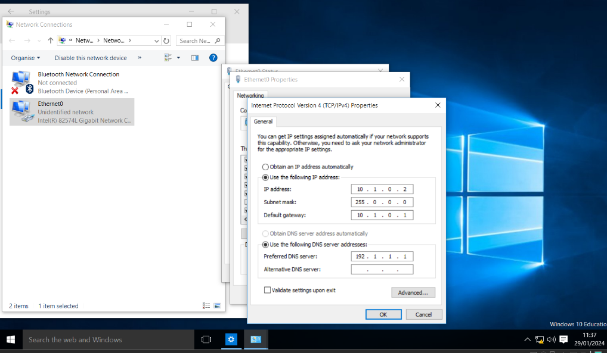

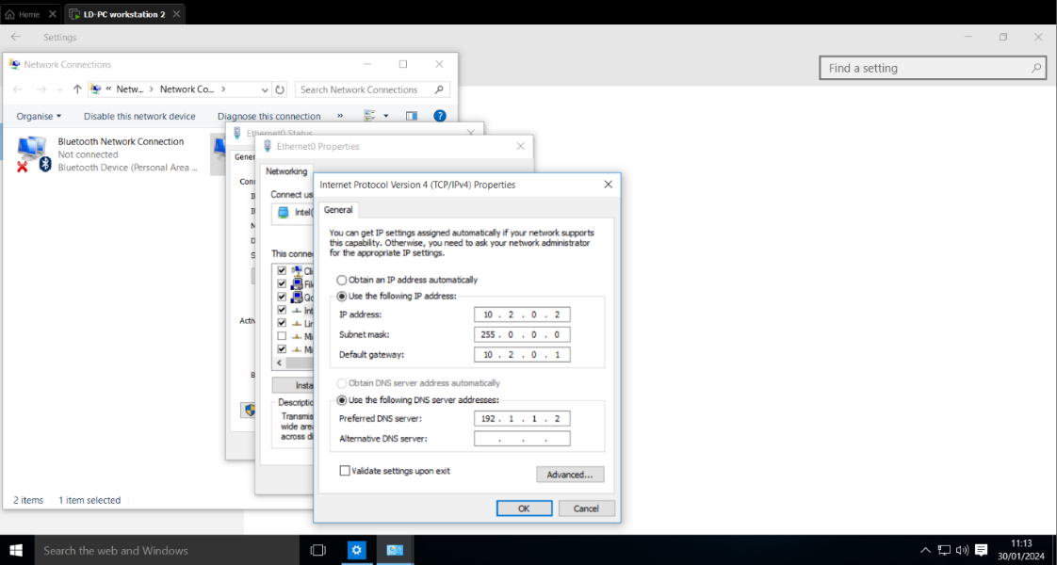

Setting up the names for workstation

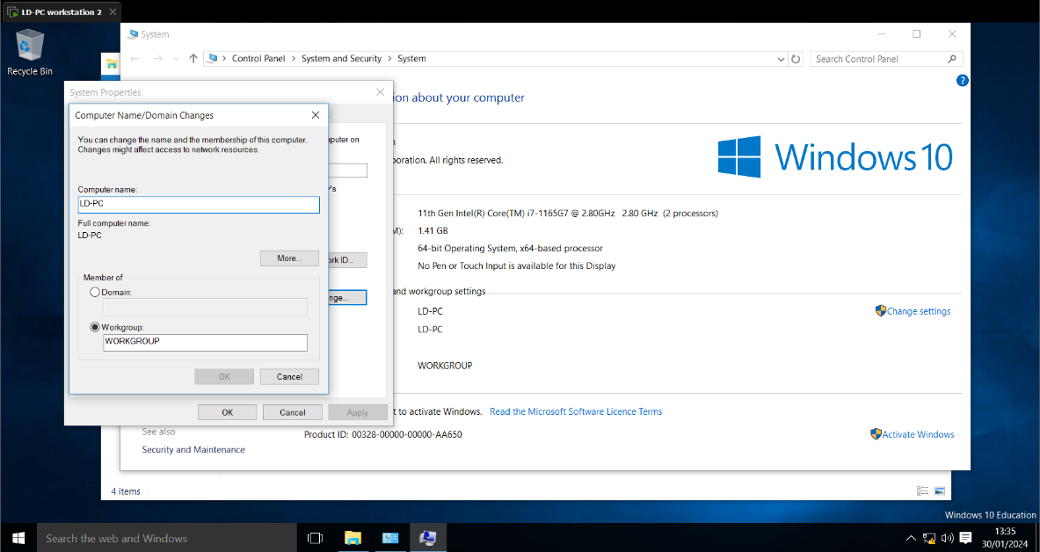
On this part the administrator set up the workstation PC names. So, the first workstation name he changed was the Swansea workstation PC to SW-PC. He has also done the same thing for the London Workstation PC to change its name to LD-PC. This naming will help people know which workstations they will be using in the future when the administrator will be making their users accounts.

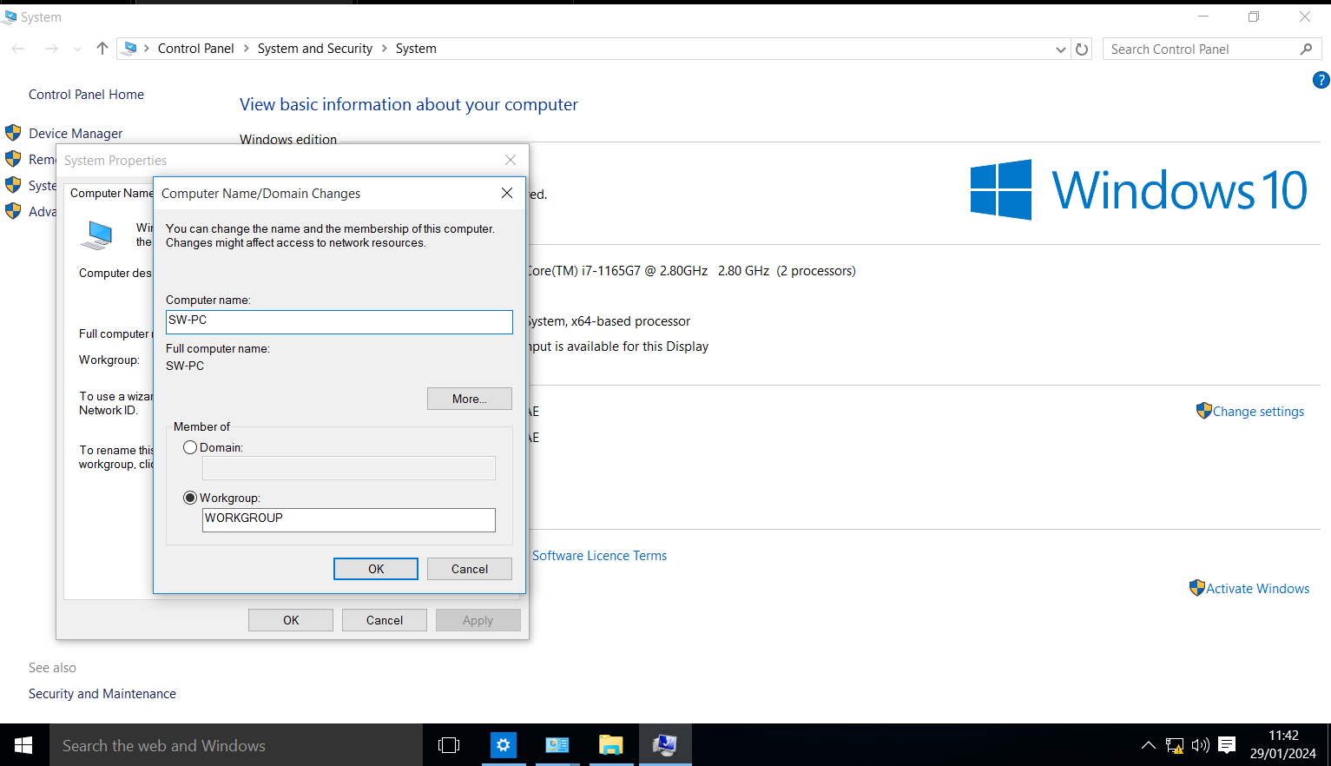

Setting up network cards

The first network card the administrator set up was the Swansea domain network card which was named SW-Domain. This will allow the domain to get a network connection. So, it will be able to give the users a network connection SW-PC Workstation. The administrator also has done the same thing for the London Domain as he added a network card. So, this would help the system connected to the network. This network will also give access to the LD-PC workstation as they will also get a network connection running through the server. [8] “As stated by Gustavus they say a network card, network adapter, LAN adapter or NIC (network interface card) is a piece of computer hardware deigned to allow computers to communicate over a computer network.” So, the role of a network card is to allow computers to communicate over the network. It also gives users access to connect other devices to the network.
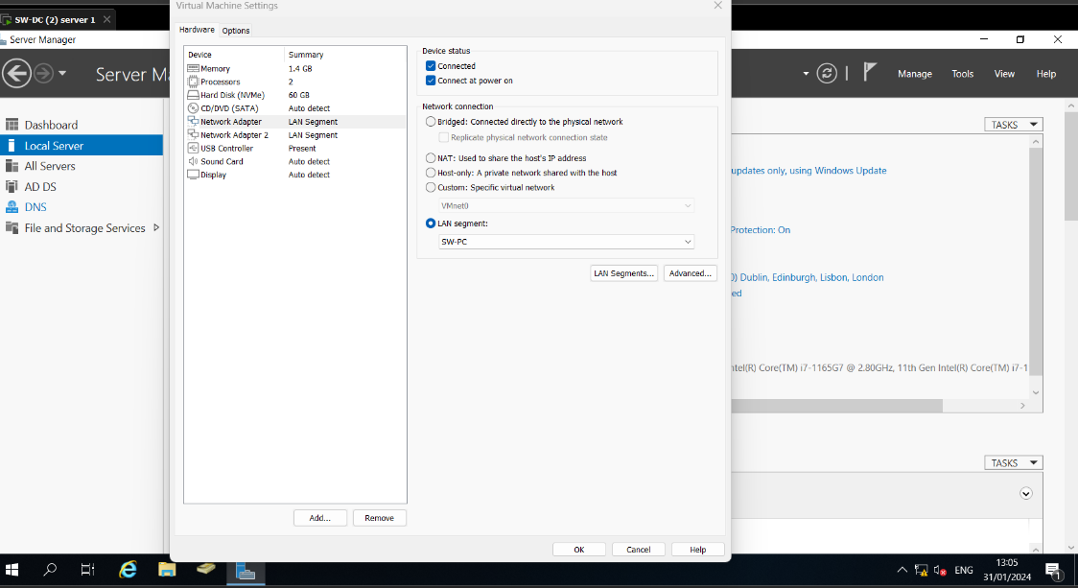

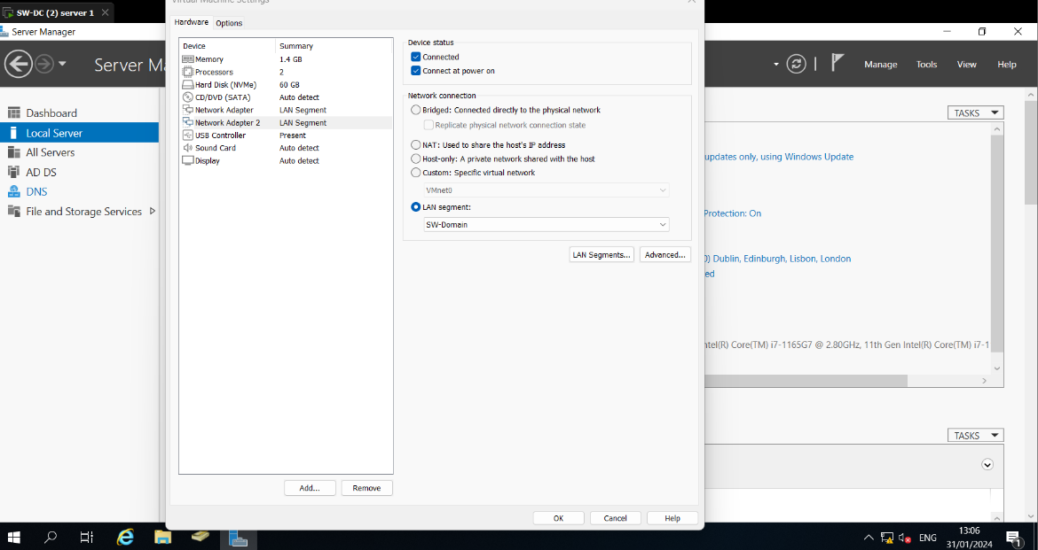

Testing connections

In this screen shot the administrator tested the connections if they are working correctly or not. Firstly, he tested the Swansea domain server. So, first he commanded the IP config to the system to check if it is recognizing the IP address which he put in the system. So, the server recognized the IP address which he gave to the Swansea server. Then he Ping the Swansea-workstation and it sent the packets to the system and the connection was successfully.
The next screen shot is where he tested the London domain server. On this server he also IP config the system to check if all the connections are correct and also it is recognizing the IP address. Then again, he pings the server to the London workstation. The ping was successful as it sent all the packets to the system and none of the packets were lost.
[9] “As stated by Microsoft they say, this command is most useful on computers that are configured to obtain an IP address automatically. This enables users to determine which TCP/IP configuration values have been configuration values have been configured by DHCP, automatic Private IP Addressing (APIPA), or an alternate configuration.”
So, the command Ip config will show if everything is running properly. For example, the DHCP should automatically provide the IP address which are given to the workstations and server. [10] “As stated by Shiksha online they say, With the ping command, you can quickly determine whether a machine has internet access and can communicate with other computers or network devices. Ping also has additional features such as: Network connectivity testing and network interface card troubleshooting.”
So, the command ping can help you to check if the network is connected with the servers and the workstations. It is a good test to check if the network is connected to the system or not. It can also be used for network interface card troubleshooting tasks.

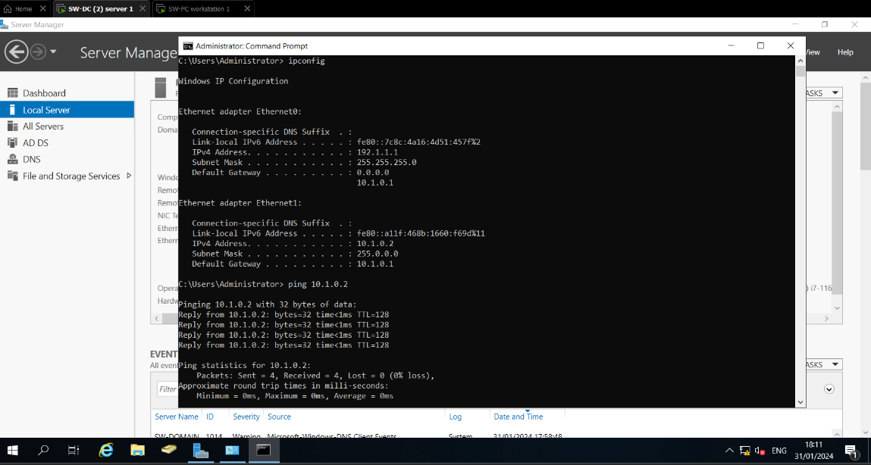

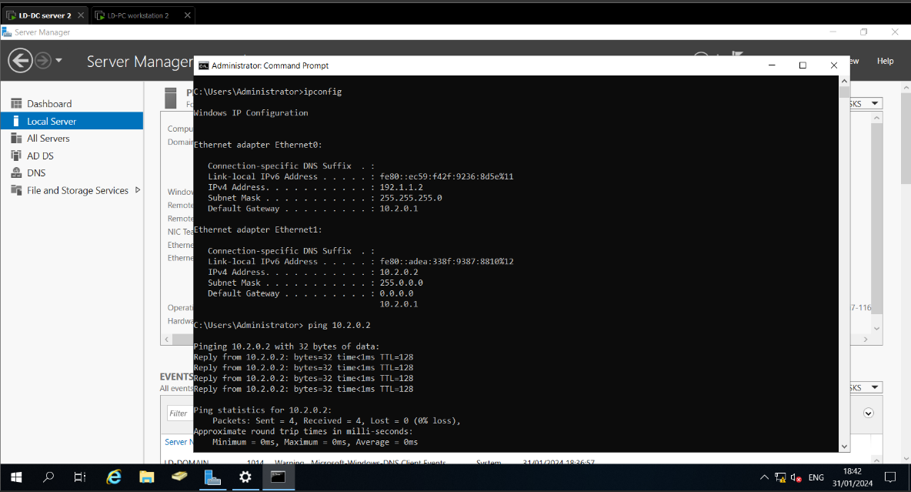

Conclusion

In conclusion, the Administrator (IT-professional) looked at different hypervisors and chose the one that suited him for the task he was given. He also set up the workstation for the Swansea workstation and the London workstation. Then he set up the servers and gave them names which were SW-DC and LD-DC. Then he gave the two severs IP addresses and the workstation. After giving them IP addresses, he tested if the network is running correctly with the system. So, this is a very efficient and reliable system for any users.

Bibliography

[1] | VMWare, “Implementing a new security approach with VMware,” VMWare, Friday January 2024. [Online]. Available: https://www.vmware.com/welcome/better-protect-apps.html#:~:text=VMware%20security%20solutions%20turn%20points,and%20responds%20to%20advanced%20attacks.. [Accessed 26/01/2024 January 2024].
[2] | H. Ashtari, “What Is VirtualBox?,” Spiceworks, Saturday January 2024. [Online]. Available: https://www.spiceworks.com/tech/cloud/articles/what-is-virtualbox/#:~:text=Oracle%20VM%20VirtualBox%20is%20a,architecture%20has%20the%20resources%20for.. [Accessed 27/01/2024 January 2024].
[3] | RedSwitches, “What are the main VMware benefits?,” RedSwitches, Tuesday January 2024. [Online]. Available: https://www.redswitches.com/blog/vmware-benefits/#:~:text=VMware%20provides%20better%20disaster%20recovery,and%20helps%20with%20resource%20management.. [Accessed 30/01/2024 January 2024].
[4] | E. Matzelle, “What is a server Administrator,” CompTIA, Monday May 2023. [Online]. Available: https://www.comptia.org/blog/your-next-move-server-administrator#:~:text=A%20server%20administrator%20configures%20and,network%20maintenance%20standard%20operating%20procedures. [Accessed 30/01/2024 January 2024].
[5] | K. Hoffman, “What is an IP packet,” Civo, Tuesday January 2023. [Online]. Available: https://www.civo.com/learn/ip-packets#:~:text=An%20IP%20packet%20is%20a,the%20packet%20over%20a%20network.. [Accessed 30/01/2024 January 2024].
[6] | Paessler, “What is a server,” Paessler, Wednesday January 2024. [Online]. Available: https://www.paessler.com/it-explained/server#:~:text=A%20server%20is%20a%20computer,as%20clients%2C%20over%20a%20network.. [Accessed 31/01/2024 January 2024].
[7] | Linksys, “Difference between IPv4 and IPv6,” Linksys, Thursday February 2024. [Online]. Available: https://www.linksys.com/in/support-article/?articleNum=139604#:~:text=The%20Internet%20Protocol%20version%206,the%20IP%20address%20exhaustion%20problem.. [Accessed 01/02/2024 February 2024].
[8] | Gustavus, “Network Card,” Gustavus, Wednesday January 2024. [Online]. Available: https://gustavus.edu/gts/Network_card#:~:text=A%20network%20card%2C%20network%20adapter,communicate%20over%20a%20computer%20network.. [Accessed Wednesday January 2024].
[9] | Microsoft, “Remarks,” Microsoft, Thursday February 2024. [Online]. Available: https://learn.microsoft.com/en-us/windows-server/administration/windows-commands/ipconfig. [Accessed 01/02/2024 February 2024].
[10] | S. online, “what is a ping,” Shiksha online, Thursday August 2023. [Online]. Available: https://www.shiksha.com/online-courses/articles/ping-and-why-to-use-the-ping-command/#:~:text=With%20the%20ping%20command%2C%20you,Network%20interface%20card%20troubleshooting. [Accessed 03/02/2024 February 2024].

