
Changemakers: Creativity and Value Creation
Artificial intelligence. Is it a good thing for the world of work?


liam jackson (2022666)

Contents
Is Artificial intelligence a good thing for the world of work or is it a threat to people’s jobs and livelihoods? 2
survey sample size and data analyse. 4
poster 7
elevator pitch 8
Conclusion 9
Reference list 10

Is Artificial intelligence a good thing for the world of work or is it a threat to people’s jobs and livelihoods?

Has artificial intelligence gone to far? According to (Kolmar, 2023) about half of all the worlds company’s use and implement some sort of artificial intelligence software within their workforce, due to the fact of more and more companies are implementing artificial intelligence it is estimated the over one billion people are at risk of losing their jobs and a total of 375 million jobs will be made totally obsolete within the next 10 years. What does this mean for everyday working people? And what benefits will companies gain from implementing the use of A.I instead of a human workforce? Will the use of A.I benefit the world, or will it do more harm then good? How will it effect the global economy? Will it benefit humanity for the better?
What is research design? According to (Creswell, 2009) are procedures and plans for the research that shape the decisions from broad statements and shape them into fine detailed methods of data collection and analysis. These plans can involve several decisions. The overall decisions involves what design should be used to study the topic that the researcher has chosen to study. The selection of a research design can also be shaped by the nature of the problem or issue that is being researched.
These are some of the questions that the author of this assignment (Liam Jackson) will try to answer within this assignment they have used a variety of research methods such as deductive research according to (Streefkerk, 2023) deductive research is the method of reviewing these theories that already been researched usually in an inductive way by other researchers, and testing the research to find out if the research matches up with the general consensus of these theories. The theory in question is, is artificial intelligence good for the world?
The author has also done a mixture of primary and secondary research to collect data for their assignment according to (George, 2023) primary research is research that has been done first hand by the researcher these can be in the form of surveys, questionnaires, interviews etc. some of the benefits of primary research is it gives the researchers the ability to directly ask the questions that matter the most to them allowing them to get to the heart of the issue that they are researching for. This type of research allows the researchers see through all the useless information that is surrounded the topic and get the information they need to conduct their research. Secondary research on the other hand according to (George, 2023) can also be a useful tool for researchers to use in their research. Secondary research is research that has already been done and published by other researchers. This type of research can be a massive benefit because most theories have had some sort of research undertaken on them already. some of the researchers are people within the industry that have the right connections to ask the right questions to the right people and in doing so will gain you massive value towards your own research. Some of the drawbacks of secondary research is that some information can get lost and become unfocused towards your own research not necessarily pinpointing the information that you need or are looking for. Another drawback is that is that some of the information that is published could not always be from credible sources, leaving the data and information you collected incorrect thus giving your own research a weak foundation to build upon. Loosing its weight and credibility in the world of research.
The researcher has also implemented a mix of qualitative and quantitative research methods according to (Bhandari, 2023) qualitive research is a collecting of non-numerical research such as text, video, audio data. The opposite of qualitive data is quantitative data according to (Bhandari, 2023) quantitative data is the collecting of numerical data such as statistics. The author of this assignment has done qualitive research in the form of surveys/questionnaires they then have taken the data they collected from their qualitative data and turned it into quantitative data that can easily be view and comprehended by the reader of the data.
According to (Creswell, 2009) a study can be either more quantitative or qualitative or vice versa. Mixed methods tend to be in the middle of these methods using both to better research your desired subject.

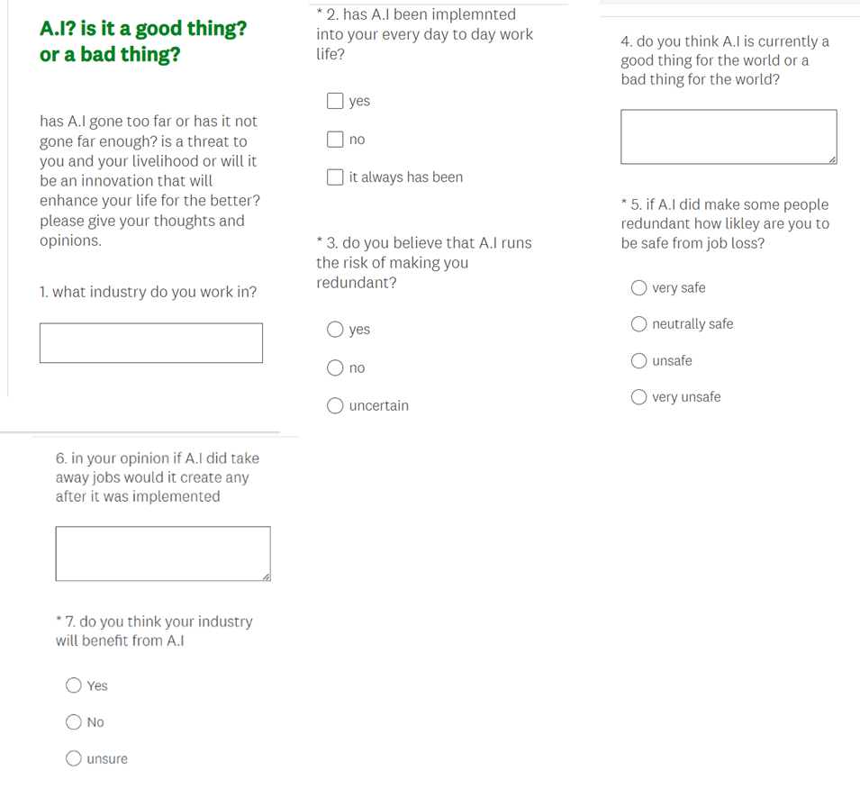
survey
sample size and data analyse.
The author of this assignment sent out a total of 14 surveys and got a total of 10 surveys completed and returned to them for them to further be analysed. What the author found was about 50% of the participants had a positive experience with A.I and the other 50% had a negative experience. With the group that had a positive experience with A.I did not fear that it would take over their life in a negative way. They believed that their industry was safe because their livelihood relied on human-to-human interaction in order to function on a day-to-day basis. These people word in industries such as the carer and beaty industry that requires human to human interaction as its very core to be effective and up to standard something that an A.I in their opinion would not be able to do. These people also had a positive opinion on A.I software such as chat GBT or MY A.I from snapchat and use that software as a tool for study or recreational fun. However, the group that had a negative response to A.I worked in industries such as tech. their jobs already had some sort of A.I software in place when they started working there and fear that with the advancements the A.I are making that they will be either made redundant or have a smaller human workforce leading to job loss and a more competitive nature within their company to keep their job. These people worked for companies such as amazon and uber. These people thought that the use of A.I will only increase over the next few years and will make many people obsolete. believing that Amazon will have totally human less factories with only a few technicians to run maintenance on the machines. The people that worked for Uber believed that in the near future Uber will have a fleet of driverless cars making the drivers redundant.
The author of this assignment did not have a big sample size only about 14 people of which 10 replied leaving the author with not a big pool of data to analyse from but however According to (Andrade, 2020) having a small sample size can have its benefits because the researchers are able to pinpoint and directly target who they want data from. You can also gain highly sophisticated and accurate measurements within your field of research. But having a small sample size still has its draw backs when compared to a larger sample size according to (www.caniry.com, 2023) a larger sample size is better because you are less likely to get false negatives or false positives and are more likely to identify outliers and reduce the risk of bias.
negative
positive
Below this page is a poster that has some questions around the research topic as of the nature of the data that was analysed the author has tried to make half of the graphic positive and friendly and the other half of the graphic negative and unfriendly in order to align with the 50/50 data they collected through the use of their research.






poster
Is artificial intelligence your friend? Or is it your enemy? Could it be used to make you more financially stable? Or will it take more than it gives? Is it affecting you or will it be affecting you in the near future? Has it been implemented within your workplace? Has it made work more productive for you? Or does it run the risk of taking your job from you? Or will it benefit you into a prosperous career?
A.I
Friend or foe?
according to (guides.nyu.edu, 2023) a conference poster is a tool used to portray your idea in a broad and creatively way leaving your idea more able to come to life within the minds of the people that see it, thus giving your idea to have a better chance that people will engage with it.

elevator pitch
what is an elevator pitch and why is it important? According to (Kenton,2022) an elevator pitch is a brief speech that is used to sell an idea to an individual. A good elevator pitch will allow the audience to feel interested and engaged with the idea that has been presented to them. Leaving them more likely to get on board with your idea and more willing to listen to what you have to say.
please click link to take you to elevator pitch.

https://uowtsd.sharepoint.com/teams/eleipitch_GRP/Shared%20Documents/General/Recordings/New%20channel%20meeting-20230616_125103-Meeting%20Recording.mp4?web=1
New channel meeting-20230616_125103-Meeting Recording.mp4

Conclusion
In conclusion is A.I effecting people for better or worse. In short yes and no, the sample size for the research reported a 50/50 positive and negative ratio with the answers they provided the 50% that had a positive experience with A.I worked in jobs where human to human interaction was at the very foundation of what their job was, such as beauticians and carers something that will always need a human touch to do. However, the 50% that had a negative opinion of A.I worked in industries that had already have implemented some sort of A.I software and worked for companies such as tech giant’s amazon and uber, companies that are already on the front line when it comes to innovation. Leaving them to believe that their workforce will either be made redundant or super competitive in the near future. However due to the relatively small size of the sample size it is hard to get a good idea of what this means for the world of work. The author of this work may have gone too wide and broad within their research question and may have gone not specific enough to accommodate the relatively small sample size. but as of now the author has concluded that about half of their study worry about the loss of their jobs and livelihoods and about half do not worry at all and are looking forward to what innovation the future of artificial intelligence brings.

Reference list

Andrade, C. (2020). Sample Size and its Importance in Research. Available at https://www.ncbi.nlm.nih.gov/pmc/articles/PMC6970301/ . (Viewed on 14/05/23)
Bhandari, P. (2022). What Is Quantitative Research? | Definition & Methods. Available at https://www.scribbr.co.uk/research-methods/introduction-to-quantitative-research/#:~:text=Quantitative%20research%20is%20the%20process%20of%20collecting%20and,causal%20relationships%2C%20and%20generalise%20results%20to%20wider%20populations. (viewed on 14/05/23).
Bhandari, P. (2023). What Is Qualitative Research? | Methods & Examples. Available at https://www.scribbr.co.uk/research-methods/introduction-to-qualitative-research/.(Viewed on 14/05/23).
Creswell, J.W. (2009). research design: qualitative, quantitative, and mixed method approaches. 3rd ed. Los Angeles, California: sage publications.
George, T. (2023). Primary Research | Definition, Types, & Examples. Available at https://www.scribbr.com/methodology/primary-research/. (Viewed on 14/05/23).
guides.nyu.edu. (2023). How to Create a Research Poster. Available at https://guides.nyu.edu/posters. Viewed on (20/05/23).
Kenton, W. (2022). What Is an Elevator Pitch? Definition and How They're Used. Available at https://www.investopedia.com/terms/e/elevatorpitch.asp (viewed on 20/05/23)
Kolmar, C. (2023). 23+ ARTIFICIAL INTELLIGENCE AND JOB LOSS STATISTICS [2023]: HOW JOB AUTOMATION IMPACTS THE WORKFORCE. Available at https://www.zippia.com/advice/ai-job-loss-statistics/. (Viewed on 14/05/2023).
Streefkerk, R. (2023). Inductive vs. Deductive Research Approach | Steps & Examples. Available at https://www.scribbr.com/methodology/inductive-deductive-reasoning/#Deductive%20Research%20Approach . (Viewed on 14/05/2023).
www.caniry.com. (2023). Why Is A Larger Sample Size Better? Available at https://www.caniry.com/why-is-a-larger-sample-size-better/. (Viewed on 20/5/23)

