Amy Gait
1702331
BA Fine Art
M4X01559

For my exhibition, I’m going to base it on feminist art. I feel like this genre isn’t talked about enough, as you have a range of mediums, artists that have their own spin on it. As, they have had different experiences positive and negative. As I read a statement that I agree with and have organised what artwork will present this statement best. “When a man gives his opinion, he’s a man. When a woman gives her opinion, she’s a bitch.” – Bette Davis. I feel like this is a valid statement as the world is very contradicting, and it seems like a lot of things don’t work two ways. I have picked six feminist artists to bring the statement to life, as well as picking their artworks that are able to teach lessons.
On the far left of the wall I would have Jenny Saville’s artwork ‘Propped’ (1992). It’s a large-scale oil painting. It’s a nude self portrait of herself sat on top of a stool, aggressively gripping onto her thighs with her ankles crossed. Her arms are crossed pressing her breasts together. This painting shows that she is distressed and weak as the head is tilted back out of the frame and her lips parted. In the background of the painting there is messy writing, with the quote by Luce Irigaray, a Belgian feminist theorist “if we speak as men have spoken for centuries, words will make us disappear.” Saville’s aim was to create a juxtaposition painting to the that men paint woman. It shows the natural form of the human body. Altogether this painting represents body consciousness and vulnerability, and Saville does it through body language, and the raw expression on her face. In this artwork the female would be portrayed negatively, as she is exposing the human body in and ‘ugly’ way. Jenny done this to question what ‘beauty’ actually is, it shows that everyone is beautiful in their own way, and it makes people evaluate their judgement.
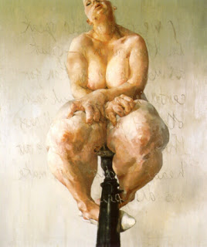
On a wall next to Jenny Saville I would then have a Tracy Emin’s video ‘Why I never became a dancer’ 1995, playing. It’s a video that has scenes from Emin’s hometown. This video shows her story of when she was growing up, and about sex she would have at 13,14 with older men. “I never asked them what the attraction was, I knew sex was what it was”. She explains the good and bad stories, what they had done and why she wanted to do this. She realised she was “innocent” and people had taken advantage of her at her worst time. She goes on to say how they thought of her as “flesh”, and she didn’t realise that until after she stopped having sex. The reason that she never persuade her dream of being a dancer was because of the people calling her names, chanting them as she was preforming. This shows how men see women as objects, as they only want them for sex, and once they get it they will put you down. It also takes us back to the statement, if it was a man sleeping around with different people they would be applauded and get called a ‘lad’. Whereas when a woman goes and has sex with a lot of people she’s a ‘slag’.
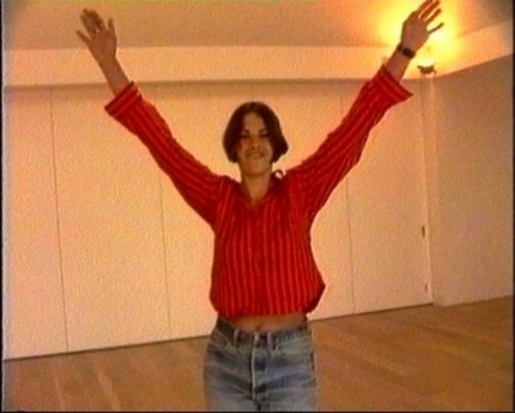

At the middle of the room I would want to put the artwork ‘Three weeks in January’ by Suzanne Lacy. I feel like this artwork is very informative and teaches people that there is a lot of problems involving sexual assault. The thought behind this artwork was to create awareness and to have daily rape reports stamped on a map by a performer on a map where it had happened. Apart of this artwork there was a series of events, workshops and self defence demonstrations, which was set up by Suzanne Lacy. Lacy done that along with sharing this information across social media platforms, radio interviews, featured in newspapers, and gave political speeches.
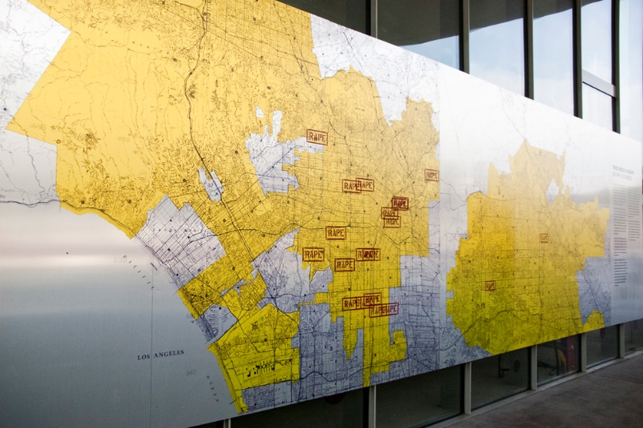

Next to Suzanne Lacy’s artwork, I will then display Jenny Holzer “Untitled (Men don’t protect you anymore)”. In a box which you can take one with you. She has created an artwork out of condoms and used her personal issues. It become apparent that she had AIDS and was worried about having this illness. So, she come up with ways to use that in this artwork, and yet teaching people a lesson at the same. Holzer had printed onto condom packets different quotes such as “Men don’t protect anymore” creating a juxtaposition between the quote and what its printed on. Also, it’s a good idea to have this in the exhibition as its different to a painting and a video, it stands out.
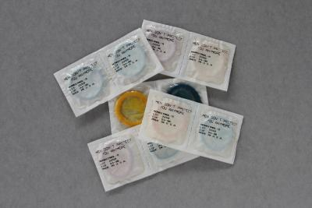

Next to this I would have the painting ‘Self-portrait with Cropped Hair’ by Frida Kahlo. Frida is a well know feminist artist which paints from her own personal experiences. In this painting she creates herself more masculine with short hair, and in a blazer suit. The haircut shows a small expression of her identity. She’s holding a braid on one hand showing the change in herself from this experience in her life, of her rejecting her innocence, but also shows that she had cut ties with that part of her life. On the wall Kahol has wrote lyrics from a song “Look, if I loved you it was for your hair, now that you are hairless I love you anymore” this is her own rejection from female roles.
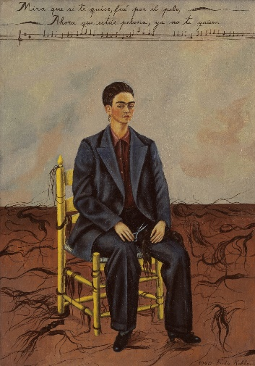

Then on the far right to finish the exhibition is Louis Bourgeois’ artwork called ‘Femme Maison (Women’s House). I would have this series of paintings which are representations of Bourgeois’ her early life in the 40s. Within marriage and domesticity and being a mother to three children. Each drawing or painting from the series is a nude female figure with the head being replaced with some sort of building that represents houses. These artworks show what the ideal representation is of women being ‘housewives’, and to have the domestic responsibilities. She struggled doing this in her early life as she felt trapped in the house but exposed by the responsibilities. It shows her vulnerability being exposed and shamed as the paining is a nude body. This artwork leads us back to the quote in the beginning, that we are living in a male dominant world, and we are seen at the ‘wives’, being judged by our sexuality. By exposing herself to her raw emotions to show the truth, and it can have a lot of backlash, which has a lot of courage.
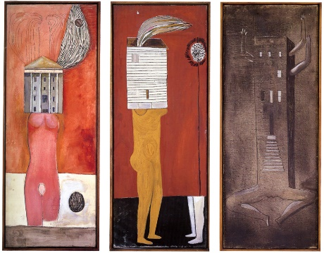
In conclusion I feel like I have picked a range of different pieces of artwork that would represent the statement in the beginning in its own way. I have also chosen a range of mediums on display, I have done this as I think it’s a lot more interesting, and there is something there for everyone. Also, with the placement of the artwork it’s not painting after painting, as I didn’t want it like that as I feel like that gets boring fast. So, mixing it up and putting something different artworks next to each other, although that could be cluttered and unorganised.

Goodreads.com. (2018). Feminism Quotes (3420 quotes). [online] Available at: https://www.goodreads.com/quotes/tag/feminism [Accessed 8 May 2018].

Anon, (2018). http://www.artnet.com/magazineus/reviews/cronin/jenny-saville-norton-museum1-12.aspway. [online] Available at: http://www.artnet.com/magazineus/reviews/cronin/jenny-saville-norton-museum1-5-12.aspway [Accessed 8 May 2018].

The Art Story. (2018). Tracey Emin Biography, Art, and Analysis of Works. [online] Available at: http://www.theartstory.org/artist-emin-tracey-artworks.htm#pnt_1 [Accessed 8 May 2018].

Artspace. (2018). "Some died, and the rest of us were changed": Jenny Holzer on Surviving the HIV Epidemic & Making an AIDS Memorial in New York. [online] Available at: https://www.artspace.com/magazine/interviews_features/qa/some-died-and-the-rest-of-us-were-changed-jenny-holzer-on-surviving-the-hiv-epidemic-making-an-55138 [Accessed 8 May 2018].

The Art Story. (2018). Louise Bourgeois Biography, Art, and Analysis of Works. [online] Available at: http://www.theartstory.org/artist-bourgeois-louise-artworks.htm [Accessed 8 May 2018].

Gompertz, W. (2018). My life in art: The day Bourgeois moved me to tears. [online] the Guardian. Available at: https://www.theguardian.com/artanddesign/2008/oct/07/louise.bourgeois [Accessed 8 May 2018].

The Art Story. (2018). Frida Kahlo Biography, Art, and Analysis of Works. [online] Available at: http://www.theartstory.org/artist-kahlo-frida.htm [Accessed 8 May 2018].

