LEVEL 4 ASSESSMENT SPECIFICATION
Programme: CertHE Computing Skills for Workplace
Module: Introduction to Web and Database Concepts
Module code: ACCA4023
Assignment Title: Design and Implementation of a Relational Database System
Student name: Naseer Sardar
Student ID number: 2512875

Contents
1. Introduction 2
4. Data Structure Design 7
4.1 Table Creation 7
Customers Table 10
Sales Table 10
Medicines Table 10
Suppliers Table 10
SaleDetails Table 10
7. Query Development 13
Query 1: Medicines Low in Stock 14
Query 2: Total Sales per Customer 14
Figure 9: Total sales amount for each customer, summarising their purchasing activity. 15
Query 3: Prescriptions by Customer 15
Query 4: Most Sold Medicines 15
Query 5: Sales by Date 15
8. Forms and Reports 16
8.1 Forms 16
12. References 20

1. Introduction
In the healthcare and retail setting of the contemporary healthcare industry, efficient data management is a key aspect that guarantees operational effectiveness, precision, and quality service provision. Pharmacies, especially, deal with huge amounts of organized and sensitive information, such as customer data, prescriptions, inventory data, and sales data. Conventional manual systems are not always able to handle such data and as a result of this their efficiency, duplication and chances of human error are likely to occur [1].
MediLink Pharmacy is a fast developing chain of community pharmacies, which, at the moment, operates using manual procedures to coordinate its everyday business activities. Such a strategy leads to a few operational problems, which include failure to follow the stock level, delays in accessing the customer records and inaccuracy in financial reporting. The larger an organisation is the more the necessity of automated and integrated systems to stay competitive and uphold quality of the service provided become critical [2].
The given project will have the following main goal: to design and introduce a relational database system based on using Microsoft Access which will allow beneficially administer all the activities of the pharmacy. The implicated proposed system will automatize the storage and retrieval of data pertaining to the medicines, suppliers, customers, prescriptions, and sales. This will allow increased accuracy of data, less redundancy and make it possible to make better decisions with structured queries and reports.
Relational database management systems (RDBMS) have become widely used because of their capability of storing information into a structured table which is connected by relationships to facilitate easy retrieval and manipulation of data [3]. Moreover, data consistency, integrity and scalability are guaranteed by the deployment of database design techniques like entity-relationship modelling and normalization [4]. This report presents the design and implementation of MediLink Pharmacy database, which shows how important database concepts and principles are applied.
2. Scenario Analysis
2.1 Identification of Entities
Entities are real life objects or concepts in database design where data is gathered and kept about the objects. The identification of the right entities is one of the key procedures in developing an efficient database system as it guarantees that all the required properties of the business procedure are addressed [5].
According to the needs of the MediLink Pharmacy, the following core entities were also determined:
- Customers
- Medicines
- Suppliers
- Prescriptions
- Sales
- SaleDetails
All these are the entities that constitute the operation structure of the pharmacy. As a case in point, the customers can engage with the system by making purchases and prescribing medicine, whereas medicines and suppliers are necessary in managing inventory. Data on sales and SaleDetails are transactional data, very important in financial analysis and reporting.
2.2 Attributes of Entities
Every entity is characterized by a collection of attributes that define the features of it. Attributes are necessary to organize the tables of the database and to make sure that all the necessary information is recorded correctly.
Customers Entity
The Customers table contains the data regarding people who buy medicines. It has these characteristics: CustomerID (primary key), Name, Phone, and Address. A special primary key is used that guarantees the uniqueness of the identification of each customer in the system [3].
Medicines Entity
The Medicines entity holds the information of pharmaceutical products. Attributes are MedicineID (primary key), Name, Category, Price, Stockquantity, SupplierID (foreign key). SupplierID allows establishing the linkage between medicines and suppliers.
Suppliers Entity
This entity is a representation of organisations that will provide medicines to the pharmacy. It contains SupplierID (PK), Name, Contact, and Address. The keeping of supplier information separately helps in eliminating redundancy and enhancing data organisation.
Prescriptions Entity
The Prescriptions entity stores information of medical prescriptions given to customers. These attributes are PrescriptionID (PK), CustomerID (FK), Date, and DoctorName. This body makes sure that there is proper linkage of prescription data with customers.
Sales Entity
The Sales table is a table that stores the transaction information such as SalesID (Primary Key), CustomerID (Foreign Key), Date and Total Amount. The table is important in monitoring revenue and customer activity.
SaleDetails Entity
The many to many relationship between the Sales and Medicines is solved with the help of the SaleDetails entity. It has SaleDetailID (primary key), SaleID (foreign key), MedicineID (foreign key), and Quantity. This format is capable of linking several medicines with one sale.

2.3 Relations between Entities
Relationships indicate the interaction between entities in a database. Proper relationships need to be established to make sure that data is consistent and data can be readily retrieved [4].
MediLink Pharmacy database contains the following relationships:
- Multiple prescriptions (one-to-many relationship) of a customer are possible.
- There is a one-to-many relationship where a customer is able to make several sales.
- The sale may consist of a combination of various medicines which are denoted by the SaleDetails entity (One to many relationship between Sales and SaleDetails).
- The relationship between a medicine and a sale may be many-to-many between SaleDetails.
- A supplier is capable of providing more than one medicine (one-to-many relationship).
Such relationships provide a logical structure of data and reduction of redundancy. A database design method, which is a well-accepted one, is to solve many-to-many relationships using associative entities, which increases flexibility and scalability [5].
3. Entity Relationship Diagram (ERD)
ERD gives an overview of the database design in the form of a graph. It depicts entities, attributes, primary keys, foreign keys as well as the relationship between entities. ERDs are important database design tools because they aid in visualising the organization and correlation of data prior to implementation [6].
The ERD in the MediLink Pharmacy system shows the connection of Customers with Sales and Prescriptions by use of foreign keys. Likewise, the association with Suppliers exists so that any product is connected with an actual supplier. The SaleDetails entity is responsible of mediating between Sales and Medicines and the many-to-many relationship is solved.
ERD also determines the cardinality which determines how many times an entity can be associated to another one. As an illustration, between the Customers and Sales, the relationship is one to many implying that a customer may have various sales records. Correct definition of cardinality is useful in proper data modelling and in avoiding logical mistakes in database design [6].
Designing an ERD before implementation enables the designer to detect some potential problems, verify requirements as well as making sure that database architecture is business friendly. It can also be used as a template in developing the database in Microsoft Access.

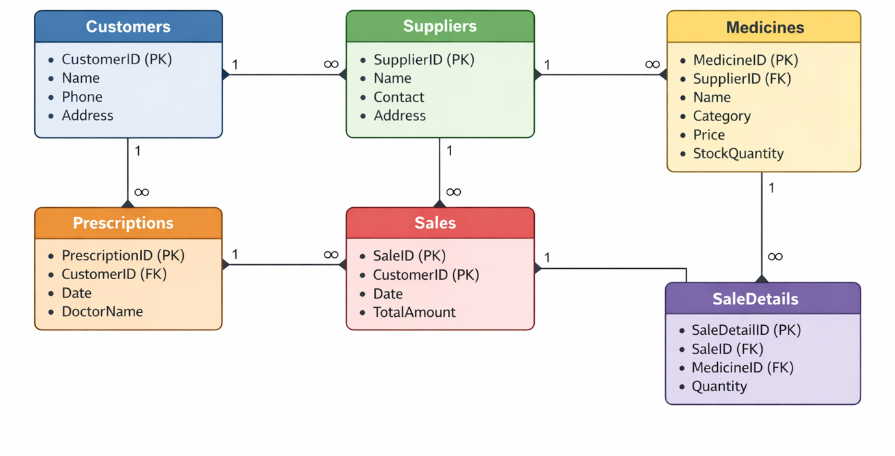
Figure 1: ERD Diagram for MediLink Pharmacy

4. Data Structure Design

4.1 Table Creation
The database was installed in the Microsoft Access by creating tables that represented each of the identified entities. Each of the tables was thoroughly planned to hold particular details of data pertaining to the operations of the pharmacy.
The tables created include:
- Customers
- Medicines
- Suppliers
- Prescriptions
- Sales
- SaleDetails
All the tables have a primary key to identify records uniquely and the right fields to store entity attributes. This systematic style makes data to be structured and manageable.
4.2 Data Types and Field Selection
It is important to choose proper data types to ensure data integrity and enhance the performance of the system. Data of various kinds demand various forms of data storage and data of the wrong type may cause inconsistency and errors [3].
The database used the following types of data:
- Primary keys: autonumbered so that they are unique.
- Short Text As the names, categories and addresses are short.
- Quantity and identifier number.
- Currency of price and sum total.
- Date/Time of taking the transaction and prescription dates.
The proper data types guarantee that there is an efficient storage of data and that facilitates proper calculation and queries.
4.3 Relationships and Constraints
The Microsoft Access was used to establish the relationships between tables through the use of a foreign key. The referential integrity was imposed in order to provide consistency between the table relations. As an illustration, it is impossible to have a sale record without an existing customer, and a medicine without an existing supplier.
Primary key constraints and foreign key constraints were used as constraints to ensure the accuracy of data and avoidance of invalid data entry. Moreover, there was also the use of cascade update options where possible to make sure that any updates in one table are passed onto other related tables.
These constraints are essential in avoiding anomalies like orphan records and also maintaining the stability and quality of the database at a later point in time [4].
5. Normalisation (Up to Third Normal Form)
Normalization is a methodical way of structuring data in a database so as to minimize redundancy and enhance data integrity. It is associated with the separation of data into various related tables and the establishment of relationships between them [5].
Table1: Unnormalized form (UNF)
SaleID | CustomerName | MedicineName | Quantity | SupplierName
S001 | Ali Khan | Paracetamol | 2 | PharmaSupplies
S001 | Ali Khan | Cetirizine | 1 | HealthCorp
- Repeating data
- Redundancy
- No structure
First Normal Form (1NF)
The database meets First Normal Form since all the tables have atomic values, there are no repetitive groups or multi-valued attributes. There is only one value of each field making it clear and consistent.
Table 2: First Normal Form
SaleID | CustomerName | MedicineName | Quantity
S001 | Ali Khan | Paracetamol | 2
S001 | Ali Khan | Cetirizine | 1
- Atomic values
- Still redundancy
Second Normal Form (2NF)
The database satisfies Second Normal Form because all the non-key attributes are entirely dependent on the primary key. The partial dependencies were eliminated through taking data to different tables which includes disentangling Sales and SaleDetails.
Table 3: Second Normal Form
SaleID | CustomerName
S001 | Ali Khan
Sale details
SaleID | MedicineName | Quantity
S001 | Paracetamol | 2
S001 | Cetirizine | 1
- Removes partial dependancy
Third Normal Form (3NF)
The database meets Third Normal Form as it will remove transitive dependencies. All the non-key attributes are based on the primary key and not on other non-key attributes. To illustrate, suppliers information is stored in the Suppliers table rather than in the Medicines table as it is duplicated.
Table 4: Third Normal Form

Customers Table
CustomerID | CustomerName
C001 | Ali Khan

Sales Table
SaleID | CustomerID
S001 | C001

Medicines Table
MedicineID | MedicineName | SupplierID
M001 | Paracetamol | S001
M002 | Cetirizine | S002

Suppliers Table
SupplierID | SupplierName
S001 | PharmaSupplies
S002 | HealthCorp

SaleDetails Table
SaleID | MedicineID | Quantity
S001 | M001 | 2
S001 | M002 | 1
Normalization enhances the efficiency of database by minimizing redundancy and also, an update, an insertion and a deletion do not cause any inconsistency [2].
6. Sample Data Population
Upon coming up with and deploying the database structure, the sample data was inserted in every table to replicate real operations in MediLink Pharmacy. The process of data population is very crucial in the development of a database since it enables testing of the relationships, queries as well as system functionality [1].
The records that were brought into the table were at least five that comprised the following tables; Customers, Medicines, Suppliers, Prescriptions, Sales, and SaleDetails. The sample data was planned to be realistic representing the pharmacy situations, i.e., customers buying medicines, prescription issue, and suppliers delivery.
In their example, the table of Customers had the records of Ali Khan and Sara Ahmed, whereas the table of Medicines had a list of commonly used pharmaceutical products and price and stock quantities. In the same manner, the Sales table was to be filled with the transaction data, such as dates and sums.
The quality data in the database facilitated the testing of queries and report to be sure that the system will act as per the real world scenario. It was also useful in detecting the possible data mistakes and making sure that the connections between tables were valid.
As illustrated in the tables below, the sample data that will be inserted in the database of the MediLink Pharmacy is the following data that will be used to simulate real-world operations. In every table, there are at least five records to illustrate the storage and relationship of customer, medicine, supplier, prescription, and sales information.

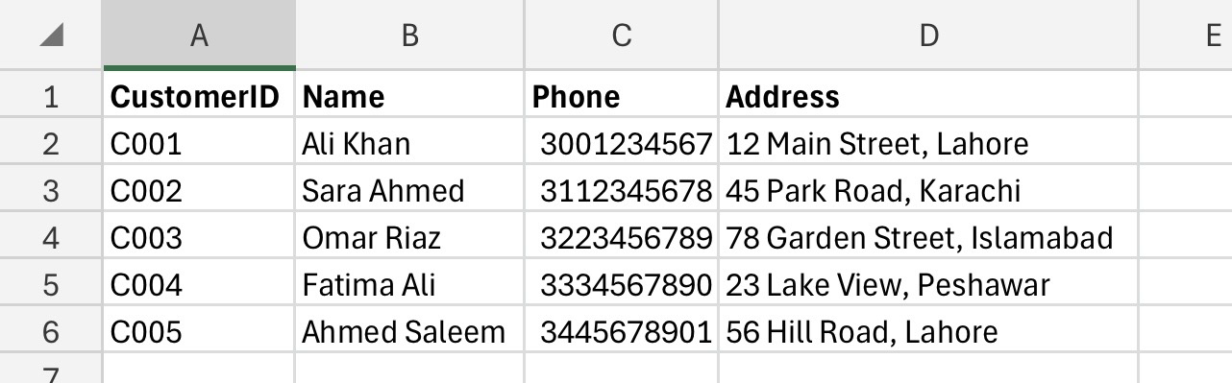

Figure 2: Sample Customers table with five records
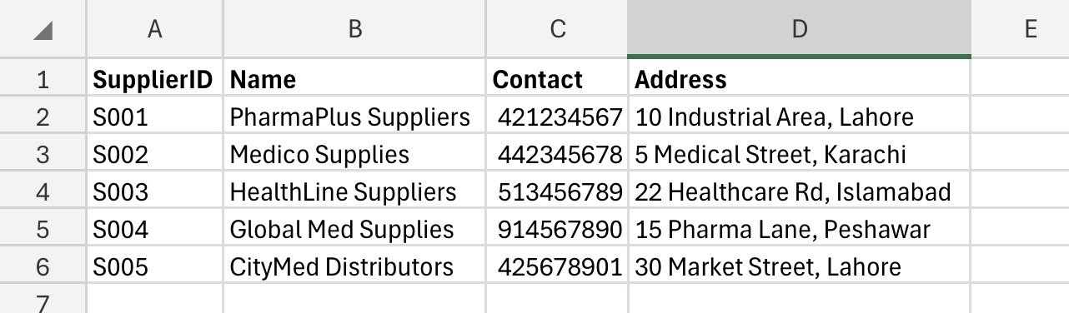
Figure 3: Sample Suppliers table with five records

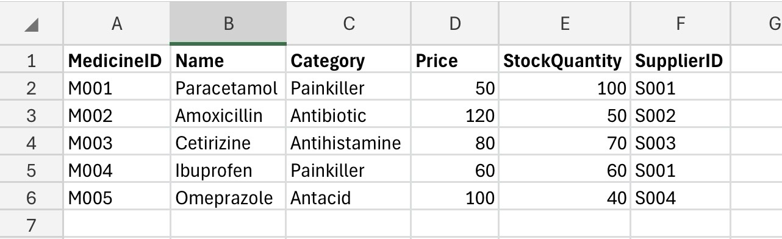

Figure 4: Sample Medicines table with five records
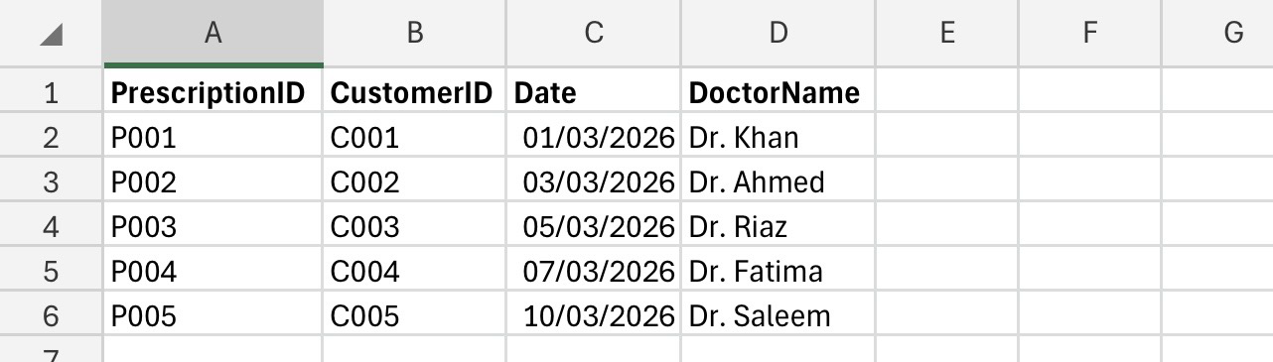
Figure 5: Sample Prescriptions table with five records

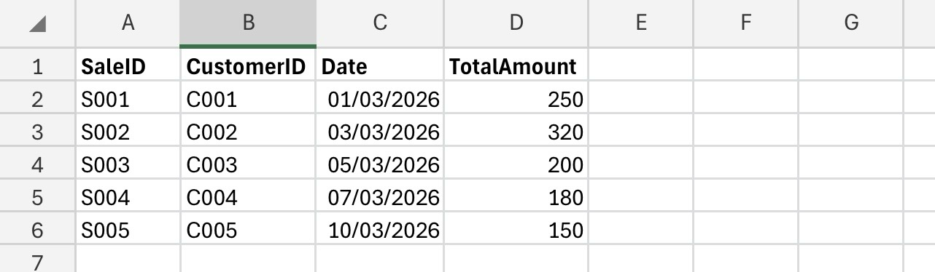
Figure 6: Sample Sales table with five records

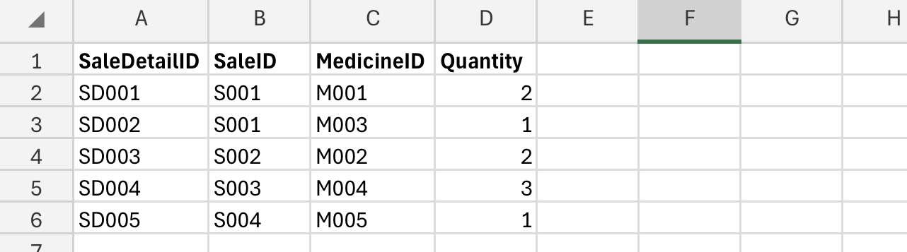

Figure 7: Sample SaleDetails table showing medicine quantities per sale

7. Query Development
The queries are an essential part of relational databases that enables users to access, filter, and analyse data effectively. This project has developed a number of queries that will be used to address the operational and analytical requirements of MediLink Pharmacy [3].
7.1 Medicines Low in Stock
This query is used to describe medicines whose level of stock falls below a set level. It is more valuable in terms of inventory management whereby the staff know when to re-order products.
7.2 Total Sales per Customer
This query sums up the total expenditure made by individual customers. It gives information on the customer buying behaviour and assists in the identification of the high-value customers.
7.3 Prescriptions by Customer
This query gets all the prescriptions of a given customer. It enables the pharmacy to keep proper medical records that can be easily accessed in order to dispense the medicines properly.
7.4 Most Sold Medicines
This query helps in determining medicines that have the largest volume of sales. It assists in decision-making associated with the analysis of stock and demand of the products.
7.5 Sales by Date
This query presents sales transaction of a particular date or period. Depending on its use of computing daily performance and production of financial summaries is helpful.
All queries were well structured using query logic to make them accurate and efficient. Sample data was used to test queries to make sure that the queries gave correct and meaningful results. Properly written queries are important in converting raw data to practical data in order to make decisions [4].

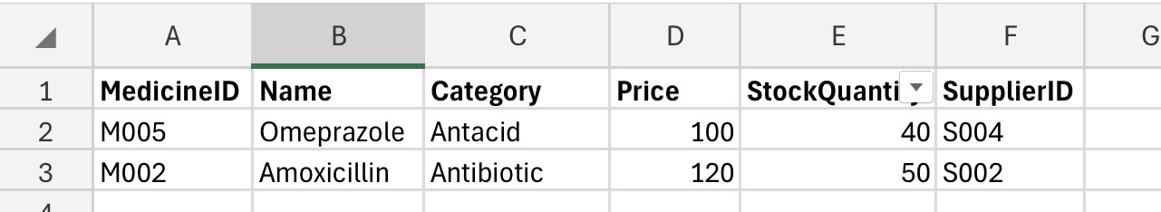
Query 1: Medicines Low in Stock

Figure 8: Medicines with StockQuantity less than 50, highlighting items that require reordering.

Query 2: Total Sales per Customer

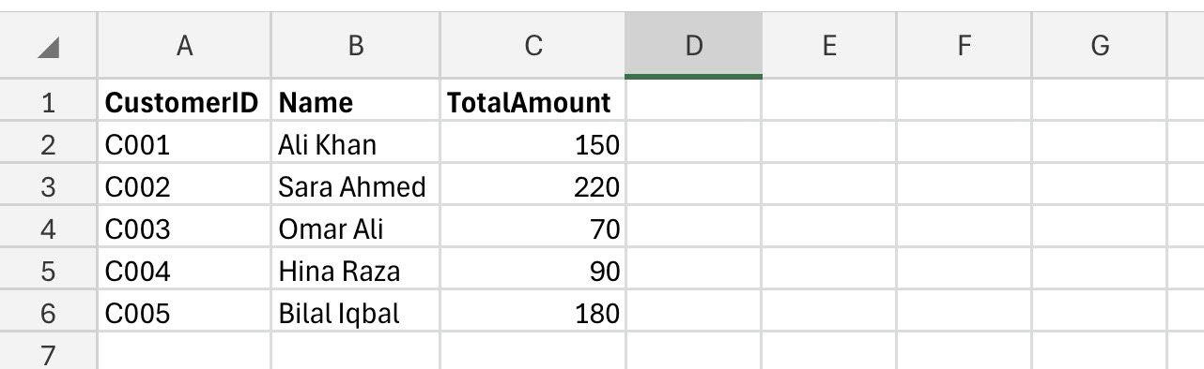
Figure 9: Total sales amount for each customer, summarising their purchasing activity.

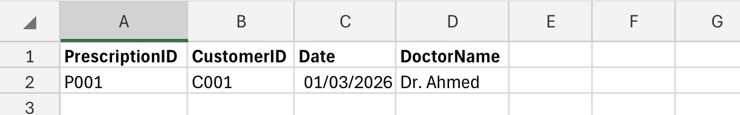
Query 3: Prescriptions by Customer
Figure 10: List of all prescriptions associated with a specific customer, showing prescription dates and prescribing doctors.

Query 4: Most Sold Medicines
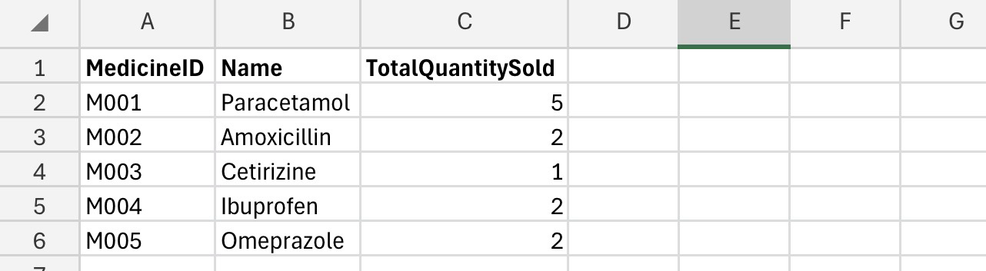
Figure 11: Medicines with the highest sales volume, used for analysing product demand and inventory planning.

Query 5: Sales by Date
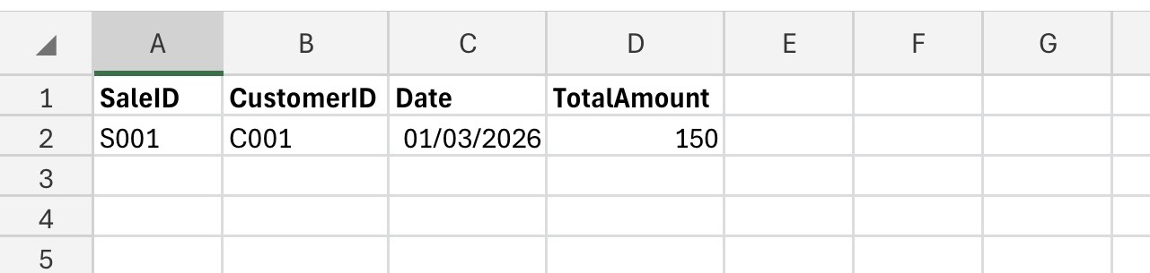
Figure 12: Sales transactions for a selected date or period, supporting daily performance and revenue monitoring.

8. Forms and Reports

8.1 Forms
Microsoft Access forms were designed to give a convenient user interface to data entry and management. Forms make it easy to communicate with the database: they enable the user to feed in information without starting to access tables, so there is less chance of a mistake [3].
It has developed the following forms:
- Customer Form: Adds and updates customer.
- Sales Form: This is used to capture sales transactions.
These forms have been developed with the help of the Form Wizard and adjusted to add specific fields and labels. Input controls were put in place so that the data that is keyed in by the user is correct.
8.2 Reports
Reports were prepared to present information in a coherent and comprehensive format. Reports play a crucial role in summarising the information and assisting the managers in decision-making [1].
The following reports have been prepared:
- Sales Summary Report: This shows the total sales and transactions.
- Medicine Stock Report: Displays the stock quantities of medicines.
These reports entailed groupings and calculations, including totals and averages, to have a closer look at business performance. As an illustration, Sales Summary Report will enable the management to examine the trends in revenues whereas Stock Report will be used to track inventory.
Forms and reports make the database system easier to use and are needed to be able to interact with data.
9. Validation and Testing
Validation and testing are important parts of the database development, as it makes sure that the system works properly and that it offers what the users need. By adequate testing, errors, inconsistencies, and possible improvements can be determined prior to deployment [4].
9.1 Testing Methods
The MediLink Pharmacy database was developed using several testing methods:
- Data Entry Testing: Made sure that data was able to be inputted properly using forms.
- Relationship Testing: Checked foreign key relationships to be enforced correctly.
- Query Testing: Did queries give correct and expected responses?
- Integrity Testing: Ensured that referential integrity constraints were enforced.
9.2 Results
As revealed in the testing process:
- Every association among tables was working well.
- Queries generated useful and valid outputs.
- Integrity of data was ensured in all tables.
- Forms enabled entry of data in an efficient and error-free way.
9.3 Issues and Improvements
Minor problems were found during testing and corrected. As an illustration, certain earlier faults in the relationships were removed by adequately connecting foreign keys. Also, the types of data were modified to have correct calculations, specifically for currency fields.
The validation rules may be extended further in subsequent versions to limit invalid entries of data, including negative stock values or improper date format.
10. Reflection
The MediLink Pharmacy database also offered possible insights into database design and implementation. The problem of defining relationships between entities was one of the major problems and the key issue that needed to be resolved was how to solve many-to-many relationships through associative tables like the SaleDetails.
The other problem was making sure that the database complies with normalization principles but can still be used. To attain Third Normal Form, tables have been restructured so that redundancy is removed without affecting functionality.
Writing queries was a complicated process, too, since it involved a good idea of what the user needed and the connections in the data. Making sure that queries yielded significant answers required several reiterations and trial.
The system may be improved in future by:
- Installing alerts of running out of stock.
- Combining the database with web based ordering systems.
- Additional features with graphical analysis of reporting.
- Enhancing computer interface design to enhance usability.
This project has made a great contribution in improving the knowledge of relational databases and a realistic approach of working with Microsoft Access.
11. Conclusion
The problem of manual management of data cannot be managed effectively in MediLink Pharmacy database system because it offers a streamlined and organized solution to the management of pharmacy functions. The system brings together important constituents like customers, medicines, suppliers, prescriptions and sales into a single database.
Using the principles of relational databases such as entity-relationship modelling, normalisation, the system can guarantee data integrity, reduce redundancy and facilitate effective data retrieval. Forms, reports, and queries add functionality to the system and allow users to complete their day-to-day tasks and generate meaningful insights.
Generally speaking, the database system fulfills the functionality needs of MediLink Pharmacy and gives the system a scalable base to build on in the future. The project indicates the significance of good database design in enhancing organisational efficiency and decision making.

12. References

[1] T. Connolly and C. Begg, Database Systems: A Practical Approach, 6th ed., Pearson, 2015.
[2] R. Elmasri and S. Navathe, Fundamentals of Database Systems, 7th ed., Pearson, 2016.
[3] Microsoft, “Microsoft Access Documentation,” 2024.
[4] A. Silberschatz, H. Korth, and S. Sudarshan, Database System Concepts, 7th ed., McGraw-Hill, 2019.
[5] C. J. Date, An Introduction to Database Systems, 8th ed., Pearson, 2004.
[6] Oracle, “Database Design Basics,” 2023.
[7] S. Coronel and P. Rob, Database Systems: Design, Implementation, and Management, 13th ed., Cengage, 2019.

