STRATEGIC MANAGEMENT AND SUSTAINABILITY
MODULE CODE: LCBB 6015
COMPONENT 1: COURSEWORK: WRITTEN REPORT

STUDENT NAME:STOICAN RAMONA-IULIANA
STUDENT ID:2246688

Executive Summary
This report is an analysis of the strategic position of Jaguar Land Rover in the global automotive industry that is rapidly changing. It analyses the external environment on either PESTLE and Porter's five forces frameworks and examines internal capabilities on Value Chain, VRIO and SWOT analysis. The results show that good brand equity, leadership in the premium SUV, is a competitive advantage, whereas supply chain risks and the high costs of operation are a challenge. The report sets strategic options for the areas of electrification, brand differentiation, expansion into emerging markets, and operational efficiency. The recommendations are given clearly to reinforce JLR's market share and to make the business sustainable in the long run.

Table of Contents
Executive Summary 1
1. Introduction 4
2. Strategy Analysis 5
2.1 External Environment Audit 5
2.1.1. PESTLE Analysis 5
2.1.2. Porter’s Five Forces Analysis 7
2.2. Internal Environment Audit 7
2.2.1 Value Chain Analysis 7
2.2.2 VRIO Analysis 9
2.3 SWOT Analysis 9
3. Strategy Formulation – Jaguar Land Rover 11
4. Conclusion and Recommendations 12
References 13

1. Introduction
Organisational strategic management is critical in an organisation that competes in a dynamic and competitive industry, as it allows organisations to match internal competencies with the external market conditions to be able to grow sustainably (Bari, Chimhundu and Chan, 2022). In the case of Jaguar Land Rover (JLR), one of the most renowned manufacturers of luxury vehicles in the United Kingdom, strategic direction cannot be underestimated in the context of the industry change under the pressure of electrification, digitalisation, and sustainability. Having an effective vision, mission, and clear objectives contributes to the long-term competitiveness and position of JLR in the market of premium cars in the world (Jaguar Land Rover, 2018). The report analyses the environment of JLR, capabilities, strategic problems, alternatives, and recommendations for sustainable growth.
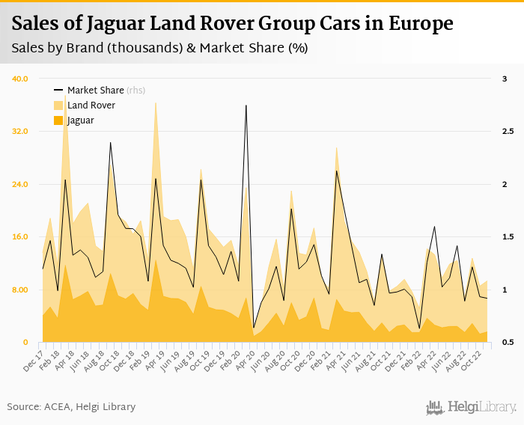
Figure 1: Sales of Jaguar Land Rover Group
Source: (Helgi Library, 2022)

2. Strategy Analysis

2.1 External Environment Audit

2.1.1. PESTLE Analysis
Political
Jaguar Land Rover has a very controlled worldwide business environment in which political aspects play a key role in performance. Brexit has also changed trade decisions between the United Kingdom and the European Union, which has resulted in more customs checks and lower administrative expenses (Kren and Lawless, 2024). Also, geopolitical tensions and trade wars among the key global economies like the US, China, and Europe have the capability of upsetting both supply chains and export markets. Subsidies and tax credits on electric vehicles (EVs) are among the government policies that open up potential for the electrification strategy of JLR.
Economic
The demand for high-end cars is highly influenced by the macroeconomic situation. According to January 2026 data, UK consumer price inflation decreased to 3.0 per cent, which was lower than the inflation rate of 3.4 per cent in December, and it is as per market expectations. This is the lowest annual inflation rate since March 2025, which is mainly supportive with respect to the decreased growth in prices of transport and food (Trading Economics, 2025). The issue of fluctuations in the exchange values will impact JLR's profitability as it has a global sales footprint and its manufacturing base is located in the UK. Disruption of supply chains and shortage of semiconductors have raised the production costs.
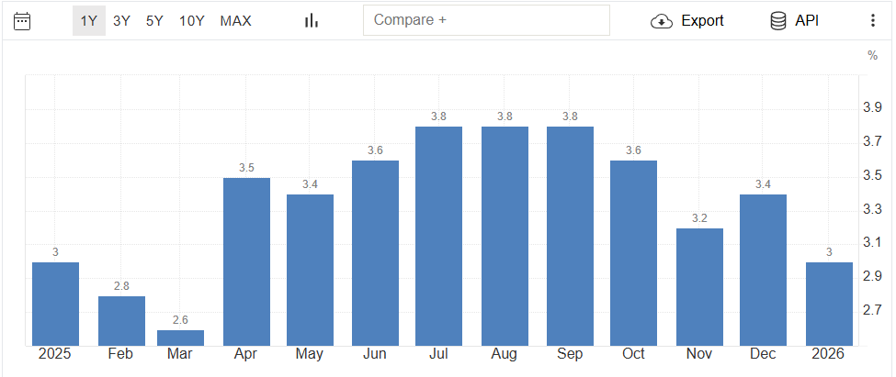
Figure 2: Inflation Rate in the UK
Source: (Trading Economics, 2025)
Social
The consumers are moving to be more sustainable, connected digitally, and premium. Environmental responsibility is under a growing awareness, which is stimulating the demand for electric and hybrid vehicles (Kurniawan and Sidi, 2024). Younger up-market buyers have a more specific knowledge of the authenticity of the brands, innovation and integration of technologies. Nature of Urbanisation and the changing preference of mobility is transforming the ownership trend, and the luxury SUV is continuing to perform well in the global markets.
Technological
The automotive industry is changing with the rapid innovation of battery technologies, autonomous driving innovations, and connectivity of vehicles (Abro et al., 2023). To stay competitive with rivals who have advanced technologies, JLR requires a huge investment in research and development. The emergence of software-defined cars and OTA updates necessitates digital capabilities and alliances. Lightweight materials and electrified powertrains innovation has only minor progress to efficiency and regulatory demands, but requires a significant amount of capital to execute.
Legal
The emissions laws in the UK, EU, China and North America motivate adherence to the emerging carbon standards. Imperative considerations are safety regulations, data protection laws of connected vehicles and the protection of intellectual property. Failure to do so may lead to fines and, more importantly, reputation damage, which is why JLR needs to be monitored in terms of regulations.
Environmental
The automotive environment is being redefined by climate change forces and worldwide carbon emission limits (Damert and Baumgartner, 2018). Governments are also imposing deadlines to phase out internal combustion engine cars and speed up the transition to electrification. Sustainability reporting, as well as ethical sourcing, to the investor and its stakeholders, are becoming more and more transparent. To achieve its net-zero targets and improve brand recognition, JLR needs to lower its emission levels in the supply chain and its manufacturing operations.

2.1.2. Porter’s Five Forces Analysis
Force | Intensity | Analysis
Competitive Rivalry | High | Price, innovation, and technology competition could be enhanced due to a strong rivalry of such premium brands as BMW, Mercedes, Audi, and EV leader Tesla.
Threat of New Entrants | Moderate | There are barriers due to high requirements of capital and high loyalty to brands; still, the startups of electric vehicles and Chinese producers put more pressure on the competitive environment (Hossain, 2024).
Bargaining Power of Suppliers | High | The reliance on suppliers of semiconductors and batteries increases the cost vulnerability and the supplier risk.
Bargaining Power of Buyers | High | Luxury buyers are innovative, quality-conscious, and sustainability-focused, placing higher demands and switching brands based on the expectation (Hemonnet-Goujot, Kessous, and Magnoni, 2022).
Threat of Substitutes | Moderate | Other alternative mobility modalities like ride sharing and transport, lower the conventional vehicle ownership requirement.
Table 1: P5F analysis
Source: (Learner)

2.2. Internal Environment Audit

2.2.1 Value Chain Analysis
Inbound Logistics
A complicated international supply chain allows Jaguar Land Rover to source its components, raw materials, batteries, and semiconductors from foreign suppliers (De Ruyter, Hearne and Henry, 2021). The company privileges strategic alliances with suppliers to guarantee quality and innovation, especially on a battery of electric vehicles (EV) and high-tech electronics. Nevertheless, the global supply networks have appeared weak as of late due to a series of semiconductor shortages and disruptions in the logistics process. High-performance inbound logistics are key to ensuring continuity of production and costs in high-quality sports automotive.
Operations
The business operations of JLR revolve around high-technology production, engineering perfection, and high-quality craftsmanship. The company has large manufacturing production plants both in the UK and globally, with the inclusion of robotics, digital manufacturing systems, and quality management procedures. As part of an electrification plan, JLR is reining in plants to such an extent that they can produce EVs and flexible modular architectures. The improvements in its operational efficiency through its strategy of Reimagine are geared towards eliminating waste, improving its productivity and profitability. Nevertheless, the high rate of fixed costs and capital investments is also a major obstacle in competitive margin maintenance (Boubaker, Dang and Sassi, 2022).
Outbound Logistics
JLR sells cars to customers in different parts of the world via a network of dealerships and logistics. The luxury segment requires efficient customer satisfaction through transportation of vehicles, inventory handling, and delivery of orders. Digital tracking solutions, as well as demand prediction tools, employ supply chain responsiveness. Delays and added costs are, however, caused by shipping disruptions and international trade restrictions.
Marketing and Sales
JLR employs good brand equity with the marque of Jaguar and Land Rover and has positioned itself in the modern luxury, performance, and innovation. The strategies of marketing focus on electrification, sustainability and high design. To enhance brand engagement and internationalisation, the company is becoming more and more online, incorporating digital platforms, online configurators and individual customer experiences.
Service
Customer retention and brand loyalty. After-sales service is important in retaining clients. JLR provides warranty schemes, service, connected car updates, and customer service in authorised dealerships. Quality service in the form of high customer satisfaction, enhancement of premium positioning, and long-term revenue (service contracts and sale of parts) (Borchardt et al., 2018).

2.2.2 VRIO Analysis
Resource / Capability | Valuable (V) | Rare I | Inimitable (I) | Organised (O) | Competitive Advantage
Strong Brand Equity (Jaguar & Land Rover) | Yes | Yes | Yes | Yes | Yes
Engineering & Design Expertise | Yes | Yes | No | Yes | No
Global Manufacturing Network | Yes | No | No | Yes | No
Electrification Strategy (“Reimagine”) | Yes | No | No | Yes | No
Luxury SUV Market Position | Yes | Yes | No | Yes | No
Table 2: VRIO analysis
Source: (Learner)
According to the VRIO analysis, strong brand equity is the main source of sustained competitive advantage to Jaguar Land Rover since it is valuable, rare, imitable, and well-supported by organisational structure. The competitive strength presented by engineering expertise and the positioning of luxury SUVs cannot be entirely imitated because competitors have such a capability. Its global manufacturing network and its electrification strategy are useful, but well-structured ones that are not unique and hard to implement in the high-end automotive market. On the whole, the long-term competitive edge of JLR relies on its ability to sustain brand differentiation and enhance unique technological and innovation features.

2.3 SWOT Analysis
Strengths | Weaknesses
- Large brand equity in the world by Jaguar Land Rover.  - High level of penetration in the high-end SUV market with a pool of long-term customers.  - High engineering capacity and design superiority.  - defined an electrification plan as part of the Reimagine transformation plan (Nolan, 2025). | - Both the UK manufacturing and the trade costs associated with Brexit are highly dependent and predisposed.  - Profiteers and economies of scale make operations and production costly, resulting in a decrease in profit margins.  - Semiconductor and battery dependency are the main supply chain weaknesses.  - The historical lapses in financial performance and restructuring difficulty.
Opportunities | Threats
- The increasing demand for electric and hybrid luxury cars in the world.  - Growth in developing markets, especially China and India.  - The battery efficiency and autonomous driving have been technologically innovated (Abro et al., 2023).  - Aligned supply chain resiliency through strategic alliances to enhance the EV supply chain. | - Extreme rivalry with luxury competitors like BMW, Mercedes-Benz, Audi and Tesla.  - Increased international emission standards and the penalties for non-compliance.  - Recessions decrease the demand for luxury cars.  - Political instabilities and continuous disruption of supply chains.
Table 3: SWOT analysis
Source: (Learner)

The SWOT analysis indicates that Jaguar Land Rover is a company that has strong brand equity, leadership in the SUV market, and engineering capabilities that can be used in positioning itself. But profitability is hampered by operational inefficiencies, a high cost of production, and vulnerability of the supply chain. On the outside, the rising popularity of electric luxury vehicles and the development of emerging markets have massive business potential in line with the electrification plan of JLR. However, high competition with industry leaders who are well-known and renowned premium coffee businesses, stricter environmental policies, and unpredictable macroeconomic factors pose a significant threat.

3. Strategy Formulation – Jaguar Land Rover
Accelerate Full Electrification and Software-Defined Vehicle Development
JLR needs to increase its investment in electric vehicle platforms and battery technology to distinguish its luxury EV range. As Jaguar becomes a fully electric brand, Land Rover has the opportunity to increase the number of premium electric SUVs, with a better range, faster charging and wireless connections. Enhancing the vehicle architecture into a software-defined architecture, over-the-air updates, and autonomous driving capabilities will improve competitiveness on the technological level against Tesla and BMW. The approach of strategic mass partnerships with suppliers and possible verticalisation would lower the reliance on suppliers and enhance the long-term cost-efficiency (Bhandari et al., 2024).
Strengthen Brand Differentiation through Modern Luxury Positioning
JLR needs to adjust its modern luxury approach further by concentrating on exclusivity, sustainability, and luxury customer experience. The availability of limited assets, customised materials and sustainable resources may support the rarity and pricing strength of the brand (Minh and Hue, 2025). The new position of Jaguar should be that of a high-end electric performance brand, whereas Land Rover is still dominant in the luxury SUV market with its electrified off-road performance. The greater brand segmentation will reduce the internal cannibalisation and strengthen the brand perception.
Expand in High-Growth Emerging Markets
Revenue growth can be achieved through targeted growth in China, India, and the Middle East. Local production, joint venturing and customised product delivery will enhance competitiveness in cost and utility to the market. The build-up of the dealership chains and virtual sales channels will improve accessibility and brand recognition among the customers in these highly demanded markets.
Improve Operational Efficiency and Supply Chain Resilience
JLR must improve its operating efficiency by employing lean manufacturing, automation and regionalisation of the supply chain to maximise the company's profits. The risk of disruption will be minimised through the diversification of suppliers of semiconductors and batteries, improving the visibility of their inventory, and nearshoring of critical components (Singh, Hamid and Garza-Reyes, 2023). Optimisation of the costs alongside a premium pricing approach will help in mitigating the financial performance and competitive advantage in the long run.

4. Conclusion and Recommendations
To sum up, the automotive industry in which Jaguar Land Rover functions is very competitive and fast-moving as it is influenced by electrification, regulation, and technological advancement. Although a good brand equity and high positioning are strategic, operational issues and external forces are equally important. JLR can reinstate its stand and attain long-term sustainable growth by increasing speed in electrification, brand differentiation, market penetration in new markets, and enhancing efficiency.
Recommendations – Jaguar Land Rover
- Prioritise Investment in Dedicated EV Platforms: Intensify the creation of superior electric architectures to enhance range, performance, and production efficiency and decrease dependency on legacy platforms.
- Enhance Supply Chain Resilience: Contract battery and semiconductor long-term, geographic diversification of suppliers, and consider strategic vertical integration to minimise the risk of disruption (Brsakoska, Ebert and Pavlov, 2022).
- Strengthen Digital and Customer Experience Capabilities: Old-fashioned Infrastructure Invest in software development, related services and digital sales platforms that the customers have as their own brand loyalty and recurring revenue streams.
- Drive Cost Optimisation and Operational Efficiency: Put in place lean manufacturing, automation and modernisation of the plant to enhance margins, without compromising on the premium quality (Xiong, Wu and Yeung, 2025).

References
Abro, G.E.M., Zulkifli, S.A.B., Kumar, K., El Ouanjli, N., Asirvadam, V.S. and Mossa, M.A., (2023). Comprehensive review of recent advancements in battery technology, propulsion, power interfaces, and vehicle network systems for intelligent autonomous and connected electric vehicles. Energies, 16(6), p.2925.
Bari, N., Chimhundu, R. and Chan, K.C. (2022). Dynamic capabilities to achieve corporate sustainability: a roadmap to sustained competitive advantage. Sustainability, 14(3), p.1531.
Bhandari, R., Gupta, G., Sanne, H.V., Perumal, A.P., Balakrishnan, A. and Gochhait, S. (2024), August. Software-Driven Revolution Redefining Automotive Industry. In International Conference on ICT for Sustainable Development (pp. 97-105). Singapore: Springer Nature Singapore.
Borchardt, M., Souza, M., Pereira, G.M. and Viegas, C.V. (2018). Achieving better revenue and customer satisfaction with after-sales services: how do the best branded car dealerships get it? International Journal of Quality & Reliability Management, 35(9), pp.1686-1708.
Boubaker, S., Dang, V.A. and Sassi, S. (2022). Competitive pressure and firm investment efficiency: Evidence from corporate employment decisions. European Financial Management, 28(1), pp.113-161.
Brsakoska, D., Ebert, A. and Pavlov, B. (2022). The Relationship Between Vertical Integration and Risk. A Statistical Analysis of Changes in Vertical Integration within Industries Affected by the Global Semiconductor Shortage.
Damert, M. and Baumgartner, R.J. (2018). Intra‐sectoral differences in climate change strategies: Evidence from the global automotive industry. Business strategy and the environment, 27(3), pp.265-281.
De Ruyter, A., Hearne, D. and Henry, I. (2021). The resilience of advanced manufacturing supply chains across the Midlands. Midlands Engine.
Helgi Library (2022). Sales of Jaguar Land Rover Group Cars in Europe. [online] Helgi Library. Available at: <https://www.helgilibrary.com/charts/sales-of-jaguar-land-rover-group-cars-in-europe-monthly-1/> [Accessed 28 February 2026].
Hemonnet-Goujot, A., Kessous, A. and Magnoni, F., (2022). The effect of sustainable product innovation on the consumer–luxury brand relationship: The role of past identity salience. Journal of Business Research, 139, pp.1513-1524.
Hossain, M. (2024). How Chinese companies are dominating the electric vehicle market worldwide. California Management Review, 67(2), pp.1741840091-1.
Jaguar Land Rover (2018). JAGUAR LAND ROVER REMAINS THE LEADING UK CAR AND ENGINE MAKER. JLR Media Newsroom. [online] 26 Jun. Available at: <https://media.jaguarlandrover.com/news/2018/01/jaguar-land-rover-remains-leading-uk-car-and-engine-maker> [Accessed 28 February 2026].
Kren, J. and Lawless, M. (2024). How has Brexit changed EU–UK trade flows? European Economic Review, 161, p.104634.
Kurniawan, H.H. and Sidi, A.P. (2024). The role of environmental awareness, innovation, and price in encouraging interest in buying electric vehicles. Jurnal Apresiasi Ekonomi, 12(3), pp.568-575.
Minh, H.V. and Hue, N.T.T., (2025), October. Branding Strategies in the Luxury Goods Market: Managing Brand Identity, Customer Perception, and Competitive Positioning in a Saturated Market. In Proceedings of the International Conference on Contemporary Studies in Social Sciences (ICSSSS 2025) (p. 97). Springer Nature.
Nolan, S. (2025). Reimagine strategy drives record revenue for JLR. [online] EV Magazine. Available at: <https://evmagazine.com/news/reimagine-strategy-drives-record-revenue-for-jlr> [Accessed 28 February 2026].
Singh, J., Hamid, A.B.A. and Garza-Reyes, J.A. (2023). Supply chain resilience strategies and their impact on sustainability: an investigation from the automobile sector. Supply Chain Management: An International Journal, 28(4), pp.787-802.
Trading Economics, (2025). United Kingdom inflation rate. [online] TRADING ECONOMICS. Available at: <https://tradingeconomics.com/united-kingdom/inflation-cpi> [Accessed 28 February 2026].
Xiong, W., Wu, D.D. and Yeung, J.H. (2025). Semiconductor supply chain resilience and disruption: insights, mitigation, and future directions. International Journal of Production Research, 63(9), pp.3442-3465.

