University of Wales Trinity Saint David
London Campus
Assessment
Synthesize a solution to a potential real-life scenario
Module Name: Networks and Cyber Security Essentials
Module Code: ACCA4024_LON

Student Name: Dumitru Danilov
Student ID: 2430681
Group: 2

Lecturer’s Name: Amit Naik

Introduction 2

Identification of modern Threats 3
External Threats 3
Internal Threats 4

Security Policies 5
Zero Trust Architecture Overview 5
Modern Security Policies 6

Technical & Administrative Mitigation Measures 7

Monitoring and Response 9
SIEM & SOAR Integration 9
SIEM/SOAR Process Flow Diagram 11

Ransomware Incident Response Process 11

Continuous Training & Security Awareness Program 13

Conclusion 15

Appendix 1 16

Appendix 2 17

References 24

Introduction
The scope, frequency, and sophistication of cyber security threats are still changing quickly. Due to the significant value of financial data, personal client data, and funds under management, financial organizations like Vigilant Trust & Asset Management (VTAM) are potential targets [4]. The organization's recent vulnerability to an attempted ransomware outbreak and a successful phishing effort highlights the urgent need for a cutting-edge, robust security architecture [10].
The attack surface of VTAM has increased dramatically due to the trend toward hybrid working, cloud services, mobile device usage, and Software-as-a-Service (SaaS). Conventional security concepts based on perimeters are no longer adequate. As a result, this paper suggests a thorough Zero Trust security framework that is in line with:
NIST Cybersecurity Framework (CSF) [7]
ISO/IEC 27001[5]
CISA Known Exploited Vulnerabilities (KEV) Catalog [1]
The CIA Triad (Confidentiality, Integrity, Availability)
This framework aims to strengthen VTAM’s ability to prevent, detect, respond to, and recover from modern cyber threats [8].

Identification of modern Threats
VTAM faces both external and internal threats driven by modern attack techniques.

External Threats
- Ransomware-as-a-service, or RaaS
Hackers with minimal technical knowledge can install powerful ransomware systems thanks to RaaS. These attackers encrypt important systems and demand large cash ransoms [10]. Financial institutions are frequently targeted due to their high-risk tolerance and urgent need for system repair [4].
- AI-Powered Social Engineering (Phishing & Vishing)
Artificial intelligence is now used to: • Create realistic phishing emails; • Clone voices for phone-based fraud (vishing); and • Automatically personalize messages using compromised data [9], [10].
These attacks, which evade traditional email filters, target senior executives and finance staff.
- Attacks on Supply Chains
Attackers may be able to indirectly access VTAM systems by compromising reliable vendors or software providers. The MOVEit data breach showed how thousands of organizations could be compromised by a single third-party software vulnerability [3].
- Misconfiguration of Cloud and SaaS
Publicly accessible cloud storage;
Inadequate API security;
A lack of user-access governance and an excessive number of permissions are examples of common vulnerabilities [1].
These result in regulatory violations, credential theft, and data leaks.

Internal Threats
- Insider threats (malicious or negligent staff)
When partners, contractors, or employees purposefully or unintentionally jeopardize security, insider threats occur [3]. While careless users may inadvertently expose systems through risky behavior like clicking on phishing links, malicious insiders may steal confidential financial information for their own benefit. Because they have trusted access to vital systems, insider threats are especially dangerous in financial institutions like VTAM.
- Weak password reuse
The risk of credential compromise is greatly increased when weak passwords are used on several different systems. Attackers can access internal systems, email, and cloud services with the same credentials if one platform is compromised. Credential stuffing is a common way to exploit this kind of attack, which can lead to a complete network breach [10].
- Unpatched devices
There are known vulnerabilities in unpatched operating systems and applications that are actively exploited in the wild. Attackers often use publicly accessible exploit tools to infect outdated systems with ransomware or obtain unauthorized access. VTAM's security posture is severely weakened and it is exposed to regulatory risk if systems are not patched on time [1].
- Shadow IT (unauthorised cloud apps)
When employees use unapproved software or cloud services, it's known as shadow IT. These services frequently lack adequate security measures like access control, auditing, and encryption. Shadow IT raises the risk of data leakage and compliance infractions, as well as creating blind spots in security monitoring [6].

Security Policies

Zero Trust Architecture Overview
Zero Trust operates under the principle:
“Never trust, always verify.”
No user, device, application, or network is trusted by default — even if already inside the organisation.
Zero Trust Core Principles [7], [8]
- Continuous authentication
- Least-privilege access
- Micro-segmentation
- Strong identity verification
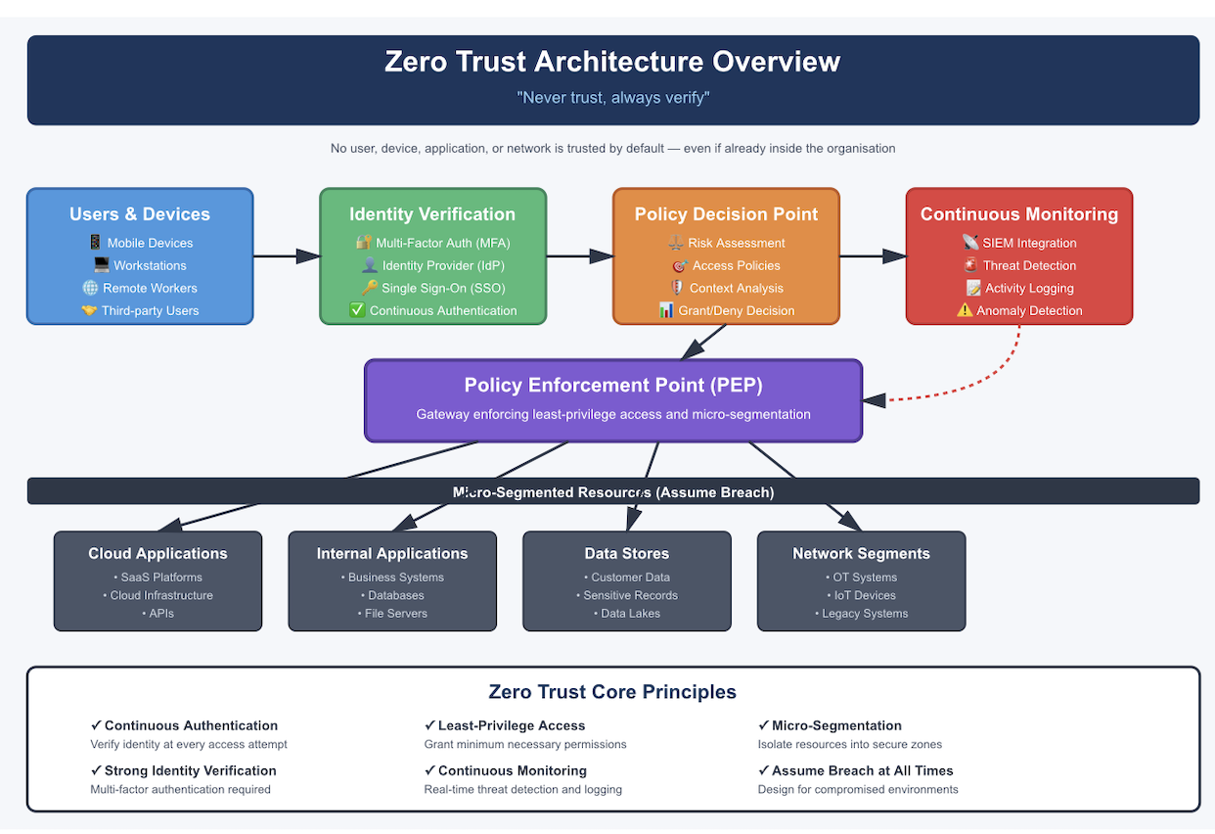
- Continuous monitoring

Modern Security Policies
Security policies must align with:
ISO 27001 controls / NIST CSF Core Functions / Zero Trust principles [5], [7]
Key Security Policies
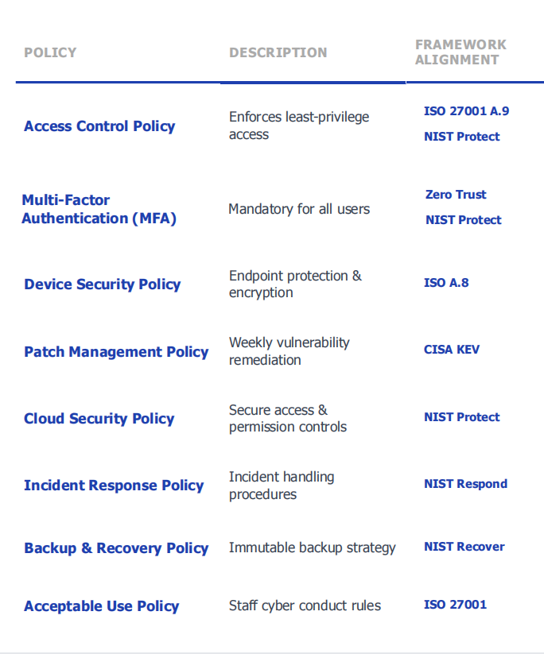

Technical & Administrative Mitigation Measures
- Identity & Access Management (IAM)

All crucial access points, such as VPNs, cloud services, business email, and privileged administrator accounts, must implement multi-factor authentication (MFA). This guarantees that biometric verification, hardware security keys, or secure password managers will prevent unauthorized access even in the event that credentials are compromised. The risk of credential-based attacks like phishing, brute force, and credential stuffing is greatly decreased by effective IAM [7], [9], [10].

- Endpoint Detection & Response (EDR)

In order to identify malicious activity and suspicious behavior, EDR offers continuous real-time monitoring of all endpoints, including servers, laptops, and mobile devices. While behavior-based detection finds zero-day threats that evade conventional antivirus software, automated isolation of compromised systems stops lateral movement within the network [3], [8].

- Patch Management (CISA KEV Driven)

Everyday vulnerability scanning guarantees that newly revealed security holes are quickly found in every system. Every vulnerability in the CISA Known Exploited Vulnerabilities (KEV) catalog is given priority for fixing, and patches are automatically applied within 48 to 72 hours. Accountability and regulatory oversight are guaranteed by executive-level patch compliance reporting [1], [7].

- Cloud Security Posture Management (CSPM)

CSPM makes it possible to monitor cloud environments in real time and spot configuration errors that frequently result in data breaches. This enables security teams to address risks before they are exploited by identifying publicly accessible storage, lax identity and access controls, and excessive administrative privileges [6], [8].

- Data Protection Controls

Even if devices are misplaced or stolen, full-disk encryption guarantees that data is unreadable. While secure backups with air-gap storage guarantee business continuity in the event of ransomware or system compromise, Data Loss Prevention (DLP) and tokenization prevent sensitive financial and personal data from being disclosed without authorization [4], [5].

Monitoring and Response

SIEM & SOAR Integration
To offer round-the-clock visibility, quick threat detection, and automated incident response, VTAM will implement an integrated SIEM and SOAR security monitoring framework. The company can correlate security events throughout the whole IT environment and react to cyber incidents instantly thanks to this integration [7].

SIEM (Security Information & Event Management)
- Central log collection

Security logs from servers, firewalls, endpoints, cloud platforms, and apps will be gathered and centralized by the SIEM platform. This gives VTAM's infrastructure a single, cohesive view of security activity [7].

- Threat detection

To identify suspicious activity, possible intrusions, and new attack patterns, advanced analytics and machine learning will be employed. This makes it possible to detect threats like ransomware encryption attempts, lateral movement, and unusual user behavior early on [3], [10].

- Correlation of abnormal behaviour

Multiple low-level security events are correlated into significant security incidents by SIEM. This lowers false positives and makes it possible for security teams to spot coordinated attacks that might otherwise go unnoticed [7].
SOAR (Security Orchestration, Automation & Response)

- Automated containment

Predefined containment measures, like blocking malicious IP addresses, disabling malicious user accounts, and isolating compromised endpoints, are automatically carried out by SOAR. This restricts the potential impact of an active cyberattack and drastically cuts down on reaction time [1], [7].

- Incident response playbooks

Technical teams are guided through each stage of an incident by standardized response playbooks, which guarantee uniform, legal, and auditable response processes. These playbooks are designed to address insider threats, ransomware, phishing, and cloud security issues [7], [8].

- Threat intelligence integration

In order to enhance alerts with contextual information like known malicious IP addresses, ransomware signatures, and exploited vulnerabilities, SOAR incorporates real-time threat intelligence feeds. This facilitates proactive defense against new threats and enhances decision-making [1].

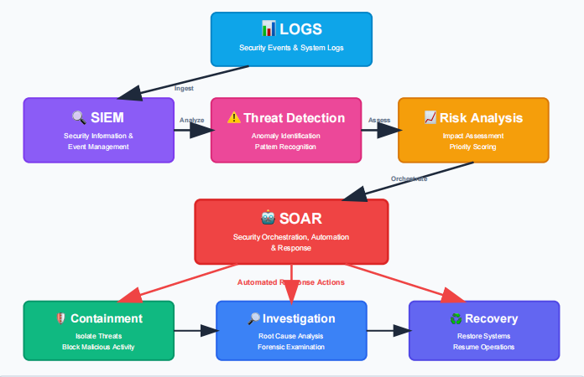
SIEM/SOAR Process Flow Diagram

Ransomware Incident Response Process
- Immediate system isolation
Immediately isolate all infected and suspected systems from the network to prevent further encryption and data exfiltration. This includes disconnecting affected devices from wired and wireless networks and disabling compromised user accounts [7].
- Disable lateral movement
Network segmentation controls are enforced to prevent the attacker from spreading across internal systems. Firewall rules, endpoint containment, and privileged access restrictions are applied to block any further unauthorised movement between systems [8], [10].

- Activate forensic investigation
A formal digital forensic investigation is initiated to identify the attack vector, compromised assets, attacker behaviour, and data exposure. Evidence is preserved in a forensically sound manner to support legal proceedings, regulatory reporting, and root cause analysis [5], [7].
- Restore from immutable backups
Systems are securely restored using immutable, offline backups that cannot be altered by ransomware. This ensures data integrity and enables rapid business recovery without paying ransom demands [4].
- Regulatory breach notification
If personal or financial data is affected, regulatory bodies such as the Information Commissioner’s Office (ICO) and the Financial Conduct Authority (FCA) are notified in accordance with UK GDPR and financial sector regulations. Impacted clients are also formally informed where required by law [5].
- Post-incident security review
Following recovery, a full post-incident review is conducted to identify control weaknesses, human factors, and technical failures. Lessons learned are used to strengthen policies, improve detection controls, and update employee training programmes [7].

Continuous Training & Security Awareness Program
Since human behavior is still one of the main attack vectors for contemporary cyber threats, an effective cyber security strategy must address human behavior in addition to technical controls. In order to increase employee awareness, decrease human error, and fortify organizational resistance to social engineering attacks, VTAM will establish an ongoing, role-based cyber security training and awareness program [9], [10].
- Modern Training Strategy
Every month, VTAM will run phishing simulation campaigns that mimic actual attack methods like invoice fraud, credential harvesting, and compromised business emails. In order to provide focused follow-up training, these simulations will be analyzed to identify high-risk departments and users.
The company will implement AI-generated vishing drills that mimic actual voice-based fraud scenarios in response to the growing threat of AI-powered social engineering. Through these exercises, staff members will learn how to challenge odd financial requests, confirm caller identities, and adhere to secure verification protocols.
To represent actual operational risks, department-specific simulations will also be used. Senior executives will be tested against CEO impersonation attacks, IT teams will be trained to identify instances of privilege escalation and identity abuse, and finance staff will be trained to identify invoice redirection and payment diversion fraud [9], [10].

- Training Delivery Methods

In order to maximize engagement and knowledge retention, training will be delivered through a blended learning approach. While gamified exercises will reinforce learning through competitive scenarios and scoring mechanisms, interactive workshops will give staff members a controlled environment in which to practice responding to simulated attacks.
To illustrate the actual business repercussions of cyber incidents, training will incorporate real-world breach case studies, such as ransomware attacks on financial institutions and significant supply-chain compromises. Staff members will be able to practice escalation protocols, incident reporting, and making decisions under pressure through attack-response simulations.
Continuous improvement will be made possible by security awareness dashboards, which will give management insight into departmental risk levels, phishing failure rates, and training participation [9], [10].

- Security Culture Promotion
VTAM will implement a "report-without-punishment" policy to encourage staff members to report suspected phishing emails or security errors without worrying about facing disciplinary action in order to foster a strong security culture. This shortens the attacker's dwell time and encourages early detection.
A Cyber Champion will be assigned to each department, who will be in charge of encouraging safe work practices, serving as a security liaison, and spreading awareness locally.
Staff will be kept up to date on new threats, regulatory changes, and lessons learned from actual incidents through quarterly cyber risk briefings. Cybersecurity will become a shared organizational responsibility and positive security behavior will be reinforced by employee reward programs, such as recognition programs and performance incentives [3], [9].

Conclusion
Cyberattacks are becoming more sophisticated, frequent, and financially damaging in the threat landscape in which Vigilant Trust & Asset Management operates. The organization can greatly improve its capacity to prevent, detect, and respond to emerging threats by implementing modern security technologies, aligning controls with recognized frameworks like NIST CSF and ISO 27001, and adopting a Zero Trust approach. VTAM's resilience is further strengthened by raising employee awareness through ongoing training and role-playing. When combined, these strategies provide a strong and flexible security posture that promotes long-term business trust, regulatory compliance, and operational continuity.

Appendix 1
ICSCO certificate

Appendix 2
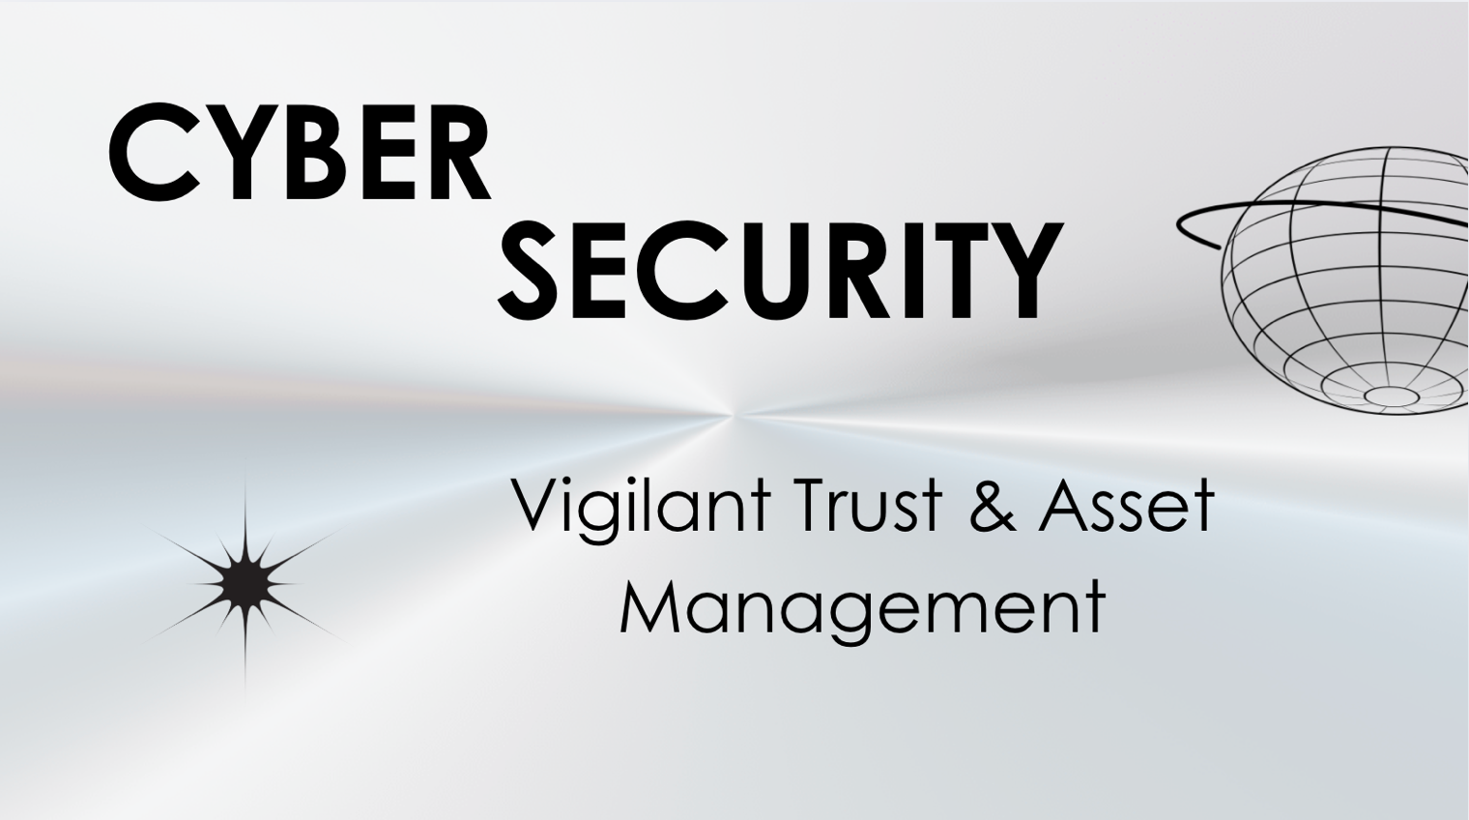
Slide 1 – Title
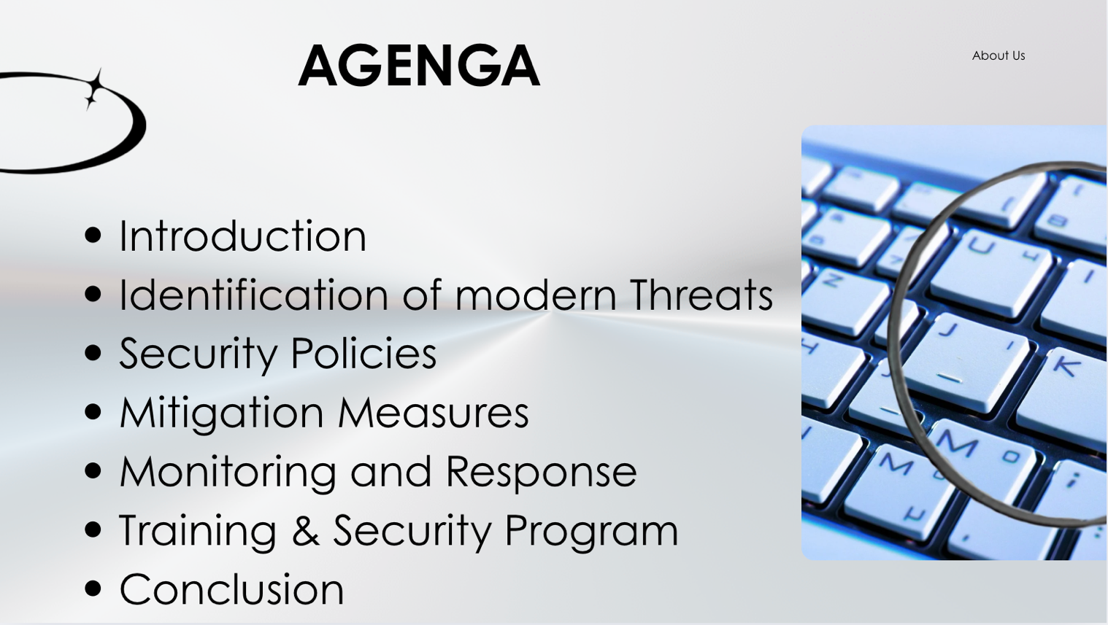Slide 2 – Agenda
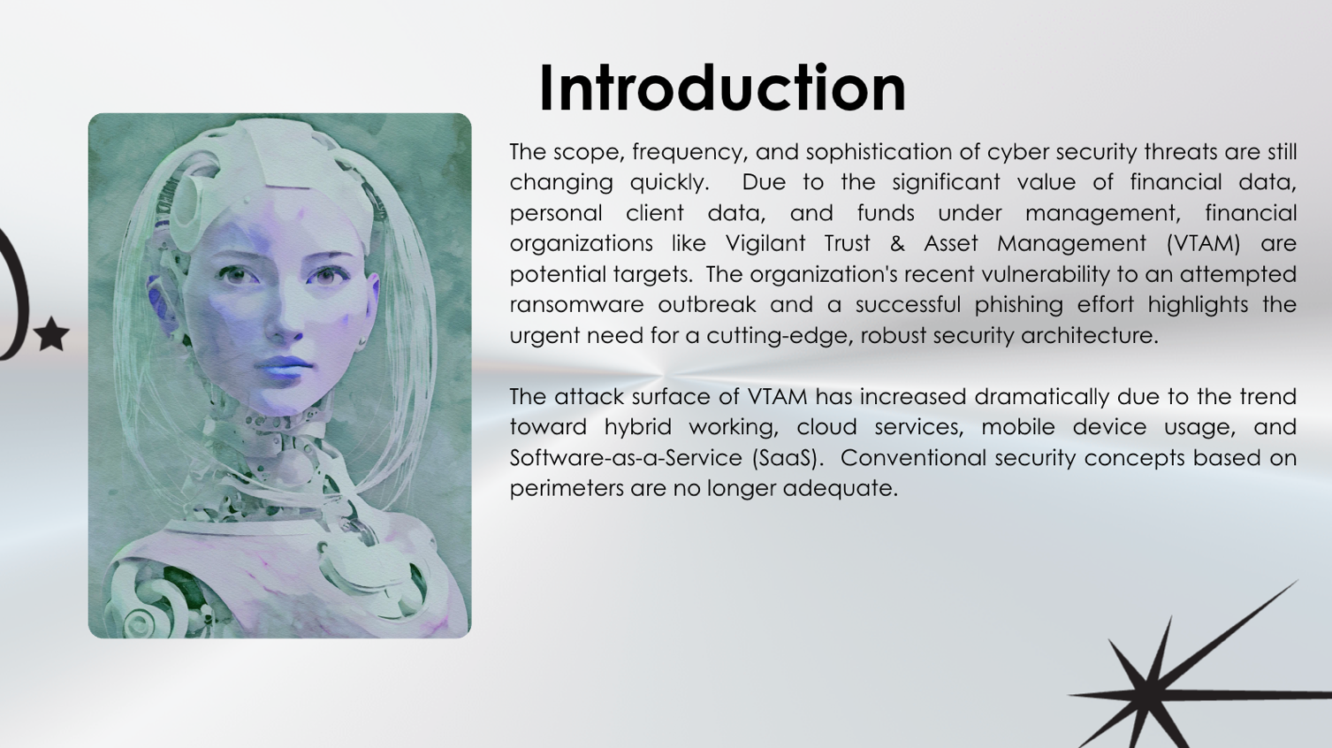Slide 3 – Introduction
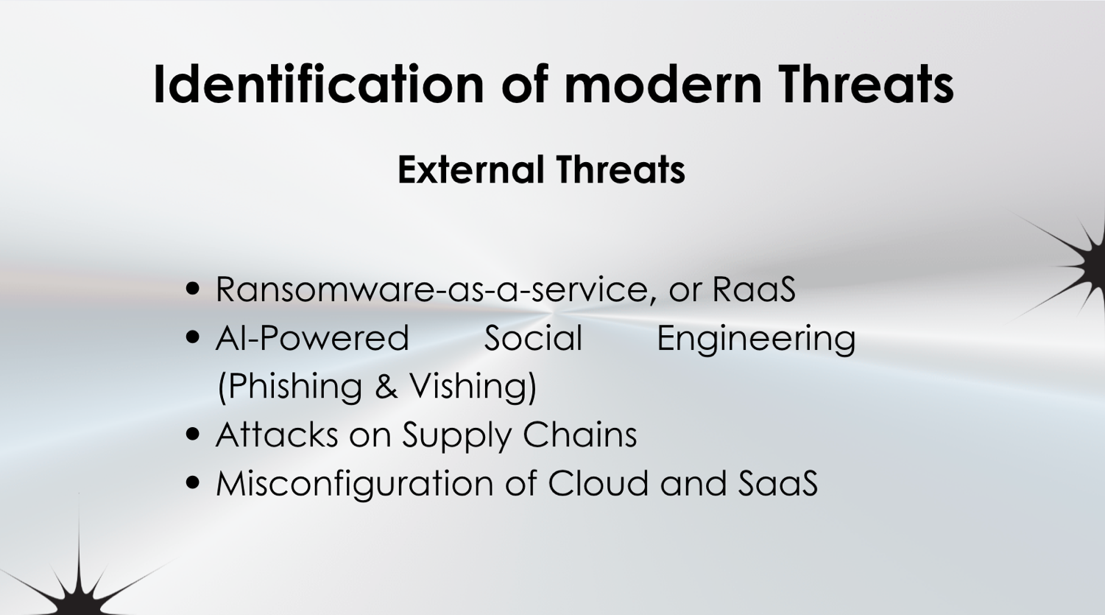Slide 4 – Identification of modern Threats (External Threats)
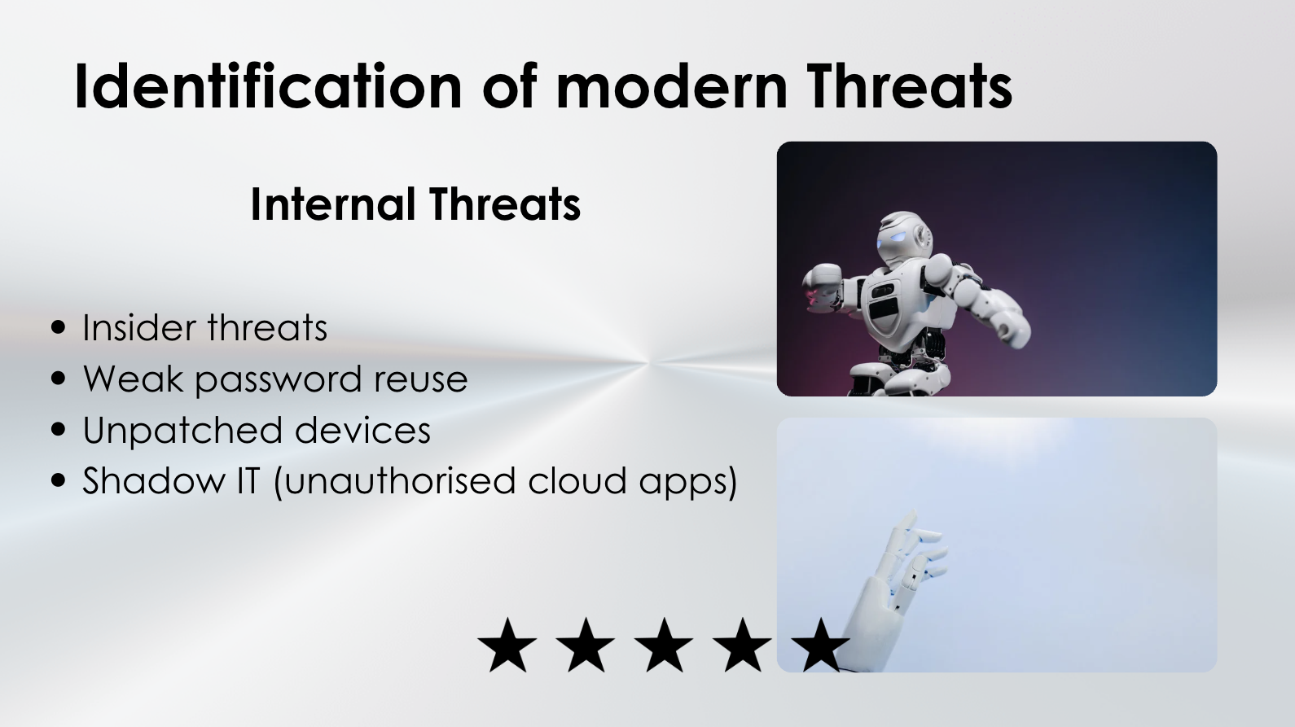Slide 5 – Identification of modern Threats (Internal Threats)
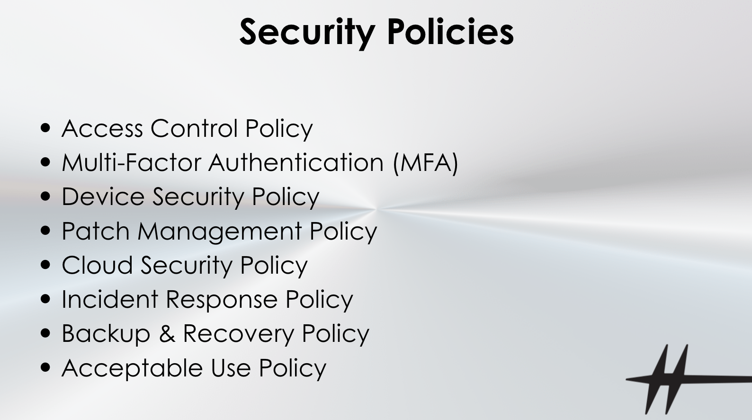Slide 6 – Security policies
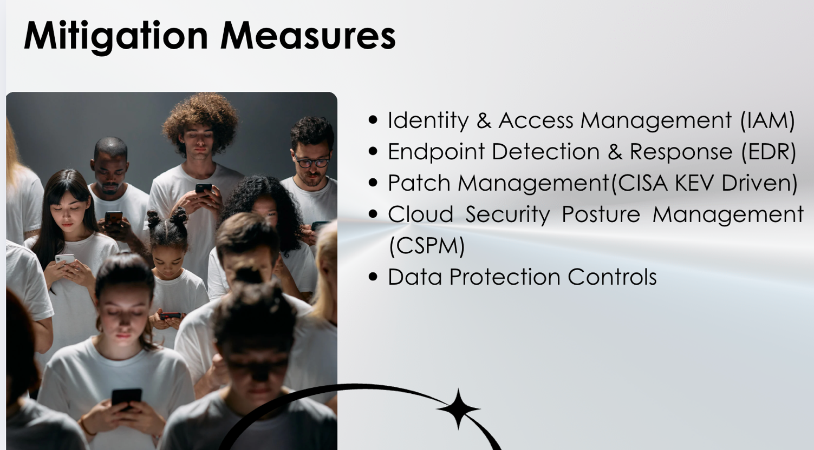Slide 7 – Mitigation measures
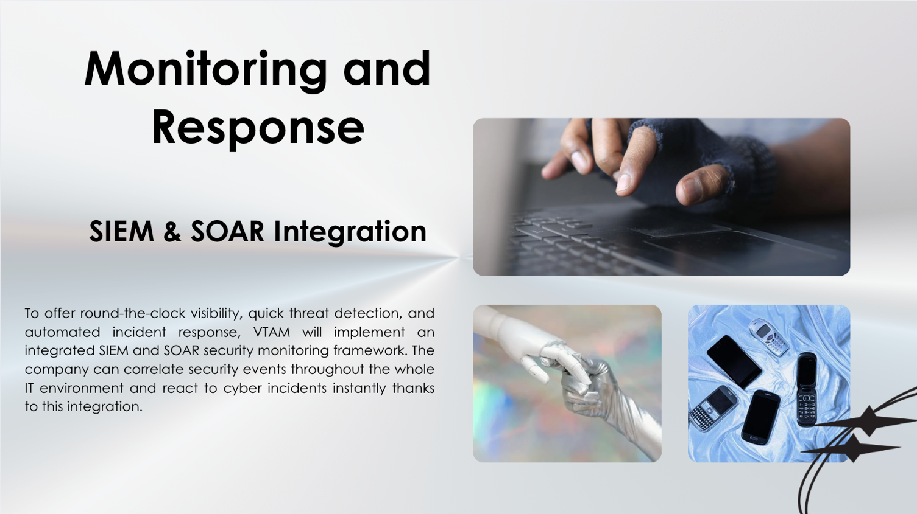Slide 8 – Mitigation measures
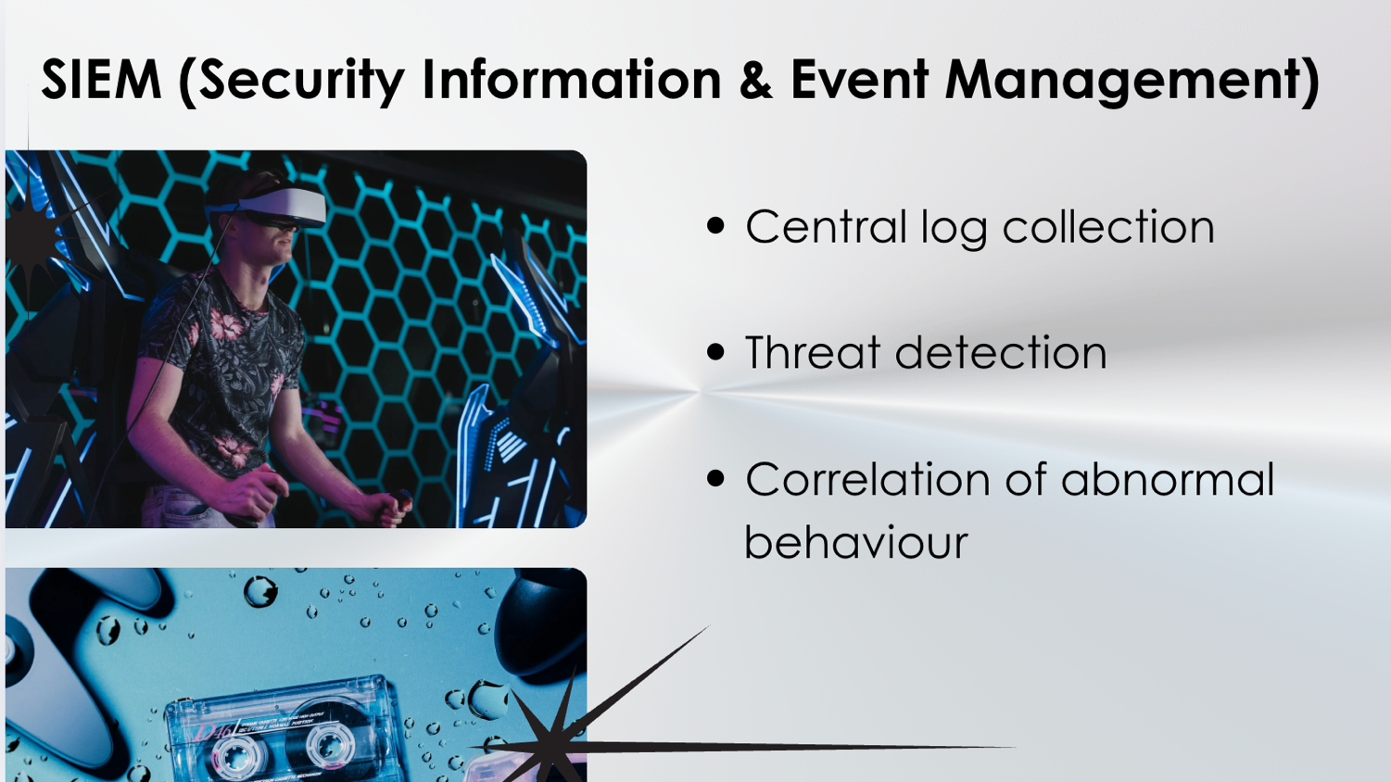Slide 9 – SIEM
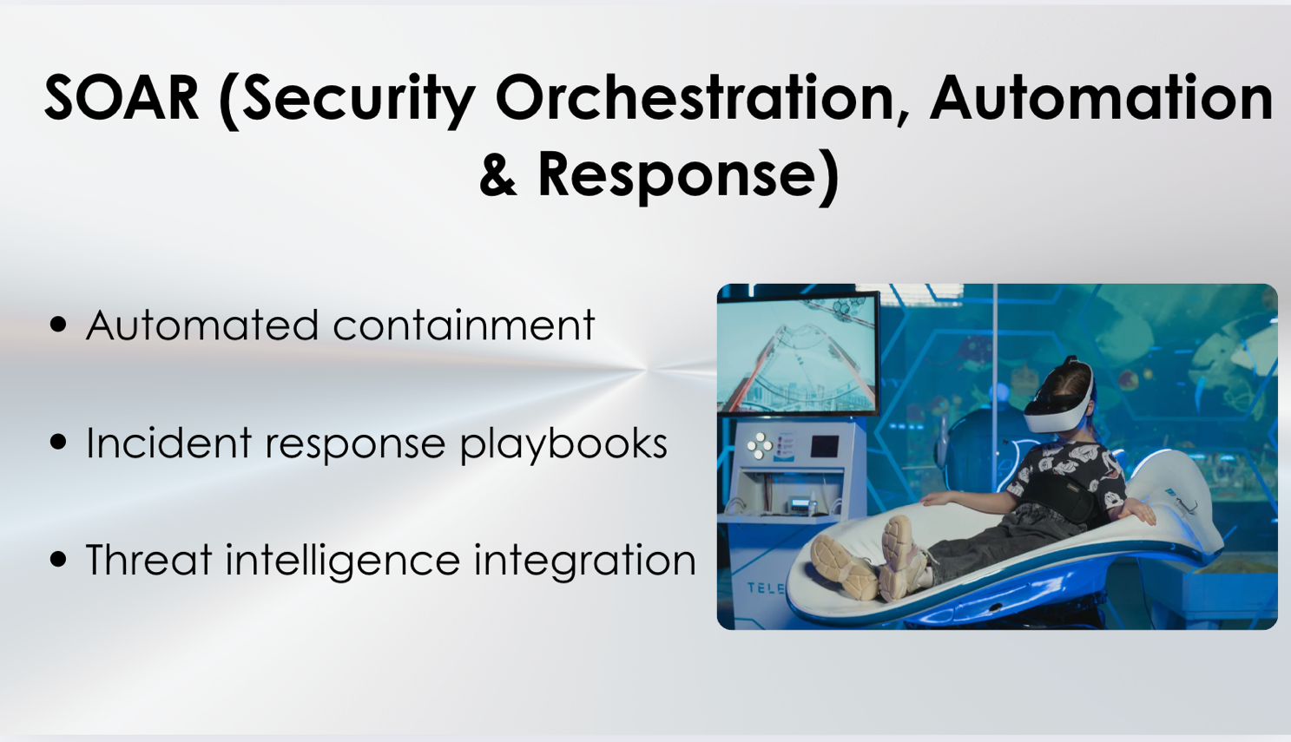Slide 10 – SOAR
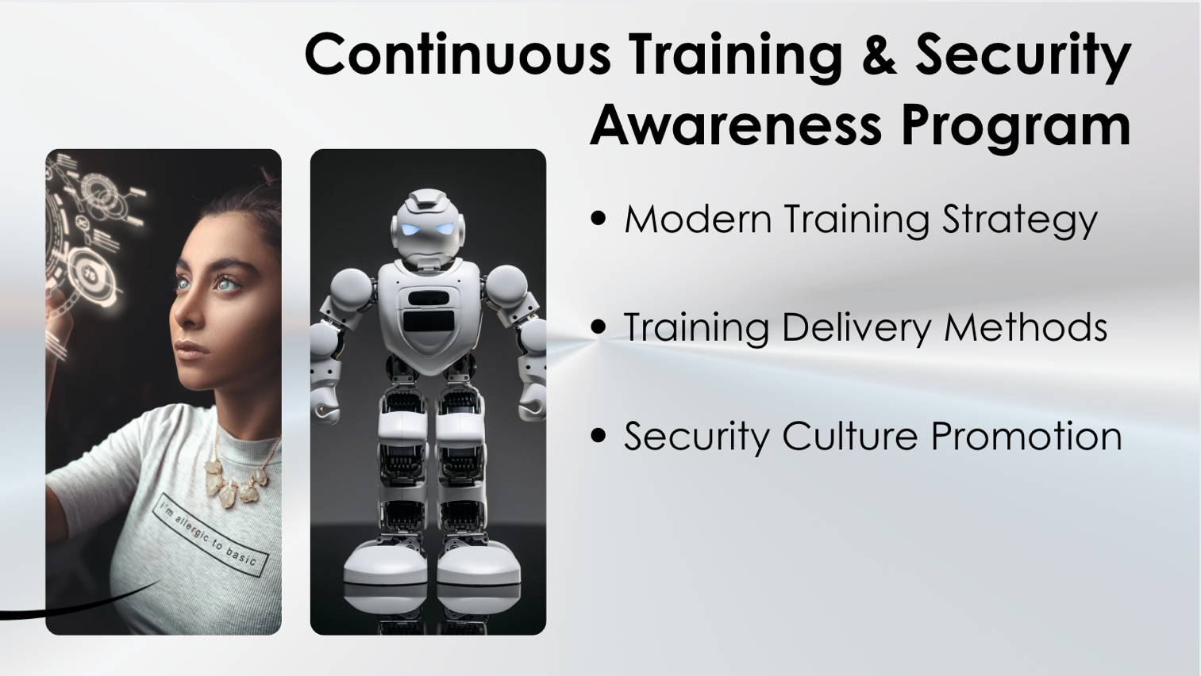Slide 11 – Training and Security program
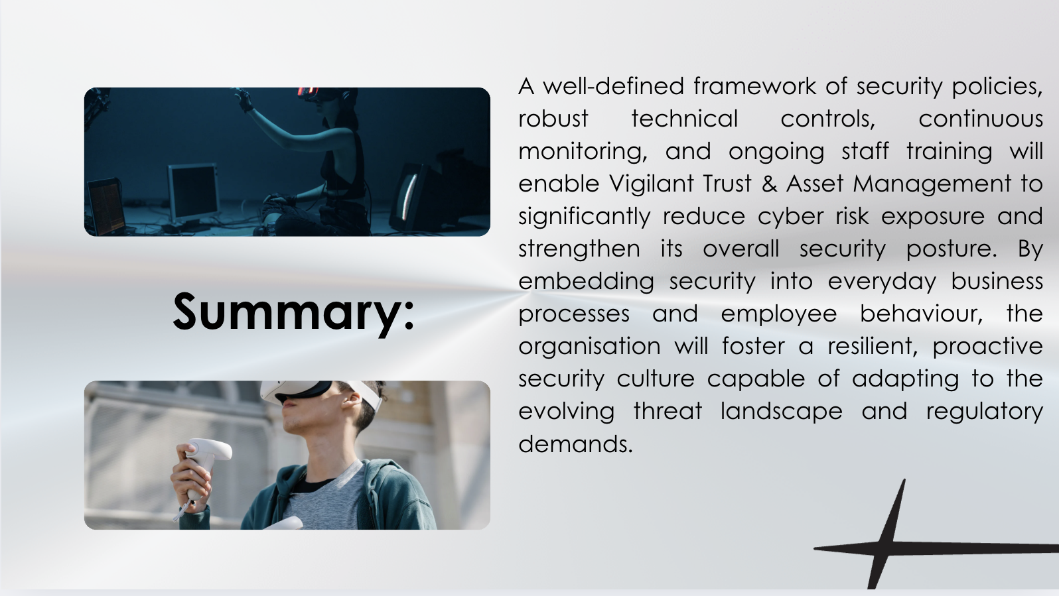Slide 12 – Summary

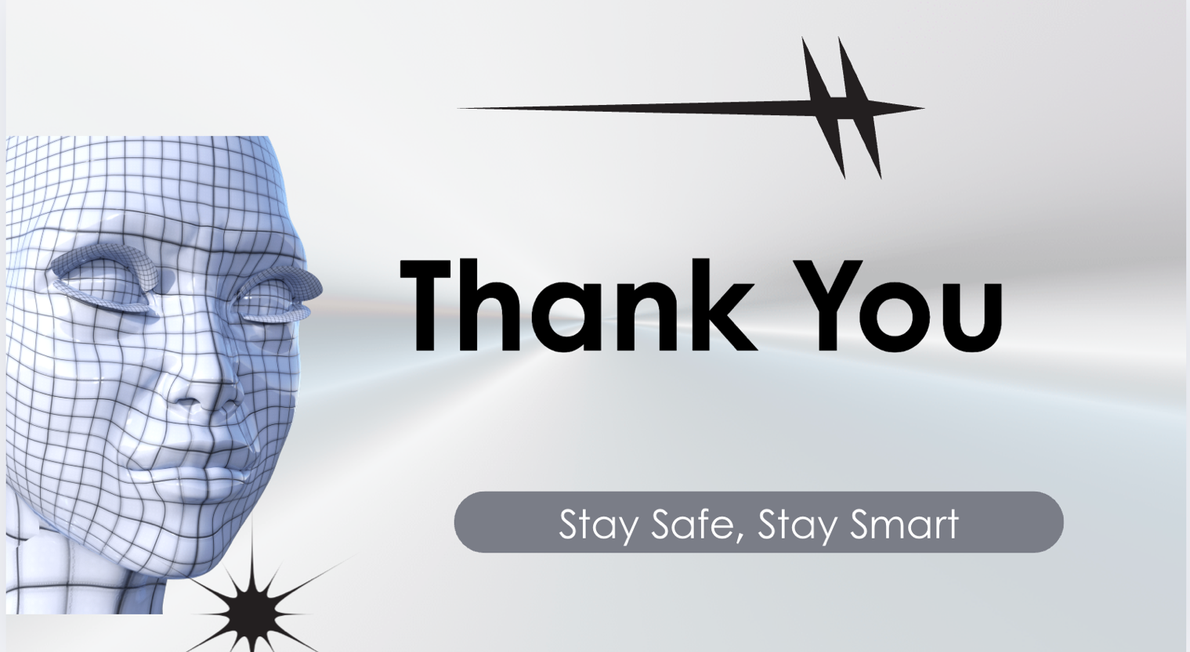
Slide 13 – Thank You

References

[1] CISA, “Known Exploited Vulnerabilities Catalog,” 2024. [Online]. Available: https://www.cisa.gov/known-exploited-vulnerabilities. Accessed: Dec. 10, 2025.
[2] CISA, “Zero Trust Maturity Model,” 2023. [Online]. Available: https://www.cisa.gov/zero-trust-maturity-model. Accessed: Dec. 10, 2025.
[3] ENISA, Threat Landscape 2023. European Union Agency for Cybersecurity, 2023. [Online]. Available: https://www.enisa.europa.eu/publications. Accessed: Dec. 10, 2025.
[4] IBM Security, Cost of a Data Breach Report 2024. IBM, 2024. [Online]. Available: https://www.ibm.com/security/data-breach. Accessed: Dec. 10, 2025.
[5] ISO/IEC, ISO/IEC 27001:2022 Information Security Management Systems — Requirements. Geneva, Switzerland: ISO, 2022.
[6] Microsoft, “Zero Trust Architecture Overview,” Microsoft Documentation, 2024. [Online]. Available: https://learn.microsoft.com. Accessed: Dec. 10, 2025.
[7] NIST, NIST Cybersecurity Framework (CSF) 1.1. National Institute of Standards and Technology, 2020. [Online]. Available: https://www.nist.gov/cyberframework. Accessed: Dec. 10, 2025.
[8] NIST, SP 800-207: Zero Trust Architecture. National Institute of Standards and Technology, 2022.
[9] Proofpoint, State of the Phish Report 2024. Proofpoint Inc., 2024. [Online]. Available: https://www.proofpoint.com. Accessed: Dec. 10, 2025.
[10] Verizon, Data Breach Investigations Report 2024. Verizon, 2024. [Online]. Available: https://www.verizon.com/business/resources/reports/dbir/. Accessed: Dec. 10, 2025.

