

Name: Riana Kasule
Student ID: 2337024
Module Code: (BMHP5014_LON)
Module: Changemakers: Creativity and Value Creation
Lecturer: Dr Laila Surani

CAREWELL
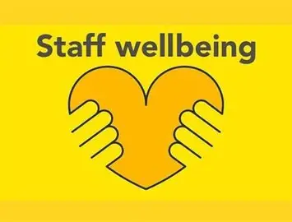
  - A Preventative Mental Wellbeing & Retention Programme for Health and Social Care Workers

- Innovation Overview
Care Well is a preventative mental health and wellbeing programme designed specifically for health and social care workers. The health and social care workforce is the backbone of care delivery, yet staff wellbeing is increasingly under threat. High stress, burnout, and emotional exhaustion are widespread, impacting both staff and service users (NHS England, 2023). Care Well is a preventative mental wellbeing programme that supports health and social care workers proactively, offering a combination of structured peer support, digital monitoring, and fast-track access to professional mental health services. Unlike reactive interventions, Care Well focuses on early identification and prevention of stress-related problems.
It combines:
- Structured wellbeing check-ins
- Peer-support circles
- Rapid-access mental health support
- Digital monitoring tools
➡️ The innovation addresses burnout before it leads to sickness absence, errors, or staff leaving the sector.
- The Issue: Gaps in Health & Social Care
🔴 Burnout crisis
- Over 40% of NHS staff report feeling unwell due to work-related stress.
🔴 Staff shortages
- High turnover in health and social care is linked to poor mental wellbeing and lack of support.
🔴 Reactive support
- Mental health support is often only offered once staff reach crisis point.
📊 Evidence
- Poor staff wellbeing negatively affects patient safety, quality of care, and service sustainability.
- Preventative mental health interventions improve retention and care outcomes.

Target Audience and Impact
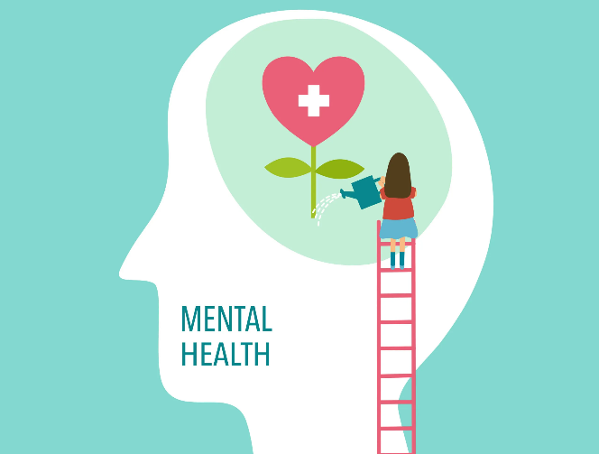
Primary Target Group
- Nurses
- Care assistants
- Social workers
- Allied health professionals
Impact on Health & Wellbeing
✔ Reduced burnout and stress
✔ Improved job satisfaction
✔ Lower sickness absence
✔ Improved quality of care for service users

🌍 Contribution to the Common Good
- Safer care for patients
- Stronger, more sustainable workforce
- Reduced NHS and social care costs
- Implementation
📍 Where
- NHS trusts
- Care homes
- Community health services
- Local authority social care teams
👥 By Whom
- Mental health practitioners
- Occupational health teams
- Trained wellbeing leads
- Peer facilitators
⚙️ How
- Staff enrol via employer
- Monthly wellbeing check-ins
- Peer-support group sessions
- Fast-track referral to counselling when needed
- Timeline
🗓 Phase 1 (Months 1–2):
- Staff consultation and co-design
🗓 Phase 2 (Months 3–5):
- Pilot programme in selected services
🗓 Phase 3 (Months 6–9):
- Evaluation and refinement
🗓 Phase 4 (Months 10–12):
- Organisation-wide rollout

Development and Regulations
✔ Mental Health & Occupational Health Standards
- NICE Guidance (2022): Supports proactive workplace mental health strategies
- NICE workplace mental wellbeing guidance
NHS Workforce Wellbeing Strategy (2023): Encourages preventative interventions7
✔ Data Protection: Complies with UK GDPR and Data Protection Act 2018 (UK Government, 2018)
✔ Safeguarding & Confidentiality
- Professional codes of conduct
- Secure reporting pathways
✔Professional Standards: Aligns with occupational health, safeguarding, and ethical codes

Technology Integration
📱 Care Well Digital Platform
- Confidential mood tracking
- Stress-level self-assessments
- Wellbeing resources
🤖 AI-Supported Alerts
- Identifies early signs of burnout
- Flags need for support (non-punitive)
🔐 Data Security
- Anonymised reporting to employers
- Individual data protected and confidential
✨ Technology Benefits
- Early intervention
- Reduced stigma
- Evidence-based workforce planning

Dissemination & Promotion
📢 Internal Promotion
- Staff briefings
- Wellbeing champions
- Induction programmes
📢 External Dissemination
- NHS workforce conferences
- Professional bodies
- Social care forums
🤝 Stakeholders
- NHS trusts
- Care providers
- Trade unions
- Regulatory bodies


Conclusion
Care Well prioritises the mental wellbeing of the people who deliver care every day.
By shifting from reactive to preventative support, it:
- Protects staff
- Improves care quality
- Strengthens the health and social care system
💙 Caring for carers is essential for sustainable care.

Health and social care systems rely on a resilient and supported workforce to deliver safe, effective, and compassionate care. Yet in recent years, concern has grown over the mental wellbeing of health and social care staff, with high levels of stress, burnout, and psychological distress reported across the sector (NHS England, 2023). Care Well is a preventative mental wellbeing and workforce retention programme designed to address these challenges proactively. This document complements the accompanying poster by providing a rationale, policy context, and justification for adoption, while emphasizing public engagement as key to the initiative’s success.
Health and social care workers face sustained emotional, physical, and psychological pressures, including heavy workloads, staffing shortages, and exposure to trauma. Evidence indicates that over 40% of NHS staff experience work-related stress, anxiety, or depression, with similar patterns across the social care sector (Health and Safety Executive, 2023). Burnout is linked to increased sickness absence, reduced job satisfaction, and higher staff turnover, which further intensifies workforce shortages (Royal College of Nursing, 2023).
Poor workforce wellbeing also directly impacts service users. Research shows that burnout is associated with lower quality of care, higher incidence of clinical errors, and reduced patient satisfaction (NICE, 2022). From a system’s perspective, failing to address staff mental health represents a significant risk to patient safety and the long-term sustainability of health and social care services. Despite recognition of these challenges, many organizations continue to rely on reactive approaches, offering support only when staff reach crisis point. This highlights the urgent need for preventative, embedded wellbeing interventions, which Care Well seeks to provide.
The Innovation: Care Well
Care Well is a structured, preventative wellbeing and retention programme combining human support mechanisms with secure digital technology. It is designed to detect early signs of stress and burnout, reduce stigma around mental health, and ensure timely access to appropriate support.
Key components of Care Well include regular well-being check-ins, facilitated peer-support circles, and fast-track referral pathways to occupational health and mental health services. A secure digital platform allows staff to complete confidential mood tracking and self-assessment tools. Evidence suggests that early identification of stress and access to timely support can significantly reduce burnout and improve workforce retention (World Health Organization, 2022). By embedding wellbeing into routine professional practice, Care Well normalizes mental health support and fosters a culture of openness, compassion, and shared responsibility.
Target Population and Impact
The primary beneficiaries of Care Well are health and social care staff, including nurses, care assistants, social workers, allied health professionals, and community care staff. These groups are disproportionately affected by occupational stress and may hesitate to seek help due to stigma, time constraints, or fear of professional consequences (NHS England, 2023).
Care Well improves health and wellbeing outcomes by reducing emotional exhaustion, enhancing coping strategies, and increasing access to mental health support. Evidence links improved staff wellbeing to higher job satisfaction, improved retention, and better care outcomes for service users (RCN, 2023). Beyond individual benefits, Care Well strengthens the wider system by supporting safer care delivery, reducing reliance on agency staff, and improving continuity of care. These outcomes align with public health principles emphasizing prevention, equity, and system sustainability (WHO, 2022).
Policy, Legislation, and Professional Alignment
Care Well aligns closely with current UK health and social care policy. The NHS Workforce Wellbeing Strategy highlights the importance of psychologically safe workplaces and preventative mental health interventions (NHS England, 2023). Care Well operationalizes these priorities by providing structured, accessible wellbeing support.
The programme also reflects NICE guidance on mental wellbeing at work, which recommends early intervention, supportive management practices, and access to evidence-based mental health services (NICE, 2022). Legally and ethically, Care Well complies with the Data Protection Act 2018 and UK GDPR, ensuring that personal wellbeing data is handled securely and confidentially (UK Government, 2018). It also adheres to the Equality Act 2010, guaranteeing inclusive access to support regardless of role, background, or protected characteristics (UK Government, 2010). Professional involvement from occupational health teams, mental health practitioners, and organizational leaders ensures that Care Well meets regulatory, safeguarding, and professional standards.
Implementation and Professional Involvement
Care Well is designed to be flexible and scalable across NHS trusts, care homes, and community social care settings. Implementation begins with staff consultation and co-design to ensure relevance and acceptability. Delivery is supported by occupational health services, trained wellbeing leads, and peer facilitators, providing both clinical oversight and peer engagement.
The digital platform supports early identification of risk trends while maintaining confidentiality through anonymized reporting to employers. This approach aligns with best practice guidance on digital health tools and workforce wellbeing monitoring (NHS Digital, 2023). By combining human support with digital monitoring, Care Well enables organizations to respond proactively rather than reactively to emerging mental health challenges.
Public Engagement and the Wider Community
Although Care Well primarily addresses workforce wellbeing, public engagement is essential. The wellbeing of care workers directly influences the quality and safety of care provided to the public. Public awareness and support can help reduce stigma, encourage ethical employment practices, and reinforce the principle that workforce wellbeing is a societal responsibility rather than solely an organizational issue.
The public can engage with Care Well through campaigns promoting staff wellbeing, participation in consultations, and advocacy for policies that protect and value care workers. This shared responsibility approach strengthens the message that the health and social care workforce is a public asset, and investment in their wellbeing benefits everyone.
Why Care Well Should Be Adopted
Care Well offers an evidence-based, cost-effective solution to workforce burnout and retention challenges. High staff turnover and sickness absence create significant financial pressures on health and social care systems. Preventative well-being interventions have been shown to reduce long-term costs while improving staff morale and care quality (WHO, 2022).
Adopting Care Well demonstrates an organization’s commitment to compassionate leadership, staff dignity, and sustainable care delivery. The programme represents a shift from reactive crisis management to proactive wellbeing promotion, positioning organization’s as responsible, forward-thinking employers.
Conclusion
Care Well provides a preventative, ethical, and policy-aligned response to the mental health challenges facing health and social care staff. By protecting workforce wellbeing, the programme improves care quality, strengthens system sustainability, and benefits society as a whole. Supporting Care Well is an investment in the resilience, effectiveness, and long-term sustainability of health and social care systems.

References
- Health and Safety Executive (2023) Work-related stress, anxiety or depression statistics in Great Britain. Available at: https://www.hse.gov.uk (Accessed: 10th December 2025).
- National Institute for Health and Care Excellence (NICE) (2022) Mental wellbeing at work (NG212). Available at: https://www.nice.org.uk (Accessed: 8th December 2025).
- NHS Digital (2023) Data security and protection toolkit. Available at: https://digital.nhs.uk (Accessed: 10th December 2025).
- NHS England (2023) NHS workforce wellbeing strategy. Available at: https://www.england.nhs.uk (Accessed: 14th December 2025).
- Royal College of Nursing (2023) Beyond burnout: Improving nurse wellbeing. London: RCN.
- UK Government (2010) Equality Act 2010. London: The Stationery Office.
- UK Government (2018) Data Protection Act 2018. London: The Stationery Office.
- World Health Organization (2022) Mental health at work: Policy brief. Geneva: WHO.

