MANAGEMENT ECONOMICS

Student Name: Vasile Ciprian Alin Diaconu

Student ID:2030168

Table of Contents
Introduction 3
Discussion 3
Business description 3
Identification of demand and market equilibrium 4
Price elasticity of McDonald’s 7
Conclusion 11
Reference List 12

Introduction
The phrase “market demand” refers to the number of people who desire to buy a particular product. This is defined by the amount of money that people are likely to invest on a specific product or service at a given price. The price of an item will increase in tandem with the level of demand in the market. The price will fall to a lower level when there is less demand for the good or service. Demand is significantly impacted by one’s level of income. If people’s salaries improve, they will need more money available for spending, therefore, as a result, they will be able to buy more things, especially products sold by McDonald’s. In this study the market demand of Mcdonalds fast food has been evaluated with contrast to its pricing strategy and customer expectation.

Discussion

Business description
Chosen product
The chosen product is fast food that is McDonald’s hamburgers. Richard McDonald and his brother Maurice launched the company in 1940 in San Bernardino, California McDonald’s is among the largest fast-food restaurants in the world.
Reason for choosing McDonald’s
McDonald’s is a worldwide chain of fast food with locals in more than hundred different countries. The largest food restaurants in the world, famous for hamburgers, French fries as well as quick meals for consumers and consumers prefer this food. McDonald’s is a worldwide chain of fast-food restaurants that provides a wide selection of meals as well as other items and services to its consumers, also McDonald's guidelines of corporate and consumer trends of items of foods (Eisenhardt et al, 2020). McDonald's has extended its menu over the decades to include many different types of cuisine, including chicken sandwiches, breakfast dishes, deserts as well as salads in addition to its iconic burgers (burgers of varieties) and fries. In an effort to meet the needs of its customer, the company has also begun offering flight fare such as grilled chicken and salads. McDonald’s not only sells meals but also provides a number of services including drive-thru, sit-down, and delivery (Dana et al, 2020). The company has also made significant investments in technology, self-service machines as well as mobile ordering to improve the experience for their customers. The fast, easy, and economical meals are at the core of McDonald’s business model. The company is among the most popular fast-food franchises in the world due to its widespread name recognition and enormous client base. McDonald’s is a franchise-based enterprise (Shore et al, 2019). Franchisees, rather than the firm, own and run the vast majority of the chain’s restaurants. McDonald’s franchisees receive marketing assistance, operational guidance, and use of the McDonald’s name and trademark in consideration of a financial cut of their sales.
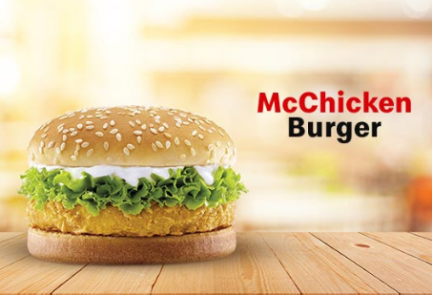
Figure 1: Mcdonald’s hamburgers
(Source: mcdonalds,2020)

Identification of demand and market equilibrium
Fast food chain McDonald’s main rival is privately held Burger king. Yum brands are the parent company of fast-food chains KFC, Pizza Hut as well as Taco bell. Compared to other restaurant chains, Subway is by far the largest in the world (Fontana et al, 2019). The pricing of the McDonald's several fast-food different types of burger prices, there is a double cheeseburger for $5.95 and a triple cheeseburger for $1 more and also these are only a few of the items available. The majority of the big burgers cost $3 and above. Depending on the item people purchase, “Burger King” menu prices vary, but generally speaking, the average cost is $4.50, according to data conducted by a “Burger King” survey (Costello et al, 2022). Most folks carry $5 in their pockets; therefore, they will go to Burger King to get something to eat so it has a competitive company king burger advantage over McDonalds.
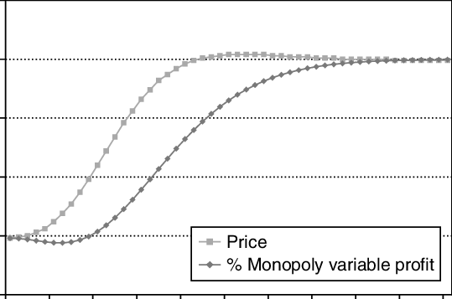
Figure 2: Demand and Market Equilibrium
(Source: Researchgate,2020)
Price of complements
The consumer interest in the commodity whose price goes up will go down as a direct result of the price increase of the other commodity. The demand curve can also be shifted by the prices of commodities that are complementary to or substitutes for one another. When there is a decrease in the cost of an item that complements another good, then there is an increase in both the quantity wanted of the first good and the demand curve of the second good (Dukpa et al, 2020). Yet, there was some positive thing for those who craved dollar menus in the year 2022. Pricelist reports that Burger King only managed a 2% increase in the pricing of its menu items in 2022 relative to the prior year, whereas McDonald's was able to achieve a 5% decrease in the costs of its menu items. Furthermore, as the price of compliments continues to drop, demand is rising on the basis of the complimenting criterion of fast food.
Consumer Income
The trend in consumer income depends on various factors, including economic conditions, government policies and global events (Game et al, 2023). Income fluctuations can have varying effects on the demand for McDonald's products and services. More discretionary income could lead to a surge in fast food consumption as more people can afford to eat out. Fast food consumption, however, may rise if consumers’ incomes fall and they seek out less expensive dining options. Yet, if people’s disposable income drops dramatically, they may choose to spend less on dining out and more on needs. The effect that the income of consumers has on the demand for products or services offered by McDonald's is a complicated one that is dependent on a number of different factors. Despite this, the fast-food business has generally been able to weather economic storms well since customers frequently look for food options that are both economical and accessible.
Consumer tastes & preferences
This tendency is evident in popular fast food restaurants menus, such as McDonald's, that now provide a wider variety of meal options. Many companies have expanded their menus to include more salads, fruits, as well as even plant-based meal options; some of these chains, such as Chick-fil-A, have even committed to solely utilising antibiotic-free chicken in their products. This tendency is evident in popular fast food restaurants' menus, such as McDonald’s, that now provide a wider variety of meal options. Many companies have expanded their menus to include more salads, fruits, as well as even plant-based meal options; some of these chains, such as Chick-fil-A, have even committed to solely utilising antibiotic-free chicken in their products (Carrillo et al, 2019). Given the multitude of factors that are driving change in the fast-food sector, customers and business owners of restaurants will both need to reevaluate their ideas about what constitutes “fast food” in the years to come. This will work out for the best in the long run. In point of fact, in a Special Report published by QSR in August 2022, industry analysts forecasted that fast food business is on the cusp of a new “golden period”. Demand will be positively impacted if the consumer’s taste and preferences are taken into consideration. In the event that consumers enjoy the flavours and preferences, there is bound to be an increase in demand.
Consumer expectations of price
McDonald’s Corp was an early leader in the fast-food sector, but today it is seen as complacent. So, the corporation seems to be losing contact with customers and team owners everywhere. Both revenue and the average share price at McDonald’s dropped in the second half of 2015. In contrast to McDonald’s, which exists solely to serve fast food at low prices, customers who are prepared to spend more than $5 on a burger will visit a fast-casual burger joint. McDonald's is disappointing its shareholders and the customers that frequent the restaurant because of the low cost of their burgers and sandwiches.
McDonald's may save money on labour costs and food costs by embracing self-serve ordering and streamlining their menu. Franchisees can save money in a number of ways by offering fewer, simpler products on their menus (David et al, 2020). This includes requiring fewer workers, as well as less expensive, specialized equipment and stock. Consumer thing the McDonald’s price increases so the consumer demand is low if McDonald princess decreases the product demand of the consumers.
Demographics
McDonald's wants to appeal to customers of all ages, from youngsters to senior citizens. Data from the year 2020 suggests that the average McDonald's consumer is a widower here between the ages of 41 and 56 who enjoys the breakfast menu items. McDonald's targets kids and retirees alike, from the age of six to 70.
McDonald's targets children in families of varying ages with its vast range of offerings, which include anything from McCafé morning beverages to combo meals suited for school lunches (Jurajda et al, 2020). Professionals, students, and the working class alike frequent McDonald's for its cheap food and free Wi-Fi.

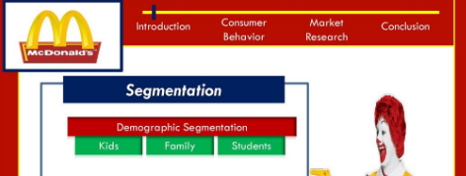
Figure 3: McDonalds demographic strategy
(Source: Researchgate,2020)

Price elasticity of McDonald’s
The price elasticity of demand in McDonald's is affected by a number of factors, such as the availability of substitutes, the level of brand loyalty, the type of product and the price of the product. Generally, the price elasticity of demand in McDonald's is inelastic, meaning that changes in price do not significantly affect the demand for McDonald's products. This is due to the fact that McDonald's is a well-established brand with a large customer base and a relatively high level of brand loyalty, meaning that customers are more likely to purchase McDonald's products at whatever price they are offered (McDonald et al, 2020). Additionally, McDonald's offers a wide variety of products, meaning that customers have a range of options and are less likely to be affected by price changes. On the other hand, there are certain factors that can affect the price elasticity of demand for McDonald's products. For example, if a new competitor enters the market with a product that is similar to McDonald's and is offered at a lower price, this could increase the price elasticity of demand for McDonald's products. Additionally, if McDonald's raises its prices significantly, this could lead to a decrease in demand for its products, as customers may switch to other products that are cheaper. Finally, the level of brand loyalty can also affect the price elasticity of demand for McDonald's products, as customers with a high level of brand loyalty may be willing to pay a premium for McDonald's products, regardless of price.
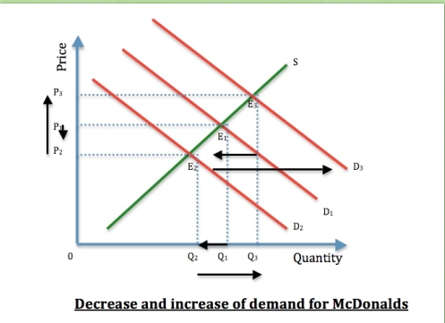
Figure 3: price increases and decreases of demand
(Source: Researchgate, 2020)
Elastic or Inelastic Demand
The demand for McDonald's products can vary depending on a range of factors such as price, availability, consumer preferences and economic conditions. However, in general, the demand for McDonald's products is considered to be relatively inelastic (Quah et al, 2022). The demand for McDonald's products can vary depending on a range of factors such as price, availability, consumer preferences and economic conditions. However, in general, the demand for McDonald's products is considered to be relatively inelastic. Inelastic demands means that changes in price have a relatively small impact on the quantity of goods or services demanded by consumers. For instance, if McDonald’s were to raise the price of its Big Mac by a small amount, consumers may still continue to purchase the Big Mac because they perceive it to have a high value and convenience. In contrast to inelastic demand, elastic demand means that changes in price have a significant impact on the quantity of goods or services demanded by consumers (Marks et al, 2023). Likewise, if McDonald’s were to raise the price of its products by a significant amount, consumers may choose to switch to other fast food chains or restaurants that will offer similar products at much lower prices when compared. While the demand for McDonald’s products may not be completely inelastic, it is generally considered to be less elastic than many other consumer goods and services.
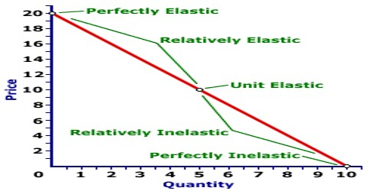
Figure: Elastic and inelastic demands
(Source: slideplayer, 2022)
The demand for McDonald’s products can be considered severely inelastic because of several factors:
- Brand Loyalty- As McDonald’s is a well-established brand with a loyal customer base, the customers are likely to continue purchasing products even if the price of the products get increased.
- Low Price: McDonald's offers its products at a relatively low price point, making it affordable for many customers (Robinson et al, 2021). When the price of its products increases, customers may not be willing to switch to a competitor's products, as they may be more expensive.
- Convenience: McDonald's has a widespread network of outlets, making it convenient for customers to purchase its products. If a customer wants a quick meal or snack, they are likely to go to the nearest McDonald's outlet, regardless of the price.
- Addiction: Some people become addicted to the taste of McDonald's products, making them less sensitive to price changes. This is especially true for products like burgers, fries and soft drinks, which contain high levels of sugar and fat that can trigger cravings.
Luxury or Necessity
As per the consumer's point of view, McDonald's can be both a luxury and a necessity. On the one hand, McDonald's can be seen as a luxury due to its convenience and affordability, making it a popular choice for quick meals on the go. It offers a wide range of fast-food options, from burgers and fries to salads and wraps, that can be customised to suit individual tastes (Dana et al, 2020). Furthermore, McDonald's has become a staple of the American food culture, with its iconic golden arches a familiar sight in most cities and towns. On the other hand, McDonald's can be seen as a necessity for those who lack the time, resources, or skills to make a meal from scratch. Many people rely on McDonald's for quick meals that are both affordable and convenient. Additionally, McDonald's often offers discounted or free meals to those in need, providing an important source of nourishment for those who might otherwise go without. In this way, McDonald's can be both a luxury and a necessity, depending on the individual's circumstances.
Pricing policy
- Some of the most successful fast-food chains employ value pricing. In value pricing, the cost is taken to be the main determinant of the product's worth to the consumer. The value price arises when the corporation develops the product while keeping the price the same or lowering it. The possibility of “super-size” drinks and fries at a fast food centre is a brilliant example of value pricing.
- To get into a market, it's good to set an investment in order that's lower than what you'd eventually cost. The idea here is to broaden the audience and increase sales.
- Fast food restaurants typically use this type of pricing structure. In order to provide fair rates, it is essential that you track the pricing structures of similar firms.
- Bundle pricing is a selling method that involves selling and marketing multiple products in a coordinated effort to spare the buyer money. Value meals are a similar type of packaging done by fast food establishments.

Conclusion
A competitive advantage over other quick-service restaurants was achieved by the company’s production of a wide range of products in accordance to consumer demands’ requests for just a wide price range. McDonald’s is able to fortify itself against industry competitors thanks to its responsiveness to customer needs and stellar reputation for service. If McDonald's is going to compete, including its rivals, it needs to come up with some way to differentiate itself that will last, or it needs to collaborate with its rivals to expand the size of the market. Losing customers could be the biggest obstacle. The company's drive to perpetual fast food product improvement is directly responsible for its continued success.

Reference List
Ashenfelter, O. and Jurajda, Š., 2022. Minimum wages, wages, and price pass-through: The case of mcdonald’s restaurants. Journal of Labor Economics, 40(S1), pp.S179-S201.https://www.journals.uchicago.edu/doi/abs/10.1086/718190
Calderón Carrillo, J.M., 2019. Relationship analysis between culture and business within the indian market. Case: Mcdonald’s, Hennes & Mauritz and L'oréal (Bachelor's thesis, PUCE-Quito).http://repositorio.puce.edu.ec/handle/22000/17721
Castonguay, A.C., Polasky, S., Holden, M.H., Herrero, M., Chang, J., Mason-D’Croz, D., Godde, C., Lee, K., Bryan, B.A., Gerber, J. and Game, E.T., 2023. MOO-GAPS: A multi-objective optimization model for global animal production and sustainability. Journal of Cleaner Production, 396, p.136440.https://www.sciencedirect.com/science/article/pii/S095965262300598X
Deschenes, O., Costello, C., McDonald, G., Melnychuk, M. and Missirian, A., 2022. Can Demand-Side Interventions Rebuild Global Fisheries?. Available at SSRN 4088011.https://papers.ssrn.com/sol3/papers.cfm?abstract_id=4088011
Feuerbacher, A., McDonald, S., Dukpa, C. and Grethe, H., 2020. Seasonal rural labor markets and their relevance to policy analyses in developing countries. Food Policy, 93, p.101875.https://www.sciencedirect.com/science/article/pii/S0306919220300774
Hung, K. and David, K.T., 2020. Luxury brand consumption in emerging economies: Review and implications. Research handbook on luxury branding, pp.93-116.https://www.elgaronline.com/display/edcoll/9781786436344/9781786436344.00017.xml
Lane, T., Fontana, M., Martinez-Naharro, A., Quarta, C.C., Whelan, C.J., Petrie, A., Rowczenio, D.M., Gilbertson, J.A., Hutt, D.F., Rezk, T. and Strehina, S.G., 2019. Natural history, quality of life, and outcome in cardiac transthyretin amyloidosis. Circulation, 140(1), pp.16-26.https://www.ahajournals.org/doi/abs/10.1161/CIRCULATIONAHA.118.038169
McDonald, N.J. and McDonald, G.W., 2020. Towards a dynamic equilibrium-seeking model of a closed economy. Systems, 8(4), p.42.https://www.mdpi.com/880140
McDonald, R.M. and Eisenhardt, K.M., 2020. Parallel play: Startups, nascent markets, and effective business-model design. Administrative Science Quarterly, 65(2), pp.483-523.https://journals.sagepub.com/doi/pdf/10.1177/0001839219852349
Nikam, S.P., Hsu, Y.H., Marks, J.R., Mateas, C., Brigham, N.C., McDonald, S.M., Guggenheim, D.S., Ruppert, D., Everitt, J.I., Levinson, H. and Becker, M.L., 2023. Anti-adhesive bioresorbable elastomer-coated composite hernia mesh that reduce intraperitoneal adhesions. Biomaterials, 292, p.121940.https://www.sciencedirect.com/science/article/pii/S0142961222005804
Quah, D., 2022. Platform Companies and Platform Workers: Price and Quantity Responses to Changing Cost.https://dannyquah.github.io/Storage/2022.08-Danny.Quah-Platform-Companies-Workers-Responses-LKYSPP.pdf
Sainsbury, K.A., Shore, R.F., Schofield, H., Croose, E., Campbell, R.D. and Mcdonald, R.A., 2019. Recent history, current status, conservation and management of native mammalian carnivore species in Great Britain. Mammal Review, 49(2), pp.171-188.https://onlinelibrary.wiley.com/doi/abs/10.1111/mam.12150
Thierfelder, K.E., McDonald, S. and Robinson, S., 2021. Taxing Energy Use and Carbon Emissions to Reduce Global CO2 Levels. United States Naval Academy, Department of Economics.https://www.usna.edu/EconDept/RePEc/usn/wp/usnawp66.pdf
Tien, N.H., Dana, L.P., Jose, R.J.S., Van Dat, N. and Duc, P.M., 2020. Analysis of McDonalds’ entry strategy into Vietnam market. International journal of advanced research and development, 5(3), pp.23-29.https://www.researchgate.net/profile/Nguyen-Tien-32/publication/342623916_Analysis_of_McDonalds'_entry_strategy_into_Vietnam_market/links/6395d0eee42faa7e75b594a9/Analysis-of-McDonalds-entry-strategy-into-Vietnam-market.pdf
Tien, N.H., Dana, L.P., Jose, R.J.S., Van Dat, N. and Duc, P.M., 2020. Analysis of McDonalds’ entry strategy into Vietnam market. International journal of advanced research and development, 5(3), pp.23-29.https://www.researchgate.net/profile/Nguyen-Tien-32/publication/342623916_Analysis_of_McDonalds'_entry_strategy_into_Vietnam_market/links/6395d0eee42faa7e75b594a9/Analysis-of-McDonalds-entry-strategy-into-Vietnam-market.pdf

