Programme: BSc Business Information Technology

Author name: Mohammad Zanganeh
Student P Number: P108304

Module Code: M2X8622
Module Name: E-Commerce
Lecturer: Sue Maw

Assignment Title: Build a Prototype E-Commerce Website
Report
Submission Date: 13/05/2016

Table of Content

- Title Page…………………………………………………………..I
- Table of Content…………………………………………………...II
- Introduction……………………………………………………….1
- Ecommerce Infrastructure Platform……………………………1
- Building the ecommerce application.……………………………3
- The Design of the SolREnergy E-commerce Website………….4
- Electronic Transaction…………………………………………..8
- Marketing metrics analysis……………………………………..9
- Conclusion……………………………………………………….10
- References………………………………………………………..11

Introduction
To create an efficient online store, secure and full-featured online shopping cart software with the complete set of powerful e-commerce options must be in place. Successful ecommerce businesses need a powerful infrastructure includes equipment, facilities and processes to support customers’ needs and all the other functional areas of the business [1].

The aim of this essay is to investigate ecommerce solutions and develop an ecommerce store to suit “Sol R Energy Company”. Sol R energy is a family business with over three years experience in retrieving solar power and installing solar panels. The business initially set up a simple administrative system with manual invoicing and stock control system. Due to rapid growth of the company, they need an ecommerce platform to support all the scheduling and invoicing and other needs of the growing business.

It is important to define the ecommerce infrastructures necessary to support the website development and justifying the options available for the development [2]. The website should enable the company to sell products and provide services for consumer over the Internet with payment processing such as credit card concepts. This e-commerce website also needs to cover “business to business” and “business to customers” elements.

Ecommerce Infrastructure Platform
To provide high-level customer service for premium products, which is one of the company’s value propositions, the infrastructure should include fast delivery processes, responsive service, self-service tools, and live chat for questions and orders [3].

According to Traxler (2012) [1], it is important to consider seven infrastructure decisions as follows: Marketing, Facilities, Customer Service, Information Technology, Fulfilment, Finance and Administration and Human Resources.

Marketing is the most important infrastructure element. To succeed the website must be found and it needs to keep customers on the site and compel them to buy from the site [3]. For effective marketing activities, website design, social media, email or other strong form of marketing are necessary [4].

Physical office and facilities are another key element that needs to be kept flexible particularly when a business is growing [2]. Another important decision is to choose e the right ecommerce platform to build and host the website [2].

The business also needs to consider options available for finance and administrations, whether they decide to manage their finance using outside services or in-side house [1]. Many businesses are focussing on sale, marketing and customer service and use outside services for managing their pay role and vendor payments.

Once the solar company realised that their business can benefits from an online presence, they should decide what type of business they want to run and how the website should be developed. There are a number of different types of ecommerce providers with different type of websites, including B2B and B2C. However, all the type usually uses the same underlying applications and provides the similar sorts of functionality [5]. Nickerson (2002) [3] states that an electronic store needs to support the same tasks of the physical store; they need to offer certain capabilities to customers and merchants. It is particularly important to provide consumers with the information about the products and services, electronic order entry and electronic payment function [3, 5].
As the business would like to have both the B2C and B2B type of business, it is helpful if they have a personalised catalogue and customised webpage for all major buyers [6].

Building the ecommerce application
There are some sorts of technology for building an ecommerce website includes Html, PHP, CSS, SQL, and Java Script [7]. To build an ecommerce application rapidly, there are many open-source platforms such as WordPress, Shopify, Wix and etc. Although, it should be take care about the chosen platform that implements all these technologies for an online store. Wix is one of the platform that have all the features to build the website for a monthly fee [8].

Every business should find a correct ratio quality-price that includes all the features and extra tools for developing a productive website [8]. Wix is on the top of the web builders’ pile and host around 80 million websites [7]. It offers different features and allows any type of website to flourish beautifully. Its templates are visually impressive, easy to use and designed for small businesses such as “Sol R Energy Company” [8]. Wix is available free for as long as required, although, when the company choose to have their own domain name or priority support, it is possible to choose one of the five premium plans offered by Wix (Figure 1).

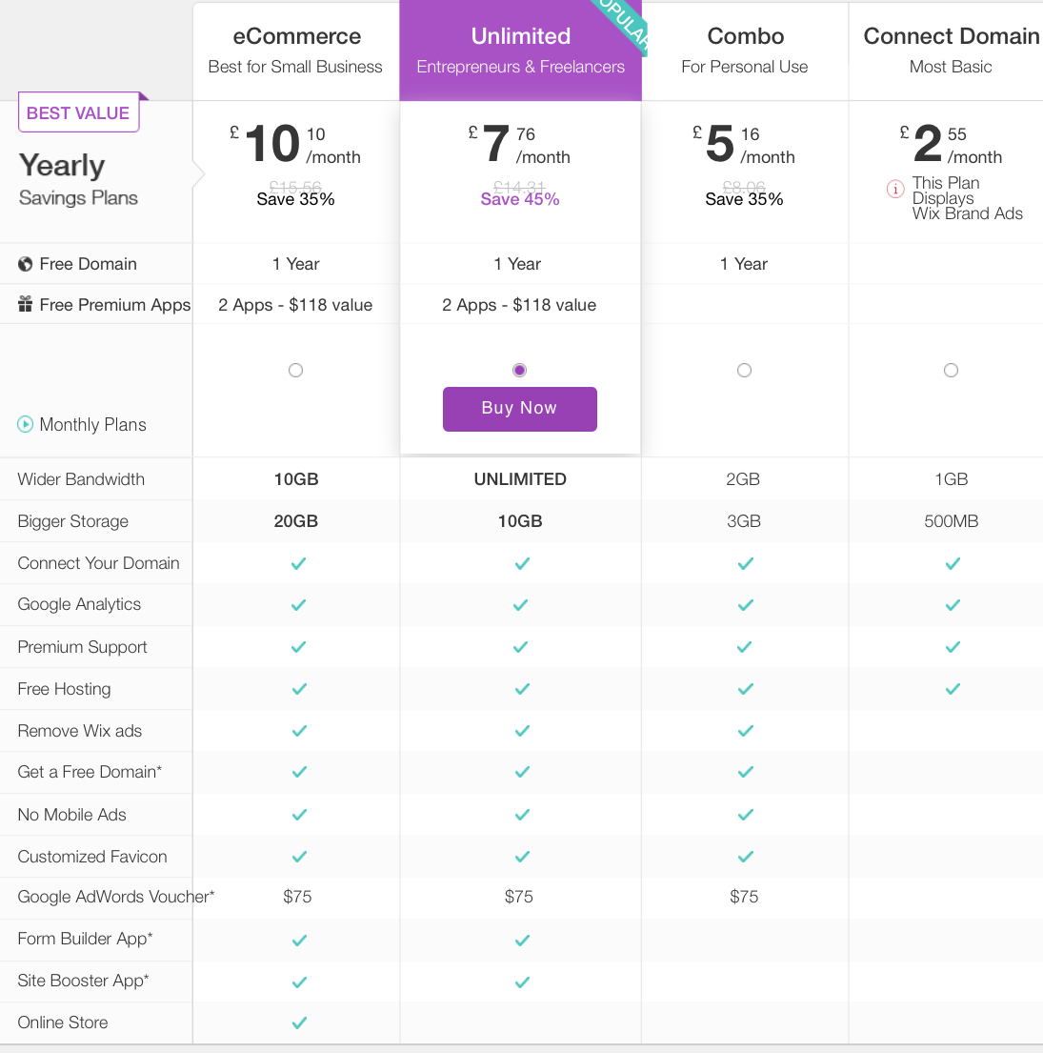

[Fig 1]

For developing an ecommerce website, a great logo is considered to introduce the company’s Brand [figure 2]. Logo is the graphical representation of the company and the critical aspect of business marketing [9]. Also logos are shortened way of referring to the company and sometimes customers can identify the company name by seeing the logo of the company [10, 11].

[Fig 2]
One of the key usability of the website is the ease of navigation. User interface must easily find what they are looking for in the website. Effective design is more likely to keep the users on the site rather than going to somewhere else. So, effective design, responsive menu (figure 3), and ease of navigation are three important elements that increase the web users [12].
[Fig 3]

The Design of the SolREnergy E-commerce Website
According to Beaird J. (2010) [13], users determine two standpoints whether design of the website is “good” or “bad”. One of them is difficulty of usability angle, which is about focuses on presentation of information, functionality and efficiency. The other one is the purely aesthetic perspective that is about the artistic value and beauty of the design [13]. Some people just consider the graphic and aesthetics and forget about the users and the usability that can affect the business negatively [13].

The home page on an e-commerce website always is the highest traffic page, this page is very important and it should have motivational web contents to create long-term customers and driving sales [14]. The home page is very difficult task to create; it should be effective and attractive. As the SolREnergy e-commerce website is B2C an also B2B website, it needs attractive home page or welcoming page with incredible contents to introduce the business type and products or services [Figure4].
The customers who visiting the website need to feel confident while they are in the website, they must be attracted by the quality products and services that is offered by the company. In servicer page, it is considered to offer some services to the customers such as commercial solar panel, Aftercare Support, Consultancy, Planning, Maintenance and cleaning, full home health check, and panel cleaning [Figure5].


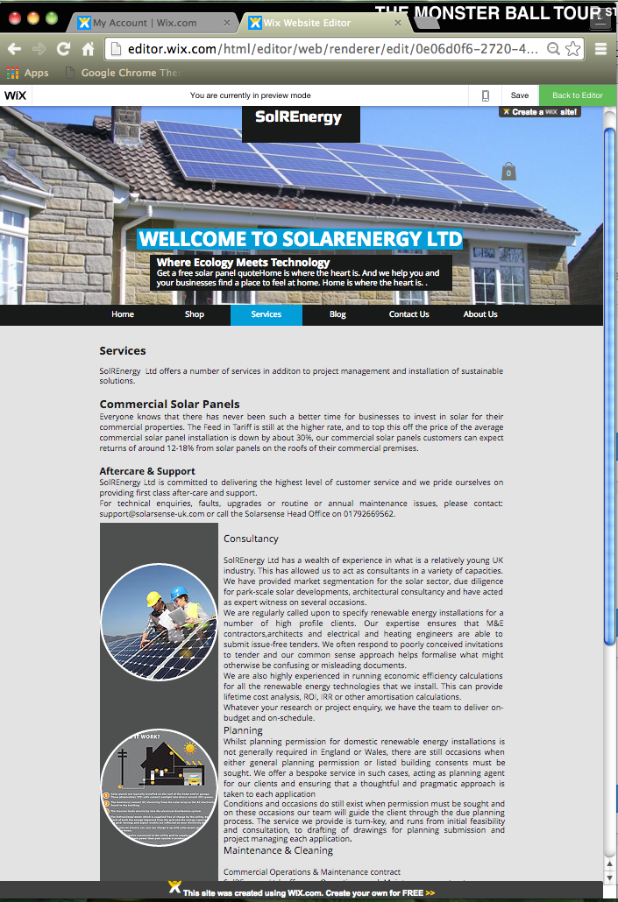
[Fig4] [Fig5]
When customers need any extra information about organisation, they look at the “about us” page. It is a part of every website to share the story behind the company name, their motivation for starting the business and explain what the customers can expect from the business [23] [Figure6]. Some customers’ needs to communicate with the business to get further information or getting quote, contact page is the best way for every e-commerce website [Figure7].
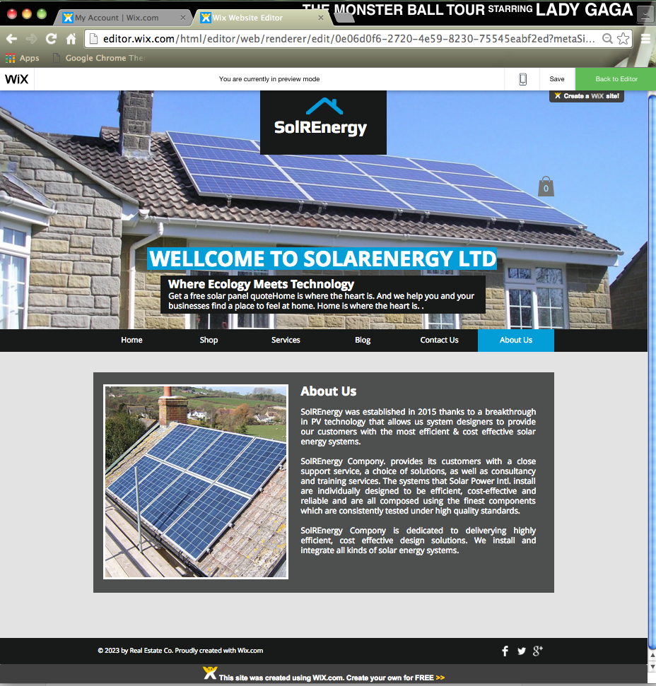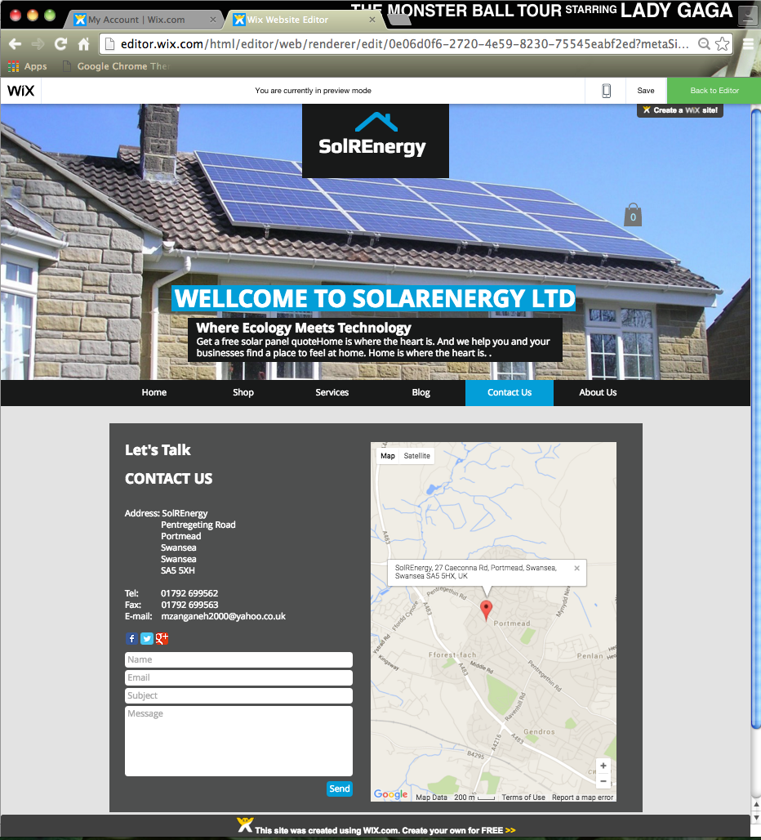
[Fig6] [Fig7]

To make a website more strong and powerful creating “Blog page” could be important and helpful. Sharing and creating content value for the target audience can be another e-marketing strategy [24]; it is one of the main reasons for having a blog page that is linked to an external blog [figure8]. Also, Providing some External Pages to give extra information about the products and services is very helpful for users and to stay longer in the site [figure9].

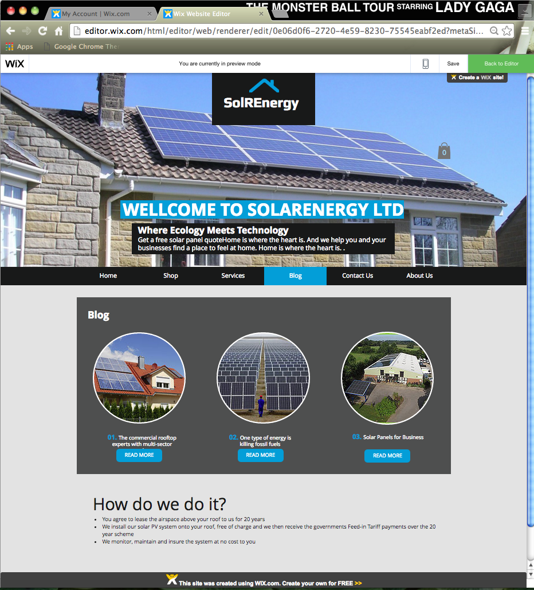
[Fig8] [Fig9]

To promote the business and e-marketing “Twitter”, ”Facebook” and ”Google+” are popular and the fastest way to growing the website over Internet [Figure9].

[Fig 9]
The sale processes in e-commerce website starts from shop page by clicking on the item, when the customers click on the items the new page will open to add the item into the shopping cart [Figure10, 11].

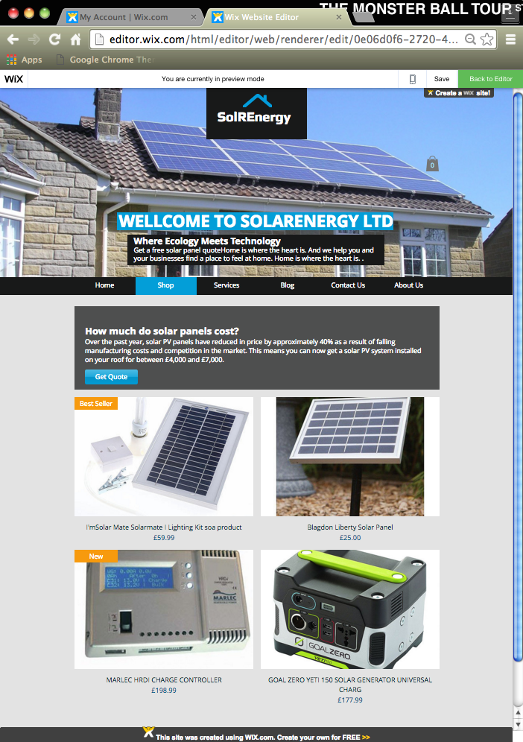
[Fig10] [Fig11]

The customers can view the cart to make sure the item is added and also they can check the quantity of the items [Figure12]. It is possible to proceed to checkout by clicking on the checkout button and makes the payment if the customer wishes to continue [Figure13].
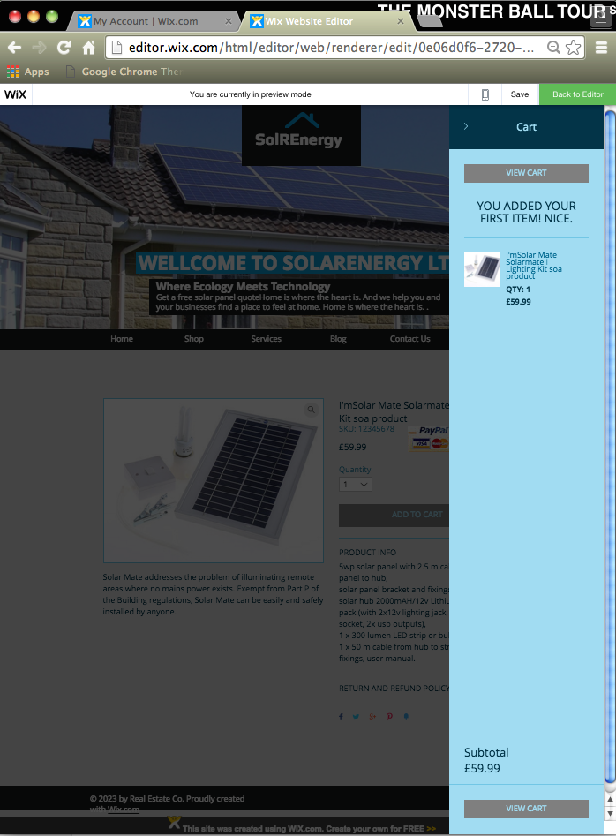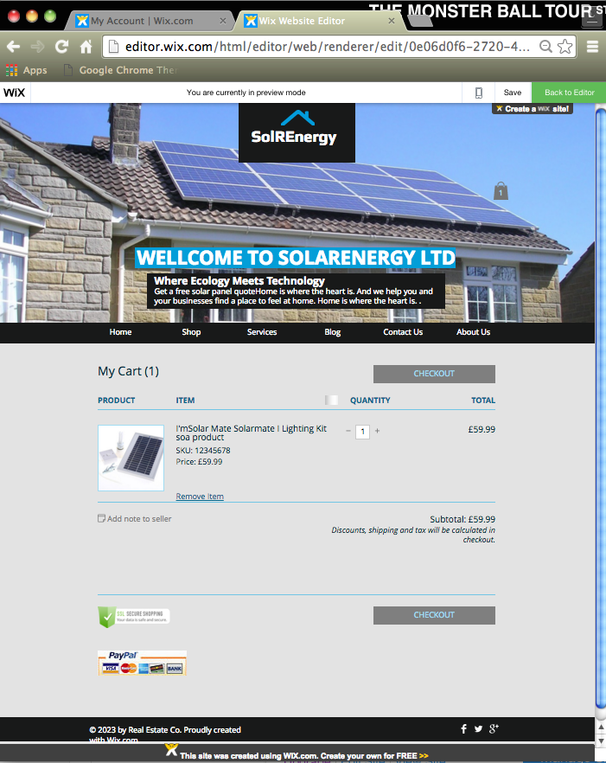
[Fig12] [Fig13]

The shopping processes will be finished, by choosing payment provider such as PayPal, MasterCard or any secure payment depending on the site acceptance [Figure14].



[Fig14]

Electronic Transaction
Today, electronic transaction opens the door to a much more secure and efficient way in exchanging information and document transactions [15]. Government entities and many companies, regardless of size are adopting these solutions. It is very easy for electronic signature to make a business case with identity of the credentialing, document verification, secure document exchange, and the electronic storage [15]. In addition, electronic transaction is environment friendly, more flexible, and reduce the cost of managing documents [15].

Electronic payment is a part of “E-commerce transection” which means selling and buying goods and services through the Internet [16]. There are different methods and forms of electronic payments. Using check and cash transaction is going to decrease because of the technology developments. By contrast, the types of electronic payments processes continue to increase [15]. The Internet shopping has become most active by allowing customers to easily buy a variety of products and services from around the world [17]. The businesses and consumers are confidence when using secure electronic payment systems such as PayPal, e-wallet, and etc [17].

After selecting a payment method and choosing to pay by credit or debit cards, the site will pass the information of the cardholder to payment processers. Payment processor then sends that information to the issuing bank for authorisation [18]. The bank approved or denies the transaction based on the card status; if the payment approved, the card issuer forwards the funds and charges the user (Figure 15).

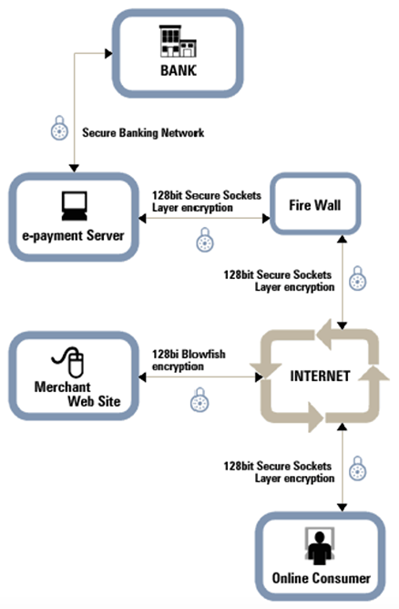
[Fig2]

One of the main electronic payment providers is “PayPal”. It is the safer way to pay and receive payments for the good and services [19]. PayPal takes fraud seriously and provides specific guidelines to decrease transaction risks with the fraudulent seller [19]. The buyer protection policy from PayPal protects people privacy by securing their information over the Net and will refund the customers if they didn’t receive the goods they purchased. The customer can receive the refund within twenty days of opening dispute [20].

Marketing metrics analysis
A marketer needs to be skilled at using data because it helps the business find opportunities for different marketing channels and the owner to make smart decision when necessary [22]. These metrics can be categorized into traffic metrics, conversion and revenue metrics [21].
Traffic metrics are very important for both search engine optimization and pay-per-click (PPC) digital marketing techniques [21]. Significant changes in traffic flows of the site or particular webpage demonstrates how well the business works what area the business should focus to get more unique visitors and success [21].

Converting website traffic into business leads the sales of the site that is primary purpose of digital marketing. So it is important to know what particular metrics are effective during conversion and which area of digital marketing is driving sales and revenue [22].

In fact, the success of digital marketing can be measured properly by revenue metrics such as “return on investment”. This will tell the marketer how to improve the content for better engagement and if a particular campaign is profitable and makes bigger revenue [21].

Conclusion
To conclude, when planning any part of the company infrastructure, it is important to make sure that each elements support the target market and the value proposition they have defined. Using a web builder site such as Wix was very easy with full features to create a stunning ecommerce site.
In addition, switching to an electronic payments provider such as PayPal is very easy and secure for both the seller and buyer.
Marketing metrics plays a key role in the business success and they should be measured on a regular basis to improve the business performances.

References
- Traxler, D., (2012), 7 Key Ecommerce-Infrastructure Decisions, It is Available at: http://www.practicalecommerce.com/articles/3545-7-Key-Ecommerce-Infrastructure-Decisions [Accessed: 26/04/2016]
- Kowtha NR, Choon TW. Determinants of website development: a study of electronic commerce in Singapore. Information & management. 2001 Dec 20; 39(3):227-42.
- Nickerson, R. “An E-Commerce System Model.” Eighth Americas Conference on Information Systems, Dallas, TX, August 9–11, 2002.
- Grier S, Bryant CA. Social marketing in public health. Annu. Rev. Public Health. 2005 Apr 21; 26:319-39.
- Turban E, King D, Lee J, Viehland D. Chapter 19: Building E-Commerce Applications and Infrastructure. Electronic Commerce A Managerial Perspective. 2008:27.
- Nazir, R. The Business of B2B Ecommerce Requirements. Jul. 2015. Available at: http://www.monsoonconsulting.com/kite-flying/blog/the-business-of-b2b-ecommerce-requirements [Accessed 11/05/16]
- Shoy, C. Quora. What technologies are needed to build an e-commerce website? Available at: https://www.quora.com/What-technologies-are-needed-to-build-an-e-commerce-website [Accessed 11/05/16]
- Website tool tester. Wix.com Review – The Flexible Website Builder. Available at: http://www.websitetooltester.com/en/reviews/wix-review/ [Accessed11/05/16]
- Gilmore JH, Pine BJ. The four faces of mass customization. Harvard business review. 1997 Jan 1; 75:91-101.
- Baruch Y. On logos, business cards: the case of UK universities. Artifacts and organizations: Beyond mere symbolism. 2006:181-98. Available at: https://books.google.co.uk/books [Accessed: 12-05-2016]
- Gillikin J. Demand Media, Importance of Logos in Business: http://smallbusiness.chron.com/importance-logos-business-577.html [Accessed: 12-05-2016]
- Cao M, Zhang Q, Seydel J. B2C e-commerce web site quality: an empirical examination. Industrial Management & Data Systems. 2005 Jun 1; 105(5):645-61.
- Beaird J. The principles of beautiful web design. Sitepoint; 2010 Nov 28. It is Available at: https://books.google.co.uk/books? [Access 11/05/16]
- Wirtz BW, Schilke O, Ullrich S. Strategic development of business models: implications of the Web 2.0 for creating value on the Internet. Long Range Planning. 2010 Jun 30; 43(2): 272-90.
- Kolodinsky JM, Hogarth JM, Hilgert MA. The adoption of electronic banking technologies by US consumers. International Journal of Bank Marketing. 2004 Jun 1; 22(4): 238-59.
- Gray RN, Fitzgerald SV, Piket JR, inventors; Gray R O'neal, Fitzgerald Shawn V, Piket Joseph R, assignee. Method for electronic payment. United States patent US 7,757,945. 2010 Jul 20.
- Atkearney. Global Retail E-Commerce Keeps On Clicking The 2015 Global Retail E-Commerce Index. 2015. Available at: https://www.atkearney.com/consumer-products-retail/e-commerce-index/full-report/-/asset_publisher/87xbENNHPZ3D/content/global-retail-e-commerce-keeps-on-clicking/10192 [Accessed 12/05/16]
- Katis T, inventor; Citibank, NA, assignee. Method and system for co-branding an electronic payment platform such as an electronic wallet. United States patent US 6,601,761. 2003 Aug 5.
- Ongtang M, McLaughlin S, Enck W, McDaniel P. Semantically rich application‐centric security in Android. Security and Communication Networks. 2012 Jun 1; 5(6):658-73.
- Paypal. Fraud prevention tips for buyers. Available at: https://www.paypal.com/buyertips [Accessed 12/05/16]
- Digital marketing. 14 most important metrics to focus in your digital marketing Campaign. Available at: http://digitalmarketingphilippines.com/14-most-important-metrics-to-focus-in-your-digital-marketing-campaign/ [Accessed 12/05/16]
- Goward C. You should test that: conversion optimization for more leads, sales and profit or the art and science of optimized marketing. John Wiley & Sons; 2012 Dec 21
- Geraham, S. How to write Greate about us page content. (N.D). Available at: http://shawngraham.me/blog/how-to-write-great-about-us-page-content [Accessed 13/05/16]
- Lincoln SR. Mastering Web 2.0: transform your business using key website and social media tools. Kogan Page Publishers; 2009 Jun 3.
Digital Marketing Campaign (

