A summary of academic and employment skills.
1a. The aim of this course is to pick up essential skills that will give me entry into the workforce, developing and creating content using related programs that will enhance my ability to produce. Maya is a professional 3D animation, modelling, simulation, and rendering toolset, designed for creating realistic characters and blockbuster-worthy effects [3]. This is a program I need more assistance using and would like to be at a stage where I am very competent. There are many skills sets which will be attained during my three years on Games Design some of which will be teamwork and time management, as many tasks will have deadlines to work to and must do it in small groups. Effectively being able to work in a team will allow each of us to be able to bring the best of what were doing to the table. Picking up vital experience will allow me to be able to grow into my role and improve my ability to perform and showcase my training and knowledge.
Being capable of listening and understanding what others are offering and bringing to the table will improve my understanding of other people’s directions and help improve communication. I’m hoping that each year I study the level of understanding and my ability will improve that I can move into more advanced stages of games design before deciding where I would like my focus to be.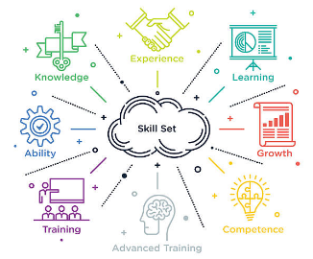 [1]
The industry tries to balance what the sector is asking for with what educators are teaching and in 2004 skillset CEO Dinah Caine highlights her organisations intention to ‘put employers in the driving seat’ [2]. This would suggest that criteria for what’s being taught can be changed to accommodate what the industry needs to what’s being taught.

[1] Herk, M. (2015) Which skills are most important on the job and which skills are in short supply?, Committee for Economic Development of The Conference Board. Available at: https://www.ced.org/blog/entry/which-skills-are-most-important-on-the-job-and-which-skills-are-in-short-su (Accessed: October 17, 2022).
[2] Jeffries, K.K. (2010) Skills for creativity in games design, Design Studies. Elsevier. Available at: https://www.sciencedirect.com/science/article/pii/S0142694X10000499 (Accessed: October 17, 2022).
[3] Maya software: Get prices and buy maya 2023 (2022) Autodesk. Available at: https://www.autodesk.com/products/maya/overview?term=1-YEAR&tab=subscription (Accessed: October 17, 2022).

The similarity score I received from my Turnitin submission was 26%. When investigating the similarities, I can see that one sentence is like another online based on a general description of the program I was talking about, I could potentially get this lowered by altering the sentence sequence and using alternative words. The remaining percentage points which were three percent, three percent and six percent were all in relation to my references, so I don’t think it is possible to lower my similarity score any more than it currently sits at.

