19/11/2025
Kwame Assa-Agyei

Software Solutions for Business Assigment 1

Table of Contents
Introduction 1
Task 1. e-Commerce Website builders or software solutions 1
1.1 WooCommerce 1
1.2 Wix 1
Task 2. Mind-map of contemporary software applications 1
a. Mind mapping and explain the benefits of using mind mapping in business operations 1
b. Create a mind map of contemporary software applications 1
Task 3. Office Applications 1
a. Four office software solutions for business operations 1
MS Word 1
MS PowerPoint 1
MS Excel 1
MS Access 2
b. Practical demonstration of Two Office Features 2
Mail Merge 2
If Statement 2
Task 4. Communication and Collaboration applications 2
a. One contemporary Communication and one Online Collaboration applications/tools 2
MS Outlook 2
MS Teams 2
b. One feature of a freely available Communication (1) and one feature of a Collaboration (1) application 2
MS Outlook 2
Ms Teams 2
Conclusion 2
References 3

Introduction
<Insert Information Here>

Task 1. e-Commerce Website builders or software solutions
- Shopify
Shopify is one of the completely hosted e-commerce platforms, which is designed to facilitate everyone with building up an online store. It is a subscription-based comprehensive service; Shopify offers web hosting, security, checkout tools, product management, and processing of payments. This makes it ideal for beginners or business owners who want to avoid the technical problems of running a website [1].
In addition to these core features, Shopify also includes automatic updates and server maintenance; therefore, users never need to worry about installing any kind of software or security patches. This kind of convenience is another major reason why many small businesses go for Shopify instead of self-hosted platforms.
Shopify is popular because it is easy to be set up; users can choose a theme, customise it with drag in and drop tools, and start adding products quickly. It also includes helpful features for inventory tracking, discount codes, and marketing tools. The checkout system of this platform is fast and well-optimized, which helps in increasing conversions[2].
Another strong advantage is the vast number of applications available in the Shopify App Store; this gives store owners a chance to implement features like email marketing, customer reviews, and social media integrations in just a few clicks. Shopify supports several channels of sale, including Facebook, Instagram, and point-of-sale systems for in-store sales.
The downside is that Shopify can get expensive once you grow, especially if you need premium apps or external payment gateways. Deep customization may also require learning Shopify's Liquid coding language. Still, it is one of the best choices for businesses that want a reliable and scalable store without having to handle technical maintenance themselves.
Indeed, despite the much higher costs, many businesses find that the time saved and the platform's stability pay off.[3]

2. WooCommerce
WooCommerce is an open source, that turns any WordPress site into a fully functional online shop. Unlike Shopify, WooCommerce is self hosted, meaning you choose your own hosting provider and control much more of your site[4]. This level of control appeals to users who prefer having ownership over every part of their store setup, including performance settings and data management. Many website owners appreciate that they can scale their store in their own way without depending on a third-party platform’s rules.
The biggest advantage of WooCommerce is flexibility, because it is open source you can customise your store however you like, add almost unlimited numbers of plugins, or modify the design of the site in ways hosted platforms may restrict. It is also cost effective at the start since the core plugin is free[5]. Another benefit is the massive community support available, with thousands of tutorials, forums, and developers ready to help. WooCommerce also integrates smoothly with WordPress themes, which gives users a wide range of design choices and allows them to match the store’s look to their existing website easily.
However because WooCommerce is more based on yourself, youre responsible for updates backups security and hosting quality. While the plugin is free, costs can increase when you add paid addons premium themes or higher quality hosting. It is a great option for businesses that want to complete control and are comfortable managing the technical side, or for anyone already familiar with WordPress[6]. For users willing to manage these responsibilities, WooCommerce can offer a powerful and highly personalised online store experience.
3. Wix eCommerce
Wix is known for its user friendly drag and drop website builder, and its e-commerce tools have grown significantly in recent years. Wix eCommerce is ideal for beginners or creative businesses who want an attractive-looking store without learning any technical skills. It is especially helpful for small businesses, artists, and freelancers who build up an online presence more quickly. Moreover, Wix offers a library of templates that suit many different types of shops, allowing users to pick a design that fits their brand without requiring any coding experience. The platform takes the user through setup step by step.[7]

The biggest selling point of this platform is ease of design: you can put elements anywhere on a page, edit styles with ease, and quickly build up a professional-looking shop. Wix includes standard e-commerce features-product management, digital downloads, abandoned cart recovery, and a marketing toolset-built right in. Along with that, Wix provides built-in SEO features to help stores appear on search engines, making it easier for customers to find products online. Social media platforms can also be integrated, wherein users may sell directly through channels like Instagram or Facebook. While simpler than some of the other options, Wix still provides enough customization options for businesses who focus on the design and presentation aspect. In general, it is considered a good option for users who like intuitive functioning and creative visual development over deeply technical control, and it works well for users who want a store they can manage with minimal time and effort.[8]

Task 2. Mind-map of contemporary software applications
Mind mapping is a visual method of organising information, ideas and tasks in a way that reflects how the brain thinks through connections rather than straight. Instead of writing notes in long list or paragraphs, a mind map begins with a main idea placed at the centre of a page you are working on. From that point, branches extends outward to represent main themes, categories or topics. Those branches can then split into smaller sections, forming kind of map for thoughts. This layout makes a mind map easy to read and helps people with agreement between ideas more clearly.
The concept was popularised by educational author Tony Buzan, who described mind mapping as a technique that uses whole brain thinking. According to Buzan, mind maps encourage the use of both the logical analysis left side of the brain and the creative, visual right side. His research suggested that combining images, colours and keywords helps with a memory and improving understanding of information.
Modern learning research supports this idea, The University of Adelaide and various visual learning studies have shown that people process images and structured visuals faster and better than plain blocks and loads of text. Because a mind map relies on visual cues such as colour, shapes and layout informations becomes easier to remember and rewind. These qualities make mind maps especially useful in workplaces, where employees often deal fast moving information.
In business operations, mind mapping have much practical benefits. One of the most common uses is brainstorming. When a team needs to generate ideas, whether for a marketing campaign a new product or problem solving session a mind map allows ideas to flow free without needing to organise them immediately. Team members can add keywords, branches, wherever they feel is fitting.
This encourages creativity and help the group think more open with thoughts , since the structure is flexible and not restrictive like a traditional list of planning.
Another good benefit is project planning and organisation of it. Business projects can become complicated quickly when they have multiple tasks. A mind map helps by breaking down the project into smaller ones, and easier parts of work. For example, a central project might branch into Team Roles, Timeline, any Budget, Risks and Tasks. Each branch can then be expanded into more detailed steps. This visual breakdown makes it easier to communicate expectations and for employees to understand their responsibilities. Instead of being overwhelmed by a long document, team members can see the entire project structure at one map.
Mind maps are also effective tools for problem solving situations. When a business encounters an issue such as delays, customer complaints, mind maps can help teams explore possible causes and work out solutions. For example, placing Customer Satisfaction Decline at the centre of a mind map might lead to the branches like Product Issues, Customer Service, Pricing, and Delivery. Each of those branches can then be explored further. This approach allows teams to break down problems automatically without missing important connections with any of the customers or potential clients.
Another important advantage in modern workplaces is digital mind mapping. Tools like MindMeister, Miro, LucidSpark, make it possible for teams to collaborate on mind maps in real time, even when they are working for example at home. These websites allow users to add images, attach files, colour code branches and share ideas instantly. For businesses working in hybrid or in home environments, this makes mind mapping a practical and interactive way of planning together.
Overall, mind mapping is valuable in business because it improves clarity, encourages creative thinking and helps teams manage complex of information in a simple, visual format. Whether used for planning, brainstorming, meetings or problem solving, mind mapping remains a powerful tool for supporting effective business operations.

Create a mind map of contemporary software applications
Link for the Mind Map:
Software Applications - MindMeister Mind map


Task 3. Office Applications

Four office software solutions for business operations

MS Word

Microsoft Word is a program that many people use, for example, in schools and offices, people use it daily to create many different documents, like reports, letters or essays. One important reason Word is so popular is that it is easy to use and gives people the tools they need to make organised documents without much difficulty. For students, it helps with writing assignments or projects, and for workers, it is an important tool for producing professional documents that need to be shared with colleagues, clients or managers.

A key strength of Microsoft Word is the wide range of formatting options it offers. Users can change fonts, colours, spacing, headings and margins to make their documents look neat and consistent. Word also provides many built-in templates that help people start quickly. For example, users can choose templates for letters, resumes, newsletters or reports. These templates include layout and design elements that save time and ensure the final result looks professional[9]. This is especially useful for people who may not have strong design skills but still want their documents to look polished[10]

Word also makes it easy to add different kinds of content. Instead of only typing text, users can insert images, charts, tables, shapes and even links to websites. This allows a document to be more informative and visually appealing. For example, a business report might include charts to show sales results, or a school project might contain pictures to support the topic. Word’s ability to combine text with visuals helps people explain ideas more clearly and make their work more engaging.

One of the most important features of Word, especially in workplaces, is its strong support for collaboration. Many jobs require several people to work on the same document, and Word makes this process simple. With tools like Track Changes and comments, users can review each other’s work, leave suggestions and highlight edits. When documents are saved in OneDrive or SharePoint, several people can work on them at the same time. This real-time editing helps teams stay organised, reduces confusion and prevents multiple versions of the same document from being created.

Word also includes helpful tools for improving writing quality and looks. Features like spell check, grammar suggestions and the built editor tool help users correct mistakes they do. Word also offers accessibility features, such as a reading tool and accessibility checker, which helps ensure documents are easy for everyone to use.

Word is great, but it still has some limits. Word isn’t made for big data or hard calculations. You can add tables and do small ammount of math, Excel is much better for large data. Word can also slow down when a document is very long or has many pictures. Sometimes the text can move around if the formatting is not right, which can be annoying. Additionally, compatibility issues may sometimes occur if people use different versions of Word or alternative word-processing programs.

Despite these challenges, Microsoft Word remains one of the most essential tools for creating written documents. Its combination of ease of use, flexibility and powerful features makes it suitable for almost any writing task. Whether someone is preparing a school essay, a business report or a simple letter, Word provides everything needed to create clear, organised and professional-looking work[11]. Its long-lasting popularity shows how important it continues to be in both education and the workplace.

MS PowerPoint
Microsoft PowerPoint is one of the most used tools for creating presentations in schools, businesses and many other organisations. It helps people share information through slides that combine text, images and other visual elements. One of the main reasons PowerPoint is so popular is that it is easy to learn, even for beginners, while still offering enough features to produce professional-looking presentations. Whether someone is preparing a business pitch, a classroom lesson or a training session, PowerPoint provides a simple way to organise ideas and present them clearly.
The best strength of Powerpoint is the variety of templates and themes that program offers. These come with pre designed layouts, colours and fonts, which give users a very good starting point. Instead of building a presentation from nothing, people wo doing the presentation can select a many of templates or looks that fits their needs of presentation then add their own information. This saves time and also ensures the slides look neat and consistent. For companies that want to maintain their brand style, PowerPoint allows custom themes with matching colours and logos, helping all presentations look professional.[12]
PowerPoint also supports many types of content, not just text. Users can insert pictures, videos, tables, charts and even sound recordings. These features make work more interesting and help explain ideas clearly. For example, a manager can import charts from Excel to show performance and succesess results, or a teacher can include images and short clips to make a lesson more interesting.
Another helpful part of PowerPoint is the ability to add animations and slide transitions. Animations allow text or images to appear with effects, slide transitions make the movement between slides smoother. However, while these features can improve presentations, they should be used carefully, too many animations or flashy transitions can distract the audience instead of helping them.
PowerPoint also includes tools that support the presenter. The Presenter View lets the speaker see notes, a timer and the next slide while the audience only sees the main slide. This makes presenting more comfortable and helps the speaker stay organised. Users can also practise their presentation using the rehearsal feature, which helps with timing and flow.
Another important advantage is how well PowerPoint works with other Microsoft applications. It also works well with Microsoft Teams, making it easy to share the presentation during online meetings. This is very useful for remote work and learning. Powerpoint also allow users to turn into their presentations as PDF or videos. This means people can view the slides even if they do not have PowerPoint installed on their device.
Despite its many strengths, PowerPoint does have limitations. If slides contain too much text and too many images or not necessary animations, the presentation can become confusing or distracting. Powerpoint also does not handle detailed data analysis it can show charts, but calculations need to be done in programs like Excel. Additionally, PowerPoint heavily depends on the presenters skills. Even if the slides look amazing and well prepared, the presentation can slip in a wrong way if the speaker is confusing or not prepared.
Basically, Microsoft PowerPoint is a great tool for making and giving presentations. It helps people share their ideas in a clear and a good way. Because it is easy to use and works well for many tasks, it is still an important tool in both schools and workplaces.[13]

MS Excel
Microsoft Excel is one of the most used programs for working with numbers, lists and data. People in schools, offices use Excel every day to organise information, make calculations and understand results. The reason Excel is so popular is because it has a simple layout made up of rows, columns and cells but still offers powerful tools for analysing and displaying data.
Excel works through spreadsheets. A spreadsheet is a large grid where each box is called a cell. Users can type numbers, text or formulas into these cells. Formulas are instructions that tell Excel what to calculate, such as adding numbers or finding an average. This makes Excel extremely helpful in workplaces where calculations need to be done quickly and correctly. Tasks that would take a long time to do by hand can be done in seconds with the right formula.
Another strong feature of Excel is its wide range of build in it functions. These are ready made formulas that help users do common tasks. Functions like SUM, AVERAGE, IF, and VLOOKUP make it easy to total numbers, check conditions or look up data in a table. These tools save time and reduce mistakes. Even people who only know the basics can use these functions to get useful results from their data.
Excel also makes it easy to sort and filter information. Sorting helps organise data, such as putting names in alphabetical order or arranging numbers from smallest to largest. Filtering lets users show only the information they want to see. For example, someone tracking inventory could filter a list to see only products that are low in stock. These tools make large amounts of data easier to manage and understand.
One of Excel most useful features is to create charts. Charts turn numbers into visuals bar graphs, pie charts or line graphs. These visuals help people understand data well without reading long tables. A business might use a chart to show sales increasing over time, or a student can use one to display survey results. Charts are a great way to present information clearly and make results more engaging[14]
Excel also includes more advanced tools, like PivotTables. A PivotTable helps summarise large data sets into simple, clear groups. For example, instead of scrolling through hundreds of rows, a PivotTable can show totals, average or patterns with a couple of clicks. This makes it much easier for workers, teachers or students to analyse informations.
Another advantage of Excel is how well it works with other Microsoft programs. Users can copy a chart from Excel into a PowerPoint presentation or include a table from Excel inside a Word document. Excel also works smoothly with OneDrive, which allows people to share documents and edit them together in real time. This makes group projects and teamwork much easier.
Even though Excel is very useful, it does have some limits. It can be really confusing for the beginners, especially working with complicated formulas or large files. It is also not the best tool for very large databases with many people accessing data at the same time. Mistakes can happen easily, too, changing one formula or deleting a number can affect the whole spreadsheet. Because of this, users need to double check their work.
Excel remains one of the most important tools for organising and analysing information. Its mix of simple design and powerful features makes it useful for budgeting, planning, tracking and reporting. Whether in school or at work, Excel helps people understand data and make better decisions[15]

MS Access
Microsoft Access is a program used to create and manage databases. A database is a collection of information that is organised so it can be easily stored, searched and updated in any time. Many businesses, schools and organisations use Access to keep track of important data such as customer details, stock levels, bookings, staff records. Access is a good option because it gives people the tools to build database systems without needing advanced programming skills. It offers a simple way to handle large amounts of information that would be difficult to manage in programs like Word or Excel.
One of the main features of Access is the use of tables. A table stores information in a row and columns, in Access each table focuses on one type of data. For example, one table might hold customer names and contact details, while another one stores order information. These tables can be linked together using keys, which helps keep everything organised and reduce mistakes. Access is a related database because it have tables connect to each other. It means information only needs to be entered once, and Access can connect the pieces together when needed.
Access also allows users to create forms, which are easy to use for entering and viewing data. Forms help make the database more user friendly, especially for people who are not comfortable working directly with tables. A form might show one customer’s information at a time, with boxes to type in names, phone numbers or addresses. Forms can also include buttons for saving data or moving between records. This makes the database feel more like a small application rather than just a collection of tables.
Another good feature in Access is queries. A query allows users to search the database and find exactly what they need. For example, a query can show all customers who live in a certain area, or all products that are low in stock. Queries can also be used to sort data, filter out certain records or even update information in bulk. They are extremely helpful for pulling out useful information quickly, especially when the database grows large[16]
Access also include reports, which are used to present information in a clean and organised way. Reports are often printed or shared with managers and team members. They can include totals, charts, headings and grouped data. Businesses might use reports to show monthly sales results, attendance lists or equipment summaries. Reports make it easy to share important information in a professional format.
One advantage of Access is how well it works with other Microsoft programs. Data from Excel can be imported into Access, and data from Access can be exported back to Excel when its needed. Access can also be used as a front-end tool connected to a larger database system like SQL Server, allowing small teams to work easily while still working on data safely.
Even though Access is useful, it does have some limits as well. It is not ideal for very large databases or systems that need to support many users at the same time. If too many people try to access the same file, it can become slow or cause errors. Access can also be confusing for beginners because of understanding tables, keys and relationships takes some practice. It is mainly designed for Windows computers, so it is not always easy for people using other systems.
Even with limits, Microsoft Access is still a valuable tool for managing information. It helps people create organised, reliable databases that support everyday tasks in businesses, schools and other organisations[17].

Practical demonstration of Two Office Features

Mail Merge
<Insert screenshots with captions>

If Statement
<Insert screenshots with captions>

Task 4. Communication and Collaboration applications

One contemporary Communication and one Online Collaboration applications/tools

MS Outlook

Microsoft Outlook is one of the most widely used communication tools in professional, academic, and organisational environments. Developed as part of the Microsoft Office suite and now closely integrated with Microsoft 365, Outlook provides a central place for email communication, scheduling, organization of information, and management of personal productivity. With workplaces moving increasingly toward hybrid and remote operations, Outlook has become even more important as a contemporary communications tool because it facilitates streamlined interactions, enables increased coordination, and promotes effective information exchange.

At its very core, Outlook is primarily an e-mail management system. It allows sending, receiving, organizing, and archiving emails with advanced features like folders, categories, flags, rules, and even enhanced search functions. These abilities will effortlessly help you handle high volumes of messages, prioritize any communication, and make sure that no important tasks or inquiries go unnoticed. The full capability of setting up auto-responders, creating distribution lists, and scheduling emails improves communication efficiency in a world moving at an incredible speed.

Beyond email, Outlook incorporates an effective calendar system that supports users in scheduling and managing meetings, appointments, and events. Shared scheduling in the calendar makes it very easy for teams to see the availability of different team members, send meeting invitations, and plan activities across different departments. In this way, it enhances time management and limits the backward-and-forward movement that always characterizes the process of organizing group meetings. Other reinforcing features for Outlook not only as a tool for communication but also as a personal assistant in keeping oneself organized include reminders, recurring events, and meeting notes.

Outlook also features a native contact management system wherein users store valuable information about clients, colleagues, suppliers, or other stakeholders. This can then be organized into groups and categories and synchronized across devices to ensure that these are accessible and up-to-date. In addition, the ability to manage tasks-what it calls "To Do" or "Tasks"-makes Outlook a productivity ecosystem in its own right. These tasks can have due dates, priority, and progress indicators, thereby providing direct links to emails for ease of workflow management.

A key strength of modern Outlook is the integration with the greater Microsoft 365 environment. Outlook integrates well with applications such as Teams, OneNote, SharePoint, and OneDrive. Meeting invites can include Teams links, emails can link to cloud stored files, and tasks can sync with Microsoft. This connected system enhances efficiency and reduces problems because users can access files, join meetings, and share information without changing between platforms.

It also integrates with todays security features, including encryption, multi factor authentication, junk mail filtering, and phishing protection, crucial in today’s digital communication area dominated by growing sophisticated cyber threats. Organizations depend on Outlook’s enterprise grade security for confidential messages and sensitive data protection.

Finally, Outlook is flexible across desktops, laptops, tablets, and mobile phones. This means that communication can continue absolutely without stop from virtually anywhere. Its offline mode guarantees productivity even without internet access, syncs the changes once connectivity is restored. Normally, MS Outlook remains the most efficient and versatile means of communication nowadays. Combination of email, calendar, contacts, tasks, and integration with Microsoft 365 makes it a complete platform that supports clear, organized, and secure communications across diverse environments.

MS Teams
Microsoft Teams is currently one of the most demand online collaboration platforms, designed to support communication, collaboration, and productivity across today’s hybrid and digital workplaces. Since its release as part of Microsoft 365, Teams has grown into a single hub where people meet, chat, collaborate on projects, and share information in real time. The global move to remote work and the resulting demand for robust digital collaboration tools have increased its growth in popularity.

The core of MS Teams includes instant messaging capabilities that enable individuals and groups to communicate quickly. Chats can include text messages, images, GIFs, voice notes, and file attachments. Users can create a group chat for team discussions, projects, or tasks, making sure conversations remain organized and easy to follow. Features like @mentions, pinned messages, and bookmarks help users keep tabs on important information without losing context.
One of the most powerful features in MS Teams is its integration of video and audio conferencing. Teams meetings support screen sharing, recording, breakout rooms, live captions, and collaborative whiteboards. These features make virtual meetings even more interactive and productive, closely mirroring in person collaboration. Teams are used in organizations for hosting conferences, training, workshops, interviews, and check ins, so it works well for both internal and external communication.
File sharing and collaborative document editing are some of the strong points of Teams. One can upload files directly into a chat or channel in Teams, and then everyone in a team can open, co op edit, and view documents in real time using Word, Excel, or PowerPoint Online. This will avoid the same thing many times emailing of files back and forth and will guarantee that everyone is editing the most updated document. Integration with SharePoint and OneDrive supports secure, cloud based file storage with version control, permission
- One feature of a freely available Communication (1) and one feature of a Collaboration (1) application
MS Outlook
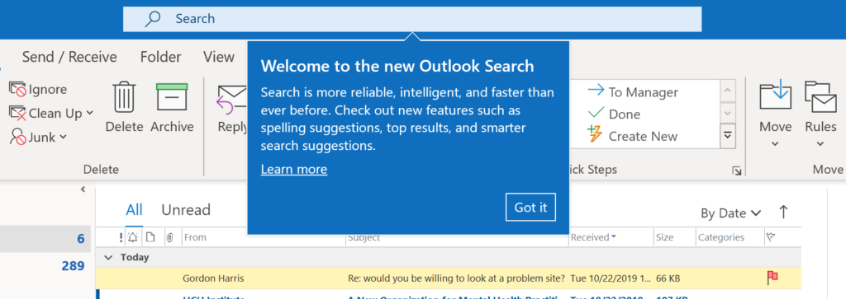

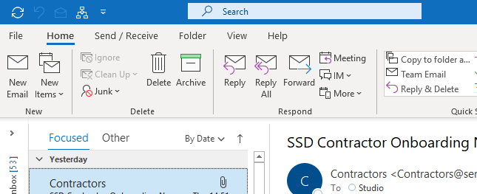
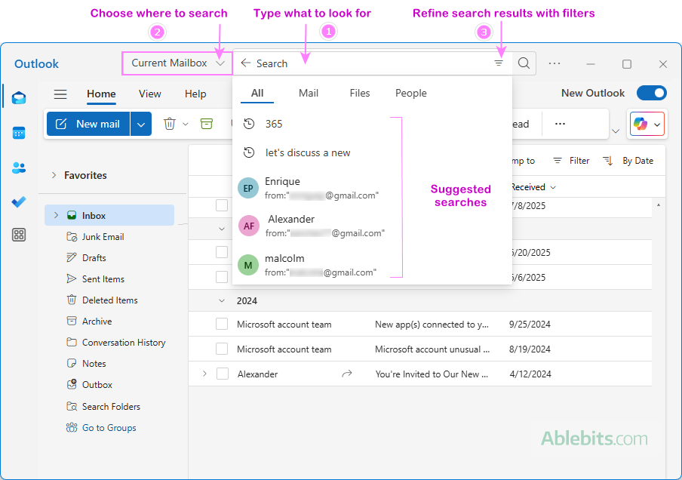

The Search Bar in Outlook allows users to quickly find emails, contacts, attachments, and events by typing keywords, improving communication efficiency.

Ms Teams
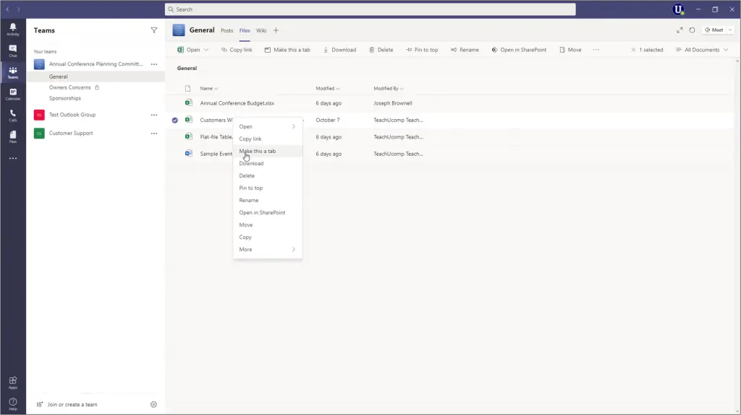
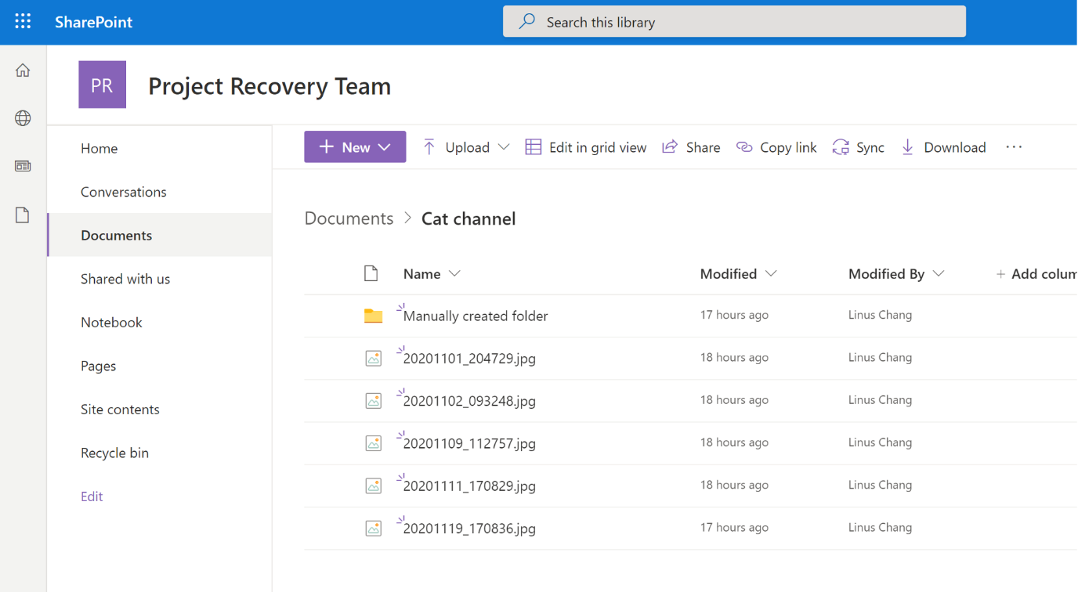
Search Results show matched emails along with filters such as From, Attachments, and Date, helping users locate information instantly.

Conclusion
<Insert information>

References
[1] G. Dushnitsky and B. K. Stroube, "Low-code entrepreneurship: Shopify and the alternative path to growth," Journal of Business Venturing Insights, vol. 16, pp.e00251, 2021.
[2] F. Rustam, et al., "Classification of shopify app user reviews using novel multi text features," IEEE Access, vol. 8, pp.30234–30244, 2020.
[3] D. Dolifka, "Conducting Experimental Research on Shopify: An Initial Discussion and Guide to Getting Started," Available at SSRN 4451011, 2023.
[4] R. Ravensbergen, Building E-commerce solutions with WooCommerce, Packt Publishing, 2015.
[5] L. Sims, Building Your Online Store With WordPress and WooCommerce: Learn to Leverage the Critical Role E-commerce Plays in Today’s Competitive Marketplace, Apress, 2018.
[6] P. Rauland, WooCommerce Cookbook, Packt Publishing Ltd, 2015.
[7] T. N. Lina, et al., "Peningkatan Daya Saing Toko Safar Melalui E-Commerce dan Pemasaran Digital Berbasis Wix," ABDIKAN: Jurnal Pengabdian Masyarakat Bidang Sains dan Teknologi, vol. 3, no. 4, pp.239–248, 2024.
[8] G. V. Sreenivasamurthy, "A STUDY ON E-COMMERCE MARKETING," Editorial Board, vol. 7, no. 12, pp.256, 2018.
[9] T. McGee and P. Ericsson, "The politics of the program: MS Word as the invisible grammarian," Computers and Composition, vol. 19, no. 4, pp.453–470, 2002.
[10] H. I. Assaad, et al., "Rapid publication-ready MS-Word tables for one-way ANOVA," SpringerPlus, vol. 3, no. 1, pp.474, 2014.
[11] A. Anyan, B. Ege and H. Faisal, "Pengembangan media pembelajaran interaktif berbasis Microsoft Power Point," JUTECH: journal education and technology, vol. 1, no. 1, 2020.
[12] A. Kohlhase, "Semantic PowerPoint: Content and semantic technology for educational added-value services in MS PowerPoint," EdMedia Innovate Learning, 2007.
[13] C. Tanavalee, P. Luksanapruksa and W. Singhatanadgige, "Limitations of using Microsoft Excel version 2016 (MS Excel 2016) for statistical analysis for medical research," Clinical spine surgery, vol. 29, no. 5, pp.203–204, 2016.
[14] E. Hossain, "MS Excel in Engineering Data," in Excel Crash Course for Engineers, Springer, 2021, pp. 169–242.
[15] R. M. Mayberry, F. Mili and E. Ofili, "Racial and ethnic differences in access to medical care," Medical Care Research and Review, vol. 57, no. 1_suppl, pp.108–145, 2000.
[16] R. M. Mayberry, F. Mili and E. Ofili, "Racial and ethnic differences in access to medical care," Medical Care Research and Review, vol. 57, no. 1_suppl, pp.108–145, 2000.
[17] K. Reichardt, "Using Microsoft Access® for journal collection management," The Serials Librarian, vol. 37, no. 4, pp.69–78, 2000.

