

ACFA7004 Module Research Proposal

Optical response prediction of
optical structures
based on deep learning

by
Kaicheng Li (2106269)

March 2022
CONTENTS

1. INTRODUCTION 1
2. LITERATURE REVIEW 3
2.1. Advantages of Deep Learning Applied to Optics 3
2.2. Optical response prediction of optical structures based on neural network 4
3. METHOD：Prediction based on Convolutional Neural Network 8
4. RESULTS 9
5. EVALUATION 10
REFERENCE 11

- INTRODUCTION
Novel optical devices capable of controlling optical flow down to the nanoscale have become an extremely dynamic area of ​​research. With the help of advanced numerical simulation, fabrication and characterization techniques, it is possible to design, fabricate and demonstrate dielectric and metallic micro-nanostructures with complex geometries and arrangements, such as metasurfaces containing subwavelength structures called superatoms can exhibit superior performance. The characteristics of the present invention provide the possibility for breakthroughs in widely used technologies such as imaging, sensing, and polarization control.
In traditional design methods of optical structures, it is common to start with a full-wave simulation of the initial design based on empirical knowledge, and then adjust geometric or material parameters to approximate specific optical response requirements. But such a trial process requires a lot of time and computing resources even for experienced researchers.
As a subset of artificial intelligence, deep learning algorithms have been applied to learning forward prediction and reverse design problems in light, and have shown good results; image processing also plays an important role in these studies, with the purpose of Converting observed measurements into desired property values ​​is an information-processing process similar to that of computer vision and computer imaging. In recent years, deep learning algorithms, in which machines automatically learn patterns from large amounts of data, have shown certain advantages in optics. Unlike traditional physics-based methods, the methods supporting deep learning are “data-driven” methods. It has provided alternative solutions to many challenging problems in this field with good performance.
Optical structure design strategies combined with deep learning are expected to increase computational speed by many orders of magnitude. Artificial neural networks are a potential solution to bypass the complex design process, allowing us to directly predict the optical response of optical structures or perform inverse design efficiently and accurately. The first is to replace the forward simulation in iterative optimization with an artificial neural network, while the second is to build an artificial neural network that directly solves the inverse problem. Artificial neural networks can establish implicit relationships between inputs (geometric or material parameters) and outputs (optical responses), bypassing complex and time-consuming design processes that rely on numerical simulations and optimization. Forward predictive models are used to determine the optical response of geometric or material parameters and can be used as an alternative to full-wave simulations; inverse design models are designed to efficiently retrieve the optimal structure from a given optical response, a design process that is often challenging.
The focus of this research proposal is the prediction of optical responses of optical structures based on deep learning. The optical structure is represented in the form of an image, and the deep learning algorithm is used to predict the optical response of the optical structure to the incident electromagnetic wave, which is the prediction process of the system from the input optical structure image to the output optical response. The purpose is to try to use deep learning algorithms to replace traditional methods such as numerical full-wave simulations to improve the speed of computation, and get accurate predictions at the same time.
- LITERATURE REVIEW
Micro-nano technology is micro-electromechanical system (MEMS) technology and nano-science technology is micro-electro-mechanical system (MEMS) technology and nano-science technology. Due to its huge application prospects, micro-nano technology has been widely valued by governments and scholars from all over the world. One of the hot research fields in the tech world. MEMS technology mainly involves the research and development of sensors and microsystems in the range of several micrometers, and the technology of manipulating and processing atoms and molecules in the nanometer range is called nanotechnology.
Metasurface and metamaterials containing subwavelength structures (called superatoms) can exhibit extraordinary properties[1][2]. In the traditional approach, we can handle most micro- and nanostructure design problems. However, the inverse design problem of finding the optimal structure for the target optical response and function usually requires a lot of time and computational resources.
When traditional methods don't apply, experience can limit our search for entirely new designs for the same or even more complex functionality. Obtaining the geometry of the desired function has always been a challenge when inversely designing optical structures, when viewed as a pure optimization problem, due to the highly nonlinear nature of the problem, even using state-of-the-art algorithms such as evolutionary or topology optimization algorithms, a single design Tasks require hundreds to thousands of iterations.
With the digital transition, image processing plays an important role in these studies in order to transform observed measurements into desired properties, a process similar to that of computer vision. Modern deep learning algorithms have also been applied to forward prediction and inverse design problems in optical structures, and have shown promising prospects.
  - Advantages of Deep Learning Applied to Optics
At present, the application of deep learning[3] in the field of optical metrology is attracting people's interest and gaining widespread attention. Different from traditional physics-based methods, deep learning subverts the traditional "physical model-driven" approach and opens up a "data-driven" based approach. The way of learning has provided alternative solutions to many challenging problems in this field, which can regain the knowledge of the forward model from experimental data and have better performance[4].
An artificial neural network (ANN) is an important algorithm in deep learning. The network consists of interconnected computational units called artificial neurons. The perceptron was the first artificial neural network that allowed neurons to learn, and Rumelhart et al. proposed the idea of ​​a back-propagation algorithm (BP)[5] for MLP, which is based on a chain rule method to continuously update network parameters to minimize network loss. LeCun et al. proposed a bionic CNN model based on BP algorithm[6], which laid the foundation for deep learning algorithms for modern computer vision; in this wave of development, various models such as long short-term memory (LSTM) recurrent neural network ( RNN) appeared and is still a key component of various advanced applications of deep learning; Krizhevsky et al. proposed a deep CNN architecture, AlexNet[7], which made CNN the dominant framework for deep learning years later. With more attention and efforts from academia and industry, different types of deep neural networks have been proposed in recent years, such as VGGNet[8], ResNet, and Generative Adversarial Networks (GAN)[9], etc.
Many experiments have shown that even complex artificial neural networks trained on well-crafted datasets contain their prediction singularities, which is a notable problem with data-driven techniques, they have a risk of bias in the training data, therefore, artificial neural networks The network model is only the second most important component of deep learning, the basic element is the training data first. High-quality training data is paramount, which is often underestimated and underappreciated.
  - Optical response prediction of optical structures based on neural network
We can manipulate light in desired ways through rationally designed subwavelength structures, yet building complex optical structures remains a time-consuming process even for experienced researchers. Artificial neural networks allowing us to directly and quickly predict the optical response of optical structures, and even help us perform inverse design efficiently and accurately[10].
Artificial Neural Networks (ANNs) provide a new and powerful method for optical structure design [11-19]. Artificial neural networks can establish an implicit relationship between input (i.e. geometric or material parameters) and output (i.e. optical response), simulating nonlinear neural conduction processes in the human body. With the help of well-trained artificial neural networks, we can bypass complex and time-consuming design processes that rely heavily on numerical simulations and optimization. The function of most ANN models for optical structure design is twofold: forward prediction and reverse design. Forward prediction networks are used to determine the optical response of structures with specific geometric or material parameters, and it can be used as an alternative to full-wave simulations. Inversely engineered networks aim to efficiently retrieve optimal structures from a given optical response, which is often more important and challenging during the design process. A major advantage of the ANN model is speed. For example, it takes only a few milliseconds to generate spectra of meta-atoms from a well-trained forward prediction model, which is orders of magnitude faster than analog simulations [20-22]. At the same time, the accuracy of the artificial neural network model is comparable to that of a rigorous simulation. In addition, artificial neural networks can disentangle non-intuitive and non-unique relationships between physical structures and optical responses.
To improve the quality of the training dataset, some researchers try to increase the dimension of the training data in the generation of the initial training data[23]. Then we design an artificial neural network with a certain network structure, such as a fully connected layer (FCL) based neural network or a convolutional neural network (CNN). Next, feeding the training dataset into the network, we optimize the weights and biases of each node. Finally, a well-trained ANN can be used to predict responses for other input structures beyond the training and testing datasets.
- Prediction based on fully connected neural network
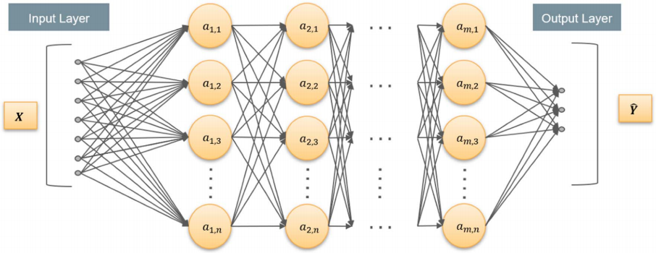
Figure 1. Neural network based on fully connected layer
As shown in Figure 1, a fully connected layer-based neural network consists of an input layer, a hidden layer, and an output layer. Besides spectral prediction [24-25], ANNs based on fully connected layers are also used in reverse design to achieve other functions and benefit for practical applications [26-31].
Due to the data-driven nature of deep learning, the performance of well-trained artificial neural networks is highly dependent on the training set, and the prediction loss may increase as the input deviates from the training set. Therefore, the challenge of deep learning-assisted reverse engineering lies in extending the capabilities of artificial neural networks to datasets that are very different from the training data. Often, an entirely new training set needs to be generated for similar but different physical scenarios. In this case, reducing the need for computational data is an effective way to speed up the training of deep learning models. Y. Qu et al. proposed a transfer learning method for transferring knowledge in different physical scenarios [32].
- Prediction based on convolutional neural network
In some cases we need to deal with complex optical responses as input. When the structure of interest contains many basic shapes [33][34] or free forms [35][36], the desired design and structure are often difficult to parameterize. Therefore, converting structures into 2D images is often a good approach in these studies, and it allows greater freedom in the design process.
If FCL based models are still used, preprocessing is required to process the image input, reshaping the image into a 1D vector and applying linear embeddings for feature extraction, such as principal component analysis and random projection, is to preprocess the image to match the input with FCL Compatible and efficient method. But the performance is usually unsatisfactory, because these transformations either destroy the correlation of the nearest pixels.
Convolutional Neural Networks (CNN) are great for handling this situation.
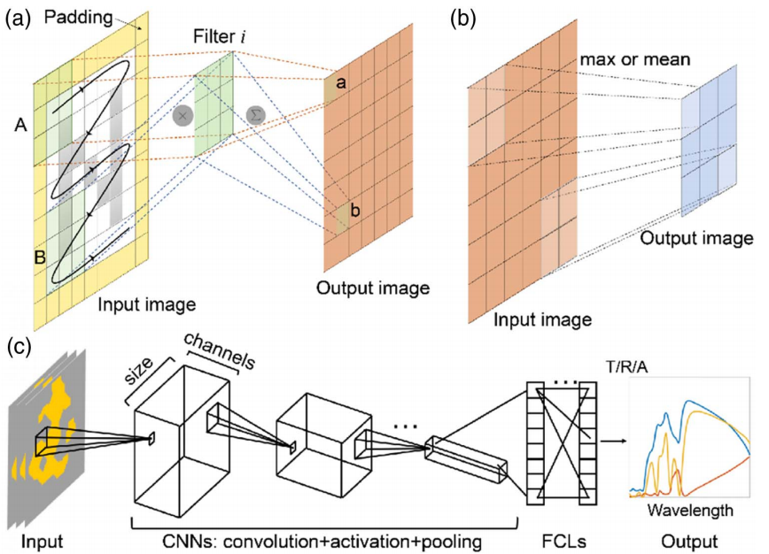
Figure 2 traditional CNN
CNN can effectively reduce the complexity of the feedback neural network (traditional neural network). Common CNN structures include LeNet-5, AlexNet, VGGNet, GoogleNet, ResNet, etc. For example, in the work published by I. Sajedian et al. in 2019, the authors combined a CNN with a recurrent neural network (RNN) to predict the absorption spectra of complex plasmonic structures in the near-infrared region[37]. CNNs help to extract features from images, while RNNs with gated recurrent unit layers are used for spectral prediction.

A neural network is often considered a "black box" because the relationship between the input and output learned by a neural network is often implicit. Artificial neural networks can bypass the complex design process and help us directly predict the optical response of optical structures or perform inverse design. In some published work, it is a good attempt at researchers to visualize the output of each individual layer to provide some information about what features (or functions) are learned by each layer. If we can further extract the relationship between optical structure and optical response explicitly from the trained neural network, it will be very helpful to find new structures such as H-shape, cross-shape, etc. Optics design provides new guidance.
In the past few decades, optical structure design and deep learning have developed as two separate research disciplines. In recent years, the intersection of these two disciplines has also brought exciting results. On the one hand, artificial neural network models provide a powerful tool for accelerating the process of optical design and implementation, and this new strategy discovers some non-intuitive structures and phenomena; on the other hand, optical structure[41] design is expected to lead to practical applications, such as optical imaging[39], holography[40], communication and information encryption technology[38]. Toward this goal, we need to incorporate practical manufacturing constraints and underlying material properties into the design space in order to globally optimize devices and systems.
- METHOD：Prediction based on Convolutional Neural Network
The optical structures we study may contain many fundamental shapes or free forms, and such structures are often difficult to parameterize. Unlike structures of basic shapes, structures can be adequately represented by setting only a few geometric parameters. Therefore, it is generally a good idea to convert the structures we study here into 2D image representations.
We want to predict the optical response of the optical structure based on deep learning, that is, the process from the input optical structure image to the output response of the system. We can use the model based on convolutional neural network for the deep learning algorithm here.
Of course, the deep learning algorithm here can also use models based on fully connected neural networks, but in general, for image analysis performance, models based on convolutional neural networks are better than models based on fully connected neural networks. This has been proved by scholars' experiments on image processing and analysis. So based on this consideration, we use a model based on convolutional neural networks.
One part of the data set used for neural network training is 2D images of optical structures, and the other part is the optical response values ​​corresponding to these structures obtained in the simulation software. Using pre-made optical structure images and a dataset of corresponding optical response values, the model is trained so that the neural network learns the hidden correspondence between the structure image and the corresponding optical response.
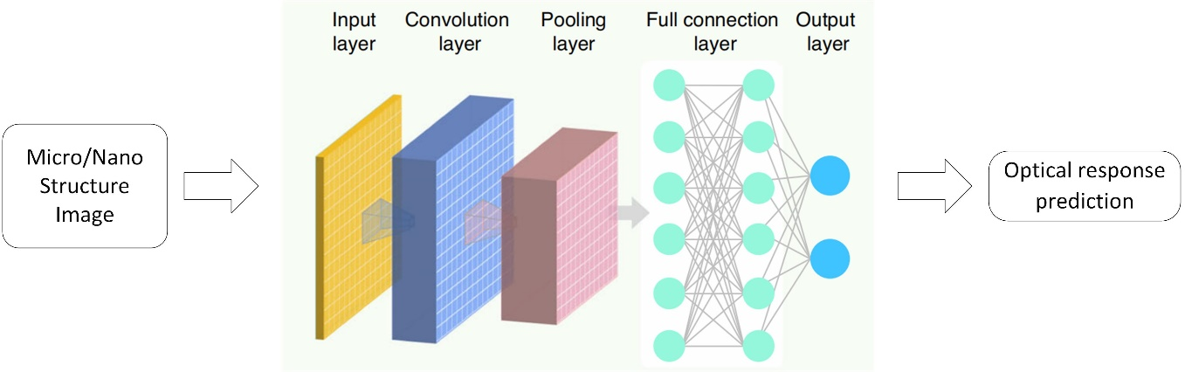
Fig 3. Schematic diagram of model structure
After the model training is completed, we can test the model, input the optical structure image in the test data set, and the neural network can predict the optical response. By comparing the error between the predicted value and the real value, we can evaluate the performance of the neural network model. If If the performance is better, then the neural network model can help us predict the optical response of the optical structure, instead of the traditional method such as numerical full-wave simulation, and improve the speed of calculation.
- RESULTS
One part of the data set used for neural network training is 2D images of optical structures, and the other part is the optical response values ​​corresponding to these structures obtained in the simulation software. The structural images in the dataset are free-form, and the image resolution is temporarily set to 32*32. The commercial mathematical software MATLAB can be used to randomly place several rectangles with random shapes on the canvas for image production; after obtaining the structural image, use the application The simulation of the optical response corresponding to the structure diagram is carried out with the numerical full-wave simulation software in optics. 10,000 sets of structural images and corresponding optical response data are tentatively produced, 8,000 sets of data are used for model training, and 2,000 sets of data are used for model testing.
In order to analyze and verify the effectiveness of our method, we need to visually monitor the training process of the model, and perform performance testing and instance verification on the test results.
When training the model with the training dataset data, the first thing we need to ensure is that the loss value (Loss) of the convolutional neural network model can converge, which can prove that the model can be trained to a stable state on these data. Second, we need to adjust the hyperparameters of the neural network model, such as the number of network layers, the size of the convolution kernel, the learning rate, and the number of neurons. Finally, when the model parameters are determined, the curve of the neural network loss function value changing with the number of training iterations needs to be drawn. Generally speaking, the loss function value gradually decreases and tends to a small stable value.
After the optical response prediction model based on convolutional neural network is trained, randomly select several structural samples in the test data set for optical response prediction, and compare and verify with the real optical response, and draw a table for example verification and model prediction effect proof.
- EVALUATION
The picture below is the Project Planning Gantt chart, which can be used as a schedule to plan and monitor the progress of our work.

Fig 4. Project Planning Gantt Chart
We are full of hope for deep learning-based research on optical structure design strategies, but at the same time pay attention to the limitations of the designed problem-specific models.
On the one hand, optical structure design and deep learning have developed as two separate research disciplines in the past few decades, and in recent years, the intersection of these two disciplines has also brought exciting results. Neural network models provide a powerful tool for accelerating the optical design and implementation process, and this new strategy addresses some non-intuitive problems.
On the other hand, we need to pay attention to the limitations of our designed model, mainly due to the comprehensiveness of the produced dataset. If the training data is in an environment that reproduces real experimental conditions, compared to traditional physical model-driven or knowledge-driven approaches, comprehensive and promising to produce a better "data-driven" learning-based approach by applying different types of training datasets, A specific class of neural network models can be trained. But many experiments have shown that even complex artificial neural networks trained on the most carefully crafted datasets contain their risk of biased predictions. Whether our model can be transformed for different tasks to improve generalizability is still an open question.

REFERENCE
- Y. Liu and X. Zhang, “Metamaterials: a new frontier of science and technology,” Chem. Soc. Rev. 40, 2494–2507 (2011)
- 石纪轩,饶庆鸿,王恒毅,等. 基于非对称开口环超表面结构的光学响应研究[J]. 物理实验,2021,41(6):17-24. DOI:10.19655/j.cnki.1005-4642.2021.06.002.
- Goodfellow, Ian, Yoshua Bengio, and Aaron Courville. Deep learning. MIT press, 2016.
- Zuo C, Qian J, Feng S, et al. Deep learning in optical metrology: a review[J]. Light: Science & Applications, 2022, 11(1): 1-54.
- Rumelhart D E, Hinton G E, Williams R J. Learning representations by back-propagating errors[J]. nature, 1986, 323(6088): 533-536.
- LeCun Y, Boser B, Denker J S, et al. Backpropagation applied to handwritten zip code recognition[J]. Neural computation, 1989, 1(4): 541-551.
- Krizhevsky A, Sutskever I, Hinton G E. Imagenet classification with deep convolutional neural networks[J]. Advances in neural information processing systems, 2012, 25.
- Simonyan K, Zisserman A. Very deep convolutional networks for large-scale image recognition[J]. arXiv preprint arXiv:1409.1556, 2014.
- Goodfellow I, Pouget-Abadie J, Mirza M, et al. Generative adversarial nets[J]. Advances in neural information processing systems, 2014, 27.
- Xu Y, Zhang X, Fu Y, et al. Interfacing photonics with artificial intelligence: an innovative design strategy for photonic structures and devices based on artificial neural networks[J]. Photonics Research, 2021, 9(4): B135-B152.
- Yao K, Unni R, Zheng Y. Intelligent nanophotonics: merging photonics and artificial intelligence at the nanoscale[J]. Nanophotonics, 2019, 8(3): 339-366.
- Zhang Q, Yu H, Barbiero M, et al. Artificial neural networks enabled by nanophotonics[J]. Light: Science & Applications, 2019, 8(1): 1-14.
- Hegde R S. Deep learning: a new tool for photonic nanostructure design[J]. Nanoscale Advances, 2020, 2(3): 1007-1023.
- So S, Badloe T, Noh J, et al. Deep learning enabled inverse design in nanophotonics[J]. Nanophotonics, 2020, 9(5): 1041-1057.
- Ma W, Liu Z, Kudyshev Z A, et al. Deep learning for the design of photonic structures[J]. Nature Photonics, 2021, 15(2): 77-90.
- Elsawy M M R, Lanteri S, Duvigneau R, et al. Numerical optimization methods for metasurfaces[J]. Laser & Photonics Reviews, 2020, 14(10): 1900445.
- Piccinotti D, MacDonald K F, Gregory S A, et al. Artificial intelligence for photonics and photonic materials[J]. Reports on Progress in Physics, 2020, 84(1): 012401.
- Huang L, Xu L, Miroshnichenko A E. Deep learning enabled nanophotonics[J]. Advances and Applications in Deep Learning, 2020: 65.
- Jiang J, Chen M, Fan J A. Deep neural networks for the evaluation and design of photonic devices[J]. Nature Reviews Materials, 2021, 6(8): 679-700.
- Peurifoy J, Shen Y, Jing L, et al. Nanophotonic particle simulation and inverse design using artificial neural networks[J]. Science advances, 2018, 4(6): eaar4206.
- Peurifoy J, Shen Y, Jing L, et al. Nanophotonic particle simulation and inverse design using artificial neural networks[J]. Science advances, 2018, 4(6): eaar4206.
- Sajedian I, Kim J, Rho J. Finding the optical properties of plasmonic structures by image processing using a combination of convolutional neural networks and recurrent neural networks[J]. Microsystems & nanoengineering, 2019, 5(1): 1-8.
- Wen F, Jiang J, Fan J A. Robust freeform metasurface design based on progressively growing generative networks[J]. ACS Photonics, 2020, 7(8): 2098-2104.
- Zhang T, Wang J, Liu Q, et al. Efficient spectrum prediction and inverse design for plasmonic waveguide systems based on artificial neural networks[J]. Photonics Research, 2019, 7(3): 368-380.
- Nadell C C, Huang B, Malof J M, et al. Deep learning for accelerated all-dielectric metasurface design[J]. Optics express, 2019, 27(20): 27523-27535.
- Alagappan G, Png C E. Deep learning models for effective refractive indices in silicon nitride waveguides[J]. Journal of Optics, 2019, 21(3): 035801.
- Tahersima M H, Kojima K, Koike-Akino T, et al. Deep neural network inverse design of integrated photonic power splitters[J]. Scientific reports, 2019, 9(1): 1-9.
- Long Y, Ren J, Li Y, et al. Inverse design of photonic topological state via machine learning[J]. Applied Physics Letters, 2019, 114(18): 181105.
- Pilozzi L, Farrelly F A, Marcucci G, et al. Machine learning inverse problem for topological photonics[J]. Communications Physics, 2018, 1(1): 1-7.
- Alagappan G, Png C E. Modal classification in optical waveguides using deep learning[J]. Journal of Modern Optics, 2019, 66(5): 557-561.
- Sajedian I, Badloe T, Rho J. Optimisation of colour generation from dielectric nanostructures using reinforcement learning[J]. Optics express, 2019, 27(4): 5874-5883.
- Qu Y, Jing L, Shen Y, et al. Migrating knowledge between physical scenarios based on artificial neural networks[J]. ACS Photonics, 2019, 6(5): 1168-1174.
- Ma W, Cheng F, Xu Y, et al. Probabilistic representation and inverse design of metamaterials based on a deep generative model with semi‐supervised learning strategy[J]. Advanced Materials, 2019, 31(35): 1901111.
- Liu Z, Zhu D, Rodrigues S P, et al. Generative model for the inverse design of metasurfaces[J]. Nano letters, 2018, 18(10): 6570-6576.
- Jiang J, Sell D, Hoyer S, et al. Free-form diffractive metagrating design based on generative adversarial networks[J]. ACS nano, 2019, 13(8): 8872-8878.
- Trivedi R, Su L, Lu J, et al. Data-driven acceleration of photonic simulations[J]. Scientific reports, 2019, 9(1): 1-7.
- Sajedian I, Kim J, Rho J. Finding the optical properties of plasmonic structures by image processing using a combination of convolutional neural networks and recurrent neural networks[J]. Microsystems & nanoengineering, 2019, 5(1): 1-8.
- 邵金友. 微纳结构压印制造的原理、方法及其应用[C]//.第五届粤港澳真空科技创新发展论坛暨广东省真空学会2021年学术年会论文集.[出版者不详],2021:30.DOI:10.26914/c.cnkihy.2021.043207.
- 韩申生,胡晨昱.信息光学成像研究回顾、现状与展望(特邀)[J].红外与激光工程,2022,51(01):43-64.
- 李丽,毛爱英,张喜玥,张秋萍,王妍心,张惠,李灿.3D全息技术应用现状及前景研究[J].技术与市场,2021,28(09):36-37.
- 罗皓. 微纳光学结构调控室外热管理[D].浙江大学,2021.DOI:10.27461/d.cnki.gzjdx.2021.000578.

