Assignment Task 2

Name: Alpesh Machhi
Student No: 2022470
Lecturer: Timothy Hopkins
Academic and Employability Skills

1

Table of Contents
Introduction: 3
Two chosen areas: 3
Reflection on the first topic: Time management 4
Reflection on the second topic: 5
Personal action plan: 6
Conclusion: 7
References 7-8


2

Introduction.
In this task I will talk about my learning of Academic and Employability skills during this semester. What is academic and employability skills? The report will select few topics for describing my learning experience and the way it will be useful for me in future. A personal action plan will also develop based on strengths and weakness on me that needs to be improved. Gibb's reflective model will be used for describing my learning experience in this study.

Two of the chosen area.

I have selected two topics which include time management of my study, summarising the aspects which I have learnt in the class, which I have gained during the class. I have selected Gibb's reflective model in this study which help me in evaluating the importance of managing time, summarising the study and experiencing online learning, which has helped me in completing a task about academic skills requirements in employing sectors. Gibb's reflective model is referred to as the framework used to encourage people to think systematically about their experience of taking part in any event or activity (Adeani, et al., 2020).

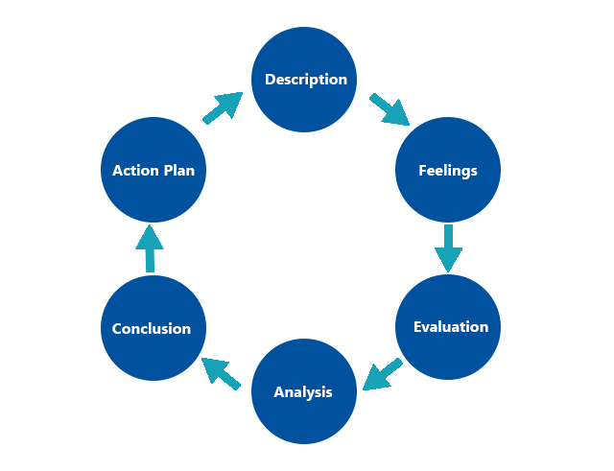

Figure 1: Gibbs reflective model, Source: (Adeani, et al., 2020)
3

Reflection on the first topic: Time management

Time management is considered as one of the most significant aspects for a student, which encourage them to complete their task within the required time. According to Gibb's reflective model, the first stage describes where an individual describes their experience, situation, an activity they have taken part (Sekarwinahyu, et al., 2019). I have learned the technique of time management within the class that has guided me in utilising my time more effectively and completing all the actions within the given period. I feel that knowing time management is beneficial for me as it assists me in dividing my work into small subparts and completing them. I have taken part in an assignment about Academic employability skills and the benefit of it in business and individual. Knowing time management is beneficial for me as it has encouraged me to complete the assignment within the given period.

Effective time management enables a student in taking control of the time and energy that support them in achieving a bigger and better result in a lesser period (Kirillov, et al., 2015). During the class, I have learned about the importance of time management which will help me in creating a positive image in front of the class by completing my task in lesser time. I have completed my work before the given time and took feedback from the teacher about my work. As a result of this, I have been able to make the required changes in the information given about Academic and Employability skills in my assignment before final submission. It, as a result, support me in getting a good academic score.

Good time management by a student enables them to achieve a greater level of productivity. (Kutsyuruba, et al., 2015). In my learning in the class about the time management technique, I have realised that organising myself with all the relevant sources and utilising them appropriately will help me in better time management. I have understood that managing time to complete the assignment will help me make an in-depth analysis of the topic, etc. The third stage of Gibb's Reflective Model is an evaluation that described the good and bad experience after taking part in an event (Adeani, et al., 2020). But in the context of my experience of completing the assignment, I have realised that managing time has helped me in completing my task within time, along with hoping to get good marks.

4

Reflection on the second topic:

I have also learned about the way summarising the learning efficiently. Summarising is described as the process that involves reducing a large section into small points for offering more concise learning to a student (Lee & Grauman, 2015). I have realised that being able to summarise my learning will help me in future to determine the essential ideas and also support me to consolidate the most significant detail from learning. During the class, I have learned about the use of a summary map that I can use in future for summarising a long context into smaller parts. The summary map is described as the visual way of displaying the main characteristics, setting, problems, and solution about a particular topic (Moreau, 2016). I have understood that gaining knowledge about the use of summary map will help me establish visual description. I have understood that knowing the summary map will help me make a visual representation of a topic. Visualising the topic is also beneficial for memorising any subject or information.

At the time of taking part in the assignment, I have realised that I was not able to remember all the important point about the topic. It created challenges for me in enrolling all the required data about online learning and using of computer. I have realised that I need to be more focused on gaining detailed knowledge about a topic which will help; me in making an appropriate summarisation and completing the task in a lesser period. Being able to summarise enable a student to pay their focus on identifying the keywords and phrases which are important for completing a task (Egan, et al., 2016). At the time of attending the class in the university, I have realised that I need to be more focused on enhancing my ability to summarise any topic which I can use at the time of reviewing session.

According to Gibb's reflective model, an individual needs to analyse the sense of the situation and conclude what they have learned after taking part in an event (Sekarwinahyu, et al., 2019). Attending the class has helped me evaluate how I can summarise all the collected information related to academic and employability in companies and businesses. I have understood that I need to be more focused on identifying the keyword and phrases which will help me in future to complete the task.

5
Personal action plan:

The action plan is described as the list of required tasks for completing a particular job or achieving the goal. I have developed my action plan, which will help me in improving my knowledge in future and getting a good academic score.
Sl no | Goals | Action | Description of action | Time
1 | Improving time management ability | Dividing the task into a small subtask  Setting a time limit for small subtask  Prioritising the task | I have to break my work into small subparts like collecting data, analysing the data, etc. Dividing time for each task and meeting the time limit will help me in managing the overall time. | 1 month
2 | Leaning to make a Summary map | Taking help from online learning | I can use the online platform for enhancing my knowledge about the summary map, the way it can be made. | 1 month

6
Conclusion:

This study has evaluated the way attending the class has helped me in enhancing my knowledge about time management, summarisation and gaining confidence with presenting presentation front of the class. It eventually supports me to complete my assignment efficiently. I have enrolled myself in Academic and employability skills to improve me to achieve my future goals, which helps me gain more detailed information about skills requirement and its importance in business. I have taken part in developing an assignment that is focused on evaluating the importance of overcoming my weaknesses.

References
Adeani, I. et al., 2020. Using GIBBS reflective cycle in making reflections of literary analysis. Indonesian EFL Journal (IEFLJ), 6(2), pp. 139-148, DOI: 10.25134/ieflj.v6i2.3382.

Egan, C., Siddharthan, A. & Wyner, A., 2016. Summarising the points made in online political debates. In Proceedings of the Third Workshop on Argument Mining (ArgMining2016) , 1(1), pp. 134-143, DOI: 10.18653/v1/W16-2816;.

Husebø, S., O'Regan, S. & Nestel, D., 2015. Reflective practice and its role in simulation. Clinical Simulation in Nursing, 11(8), pp. 368-375, DOI:10.1016/j.ecns.2015.04.005.

Kirillov, A., Tanatova, D., Vinichenko, M. & Makushkin, S., 2015. Theory and practice of time-management in education. Asian Social Science, 11(19), pp. 193-204, DOI:10.5539/ass.v11n19p193.

Kutsyuruba, B., Klinger, D. & Hussain, A., 2015. Relationships among school climate, school safety, and student achievement and well‐being: a review of the literature. Review of Education, 3(2), pp. 103-135, DOI: 10.1002/rev3.3043.
Lee, Y. & Grauman, K., 2015. Predicting important objects for egocentric video summarisation. International Journal of Computer Vision, 114(2), pp. 38-55, DOI: 10.1007/s11263-014-0794-5.

7
Moreau, L., 2016. Aggregation by provenance types: A technique for summarising provenance graphs. arXiv preprint arXiv:1504, 1(1), p. 02616.

Sekarwinahyu, M., Rustaman, N., Widodo, A. & Riandi, R., 2019. Development of problem based learning for online tutorial program in plant development using Gibbs' reflective cycle and e-portfolio to enhance reflective thinking skills.. In Journal of Physics: Conference Series , 1157(2), pp. 022099, DOI: 10.1088/1742-6596/1157/2/022099.

8

