STUDENT
Adriana Elisabeth Steinweg
(1906022)

MODULE
Psychology in Health and Social Care
(BMHP4019_BIRM)

LECTURER
Rebecca Kavanagh

TITLE
Written Assignment (Case Study)

April - 2021

CONTENTS

- INTRODUCTION……………………………………….………….…… 3
- SOCIAL IDENTITY THEORY…………………………….….……….. 3
- THEORY OF PLANED BEHAIVOUR………………………….…….. 4
- FRUSTRATION AGGRESSION HYPOTHESIS……………...…….. 6
- CONCLUTION……………………………………………………….…. 7
- REFERENCES……………………………………………………….… 8
INTRODUCTION
Complex human behaviour is influenced by biological and environmental determinants. There are psychological theories that help to analyse it. This report highlights Social Identity Theory, Theory of Planned Behaviour and Frustration Aggression Hypothesis, with the purpose of provide the Juvenile Offenders Team with information to understand and help improve the behaviour of Mason Kabee, a 17-year-old offender.
Despite the efforts of those that work to prevent crime and recidivism of children and young people, statistics for children in the system, aged 10-17, in England and Wales, (2018/2019) shows that 21,700 received a caution or sentence (83% less respect 2017/2018).
The percentage held in custody on remand increased by 12% in the last year (28% in youth custody). 38.4% of children and young people reoffended (2.5% less respect 2017/2018)
(Youth Justice Board and Ministry of Justice, 2020)

SOCIAL IDENTITY THEORY (SIT)

This theory is currently accepted throughout the world as one of the most important theories about the relationship between the self and the group. The three main processes are Social Categorization, Social Identification, and Social Comparison. This has evolved since its development in 1970 by Henri Tajfel, who described Social Identity as the knowledge, emotional and evaluative meaning that belonging to a social group, and the self-conception as one of its members gives the individual.
Subsequently, it was argued about the relationship between Group Identification and Intragroup Bias, the Hypothesis of self-esteem, Intergroup Discrimination, and the choice of Identity Strategies by low-status groups, (Brown, R. 2000)
A group exists if three or more people interpret and evaluate themselves in terms of shared attributes that collectively distinguish them from other people. (Hogg, 2018)
Baumeister (1998) describes self-concept as "What you mean, when you say “I", but according to one of the processes of this theory, Social Categorization, people neglect the uniqueness of the individual. This happens due to changes in self-concept: after joining a social group, the individual defines himself based on the characteristics and status of the group, eventually being able to switch between both concepts. (Turner, 1982)
In Mason's case, it is likely that although his personal identity dictated accepting the help and opportunity provided, this would conflict with his social identity, his loyalty to his group and the need to be value and accepted by it, causing him to return to their previous attitudes and behaviours.
Thus arises another conflict, the intergroup, which despite being a pervasive feature of human society and some of its forms are socially condoned, other of its manifestations are regarded as highly pernicious. (Conor and Brown, 1988) It is important to consider that within Mason's age range there is a predisposition to show behaviours that are harmful to his health, (Morrison and Bennett, 2016).
Belonging to a group reduces uncertainty about himself and his role as an individual. Consequently, even though the values, characteristics, and status of the group with which Mason identifies have a negative influence on his life, he decides to confront the group that tries to help him, perhaps given the value and importance that belonging to his own known group implies for him and his identity.

THEORY OF PLANNED BEHAVIOR (TPB)

Between 1920 and 1990, research and discussion had focused on how attitudes are related to behaviours and how these could change on a social level.
Attitudes are neurologically stored concepts, that can be based on Direct Experiences, Classical Conditioning, Observational Learning. The preconceptions and beliefs towards objects, people, groups or activities, can influence how an individual see and approach situations and leads it to have a positive or negative attitude towards something or someone.
Though attitudes are inferred rather than observed, they must be admitted as real and substantial ingredients in human nature, for without them it is impossible to account satisfactorily either for the consistency of any individual's behaviour or for the stability of any society. (Allport, 1935)
The Theory of Planned Behaviour, developed by Icek Ajzen in 1985, links beliefs with behaviour. It suggests that Attitude, Subjective Norms, and Perceived Behavioural Control, shape an individual's Behavioural Intentions. These intentions can be different from actual behaviour, which can be predicted. (Brown, 2006)
Attitude: depends on the person’s expectancy that the behaviour will produce a desired consequence and the value attached to this consequence. Subjective Norms: individual’s beliefs about how significant others view the relevant behaviour and how them expect him or her to act. Perceived Behavioural Control has a direct effect on Intentions. An individual’s intention to engage in a particular behaviour is affected by their confidence in their ability to perform the action.
Perceived Behavioural Control has a direct effect on Behaviour. This effect depends on the Actual Control of the relevant action. (Maio & Haddock, 2009)
Beliefs about specific attitudes can differ in different social groups. If a group's attitude toward established social norms is unfavourable, as is the case with the group Mason identifies with, it is predictable that his attitude will be negative.
Mason belongs to a stereotypical group. According to Steele, Spencer, and Aronson (2002), “stereotype threat is greatest when there are cues that the context is dominated by a cultural world view that differs from that of our own group”.
They are aware that others may judge them and are concerned that their behaviour confirms stereotypes. These worries increase anxiety, causing an adverse impact on their behaviour. (Hogg and Vaughan, 2013).
In the following diagram, the Theory of Planned Behaviour is applied to better compare and understand Mason's switch between the behaviour expected by the Youth Offending Team ("Group 1") and the one he presents with his former associates ("Group 2").
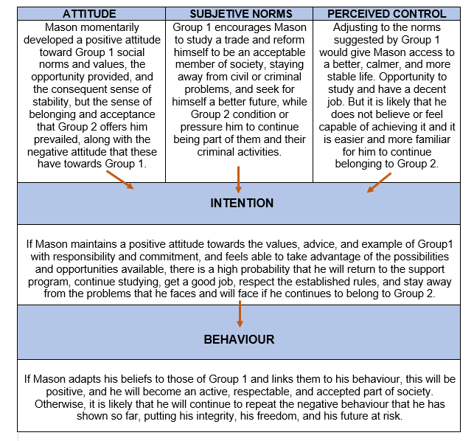
(Diagram by Author, 2021)

The team that intervenes in his case should identify the relevant factors, both social, cultural economic, and family, and barriers that prevent a positive change in his Attitudes, Subjective Norms, and Perceived Control. It is essential for Mason to be able to assess the ventages and disadvantages of his behaviour, and to understand that he has the ability to change it.

FREUSTRATION AGGRESSION HIPOTHESIS (FAH)

In 1939, John Dollard and his colleagues published their Frustration– Aggression Hypothesis, in which they argued that “the occurrence of aggressive behaviour always presupposes the existence of frustration, and contrariwise, the existence of frustration always leads to some form of aggression” (Dollard, Doob, Miller, Mowrer and Sears, 1939).
It was one of the first attempts to model and explain aggression in humans.
Subsequently, Leonard Berkowitz (1969) proposed that the probability of Frustration-Induced Aggression occur is increased by the presence of cues to aggression, including past or present associations of a specific group with conflict or dislike. And that it is not objective frustration that instigates aggression but the subjective feeling of being frustrated.
Aggression is divided into two classes that can provide a compelling analysis of why people attack others:
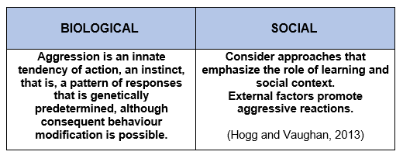
(Diagram by Author, 2021)

Aggression can be physical or verbal, direct or indirect, affective or instrumental, impulsive or premeditated, provocative or reactive, personological or situational. (Hogg and Cooper 2007)
Frustration-induced aggression is generated by personal and situational factors, and cognitive and affective processes. Among them are cultural values, the underlying effects of poverty, relative deprivation, discrimination, stigmatization, margination, social stress, social pressures, social disadvantage, and prejudice.
Stigmatized individuals possess (or are believed to possess) some attribute, or characteristic, that conveys a social identity that is devalued in a particular social context. (Crocker, Major and Steele, 1998).
Mason and the group he belongs to, are discriminated against and marginalized by society. When Mason changed his intentions and behaviour, began to study, and changed his environment and company, he became a marginal element within his own group.
The people found on the boundary between ingroup (the own group) and outgroup (the groups we compare the own group to) are often dis-liked by the group and treated as ‘black sheep’ or deviants. Generally receive harsher penalties and more negative evaluations than members of the outgroup. (Marques and Páez, 1994).
One possible explanation for why the aggressive reaction demonstrated by Mason during the probation visit was directed at the Youth Offending Team is that when a person is unable to express their frustration with aggressive behaviour towards the agent who actually caused that frustration, be it a person, a group or a set of circumstances, some times the individual redirects that aggressive energy towards a different objective or "Scapegoat". This is referred to as Displaced Aggression. (Hogg and Cooper 2007)
In addition to all the factors mentioned, his behaviour could be based on his previous experiences, on the aggressive behaviour of others, the success that this behaviour has achieved in the past and the probability that this aggressiveness will be rewarded or punished.

CONCLUTION

Psychological theories, hypotheses and concepts help to understand how and why different processes occur in the human mind. Those exposed in this document, thinking about a better future for the young Mason Kabee, can be summarized as follows:
Each individual is part of society, a family, a specific group of people. All, when comparing themselves with others, can identify with them or feel rejection, can be benefited or harmed. But an individual should not condition, define or value himself in terms of others.
It is essential to be formed through their own experiences, respect their values, be guided by their thoughts and beliefs, have a positive attitude and behaviour, nurture their confidence and self-esteem, and be true to their identity.

REFERENCES

- Ajzen, I. (1991) The theory of planned behaviour. Organizational Behaviour and Human Decision Processes.

- Allport, F.H. (1935). Attitudes. Handbook of social psychology, (pp. 798-844). Worcester: Clark University Press.

- Baumeister, R. F. (1998). The Self. In D.T. Gilbert, S. T. Fiske, & G. Lindsey (Eds), The handbook of social psychology (Vols. 1 & 2, 4th ed., pp680-740), New York: McGraw-Hill.

- Berkowitz L. (1978). Whatever Happened to the Frustration-Aggression Hypothesis? American Behavioural Scientist. Madison: University of Wisconsin.

- Berkowitz L. (1989). Frustration-Aggression Hypothesis: Examination and Reformulation. Madison: University of Wisconsin.
- Brown, C. (2006). Social Psychology. Attitudes and attitude change. SAGE Publications Ltd.

- Brown, R. (2000). Social identity theory: past achievements, current problems and future challenges. European Journal of Social Psychology.

- Conor, S. & Brown, R. (1988). Psychological Processes in Intergroup Conflict. The Social Psychology of Intergroup Conflict (pp 3-26).

- Crocker, J., Major, B. and Steele, C. (1998). Social stigma. The handbook of social psychology. New York: McGraw-Hill.

- Dollard, J., Doob, L. W., Miller, N. E., Mowrer, O. H. and Sears, R. R. (1939). Frustration and aggression. New Haven, CT: Yale University Press.

- Hogg, M. A. and Cooper, J. (2007) The SAGE handbook of social psychology. Concise Student Edition. SAGE Publications Ltd.

- Hogg, M. A. and Vaughan, G. M. (2013) Social Psychology. Pearson Education.

- Maio, G. R. & Haddock, G. (2009). The Psychology of Attitudes and Attitude Change. SAGE Publications Ltd.

Marques, J.M. and Páez, D. (1994) The ‘Black Sheep Effect’: Social Categorization, Rejection of Ingroup Deviates, and Perception of Group Variability. (Chapter 2), European Review of Social Psychology. University of Porto.

- Morrison, V. & Bennett, P. (2016). Introduction to Health Psychology. 4th Ed, Harlow: Pearson.

- Tajfel, H. (1972). Social categorization. In S. Moscovici (Ed.), Introduction à la psychology sociale. (pp. 30-37). Paris: Larousse.

- Turner, J. C. (1982). Towards a cognitive redefinition of the social group. In H. Tajfel (E d.), Social identity and intergroup relations. Cambridge: Cambridge University Press.

- Youth Justice Board / Ministry of Justice (2020). Youth Justice Statistics 2018/19 England & Wales.

