ROISIN HANNON
A local economic study of a Major event: A case study of Swansea Air show



Award BA (Hons) Degree
Dissertation – Event Management
UWTSD Swansea (2020)
Module: BMTH6000
Tutor: Caroline Jawad
Supervisor: James Prosser

DECLARATION 1
This work has not previously been accepted in substance for any degree and is not being concurrently submitted in candidature for any degree.
Signed................................................... Date......................................................
DECLARATION 2
The researcher is currently employed within the industry and as such an extra effort will be made to keep this dissertation free from subjective validation and bias.
Signed................................................... Date......................................................
STATEMENT 1
This dissertation is being submitted in partial fulfilment of the requirements for the degree of BA Event Management.
Signed.................................................... Date......................................................
STATEMENT 2
This dissertation is the result of my own independent work/investigation, except where otherwise stated. Other sources are acknowledged by footnotes giving explicit references. A bibliography is appended.
Signed................................................... Date......................................................
STATEMENT 3
I hereby give consent for my dissertation, if accepted, to be available for photocopying and for interlibrary loan, and for the title and summary to be made available to outside organisations.
Signed...................................................... Date.........................................................
STATEMENT 4
I hereby give consent for my dissertation, if accepted, to be available on the university’s IT system to those who have consent to use the system.
Signed...................................................... Date.........................................................

Acknowledgments
I dedicate this dissertation to my mother, who sadly passed away on the 26th August 2019.
Firstly, I would like to thank all the lecturers who have supported me throughout my time at university and to the friends who I have met along the way. I would especially like to thank Caroline Jawad for the amazing support she has provided throughout writing this dissertation.
To the girls in my dissertation module, who have supported me and motivated me to complete these dissertation chapters. Also, to my friends outside of university for always believing in me.
Lastly, I would like to thank my partner, Jack, who has been a consistent support throughout my three years studying and motivated me to finish my course.

Contents
1.0 Chapter 1 – Introduction 9
1.1.1 Background 9
1.1.2 Rationale 10
1.1.3 Aims & Objectives 11
1.1.4 Structure 11
1.1.5 Conclusion 11
2.0 Chapter 2 – Literature Review 12
2.1.1 Event Impacts 12
2.1.2 Economic impacts of major events 13
2.1.3 Assessing and measuring the economic impacts of events 14
2.1.3 Key factors of the economic analysis 15
2.1.4 Issues in economic impact estimation 17
2.1.5 Event attendee spending on a host region 18
2.1.6 Multiplier Effect and Analysis 19
2.1.7 Conclusion 21
3 Methodology 22
3.1.1 Chapter Overview 22
3.1.2. Research Onion 22
3.1.3 Philosophy 23
3.1.4 Strategy & Approach 24
3.1.5 Data collection 24
3.1.6 Sampling 25
3.1.7 Sampling Framework 26
3.1.8 Reliability & Validity 26
3.1.9 Pilot Study 27
3.1.10 Limitations 27
3.1.11 Ethical Considerations 28
3.1.12 Conclusion 28
4.0 Chapter 4 – Analysis 29
4.1.1 Introduction 29
4.2 Questionnaire A - section 1: Demographics 30
4.2.1. Gender 30
4.2.2 Age 30
4.2.3 Location 31
4.3 Section 2 31
4.3.1 Attendance 31
4.3.2 Duration 34
4.3.3 Tourism 35
4.3.4 Attendee Spending 38
4.4 Survey B – Section 1: Services 39
4.4.1 Awareness 39
4.4.1 Service provided 40
4.4.2 Location 41
4.5 Section 2 41
4.5.1 Economic Impacts on local businesses 41
4.5.2 Conclusion 42
5.1 Conclusion 43
5.1.1. Introduction 43
5.1.2 Aims and Objectives 43
5.1.3 Recommendations 46
5.1.4 Limitations 47
5.1.5 Further Study 47
5.1.6 Final Summary 48
5.1.7 Self-reflection 48
6.0 Reference List 49
7.0 Appendix 55
Appendix A – Matrix Table 55
Appendix B – Ethics Form 57
Appendix C – Consent to questionnaire 71
Appendix C – Questionnaires 72
Appendix D - Gannt Chart 83

List of Figures
Figure 1 – Model of understanding for undertaking economic impact studies.……17
Figure 2 – ‘Research onion’………………………………………………………..……23
Figure 3 – Sampling Framework………………………………………..………………26
Figure 4 – Questionnaire A: Gender, Q1………………………………….……………30
Figure 5 – Questionnaire A: Age, Q2……………………………………………………30
Figure 6 – Questionnaire A: Location, Q3………………………………………………31
Figure 7 – Questionnaire A: Attendance, Q6……………………………………..……32
Figure 8 – Questionnaire A: Attendance, Q7……………………………………………32
Figure 9 – Questionnaire A: Attendance, Q8……………………………………………33
Figure 10 – Questionnaire A: Attendance, Q9…………………………………………33
Figure 11 - Questionnaire A: Duration, Q11……………………………………………34
Figure 12 – Questionnaire A: Tourism, Q.12. ………………………………..………..35
Figure 13 – Questionnaire A: Tourism, Q13…………………………………………….36
Figure 14 – Questionnaire A: Tourism, Q14……………………………………………36
Figure 15 – Questionnaire A: Tourism, Q15…………………………………………….37
Figure 16 – Questionnaire A: Attendee spending, Q16………………………………38
Figure 17 – Questionnaire A: Attendee spending, Q23………………………………39
Figure 18 – Questionnaire B: Awareness, Q1………………………………………..40
Figure 19 – Questionnaire B: Service provided, Q4…………………………………40
Figure 20 – Questionnaire B: Location, Q5……………………………………………..41

List of tables
Matrix Table……………………………………………………………………………. 5
Abstract
The aim of this dissertation was to investigate the local economic impacts of Swansea Air Show and evaluate how local businesses are affected. The researcher has conducted both primary and secondary research throughout the study to help ascertain whether the hosting city is seeing economic impacts.
A substantial literature review has been provided on the key economic impacts generated from events and what models can be used to assess and measure them. The findings from this literature have been used to create and develop the researcher’s questionnaire.
An online questionnaire was created and distributed through social media platforms as the survey was created for the public and local businesses. There were 116 respondents in total. The data collected from both questionnaires found themes relevant to chapter two. The findings supported major events bringing economic benefits to a hosting city, it was found that the event is providing an additional income to Swansea’s economy, food and beverage stalls were the most visited among respondents and the attendee type was playing a factor in the amount of economic activity generated. Recommendations made to Swansea Council and event organisers to extend the ‘After Dark’ event and advertise to a wider audience, conduct primary research into the social impacts of Swansea air show and to see if advertising to a wider audience would increase footfall around Swansea and the surrounding areas.
Coronavirus:
After the announcement of a UK lockdown the University took steps in supporting the research student and research during the closing of University building closures. Some research during this study was at risk of delays and unable to be completed due to physical presence to undertake interviews, field work and data collection. University supervisors have had to urgently review research plans throughout this study. Formal supervision meetings continued, and meetings arranged through appropriate software were conducted with documents shared electronically. UWTSD understands that the researchers project was designed to require in-person research and data collection that is impossible to obtain during this period of remote learning. Considerations to any changes made to the project plan should be considered offset, wherever possible and all fieldwork conducted by the research student has been through electronic means.

Chapter 1 – Introduction
The purpose of this dissertation is to analyse how an annual event held in Swansea is economically impacting the local area. Tourists/visitors coming to a visit a destination means that their expenditures are recycled through the local economy making many events beneficial to local communities and businesses (Zima K, 2011). The case study that will be investigated will be Swansea Air show which creates 200,000 attendees each year and continues to grow Harding (2017). A major event can be defined as an event that ‘possesses such significance, in terms of tradition, attractiveness, quality or publicity, that the event provides the host venue, community, or destination with a competitive advantage’ (Getz , 2005, p.16). This will then result in the destination and event becoming inextricably linked. This dissertation will be investigating what scale of economic impact this specific major event is having directly on the local area.

Background
Swansea Air Show is a free two-day annual event which has seen attendance figures grow each year, Williams (2019). The event was estimated to be worth £9.7 million to the economy whilst generating 250,000 visitors in 2018, compared to 200,000 in 2015. Walesonline.co.uk, (2015). The event draws in visitors from all over the UK to watch the air displays which feature the Battle of Britain Memorial Flight and The Red Arrows, the event also provides a range of ground displays/activities. The event continues to develop each year, adding an ‘After Dark’ element to 2019’s display helped to draw in more tourists and local attendees than previous years.
Chalip & McGuirty (2004) argue that an event is a part of a tourists over all experience and it becomes more attractive to the attendee once they can incorporate an array of tourism experiences. Swansea Air show continues to draw in more tourists each year Williams (2019). There has been an increasing interest in event attendee spending patterns of tourists Laesser and Crouch (2006), and the purpose of this study is to investigate local business perceptions of costs and benefits in order to determine if local businesses/organisations within the local economy are benefiting from this event. The event’s marketing/advertising, along with media coverage, will help to benefit and enhance the destination’s image, thus helping to build visitation at other times of the year (Chalip, Green, & Hill, 2003, p. 214). Creating attendees or tourists to visit at other times in the year can create additional visitor spend for Swansea. Preuss (2005) argues that event attendees can have both a positive and negative effect which could create a problem for Swansea Air Show. Negative environmental impacts could cause issues for the event as well as money leakages. Tourists can bring in new money from outside into the hosting region directly into the economy therefore creating a positive impact, however, money can also leak out of the local economy therefore producing a negative impact for local businesses. However there remains a paucity in academic literature that identifies specific spending around major events such as Swansea Air Show.

Rationale
All events have tourism potential according to Getz (2008) but only larger events such as mega and major events, dominate throughout literature and in event tourism development. There is a growing need for academics and event managers to accurately measure the economic impacts generated from major events and as Swansea Air show continues to draw in more tourists each year Williams (2019), this study is needed to gain a deeper understanding and insight into the economic impacts this event is generating. Chalip & McGuirty (2004) argue that an event is a part of a tourists over all experience and it becomes more attractive to the attendee once they can incorporate an array of tourism experiences. There has been an increasing interest in event attendee spending patterns of tourists (Laesser and Crouch, 2006) and the purpose of this study is to investigate local business perceptions of costs and benefits in order to determine if local businesses/organisations within the local economy are benefiting from this event. The event’s marketing/advertising, along with media coverage, will help to benefit and enhance the destination’s image, thus helping to build visitation at other times of the year (Chalip, Green, & Hill, 2003, p. 214). Attracting attendees or tourists to visit at other times in the year can create additional visitor spend for Swansea. Preuss (2005) argues that event attendees can have both a positive and negative effect, which could additionally create a problem for Swansea Air Show. Tourists can bring in new money from outside into the hosting region directly into the economy therefore creating a positive impact, however, money can also leak out of the local economy therefore producing a negative impact for local businesses. There remains a paucity in academic literature that identifies specific spending around events such as Swansea Air Show.

Aims & Objectives
The overall aim of this study is to investigate the local economic impacts of Swansea Air Show and evaluate how local businesses are affected.
To fully meet the aim of this dissertation will look to meet the following objectives:
• To critically analyse previous academic literature on how destinations/local areas can economically benefit from staging events.
- To establish whether local businesses see a benefit to their profits whilst Swansea Air Show is displayed.
• To conduct mixed method primary research in the form of two online surveys and 10 interviews to help address the key economic impacts of Swansea Air Show.

Structure
To successfully attain all objectives set and therefore achieve the aim of this study chapter two will analyse and evaluate all pre-existing literature about economic impacts generated from major events. This will aid the researcher in identifying if there are any weaknesses in current academic literature.
Chapter three aims identify the appropriate methodology that will be used throughout this study in to conduct primary research in accordance with the weakness in pre-existing literature of chapter two.
Chapter four will include all of the data collected through a mixed methods approach; the online questionnaire will firstly be analysed followed by the interviews. Allowing the researcher to gain a wider insight towards the economic impacts of Swansea air show.

Conclusion
This research has analysed the economic impacts that can be obtained from a major event such as Swansea air show. The following chapter of this study will explore and review existing literature around this subject forming a foundation for the basis of theory in economic impact factors.

Chapter 2 – Literature Review

A literature review can be broadly defined by Baumeister & Leary (1997) as a systematic way of collecting and synthesizing previous research. This chapter is designed to investigate the secondary research that is already provided within this subject area and seeks to achieve the first objective of this study:
- To critically analyse previous academic literature on how destinations/local areas can economically benefit from staging events.
This chapter will be using a mixture of resources that will include peer-reviewed journals and articles to help gain a better understanding on how events can have an economic impact on the local economy. Literature included within this chapter will also assist the researcher in the design of the methodology included within chapter three.
The purpose of this literature review is to provide and identify the economic impacts of major events from pre-existing literature which is relevant to this field of study. Additionally, it will analyse current theoretical concepts and previous economic models. Lastly this chapter will identify any limitations of the current research and recognize any gaps within the literature.

2.1.1 Event Impacts
Since the early 1990s, there has been an expanding recognition of the longer-term economic benefits that hosting a major event can bring to a destination, through the growing profile/brand of the hosting destination and the extra induced tourism this can generate (Jago, Chalip, Brown, Mules, & Ali, (2003); Macfarlane & Jago, (2009). As a result of this, the hosting of events has become a significant part of the tourism strategy for a lot of destinations (Dwyer, Forsyth, & Dwyer, 2010). Getz (2008) classified events on scale and put them into four different categories, these being: mega events, periodic hallmark events, regional events, and local events. For the current research, the term major event encompasses the first two events: mega events and hallmark events. Mega events such as sporting World Cups and Championships, will have large scale investors resulting in large impacts and hallmark events can be described as a ‘major one-time or recurring events of limited duration, developed primarily to enhance the awareness, appeal and profitability of a tourism destination’ (Getz, 2005, p. 16). Major events can have a huge economic impact on the hosting destination and when investing public funds into a major event which will generate tourism, the decision to host a major event is almost always preceded with an economic impact study that shows the return of investment to local businesses and the community, (Loftsgaarden, 2017). For many years, there has been wide recognition of the highly desirable economic impacts that major events can bring whilst attracting visitors to an area to participate or observe an event. The spending of these visitors flows through the local community generating economic benefits for the host destination and local businesses. (Jago & Li, 2012). There are a range of different approaches event managers have developed in assessing the impact of major events due to the evaluation of economics being applied to events for many years. Previous literature shows that one of the main issues when investigating the economic impact of major events on a hosting region is the lack of knowledge on consumption patterns of visitors and the number of persons that are visiting the event. To assess and to calculate the overall economic impact driven from spectators of the host city/region, many models are available (Preuss, 2005). The TEIM (Travel Economic Impact Model) was the first comprehensive bit of event research to be conducted and is among the most famous. Developed by Burns, Hatch and Mules after they measured the economic impacts of the 1986 Grand Prix (Getz, 2008).

Economic impacts of major events
Economic impact can be defined as ‘the net economic change in the income of host residents that results from spending by visitors outside the community’ (Crompton, 2006, p71). For years there has been a huge recognition of the positive economic impacts that major events can create in attracting tourists (Jago & Li, 2012). As previously noted, and explained by Gratton et al (2000), major events, especially including major sports events, are now regarded as a very important part of a destination’s tourism strategy. It is necessary for the economic benefits to be measured accurately so that the hosting city can decide between the estimated investment and estimated return of a major event. Previous literature from academics such as Getz (1949) and Tyrell and Johnston (2001) has shown that researchers have been imprecise about the distinctions between economic benefits, economic impact and increased spending and have often interlinked them. It is found that increased spending in an area does not necessarily lead to increased incomes and therefore may not provide an economic benefit. Whilst most practitioners of economy would define the benefits of an event to a hosting city as being related to the income generated for its locals, an economic impact report always correspond to spending (Matheson, 2009).

Assessing and measuring the economic impacts of events
Due to a rise in the construction of public financed event stadiums and arenas in 1990-1998, this is when most economic impact research was conducted (Seigfied & Zimbalist, 2000). Since then, the measurement and assessment of economic impacts has come under increasing criticism over the years, with a range of academic authors such as Delpy & Li (1998), Crompton & Mckay (1994) and Manete (1999) stating that this research can often overestimate the economic benefit to hosting communities (Noll & Zimbalist, 1997). However, other analysts and researchers have discovered that visitors to events, whether it be a sporting, music or food event can help produce a considerable economic impact for the hosting destination (Gazel & Schwer 1997; Hodur et al, 2006).
Primary data collection is essential when undertaking an economic impact assessment. Determining event attendee’s residence, expenditure, motivations for attending the event and what they would have done if the event didn’t go ahead is important information to obtain from participants in order to determine the full economic impact (Hodur & Leistritz, 2006). Tyrell & Johnston (2001) also emphasise the significance of addressing attendees motivations for attending the event and in contrast to Wang and Irwin (1993) noted that local attendee expenditures could have a positive economic impact , only if the attendees had travelled outside of the local area to attend a similar event in the absence of the main event.
Secondary research is highly important in an economic impact study. Using the input-output models (I-O model) helps to provide a means of estimating the effect of additional expenditure on every sector of a local economy. The model includes those that are affected indirectly through the expenditure of event tourists spending and re-spending within the local economy that is set in motion by the initial expenditure (Hodur & Leistritz, 2006). Once the direct impacts from the event have been estimated, indirect and induced economic impacts need attention. These come from the spending and circulation of the initial expenditure and are sometimes termed ‘multiplier effect’. Several different types of economic impact models are available to estimate the secondary effects of an events with the I-O model being seen as the best and most useful to academics (Loveridge, 2004). The income multipliers and base models captured from these models are the oldest economic impact estimation approach however these models have recently replaced by regional input – output models as a tool to help local economic development decision making (Loveridge, 2004).
With the economic evaluation of events becoming more widespread, even more event evaluation studies are used in the policy arena (Deply & Li, 1998). This is usual for event organisers and promoters to find financial assistance from councils or governments and will heavily highlight the economic impacts when seeking assistance. Studies have previously found various measures of impact: impacts on gross output, impacts on gross domestic or regional product and jobs created (Dwyer et al, 2006). Invariably, the model and technique used to make this assessment is that of an I-O analysis or variant of it. The analysis will start with the estimation of the flow of expenditure into the economy and this would come from the event expenditure itself.
Although, Kesenne (2005) suspected that some economic impact studies can have hidden motivations. It was expressed that ‘many economic impact studies have been made in the interest of politicians and administrators’ (p. 133). In the same sense Getz (1991) noted that economic studies can be biased towards the increase of economic activity and benefits in order to help gain assistance and credibility for organisers and stakeholders. Mondello & Riche (2004, p.333) also confirm previous academics suspicions by disclosing ‘economic impact studies are undertaken not necessarily to provide an accurate assessment of the impact but rather to legitimize positions.’

2.1.3 Key factors of the economic analysis
Economic impact studies are among the most popular tools to help investigate both major and small-time events in order to contribute to the assessment of the direct and indirect economic futures for the hosting countries and surrounding local areas (Porter & Chin, 2012). Walpole and Godwin (2000) state that to properly consider the local impacts of the economic impact of an event, effects on employment, local businesses and tourism must be considered. Visitor spending is also of great importance to determine the economic impacts. Frechtling (2006) also agrees that visitor expenditures are crucial for the estimation and assessment of economic benefits and impacts. Scientists and researchers have been investigating different methods to help establish a suitable methodology for calculating the economic impacts of different typologies of events. Some researchers focus solely on ‘primary economic effects’ whereas others aim to add an analysis about the indirect and direct effects/impacts of the event itself (Diedering & Kwiatkowski 2015). The economic impacts of specific events have become clearly established with researchers such as Grado, Strauss & Lord (1998) looking into conventions and conference events whilst Dywer (2002) provided an overview of convention tourism. The economic impacts of public events such as Swansea Air show have also been studied by Andersson & Samuelson (2002) with huge social and economic impacts being recorded. When referring to the purpose of economic impact studies within the context of events Crompton (1995) goes on to say that an economic impact event analysis is purely created to study the effect of extra expenditure caused by an event, which should then be compared to the equivalent investments which were designed to create economic stimulus in other sectors of an economy. Economic impact analyses are needed when trying to convince sponsors, investor’s and governments to invest public and private money into event (Diedering & Kwiatkowski 2015). As stated by Crompton et al (2001) to create economic impacts by investing public money in an event with the sole purpose of economic intent, it can be described by the succession of actions that are illustrated below in Figure 1.
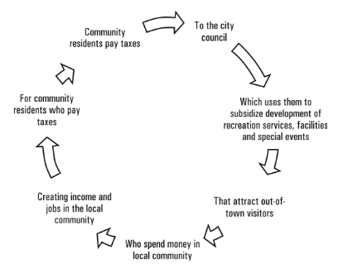

Figure 1: Basic understanding for undertaking economic impact studies
Source: Crompton, Lee & Shuster (2001, p.80)
Firstly, residents and local businesses are funding the local council through paying their taxes. The council will them use some of this money to support the building of more facilities or the realization of a certain event. This then results in the event drawing in attendees and visitors from other destinations. These incoming visitors will spend money in the hosting city pre, during and post event both inside and outside of the facility. This money then helps to generate extra income and jobs for the hosting community. By local businesses and residents giving money through taxes and other means they are then in return rewarded with additional jobs and the possibility of a higher household income (Crompton et al, 2001).

Issues in economic impact estimation
In almost every economic impact assessment a range of issues must be addressed. Among these issues are, (1) selecting the study area, (2) collecting data, (3) estimating the direct economic impacts, (4) selecting a secondary economic impact estimation and (5) using and analysing the results. Data collection issues almost always arise as well, such as event selection (problems can be caused when a venue hosts more than one type of event) and estimating event attendance can also cause problems due to the fact not every event is controlled, for example a festival (Hodur & Leistritz, 2006).

2.1.5 Event attendee spending on a host region
The flow of money originating from tourists coming into the destination has been distinguished as the ‘engine’ of an event’s economic impact (Crompton et al, 2001). With Kwiatkowski (2016) confirming this statement explaining that this group of event attendees increases the highest economic impact expectations between event supporters and politicians. However, as Fourie & Santana-Gallego (2011) expressed whilst some tourists may be only attracted to the event, regular tourists who could visit the destination on a frequent basis may cancel their trip due to a certain event taking place. This is known as the ‘crowding out effect’ (Preuss, 2011). Crowding out can be distinguished between supply side and demand side. Supply side occurs when due to the capacity constraints of the hosting destinations tourism-related infrastructure (transport, food and beverage, accommodation) tourists who come especially for the event will replace regular tourists. Demand side occurs when traffic, noise or other disturbances caused by the event will put off regular tourists (Kwiatkowski, 2016). It is important to consider the length of stay and the consumption patterns of the event tourist as they differ from the regular tourist due to the fact they are far less likely to spend time and money shopping or on visitor attractions (Litvin, 2007).
Local resident’s expenditures are usually neglected by academics when estimating the total economic impact of an event (Crompton, 1995). The exclusion of locals spending has been promoted by an argument offered by Crompton & McKay (1994) with them stating that any money spent by people who reside in the local area do not represent the circulation of new money, they only represent the circulation of money that was already there in the first place. Any expenditure related to the event by local residents are more likely to be ‘switched spending’ and therefore offers no net economic incentive to the community and therefore should not be included when calculating the economic impacts. However, more recent methodological donations argue that the spending of residents during the event hosting time may not solely create a relocation of money but could entail some relevant impacts (Tyrell & Johnson, 2001). For example, Baade & Matheson argues that “it is conceivable that some locals may dramatically change their spending given their desire to avoid the congestion at least in the venue environs” (p. 345). A variety of academics and researchers have stated that some locals could opt to remain at home to attend the event (McHone & Rungeling, 2000; Tyrell & Johnson, 2001). Dwyer et al (2010) states that the spending of locals caused by an event induced trips out of the region must be counted as a loss due to the event. Following on from existing methodological literature, Kwiatkowski (2016) conveys that the behaviour of local residents can be put into 3 categories: (1) residents can decide to cancel a trip and stay for the event, (2) locals can decide to leave the local area whilst the event is on, (3) locals can shift they’re spending in the hosting destination due to the event. According to Getz (1991) evidence suggests that major events do help to keep residents at home who would normally leave the area for a trip. Due to this, their expenditure would have been spent outside of the hosting region, but the event will help to keep the money within the hosting destination (McHone & Rungeling, 2000). Resulting in these expenditures acting as a benefit for the community (Mules & Faulkner, 1996). Agreeing with McHone & Rungeling, Preuss (2005) defines the group of local residents as ‘residents who opt to stay in the city and spend their money at home rather than on a vacation outside of the region at some other time in the year’ (p.283).

2.1.6 Multiplier Effect and Analysis
Multipliers have been used since early economic studies were conducted. Kahn (1931) was the first person to design a detailed and accurate model showing the primary and secondary effects of an increase or decrease in economic activity on an economy (Archer, 1982). B, Archer is among one of the first academics to apply multiplier models towards tourism and has a range of journal articles, books and topics on the subject such as the theory of multipliers (see Archer, 1984) and application of multiplier models to the economic impacts of tourism (see Archer, 1995). With reference to the economic impacts of major events, a multiplier is a proportion which helps to measure the positive or negative changes in an economic indicator such as high employment or sales, in response to change of demand, such as a change in event related tourism demand (Jago & Li, 2013). Dwyer et al (2010) stated that there are five common tourism multipliers, sales, output, income, value added and employment. The multipliers capture small adjustments in economic activity such as what change of income is due to one unit of increase in tourism expenditure (Archer, 1982).
To help assess the multipliers, it is important to look at the three components of expenditure: direct, indirect and induced expenditure. Direct expenditure is referred to as the initial money spent by the tourist, for example in the event or on shops and restaurants therefore flowing back into the economy. Indirect expenditure can be explained as additional expenditure that occurs when the business or organisation that first received their direct expenditure then goes on to purchase stock or supplies from other businesses in the hosting destination. (Jago & Li, 2013). For example, a restaurant purchasing food from its suppliers with the money it made through the tourists direct spend. Induced expenditure refers to the further expenditure which is generated. It can be described as ‘the beneficiaries of direct and indirect effects spend their increased incomes on consumption or investment goods’ (Khan, Seng, & Cheong, 1990, p. 409). For example, the staff from the restaurant spending their wages being spent outside of the restaurant or hosting city. This then causes leakages instead of the money circling back to the hosting destinations economy. A multiplier analysis can be performed by using 3 models according to Jago & Li (2013). The base model, Keynesian and input-output models are the most used, however in regards to events and tourism, the I-O model is the most popular method.
When assessing a major event, the tourism multipliers become even more problematic. During a major event, the destination will see more economic activity than normal due to more people being in the area, such as Swansea air show. Most multiplier models are based upon the region’s economic normal production rate and pattern but as stated by Porter and Fletcher (2008) since usual economic multipliers are not the same during a major event, any analysis made using these multipliers could be inaccurate. According to Matheson (2009) there is a reason to believe these multipliers are highly increased and their use could overestimate their true impacts. These multipliers would not be reliable to assess Swansea air show as the destination will produce economic activity at a faster rate than normal, meaning the use of multipliers would make this study inaccurate.

2.1.7 Conclusion
This chapter has provided a substantial amount of research on economic impacts of events. There has been numerous academic theories and practises within the event economic impact study area, and it is evident that major events can have an impact on local communities and businesses. It has found that there are various methods towards conducting an economic analysis and this will help the researcher to develop the study and methodology. The gap in the literature review has identified that there is a need for Swansea air show to be economically investigated as the need for economic benefits grows within tourism strategies.

Methodology

3.1.1 Chapter Overview
This chapter has the aim of addressing the third research objective: To conduct mixed method primary research in the form of two online surveys and 10 interviews to help address the key economic impacts of Swansea Air Show. This will aid the researcher in developing key understandings.
The method of primary research used will be analysed using Saunders, et al (2016) ‘Research Onion’ which has provided helpful to the researching in helping to understand the importance of different research and will aid in the process of justifying and identifying what type of methods (data collection) and research strategies will provide to be more useful to the researcher.
Firstly, research has the aim of investing a truth which has not yet been discovered according to Kothari (2004) however Rajasekar (2013) argues it is defined as a logical and systematic search for new and useful information on a specific topic. Research can be explained as an enquiry process which is both highly organised and explore a proposed question to test hypothesis (Punch, 2016) and similar to this Hussey (2003, p.1) explains it as ‘a process of enquiry and investigation which can increase knowledge’.

3.1.2. Research Onion
An effective research strategy has been created by Saunders et al (2009), The Research Onion, which is made up of layers that relate to certain stages of research. The researcher will use ‘The Research Onion’ to help the establish a correct research methodology.
Understanding the many different types of research is extremely important to the researcher as they need to choose the appropriate/correct method for their research. Understanding the different methods also enables the researcher to establish good practice for implementing their methods correctly (Bryman & Bell, 2007). Please note the circled sections is the path chosen by the researcher.
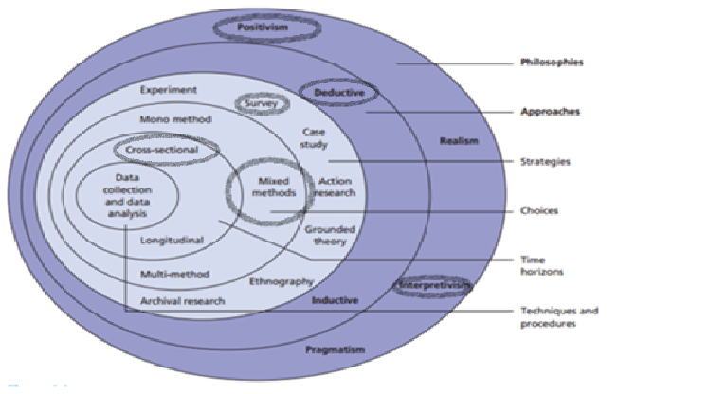

Figure 2 – ‘Research Onion’ (Saunders, et al 2007).
Following the above diagram and for the purpose of this study quantitative and qualitative research will be conducted. A mixed methods approach will combine both quantitative and qualitative research components, it will help to strengthen and expand a study’s conclusion, and therefore contribute to resolving the title of this study. Online questionnaires were put to participants on 20th February 2020 and all data was collected by 1st April.

3.1.3 Philosophy
The philosophy taken for this research will be both positivism and interpretivism. A positivist approach will be used by the researcher to analyse the closed ended questions in the questionnaire and interpretivism will be used to evaluate and analyse all open-ended questions from the questionnaire and interviews. Williamson (2002) states that the interpretivism form of research philosophy allows data to be distorted by perceptions of the participants chosen and this allows for different views to the same problem to be analysed. Interpretivism also applies to this study as the researcher will be using the questionnaire and interviews to gather quantitative data, this research method usually requires large samples (Saunders et al ,2012).
For this study, the researcher has chosen to identify the economic impacts within a hosting community and therefore online questionnaires and closed questions will be used and will involve a deductive approach, positivist. All interview questions will involve an inductive approach, interpretivism.

3.1.4 Strategy & Approach
The researcher will be using the deductive approach. The deductive approach helps to develop a hypothesis upon a pre-existing theory and then formulates the research approach to test it (Silverman, 2013). Research conducted during this dissertation will follow this approach where pre-existing theories based on the economic impacts of events will be tested and advanced and a hypothesis will be made based on the researcher’s findings. To conduct this research the researcher will be using a mixed method approach, using interviews and online questionnaires. Tashakkori and Teddlie (2003) state that multiple methods of research are useful as they can provide the researcher with better opportunities to answer the questions they need to.
The researcher will use online surveys through platforms such as google forms and will utilise social media such as Facebook and Instagram to help advertise the survey to create a wider participant response. Interviews will also be conducted through online social media platforms. Any information/data gained will be used to provide a framework for a hypothesis and the research conducted will have the purpose of linking with this dissertation.

3.1.5 Data collection
Saunders et al (2006) states that if a researcher uses multiple data collection methods this will enable them to gain wider knowledge, for example, interviews can be used to identify the key impacts/issues whereas questionnaires or surveys can then address the topic in further depth. Collin & Hussey (2009) explain that numerical data (quantitative) can be collected using positivist studies due to the high reliability of this study type. Collecting data using online surveys/questionnaires the researcher is going through the positivist process. Using two surveys the researcher is helping to ensure high validity and will be shared through social media platforms daily, to ensure a high number of participants. One survey will be targeted for the public whilst the other will be aimed towards local businesses. Survey A (The public) will consist of twenty-five questions whereas Survey B (businesses) will consist of 16 questions. The extensive literature review has enabled the researcher to develop closed questions for both online questionnaires, please see appendix A for matrix table. The researcher will use statistical analysis techniques to find similarities in results once all primary research has been completed.

3.1.6 Sampling
Due to the nature of this research project and to collect the credible primary data several selective participants were chosen by the researcher to be interviewed. This was conducted on platforms of social media such as Instagram, Facebook and Twitter. This is known as a purposive sample according to Saunders et al (2009) who describes purposive sampling as one that is non-probability as the researcher used their judgement to select participants who are involved within their certain topic area. This type of sample is most used for small-scale samples which helped the researcher collect informative samples and has allowed the researcher to select people who were the most appropriate in helping the researcher answering the research question.
For the first survey (participants from the public) random sampling has been used, enabling the researcher to gain as much information as possible. This sample size will be put together of roughly over one hundred participants, the larger the size of the sample the finer it will be to represent the public who have attended Swansea Air Show (Collis & Hussey, 2009).
For the second survey (businesses) participants were selected through purposive sampling. The researcher wanted to gather the information through businesses within a one-mile radius, making this sample size smaller than the first survey to help minimise any inaccuracies. Collins & Hussey (2014) explain that having an incorrect sample can result in data becoming misleading making the research invalid.

3.1.7 Sampling Framework
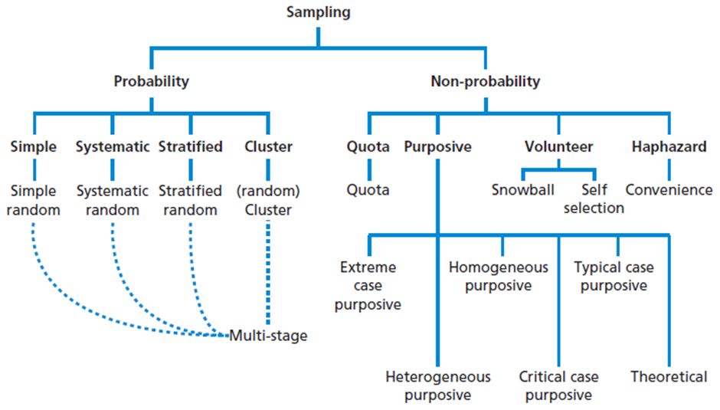Figure 3 – Sampling Framework (Saunders, et al 2016, p. 276)
As shown in figure 3.2 there are many forms of sampling frameworks. Brown (2006) states there are five advantages to sampling. Cost savings being one, makes research of any size a lot easier to manage, can results in a more accurate result of findings, opportunity to process information in a more efficient manner and it also helps to accelerate the speed of primary data collection. Non-probability sampling best applies to this dissertation paper as the researcher will choose participants in a non-random manner. The researcher will mainly be choosing specific individuals and will be focusing upon interviews and surveys meaning their main focus will be purposive sampling. The researcher will focus upon business owners in the local area within a one-mile radius (of Swansea Bay) to help aid the researcher in understanding the local economic activity.

3.1.8 Reliability & Validity
According to Cohen, et al (2011) the threat to reliability and validity can never be completely deleted therefore the researcher must do everything they can to minimise these threats whilst collecting their research with Robson (1993) agreeing there are many threats to reliability such as bias from participants or errors from the researcher themselves. Human error can also occur whilst inputting data from results, this can be minimised by the researcher using online survey software such as google forms. As Hammersley (1987) expressed there is many definitions for reliability and validity. However, Denscombe (2014, p.271) states that ‘’reliability refers to whether a research instrument is neutral in its effect and consistent across multiple occasions of use’’ similar to Hernon and Schwarts (2009) which state reliability is a concept which evaluate to ‘the extent which data can be constant’.
Validity can be referred to as the accuracy and precision of data (Denscombe, 2014). It is very important any research gathered demonstrates high validity and reliability. This will be achieved by conducting all the research in a fair and non-biased way which will make it equal to all participants. Due to the correct sample of people being targeted online with the questionnaires, it is almost certain this research project will have high validity. Robson and Mcartan (2015) go on to state that validity estimates how credible all research is. When the researcher is analysing the data, the results need to be believable otherwise this could result in the researcher having doubts about the reliability of participants and therefore their research answers. This could result in the questionnaire lacking credibility and therefore could have to be dismissed and not used for the final results.
This study will ensure that the interviews and questionnaires developed are piloted to help limit any concerns regarding the validity of the research/study.

3.1.9 Pilot Study
A pilot study was conducted before the interviews were handed to help limit the potential for the interviewee to misunderstand any of the questions (Saunders et al, 2016). A pilot study can be defined as a small-scale test of the questions the researcher will be putting forward to participants conducted prior to the to the official study to help ensure all potential issues are identified in order for the researcher to be able to make adjustments (Daniel & Sam, 2011). Both surveys were piloted by peers and various lecturers from the University.

3.1.10 Limitations
The research conducted will be open to the limitations of all undergraduate investigations. Including time frame as there is a deadline for which the research must be completed by. The researcher has produced a Gantt chart and will mitigate these limitations by efficiently managing time throughout the research process.
Another potential limitation concerned with this study is sample bias. As the questionnaires will mostly be distributed by social media and social media groups, participants are self-selecting to participate, meaning the sample may not be representative of the population at large and therefore could have an effect on generalizability of the results and some may need to be excluded from the research.

3.1.11 Ethical Considerations
One of the primary ethical concerns when conducting research involving members of the public is confidentiality. To stay within Data Collection Act, no identity of the interviewees will be disclosed, and all participants will be over the age of 18. No vulnerable individuals have been involved with this research and have all given consent to be interviewed prior to the interviews taking place. All data has been stored under password protection which only the researcher has knowledge of. The guidelines and policies of the University of Wales Saint Trinity David will always be adhered to and all data will only be viewed by the researcher and the University supporting this research. For a copy of the ethical form approval granted by the university prior to this dissertation please see Appendix B. For the consent provided by the interviewees and questionnaire please see Appendix C.

3.1.12 Conclusion
This chapter has discussed the strategic ways data will be collected for this study by gathering quantitative and qualitative data to find the true economic impact of Swansea Air Show. Research gathered has been done so through a mixed methods approach as the researcher felt this was the most appropriate way to answer this study’s aims and objectives. All research has been carried out in a systematic way. Any new information obtained throughout this study could provide useful to Swansea council enabling them to develop this major event.

4.0 Chapter 4 – Analysis

Introduction
This chapter intends to address the results of the primary research which involves two online questionnaires investigating the economic impacts of a major event, Swansea Air Show. The number of participants involved in the data collection is 116 in total counting respondents from both questionnaires. Analysis of this data will be interpreted manually, and all collected data was sequential. The researcher felt this was the most appropriate way to gather data as the first questionnaire will help inform the second. The questionnaire targeted towards members of the public had 104 respondents and the second questionnaire had 12 participants from businesses. An investigation into the members of the public spending behaviours will be called questionnaire A and the questionnaire completed by local businesses will be referred to as questionnaire B. Please note that the data presented will be in the form of percentages. All data discussed within this chapter is based upon research methods stated in chapter 3, however, a mixed method approach was not feasible as interviews were unable to be conducted due to the Covid-19 pandemic.
This chapter aims to find a solution to the third objective of this research study which has been previously discussed in chapter one. Please find it stated below:
- To conduct mixed method primary research in the form of two online surveys and 10 interviews to help address the key economic impacts of Swansea Air Show.
For the analysis of data collection for survey A the results have been grouped into two sections: section 1: Demographics and section 2: Public and visitor spending. For survey B, the data has also been grouped into two sections: section 1: Business information and section 2: Impacts. For survey A, questions 1,2 and 3 were asked to enable the researcher in understanding whether age, gender or where they lived were a factor in Swansea Air Show producing economic benefits. Questions 6-10 are centred around attendance and questions 13 and 14 are based on accommodation. Questions 16,17,18 and 19 focus on attendees spending before, during and after the event. For survey B, the questionnaire also has two sections, the start of the survey is focused on services of the business and location (Section 1). Section 2 is focused on Impacts. Questions 6-10 were centred around the economic impacts and impacts perceptions on the businesses, questions 8, 9 and 14 are open ended allowing more room for a detailed answer and discussion.

Questionnaire A - section 1: Demographics

4.2.1. Gender
The first question in questionnaire A asked participants to specify their gender. Analysis of content is depicted in figure 3. Gender demographics were as expected for this study.
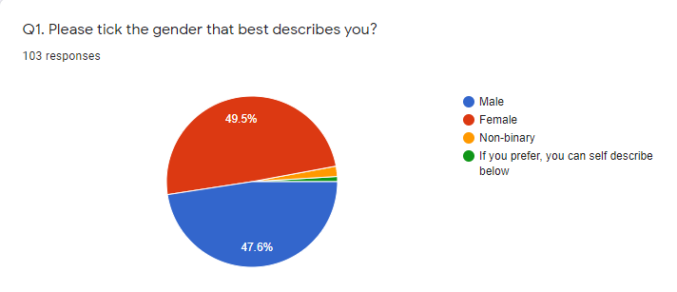

Figure 4: Pie chart depicting the gender of participants (Questionnaire A, Q1).

4.2.2 Age
Question 2 asked participants to specify the age bracket they belonged to.
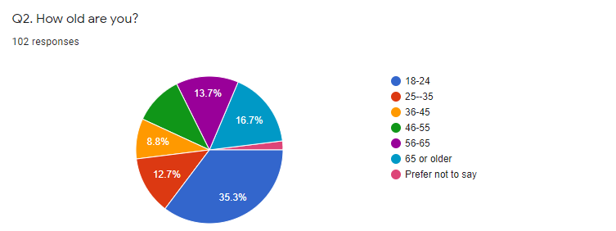
Figure 5: Pie chart depicting the age group of participants (Questionnaire A, Q2).
Question 2 found that the largest age bracket was 18-24 at 35.3% followed by 65 years or older (16.7%). The smallest age group to participate in the survey being 36-35-year olds with only 8.8%, 25-35 were the second smallest age group at 12.7%. The findings of 18-24-year olds being the largest could be due to questionnaires being distributed through social media platforms. This age group is the most likely to use social media and therefore participate in the questionnaire (Waterson, 2019).

4.2.3 Location
Question 3 asked participants if they lived in Swansea. This question is important to the researcher as it shows whether people are visiting from outside of Swansea bringing money into the local economy. Analysis of the content can is depicted in figure 5.
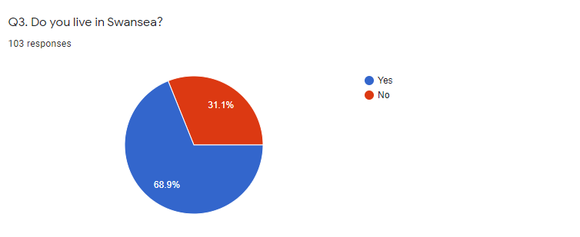
Figure 6: Pie chart depicting whether participants are residents of Swansea (Questionnaire A, Q3).
As defined in chapter two, an economic impact can be defined as ‘the net economic change in the income of host residents that results from spending by visitors outside the community’ (Crompton, 2006, p71). It was found that 68.9 of people who participated in the questionnaire were living in Swansea whilst the other 31.1% lived outside. This shows the event has attracted non-locals and visitors from outside of the local area bringing in an additional income to the economy. Jago and Li (2012) outlined previously that spending of new visitors to a destination will circulate around the local community, therefore generating economic benefits for Swansea and local businesses.

4.3 Section 2

4.3.1 Attendance
Question 6 was asked to identify whether participants had ever attended Swansea Airshow. Analysis of content is depicted in figure 7.
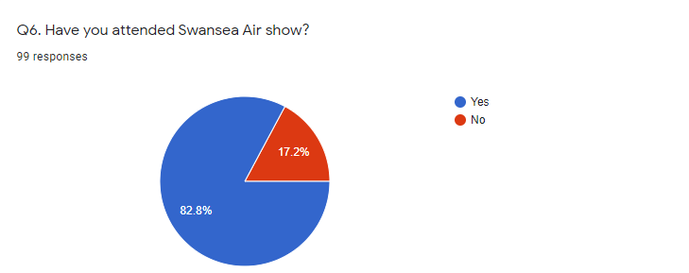

Figure 7: Pie chart depicting how many participants have attended Swansea Air Show. (Questionnaire A: Q6).
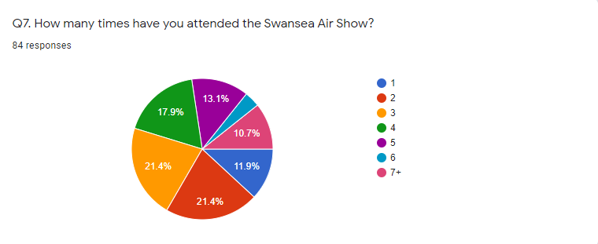
Question 7 was asked to participants to enable the researcher to determine how likely repeat business is for Swansea air show. Analysis of the content can be found in figure 8.

Figure 8: Pie chart depicting how many times participants have attended (Questionnaire A, Q7).
It was found that only 10.7% returned to the event more than seven times. The results show that 21.4% of participants visited the air show equally twice or three times. As only 3.6% of participants visited once and did not return this indicates the event is seeing a lot of repeat visitors which will continue to spend money in the event and its surrounding areas thus creating the multiplier effect as discussed in chapter two by various academics such as Dwyer et al (2010), Jago & Li (2013) and Porter & Fletcher (2008).
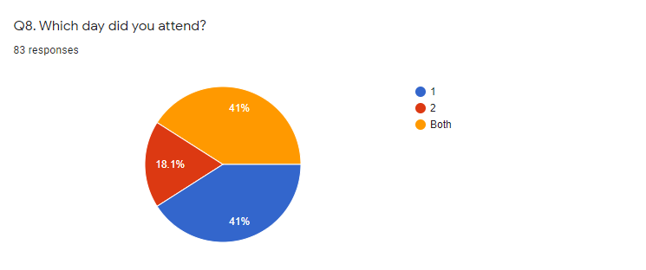

Figure 9: Pie chart depicting whether participants attended day 1 or 2 (Questionnaire A, Q8).
It is highly likely local businesses will see more of a profit if attendees are to participate in the whole duration of the event (2 days). Only 18.1% of participants stated that they attended both days at Swansea Air Show, with day 1 and day 2 both receiving 41%. If attendees are travelling from outside of Swansea, when attending the event for 2 days it is more probable for them to need accommodation, restaurants, and facilities, generating additional and secondary spend throughout Swansea. This then relates to Q9,
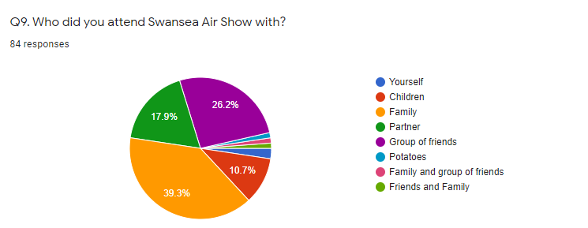
Figure 10: Pie chart depicting who visitors attended with (Questionnaire A, Q9).
Figure 10 shows that 39.3% of participants attended the air show with family, this plays a major part in what economic impacts the air show will bring. The more family members and children attending means that more money will be spent. The second highest option chosen by participants was ‘group of friends’, this also suggests that this category would be spending money throughout the event and afterwards, as people who attend events with friends are likely to go to restaurants and bars afterwards, again spending additional money within the local area and putting back into the local economy. Out of 84 responses for question 9 only 2.4% said they attended alone, this is a positive indication for the air show as it indicates they will have a higher footfall due to mainly families and friends attending.

4.3.2 Duration
Question 11 was asked to participants to gather information about the duration of their time at the air show. Analysis of the content is depicted in figure 11.
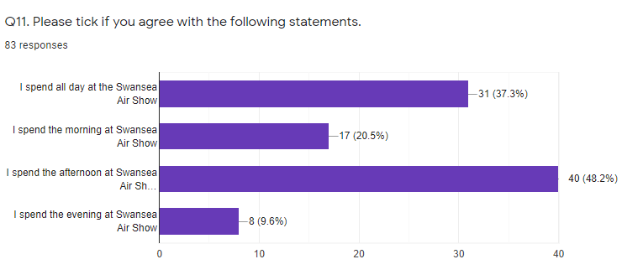
Figure 11: Likert scale depicting the duration participants attended Swansea air show (Questionnaire A, Q11).
This question was asked to determine how long attendees spent at the event, according to Getz (1991), the longer the duration attendees spend in the event the more likely the event is to see a profit. It was found that only 9.6% of participants attended the evening event of Swansea Air Show. This could be due to the evening event ‘Air show After Dark’ only being launched in 2019, as a one-off event to celebrate the 50th anniversary of Swansea’s city status Walesnationalairshow.co.uk, (2019). This could also be because families are the main type of attendee according to the results, families with young children will not want to keep them up late so would leave before the ‘After Dark’ event has started.

4.3.3 Tourism
Question 12 of the questionnaire asked participants if they travelled outside of Swansea to attend the event. Analysis of the content is depicted in figure 12.
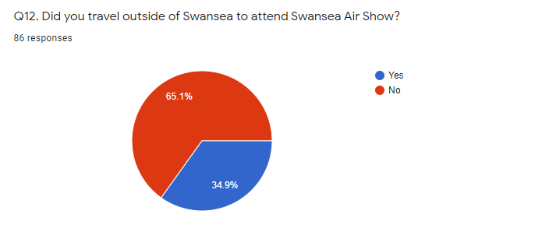
Figure 12: Pie-chart depicting whether participants travelled outside of Swansea to attend Swansea air show
Data collected from question 12 shows that 34.9% of 86 responses did travel from outside of Swansea with 8.5% travelling from England (see figure 12) thus bringing additional spends to Swansea. As previously discussed in chapter 2 Jago and Li (2012) stated that the spending of these visitors flows through the local community generating economic benefits for the host destination and local businesses. 65.1% said they travelled from within Swansea to attend, implying that this percentage reside in Swansea. As the researcher discussed previously Getz (1991) made the point of expressing evidence suggests that major events do help to keep residents at home who would normally leave the area for a trip.
Question 13 (open ended) asked participants how far they travelled to attend the event. Analysis of the content is depicted in figure 13.
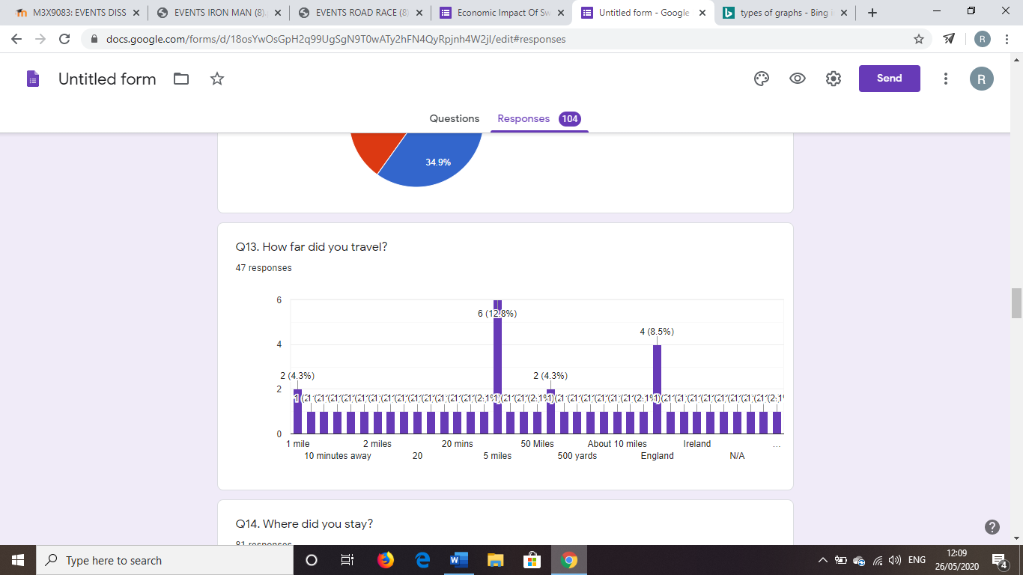

Figure 13: Bar chart depicting how far participants travelled to Swansea Air show (Questionnaire A, Q13).
The graph shows that people are willing to travel to attend Swansea air show. Attendees have stated they travelled from England and Ireland to be part of this event. Incoming tourism creates extra money in the area through direct spend of tourists, thus creating indirect spends and seeing the multiplier effect take place as Jago & Li (2013) convey throughout chapter 2. It is also evident that a large proportion of respondents did not travel more than 20 miles to attend the event which would suggest a circulation of money throughout Swansea’s economy.
Question 14 asked participants about accommodation choices when attending Swansea Air show. 63% stated they stayed at home; hotels were the second choice with 14.8%. Analysis of the content is depicted in figure 14.

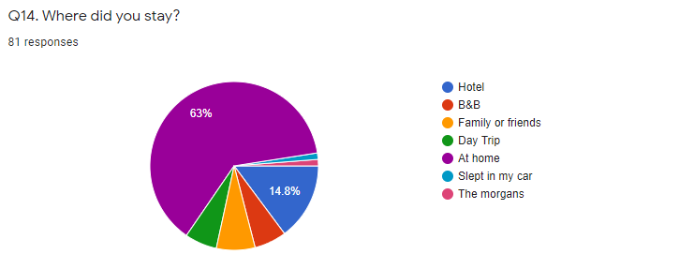

Figure 14: Pie chart depicting where respondents stayed when attending the Swansea Air Show (Questionnaire A, Q14).
As the event is drawing in visitors from outside of Swansea and the surrounding areas, hotels and other accommodations are likely to see an increase in bookings and enquiries due to visitors needing somewhere to stay. When asked how much they had spent on accommodation (Q19, see appendix C) the results showed that 18.3% of respondents chose the option of ‘prefer not to say’ indicating they spent over £120. 15% said they spent more than £120 on accommodation due to visiting Swansea for the air show providing evidence that the event is creating a positive economic impact for Swansea.
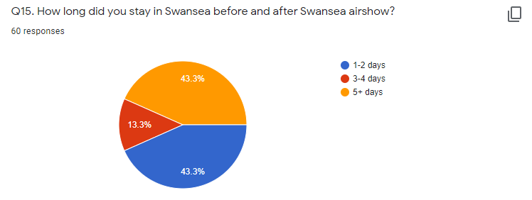
Question 15 asked respondents how long they stayed in Swansea before and after the air show. Analysis of content is displayed in figure 15.

Figure 15: Pie chart showing how many days respondents stayed in Swansea before and after the air show. (Questionnaire A, Q15).
This is an important question for the study as research from chapter 2 by Crompton et al (2001) confirms, the incoming visitors will spend money in the hosting city, pre during and after an event, both inside and outside of the facility. This money then helps to generate jobs and extra income for the hosting city. As the pie chart displays 43.3% of respondents stayed an extra 5+ days after or before the event meaning that would have generated additional expenditures in the shops, restaurants, and accommodations of Swansea. 43.3% of respondents also said they stayed in Swansea an extra 1-2 days. Daniels and Norman (2003) agree that visitors who visit a hosting city for longer than the duration of the event are more inclined to spend money on food and accommodation. When participants were asked if they spent money in any local food shops 73.3% of respondents said yes with 61.6% stating they visited a restaurant or café due to visiting the air show. As previously discussed in chapter 2 the circulation of money originating from tourists coming into the destination has been distinguished as the ‘engine’ of an event’s economic impact (Crompton et al, 2001).Kwiatkowski (2016) agrees this statement explaining that this group of event attendees produces the highest economic impact expectations between event supporters and politicians.

4.3.4 Attendee Spending
Question 16 asked participants if they spent more money at Swansea air show than the average weekend. Analysis of content is shown in figure 16.
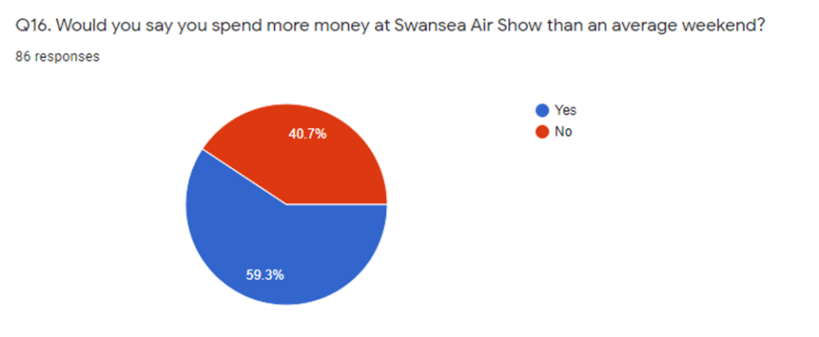
Figure 16: Pie chart depicting whether participants thought they spent more money at Swansea air show than an average weekend (Questionnaiere A, Q16).
59.3% of respodents stated that they do spend more money at Swansea air show than an average weekend, with 73.3% of people stating they spent money on the food stalls inside of the event, however, when participants were asked if they had any comments relating to the survey, it was clear that visitors think the food is too expensive inside of the event and would go to a local food shop next time. This is still a positive impact for swanseas economy as local businesses and shops will benefit. Clothing shops provided least popular with participants as 57.1% said they did not viist or spend money in any clothing shops.
Question 23 (open ended) asked participants where did they think they spent most of their money. Analysis of content can be found in figure 17.
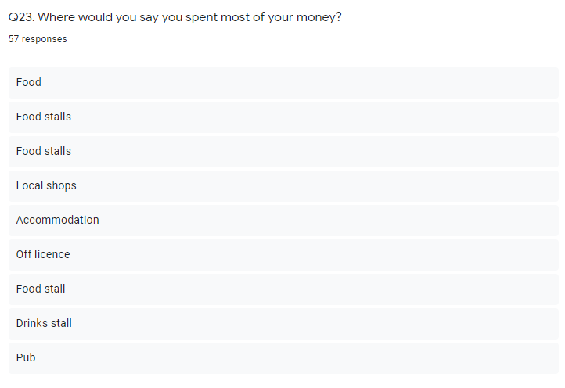
Figure 17: Open ended question depicting where respondents spent most of their money (Questionnaire A, Q23).
Question 23 was asked to participants to gather information on where they believed they spent most of their money. It is evident from the results that food and beverage was the top consumer for respondents with 34 out of 57 respondents stating that is where they spent most of their money. Daniels and Norman (2003) stated that food and drink varies substantially across events but are the main expenditure for event attendees. Local shops came second, however this could be due to people wanting to purchase food and drink from local shops instead of purchasing from the air show.

Survey B – Section 1: Services

Awareness
Question 1 asks the businesses whether they have heard of Swansea air show.
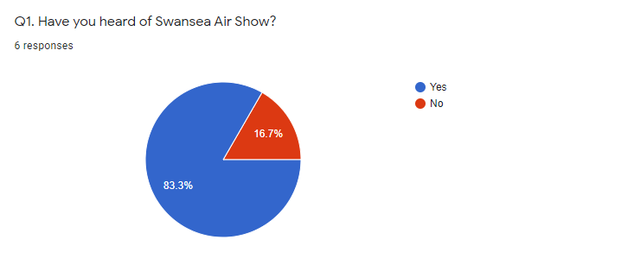
Figure 17: Pie chart depicting the percentage of businesses who have heard of Swansea air show. (Questionnaire B, Q1).
This question was asked to gather information on how aware businesses in the local area are of the event. 83.3% said they had heard of Swansea air show. 14.3% of respondents agreed with the following statement from Q12, ‘more communication is needed between Swansea air show and local businesses/organisations. This shows that businesses need to be more informed by the council in order for them to be more aware of the event and the footfall created, this gives businesses the opportunity to advertise and increase additional custom.

4.4.1 Service provided
Q4 asks respondents what service their business provides to the public. Analysis of content can be found in figure 19.
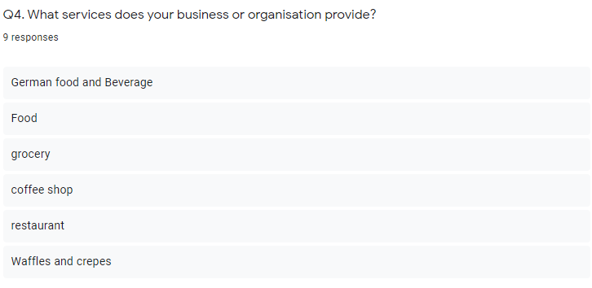
Figure 19: Open ended question asking participants what service their business provides (Questionnaire B, Q4).
This question only gathered nine responses out of twelve participants. Every respondent stated they sold some type of food or beverage. This question was asked to enable the researcher to gather an understanding in the services offered and the most popular businesses visited.

4.4.2 Location
Question 5 asked businesses where their store was located. Analysis of content is shown in figure 20.
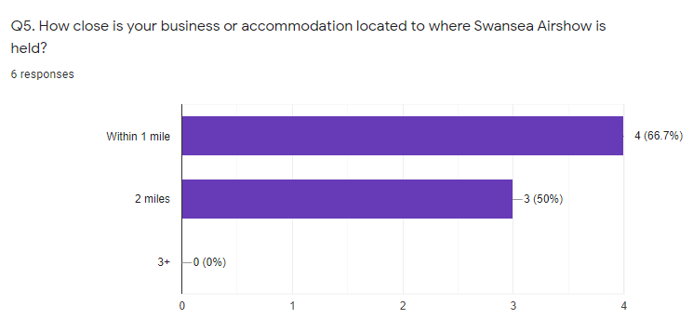
Figure 20: Likert scale depicting how far away participants businesses are located from Swansea air show (Questionnaire B, Q5).
Data collected from question five shows that all businesses who responded were within a 2-mile radius from Swansea air show. The researcher wanted to gather information from local businesses that are local to the event, with all respondents being less than 2 miles away this is sufficient to carry on with the research study.

Section 2

4.5.1 Economic Impacts on local businesses
Questions 6-14 addressed the economic impacts businesses felt the event had on their company. Please see Appendix C for questionnaire A and B.
83.3% of respondents stated the event had an economic impact on their business with 42.9% stating it had a positive effect. 28.6% of respondents thought it had a negative effect whilst the other 28.6% believed their business had not been affected from the event. Research from chapter 2 demonstrates how increased spending in an area does not necessarily lead to increased incomes and therefore may not provide an economic benefit to all businesses (Getz, 1949 & Tyrell, and Johnson, 2001). Please see Appendix D for matrix table. According to Fourie & Santana-Gallego (2001), tourists and locals who visit an area regularly may cancel their plans due to a major event taking place and this could be why not all businesses with-in a 2-mile radius are seeing a direct positive economic impact. Question 11 asked participants whether they thought the event increases footfall in the local area, 57.1% said yes with 42.9% stating no. The questionnaire also found that 71.4% of participants had more staff working than they usually did at the time of the event, providing evidence that there is more footfall in the area than usual.
Analysis of the data has identified reoccurring themes that have emerged from both online questionnaires. It is evident from the data collected and analysis of the literature review in chapter two that this major event is providing an additional income to Swansea’s economy and that attendees and local businesses are aware of the event. One of the reoccurring themes throughout both questionnaires was the use of food and beverage facilities being the most visited, reasons for this could be down to attendee type, such as families with children or limited options of where to spend additional money. The literature review has agreed with the findings of this research study and found three themes which are discussed in depth in the following chapter.

4.5.2 Conclusion
It is apparent from both online questionnaires that economic impacts can be generated from Swansea air show. Both questionnaires have proven that this event is increasing footfall throughout the local area. With families and friend’s groups being the main attendee, food and beverage stalls and shops have seen a benefit from the event. Chapter five will discuss and evaluate the analysis.

5.1 Conclusion

5.1.1. Introduction
This chapter will go on to discuss and evaluate how this study has achieved the aims and objectives of this dissertation and at length given a resolution to the title of this study. This chapter will conclude the research study and provide strategic recommendations to event organisers and will propose further areas of research that would be conducted if the researcher were to repeat this study. A Gannt chart can be found in appendix D.

5.1.2 Aims and Objectives
Based on this study’s three objectives, this final chapter will go on to conclude and summarise the findings from the research conducted whilst providing conclusions. The overall aim of this study was to investigate the local economic impacts of Swansea Air Show and evaluate how local businesses are affected.
There were 3 objectives to this research study:
- To critically analyse previous academic literature on how destinations/local areas can economically benefit from staging events.
- To establish whether local businesses see a benefit to their profits whilst Swansea Air Show is displayed.
- To conduct mixed method primary research in the form of two online surveys and 10 interviews to help address the key economic impacts of Swansea Air Show.
Having researched previous academic literature and economic assessment models, the researcher was able to provide an extensive literature review, therefore, achieving the first objective of this research study which was to critically analyse previous academic literature on how destinations/local areas can economically benefit from staging and hosting events. It was found throughout the literature a repetitive theme of multiplier analysis and visitor spend was found. Visitors/tourists additional expenditure was also found within the data collection in chapter four. The literature review has provided clear evidence that major events do create positive and negative economic impacts, however these are mainly positive, Jago and Li (2012). The critical evaluation of the literature in chapter two however, has established criticism from academics associated with how to assess and measure the economic impact from a major event. Multiplier models are usually based upon a region’s normal rate of economic production but as Porter and Fletcher (2008) and Matheson (2009) argue, the economic multipliers will never be the same throughout a major event, thus any analysis made could be incorrect and overestimate the true impacts. The themes were made apparent in chapter four of this study that the economic benefits produced are positive, as the results show an increase in additional spending through food and beverage stalls/shops. As pre-existing literature shows from chapter two Walpole and Godwin (2000) outline that to properly consider all the local impacts of the economic impact on an event, effects on employment have to be considered. Respondents from questionnaire B stated they had to hire more staff for before and after the event, again creating the multiplier effect (Dwyer et al 2010).
To achieve the second objective of this research study, primary research has been used to aid in identifying the views of the public and businesses on the economic impacts of Swansea air show. The data collected from both questionnaires found three themes:
- Swansea air show is providing an additional income to Swansea’s economy.
- Food and beverage stalls/shops were the most visited.
- Attendee type (families, group of friends) are playing a huge factor in the levels of economic activity pre, during and after the event.
Results from both online questionnaires showed that respondents are aware of Swansea air show and believe that it is generating and increasing more footfall and economic activity around Swansea. This finding confirms the pre-existing literature provided in chapter 2. Questionnaire A was conducted using random sampling whereas questionnaire B was produced using purposive sampling. A major reoccurring theme throughout both questionnaires was the amount of money spent on food and beverage. The research shows that this is where participants spent most of their money. Accommodation would have been the first producer, although only 31.1% of respondents travelled outside of Swansea, this results in locals spending more money than tourists, however, this still produces economic benefits for the hosting city as it is money that would not usually be spent (Jago and Li, 2012).
Having researched previous academic literature and economic assessment models, the researcher was able to provide an extensive literature review, therefore, achieving the first objective of this research study which was to critically analyse previous academic literature on how destinations/local areas can economically benefit from staging and hosting events. It was found throughout the literature a repetitive theme of multiplier analysis and visitor spend was found. Visitors/tourists additional expenditure was also found within the data collection in chapter four. The literature review has provided clear evidence that major events do create positive and negative economic impacts, however these are mainly positive as stated by Jago and Li (2012). One of the negative impacts found within this research study was that not all businesses were seeing a positive economic impact, this could be due to the business being located out of the area from Swansea air show so would not receive the highest level of footfall. The critical evaluation of the literature in chapter two however, has established criticism from academics associated with how to assess and measure the economic impact from a major event. Multiplier models are usually based upon a region’s normal rate of economic production but as Porter and Fletcher (2008) and Matheson (2009) argue, the economic multipliers will never be the same throughout a major event, thus any analysis made could be incorrect and overestimate the true impacts. The themes were made apparent in chapter four of this study that the economic benefits produced are positive, as the results show an increase in additional spending through food and beverage stalls/shops. As pre-existing literature shows from chapter two Walpole and Godwin (2000) outline that to properly consider all the local impacts of the economic impact on an event, effects on employment must be considered. Respondents from questionnaire B stated they had to hire more staff for before and after the event, again creating the multiplier effect (Dwyer et al, 2010).
The third objective of this research study was to conduct mixed method primary research in the form of two online surveys and 10 interviews to help address the key economic impacts of Swansea air show. The full objective was not achieved by the researcher as they did not conduct a mixed-method approach. Due to the outbreak of Covid-19 (Coronavirus), businesses were told to shut by government guidelines resulting in the researcher not being able to conduct any interviews. The survey questionnaires provided quantitative research that was sufficient enough to analyse the research collected as it provided an in-depth analysis on the economic impacts produced by attendees, whilst also providing analysis on how business owners perceived their economy activity before, during and after the event. Key economic impacts produced by the event have been addressed throughout this dissertation however the researcher felt this study could have developed greatly through using a mixed-methods pathway.
As it is evident, this event is generating an additional income for Swansea’s economy, theme one provides a great opportunity for Swansea as a destination and local authorities. As the researcher was unable to obtain information on the cost Swansea council pay for the air show, it has been proven by this major event, that a free event can generate a positive economic impact. The council could look to develop this event whilst also conducting primary research into the feasibility of other events. A food and beverage event could prove popular as one of the main findings of this study was how popular these businesses were with attendees. This will not only help boost Swansea’s image as a tourist destination but could also see Swansea develop a strategic events plan which would in time, generate more economic activity throughout Swansea and its surrounding areas.
Large scale businesses and brand organisations will see a profit from Swansea air show, such as, Tesco and Sainsburys however, the event is providing great opportunities for micro businesses pre, during and after the event. Businesses could look to develop and increase advertisement before and during Swansea air show. As shown in questionnaire B, the increase in footfall each year provides businesses with an opportunity of repeat custom from the year before and the chance to create new custom. Stalls provided by Swansea air show also offer a great way for micro businesses to advertise and create a positive brand image for themselves.

5.1.3 Recommendations
As the results show from chapter 4, it is acknowledged that Swansea air show is creating an economic impact for its hosting city. These recommendations have been provided to increase and enhance this event’s economic benefits.
1. Turn the after dark event into an annual event, however, event organisers would need to increase advertisement for this evening event as only 9.6% said they attended the evening show out of participants from the research questionnaire.
2. Provide different varieties of food and stalls.
3. Primary research to be conducted to see if advertising and branding to a wider audience would increase foot fall in Swansea.
4. Primary research to be conducted to investigate local’s perceptions of Swansea air show (social impacts).

5.1.4 Limitations
As previously discussed throughout chapter 3 of the methodology, a mixed method approach was to be taken by the researcher as they felt this was the best way in answering the title of this dissertation. The greatest limitation of this dissertation study can be attributed to the researcher not being able to conduct any interviews due to the Covid-19 pandemic. This study would have benefited greatly from collecting qualitative research as it would have enabled the researcher to develop a deeper understanding on what economic impacts this event is having on local businesses.

5.1.5 Further Study
This analysis has derived from an annual event Swansea air show, which has focused upon the economic impacts generated from the event. The literature review provided in chapter 2 enabled the researcher to gather and formulate questions for the questionnaire. To replicate this study would secure the validity and reliability of all the research obtained. It would also enable the researcher to gain a wider understanding and knowledge into the specific economic factors generated from this major event. The fact that all respondents to questionnaire B were food or beverage suppliers arguably could bring into question the effectiveness of this research. The researcher could look to provide a follow up study by conducting primary research including in – depth interviews allowing for triangulation and a mixed-methods approach to take place. The researcher could also additionally look to conduct primary research into whether wider advertising would help Swansea air show increase footfall for Swansea and the surrounding areas.

5.1.6 Final Summary
The aim of this study was to investigate the local economic impacts of Swansea Air Show and evaluate how local businesses are affected. This dissertation has provided an in-sight into the economic impacts this event has been generating for businesses, it has identified its main attendee and where they have spent most of their money. It has identified significant areas for further study whilst providing recommendations for Swansea council and micro-businesses.

5.1.7 Self-reflection
As mentioned at the start of this research study, the researcher wanted to investigate whether Swansea air show was having an economic impact on local businesses, this was due to studying BA Events Management and getting experience from her university placement.
This dissertation has proven to be very hard for the researcher to complete at times, however this research project has been thoroughly rewarding and has enabled her to develop in her independent process of self -learning whilst also developing rich knowledge on economic impacts as a whole.
Through the duration of this dissertation, the researcher has gained a wider knowledge and understanding on the economic impacts that surrounds hosting a major event and has come to the realisation that not all local businesses will see a positive impact.

6.0 Reference List
Altinay, L. & Paraskevas, A. (2008), Planning research in hospitality and tourism, Oxford: Butterworth-Heinemann.
Andersson, T., & Samuelson, L. (2000). ‘Financial effects of events on the public sector’ Evaluation of events, 86–103, New York: Cognizant.
Archer, B. (1982). ‘The value of multipliers and their policy implications’. Tourism Management, 3(4), 236–241.
Archer, B. (1984). ‘Economic impact: Misleading multiplier’. Annals of Tourism Research, 11(4), 517–518.
Archer, B. (1995). ‘Importance of tourism for the economy of Bermuda’. Annals of Tourism Research, 22(4): 918–930.
Baade, R. A., & Matheson, V. A. (2004). ‘The quest for the Cup: Assessing the economic impact of the World Cup’. Regional Studies, 35(4), 343-354.
Bajpai. N, (2011), Business Research Methods, Dorling Kindersley, India.
Baumeister, R, F., & M.R. Leary (1997), Writing narrative literature reviews, Review of General Psychology, 1(3), 311-320.
Brown, R, B., (2006), Doing your dissertation in business management: The reality of research and writing. Oxford: SAGE Publications.
Bryman, A. & Bell, E., (2007), Business Research Methods. 2nd Ed. Oxford: Oxford University Press. London: Continnum.
Burns, J. P. A., Hatch, J. H. and Mules, T. J.(1986). "An economic evaluation of the Adelaide Grand Prix". In The planning and evaluation of hallmark events, 172–185, Aldershot: Avebury.
Chalip, L. & McGuirty, J. (2004), ‘‘Bundling sport events with the host destination’’, Journal of Sport Tourism, 9(3), 267-282.
Chalip, L., & Green, B.C., & Hill, B., (2003), Effects of sport event media on destination image and intention to visit, Journal of Sport Management, 17(3), 214 -234.
Cohen, et al (2011). Research Methods in Education, Abingdon: Routledge.
Collins, J. & Hussey, R., (2003). Business Research, 3rd Ed, New York: Palgrave Macmillan.
Collis, J. & Hussey, R., (2014). Business Research: a practical guide for undergraduate and postgraduate students. 4th ed. Basungstoke: Palgrae Macmillan higher education
Crompton J.L. (1995). ‘Economic impact analysis of sports facilities and events: Eleven sources of misapplication’. Journal of Sport Management, 9(1), 14.
Crompton J.L., Lee S.B., & Shuster T. (2001). ‘A guide for undertaking economic impact studies’. Journal of Travel Research, 40(1), 79-87.
Crompton, ,T. L., & McKay, S. L. (1994). ‘Measuring the economic impact of festivals and events: Some myths, misapplications and ethical dilemmas’. Festival Management & Event Tourism, 3, 33—43
Crompton, J. L. (2006). ‘Economic impact studies: Instruments for political shenanigans?’, Journal of Travel Research, 45(1), 67–82.
Daniels M.J. and Norman, W.C. (2003), "Estimating the economic impacts of seven regular sport tourism events", Journal of Sport Tourism, 8(4,) 214-222.
Delpy, L., and M. Li (1998). “The Art and Science of Conducting Economic Impact Studies.” Journal of Vacation Marketing, 4(3), 230–54.
Delpy, L., and M. Li. (1998). “The Art and Science of Conducting Economic Impact Studies.” Journal of Vacation Marketing, 4(3), 230–54.
Descombe, M., (2014), The good research guide: for small scale social research projects. 5th Ed, London: Open University Press.
Dierding, M., & Kwiatkowski, G. (2015). ‘Economic impact of event and festivals on host regions – methods in practice and potential source of bias’. Sport Tourism, 22, 247-252.
Dwyer, L. (2002). ‘Economic contribution of convention tourism: Conceptual and empirical issues.’ Convention tourism: International research and industry perspectives, 21–35. New York: Haworth.
Dwyer, L., Forsyth, J., & Spurr, R. (2006). ‘Assessing the Economic Impacts of Events: A Computable General Equilibrium Approach’. Journal of Travel Research, 45(1), 59-66.
Dwyer, L., Forsyth, P. and Dwyer, W. (2010). ‘Economic evaluation of special events’. Tourism economics and policy, 405–453. Bristol: Channel View Publication.
Fournie, J., & Santana-Gallego, M. (2011). ‘The impact of mega-sports events on tourist arrivals’. Tourism Management, 32(6), 1364-1370.
Frechtling, D.C. (2006). ‘An assessment of visitor expenditure methods and models’. Journal of Travel Research, 45(1), 26-35.
Gazel, R. C., & Schwer, R. K. (1997). ‘Beyond rock and roll: The economic impact of the Grateful Dead on a local economy.’ Journal of Cultural Economics, 21, 41-55.
Getz, D. (1949) Event studies: theory, research and policy for planned events. 2nd ed. Abingdon, New York: Routledge.
Getz, D. (1991). ‘Assessing the economic impacts of festivals and events: Research issues.’ Journal of Applied Recreation Research, 76(1), 61-77.
Getz, D. (2005). Event management and event tourism, 2nd ed, New York: Cognizant.
Getz, D. (2008). Event tourism: Definition, evolution, and research. Tourism Management, 29, 403–428.
Gillham, B., (2004), The Research Interview. London: Continuum.
Grado, S., Strauss, C., & Lord, B. (1998). ‘Economic impacts of conferences and conventions.’ Journal of Convention and Exhibition Management, 1(1), 19–33
Gratton, C., Dobson, N., & Shibli, S. (2000). ‘The economic importance of major sports events: a case study of six events’. Journal of Managing Leisure, 5(1), 17-28.
Hammersley, M., (1987), ‘Some notes on the terms ‘validity’ and ‘reliability’’. British educational research journal, 13(1), 73-82.
Harding, (2017), ‘Wales National Air show: Full Flying Display Times & What To See’ [Online], UK Aviation. Available: https://uwtsd.ac.uk/media/uwtsd-website/content-assets/documents/library-and-learning-resources/infoskills/Harvard-eng_v.1.2.pdf, 22, November, 2019.
Hodur, N. M., & Leistritz, F. L., (2006). ‘Estimating the economic impact of event tourism’. Journal of convention and event tourism, 8(4), 63-80.
Hodur, N. M., Bangsund, D. A., Leistritz, F. L., & Kaatz, J. (2006). ‘Estimating the contribution of a multi-purpose event facility to the area economy.’ Tourism Economics,12(2), 303-316.
Hussy, R., & Collis, J., (2003). Business Research. 2ND Ed, Basingstoke: Palgrave Macmillan.
Jago, L., & Li, S. (2013), ‘Evaluating economic impacts of major sports events – a meta-analysis of the key trends’, Current issues in tourism, 16(6), 591-611.
Jago, L., Chalip, L., Brown, G., Mules, T. and Ali, S. (2003). Building events into destination branding; Insights from experts. Event Management, 8(1), 3–14.
Kahn, R. (1931). ‘The relation of home investment to unemployment’. Economic Journal, 41, 173–198.
Kesenne, S. (2005). ‘Do we need an economic impact study or a cost-benefit analysis of a sports event?’ European Sport Management Quarterly, 5(2), 133-142.
Khan, H., Seng, C. and Cheong, W. (1990). ‘Tourism multiplier effects on Singapore’. Annals of Tourism Research, 17, 408–418.
Kim, M, K., Suk-Kyu, K., Jae-Ahm, P., Michael, C., Jae-Gu, Y., & Kyunga, N., (2017). “Measuring the Economic Impacts of Major Sports Events: The Case of Formula One Grand Prix (F1).” Asia Pacific Journal of Tourism Research, 22(1): 64–73
Kwiatkowski, G. (2016). ‘Economic Impact of event attendees spending on a host region: A review of the research’. Event Management, 20, p. 501-515.
Laesser, C. & Crouch, G.I. (2006), ‘‘Segmenting markets by travel expenditure patterns: the case of international visitors to Australia’’, Journal of Travel Research, 44 (4), 397-406.
Litvin, S. (2007). ‘Research: The economic attractiveness of runners: Are they ‘’healthy’’ tourists?’, Tourisim Economics, 13(3), 481-486.
Loftsgaarden, B. (2017). ‘The economic impact of major event’s’. Economic Development Journal, 16(4), 44–50.
Loveridge, S. (2004). ‘A typology and assessment of multi-sector regional economic
Macfarlane, I., & Jago, L. (2009). ‘The role of brand equity in helping to evaluate the contribution of major events’. CRC for Sustainable Tourism Pty Ltd Report, Gold Coast: Sustainable Tourism Pty Lt.
Manete, M. (1999). “Regional and Inter-Regional Economic Impacts of Tourism Consumption: Methodology and the Case of Italy.” Tourism Economics, 5(4), 425–36
Matheson, V. (2009). ‘Economic multipliers and mega event analysis’. International Journal of Sport Finance, 4, 63-70.
McHone, W. W., & Rungeling, B. (2000). ‘Practical issues in measuring the impact of a cultural tourist event in a major tourist destination’. Journal of Travel Research, 38(3), 300-303.
Mondello, M. J., & Rishe, P. (2004). ‘Comparative economic impact analyses: Differences across cities, events, and demographics’. Economic Development Quarterly, 18(6), 331-342.
Mules, T., & Faulkner, B. (1996). ‘An economic perspective on special events.’ Tourism Economics, 2(2), 107-117.
Nancy, M., & Hodur, M. S., & Leistritz, L. (2008). ‘Estimating the Economic Impact of Event Tourism’. Journal of Convention and Event Tourism, 8(4), 63-79.
Noll, R. G., & Zimbalist, A. (1997). ‘Sports, jobs, and taxes: The economic impact of sports teams and stadiums’, The Bookings Review, 15(3), 35-39.
Porter, P., & Chin, D. (2012). ‘Economic impact of sports event’, International Handbook on the Economics of Mega Sporting Events, 246-264, Cheltenham, UK: Edward Elgar Publishing.
Porter, P., & Fletcher, D. (2008). ‘The economic impact of the Olympic Games: predictions and ex poste reality’. Journal of Sport Management, 22(4), 470-486.
Preuss, H. (2005). ‘The economic impact of visitors at major multi-sport events.’ European Sport Management Quarterly, 5(3), 281-30.
Preuss, H. (2011). ‘A method for calculating the crowding out effect in sport mega-event impact studies: The 2010 FIFA World Cup. Development of South Africa, 28(3), 367-385.
Preuss, H., Seguin, B. and O’Reilly, N. (2007), ‘‘Profiling major sport event visitors: the 2002 Commonwealth Games’’, Journal of Sport and Tourism, Vol (1), pp. 5-23.
Preuss, H., Seguin, B. and O’Reilly, N. (2007), ‘‘Profiling major sport event visitors: the 2002 Commonwealth Games’’, Journal of Sport and Tourism,12(1), 5-23.
Punch, K, F., (2016). Developing effective research proposals. 3rd Ed. London: SAGE Publications.
Rajasekar, S., Philominathan, P. & Chinnathambi, V., (2013), Research Methodology, 1-53.
Robson, C. (1993), Real World Research, Blackwell:Oxford. In Saunders, M., Lewis, P. & Thornhill, A. (2000) Research Methods for Business Students, 2nd Ed, Prentice Hall: Harlow.
Robson, C., & M, Mcartan, (2015). Real World Research, London: John Wiley & Sons.
Saunders, M., Lewis, P. & Thornhill, A,. (2007), Research Methods For Business Students, 7th Ed, Pearson: Essex.
Saunders, M., Lewis, P. & Thornhill, A., (2016). Research Methods for Business Students. 6th Ed. Essex: Pearson Education Limited
Siegfried, J., & Zimbalist. A. (2000). The economics of sports facilities and their communities. Journal of Economic Perspectives, 14(3), 95-114.
Silverman, D. (2013), Doing Qualitive Research: A practical handbook, London: SAGE Publications.
Tashakkori, A., & Teddlie, C. (2003). Handbook of Mixed Methods in Social & Behavioural research. Thousand Oaks: Sage.
Tyrrell, T. J., & Johnston, R. J. (2001). ‘A framework for assessing direct economic impacts of tourist events: Distinguishing origins, destinations, and causes of expenditures’. Journal of Travel Research, 40(1), 94-100.
Walesnationalairshow.com. (2019). ‘Yes… they are coming to Swansea’. [Online]. Available: http://www.walesnationalairshow.com/airshow-news/yes-they-are-coming-to-swansea/. (1, January, 2020).
Walpole, M.J., Goodwin H.J. (2000). ‘Local economic impacts of dragon tourism in Indonesia’. Annals of Tourism Research, 27(3), 559-576.
Wang, P., & Irwin, R. L. (1993). ‘An assessment of economic impact techniques for impact models.’ Regional Studies, 38, 305-317.
Waterson, J. (2019). ‘Social media addiction should be seen as a disease. [Online]. Available: https://www.theguardian.com/media/2019/mar/18/social-media-addiction-should-be-seen-as-disease-mps-say’. (2020, May, 1).
Williams, C. (2019), ‘Amazing Weekend for 2019 Wales Air Show’ [Online], Wales Airshow. Available: http://www.walesnationalairshow.com/uncategorized/amazing-weekend-for-2019-wales-airshow/. (22, November, 2019).
Williamson, K. (2002). Research Methods for Students, Academics and Professionals. Wagga Wagga: Centre for Information Studies.
Zima, K. (2011). Event Tourism Economical and tourstic impacts on regional economy: A study of Polish regions preparations for UEFA EURO 2012.

7.0 Appendix

Appendix A – Matrix Table
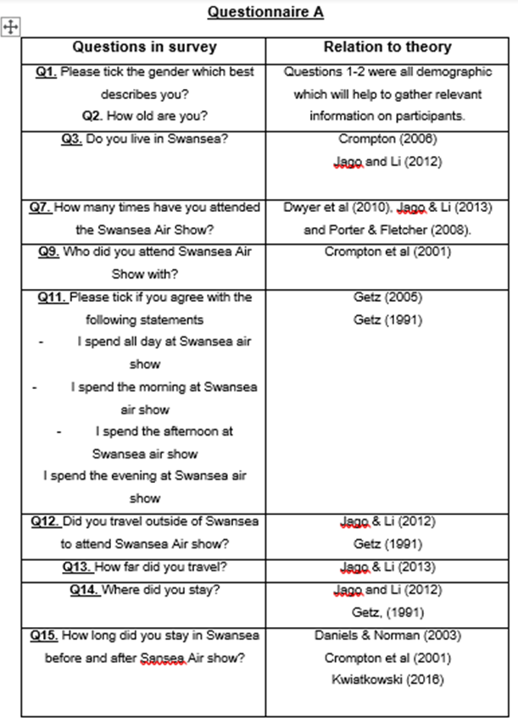
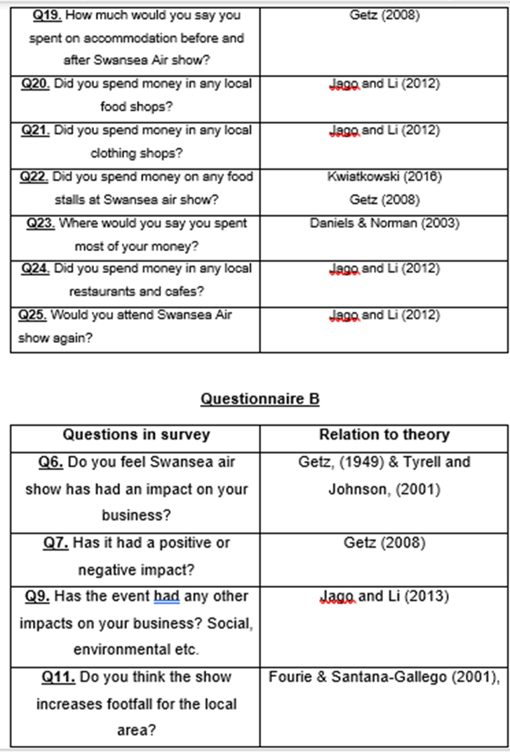
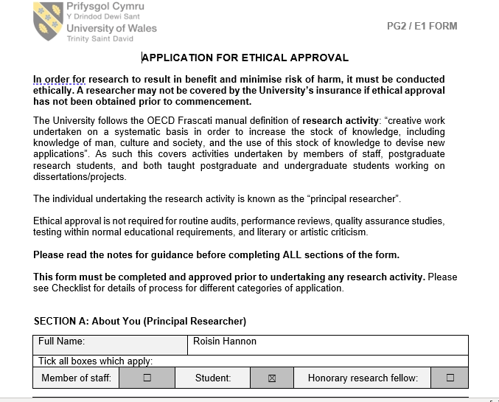
Appendix B – Ethics Form
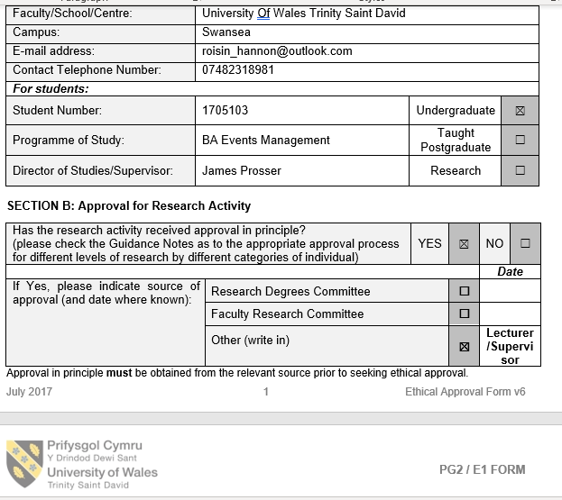
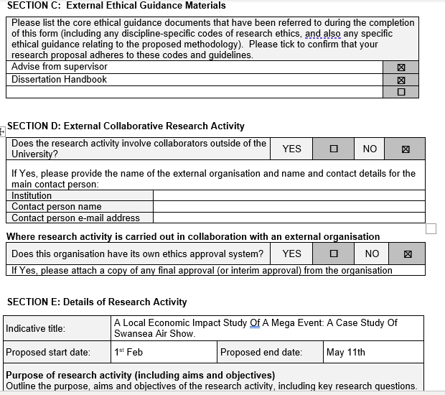
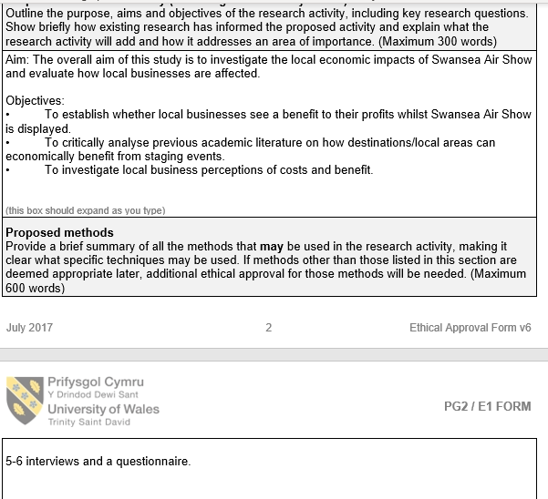
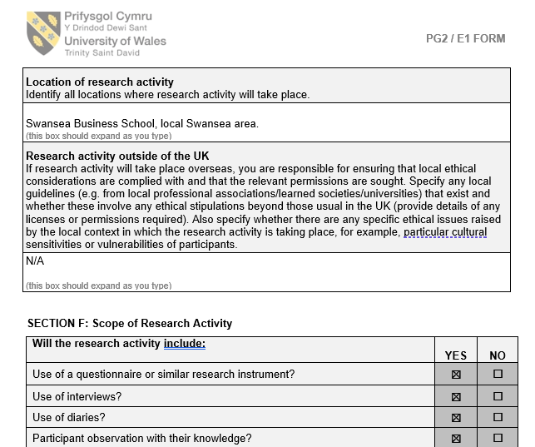
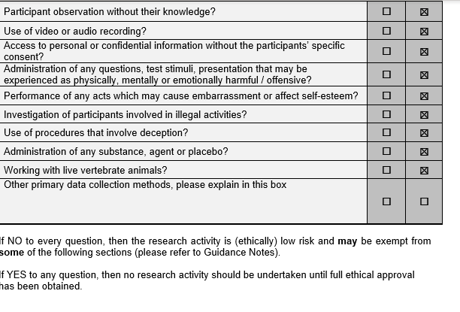
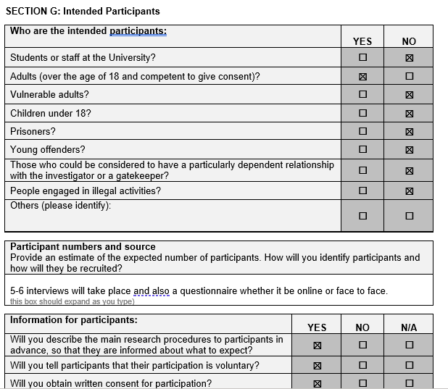
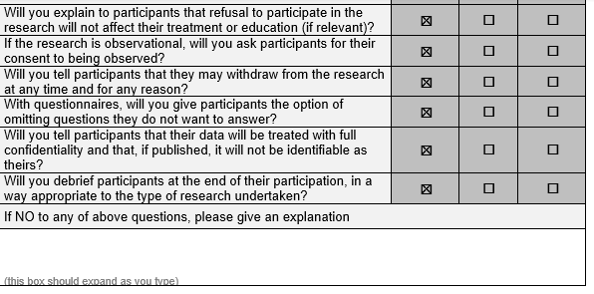
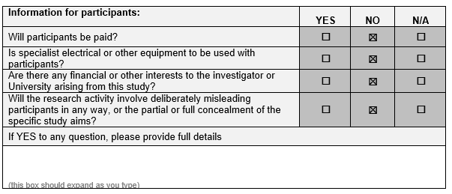
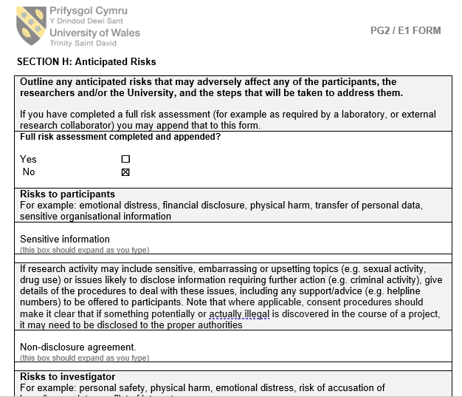
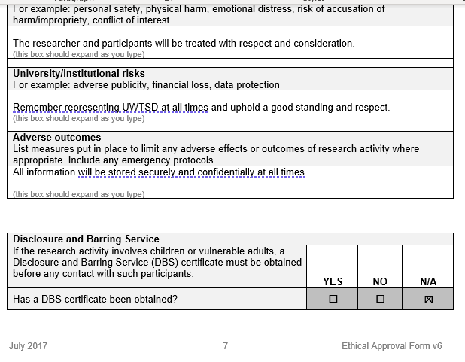
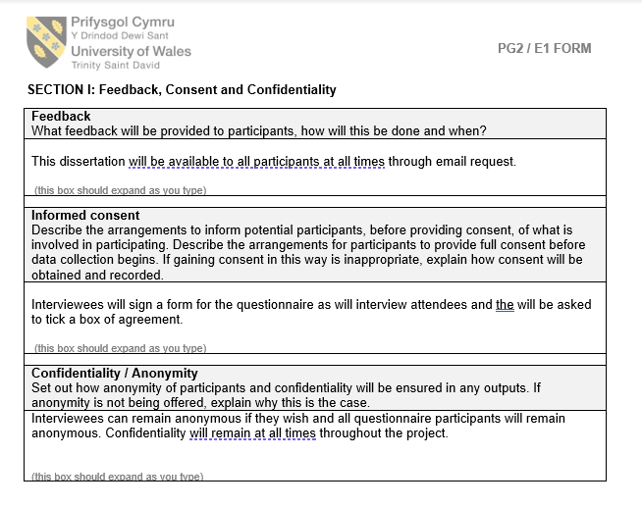
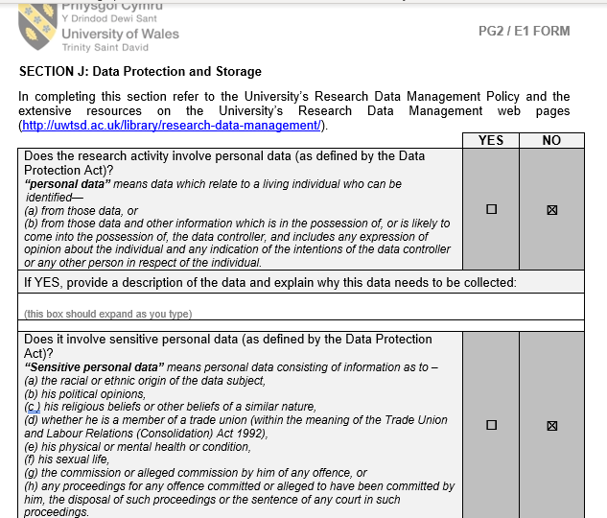
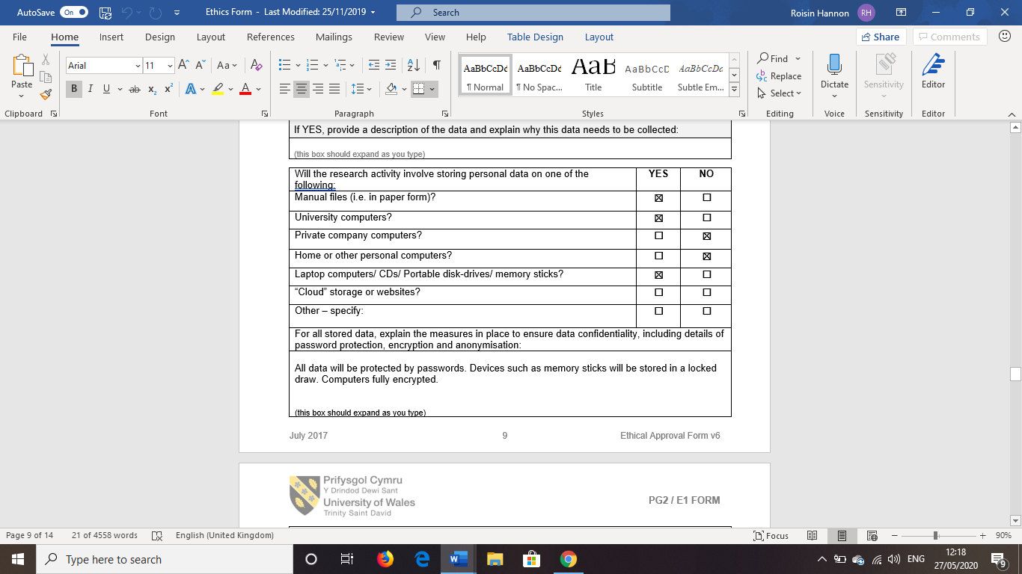
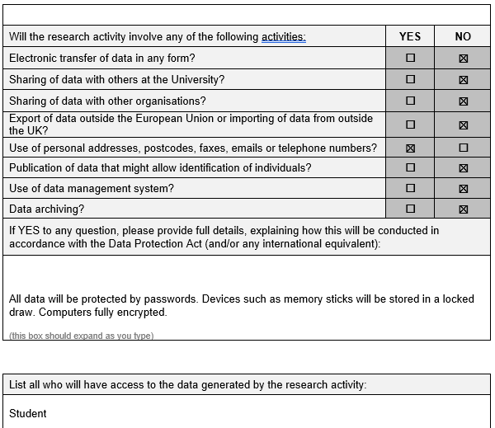
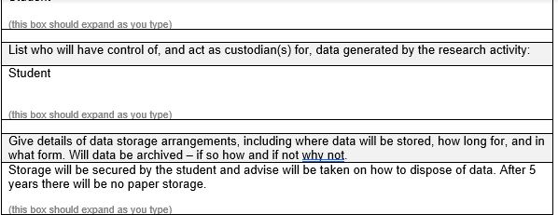
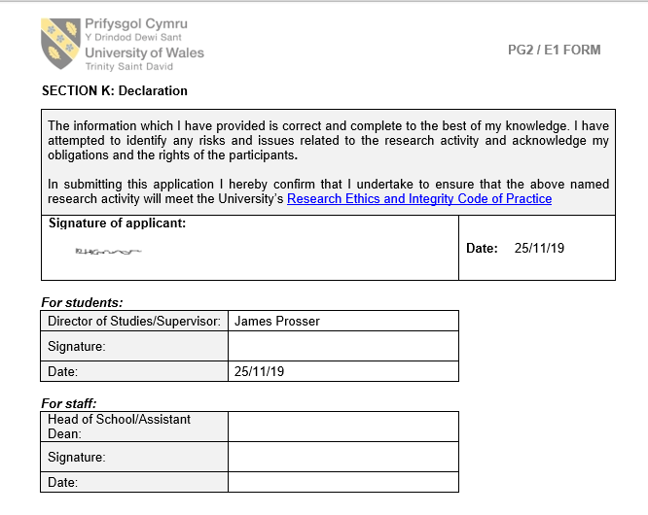
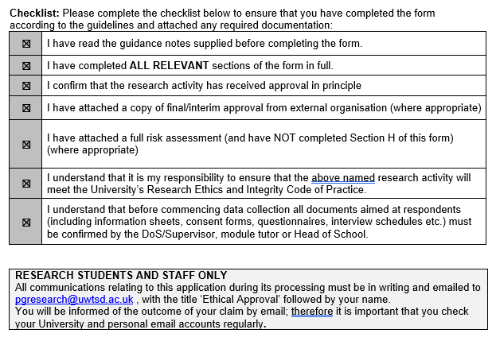
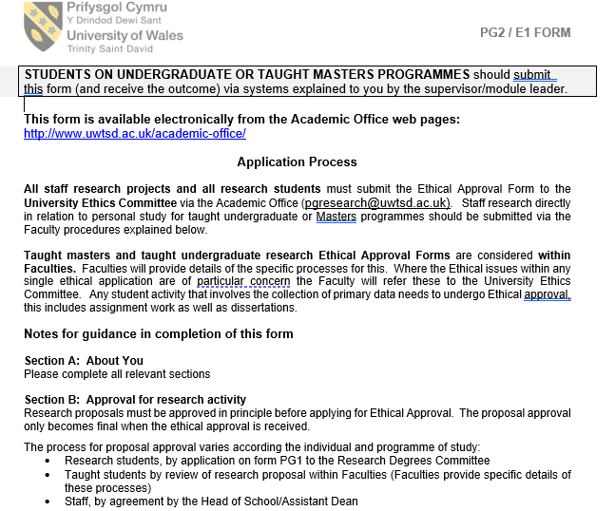
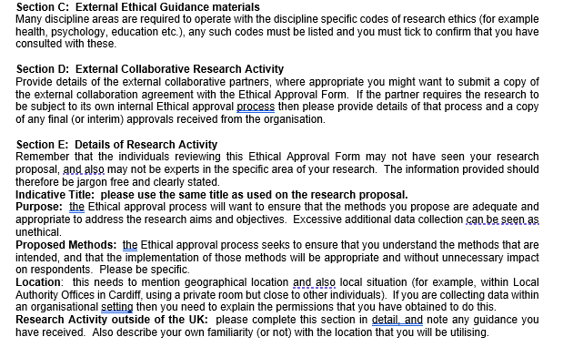
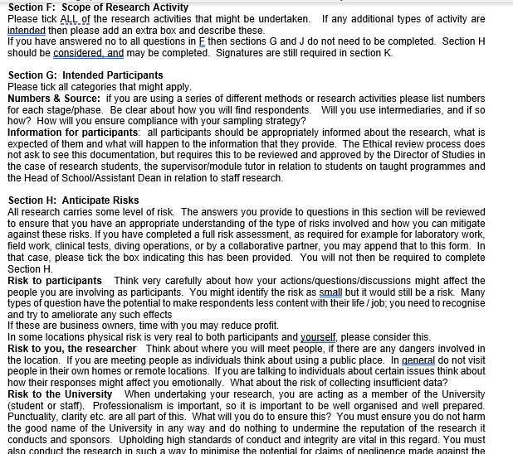
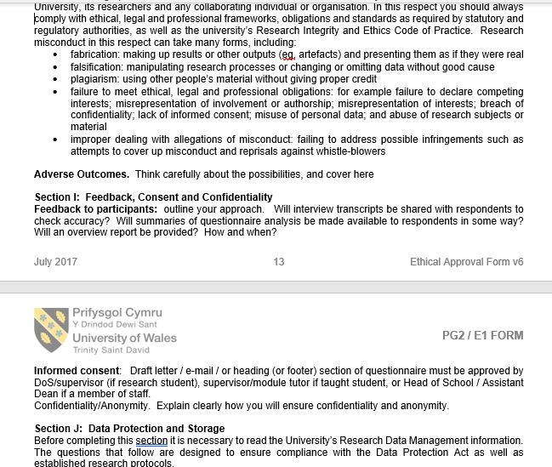
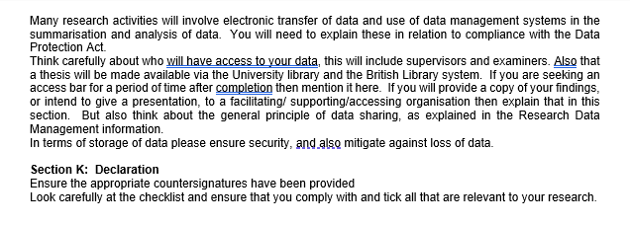

Appendix C – Consent to questionnaire
Questionnaire A: An investigation into the economic impacts of Swansea air show.
This survey will be aiming to critically investigate the economic impacts generated from Swansea air show.
This research is part of an undergraduate final year research study. If any participants wishes to contact me regarding the survey, please e-mail me at 1705103@student.uwtsd.ac.uk. A copy of the results can be found at www.roisinhannon.blogger.com from 9th March. Thank you for giving up your valuable time and participating in this survey.
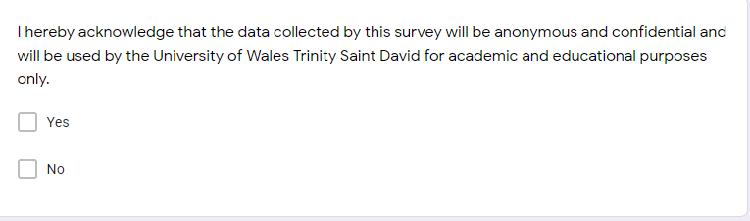
Questionnaire B:
This survey will be aiming to critically investigate the economic impacts generated from Swansea air show.
This research is part of an undergraduate final year research study. If any participants wishes to contact me regarding the survey, please e-mail me at 1705103@student.uwtsd.ac.uk. A copy of the results can be found at www.roisinhannon.blogger.com from 9th March. Thank you for giving up your valuable time and participating in this survey.
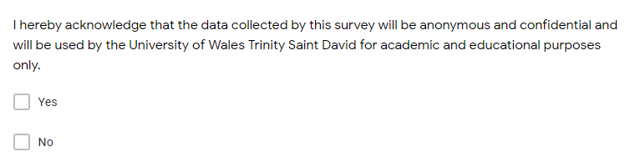

Appendix C – Questionnaires
Questionnaire A: An investigation into the economic impacts of Swansea air show: copy of online questionnaire.
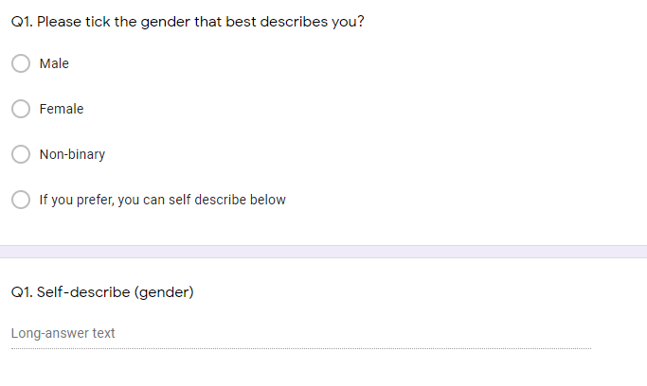
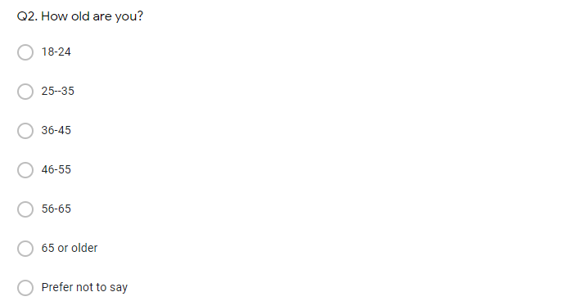
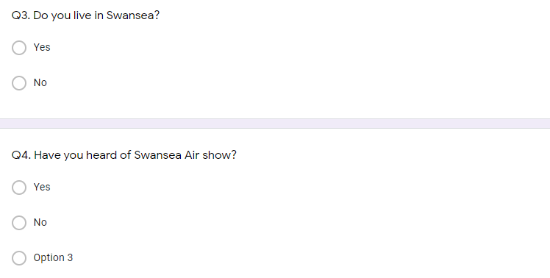
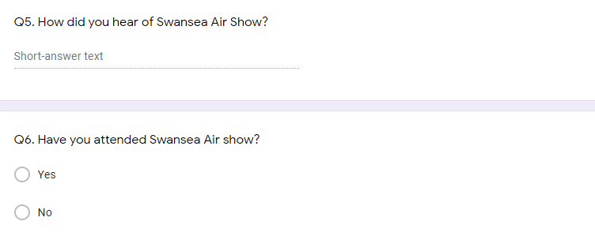
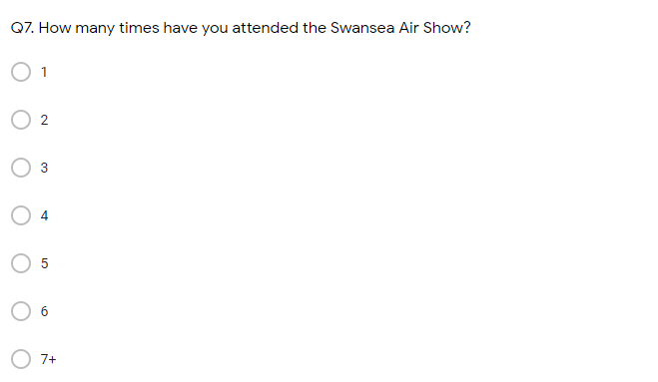
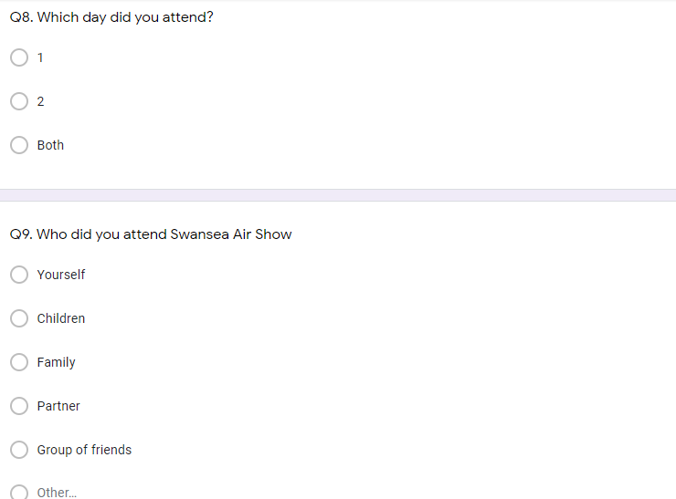
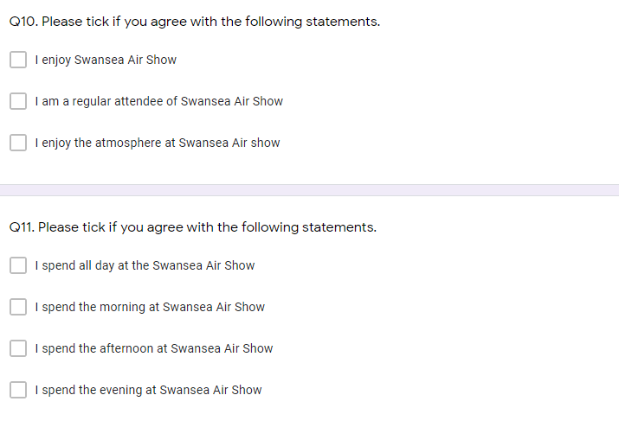
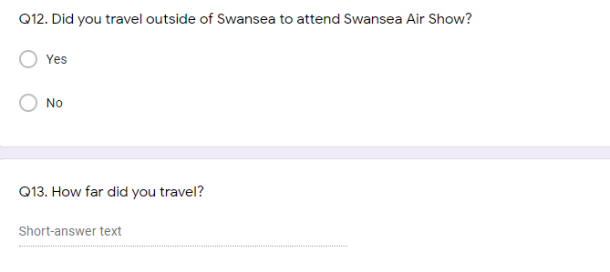
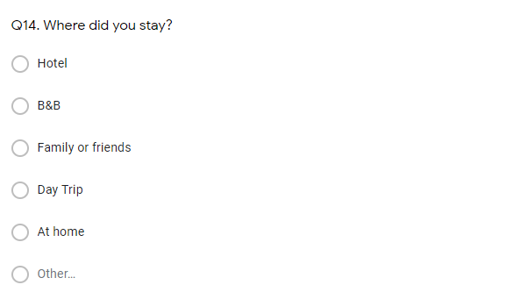
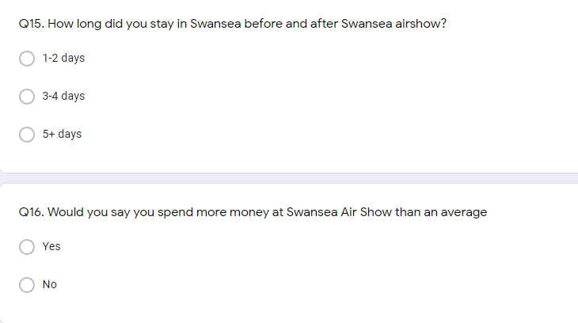
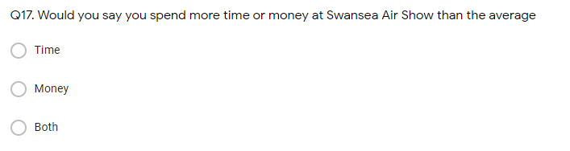
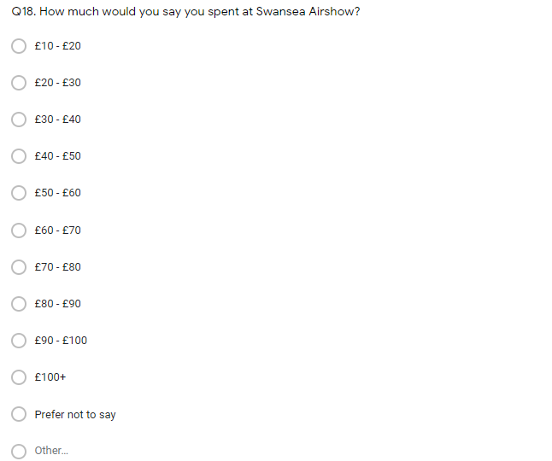
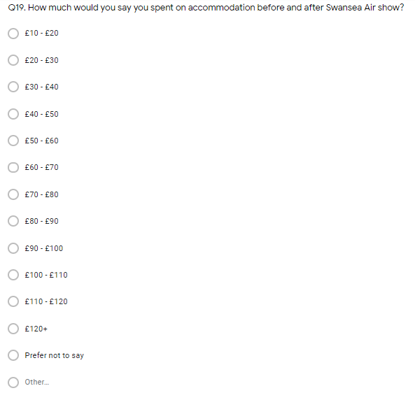
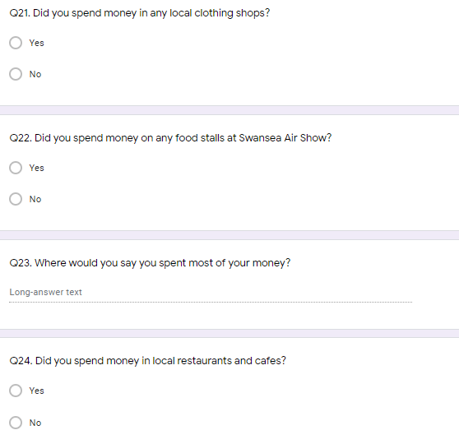
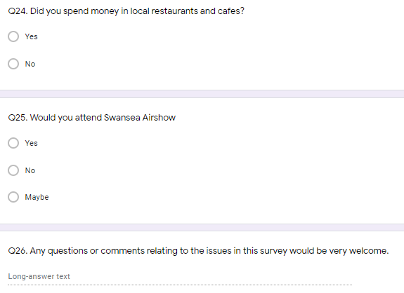
Questionnaire B: An investigation into the economic impacts of Swansea air show: copy of online questionnaire.
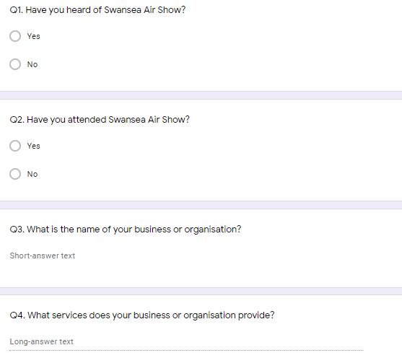
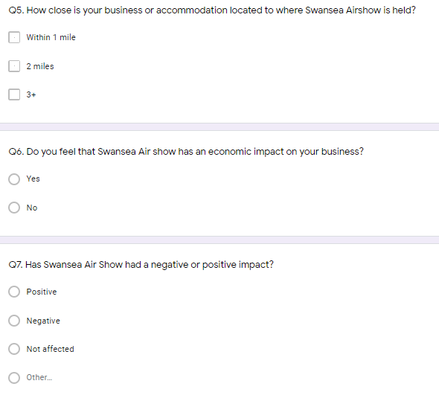
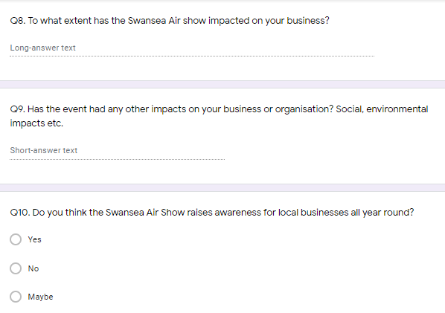
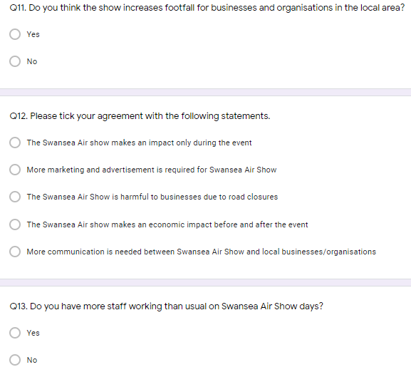
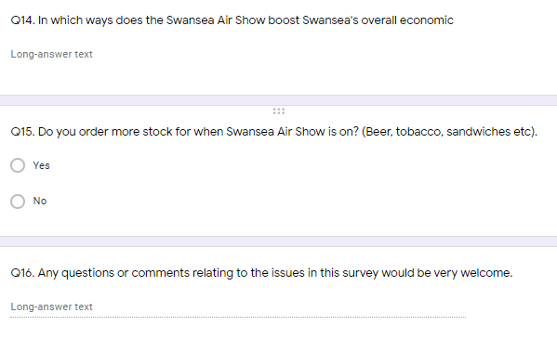

Appendix D - Gannt Chart


