Problem Solving and decision makings
Student Name: Shamim Uddin
Student ID: 1711212
Module tutor: Tanja Nathan

Executive summary
This report is prepared to solve a specific real-life problem. It is also made for the evaluation and implementation of a possible solution for that problem. It focuses on the problem of Subway Chadwell Heath Store based on the profit reduction of previous years and how the organization can find the solution of the profit reduction problem. Subway is one of the largest fast-food restaurant business in the world.
This report contains about the nature and reasons of the problem and these problems harmful effects to the business of Subway, and how to solve the problem with customers’ satisfaction, improvement of food production and distribution channel. Some technique and procedures have discussed to solve the problem.

Contents
Executive summary 2
Introduction 4
Identification of the problem 5
5W Model analysis: 7
SWOT analysis: 10
PESTLE analysis: 12
Potential solutions of profit reduction 14
Communicate proposed decision with the stakeholders 17
Plan for implementing the solutions 18
Monitoring progress for proposed decision 21
Conclusions 23
References 24

Introduction
The business organization is a legally created entity which is operated to achieve a goal by performing day to day business activities. This type of firms has a long-term objective to enhance shareholders and owner’s wealth (Brest, 2010). This organization can generate profit through customer satisfaction, improvement of the quality and reliability of goods and services. In this report, one store like Subway Chadwell Heath’s information is used to complete the report. Subway is one of the largest fast-food restaurant business across the world. Nowadays this franchise store is facing a huge problem of net losses. This report is preparing with a view to solving the problem and making decisions. Problem-solving is a process to solve a specific problem scientifically and generate alternative potential solutions to the problems. Decision making is also a process to select a course of action from the potential solution for the specific problem. This report is tried to complete depending on customer satisfaction and involvement, environmental and technological factors, and so on.

Identification of the problem
The restaurant business in the UK as well as in the world is growing very fast. This sector of industry is also very competitive. Many established organizations have lost its market share and competitive advantage. The Subway is one of the largest restaurant chain in the UK. In the previous years, it holds a large number of market shares. But the recent years it is faced huge losses for intense competition of the established firms and the newly formed entity. Many High-street stores of UK are shut down. So, Subway is needed improving its strategy, product diversification, customers satisfaction etc. It should concern about to ascertain competitive advantages and profit margin growth (Fitzgerald, 2009). Nowadays, its sales unit and sale revenue, and profit growth is declining. Its sale is reduced by average one thousand unit per margin. There are several problems for this types of results which are given below.

Inefficient inventory management and menu pricing:
Most the businesses are stopped due to the inefficient management. The owners of franchise restaurant business bear huge managing expenses. This cost is raised to protect unforeseen expenditures and supply shortage or overage (Forgang, 2011). Management uses inventory management and menu pricing to control waste and to analysis fluctuating costs. But in Subway, the inventory management and menu pricing are very poor. Its management can't control the inventory and menu properly. So its profit is reduced gradually.

Inferior customer service:
Customers are the most important element of any kind of business. No firms can run properly without customers. The first experience in buying goods is very significant. If workers deal with customers politely and intelligently, customers will keep in mind and they will want service from the same company in the future. The success of a restaurant business depends on the happiness of customers because it gives services to the respective customers directly. But the customer's satisfaction with the services of Subway is reduced gradually. So it loses its expected profit level

Reduces in sales growth rate and sales revenue:
In the UK, the restaurant business market becomes a very rivalry. There also comes a new restaurant business in the market (Hale, 2012). There are several major competitors of Subway. Recently it is experienced with huge losses in the previous years. Almost half of the stores in the UK is closed for net losses during years. Its sales growth is decreased. So its sales revenue is also declined as well.

Enhance in the cost of goods sold:
Cost of goods sold means the costs which are incurred to raise sale of company products. Nowadays this costs of Subway are growing gradually. These outcomes generate for its purchasing policy and procedures (Leonard, 2013). Subway purchases raw materials from its suppliers. It bears a huge cost to gather inventory. Subway has several distribution systems to sell products to the customers. This different distribution channel can raise huge costs for the company. Besides, this organization has huge carrying costs to bring inventory to go down and holding costs to carry a higher level of inventory.

5W Model analysis:
The five W’s is directly related to the five angle questions. It is simply used in problem-solving and decision making or information gathering. This model is very significant to prepare a report. According to this ways, a specific report is considered perfect if it answers questions which are started with some interrogative words (Linstone, 2014). Such as who, what, where, when, and why. This report is prepared for the profit reduction of the subway. This model provides the full information of the problem.

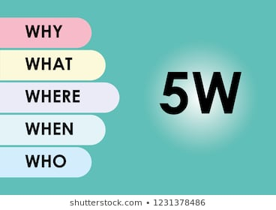
Figure: 5W Model Analysis
Source: (Zaraté, 2016)

5w | Considering the following questions | Answer the questions
Why: | - Why is so significant to reduce the problem?  - Why this problem has occurred?  - Why should the organization try to optimize it? | Profit is the main intention to run a business. Without profit a business can be imagined. This problem is occurred for inefficient inventory management and menu pricing, a rising cost of sales etc.
What: | - What material is used?  - What is the size of inventory?  - What is being presently done?  - What is the target for the future?  - What should actually be done to overcome this problem? | Only 6 inch or 9 inch Sub and Salad. The size of inventory is not so large. The future target is to increase the profit level for the branch. Appoint some skillful manager to overcome this problem. Presently the management tries to increase the level of efficiency for both management and worker.
Where: | - Where is the main problem of the firm to raise profit?  - Where has the primary impact of the specific problem?  - Where the new policy and procedures should be implemented? | To raise profitability, the organization faces many problems. It competes with some established firms and newly born restaurant. If the profitability margin is gradually decreased, the firm will be destroyed. There are many restaurant businesses in developed countries. Subway is a multinational firm. So it can implement new policy and procedures to third world countries to open branches.
When: | - When this profit reducing problem is started?  - When have the negative impact of this problem?  - When can the management implement new rules and regulations? | This problem is started some previous years. In 2018, many branches in the UK is closed for net losses. The management can implement rules and regulations at present to survive in the competitive market.
Who: | - Who is responsible for the problem?  - Who can set policy and procedures to avoid the problem?  - Who supervised the workers?  - Who will be the target customers of the organization?  - Who is involved in the respective process? | The top management is mainly responsible for the problem as they set policy and procedures to operate a business. The young people can be the target customers of this restaurant.

SWOT analysis:
SWOT analysis is a technique which is used to recognize strengths, weaknesses, opportunities, and threats. It is also used to solve the problem (Shapira, 2015). It reflects the internal and external factors of an organization. It analyzes the favorable and unfavorable factors to achieve organizations goals. Strengths and weaknesses focus on the internal factors and Opportunities and Threats focus on external factors. This following SWOT analysis describes strengths, weaknesses, opportunities, and threats to increase the profitability of Subway branch.

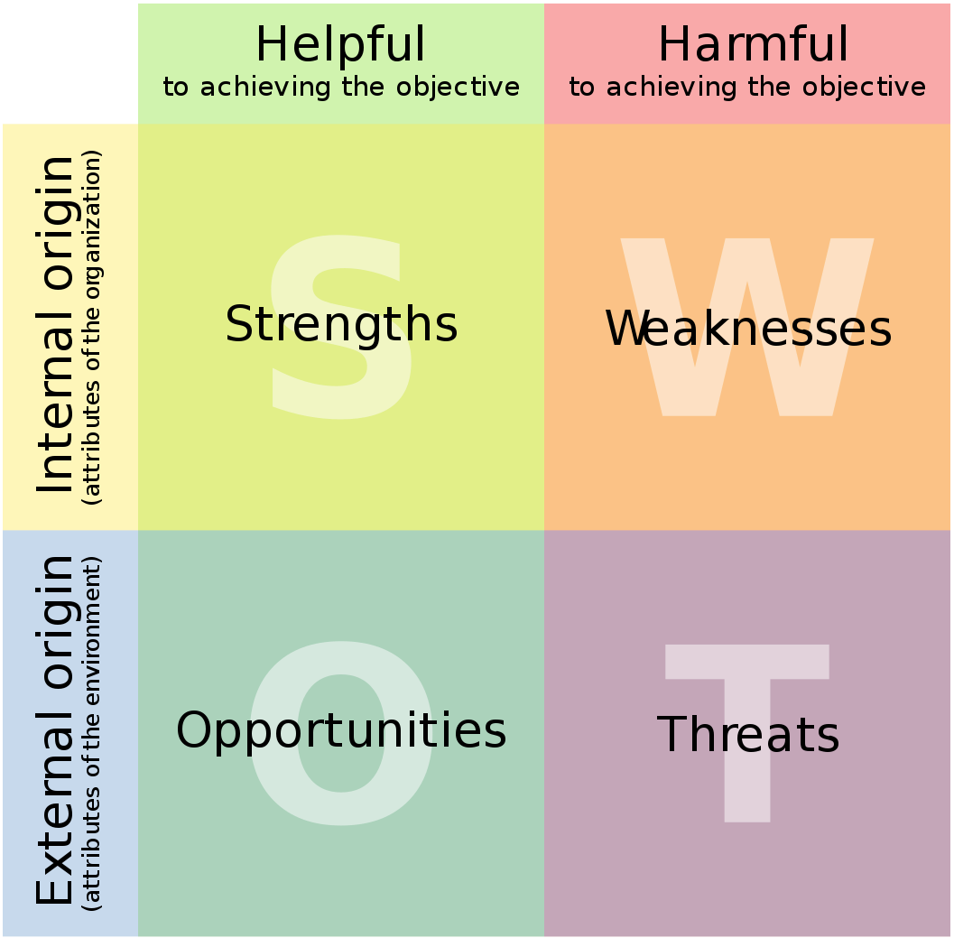
Figure: SWOT analysis
Source: (Cohen, 2017)

Strengths:  - Subway is the largest restaurant business in the UK, having 42,431 branches across the world and about one million skilled workers.  - Subway has a reputation for innovation, skilled workers, and efficient management for the production of submarine sandwich and salads.  - It has a strong production and distribution channel to serve order and services timely and cost-effectively to the respective customer.  - It has a worldwide goodwill for fast food and a brand of quality and reliability over the world.  - Subway has its own some physical assets like equipment, technology, customers etc. | Weaknesses:  - Subway produces only two categories of food. It does not change its production system to keep consistent with the tastes and preferences of the customers.  - It collects inventory from various suppliers. It is costly for Subway food production.  - Service distribution channels can't cope with modern technology.  - Subway has many franchise stores across the country. It is very difficult to connect all stores directly to the head office.
Opportunities:  - Subway is enabled to generate a reputation and goodwill across the world. It can easily expands its business quickly and take large market shares.  - Subway has many branches. It can order and buy a large size inventory from suppliers in order to reduce total inventory cost.  - It can utilize its innovation, technology, skilled workers etc. to produce fast food so that it can maximize productivity and profitability.  - Subway can add new categories of fast food in its food menu. | Threats:  - New restaurants are formed quickly in the competitive market. It is a large threat for Subway. This new entrance reduces the scope of Subway to operate it as monopoly business.  - There is no consistent and permanent of technology and innovation of food production within subway production channel.  - Since UK voted to leave EU, there will be different legislation.  - The inventory cost is rising quickly. So the production cost of Subway is also increased. It decreases the organizations’ profitability.

PESTLE analysis:
PESTLE analysis is used by the organization to trace environment issues. It is also a marketing technique (Doll, 2018). It provides information about the govt. from many angles to start a certain project. It focuses on external factors to prepare a strategic analysis or market research. It considers how the macroeconomic factors from outside affect the overall organization.
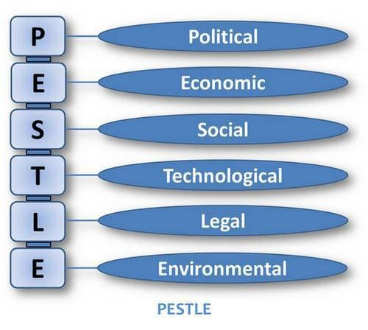
Figure: PESTLE
Source: (Kersner, 2012)

Political:
Political factor is concerned about government trespasses in the economy of a country. This factor involves tax policy, environmental law, trade restrictions, and other some policy and procedures. This factors have an impact on Subway and ascertain how this organization will be operated.

Economical:
Economic factors involves interest rate, exchange rates, inflation rate etc. These factors describe how Subway will operate and take decisions. The government can use these factors as a control mechanism of any business. These factors have a direct impact on Subway and its product and services (Deep, 2012).

Social:
Social factors describe various area about people’s belief and attitude. It includes cultures, career, attitudes, job safety, people age and growth rate etc. These factors affect the production of goods and services. The people of different countries have different tastes and preferences. For this regional tastes, Subway produces food according to local cultures.

Technological:
Technological factors include improvement of technology, development of production and distribution channel, research and development activities etc. This factors will be favorable or unfavorable. Subway should adapt its entire process with new modern technology. This organization operates the business in online and can give home delivery.

Legal:
Legal factors of an organization will affect both internally and externally (Deep, 2012). Subway has its own rules and regulations to operate business and govt. also publishes new policy and procedures to control business its own country. The rules of legal factors are consumer law, safety law, labor law etc.

Environmental:
Environmental factors are concerned with environmental and ecological aspects. This factors involves environmental regulation, climate and weather change, and so on. Subway should follow green business and reduces pollution and waste. This organization can use the recycling process for reproduction.

Potential solutions of profit reduction
Management of Subway restaurant wants to maximize its productivity and profitability as well as to increase shareholder wealth (Matte, 2015).Nowadays Subway faces several problems like a net loss, decreases profit etc. Management and shareholders are concerned about the problems. They want to reduce this problem. To discharge from this problem of Subway, the following alternative decision making technique can be implemented.

Decision making Technique within Subway:
Decision making is a process of giving an alternative solution to make appropriate course plan within the organization to achieve the desired goals. It is also a system of choosing a logical option from an alternative solution. For making good decisions, the decision makers should considers the positive and negative impact of choosing option (Fitzgerald, 2009). Subway can choose any technique for increment its profitability. Several decision-making techniques for Subway are given below.

Force filed Analysis:
For increasing the profit of Subway restaurant, this organization can implement force filed model analysis. This analysis is used to make difficult and challenging decisions. It can play a vital role in efficiency and effectiveness of decision making. This analysis is working with the analyzing the forces for and against a change (Forgang, 2011). Then all forces will be stored in a column to summarize scores and make decisions. This analysis can be applied by subways' management to maximize profits.
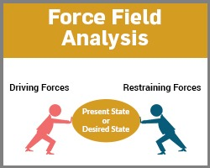
Figure: Force Field Analysis
Source: (Hale, 2012)
Implementation of Force filed analysis in Subway:
Force filed analysis is crucial decision technique of specific problem. Now the firm is facing the profit reduction problem in restaurant business. The objective of Subway should be examined. This organization would like to apply new policy in its whole operations. This change has some driving force and restraining forces that are stated in the analysis with assigning a score from 1 to 5 in which 1 is for weak force and 5 is for strong force.

Driving forces with Score:
- Improve fast food menu  - Develop production and distribution channel  - Advertising for restaurant and food  - Efficient restaurant management  - Employee and customer service | 4  3  1  3  4
 | 15

Restraining forces with score:
- Employees feared by improve technology  - Huge cost of new technology  - High cost for staff training and motivation  - Costs for new system implementation within organization | 2  3  3  5
 | 13

Based on the analysis, the driving forces are very strong in score than restraining forces for new process within the organization to maximize profit in Subway Chadwell Heath. So a change in management, food menu, customer services, and production and distribution channel will be implemented within Subway to maximize its profit. A new process should use to develop fast food menu and online for giving services to customers so that the customer can get real information faster. This technique can increase customer satisfaction with less effort. When the respective customers of Subway become happy with the service of management, the firms’ productivity as well as profitability will be maximized.

Fishbone Model:
Fishbone model is a technique used in problem solving and decision making. It is also known as cause and effect relationship. In this analysis, the management may evaluate the reasons of the defined problem. The management of Subway will not give appropriate solution of the problem. When we finish the diagram with cause and effect, the diagram will be turned into like a fish. In this model, several steps are followed to find the reasons of the problem which are described below.
- In the initial stage of fishbone analysis, the problem of Subway will be defined clearly. In this report is worked with the problem of profit reduction of Subway.
- The defined problem of Subway will be given in a rectangular box in the right side of diagram.
- Then a fishbone diagram will be drawn with the possible causes of problem under four problem standard sources like people, method, material, and machine.
- Under problem standard sources, the possible causes and effects of the problem of profit reduction should be stated.
- Every potential causes of the problem will be checked in angles of profitability, productivity, and other collected data.
Method
Material
Profit Reduction
Machine
People
Poor food production Channel
Inefficient material management
Few skilled worker to produce food
Fixed production machine
Insufficient Employee
Lack of motivation & staff service
Low food list in menu
Traditional Method
Material from supplier
Low production technology

Figure: Fishbone Model for profit reduction

Communicate proposed decision with the stakeholders
Shareholders are the owner of the business. They invest their wealth to establish a business. They also have the real interest in the business. Shareholders are primarily concerned with the business operations and its vision, mission, and goals. They want to maximize their resource within the business. Organizations’ productivity and profitability performance and shareholders interest are directly related. If the productivity and profitability of Subway increase, the shareholders’ wealth will be maximized gradually and vice versa. For smooth operations of organizations' activities, shareholders appoint management as an agent. They eagerly wait to know management decisions to overcome specific problems. Therefore Subways' management should communicate decision plan with the respective shareholders.
In this report, there is a crucial problem of Subway of profit reduction. This entity’s profit margin is decreasing during previous years. The sales level is reduced by about ten percent. Its profit level is also declined. Many branches of Subway is closed within five years. This fast food restaurant wants to increase its profit level.
The alternative solutions of profit reduction are stated in this report. There are many potential solutions of this type of problem for Subway to overcome this problem (Shapira, 2015). Various external and internal factors exist within the firm which has direct impact on decision making.
For the communication of the decision plan of Subway, the respective management can use presentation process to communicate because there are many ways for communication and the number of shareholder is huge. The presentation is a short time and an effective way of communication.
For presenting information to the shareholders, the presenter can use the slide, chart, graph, or any other figure. He /she may describe the reasons for the problem and present the best all alternative potential solution of the problem. He should discuss the specific solution of the problem to the shareholders and give an expectation to overcome the problem in the future. The presenter can also use some examples and data to avoid any hesitation of the shareholders.

Plan for implementing the solutions
Subway Chadwell Heath store can implement the solution of profit reduction. This organization should implement the solution step by step for maximizing the profit level and communicate the outcomes and strategies of the solutions to the shareholders. Identifying solutions for a problem is not meant to solve the problem (Zaraté, 2016). Subway should create a plan and procedure to implement the solutions of the problem within the organization.

Prepare a specific planning and preparation:
Plan is a concise diagram of a problem. It is also a proposal to solve a problem achieving organizational objects. Plan will be prepared for project processing, project timeline, staffing plan, project budget, new plan implementation etc. (Cohen, 2017). In this report Subway is faced a profit reduction problem during several years. It is lost a large number of market shares in the market. And productivity and profitability of Subway is decreasing gradually. We have already discussed some possible solutions of the problem in this report. For implementing these solutions, Subway Chadwell Heath store should prepare a specific plan to maximize its profit.

Defining clear objectives:
The organization should have clear and specific objectives to make a plan (Doll, 2018). Its intention is to maximize profit for the firm, gain large market share and competitive advantage. The organization will have the capability to implement the potentials solutions of the problems and it also have adequate resource and time. The management clearly defines the objectives of decision change for specific problem to the shareholders and other related parties who have interests in the organization. They work to keep a clear picture and plan in front of objectives to achieve the desirable goals.

Breaking the solutions down into tasks:
The main responsibility of the management of Subway is to make a plan to solve the profit reduction problem which have described already in this report (Kersner, 2012). They should break down the possible solutions into small tasks and implement it according to the time and situation of the organization. When the Subway breaks its activities into small works, then the works will be easy to implement and achieve the expected goals.

Allocating time and resource:
Time and other resources are very important for the Subway. This organization has huge resources of its own as it operates business for a long period of time. But the firm is not able to utilize this resource properly. The Subway is facing a profit reduction problem during some years. Proper plan implementation of a specific problem depends on how the organization implements the solution during an appropriate time frame (Deep, 2012). Though some activities take a long time for completion, Subway should allocate its production and distribution time in realistic time frame. To achieve the expected outcomes from new decisions technique, the management should allocate the resource according to the plan of implementing solutions.

Monitoring progress for proposed decision
Review technique and monitoring progress for proposed decisions are the part of implementation process of Subway. The degrees of management are not only make proper decisions for a problem but also review and monitor the implemented decisions techniques regularly. There are some steps of monitoring process for proposed decisions which are described below.

Develop a proper plan:
At first to monitor progress of a proposed decisions, the management should make a plan procedure (Matte, 2015). From monitoring progress Subway will be able to evaluate the actual outcomes of the proposed decisions. It should make a plan when the proposed decisions should be monitored like daily, weekly, monthly, quarterly, semiannually, or annually and how much resource will be spent for this monitoring. The resource of Subway which will be used in monitoring process are time, money, and human resource.

Evaluate outcomes and take corrective action:
Evaluating outcomes is a way to measure the outcomes of proposed decisions for Subway Chadwell Heath stores. The organization can evaluate and differentiated the outcomes of the proposed decisions with the previous system results (Perret, 2015). The management can take the corrective actions for the proposed solutions if they find any mistakes in the new decisions and solutions.

Comparing outcomes with other business:
Subway Chadwell Heath store can evaluate various outcomes from the implemented proposed decision with a view to comparing the outcomes with other business in same industry and different industries. If the results of proposed decisions are better than other business in the same industry, Subway can keep the proposed decisions with the organization.

Review and monitor progress regularly:
The review and monitoring progress of the proposed decisions should be monitored regular basis. They evaluate the outcomes of new technique and any other problems. The authority can implement findings and recommendation process from review to enhance its efficiency and effectiveness.

Performance auditing process:
Performance auditing is the process of evaluating outcomes of the decisions (Roberts, 2012). The lacking or any other problems can be identified through this audit. This performance audit can be done by the internal and external parties. The auditor prepares audit report after auditing and gives this report to the management to check monitoring progress.

Report to shareholders and authority:
Monitoring is a process of observation and recording of operations evaluating from the implemented new decision. Monitoring progress is a way of collecting information on the new project (Simani, 2018). The management of Subway should gather shareholders feedback to know their opinion about this proposed decision of profit reduction. The day to day review of newly implemented decisions will be reported to the other parties. These parties can be from inside the organization or outside the organization.

Conclusions
The primary purpose of carrying a business to maximize shareholders resources (Brest, 2010). An organization should follow long-term objects. There is a problem of Subway to face net losses during some previous years. But this problem is short-term period. This firm is operating for a long period with a reputation and goodwill. Subway may face some threats and challenges to overcome this profit reduction problem. In this report, the causes and reasons of profit reduction of Subway are stated properly. Subway is a large business enterprise. It has customer satisfaction, work experience, technological improvement, skilled human resources, and reputation. This organization can easily overcome this profit reduction problem. But some internal and external factors have crucial effect on the Subways' operations and activities. This report is kept away from any kind of plagiarism and grammatical errors or mistakes.

References
- ADAIR, J. (2019). DECISION MAKING ANPROBLEM-SOLVINGNG. [S.l.]: KOGAN PAGE.
- Brest, P. and Krieger, L. (n.d.) (2010) Problem-solvingng, decision making, and professional judgment.
- Fitzgerald, S. (2009). Decision making. Oxford, U.K.: Capstone Pub
- Fortgangng, W. (n.d.) (2011). Strategy-specific decision making.
- Hale, R. and Whitlam, P. (2012). Practical problem solving & decision making. London: Kogan Page.
- Leonard, B. (2013). Multidimensional decision making. [Bradford, England]: Emerald.
- Linstone, H. (2014). Decision making for technology executives. Boston: Artech House.
- Shapira, Z. (2015). Organizational decision making. Cambridge: Cambridge University Press.
- Zaraté, P., Belaud, J. and Camilleri, G. (2016). Collaborative Decision Making. Amsterdam: IOS Press.
- Cohen, H., Horak,, W. and Staley, F. (2017). Teaching science as a decision making process. Dubuque, Iowa: Kendall/Hunt Pub. Co.
- Doll, R. (2018). Curriculum improvement. Boston: Allyn and Bacon.
- Kersner, M. and Wright, J. (2012). Speech and language therapy. London: Routledge.
- Deep, K. (2012). Proceedings of the International Conference on Soft Computing for Problem Solving (SocProS 2011) December 20-22, 2011. New Delhi: Springer.
- Matte, J. (2015). The Art and Science of the Polygraph Technique. Springfield: Charles C Thomas Publisher, LTD.
- Perret, E. (2015). Radio Frequency Identification and Sensors. John Wiley & Sons.
- Roberts, J. (n.d.) (2012). Using Imperfect Semiconductor Systems for Unique Identification.
- Simani, S., Fantuzzi, C. and Patton, R. (2018). Model-based fault diagnosis in dynamic systems using identification techniques. London: Springer.

