MARKETING PLAN FOR HILTON HOTEL

Student name: Alexandra Andreea Anghel
Student number: 2226451
Module name: Marketing Essentials BMIH4005
Lecturer name: Luciana Suardi
Word count: 1307 words

Table of Contents
Introduction 3
Situation Analysis 3
5 C’s 3
Company – SWOT analysis of Hilton Hotel (Micro analysis) 3
Customers – Segmentation and Targeting customer profile 4
Competitors – Perceptual positioning map, Bowman’s strategy clock 4
Perceptual positioning map 5
Bowman’s strategy clock 6
Collaborators 6
Climate – PESTLE (Macro analysis) 7
Objectives 7
SMART goals 7
Strategy 7
Tactics 8
Marketing mix 8
Action 9
GANNT chart of marketing activities 9
Control 10
Conclusion 10
References 11
Appendices 13
Bowman’s strategy clock 13
GANNT chart 14
Figure 3 – GANNT chart 14
Appendix 2 - Slides of marketing plan 14

MARKETING PLAN FOR HILTON HOTEL

Introduction
The marketing plan will be based on detailed analysis of an organization and identification of a marketing opportunity or issue being faced by the company. The organization that has been selected for analysis is Hilton Hotel and the plan will be developed based on the SOSTAC framework, four Ps of marketing and Bowman’s Strategy clock. The micro and macro environment aspects of Hilton Hotel will be an important part of the report. The future actions that can be implemented by Hilton Hotel will be an important part of the marketing plan for understanding the activities that can be performed by the organization for solving the issue or using the opportunity.

Situation Analysis

5 C’s

Company – SWOT analysis of Hilton Hotel (Micro analysis)
Strengths –
- Hilton Hotel is a world-class hospitality organization.
- The customer base of Hilton Hotel is huge.
- The workforce of Hilton is satisfied as various benefits are provided to them (Alvarez-Risco, Estrada-Merino and Perez-Luyo 2020).

Weaknesses –
- The increase in workforce is providing pressure or revenues and profits of the hotel.
- Bad reviews provided by customers on social media have affected image of the hotel.
- The security issue and data breach faced by Hilton forced the company to pay 700,000 dollars as penalty (Binns et al. 2021).
Opportunities –
- Social media marketing of Hilton Hotel can be improved in future for using the platforms like Instagram, Twitter and Facebook effectively.
- Hilton has an opportunity of expanding its operations to the developing countries.
- Acquisitions and mergers can help Hilton to become a dominant player (Boğan 2021).
Threats –
- Legal cases faced by Hilton have provided threats to its image.
- High competition in the hospitality industry from a chain like Marriott International is a major threat faced by Hilton (Çalhan 2022).

Customers – Segmentation and Targeting customer profile
The customer segments of Hilton Hotel include the customers who prefer the services based on the unique experiences and ambience provided by the organization and the complementary services offered to the guests. The strategy of premium pricing is used by the hotel for targeting the high-profile upper class and business class individuals within the society. Differentiating strategy has been used by Hilton Hotel for developing its position in hospitality industry (Elsharnouby and Elbanna 2021).

Competitors – Perceptual positioning map, Bowman’s strategy clock

Perceptual positioning map
High price
Marriott
Sheraton
Hilton

Holiday Inn
Low quality High quality

Low Price
Figure 1 – Perceptual positioning map

Bowman’s strategy clock
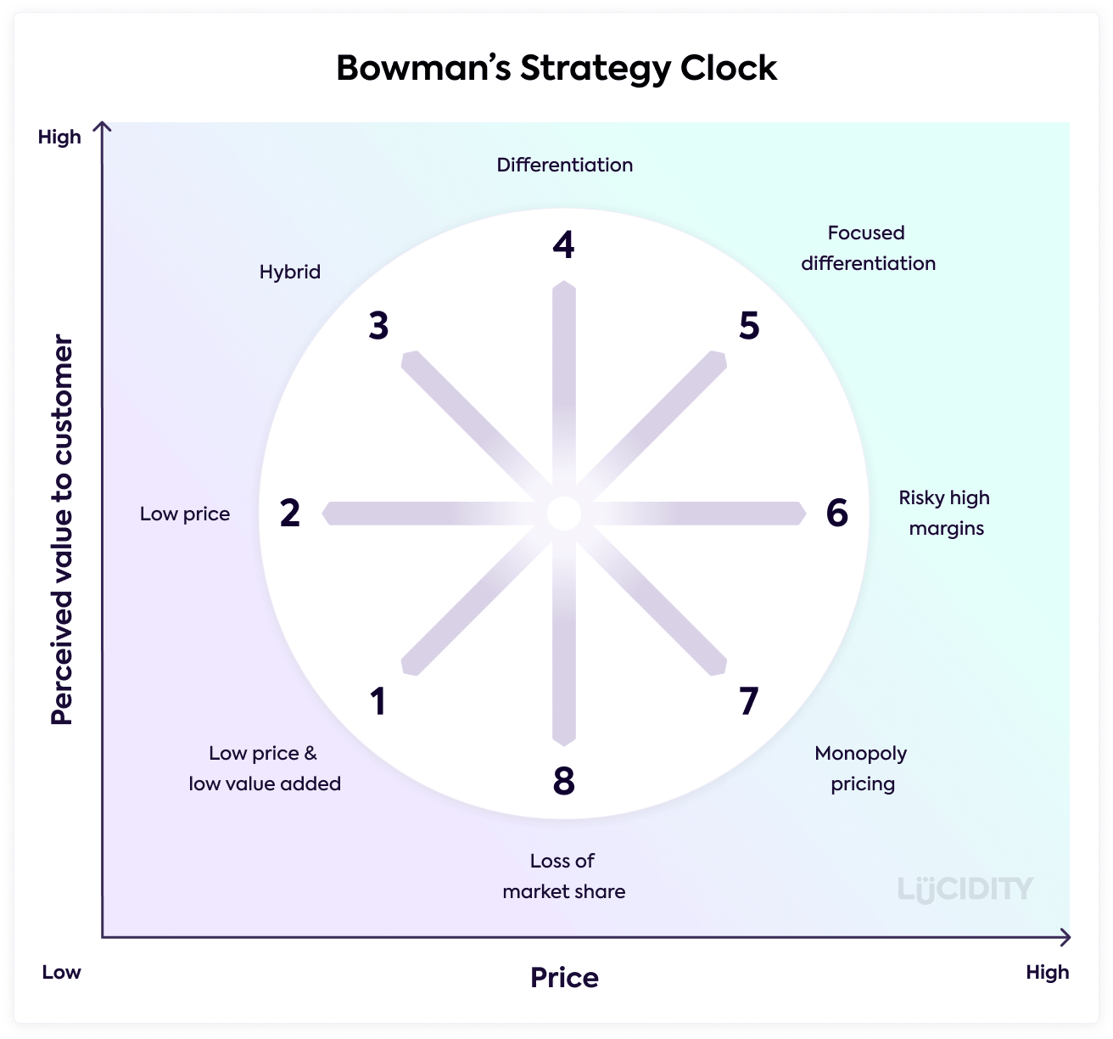
Figure 2 – Bowman’s strategy clock
Source - (Çalhan 2022)

Collaborators
The B2B relationships of Hilton Hotel are based on its partnerships with Embassy Suites Hotels and Doubletree. The e-commerce engine used by Hilton Hotel is related to the marketplace formed by the organization as a part of its partnerships. Hilton Hotel has owned, managed or franchised portfolio of the brands that include Conrad Hotels, Canopy, Hilton Garden Inn, Homewood Suites, Home2 Suites and LXR Hotels and Resorts (Guix and Font 2020).

Climate – PESTLE (Macro analysis)
Political factors | - Hilton Hotel has its operations in different countries and is exposed to the political risks.
Economic factors | - The factors like interest rates, growth rates and inflation rates in various countries can influence prices of the services of Hilton Hotel (Ikejimba 2022).
Social factors | - Social factors like lifestyle, consumer demographics and growth of population can affect the services of the hotel.
Technological factors | - Hilton Hotel has upgraded its technologies for enhancing customer experiences (Jones and Wynn 2022).
Legal factors | - Hilton Hotel needs to understand laws of different countries (Kim and Jang 2022).
Environmental factors | - Climate change can be a serious threat for the future operations of Hilton.

Objectives

SMART goals
SMART target – The aims of the marketing plan are related to developing future strategies for Hilton Hotels for using the opportunities of growth in developing countries, the future implementation of mergers and acquisitions for enhancing its position in the hospitality sector and improving the social media marketing activities of the organization (Reidhead 2020).

Strategy
The value proposition that is offered by Hilton Hotel is based on its prestigious reputation and the position that the organization had gained in the hospitality industry. The quality of services and the high-end customer experiences are also an important part of its value proposition. Hilton Hotel increased enhanced its international network and global reach in Europe, Africa, Middle East and Americas as a part of the value that it aimed at providing to customers in different parts of the world (Ristova and Dimitrov 2019). The huge brand portfolio formed by Hilton Hotel based on the high-end luxury, lifestyle brands and hospitality have an impact on the strategies being used by the organization. The targeting and positioning of Hilton Hotel can be influenced by the overall value proposition that has been developed by the organization and the high quality of services and international network that it formed in various parts of the world (Sharma and Sharma 2021).

Tactics

Marketing mix
Product – Hilton operates a large chain of the hotels that include restaurants, bars and restaurants and the hotels provide solutions for the business meetings along with the travellers. The rooms of Hilton Hotels have been developed with advanced amenities and modern diligence along with the drinks and food that are a part of the menus of the hotel (Singh 2022).
Place – Hilton Hotel is mainly engaged in deluxe experiences related to offering the luxurious services to customers in around 84 countries. Hilton provides open leverage to the various properties that are owned, franchised and managed under its brand name. The franchises and the establishments of Hilton Hotel near the airports are major channels that will be used by the organization in future for increasing its expansion (Yang, Henthorne and George 2020).
Price – The high-quality services that are being provided by Hilton Hotel based on the top-class amenities will be based on the premium pricing strategies will be effective for the organization to maintain its reputation and scale of services. The researchers and experts of Hilton Hotel have led to provided importance of premium pricing for offering four stars and the five star services being offered to customers (Kozhukhіvska et al. 2022).
Promotion – Hilton Hotel aims at implementation of unique promotional strategies for helping the organization to develop its effective position in comparison to its competitors. The highly-focussed staff and well-dedicated team of Hilton Hotel have been helpful in development of its marketing strategies. The feedback of customers that can be gained through social media platforms have been used for improving strategies of Hilton Hotel (Singh 2022).

Action

GANNT chart of marketing activities
The GANNT chart is mainly based on the personal selling strategies that can be used by Hilton Hotel for ensuring that the organization can increase awareness related to its services among the customers. The channels that can be used by the organization for reaching the customers faster have also been provided for ensuring success of Hilton Hotel in the future. The time periods that are provided in the chart are related to the timings of various activities that the organization can perform and can thereby enhance its success levels and position in the hospitality industry in future.
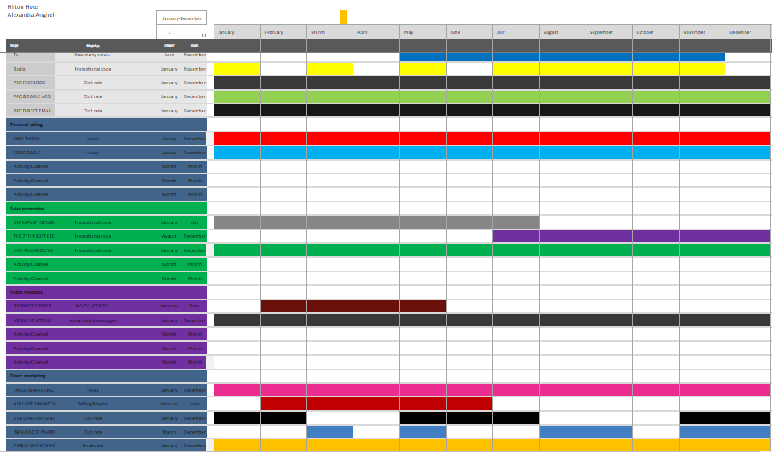
Figure 3 - Action Gannt Chart

Control
The success of Hilton Hotel in the future can be examined by analysing the increase in number of customers in different parts of the world. The increase in profits and revenues of the organization can be analysed and moreover, Hilton Hotel can aim at examining the feedback provided by customers to understand their attitudes towards the brand (Jones and Wynn 2022).

Conclusion
The challenges that can be a part of the marketing plan are mainly related to the financial resources that are required for expansion in the other countries and investments needed in promotional activities. The marketing plan can be concluded by stating that an international organization like Hilton Hotel can improve its profitable position in the hospitality industry by improving its promotional activities and expanding its operations in the developing countries.

References
Alvarez-Risco, A., Estrada-Merino, A. and Perez-Luyo, R., 2020. Sustainable development goals in hospitality management. In Sustainable hospitality management (Vol. 24, pp. 159-178). Emerald Publishing Limited.
Binns, C.A., Kempf, R.J., Binns, C.A. and Kempf, R.J., 2021. What Is Home Sharing in Relation to the Hospitality Industry?. Safety and Security in Hotels and Home Sharing, pp.11-14.
Boğan, E., 2021. A review of prominent theories in perceived CSR-employee outcomes link in hospitality literature. Journal of multidisciplinary academic tourism, 6(2), pp.99-105.
Çalhan, H.A.R.U.N., 2022. Accommodation Sector Innovations during the Covid-19 Pandemic: A Conceptual Review. Seyahat ve Otel İşletmeciliği Dergisi, 19(3), pp.565-577.
Elsharnouby, T.H. and Elbanna, S., 2021. Change or perish: Examining the role of human capital and dynamic marketing capabilities in the hospitality sector. Tourism Management, 82, p.104184.
Guix, M. and Font, X., 2020. The Materiality Balanced Scorecard: A framework for stakeholder-led integration of sustainable hospitality management and reporting. International Journal of Hospitality Management, 91, p.102634.
Ikejimba, O., 2022. Corporate Social Responsibility in Hospitality Industry: A Humanistic Perspective. In Humanistic Perspectives in Hospitality and Tourism, Volume II: CSR and Person-Centred Care (pp. 247-268). Cham: Springer International Publishing.
Jones, P. and Wynn, M.G., 2022. The Circular Economy and Natural Capital in the Tourism and Hospitality Industry. Circular Economy, 1(1), pp.1-13.
Kim, M. and Jang, J., 2022. The effect of physical environment of the employee break room on psychological well-being through work engagement in the hospitality industry. Journal of Human Resources in Hospitality & Tourism, 21(2), pp.175-196.
Kozhukhіvska, R., Sakovska, О., Maslovata, S., Dluhoborskа, L. and Chuchmii, I., 2022, June. Managing innovation in tourism and hospitality industry: International experience. In AIP Conference Proceedings (Vol. 2413, No. 1, p. 040007). AIP Publishing LLC.
Reidhead, C., 2020. Impact of organizational culture on employee satisfaction: A case of Hilton hotel, United Kingdom. Journal of Economics and Business, 3(1).
Ristova, C. and Dimitrov, N., 2019. Digitalisation in the hospitality industry-trends that might shape the next stay of guests. International Journal of Information, Business and Management, 11(3), pp.144-154.
Sharma, J. and Sharma, A., 2021. The A REVIEW ON THE HOSPITALITY INDUSTRY. Turkish Journal of Computer and Mathematics Education (TURCOMAT), 12(14), pp.6034-6038.
Singh, A., 2022. The effect of hotel brand affiliation on commercial mortgage loan underwriting in the lodging sector. International Journal of Hospitality Management, 102, p.103150.
Yang, L., Henthorne, T.L. and George, B., 2020. Artificial intelligence and robotics technology in the hospitality industry: Current applications and future trends. Digital transformation in business and society: Theory and cases, pp.211-228.

Appendices

Bowman’s strategy clock
Figure 2 – Bowman’s strategy clock
Source - (Çalhan 2022)

GANNT chart

Figure 3 – GANNT chart

Appendix 2 - Slides of marketing plan




