Students are required to consider an issue that impacts upon young people in today’s society, and design a programme of activities which addresses this this issue. The programme should take into account young people’s needs and interests, and needs to reflect the purpose, principles and values of youth work.
Introduction
This programme will focus on an issue facing young people in todays society, the issue being vaping. The writer has identified this as an issue from observation and reading/research. The writer is informed on the dangers of vaping on people’s health and has chosen to address this. The writer has taken into consideration that this programme should be the needs of young people but has put forward an argument as to why this programme is important for young people. The number of people vaping in todays society is increasing daily. BBC news has stated that there were seven-hundred thousand people vaping in 2012, this has since then grown significantly to just under three million people vaping in 2017 (2017). Vaping is seen as a good thing amongst society today as it is ‘Healthier than the dreaded smoking’ (totallywicked, no date on page). Further research into the effects of vaping on a person’s health has been done by the writer and they have identified that the term ‘Healthier’ is not a hundred percent accurate and thus the programme of activities will inform young people of these dangers.
Current government policy
In the year of 2015 the law was changed to the sales and distribution of e-cigarettes (Archie, No date on page). As of 2015 it is illegal to sell e-cigarettes to minors, this only came into effect eleven years since the first modern e-cigarette was created. In the last three years vaping has been given the same rules and regulations as regular cigarettes. With the law in place for the selling of e-cigarettes to minors being illegal, a minor purchase an e-cigarette is not considered a crime. The supplier on the other hand can face a maximum of a two and a half thousand pound fine (Quinton, 2017).
There are a few rules enforced with regards to the e-cigarettes themselves. In the UK the largest e-cigarette purchasable legally must have a tank no bigger than two millilitres. The purchasing of refillable liquid is limited to ten-millimetre bottles per person. Nicotine can be put into e-cigarettes if it never crosses the twenty milligram/millimetre mark (SHA, 2018).
A law passed recently in 2018 stated that vaping whilst driving is illegal. If caught vaping whilst driving the driver could receive a hefty two thousand five hundred pound fine or lose their license completely. Smoking cigarettes in a car as of this year is now illegal when a minor is present in the vehicle and can lead to a fifty pound fine. This law is in place, but it does not apply to vaping yet. Although the use of e-cigarettes is banned whilst driving due to the distraction of visibility you can not be fined for vaping with a minor in the vehicle (Smith, 2018).
To link the programme of activities with current government policy the writer will use a quiz and visual games to enable the young people to identify what is true or false with vaping and the law. These games will be updated to the latest law changes to ensure the young people are up to date and understand what is in place to ensure young people understand their rights and the rights of others.
Outcomes for young people
The outcomes and benefits for young people engaging in this programme of activities has been identified by the writer only and as such this could cause bias and could prove to be inaccurate. These outcomes and benefits include, but are not limited to, are as follows;
- Understand the dangers of vaping
- Understand current laws on vaping
- Consider quitting (If currently vaping)
- Enhanced emotional competence
- Active participation
- Skills development (WAG, 2007, p.7)
As seen from the list above the writer has identified the outcomes and benefits of the programme of activities and the focus being understanding the dangers of Vaping. Informing young people is the most powerful tool a youth worker has, this is supported by Sir Francis Bacon who quoted “ipsa scientia potestas est” (1597) which translates to “Knowledge itself is power”. With knowledge young people can use this knowledge in every day life. The young people can use their knowledge to inform others of the dangers and health risks caused by vaping. The programme of activities will cover all the five pillars of youth work as seen below (WLGA, 2018).
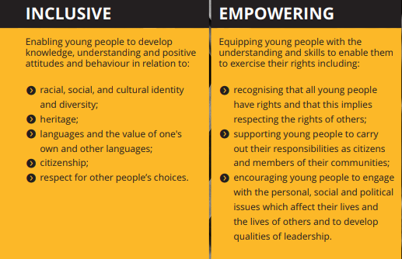
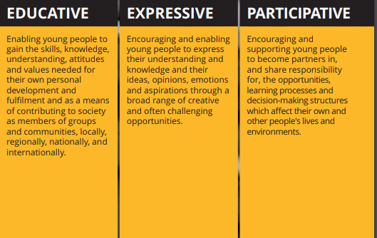
Figure 1: THE FIVE PILLARS OF YOUTH WORK IN WALES, (2018)
Educative:
The programme of activities will be a means to educate the young people on the dangers to health through a variety of methods. The young people will be able to create a device to visually see the dangers to a person’s lungs when vaping for a month (Notap, 2018). The programme of activities will inform them as to current government policies around the area of vaping.
Expressive:
The programme of activities will come at the topic of vaping with an anti-vaping approach. Participants will include smokers, vapers and people who do not divulge in such activities. The programme is not to condemn those who wish to continue smoking or vaping thus allowing them to express their opinions on the subject. The writer is a non-judgmental and understanding individual and will encourage those who do vape or smoke to share their experiences and reasons for doing so.
Participative:
All participation will be voluntary and there is no obligation to complete the entire programme of activities if they do not wish to.
Inclusive:
The programme of activities will be available to anyone who wishes to participate. The writer considered a target audience of smokers and vapers but understands that including those who do not partake in such activities could provide them with an insight to the dangers and make an informed decision if they wish to participate in vaping in their lives.
Empowering:
The programme of activities will be very informative to the participants and will allow them to understand their rights regarding vaping. The participant involved will be able to understand current laws in place to protect them such as the use of cigarettes and e-cigarettes in vehicles, they will be able to exercise their rights and if needed help in doing so the writer will support them.
Methods
The writer has done research into the three different types of methods used when researching. These methods are Quantitative, qualitative and mixed methods (Williams, 2018). As the name suggests mixed methods is the use of both qualitative and quantitative methods.
Quantitative is the more formal approach to gathering information. Quantitative methods consist of the use of questionnaires or surveys. The writer prefers to avoid this method of approach when researching due to the formality stigma that comes with it. Questionnaires are not effective for gathering accurate data for numerous reasons. The main reason questionnaires are not the most effective in gathering data is the lack of conscience responses (2016). Young people’s minds are constantly active (Mindful Staff, 2011) with their minds constantly thinking. The young people will have been in school all day being forced to learn in a formal environment meaning they would prefer to avoid this in youth clubs. Differences in understanding or misinterpretation plays a major role in the disadvantages of questionnaires. A questionnaire is created to primarily gather the data researchers want for statistical evidence, this means the questions could be read wrong and provide inaccurate answers.
Qualitative methods are the less formal approach and is favoured by the writer. This approach is more of an observational method to gathering research and less paperwork. When doing qualitative methods, the researcher must be aware of the Hawthorne effect (2018). The Hawthorne effect is the changing in behaviour when aware of being observed. The writer has done research into the Hawthorne effect and alongside this has researched into Handling the Hawthorne effect: The challenges
surrounding a participant observer (Oswald, Sherratt and Smith, 2014). With this research complete, the writer will be able to minimise the effect that the Hawthorne effect will have on the programme of activities.
Personal strengths and weaknesses
Strengths | Weaknesses
Non-Judgmental | Bias against Vaping
Informed | No first-hand experience with vaping
Experience in quitting smoking | Time
Social group consisting of people who vape | Unsure weather this is the needs of the young people
Understanding | Anti-smoking/vaping
Anti-smoking/vaping
Table 1: Strengths and Weaknesses of leading the programme of activities, (2018)
The writer has identified their personal strengths and weaknesses to delivering this programme of activities. In Table 1 the writer has highlighted a key point which could affect the outcome of the programme. The writer has a strong Anti-smoking/vaping stance in this topic, due to this view on the topic it will cause the programme to be bias and very much anti vaping.
The writer identified a key point being that they are unsure weather this is the needs of young people. All youth work should be peer led and promoting empowerment amongst the young people (WLGA 2018). The writer argues that choosing this topic for them is required. Without extensive research people do not understand that vaping is not beneficial to a person’s health. A common misconception is that where the National Health Service promotes the use of e-cigarettes. This common misconception is due to the lack of further reading, the National Health Service states that ‘you should be using e-cigarettes as a tool to gradually reduce and then quit nicotine, rather than as a long-term alternative to smoking tobacco’ (2018).
The writer has noted that one of the strengths they are able to provide to this programme of activities is the experience in quitting smoking in the past. With previous experience the writer will be able to provide strategies that worked for them. The writer has noted that they have never used an e-cigarette before and never intends to, meaning they are unable to understand the addiction level of e-cigarettes and potentially unable to provide effective strategies for quitting.
Partnership
The writer has identified that ensuring partnership is difficult within this topic area. As stated above most organisations promote vaping, alongside these organisations the UK government is promoting the use of vaping (2017).
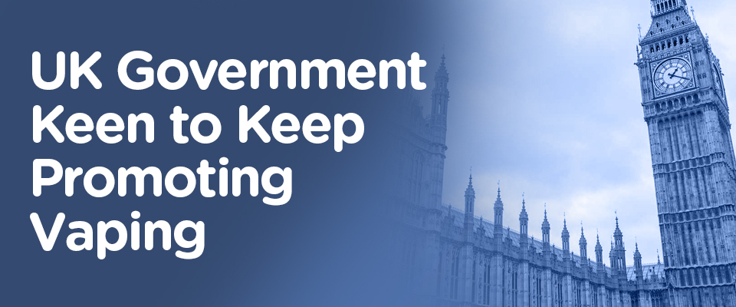
Figure 2: UK Government Keen to Keep Promoting Vaping, (2017)
With the promotion of vaping it will be difficult for the writer to gain interest from young people to participate as they could potentially see it as a good thing since the government frowns upon the use of cigarettes and promotes the use of e-cigarettes.
The promotion of vaping is not amongst all organisations and some only partially promote such as the National Health Service. As mentioned previously the National Health Service promote vaping to quit smoking completely and not to use it as an alternative (2018). The writer would like to get a guest speaker involved from the National Health Service into the programme to present their vast knowledge on the dangers of Vaping. The writer will contact the World Health organisation and inquire about partnership to run the programme as it is stated that ‘The World Health Organization is officially against e-cigarettes’ (2014). The writer believes that with the assistance of these large organisations that the message of the dangers of vaping will be conveyed effectively to the young people from a reliable source.
An American organisation the writer would like to use for partnership called Know The Risks (No date on page) are of a anti-vaping approach. Know the risks is an organisation of researchers who understand the dangers of e-cigarettes on people’s health, especially amongst young people. The researcher understands that partnership oversees can be difficult because of distance and time zones meaning a guest speaker from this organisation could only happen over a video call. The writer intends to contact Know The Risks and ask for as much information as possible on the dangers to a persons health from vaping. Know The Risks website has an incredibly powerful video on their homepage in which the writer intends to show all the participants.
Monitor and evaluate
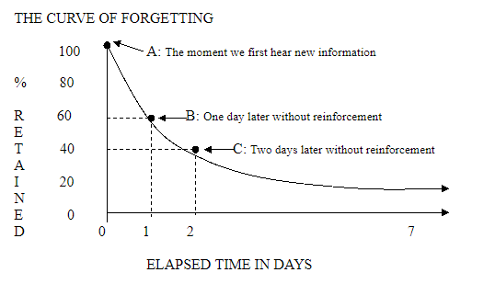
The writer has decided to use a pre and post evaluation method to monitor the young people’s knowledge and effectiveness of the programme. Active observation will be used throughout the whole process. In the writer’s opinion, active observation is the most effective way to monitor young people’s progress. Feelings and emotions are crucially important to monitoring young people’s feelings and knowledge in any field. Feelings and emotions can be conveyed through facial expressions, body language and even tone of voice. It is proven that feelings effect peoples learning, negative feelings hinder your learning potential whereas positive feelings promote learning and enable you to retain information more effectively (1994). Monitoring will be done regularly to ensure the successfulness of the programme. Drawing upon The Ebbinghuas Curve theory (1885) the writer has identified that the programme should be regular and thus monitoring can be consistent.
Figure 3: The Ebbinghuas Curve, (1885)
Pre and post evaluation are the best way for researchers to provide statistics to support their programme. Pre and post evaluation can consist of questionnaires, semi structured interviews and focus groups. The writer will not be using questionnaires due to the dislike of using them, on the other hand the writer will use a questionnaire to form a quiz to monitor progress. The quiz will be done at the beginning of the programme of activities to understand the participants current knowledge in the subject area. The quiz will then be used on the last day to note their progress on paper and be able to compare statistics to see the effectiveness of the programme. The quiz will be made fun and interactive for the young people who participate in the programme.
Challenges
The challenges facing this programme are minimal. The biggest challenge of this programme is the partnership of other organisations. The National Health Service is pro vaping over smoking and thus can be hard to make the young people gain interest in the subject area. With the programme of activities having an anti-vaping approach this could be viewed as a pro smoking approach as organisations such as the UK Anti-tobacco campaigning group, Public Health England and Juul are all approaching the issue of smoking worldwide using e-cigarettes. Majority of people understand the dangers of cigarettes and wish to eliminate this problem when asked and for the writer to condemn the use of e-cigarettes this goes against these large organisations and a portion of the public.
Another challenge which faces all youth work environment is participation. Stated in the National occupational standards of Youth work (2012), participation from young people is all voluntary. The writer will have spent time creating these sessions and contacting outside organisations and without a definite number of young people participating organisations will not spend time being guest speakers.

Appendices
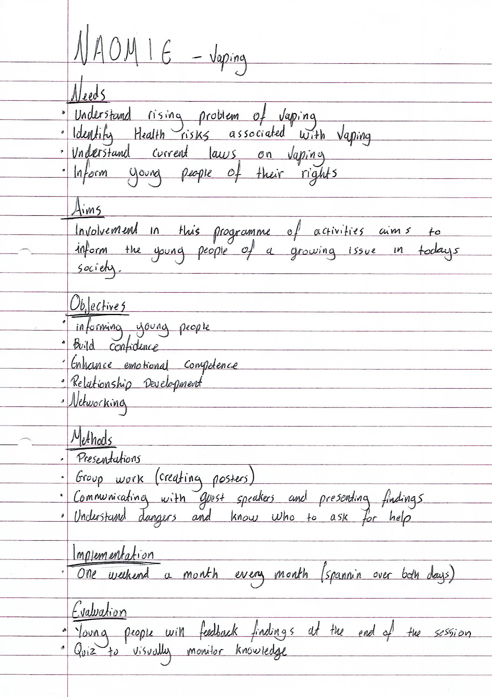
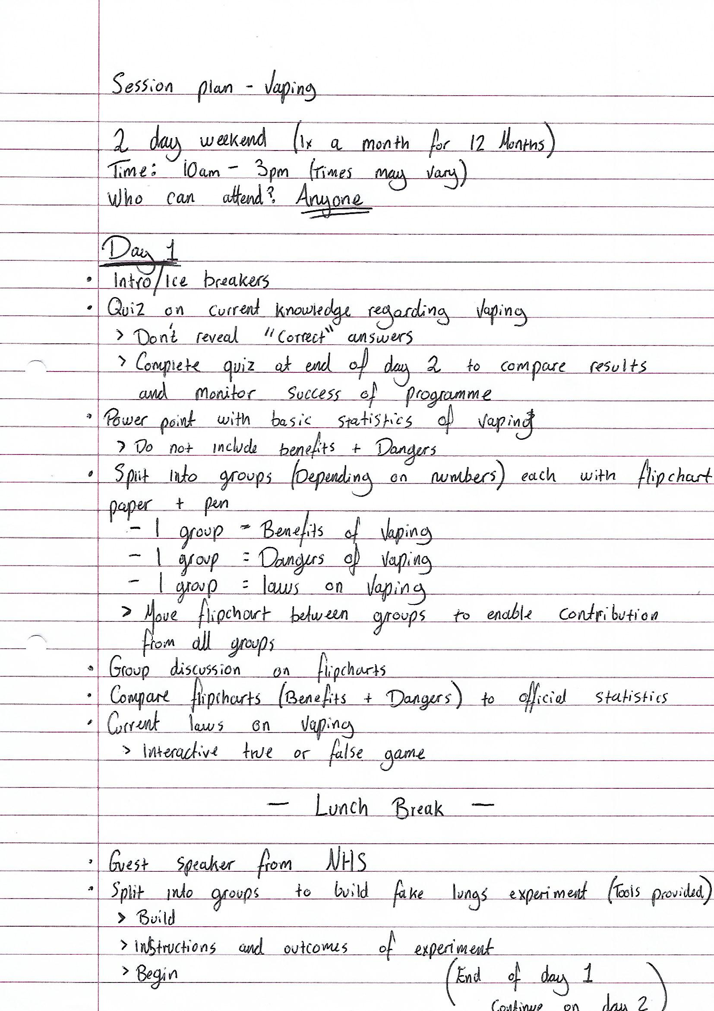

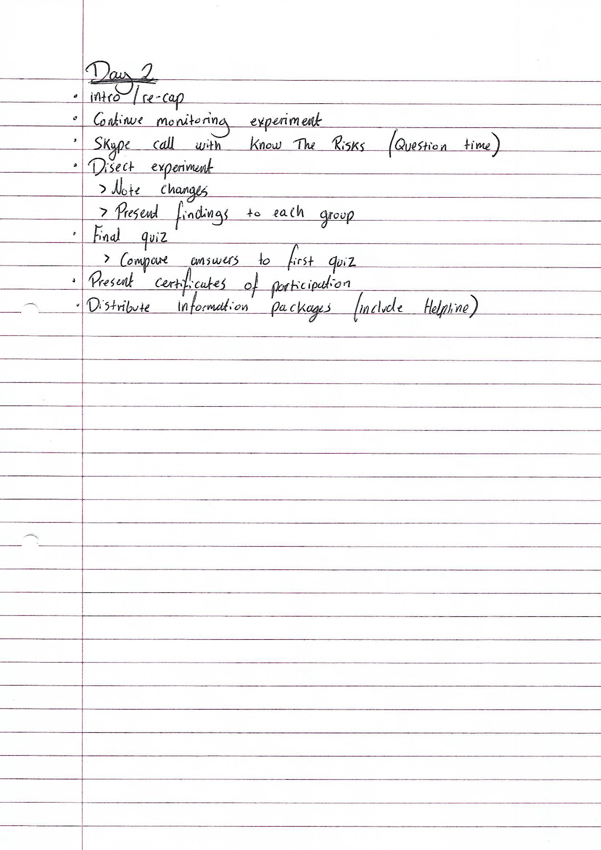

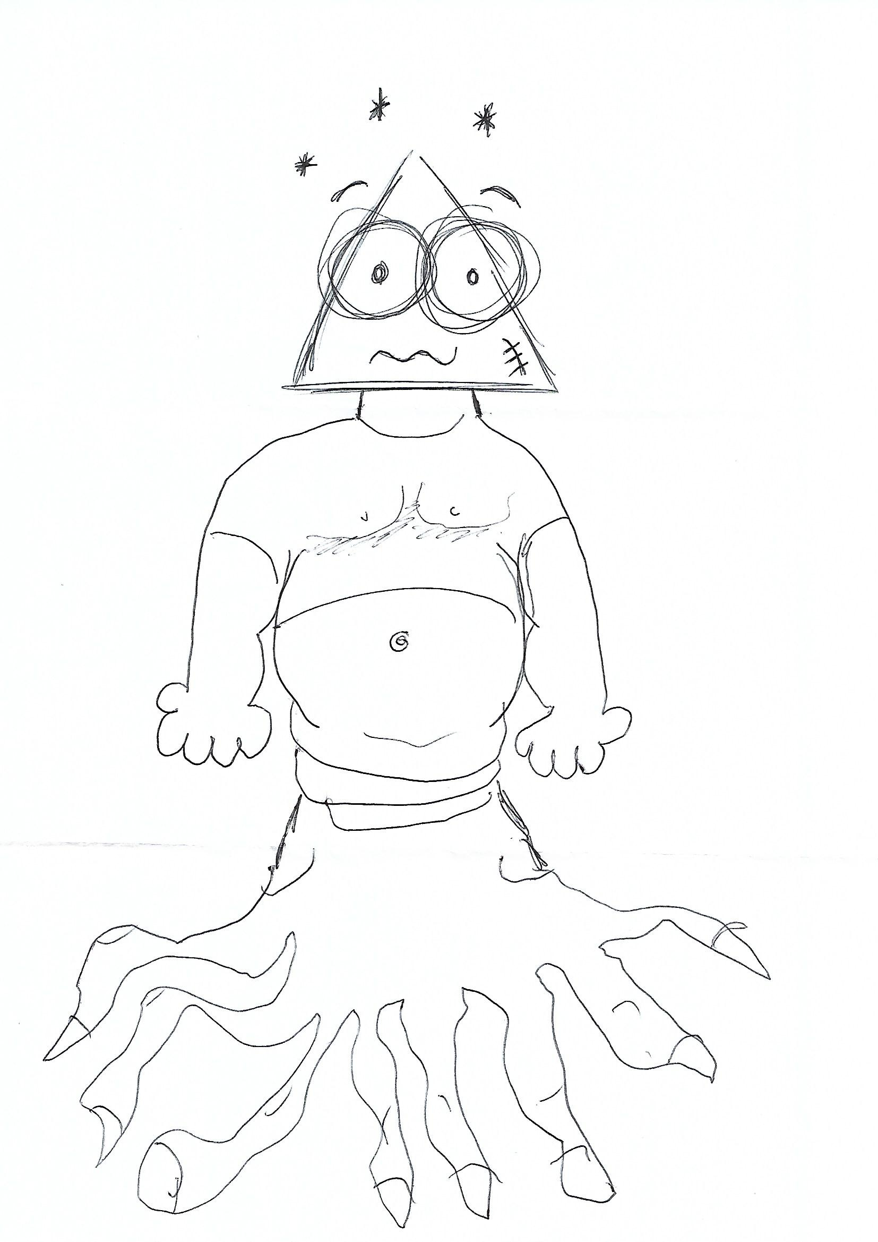
Evaluation: Exquisite Corpse Game
Head = What was good about the programme?
Body = What was bad about the programme?
Legs = What could have been improved
Reference List
Archy, D., (No date on page), How old do You have to be to vape in the United Kingdom?, [Online], Available at: https://e-cigreviews.org.uk/how-old-to-vape/, Accessed: 08/11/18
Bacon, F., (1597), Ipsa Scientia potestas est, [Online], Available at: https://www.goodreads.com/quotes/95823-ipsa-scientia-potestas-est-knowledge-itself-is-power, Accessed: 08/11/18
BBC news, (2017), More than half of UK vapers 'have given up smoking', [Online], Available at: https://www.bbc.co.uk/news/health-39823325, Accessed: 9/11/18
Cherry, K., (2018), The Hawthorne effect and Behavioural Studies, [Online], Available at: https://www.verywellmind.com/what-is-the-hawthorne-effect-2795234, Accessed: 08/11/18
Cooper, D., (2014), The World Health Organization is officially against e-cigarettes, [Online], Available at: https://www.engadget.com/2014/08/26/who-anti-vaping-report/?guccounter=1, Accessed: 08/11/18
Debois, S., (2016), 9 Advantages and Disadvantages of Questionnaires, [Online], Available at: https://surveyanyplace.com/questionnaire-pros-and-cons/, Accessed: 08/11/18
Ebbinghaus, H., (1885), The Ebbinghaus Curve, [Online], Available at: http://ol.scc.spokane.edu/jroth/Courses/English%2094-study%20skills/MASTER%20DOCS%20and%20TESTS/Curve%20of%20Forgetting.htm, Accessed: 08/11/18
KnowTheRisks, (No date on page), E-cigarettes and Brain Development, [Online], Available at: https://e-cigarettes.surgeongeneral.gov/knowtherisks.html#risks, Accessed: 08/11/18
LSIS, (2012), National Occupational Standards for Youth Work, [Online], Available at: http://www.nya.org.uk/wp-content/uploads/2014/06/National-Occupation-Standards-for-Youth-Work.pdf, Accessed: 08/11/18
Matchless, (2017), UK Government Keen to Keep Promoting Vaping, [Online], Available at: http://www.matchlessecig.co.uk/blog/uk-government-keen-to-keep-promoting-vaping/, Accessed: 08/11/18
Mindful Staff, (2011), Why We Find It Hard to Meditate, [Online], Available at: https://www.mindful.org/why-we-find-it-hard-to-meditate/, Accessed: 08/11/18
NHS, (2018), Vaping damages DNA in mice, which 'may increase cancer risk', [Online], Available at: https://www.nhs.uk/news/cancer/vaping-damages-dna-mice-which-may-increase-cancer-risk/, Accessed: 08/11/18
Notap, C., (2018), What Happens To Your Body ● When You VAPE For a Month, [Online], Available at: https://www.youtube.com/watch?v=zFyUlBpy5gU, Accessed: 08/11/18
Oswald, D., Sherratt, F., Smith, S., (2014), Handling the Hawthorne effect: The challenges surrounding a participant observer, [Online], Available at: http://www.rossjournal.co.uk/wp-content/uploads/2016/12/RoSS-Vol1-No1-Oswald-et-al-53-73.pdf, Accessed: 08/11/18
Quinton, M., (2017), VAPING BAD Children as young as 13 can illegally buy e-cigarettes as vaping stores openly flout law to make quick sales, [Online], Available at: https://www.thesun.co.uk/news/2593438/children-as-young-as-13-can-illegally-buy-e-cigarettes-as-vaping-stores-openly-flout-law-to-make-quick-sales/, Accessed: 08/11/18
Smith, L., (2018), Smoking e-cigarette while driving can land you with a £2,500 fine and a driving ban, [Online], Available at: https://www.express.co.uk/life-style/cars/922398/vaping-while-driving-UK-law-e-cigarette, Accessed: 08/11/18
Socialist Health Association, (2018), UK Vaping Regulations, [Online], Available at: https://www.sochealth.co.uk/sp/subs/uk-vaping-regulations/, Accessed: 08/11/18
Sylvester, R., (1994), How Emotions Affect Learning, [Online], Available at: http://www.ascd.org/publications/educational-leadership/oct94/vol52/num02/How-Emotions-Affect-Learning.aspx, Accessed: 08/11/18
TotallyWicked, (No date on page), New Vapers: Is Vaping Better Than Smoking, [Online], Available at: http://www.totallywicked-eliquid.co.uk/is-vaping-better-for-you-than-smoking/, Accessed: 08/11/18
WAG, (2007), The National Youth Work Strategy for Wales, [Online], Available at: https://dera.ioe.ac.uk/19353/1/140221-national-youth-work-strategy-en.pdf, Accessed: 08/11/18
Williams, D. (2018), Lecture 3 (Research Flowchart), Reflecting on and Researching Youth Work Practice (SJYW5007), University of Wales Trinity St. David, delivered 15 October 2018.
WLGA, (2018), The five pillars of youth work, [Online], Available at: http://www.cwvys.org.uk/wp-content/uploads/2018/11/YOUTH-WORK-IN-WALES-PRINCIPLES-AND-PURPOSES.pdf, Accessed: 08/11/18

