
Academic Study Skills
EGCE40002P


Cerys Baker - 1804840

Contents
Contents 1
Portfolio Task 1 – Developing your skills: vision of success as a student-teacher 2
Current skills audit 2
What would success look like for me? 3
Resources available to me as a university student - mind map 3
Portfolio Task 2 – Developing Critical Thinking 4
Summary of “Critical Thinking Skills Developing Effective Analysis and Argument” by Stella Cortell 4
Portfolio Task 3 – Developing Critical Writing 5
“What I think about education in wales” 5
References 7

Portfolio Task 1 – Developing your skills: vision of success as a student-teacher

Current skills audit
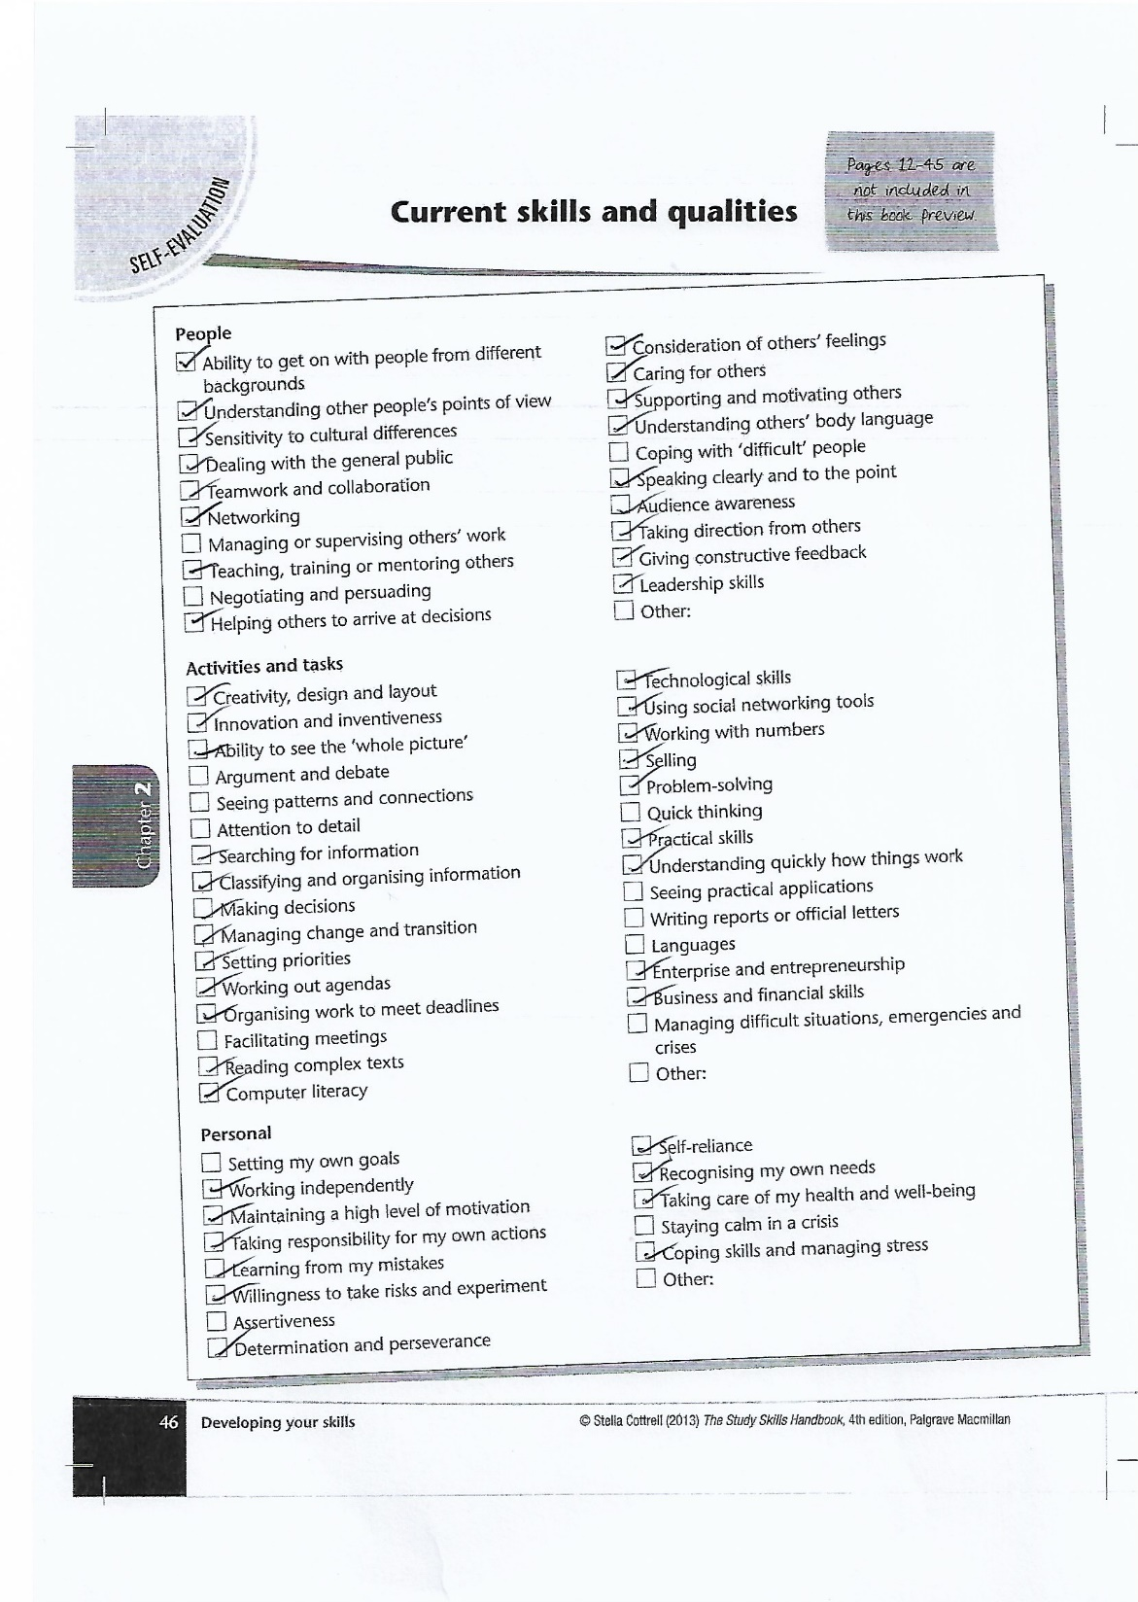

What would success look like for me?
Success is something that looks different through every set of eyes. Success is aiming high and achieving your goals, but what those goals are, is what makes your success different to everyone else’s. For me to be successful, I would like to work on my weaknesses shown in my skills audit, so I am able to become a well-rounded individual. I believe that success would be making the most of the resources and opportunities’ I am given. To me, success would be walking away from university with a 1st in my primary education degree and a qualified teacher status. To be able to have a secure job as a teacher in a school full of wonderful people would be success to me. Being able to make a difference to the children that I teach and to the individuals I work alongside. Success for me would be to make others smile when they feel like they can’t. Success to me would be creating a happy family of my own. Winston S. Churchill once said, “Success is stumbling from failure to failure with no loss of enthusiasm.” He’s not wrong. Success is picking yourself back up and trying again, but when it comes down to it, I know I have succeeded when I have achieved my goals with happiness running through my veins.

Resources available to me as a university student - mind map
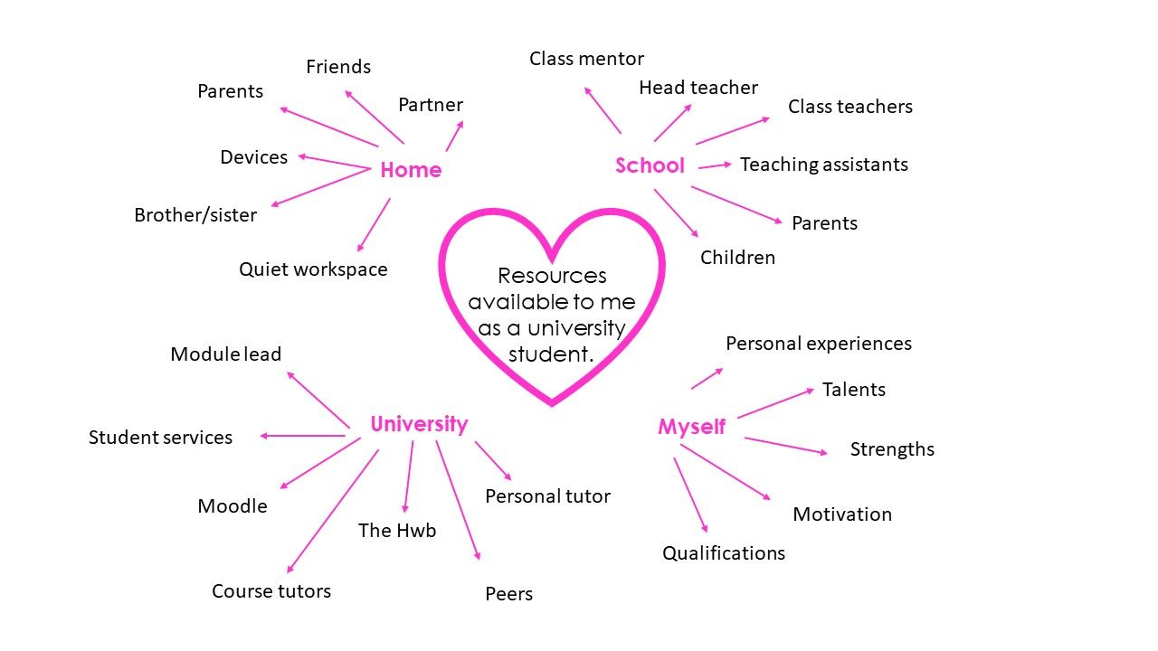

Portfolio Task 2 – Developing Critical Thinking

Summary of “Critical Thinking Skills Developing Effective Analysis and Argument” by Stella Cortell

This Stella Cortell (2005) book is all about critical thinking skills. The whole purpose of this piece of writing is to support individuals who may be studying for higher levels of education. This book allows the readers to understand what critical thinking is and help them develop their skills, for them to think more clearly and to be more aware of what they are reading or listening to. One of the main purposes of this book is to show students the benefits of critical thinking and how it can develop their: analysing, persuasion and reasoning skills. It is also suggested that critical thinking can help you develop other skills such as observation, judgement and decision making. The book suggests that without critical thinking skills you consider your own opinion and your dislikes too much to make a judgement of any kind. Critical thinking skills allow you to question your own views and reflect and compare. Stella Cortell talks about how critical thinking can help you focus on small but significant details you may not have noticed without having good critical thinking skills. Stella Cortell suggests that critical thinking will help bring precision to your work and your thinking. Stella Cortell believes that critical thinking is a process and method of analysing what you see/hear rather than something that is a personal attribute. Critical thinking is considered very important because it can help you read in between the lines and really think deeply about a piece of text. Cortell (2005) believes that critical thinking allows you to present points of view in a more structured way. Cortell believes that critical thinking can also help you reflect and engage your emotions. It can help with coming to conclusions and reflecting on issues or situations. All these areas involve deep thought and analysis, which critical thinking gives you the tools to do. Cortell states “It takes courage to argue an alternative point of view, especially when it is possible that you might be wrong”, this suggests that critical thinking can also make an impact on your personal qualities that can make a big difference to you as an individual. The idea of critical thinking isn’t perfect there are barriers which may be more for one person than another. Its likely that you may misunderstand the term “criticism”, you may only focus on negative points when you should always consider all sides of an argument or point of view. There is also the possibility of lacking methods or just not enough practice of using the skill, you may not be able to use it effectively if you haven’t had time to practice or you aren’t quite sure on what you’re doing.
In conclusion, critical thinking is an effective skill to develop and hold, but its always important to be sure your following the correct structure and you understand how the skill is used.

Portfolio Task 3 – Developing Critical Writing

“What I think about education in wales”
Education in wales Is going through a big change. Schools in Wales are currently teaching the 2008 curriculum which involves the foundation phase, for the 3 to 7-year olds and then key stages for 7 to 11-year olds. In 2022 the new curriculum is going to be put in place, hoping to improve education for the children in Wales, from 3 to 16-year olds. Graham Donaldson was asked by the Welsh Government to review the current curriculum in Wales in 2014. This then led on to developing our curriculum in wales. The new 2022 curriculum involves 6 focused areas of learning, which are: Expressive Arts, Humanities, Health and Wellbeing, Science and Technology, Mathematics and Numeracy and Languages, Literacy and communication. Although the current curriculum had lots of positive praise, I feel that there were still things children were missing out on in the classroom. According to Donaldson (2015) both teachers and pupils felt that there were areas on learning which were not covered such as ICT skills, due to the curriculum being out of date, which I agree with completely. The new 6 areas of learning cover a wider range of learning for the children. As a part time dance teacher, the arts is a big passion of mine and I have always felt children do not get to experience very much of it, even though it does so much good, which is why I think this addition to the curriculum is very promising. I like the idea of health and wellbeing being a specific area as mental health is an increasing issue in children, for them to understand and think about their health and wellbeing. I believe it will have a great impact on the children. Donaldson’s report also talks about 4 specific purposes of the curriculum, for children to become:
- Ambitious Capable learners
- Healthy confident individuals
- Ethical, informed citizens
- Enterprising creative contributors
I feel that this new curriculum focuses on the learner and the person they are going to become rather than what information the learner can learn and understand. I think that the specific areas of learning give teachers more opportunity to teach children more life skills and relevant topics that will give them a head start in the future.
Donaldson (2017) states, “Ultimate success will be strongly influenced not just by the quality of the development of the ideas in the report into workable curriculum and assessment, but also by fresh approaches to leadership, evaluation and accountability.” To me, this suggests that this curriculum is going to be a big step, all areas of the classroom needs to be pushed to achieve the goals for education in Wales.
Although the curriculum has so many positives there are limitations. School staff need more in depth training, especially in digital competency as some staff have not grown up around technology and it’s a whole new area for them. Teachers are going to need support in teaching all areas of learning due to there being a completely new approach.
In conclusion, I think that the new curriculum is going to make a big difference to education in Wales due to the curriculum opening more learning opportunities. Giving teachers more freedom to be able to shape a successful future for all children.

References

Cortell, S. (2005) Critical Thinking Skills, Developing Effective Analysis and Argument. Hampshire: PALCRAVE MACMILLAN.
Welsh Government (2015) Curriculum and Assessment. Available at: https://gov.wales/curriculum-and-assessment.
Donaldson, G. (2015). Successful Futures, Cardiff: Welsh Government.
Donaldson, G. (2017) ‘A Systematic Approach to Curriculum Reform in Wales’, Wales Journal of Education, 19(1), pp. 7-20.

