Portfolio



Module: Emergent Leadership
Skills for the Workplace
Module code: BMSW6101
Student name: Corina Berco
Student ID: 1918420
Lecturer name: Sujeewa Herath

Table of contents

Part 1. Academic report. 2
Introduction. 2
1. Leadership. 3
2. Management. 3
3. Differences between leadership and management. 4
4. Leadership styles. 4
5. Effective Leadership Skills. 5
5.1. Categories of leadership skills. 5
6. Leadership Style in COVID-19 era and other emergencies. 6
7. Ethical leadership. 7
Part 2. A reflection on learning about the emergent leadership skills module. 9
Introduction. 9
1. Concrete Experience. 9
2. Reflective Observation. 10
3. Abstract Conceptualization. 11
4. Active Experimentation. 11
Conclusion. 12
References. 12
Appendix A. 15
Appendix B. 16

Part 1. Academic report.

Introduction.
This portfolio aims to provide a brief description of what leadership and management are. Some differences between these two are given, to show they are different, although these two terms are often used alike in the workplace.
Furthermore, the paper outlines the theories of different leadership styles. Aithal and Suresh Kumar (2016) defined a leadership style as a method and process of providing task solutions and performing, directing, and motivating people. The theory of leadership presented in this paper proposes that effective leadership is important in solving difficult social problems that appear in any organization.
In addition, effective leadership skills are presented. Leadership in the COVID-19 era is also considered along with ethical leadership.
A crisis is an unplanned changing process that challenges the leaders and put at risk the entire organization’s resources and goals creating pressure among employees of the organization because of uncertainties and time pressure and covering a brief period for removing or minimizing the effects through necessary precautions (Ali and Anwar, 2021)

“If you think you are leading and turn around to see no one following you, then you are just taking a walk.” John C. Maxwell

1. Leadership.
Mihelič et al. (2010) defined leadership as the art of convincing a follower to want to do tasks that the leader sets as a goal. The role of leaders in controlling the group member’s behavior toward a wanted goal. Leaders are different, depending on the personal leadership style that comes from personality qualities. Armstrong (2012) described leadership as the ability to lead other people ready to behave differently.
Leadership has a decisive influence in forming an organization’s culture, ensuring that effective performance is maintained (Ali and Anwar, 2021; Gandolfi and Stone, 2018). If it is not effective, or not present, organizations, employees, and society are affected, sometimes in a negative manner (Gandolfi and Stone, 2018).
Amanda Pritchard – the Chief Executive of NHS England has a strong belief that NHS will recover from the COVID-19 crisis. She, as a leader of the NHS team, should inspire and guide others and must be trustworthy and able to motivate those around her, especially in an uncertain situation. She has a big responsibility to team members, doctors, and nurses, directing them and supporting, building their trust and respect. Inspire the values of the company and supply constructive feedback, accepting, in turn, the feedback of the employees.

2. Management.
Lorenzana (1993) defines management as the process by which a manager efficiently uses resources to accomplish stated organizational goals at minimum cost and maximum profit. Managing became a more essential activity in today’s difficult environment, which brings up more new organizations every day.
Gandolfi and Stone (2018) mentioned a study that analyzed the relationships between employees and their managers. A survey conducted among 7,200 employees, showed that about half of them testified that left their jobs because of a bad manager. That is why in every organization, managing is an important task where managers always should plan, organize, and control activities, to guarantee that organizations achieve their goals (Lorenzana, 1993).
Effective management is an essential tool in every organization, as well as for NHS. Without good management to organize and control doctors and nurses, there is no performance. Being the NHS manager requires specific skills and the desire for continuous development. Manage and delegate resources efficiently to increase productivity and performance, both individually and as a team. Despite the hard period, lack of employees, and hospital spaces, Amanda Pritchard should learn how to coordinate with the situation, as she is responsible for the work of her team, always there to ensure staff is ready and able to fulfill their tasks. An effective manager ensures patient satisfaction and manages complaints and different conflict situations. The issues should be solved professionally, always searching for development plans to prevent their occurrence.

3. Differences between leadership and management.
Leadership and management are different but still are connected. While leaders are seen as charismatic and are often appreciated and admired, managers often are thought of as the organization’s chief, very demanding, screaming out commands (Kotterman, 2006).
“Management is doing things right; leadership is doing the right things.” Peter Drucker (Austrian-American management consultant)
LEADERSHIP | MANAGEMENT
Is a process of social influence, bothered with the approaches, and behaviors of employees that make others follow them (Armstrong, 2012). | Management is concerned about problem-solving and control over employees (Surbhi, 2018).
Is the quality of establishing direction, motivating, and inspiring people by encouraging them (Kotterman, 2006). | It is the action of planning, organizing, and controlling people and tasks to achieve organizational goals (Surbhi, 2018).
Leadership is more a collaboration between leaders and employees, it is based on common objectives (Aronson, 2009). | Armstorng (2012) described management as the process of getting things done through people implementing leadership.
It requires the belief of employees in the leader. | Managers plan and budget (Kotterman, 2006).

4. Leadership styles.
Sethuraman and Suresh (2014) defined leadership style as the manner and attitude of providing and accomplishing plans and orders and stimulating and inspiring people. A leader must be always ready to change the leadership style according to the circumstances, should support the team members, and form their beliefs.
The major leadership styles:
Authoritarian - leaders who direct their team members on what they should do and the way it should be done without receiving feedback or suggestion (Bhargavi and Yaseen, 2016). According to Val and Kemp (2012), the authoritarian leader is the person who has the responsibility to guide and control team members, leading them to achieve a specific goal.
Democratic - an individual who leads the group in a very relaxed way but still with a responsible attitude. Unlike an authoritarian leader, a democratic will ask the team for suggestions, when solving a problem, and considering their ideas, but still, the leader must make the final decision (Val and Kemp, 2012).
Laissez-faire (hands-off) - leaders provide minor guidance when there are problems in the team and allow employees to produce decisions on their own (Val and Kemp, 2012). The outcome is usually negative, as the team members are not controlled in any way by the leader, and do not receive any instructions or feedback.
Transactional leadership - is defined as a transaction in the sort of exchange, the idea that the relationship between leader and team members develops from the exchange of such a reward as bonuses, or promotion, in exchange for well-done work (Kippenberger, 2002).
Transformational leadership - is based on trust between the leader and employees’ intelligence, knowledge, and commitment. It motivates and emphasizes close collaboration between the leader and the team members (Aronson, 2009). Unlike transactional leadership, it is more about feelings and intelligence and empowering people (Kippenberger, 2002).
In the NHS organization, the leader should be prepared to change the leadership style according to the situation, to be more productive, focus on supporting the team members and form their beliefs and respect. Transformational leadership is the most appropriate leadership style in the NHS organization. The leader should motivate employees to take responsibility and decisions, instead of allocating tasks from the top, the leader should teach the employees how to think more than just do what they are told to do.
NHS, as the country’s largest employer, should be prepared for exceptional situations, such as the COVID-19 pandemic. It has poor health outcomes due to ineffective leadership.

5. Effective Leadership Skills.
Leadership is the foundation for all companies, but its purpose and dimensions become more complicated with increased connection in globalization and technology development. The technological approach changed the way people do business and communicate. The leadership skills needed for organizational and personal development have changed as well. To deal with these changes, leaders should develop and support effective leadership strategies for long-term change, they need to learn a set of skills that will allow them to lead effectively (Chuang, 2013).

5.1. Categories of leadership skills.
Administrative.
Defined by Yossef and Rakha (2017) as a group of skills that enable effective performance management in the organization to match their requirements and accomplish their goals and are divided into planning and organizational skills.
Administrative skills are essential for each employee in the NHS. One of the skills is time management, as if doctors and nurses will not control their schedule, patients’ lives can be in danger. Another one is the ability to plan effectively, and as seen in the COVID-19 pandemic, delegating is an important part of administrative skills.
Leaders in all areas faced a pandemic that required little time to plan how to face the changing environment. Trust is an important aspect in a crisis like COVID-19. It is an individual’s belief in government, society, or the leader (Ahern and Loh, 2020).
Interpersonal.
Interpersonal skills are defined as goal-directed behaviors used in direct interactions, to achieve a wanted condition (Guzmán et al., 2020). In this group of interpersonal skills, the most well-known are:
- negotiation – it the importance for leaders to set up agreements for ordinary benefits to employees in the company, build a more common and engaging environment, and inspire employees to experiment and come up with new ideas (Guzmán et al., 2020).
- persuasion – the importance to build a learning and innovation environment that motivates the decision-making of employees and hence, leading them to use a more open behavior (Guzmán et al., 2020).
- social perception – the importance to understand how to set and develop employees to perform in digital environments, and to guarantee contribution, trust, and cooperation, encouraging a more engaging culture.
Conceptual.
Conceptual skills are abilities that allow a leader to understand problematical situations and foresee advanced and successful solutions (Mduwile and Komariah, 2021). Important and relevant for all leaders, no matter the type of organization they lead. The ability to recognize opportunities and potential problems, logical and critical thinking, creativity in idea generation, and problem-solving are just a few abilities of conceptual skills.
In the NHS organization is essential to grasp difficult ideas and come up with answers for difficult problems. Conceptual skills are valuable to manage the NHS in finding the right solutions for multiple challenges across intentional ideas and conceptual reasoning.

6. Leadership Style in COVID-19 era and other emergencies.
The COVID-19 pandemic appeared as an exceptional worldwide pandemic, which harmed all type of institutions. Leaders were not prepared to face such a crisis. In times like this, leaders should learn how to decide and manage a difficult situation in a short time (Kaul et al., 2020). Leading during the pandemic has been a stress for leaders. They will hopefully be more prepared for managing an ongoing situation or a disruption that a lot of people are now predicting. It will also encourage advanced planning for crises and a resumed responsibility to leadership training in medicine (Kaul et al., 2020).
In this uncertain era, when society and organizations are changing in a way that we had not met before, leaders should regularly review their leadership and recreate themselves (Drysdale and Gurr, 2017). Leaders have a huge responsibility, and they should make the right choices in the changing environment. Uncertainty, cause fear and concern in every employee, no matter what position they have in the organization (Cameron and Green, 2019).
One of the most appropriate leadership styles for COVID-19 and other emergencies is the transformational leadership style. It is the best for managing an external crisis. As it needs imagination, flexibility, and the development of advanced methods of problem-solving skills. The leaders may come up with new working schedules, rotating evening and weekend shifts, and employees may have to work extended hours under pressure. It is essential to keep patients safe and make them trust a medical worker.

7. Ethical leadership.

Researchers show that ethical leaders are kind, responsible, honest, and make impartial and impartial decisions. Ethical leaders also regularly communicate with team members about ethics, set direct ethical standards, and use rewards and punishments to notice that those standards are respected (Brown and Treviño, 2016).
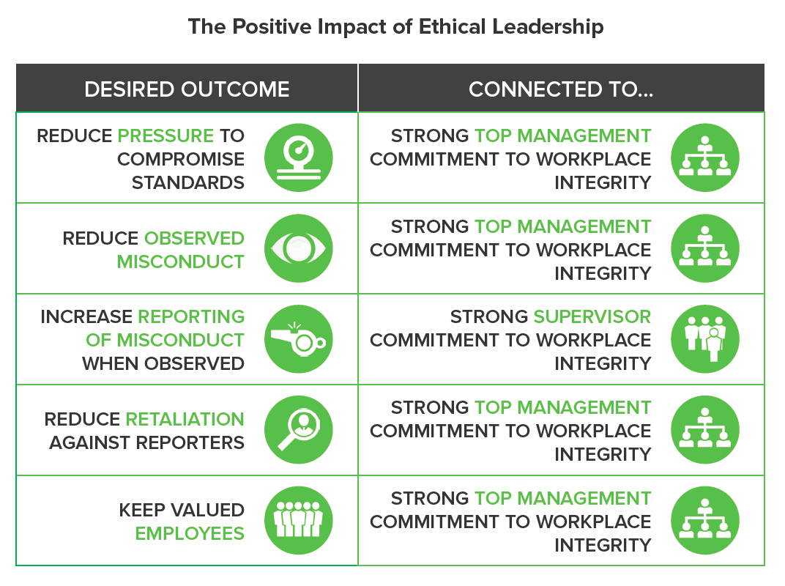
Ethical leadership is associated with the successful relationship between the leader and the employees. Their perception of ethical leadership predicts a good relationship with the leader, recognizing leader effectiveness, the leader’s effort on the task, and they wish to report issues to management (Brown and Treviño, 2016).
Source: The-Positive-Impact-of-Ethical-Leadership.png (1072×800) (trainingindustry.com)
Leaders perform as models for their employees and show the social borders set established within an organization. Ultimately, being ethical is about following the rules, thinking about the well-being of other people, and about the results and benefits of someone’s action (Hitt, 1990)
Mumford et al. (2000) suggested that a leader should be flexible in dealing with other people and in modifying plans, to the need of a changing social environment, as employees that see their leader being ethical to learn.
Ethical issues likely to affect leadership inside NHS:
- due to the situation of COVID-19, the patient's concept of the NHS has changed drastically.
- patients think nurses and doctors are not ethical to them, they do not treat them right, on time, and are disregarded and delayed in their treatment.

Part 2. A reflection on learning about the emergent leadership skills module.

Introduction.
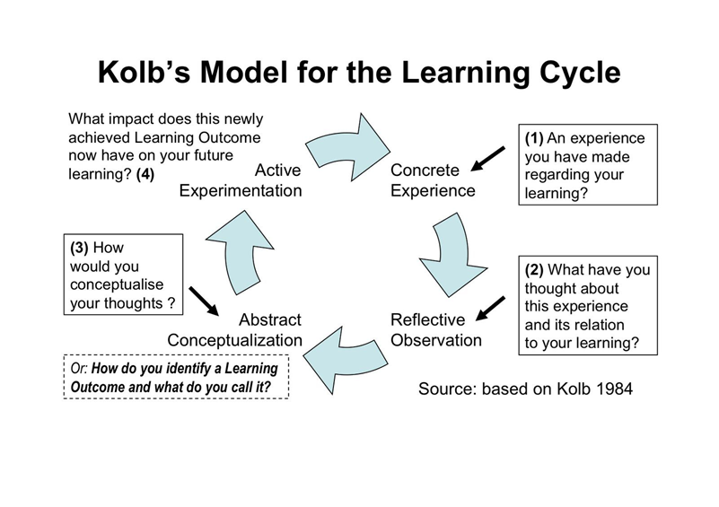
For the reflective part, Kolb’s Model for the Learning Cycle is used, which provides an influential theoretical and practical structure for learning efforts (Petkus, 2000). The learning of this module is presented in four different learning abilities, placed together into a cycle. There is no rule for the starting point of the cycle, but effective learning is only possible when a student can perform all four stages of the cycle (McLeod, 2017).
Source:ae9e667ee58f429dcce39d546e212dfc.jpg (1600×1130) (pinimg.com)

1. Concrete Experience.
In week three we learned about different leadership styles. During the class, we had to do a test to find out the leadership style that best suits each of the students.
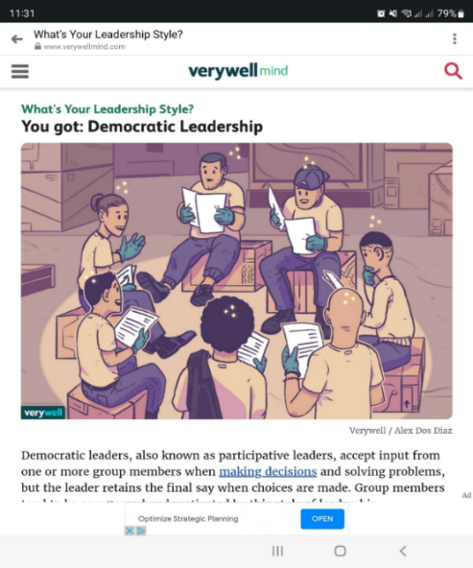
I have evaluated my leadership style, the result showed that the one that aligns with my leadership style is democratic (see Appendix A). Democratic leaders collaborate with team members and treat everyone equally without putting themselves above the rest of the team. It looks like the assumption of Theory Y. According to Theory Y, people are hard-working and have potential, love their work, are creative, and take the responsibility for work they do (Gurbuz et al, 2014).
Chong et al (2018) pointed out that the democratic leadership style is people-oriented, it motivates leaders to encourage mutual respect and belief with employees.
Source: What's Your Leadership Style? (verywellmind.com)
The people-oriented leader motivates and inspires team members to achieve organizational goals. In turn, employees are motivated in completing daily tasks. The employees see the people-oriented leader as charismatic, with excellent communication skills and good manners (Chong et al, 2018). Good leaders use all three styles depending upon the situation.
From the experience I had while working as a Quality Assurance Manager, I always used a Democratic leadership style, as the opinion and ideas of each team member were considered. The responsibilities were shared between the team.
We had a friendly team that used to celebrate corporate holidays. As the manager of a department, with a creative and competent team, I always trusted them in their choices. Team members were discussing the place to hold the party, what cake to bring, and considering everyone's preferences.

2. Reflective Observation.
With completing Emergent Leadership Skills for the Work module, I was able to benefit from a variety of current information from the class, as well as refresh my memory on things that I have already known, but just needed a reminder about.
Observed during my classes that the biggest barrier for me was implementing theory, giving examples from my working place, as I am not employed. It was a challenge for me, but I tried to manage it with some examples from my last working place. Or I found it easy to imagine how will I proceed in certain situations, how will I be as a deader for the future working place.
I listened carefully to my colleagues who are leaders in their working places, sharing their experiences, and learning some new things from them as well. Never thought I could be a leader, however, because classmates had discussions and reflections about them being a leader, I realized that I could be a successful leader in the future. Learning in this Module is an advantage to me, regardless of the career I will decide to go into.

3. Abstract Conceptualization.
Effective leadership skills influence employees’ job satisfaction and motivation in the workplace. Good leadership is the application of skills that leaders must learn to use successfully.
The process of learning in this module and my performance I will be able to apply in the workplace. Learning about being a democratic leader, where is sharing of responsibilities in a team environment, and which is the most appreciated and respected by employees.
The experience I had during this module while learning about categories of leadership skills, fundamental for being a leader, will improve my planning abilities in the workplace. Being a leader of a team, I will be able to organize work activities and delegate tasks to the right people. Besides completing tasks in time, relationships with people, and communication, is an important aspect of being a good leader.

4. Active Experimentation.
In week eight I learned about ethics in leadership. Both are important to any organization and the society. We have been introduced to the definition of ethical leadership, with examples from working place. The class has been engaged in an activity, where a questionnaire was filled, out to understand what ethical leadership style each has.
What does ethics mean to me? Results showed that my preference is duty ethics, which scored 5 points out of 10 (see Appendix B). This means that I follow a set of moral rules and do what is expected of me when facing an ethical dilemma. Focused on fulfilling my moral obligations and doing my duty. It is the responsibility of each person to learn the rules and then apply them at work. People can judge their behavior based on the qualities set up by the ethical rules (Hitt, 1990).
Kant’s ethics of duty means doing the right things, and worrying about what people do, rather than the results of their actions. Duty ethics teaches that some actions are right or wrong because of the type of things they are, and each person must behave appropriately, even if it can cause good or adverse consequences (BBC, 2014).

Conclusion.

Part 1.
After the exploration of multiple professional viewpoints about different leadership styles discussed in this portfolio, the democratic seems to be the most used and effective leadership style. However, it has advantages and disadvantages as well, some of them were pointed out here. After the exploration of multiple professional viewpoints, it can be concluded that each of the leadership styles can influence organizational effectiveness and performance, as well the productivity.
Part 2.
Is a reflective part based on Kolb’s Model for the Learning Cycle, which implies not only classic learning but also critical thinking about the experience. This part of the portfolio presents the result of a test that defines me as a democratic leader, along with a detailed explanation of this leadership style. Following the duty ethics as a leader, is to do the right thing, even if it can cause harm to people in the team. Overall, learning this module is a motivation for me to become a good leader in the future.

References.

1. Aithal, P.S. and Kumar, P.M. (2016) ‘Comparative analysis of theory X, theory Y, theory Z, and theory A for managing people and performance’, International Journal of Scientific Research and Modern Education (IJSRME), 1(1), pp.803-812. India.
2. Ahern, S. and Loh E. (2020) ‘Leadership during the COVID-19 pandemic: building and sustaining trust in times of uncertainty’, BMJ Leader 5, pp. 266-269. DOI:10.1136/leader-2020-000271
3. Ali, B.J. and Anwar, G. (2021) ‘Administrative crisis: the role of effective leadership styles in crisis management’, International Journal of Advanced Engineering, Management and Science, 7(6), pp.31-41.
4. Armstrong, M. (2012) Armstrong's handbook of management and leadership developing effective people skills for better leadership and management. 3rd edn. Kogan Page.
5. Aronson, E. (2009) ‘Integrating leadership styles and ethical perspectives’, Canadian Journal of Administrative Sciences 18(4), pp. 244-256.
6. BBC (2014) Duty-based ethics. Available at: BBC - Ethics - Introduction to ethics: Duty-based ethics (Accessed on: 13 July 2022).
7. Bhargavi, S. and Yaseen, A. (2016) ‘Leadership styles and organizational performance’, Strategic Management Quarterly, 4(1), pp. 87-117. DOI: 10.15640/smq.v4n1a5
8. Brown, M.E. and Treviño, L.K. (2016) ‘Ethical leadership: a review and future directions’, The Leadership Quarterly, 17, pp. 595–616. DOI: 10.1016/j.leaqua.2006.10.004
9. Cameron, E. and Green, M. (2019) Making sense of change management. 5th edn. London: Kogan Page.
10. Chong, A.V.N., Lee, U.H.M.S., Ismail, A., Yazid, Z. and Ahmad, N.N. (2018) ‘Person-oriented leadership enhancing employee outcomes’, IPN Journal of Research and Practice in Public Sector Accounting and Management. 8(1), pp. 103-120.
11. Chuang, S.F. (2013) ‘Essential skills for leadership effectiveness in diverse workplace development’, Online Journal for Workforce Education and Development, 6(1).
12. Drysdale, L. and Gurr, D. (2017) ‘Leadership in uncertain times’, International Studies in Educational Administration, 45(2), pp.131-159.
13. Gandolfi, F. and Stone, S. (2018) ‘Leadership, leadership styles, and servant leadership’, Journal of Management Research, 18(4), pp. 261-269.
14. Gurbuz, S., Sahin F. and Koksal, O. (2014) ‘Revisiting of theory X and Y. A multilevel analysis of the effects of leaders’ managerial assumptions on followers’ attitudes’, Management Decision, 52(10). DOI 10.1108/MD-06-2013-0357
15. Guzmán, V.E., Muschard, B., Gerolamo, M., Kohl, H. and Rozenfeld, H. (2020) ‘Characteristics and skills of leadership in the context of industry 4.0’, Procedia Manufacturing, 43, pp.543-550.
16. Hitt, W.D. (1990) Ethics and leadership. Columbus, OH: Battelle Press.
17. Kaul, V., Shah, V. H., and El-Serag, H. (2020) ‘Leadership during crisis: lessons and applications from the COVID-19 Pandemic’, Gastroenterology, 159(3), pp. 809–812. https://doi.org/10.1053/j.gastro.2020.04.076
18. Kippenberger, T. (2002) Leadership styles. United Kingdom: Capstone.
19. Kolb’s model for the learning cycle [illus.] (ND) Available at: ae9e667ee58f429dcce39d546e212dfc.jpg (1600×1130) (pinimg.com) (Accessed on: 10 July 2022).
20. Kotterman, J. (2006) ‘Leadership versus management: What’s the difference’, The Journal for Quality and Participation, 29(2), pp.13-17.
21. McLeod, S.A. (2017) Kolb - learning styles. Available at: Kolb's Learning Styles and Experiential Learning Cycle | Simply Psychology (Accessed: 30 June 2022).
22. Mduwile, P.L. and Komariah, A. (2021) ‘Leadership and administrative skills’, Advances in Social Science, Education and Humanities Research, 526, pp. 11-16. Atlantis Press.
23. Lorenzana, C.C. (1993) Management, theory, and practices. Philippines: Rex Book Store.
24. Mihelič, K.K., Lipičnik, B. and Tekavčič, M. (2010) ‘Ethical Leadership’, International Journal of Management & Information Systems, 14(5).
25. Mumford, M.D., Zaccaro, S.J., Harding, F.D., Jacobs, T.O. and Fleishman, E.A. (2000) ‘Leadership skills for a changing world: solving complex social problems’, Leadership Quarterly, 11(1), pp. 11–35.
26. Nanjundeswaraswamy T.S. and Swamy D.R. (2014) ‘Leadership styles’, Advances in Management, 7(2), pp. 57-62.
27. Petkus, E. (2000) ‘A theoretical and practical frame work for service-learning in marketing: Kolb’s experiential learning cycle’, Journal of Marketing Education, 22(1), pp. 64-70.
28. Regoli, N. (2019) 22 Advantages and disadvantages of democratic leadership style. Available at: 22 Advantages and Disadvantages of Democratic Leadership Style – ConnectUS (connectusfund.org) (Accessed: 01 June 2022).
29. Sethuraman, K. and Suresh, J. (2014) ‘Effective leadership styles’, International business Research (7)9. DOI:10.5539/ibr.v7n9p165
30. Surbhi, S (2018) Difference between leadership and management. Available at: Difference Between Leadership and Management (with Examples and Comparison Chart) - Key Differences (Accessed: 19 June 2022).
31. The positive impact of ethical leadership [illus.] (ND) Available at: The-Positive-Impact-of-Ethical-Leadership.png (1072×800) (trainingindustry.com) (Accessed on: 13 July 2022).
32. Val, C. and Kemp, J. (2012) ‘Leadership Styles’, Pathways: The Ontario journal of outdoor education, 24(3), pp. 28-31.
33. Yossef, S.A.M. and Rakha, A.H.H. (2017) ‘Efficiency of personal and administrative skills for managerial leadership on administrative creativity at Najran University’, Journal of Education and Practice, 8(6), pp.113-122.

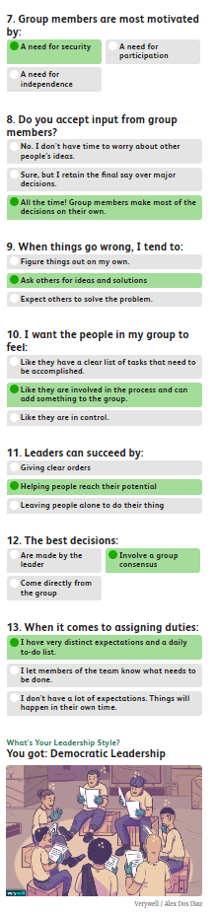
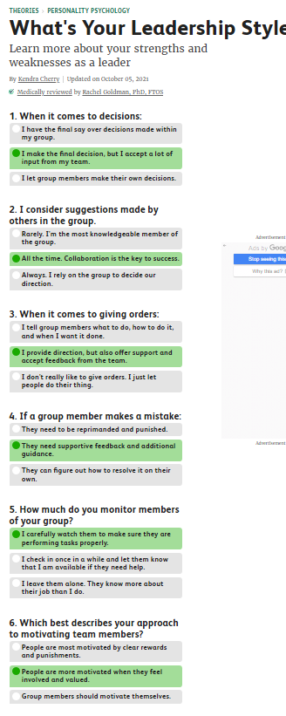
Appendix A.

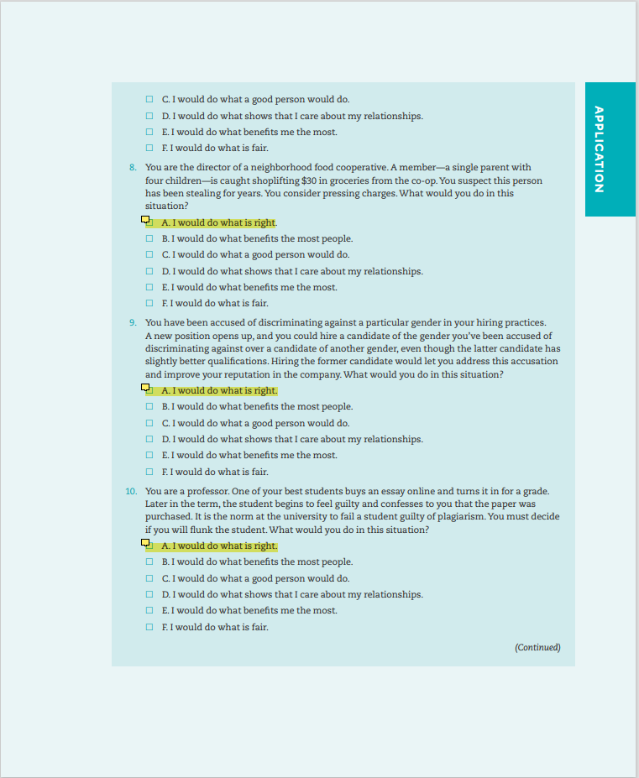
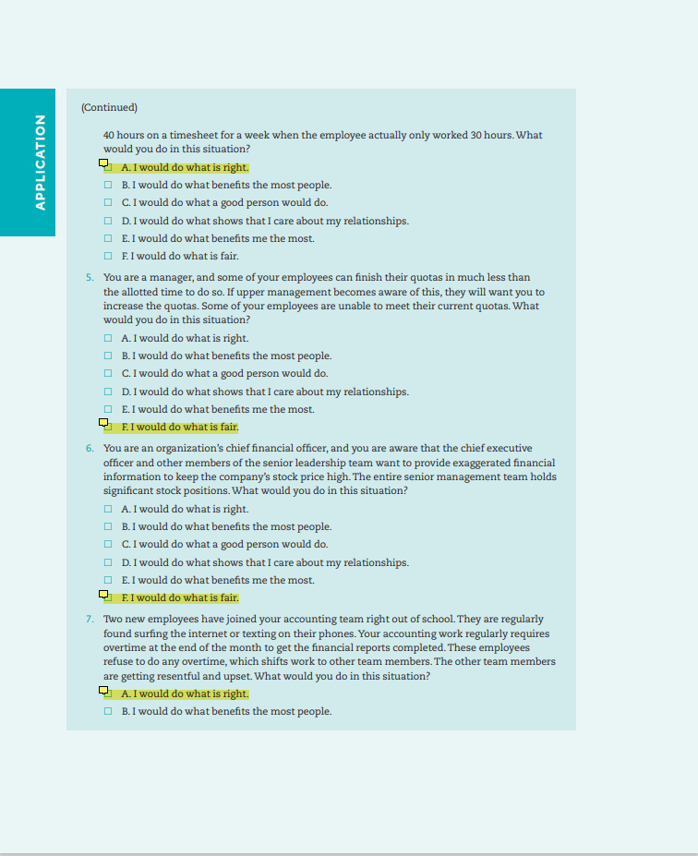
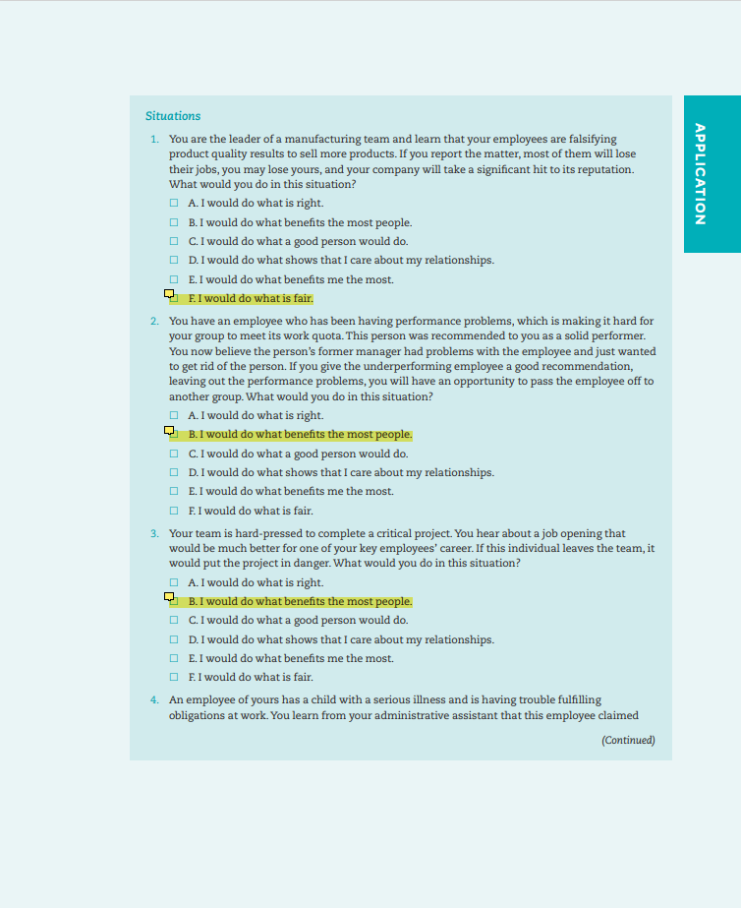
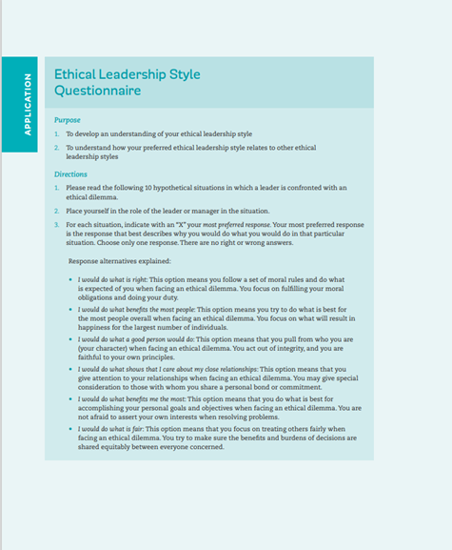
Appendix B.

