Beacon Hill, Terrington St Clement, Norfolk: Dissemination Strategy

Project Background

In 2022 Wardell Armstrong conducted an open-area excavation at Beacon Hill (Podbury 2022), which was preceded by informative trial-trenching (Lloyd-Smith and Clarke 2021). The investigations were conducted prior to residential development. The excavation site lies to the north-west of Terrington St Clement in Norfolk, situated upon an area of relative high elevation within the notably low-lying landscape of the silt fen. Comprising an irregular-shaped plot, the relatively small excavation site covered an area of c.9,200m² (Fig.1). The excavations, in summary, revealed evidence for Saxo-Norman to medieval salt production activity. The following report will provide an overview of the current research context related to medieval salt production in order to assess the significance of the archaeological findings at Beacon Hill, so that an appropriate dissemination strategy can be developed.

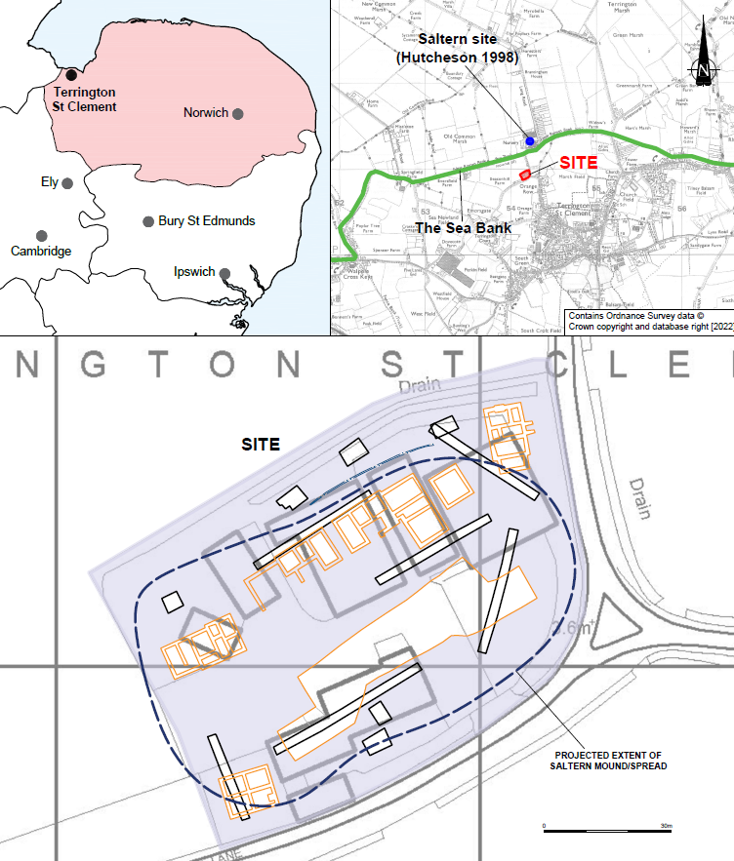
Figure 1: Detailed site location plan (Podbury 2022)
Research Context

National and International Context

Salt has been an indispensable commodity throughout history as a crucial material in many craft processes and, significantly, as a material vital to the preservation of food (Miller and Hatcher 2014: 5; Harding 2021). There have been significant investigations of Romano-British saltworks and, to a lesser extent, Anglo-Saxon and medieval salt production. The principal method employed for extracting salt during the medieval period was called ‘sand washing’ or ‘sleeching’. Medieval salt production sites are known across Britain with particularly noteworthy concentrations of excavated examples in Sussex (e.g., Holden and Hudson 1981; Ridgeway 2000), Worcestershire (e.g., Hurst and Hemmingway 1997), Cambridgeshire (e.g., Pollard et al 2001), Lincolnshire (e.g., McAvoy 1994; McAvoy et al 1994; Albone 1999), and as will be outlined below, Norfolk. Perhaps the most notable medieval saltern site excavated in Britain was discovered at Wainfleet St Mary in Lincolnshire. The excavation at Wainfleet uncovered well-preserved evidence for highly systematised salt production dating to the 15th century, and post-excavation analysis was able to equate the functions of unearthed features with the processes of marine salt extraction outlined in historic documents (McAvoy et al 1994).

Further afield, medieval saltern sites revealing evidence for ‘sand washing’ – as opposed to the solar evaporation techniques used in the warmer climates of France and Spain (e.g. Bouhier 1978; Bouhier 1980; Boutin and Guitteny 1992) – have likewise been investigated in Northern Europe. These production sites have, namely, been excavated in Frisia in Holland (Besterman 1974; Adshead 1992) and in Ireland (Ludlow 1993). These investigations, however, have been limited compared to those undertaken across Britain.

Regional and Local Context

Salt production was a particularly important element of the economy in the regions surrounding the Wash. Indeed, nearly three hundred medieval saltern mounds were recorded in the area during the Norfolk National Mapping Programme (NMP) (Albone et al 2007: 116-117). The two principal centres of salt production in the Norfolk Fens during this period were located at Terrington St Clement and to a larger extent at West Lynn, upon the bank of the Great Ouse opposite King’s Lynn (Silvester 1988; Hall and Coles 1994). A substantial programme of excavation, collectively named the ‘Lynnsport’ project, has recently provided considerable insights into the industry focused around King’s Lynn (Clarke 2016; Clarke 2017; Clarke 2018a; Clarke 2018b; Blackbourn 2019; Knight and Clarke 2019; Kwiatkowska 2020; Clarke and Clarke forthcoming), expanding upon the body of evidence provided by comparably small and isolated excavations previously conducted in the area (Trimble 2003; Timberlake 2008; Cope-Faulkner 2014). These investigations provided a unique opportunity to examine medieval craft processes and to study the evolution of the industry in this region. Radiocarbon dating during the project suggests that these salt production methods date back to as early as the 9th century, or potentially even the 8th century in the region (Clarke 2018b: 410); pushing the previously postulated date of the post-Roman salt industry in this region back by several hundred years. The recent investigations of the King’s Lynn salt production industry represent the most expansive programme of intrusive excavations examining Anglo-Saxon and medieval salterns in Britain.

Salt production activity in Terrington St Clement, in contrast, has not been subject to substantial intrusive investigation. A trial-trench evaluation conducted at Belmont Nursery, which found small patches of burnt material indicative of possible saltworking activity, is the only excavation of the local salterns (Gurney and Penn 1998; Hutcheson 1998). Aerial photography nevertheless demonstrates the scale of the saltworks in Terrington St Clement. An interlocking complex of saltern mounds, perceptible as pale soilmarks, are clearly visible in the area (Fig.2). The saltern mounds cover an area of more than 50ha, with modern developments obscuring or having destroyed further saltworks. The Beacon Hill excavation is one of the first opportunities to archaeologically investigate a saltern within the expansive complex.

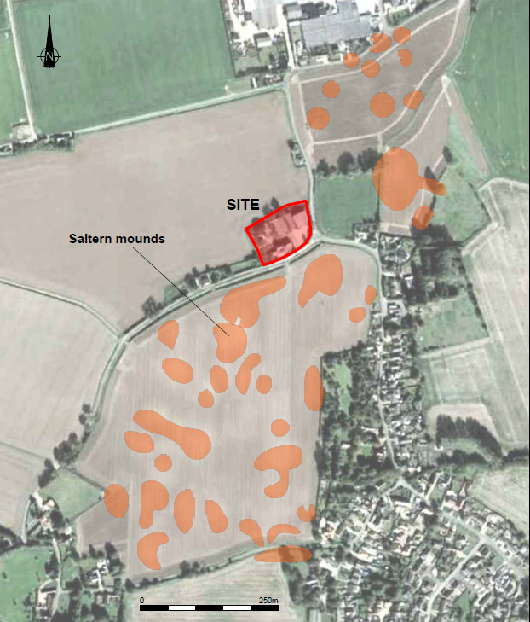
Figure 2: The Terrington St Clement saltern complex (Podbury 2022)
Archaeological Results

A complex stratigraphy of desalinated silts and hearth waste deposits, that once formed a wider saltern mound, was revealed during the excavations at Beacon Hill (Fig.3) (Lloyd-Smith and Clarke 2021; Podbury 2022). The salt making process, in brief, consisted of washing water through salt‐rich silt deposits and then evaporating the resulting concentrated brine in hearths (Owen 1979; Grady 1998; Albone 1999; McAvoy 1994; Ridgeway 2000). This process resulted in the creation of a series of layers of waste silt, thirty-three distinct but comparable deposits of which were identified at Beacon Hill (Podbury 2022). Twelve discrete dumps of fired clay and hearth waste, resulting from the use of hearths to evaporate brine, were also identified. A series of features utilised during the salt making process were found to have both cut into, and been sealed by, the waste deposits. The features included a possible water feeder channel, water tanks, brine boiling hearths and silt filtration units (Fig.4). While well-preserved evidence for salt production was revealed in the form of layers and features, the associated artefactual assemblage was limited. Nevertheless, small assemblages of locally produced pottery principally of 10th to 12th century date, briquetage, salt-making slag, ceramic building material, and animal bone were recovered. Palaeoenvironmental analysis also provided considerable insights into the varying raw materials and fuel types utilised during the salt making process.

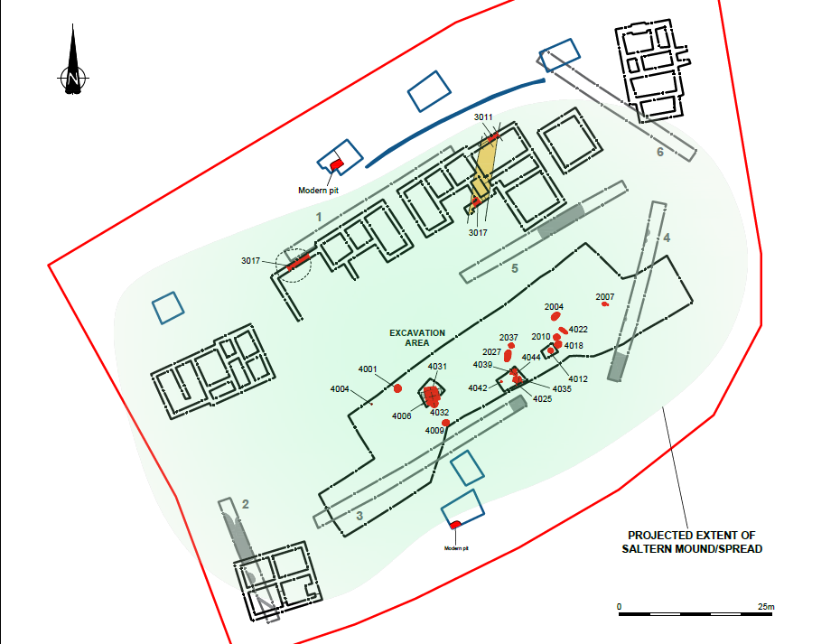
Figure 3: The Beacon Hill excavation plan (Podbury 2022)

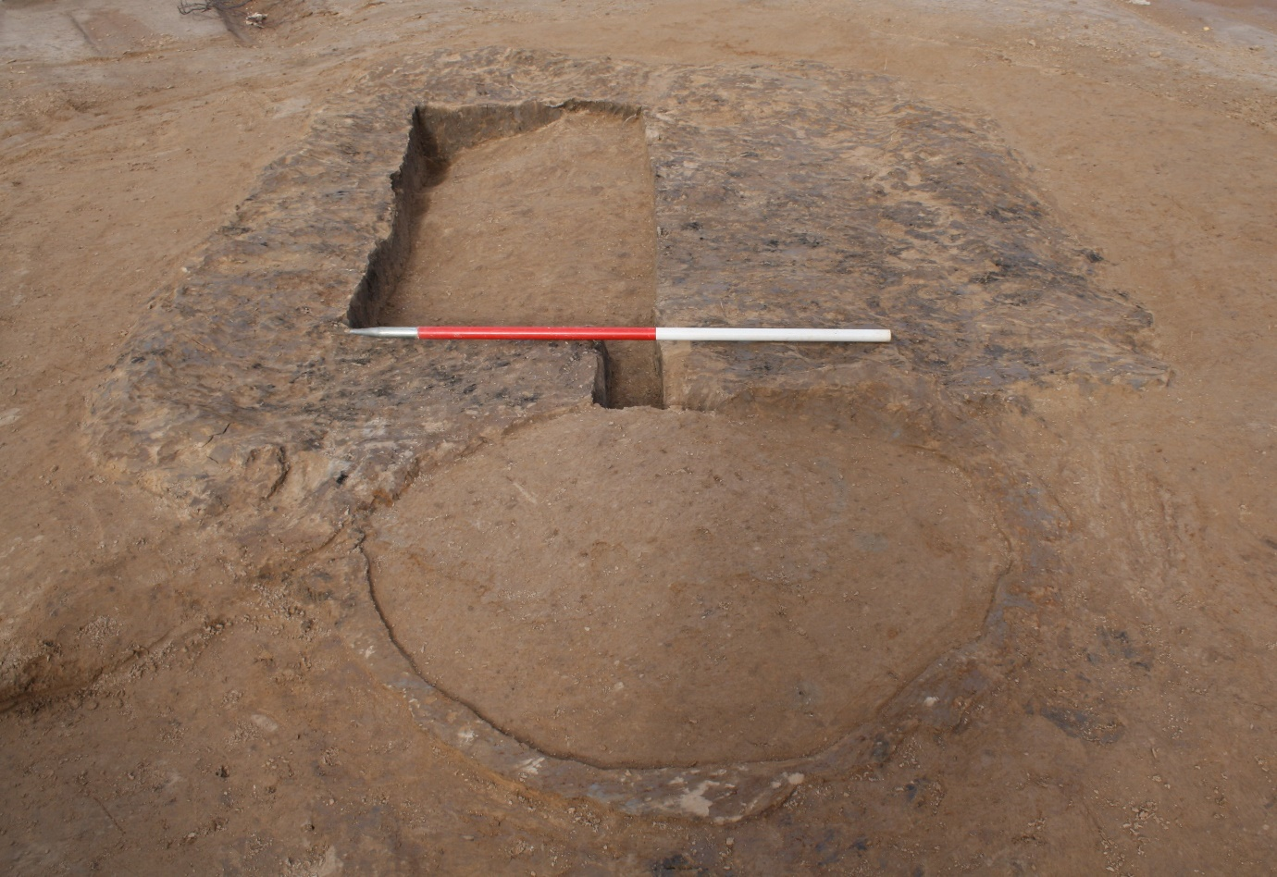
Figure 4: An example of a well-preserved silt filtration unit at Beacon Hill (Podbury 2022)

Target Audiences for Dissemination

The findings of the excavation at Beacon Hill, given the character and research context of the remains, would be of interest to a range of individuals and groups. The excavations, in particular, are of interest to the academic community that undertakes research on traditional salt making. The ECOSAL-UK organisation best represents this community as an active network of organisations, sites, bodies, and individuals with an interest in historic salt making in the United Kingdom (ECOSAL-UK 2013). More generally, the results of the excavation would be of interest of archaeologists working in Norfolk, particularly those with an interest in the medieval period and the wetlands of the Fens. This community is probably best represented by the Norfolk and Norwich Archaeological Society (NNAS 2022a), and the wider Federation of Norfolk Archaeological and Historical Organisations (FNAHO 2016). In addition to those communities intrinsically active in archaeology and heritage, the local community of Orange Row and Terrington St Clement represent a target audience. Constituting part of this local community are the members of the Terrington St Clement History Group (TSCHG 2008), which has recently been relatively inactive. The local community, nonetheless, includes those who have hitherto not taken part in archaeological projects or organisations.

Dissemination Strategy

The following discussion on the dissemination strategy will consider the significance of the excavation at Beacon Hill so that appropriate mediums can be identified. The differing mediums of dissemination may be employed to target specific audiences outlined above. The project will adhere to the Standard and Guidance for Archaeological Excavation (CIfA 2020: 14) which, in reference to publication and dissemination, states that “consideration should be given to publicising the results of the project through a range of outlets, from conventional archaeological publications to, for example, site viewing platforms, interpretation panels and lectures, open days and school visits, radio and television programmes, videos and popular publications and the Internet”. There are mediums for dissemination that have not been assessed in the following sections due to their clear unsuitability in the context of the small-scale development-led Beacon Hill project. These include the installation of viewing platforms with interpretation panels, and promotion through radio or television programmes.

Grey Literature, Publicly Accessible Databases, and the HER

As specified within the Written Scheme of Investigation (WSI) (Wardell Armstrong 2021), following the compilation of the Post-Excavation Assessment and Updated Project Design (PXA and UPD) (Podbury 2022), a grey literature report in the form of a Research and Archive Report (RAR) will be produced and suitably disseminated (Appendix 1). The resulting report and pertinent project information will then be uploaded to Online Access to the Index of Archaeological Investigations (OASIS), so that the findings of the excavation can relayed to the relevant Historic Environment Record (HER). Inclusion within the HER is essential, regardless of the significance of the findings, as it represents the principle means through which to disseminate and access archaeological data (Illsley 2019). Likewise, assuming that funding has been provisioned for this exhaustive approach, the data collected and produced during the project – including but not limited to grey literature reports, specialist reports, databases, drawn and digitised plans, digital photographs, context sheets, and appropriate paradata – would be made publicly available through the Archaeological Data Service (ADS). The deposition of a comprehensive dataset related to the Beacon Hill excavation with a publicly accessible digital repository not only makes the data easily accessible to all, a critical objective for all effective research communication (Finch 2012), it facilitates effective reuse and reinterpretation (Richards 2016; Richards 2017). Such open access has the potential to enable accountability and transparency (Lake 2012), and wider access may promote participation in archaeology and heritage (Kansa et al 2013).

Conventional Archaeological Publication

The relatively limited scale and significance of the excavation negates the necessity to produce a costly print monograph or an e-monograph, like those published by Internet Archaeology. A large-scale intrusive investigation of the wider saltern complex within the adjacent field to the south (Fig.2), however, may be of the required significance and scale to justify the production of a monograph – akin to that produced in relation to the excavations of Romano-British salterns at Helpringham and Holbech St Johns in Lincolnshire (Bell et al 1999). Rather, with regards to conventional archaeological publication, the most appropriate medium for dissemination is a peer-reviewed journal.

There are, broadly, four types of archaeological peer-reviewed journals: the international journal, the national journal, the regional journal, and the thematic journal. In consideration of the findings of the excavation at Beacon Hill, it is deemed that they are not of the required significance to justify inclusion within an ‘international’ journal. The investigation, for example, has not hitherto provided significant new insights into the international trade and exchange of salt during the medieval period. Such significant insights on a global scale would justify publication within an international journal, like that by Forsythe et al (2019) within World Archaeology on the production of salt in post-medieval Ireland and the associated colonial networks of trade.

As noted above, the excavations at Wainsfleet revealed probably the best-preserved and most coherently systematized medieval salt production site in Britain to date. These excavations were included within the generally ‘national’ journal, Medieval Archaeology, and outlined the ‘sand washing’ processes employed on the site and across Britain during the period (McAvoy et al 1994). Comparatively, the results of the investigation at Beacon Hill are of lower significance; they do not provide significant new insights into the processes used to produce salt, or specific dynamics of trade and ownership, nor were they of comparable scale or equivalently well-preserved. The saltworking structures uncovered have been reported on from a number of medieval sites (e.g. Owen 1975; McAvoy 1994; McAvoy et al 1994; Albone 1999; Clarke 2016; Clarke 2017; Clarke 2018a; Clarke 2018b; Blackbourn 2019; Knight and Clarke 2019; Kwiatkowska 2020). Furthermore, in comparison to one of the 8th or 9th century salterns excavated during the Lynnsport investigations (Clarke 2018b: 410), the saltern at Beacon Hill is not a particularly early example. On the whole, the excavation at Beacon Hill has not produced any new findings that are of the significance or rarity to be included within a ‘national’ journal.

Moreover, the artefactual assemblages retrieved during the investigation are not of the requisite quantity or uniqueness to be the exclusive focus of a journal article – akin to that by Hughes et al (2017) in Britannia, the subject matter of which was briquetage from a Romano-British saltern in Woolavington, Somerset. Similarly, the palaeoenvironmental findings are not significant enough to justify inclusion within a specialist journal that is focused on environmental archaeology, like that by Van Geel and Borger (2005) which focussed on the burning of Eel-grass (Zostera marina L.) at medieval salterns in Holland. Indeed, none of the findings are of the scale or significance to justify the publication of a data paper, like those published by Internet Archaeology and the Journal of Open Archaeology Data.

Given the inherently specialist subject matter, it would logically follow that the findings would be published in a thematic journal focused on the production of salt. Nevertheless, there is currently no such journal currently operating. The Journal of Salt History / Annales d’Histoire du Sel (GES 2017) would have been a suitable vehicle for dissemination; however, the journal has not published an issue since 2017. As such, targeted dissemination to the academic community that undertakes research on traditional salt making is to be conducted by differing means which will be outlined below.

In consideration of the significance of the Beacon Hill excavation, the most suitable vehicle for peer-reviewed publication is the regional journal, Norfolk Archaeology. The investigation is the first sizable excavation of the substantial salt production centre focused around Terrington St Clement, which was second only to that associated with King’s Lynn in medieval Norfolk (Silvester 1988; Hall and Coles 1994). The findings are of particular regional significance, not only because of the importance of salterns to the local monastic economy and local community, but also because of their relationship to the Fenland environment and the monumental medieval Sea Bank that traverses much of the western portion of the county (NHER 2187); topics which have been the subject of significant synthesis and study (e.g. Silvester 1988b; Hall and Coles 1994; Albone et al 2007; Darby 2011; Oosthuizen 2016; Oosthuizen 2017). Prior to the compilation of the journal article, the editor will be consulted on the suitability of the project and any particular themes that may be of interest to its readership. Dissemination through Norfolk Archaeology would make the findings of the investigation available to academic and commercial archaeologists with a particular interest in Norfolk; it must be noted, however, that the new issues of the journal are unfortunately not accessible online.

Magazine and Newsletter Dissemination

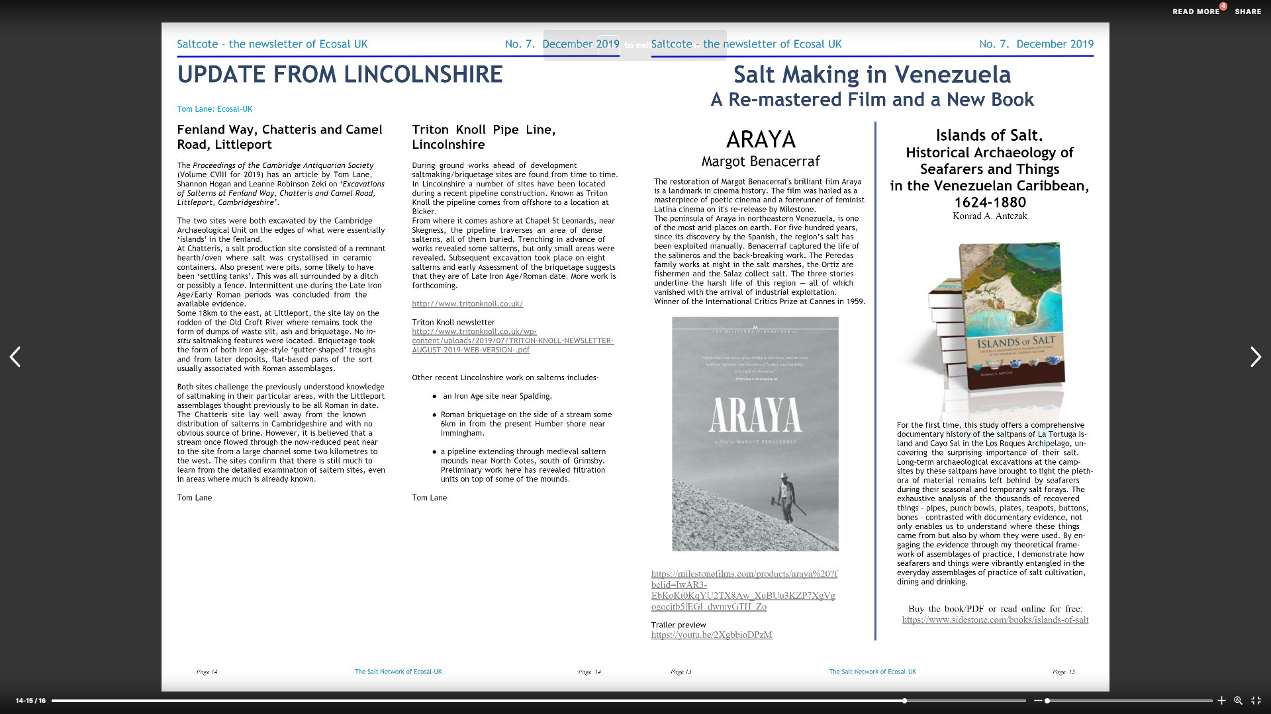
Beyond traditional publication, it is necessary to make those who study traditional salt production aware of the investigation. The abovementioned ECOSAL-UK organisation annually publishes an online magazine/newsletter, Saltcote. A note detailing the Beacon Hill investigation should be published within Saltcote, referencing any publications and outlining the findings of the excavation. It is envisaged that this note would be comparable to that produced by Lane (2019) (Fig.5), which circulated the results of an investigation of a late Iron Age or early Romano-British salt production site in Littleport and Chatteris, Cambridgeshire (Lane et al 2019).
Figure 5: The note on the Littleport excavation within Saltcote (Lane 2019)

Talks, Conferences, and Symposiums

In addition to circulation in Saltcote, it would be beneficial to hold a talk on the findings to disseminate the results amongst the salt production specialists. Recently, during the CIfA Innovation Festival in October of 2022 (CIfA 2022), ECOSAL-UK ran a session on the archaeology of salt production and the recent work of their members. Although this opportunity has passed, such an event would have been an ideal occasion to circulate the findings from Beacon Hill. There are no ECOSAL-UK events scheduled in the near future, but any opportunity to address its members at a conference or event should be seized. Indeed, an informal proposal will be put forward to ECOSAL-UK offering to hold a session on the excavation.

Although the findings are not of the requisite significance to justify a session at an event comparable to the 2018 Terra Saline International Symposium (SPF 2018), a collaborative session on the Lynnsport and Beacon Hill excavations and the wider medieval salt production industry in north-western Norfolk with Oxford Archaeology may have been suitable. Nonetheless, the Beacon Hill investigation would certainly be a secondary partner in this endeavour, and it is currently considered unlikely due the requirement of significant pre-planning for both parties.

More realistically, a talk should be held for the members of the Norfolk and Norwich Archaeological Society (NNAS). This would appropriately disseminate the results amongst interested parties of archaeologists and interested amateurs in Norfolk. Notably, the talk would follow on from a lecture on the landscape archaeology of salt working in the Broads by Tom Williamson in February of 2022 (NNAS 2022b). Alternatively, a lecture could be held in association with the Terrington St Clement History Group. However, given the comparably small size of the group and its recent inactivity, a talk addressing the NNAS is preferable. Feedback forms should be given to attendees of any talks so that we can assess what worked, and what did not. This will mean that ‘impact’ of the event can be demonstrated, rather than being judged solely on attendance figures.

Online Dissemination

The Beacon Hill excavation should also be disseminated widely, following agreement from the client, on a range of social media platforms – namely LinkedIn, Facebook and Twitter. Not only does this spread awareness of the investigation to academic and commercial archaeologists (Terras 2012; Lowe 2014; Walker 2014), it has the potential to reach and engage with the general public and non-traditional audiences (Russo et al 2009; Walker 2014). The social media content – alongside descriptions of the project and the results – could include photographs of some of the decorative pottery recovered, health and safety conscious working shots, and status updates that ask for users’ opinions on topics relevant to the project in order to elicit contributions from users and promote public dialogue.

In addition to social media, the Beacon Hill excavation should be promoted on the Wardell Armstrong LLP company website. This is another avenue for archaeologists and the public to become informed about the investigation. Indeed, promotion of the identification of a 17th century wall-painting in Hertfordshire on the Wardell Armstrong LLP (WA 2021) website resulted in numerous enquiries, including from members of local archaeology groups and national wall-painting specialists.

The Beacon Hill project is not of the required scale or significance to justify the creation of a blog exclusively focusing on the excavation or post-excavation programme. However, the project would have benefitted from its inclusion as a post within a more general blog, perhaps centring on the work of the excavating team. The post could be similar to an informal and conversational article about a roundhouse excavated in Alconbury in Cambridgeshire, named ‘Ring around the ro-undhouse’, which was published on the Oxford Archaeology Blog (Oxford Archaeology 2022). This is an easily accessible way to disseminate research in a timely manner and encourages participation in archaeology through integral two-way communication channels, which can reach academics, professionals and the general public (Caharer 2008; Kansa and Deblauwe 2011; Walker 2014).

Missed Opportunities for Dissemination

Opportunities for dissemination have been missed during the Beacon Hill project. Although likely unviable due to the development-led context and lack of funding for such an endeavour, the excavation could have been designed to employ a mixture of professional excavation and public participation. The excavation programme could have incorporated significant participant opportunities for local people and interested communities through structured field training. This programme, although certainly not focussed on archaeological remains of similar significance, could have been designed to be broadly comparable with the Pontefract Castle excavation by DigVentures (Wilkins et al 2021). Guided tours of the site during the excavation for local people and members of the Terrington St Clement History Group should have been organised. Likewise, the possibility of holding educational sessions during the excavation for school children from Terrington St Clement Community School and St Clement’s High School should have been considered. It has been argued that excavations facilitate learning through ‘doing, thinking, and feeling’, thus transferring knowledge effectively to the widest possible range of people (Jameson 1997; Simpson and Williams 2008).

While video diaries of the post-excavation process have their place, without a significant artefactual assemblage to present, the medium might have been better suited to an excavation that yielded more important artefactual and paleoenvironmental assemblages. A video diary of the excavation process, however, would have been suitable and could have been disseminated via social media. Indeed, the craft process of medieval salt production arguably suits this medium. Each step of the ‘sand-washing’ process could be described by an archaeologist whilst filming the excavation of features directly associated that stage of the process. For example, the filtration of the brine could have been described while excavating a silt filtration unit and the boiling of the resultant brine could be detailed while excavating a hearth.

Conclusions

The results of the excavation will be disseminated through a range of means in order to target the specific audiences outlined above. In summary, the ideal dissemination strategy devised includes:

- accessibility of the grey literature reports, archaeological data, and appropriate paradata through the ADS digital repository;
- inclusion of the results, via OASIS, within the Norfolk HER;
- publication of an article in the regional journal, Norfolk Archaeology;
- publication of an article of the ECOSAL-UK annual newsletter, Saltcote;
- organisation of a talk in association with ECOSAL-UK and/or the Norfolk and Norwich Archaeological Society;
- publication of posts on social media and on the Wardell Armstrong LLP website; and
- publication of an article on the general Wardell Armstrong archaeology blog.

It should be noted that not every aspect the dissemination strategy, beyond what is typically required for development-led projects, was included within the WSI (WA 2021) or incorporated within the budget for the project. Indeed, the specifications for publication and dissemination within the WSI were notably limited in scope and were largely designed to solely satisfy planning conditions (Appendix 1). In future, where viable, it is recommended that a more comprehensive strategy for dissemination is included within the initial project design and included when calculating budgets.

Bibliography

Adshead, S. (1992) Salt and Civilization. London: Palgrave Macmillan UK.
Albone, J. (1999) Archaeological Excavation Report: A late medieval or early post-medieval saltern at St Michael's Lane, Wainsfleet St Mary, Lincolnshire. Pre-Construct Archaeology report. Unpublished.
Albone, J., Massay, S. and Tremlett, S. (2007) The Archaeology of Norfolk’s Coastal Zone: Results of the National Mapping Programme. English Heritage Project Number 2913. English Heritage/Norfolk Landscape Archaeology.
Bell, A., Gurney, D. and Healey, H. (1999) Lincolnshire Salterns: Excavations at Helpringham, Holbech St. Johns and Bicker Haven. East Anglian Archaeology Monograph 89.
Besterman, J. C. (1974) ‘Frisian Salt and the Problem of Salt-Making in North Holland in the Carolingian Period’, Berichten van de Rijksdienst voor het Oudheidkundig Bodemonderzoek, 24, pp.171-174.
Blackbourn, K. (2019) Late Saxon to Early Medieval Salterns at Lynnsport 1: Land South of Aconite Road, King’s Lynn, Norfolk: Post-Excavation Assessment and Updated Project Design. Oxford Archaeology East report. Unpublished
Bouhier, C. (1978) ‘Les établissements religieux de Noirmoutier et le commerce du Sel’, Lettres aux Amis, 32, pp.24-28.
Bouhier, C. (1980) ‘Les marais salants de l’Île de Noirmoutier’, Lettres aux Amis, 39, pp.11-14.
Boutin, E. and Guitteny, M. (1992) Le sel de l’Atlantique. Les secrets de l’or blanc. Fromentine: Éditions de l’Étrave.
Chartered Institute for Archaeologists (CIfA) (2020) Standard and Guidance for Archaeological Excavation. Reading: Chartered Institute for Archaeologists.
Chartered Institute for Archaeologists (CIfA) (2022) Innovation Festival. Available at: https://www.archaeologists.net/innovation-festival (Accessed: 7 December 2022).
Clarke, G. and Clarke, R. (forthcoming) ‘A Tale of Two Salterns: Recent Excavations at Walpole St Peter and Gaywood’ Norfolk Archaeology.
Clarke, G. (2016) A Late Saxon to Medieval Saltern at Marsh Lane, King’s Lynn, Norfolk: Archaeological Excavation. Oxford Archaeology East report. Unpublished.
Clarke, G. (2017) Lynnsport 4 & 5: Middle to Late Saxon Salterns on Land Adjacent to Greenpark Avenue, King’s Lynn, Norfolk: Post-Excavation Assessment and Updated Project Design. Oxford Archaeology East report. Unpublished.
Clarke, G. (2018a) Lynnsport 1: Land South of Aconite Road, King’s Lynn, Norfolk: Archaeological Evaluation. Oxford Archaeology East report. Unpublished.
Clarke, G. (2018b) ‘Saxon Salt-Making Works Exposed by Excavations Along Salter’s Waie, King’s Lynn’, Medieval Archaeology, 62(2), pp.401-423.
Cope-Faulkner, P. (2014) ‘A Medieval Salt Making Complex in King’s Lynn: Investigations and the Former Queen Mary’s Nurses Home, 2002-2003’, Norfolk Archaeology, 47, pp.67-86.
Darby, H. C. (2011) The Medieval Fenland. Cambridge: Cambridge University Press.
ECOSAL-UK (2013) Preserving the History and Heritage of Traditional Salt Making. Available at: http://www.ecosal-uk.org.uk/about.html (Accessed 7 December 2022).
Federation of Norfolk Archaeological and Historical Organisations (FNAHO) (2016) Federation of Norfolk Archaeological and Historical Organisations. Available at: https://federation-norfolk.co.uk/home.html?name=Home (Accessed 7 December 2022).
Finch, J. et al. (2012) Accessibility, sustainability, excellence: how to expand access to research publications. Research Information Network.
Forsythe, W., McConkey, R. and Breen, C. (2018) ‘Persistence and risk: salt production in post-medieval Ireland’, World Archaeology, 50(4), pp.603-619.
GES (2017) Journal of Salt History / Annales d’Histoire du Sel / Jahrbuch für Salzgeschichte. Available at: http://www.salzgeschichte.net/ (Accessed 7 December 2022).
Grady, D. (1998) ‘Medieval and post-medieval salt extraction in north-east Lincolnshire’, in Bewley, R. (ed.) Lincolnshire Archaeology from the Air. Occasional Papers in Lincolnshire History and Archaeology No.11.
Gurney, D. and Penn, K. (1998) ‘Excavations and Surveys in Norfolk 1997’. Norfolk Archaeology, 43, pp.193-210.
Hall, D. and Coles, G. (1994) Fenland Survey: An Essay in Landscape and Persistence. Swindon: English Heritage.
Harding, A. (2021) Salt: White Gold in Early Europe. Cambridge: Cambridge University Press.
Hughes, S., Payne, N. and Rainbird, P. (2017) ‘Salt of the Hearth: Understanding the Briquetage from a Later Romano-British Saltern at Pyde Drove, near Woolavington, Somerset’, Britannia, 48, pp.117-133.
Hutcheson, A.R.J. (1998) Report on an Archaeological evaluation at land adjacent to No. 74 New Roman Bank, Terrington St. Clement. Norfolk Archaeological Unit report. Unpublished
Illsley, W. R. (2019) ‘Problematising the Historic Environment Record: Comments on Persistent Issues in England and Sweden’, Conservation and Management of Archaeological Sites, 21(2), pp.113-134.
Jameson, J. (1997) Introduction, in Jameson, J. (ed.) Presenting archaeology to the public: digging for truths. Walnut Creek: Altamira.
Kansa, E. C., Kansa, S. W. and Goldstein, L. (2013) ‘On ethics, sustainability, and open access in archaeology’, SAA Archaeological Record, 13(4), pp.15-22.
Knight, T. and Clarke, G. (2019) Late Saxon to Early Medieval Salterns on Land North of Greenpark Avenue, Kings Lynn, Norfolk: Post-Excavation Assessment and Updated Project Design. Oxford Archaeology East report. Unpublished.
Kwiatkowska, M. (2020) Late Saxon to Early Medieval Saltern and Lynnsport 3: Land South of Front Way, King’s Lynn, Norfolk: Post-Excavation Assessment and Updated Project Design. Oxford Archaeology East report. Unpublished.
Lake, M. (2012) ‘Open Archaeology’, World Archaeology, 44(4), pp.471-478.
Lane, T. (2019) ‘Fenland Way, Chatteris and Camel Road, Littleport’, Saltcote, 7, pp.14.
Lane, T., Hogan, S., Robinson-Zeki, L., Fryer, V., Irving, A. and Perrin, R. (2019) ‘Excavations of Salterns at Fenland Way, Chatteris and Camel Road, Littleport, Cambridgeshire’, Proceedings of the Cambridge Antiquarian Society, 108, pp.51-72.
Lloyd-Smith, L. and Clarke, P. (2021) Beacon Hill Farm, Terrington St Clement, Norfolk: Archaeological Trial Trenching. Wardell Armstrong LLP. Unpublished.
Lowe, J. (2014) Building a ‘community of archaeologists’ and the value of social media. Available at: http://c-u-d-i.blogspot.co.uk/2014/05/building-community-of-archaeologists.html (Accessed 7 December 2022).
Ludlow, C. G. (1993) A history of salt in Ireland with special reference to the salt manufacturing industry. Unpublished PhD Thesis. Queens University Belfast.
McAvoy, F. (1994) ‘Marine salt extraction: The excavation of salterns at Wainfleet St Mary, Lincolnshire’, Medieval Archaeology. 38(1), pp.134-163
Miller, E. and Hatcher, J. (2014) Medieval England: Towns, Commerce and Crafts, 1086-1348. London: Taylor & Francis.
Norfolk and Norwich Archaeological Society (NNAS) (2022a) Norfolk and Norwich Archaeological Society. Available at: https://www.nnas.info/ (Accessed 7 December 2022).
Norfolk and Norwich Archaeological Society (NNAS) (2022b) A landscape archaeology of salt working in the Broads. Available at: https://www.nnas.info/a-landscape-archaeology-of-salt-working-in-the-broads/ (Accessed 7 December 2022).
Oosthuizen, S. (2016) ‘Culture and identity in the early medieval fenland landscape’, Landscape History, 37(1), pp.5-24.
Oosthuizen, S. (2017) The Anglo-Saxon Fenland. Oxford: Oxbow Books.
Owen, A. (1975) ‘Medieval saltmaking and the coastline in Cambridgeshire and north-west Norfolk’, in De Brisay, K (ed.) Salt: The Study of an Ancient Industry. Colchester: Colchester Archaeological Group.
Oxford Archaeology (2022) Ring around the ro-undhouse. Available at: https://blog.oxfordarchaeology.com/ring-around-the-ro-undhouse/ (Accessed 7 December 2022).
Podbury, L. (2022) Beacon Hill, Terrington St Clement, Norfolk: Post-Excavation Assessment and Updated Project Design. Wardell Armstrong LLP report. Unpublished.
Pollard, J., Hall, D. and Lucas, G. (2001) ‘Excavation of a Medieval Saltern at Parson Drove, Cambridgeshire’ in Lane, T and Morris, E (eds.) A Millennium of Saltmaking: Prehistoric and Romano-British Salt Production in the Fenland. Heckington: Heritage Trust of Lincolnshire.
Richards, J. D. (2016) ‘Managing digital preservation and access: The Archaeology Data Service’, in McManamon, F.P., Stout, A. and Barnes, J.A. (eds.) Managing Archaeological Resources: Global context, national programs, local actions. London: Routeledge
Richards, J. D. (2017) ‘Twenty Years Preserving Data: A View from the United Kingdom’, Advances in Archaeological Practice, 5(3), pp.227-237.
Ridgeway, V. (2000) ‘A Medieval Saltern Mound at Millfields Caravan Park, Bramber, West Sussex’, Archaeological Collections, 138, pp.135-152.
Russo, A., Watkins, J. and Groundwater-Smith, S. (2009) ‘The impact of social media on informal learning in museums’, Educational Media International, 46(2), pp.153-166.
Silvester, B. (1988a) ‘The Norfolk Fens’, Antiquity, 62(235), pp.326-330.
Silvester, R. J. (1988b). The Fenland Project No.3: Norfolk Survey, Marshland and the Nar Valley. East Anglian Archaeology 45.
Simpson, F. and Williams, H. (2008) ‘Evaluating Community Archaeology in the UK’, Public Archaeology, 7(2), pp.69-90.
Société Préhistorique Française (SPF) (2018) International Symposium on Salt - Terra Salina 2018.Available at: https://www.prehistoire.org/offres/gestion/actus_all_515_32716-1/international-symposium-on-salt-terra-salina-2018-call-for-posters.html (Accessed 7 December 2022).
Terras, M. (2012) ‘The impact of social media on the dissemination of research. Results of an experiment’, Journal of Digital Humanities, 1(3). Available at: http://journalofdigitalhumanities.org/1-3/the-impact-of-social-media-on-the-dissemination-of-research-by-melissa-terras/
Terrington St Clement History Group (TSCHG) (2008) Terrington St Clement History Group. Available at: http://www.terringtonhistory.co.uk/index.htm (Accessed 7 December 2022).
Timberlake, S. (2008) Plot 13, Hamburg Way, North Lynn Industrial Estate, King’s Lynn, Norfolk: An Archaeological Evaluation. Cambridge Archaeological Unit report. Unpublished.
Trimble, G. (2003) A Report on the Archaeological Evaluation at 103 St Peter’s Road, West Lynn, Norfolk. Norfolk Archaeological Unit report. Unpublished.
Van Geel, B. and Borger, G. J. (2005) ‘Evidence for medieval salt-making by burning Eel-grass (Zostera marina L.) in the Netherlands’, Netherlands Journal of Geosciences, 84(1), pp.43-49.
Walker, D. (2014) ‘Antisocial Media in Archaeology’, Archaeological Dialogues, 21(2), pp.217-235.
Walker, D. (2014) ‘Decentering the Discipline? Archaeology, museums and social media’, Online Journal in Public Archaeology, 77-102. DOI: http://dx.doi.org/10.23914/ap.v4i2.61
Wardell Armstrong (WA) (2021) Beacon Hill Farm, Terrington St Clement, Norfolk: Project Design for Archaeological Excavation and Works Under Archaeological Supervision and Control. Wardell Armstrong LLP report. Unpublished.
Wardell Armstrong LLP (WA) (2021) A ‘Rare and Important’ Discovery Leads to Historic Building Upgrade. Available at: https://www.wardell-armstrong.com/news/a-rare-and-important-discovery-leads-to-historic-building-upgrade/ (Accessed 7 December 2022).
Wilkins, B., Casswell, C., Eno, M., Harris, M., Pina-Dacier, M., Tatton, H. and Ungemach, J. (2021) ‘Social Impact Archaeology: Pontefract Castle and the Gatehouse Project’, Internet Archaeology, 57. DOI: https://doi.org/10.11141/ia.57.18

APPENDIX 1: The Dissemination and Publication Methodology (WA 2021)

The project will be registered with the Online AccesS to the Index of archaeological investigationS (OASIS), where a digital copy of the report will be made available.

Wardell Armstrong will make arrangements for the deposition of the final Site archive with the Norwich Castle Museum and all documents, artefacts and any other material associated with the project will be marked with a unique site code, Event number (TBC), during fieldwork, obtained from the NCC HES office. Following completion of the fieldwork, preparation of the site archive will be undertaken in accordance with the project specification, and the Archaeological Archives Forum recommendations (Brown 2011).

The final Site archive will include all project records and cultural material produced by the evaluation, and will be prepared in accordance with Guidelines for the Preparation of Excavation Archives for Long Term Storage (Brown 2011) and A Standard Guide to Best Practice for Archaeological Archiving in Europe (Perrin et al 2014). The receiving archive’s guidelines will also be adhered to.

A summary of the work will be submitted to the editor any relevant journals agreed with the LPA should the results of the fieldwork warrant this. For Client information this would incur an additional fee and would be set on the completion of the PXA and UPD.

Should the quality and quantity of the archaeology recovered warrant it, the strategy for site presentation as set out in the brief Section 7.2 Outreach & Public Engagement will be considered in consultation with the Client and NCC HES. All public outreach events, if required, will be conducted following consultation with and approval by the Client and NCC HES. In the current climate, the most likely outreach options would include the following with consideration given to other methods of engagement as appropriate:

• The issue of press releases to local media outlets;
• The use of web-based social media platforms utilised by Wardell Armstrong; and
• Pop-up displays in public places.

