

Tash Halley
2417049
Demonstration of Work

- Routing:
  - Routing in Swansea Network
Install Routing and Remote access Service and modify firewall rules to allow ICMP Traffic.
  - Routing in London Network
Configure persistent IP Forwarding and Routing

What is an Excellent work?
Configure RRAS in Windows, Persistent IP Forwarding and Routing in London with Firewall Rules Customized for each required services in both Swansea and London.

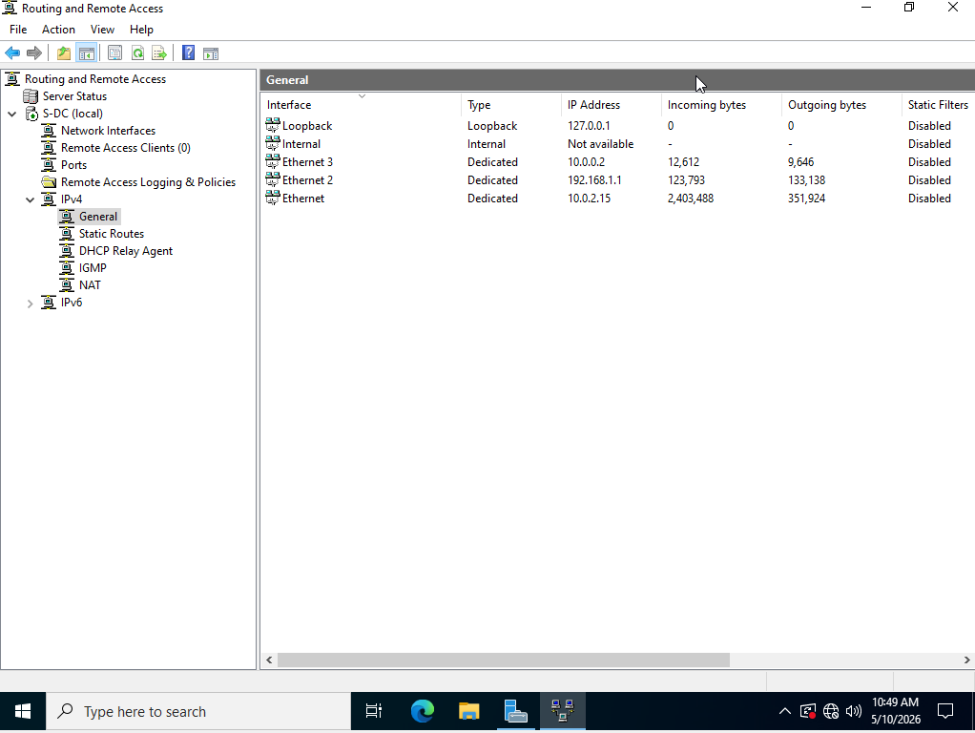

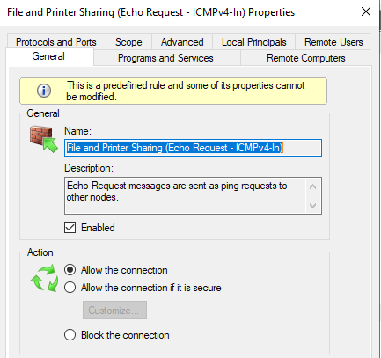
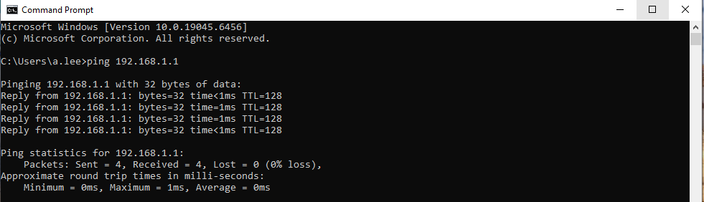
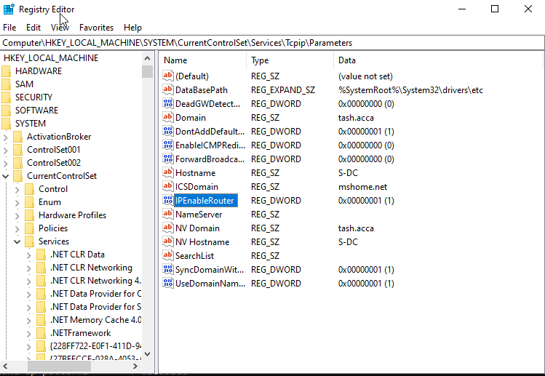
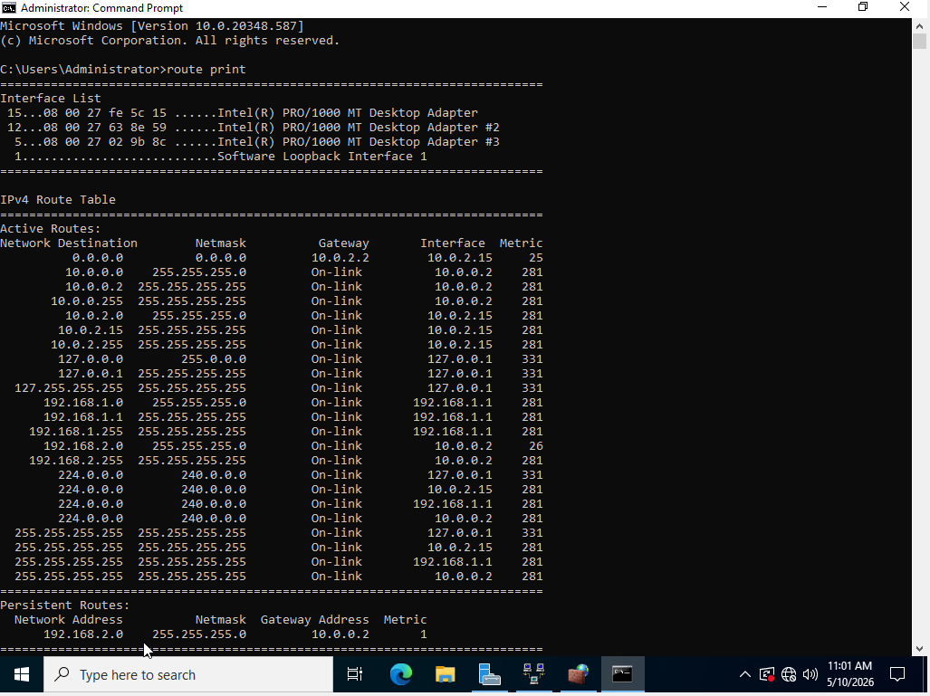

- Domain Server (Swansea)
  - Create a forest named yourname.acca (For example: nitheesh.acca)
  - Create all appropriate A records for all servers on Swansea and London Network
  - Create a reverse lookup zone creating PTR records for all servers.

What is an Excellent work?
Configure DC with a secure password policy. Include A records for critical infrastructure even if not explicitly listed, anticipating a realistic network setup and Ensure zones are configured to handle future IP allocations within the subnets

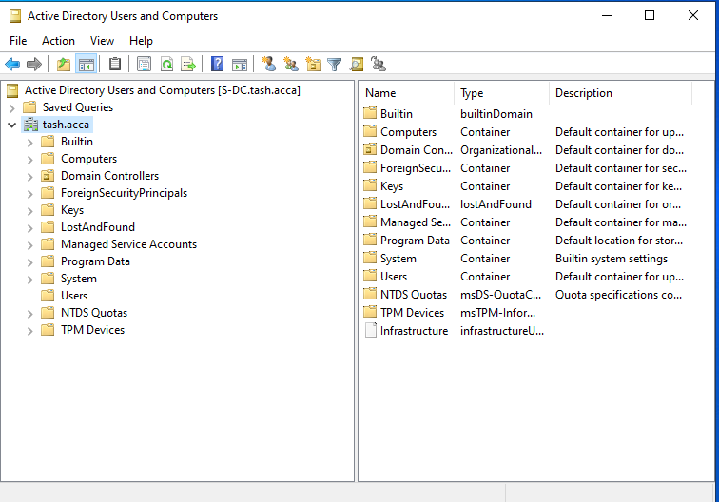
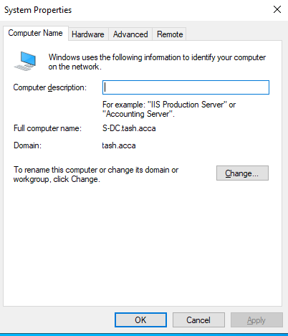

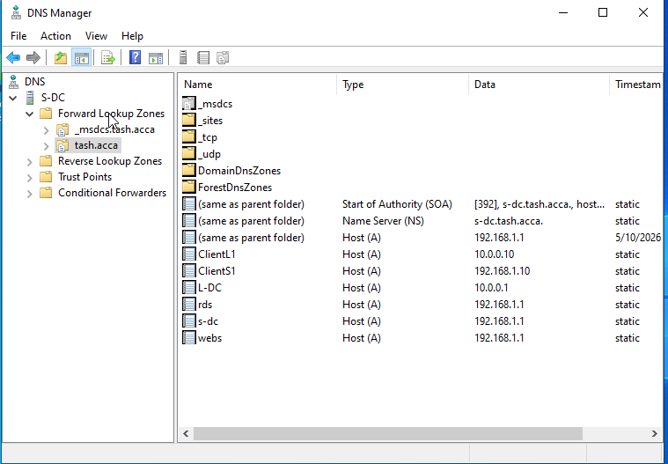
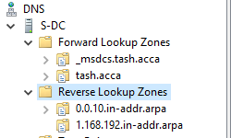
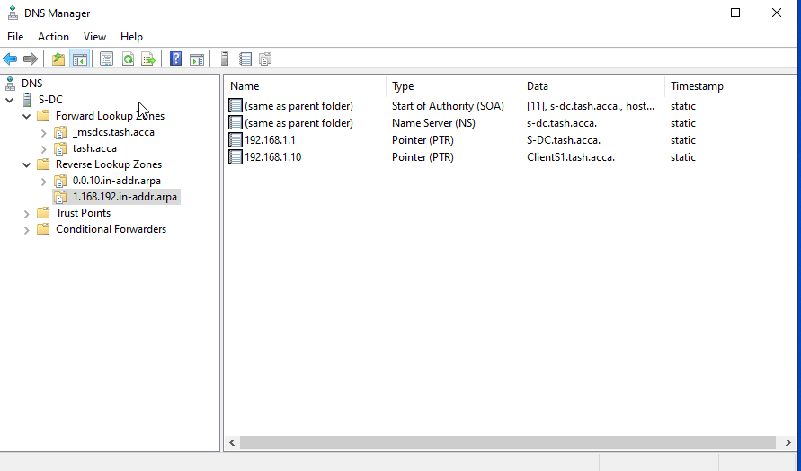

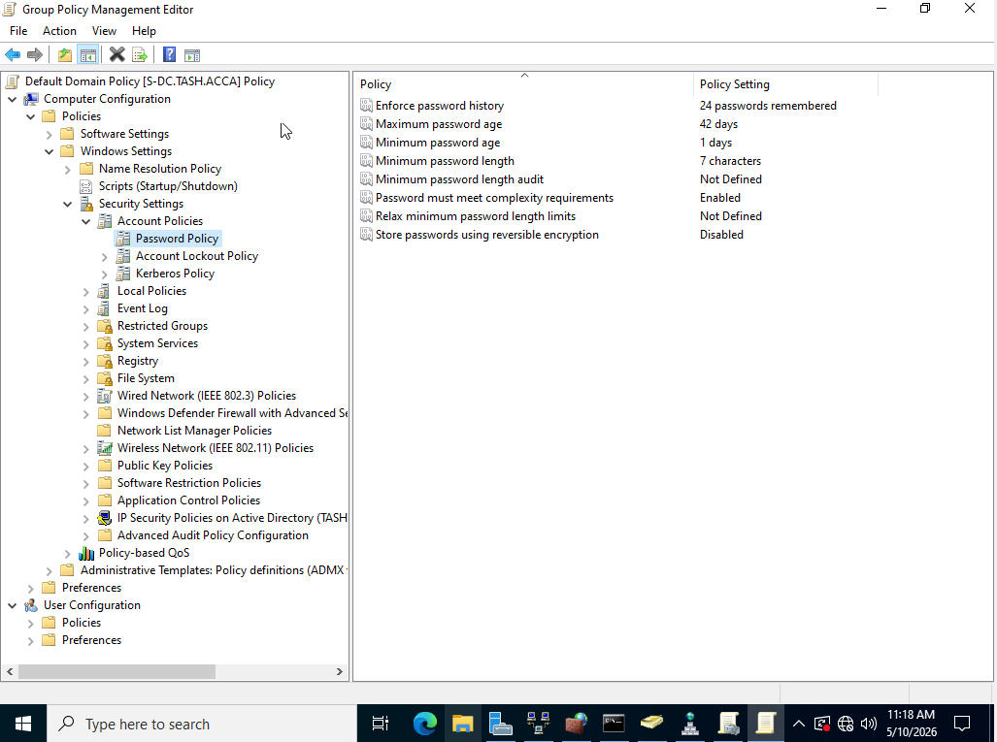

- Encrypted Connection between Swansea and London
  - Configure Site-to-Site VPN to London Network.

What is an Excellent work?
Setting up a successful Persistent connection between the two networks and using strong encryption with IKE etc
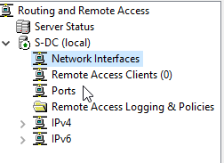
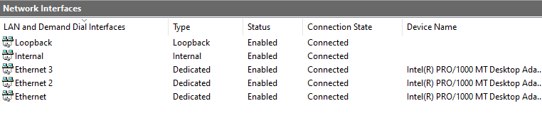

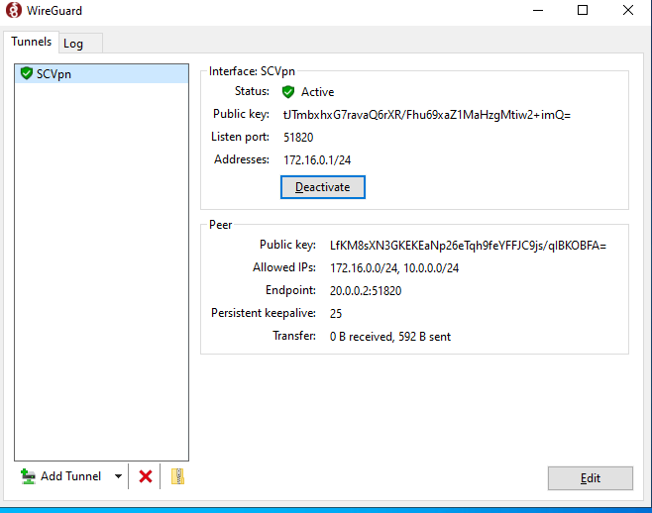
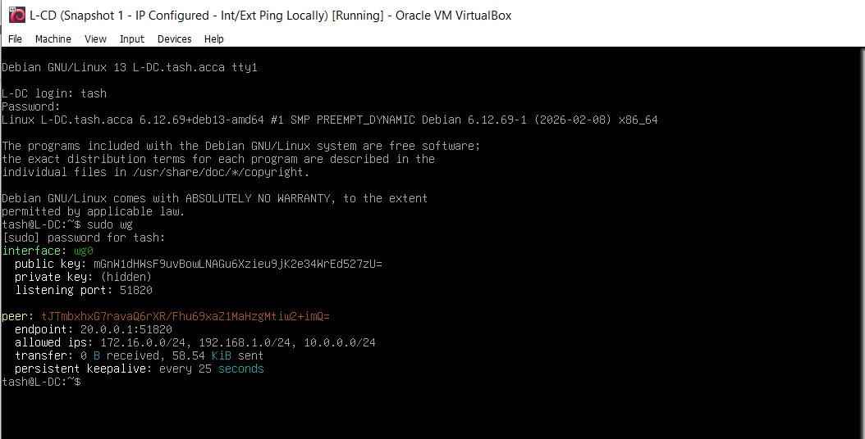

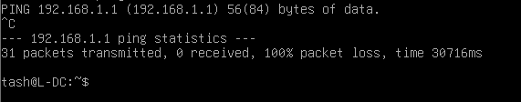

- Users
  - Create user accounts for yourname.acca domain with all the parameters defined in the users_list_updated.xlsx document. This document will be shared by your lecturer. You must use first letter from first name with a dot and last name as SAM Account Name.
Eg: First Name: Nitheesh Last Name: Kaliyamurthy. à n.kaliyamurthy.

What is an Excellent work?
Use PowerShell to bulk-create users from the Excel file, avoiding manual entry via Active Directory Users and Computers (ADUC) for efficiency and correct naming conventions are used.
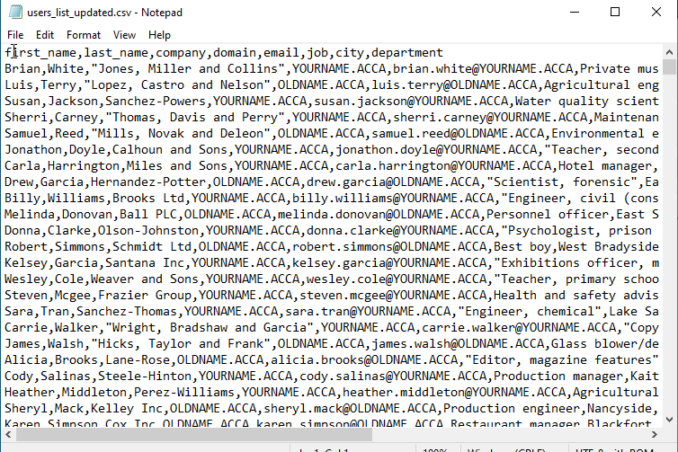
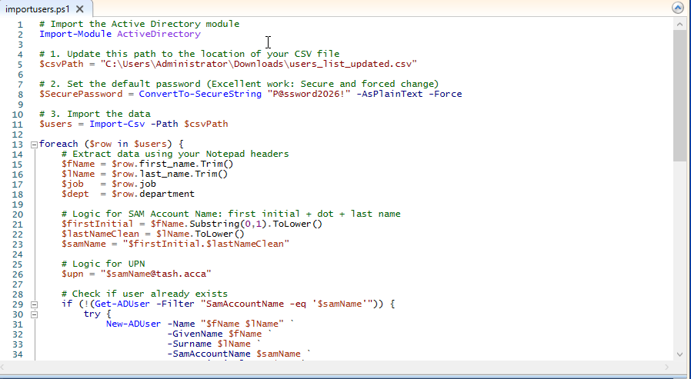
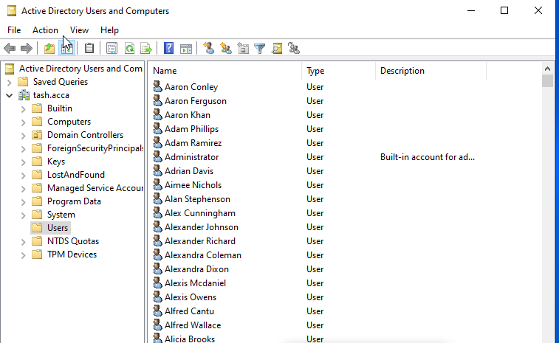
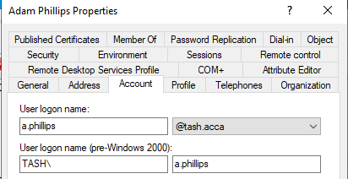
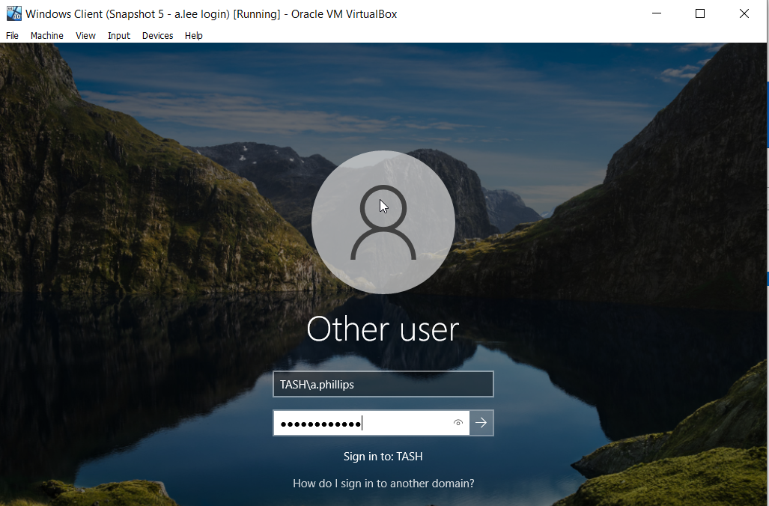
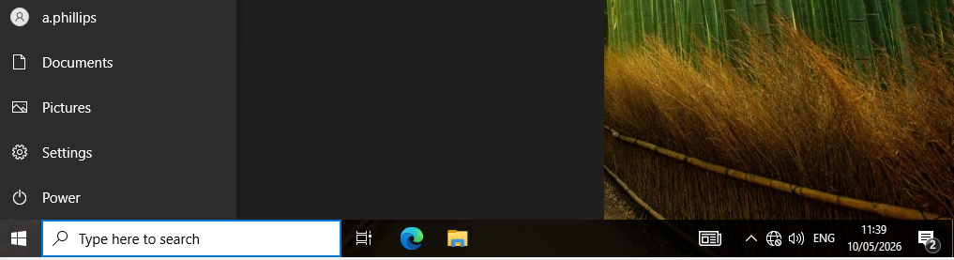

- Domain Membership
  - Join L-CD, ClientS1, ClientL1 to the yourname.acca domain.

What is an Excellent work?
Successfully joining all the systems to the domain, integrating with AD ensuring server authenticates users benchmarking industry best practices.
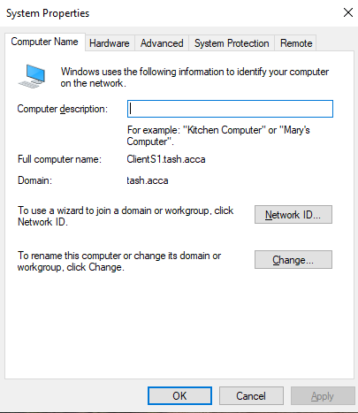
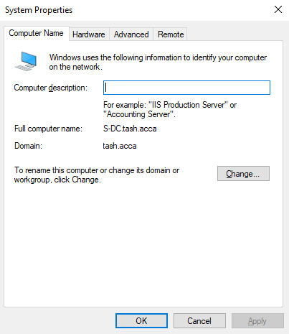
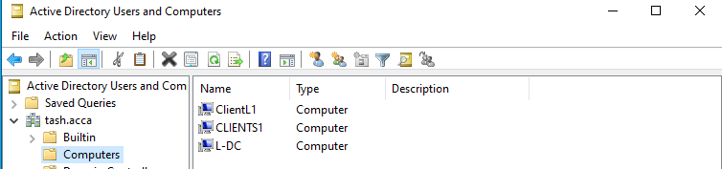

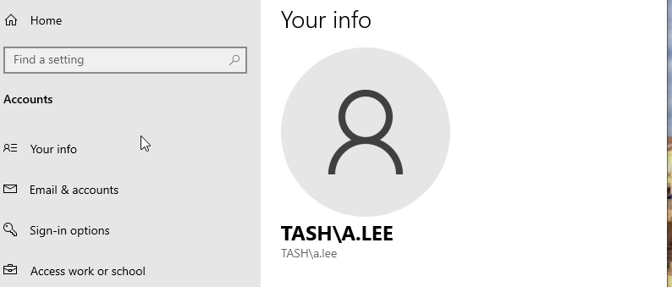

- DHCP Server
  - Configure S-DC as DHCP Server. The range is X.X.X.10 – X.X.X.20 for each network. Determine other DHCP options as per the infrastructure.
  - Configure L-CD as DHCP Relay Server.
  - All the Clients should receive IP Address automatically via DHCP Server

What is an Excellent work?
Successful allocation of IP Address from S-DC with Scope, Lease Duration, security in force. Using appropriate Group Policy to enforce client DHCP Settings is highly commended.
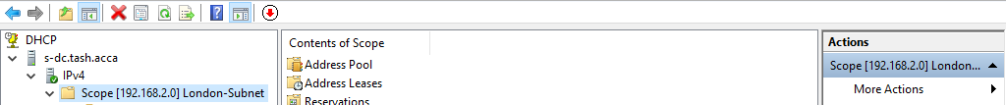
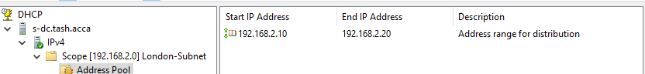
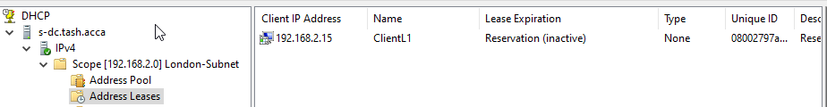
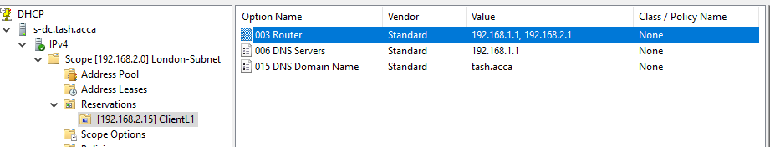
- Test and Troubleshoot
  - Test the network for Connectivity.
Note that at this stage, the Swansea and London networks are connected and fully operational. If not, Troubleshoot.
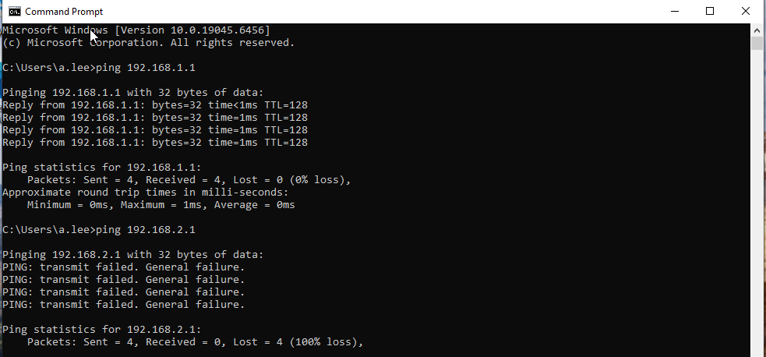
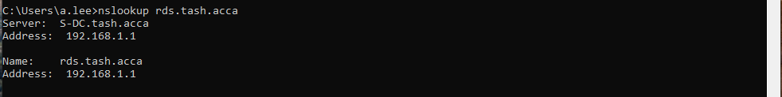
- Disk Drive
  - Mount second disk drive to E:\SwanseaFiles. Share and assign required permissions. Only the Domain Users need to have full control permissions and other network users have read only access.

What is an Excellent work?
The Drive should be accessible in both the networks with appropriate permissions.

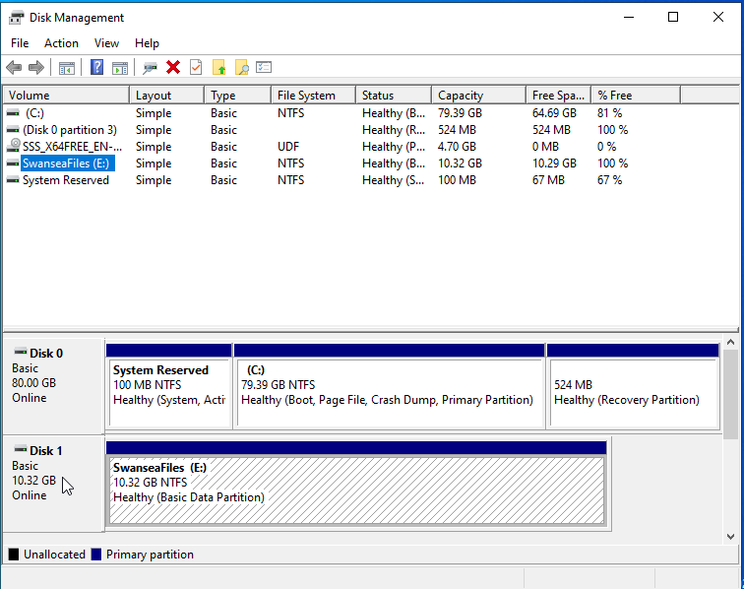
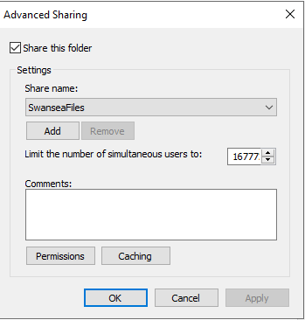

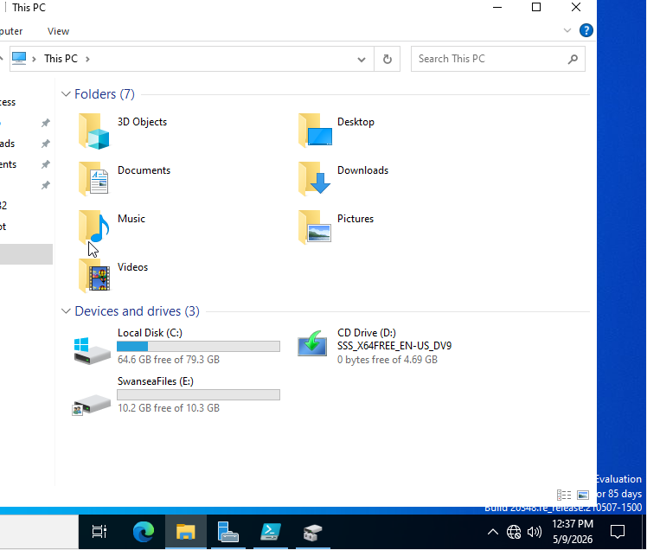

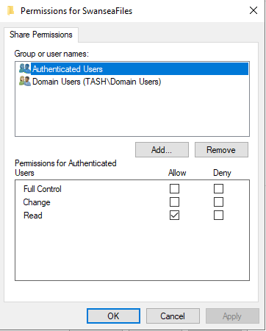

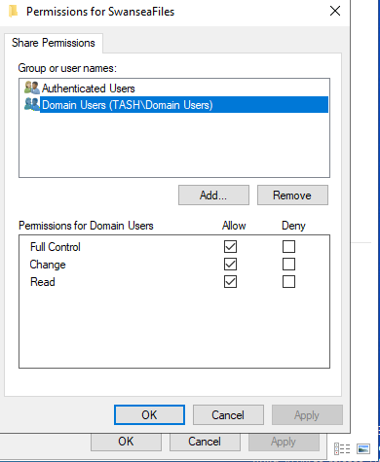
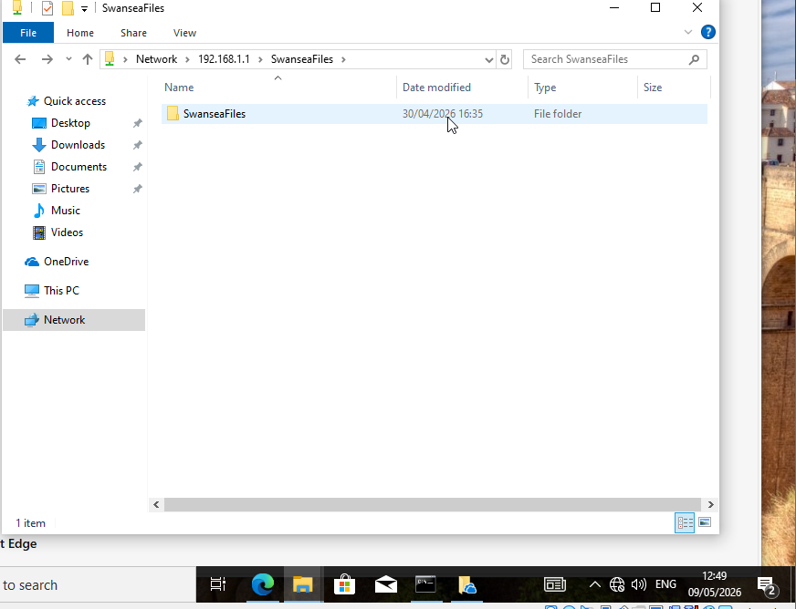

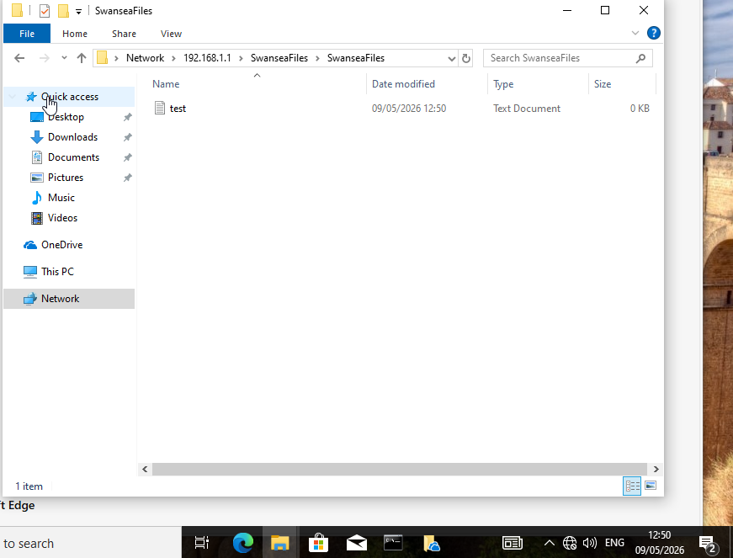

- IIS Server
  - Create webs.yourname.acca website and enable windows internal authentication.

What is an Excellent work?
The site should be https://webs.yourname.acca with all the domain users authenticated. All authenticated users should be presented a text “Welcome to Swansea Website”.
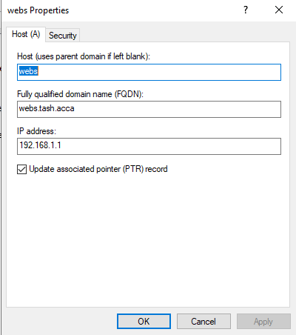
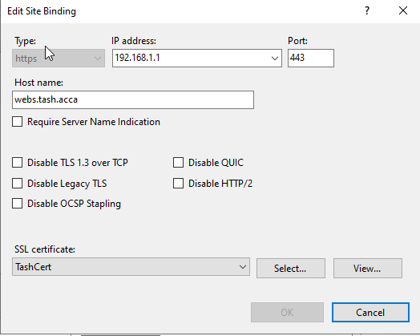
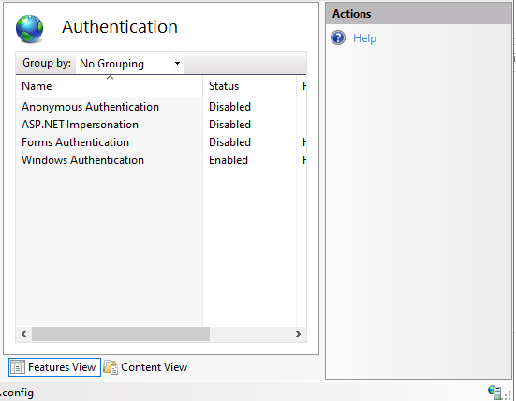
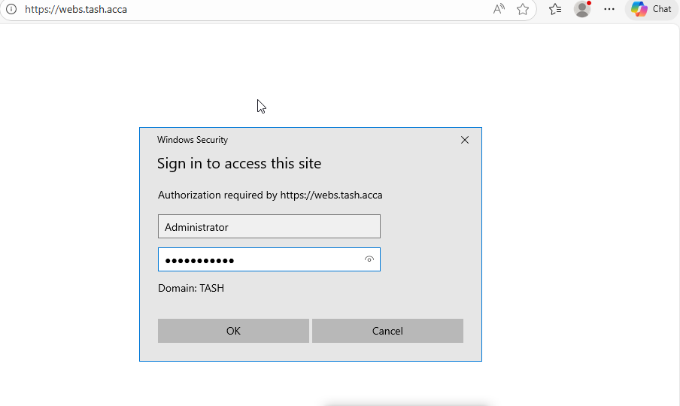

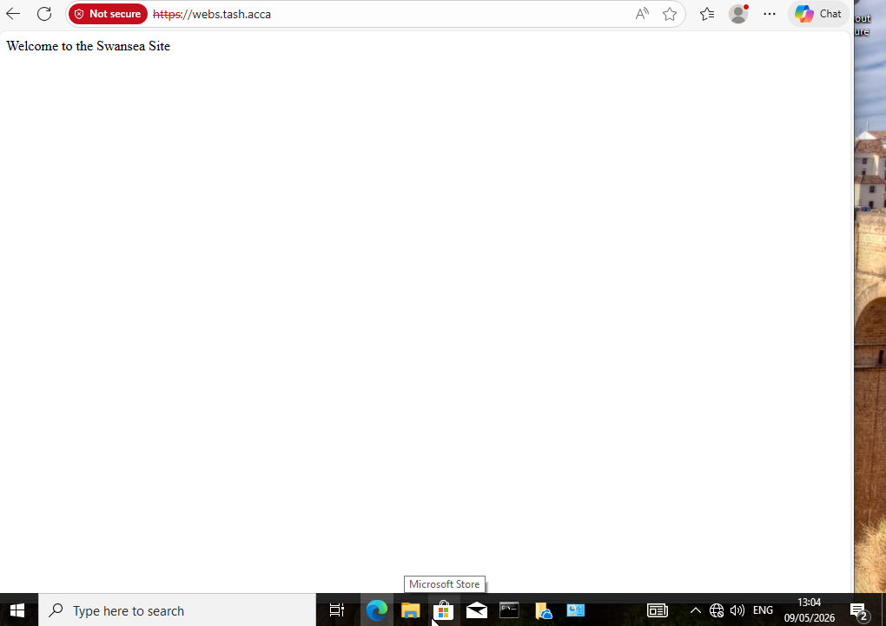

- Remote Desktop Services
  - Configure remote access for S-DC from any other machines in the network.

What is an Excellent work?
The Remote Desktop Services login page should be accessed via https://rds.yourname.acca and necessary certificates are signed.


