University of Wales Trinity Saint David
School of Engineering



Mechanical and Manufacturing Engineering

Computational Methods
Sheunesu Ziki
2205423
12/04/26
Table of Contents
1 Introduction 5
1.1 Aim and objectives 5
1.1.1 Aim 5
1.1.2 Objectives 5
1.2 Report outline 6
2 Governing equation 6
2.1 Modelling assumptions 6
2.2 Material properties 6
2.3 Derivation of the 2D transient heat equation 7
2.4 Summary 7
3 Explicit finite difference method 7
3.1 Finite difference approximations and truncation error 8
3.2 Spatial and temporal discretisation 8
3.3 EFDM formulation 9
3.4 Fourier number and stability criterion 10
4 Initial Condition, Boundary Conditions and Analytical Solution 10
4.1 Initial condition 10
4.2 Boundary conditions 10
4.3 Analytical steady state solution 11
4.4 Justification for the chosen conditions 12
5 Code details and explanations 12
5.1 Definition of material properties and thermal diffusivity 12
5.2 Users input (geometry, grid spacing and stability check) 12
5.3 Initialisation and boundary conditions 13
5.4 Time marching loop and EFDM update 14
5.5 Analytical solution and error calculation 15
6 Validation of the model 16
6.1 Comparison of steady state temperature fields 16
6.2 Absolute error field 17
6.3 Maximum absolute error and RMSE 18
6.4 Discussion of agreement between numerical and analytical results 19
7 Sensitivity analysis of key parameters 19
7.1 Effect of grid spacing 19
7.2 Effect of time step and Fourier number 20
7.3 Effect of thermal equilibrium tolerance 20
7.4 Overall assessment of model robustness 21
8 Limitations of the numerical model 21
8.1 Method related limitations 21
8.2 Limitations of the coding implementation 22
9 Suggested improvements and future developments 22
10 Conclusion 22
11 References 22
12 Appendix 24

Figure 1:Shows the 5 points stencil. 9
Figure 2:Shows the rectangular aluminium plate geometry used for the 2D transient heat conduction model. 11
Figure 3:Steady state analytical solution used for testing the numerical model 12
Figure 4: Shows the material properties of the aluminium plate. 12
Figure 5: Shows code for the user inputs. 13
Figure 6: Shows initialisation of the temperature and application of boundary conditions. 14
Figure 7: Shows the time marching loop and EFDM update. 14
Figure 8: Shows the analytical solution and error calculation. 15
Figure 9:Shows steady state numerical temperature distribution coarse(left) fine(right). 16
Figure 10: Shows steady state analytical temperature distribution coarse(left) fine(right). 17
Figure 11:Shows absolute error at steady state coarse(left) fine(right). 18
Figure 12: Shows influence on grid spacing. 19
Figure 13:The influencing on grid spacing oscillations. 20
Figure 14: Influence of the time step. 20
Figure 15: Influence of the tolerance condition. 21

Introduction
Heat conduction plays a vital role in engineering systems by controlling how thermal energy spreads within solid materials due to temperature gradients. Thin aluminium plates and heat exchangers usually show 2D heat conduction behaviour where temperature varies mainly along two spatial directions. Accurate predictions of temperature distributions are essential for assessing thermal stresses, deformation, material performance and system reliability.
The behaviour of heat conduction in solids is modelled using the 2D transient heat equation which is a parabolic partial differential equation. Getting closed form analytical solutions for transient 2D problems is possible but only for simple geometries and idealised boundary conditions. Due to this, numerical techniques such as finite difference methods are required for more complicated situations.

Aim and objectives

Aim
The aim of this report is to develop and apply a MATLAB computational model to solve the 2D transient temperature distribution in an aluminium plate using the explicit finite difference method (EFDM). This will be validated by comparing it with the analytical steady state result. The monitoring of model behaviours will be done, leading to a sensitivity analysis being conducted.

Objectives
To achieve this aim, the following objectives were pursued:
- Deriving the EFD equation and approximating the heat equation.
- Defining the truncation and round off errors.
- Validating the computational model by showing the maximum error and root mean square error (RMSE).
- Analysing the influence of grid spacing and time step on code results.
- Analysing how the result is affected through the thermal equilibrium threshold (cc/tolerance value).
- Acknowledging the numerical model and coding limitations.
- Providing overall improvement suggestions.

Report outline
Chapter 2 introduces the governing heat equation and modelling assumptions. Chapter 3 discusses the EFDM formulation and stability criterion. Chapter 4 introduces the analytical solution. Chapter 5 describes the MATLAB code. Chapters 6 and 7 show the validation and sensitivity analyses. Chapters 8 and 9 discuss the limitations of the model and summarise the main results from this report.

Governing equation
This chapter looks at the modelling assumptions and the governing equation used to model the heat diffusion in the aluminium plate. The assumptions are considered uniform and isotropic.

Modelling assumptions
The following assumptions are used:
- Unchanging density ρ throughout the plate
- Constant specific heat capacity $C_{p}$
- Steady thermal conductivity $k$
- No internal heat sources
- Heat transfer occurring by conduction.
These assumptions simplify the heat transfer model to a 2D transient diffusion equation with constant coefficients.

Material properties
The aluminium plate material properties are:
- Thermal conductivity: $k=143W/mC$
- Density: $ρ=2.8×{10}^{3} kg/m^{3}$
- Specific heat capacity: $C_{p}=795 J/kgC$
In the MATLAB code these will be clearly defined at the beginning of the code and used to compute thermal diffusivity $α$.

Derivation of the 2D transient heat equation
The following equation is derived from the conservation of energy and Fourier’s law. The rate of temperature change at a point is equal to the divergence of heat flow out of the area (Ma & Chang, 2004) Under the modelling assumptions mentioned above the temperature in the plate fulfils the 2D parabolic heat equation:
$$\frac{∂T}{∂t}=α\left(\frac{∂^{2}T}{∂x^{2}} + \frac{∂^{2}T}{∂y^{2}}\right) (2.1)$$
Thermal diffusivity:
$$α=\frac{k}{ρC_{p}} (2.2)$$
Where:
- $T\left(x,y,t\right)$ is the temperature field in ℃.
- $∂T/∂t$ represents transient time evolution.
- $∂^{2}T/∂x^{2}$ and $∂^{2}T/∂y^{2}$ represents heat diffusion in the spatial directions.
- $t$ represents the time in seconds (s).
- $α$ is the materials thermal diffusivity in m²/s.
- $x$ is a spatial coordinate and shows position in the horizontal position in meters (m).
- $y$ is a spatial coordinate and shows position in the vertical position in meters (m).

Summary
The transient conduction problem is fully defined by the governing heat diffusion equation with the specified aluminium plate properties, uniform zero initial temperature field and Dirichlet conditions. This provides the physical foundations for numerical discretisation and EFDM fulfilments shown in the next chapter.

Explicit finite difference method
This chapter introduces the finite difference structure used to discretise the governing equation. It covers the finite difference approximations and truncation error, discretisation of space and time, the EFDM update formula and the Fourier number stability condition.

Finite difference approximations and truncation error
Finite difference methods replace derivatives in the heat equation with difference approximations which are evaluated at discrete grid points. These expressions come from the Taylor series expansion of $T\left(x,y,t\right)$ about the reference point $x_{0}$and are truncated after a finite number of terms. The fundamental Taylor series mathematical expression is: $f\left(x\right)=f\left(x_{0}\right)+f^{'}\left(x_{0}\right).\frac{{(x-x_{0})}^{1}}{1!}+f^{''}\left(x_{0}\right).\frac{{(x-x_{0})}^{2}}{2!}+f^{'''}\left(x_{0}\right).\frac{{(x-x_{0})}^{3}}{3!}+f^{\left(4\right)}\left(x_{0}\right).\frac{{(x-x_{0})}^{4}}{4!}+⋯ (3.1)$
(Ataie-Ashtiani et al., 1999).Three difference approximations can be derived from the Taylor series: the forward, backward and central difference formulas for the first and second derivatives (Dixon, 2019) as shown below.
Forward:
$$f^{'}\left(x_{0}\right)=\frac{f\left(x_{0}+h\right)-f\left(x_{0}\right)}{h}+O\left(h\right) (3.2)$$
where h defines the distance from $x_{0}$ (i.e. the grid spacing)(Dixon, 2019).
Central (first and second derivatives):
$$f^{'}\left(x_{0}\right)=\frac{f\left(x_{0}+h\right)-f\left(x_{0}-h\right)}{2.h}+O\left(h^{2}\right) (3.3)$$
$$f''\left(x_{0}\right)=\frac{f\left(x_{0}+h\right)-2.f\left(x_{0}\right)+f\left(x_{0}-h\right)}{h^{2}}+O\left(h^{2}\right) (3.4)$$
where an error of order $O(h)$ means the truncation error is proportional to the grid spacing and reduces linearly as the griding spacing is reduced. An error of order $O(h^{2})$ means the truncation error is proportional to the square of the grid spacing meaning that halving the grid spacing reduces the error by approximately four times (Ataie-Ashtiani et al., 1999).

Spatial and temporal discretisation
The aluminium plate has width $L_{x}$ and height $L_{y}$ covered with a uniform grid with spacing $h$ in both directions:
- $x_{j}=jh, j∈\left[0,N_{c}-1\right] (3.5)$
- $y_{i}=ih, i∈\left[0, N_{r}-1\right] (3.6)$
Where $N_{c}= \frac{L_{x}}{h+1}$ and $N_{r}=\frac{L_{y}}{h+1}$. In the MATLAB code these are computed using Nc = Lx/h + 1 and Nr = Ly/h + 1 after checking that $h$ divides both dimensions exactly. The temperature at node $\left(i,j\right)$ and time level $n$ is denoted by $T_{i,j}^{n}$ and used in MATLAB as T(i,j). time is discretised into steps of size $∆t$, with $t^{n}=n∆t$. At each time level the known field $T^{n}$ is updated to $T^{n+1}$ by use of the explicit formula.
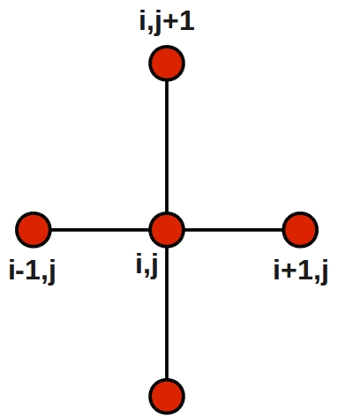
Figure 1:Shows the 5 points stencil.

EFDM formulation
For an interior node, the second derivatives are approximated by the central differences shown as:
$$\frac{∂^{2}T}{∂x^{2}}\left|\begin{matrix}n \\ i,j\end{matrix}\right.=\frac{T_{i,j+1}^{n}-2T_{i,j}^{n}+T_{i,j-1}^{n}}{h^{2}}+O\left(h^{2}\right) (3.7)$$
$$\frac{∂^{2}T}{∂y^{2}}\left|\begin{matrix}n \\ i,j\end{matrix}=\frac{T_{i+1,j}^{n}-2T_{i,j}^{n}+T_{i-1,j}^{n}}{h^{2}}+O(h^{2}) \right. (3.8)$$
The time derivative uses a forward difference shown as:
$$\frac{∂T}{∂t}\left|\begin{matrix}n \\ i,j\end{matrix}\right.=\frac{T_{i,j}^{n+1}-T_{i,j}^{n}}{∆t}+O\left(∆t\right) (3.9)$$
Substituting into the heat equation and rearranging gives the explicit update formula as shown:
$$T_{i,j}^{n+1}=T_{i,j}^{n}+F_{0}\left(T_{i+1,j}^{n}+T_{i-1,j}^{n}+T_{i,j+1}^{n}T_{i,j-j}^{n}-4T_{i,j}^{n}\right) (3.10)$$
Where there Fourier number is seen as:
$$F_{0}=\frac{α∆t}{h^{2}} (3.11)$$
In the MATLAB code this is done using the line: Tnew(i,j) = T(i,j) + F0*(T(i+1,j) + T(i-1,j) + T(i,j+1) + T(i,j-1) - 4*T(i,j)) for all the interior indices.

Fourier number and stability criterion
The Fourier number measures the ratio of diffusive flow to thermal storage in a grid cell over a period and controls both stability and accuracy. Von Neumann’s analysis shows that the 2D explicit method is stable only when $F_{0}≤\frac{1}{4}$. If this limit is passed small numerical errors begin to grow with time leading to divergence of the results. I the MATLAB code the maximum time step is computed using the line maxdt = h^2/(4*alpha) which makes the user entered time step accepted only if it is positive and contains an answer that satisfies $F_{0}≤\frac{1}{4}$. Although there is a reduction in steps when a larger $F_{0}$is used, it also increases the temporal truncation error. A smaller $F_{0}$ improves the solutions accuracy but increases computational cost (Pupeikis et al., 2012). The sensitivity analysis in Chapter 7 looks at this trade off.

Initial Condition, Boundary Conditions and Analytical Solution
This chapter specifies the initial condition and boundary conditions used in the numerical model and gives the analytical solution used for validation.

Initial condition
The aluminium plate is assumed to be isothermal at a uniform reference temperature. This is expressed as an initial domain condition $T\left(x,y,0\right)=0, ℃$ for all points $(x,y)$ within the plate. This condition is used in the numerical model before boundary heating is applied. In the MATLAB script this condition is applied by initialising the temperature matrix with zeros using $T=zeros(Nr,Nc)$ so that every grid node starts at the same temperature.

Boundary conditions
The plate is a rectangle of width $L_{x}$ and height $L_{y}$ with boundaries located at $x=0$, $x=L_{x}$, $y=0$ and $y=L_{y}$ as shown in Figure 1 below. The north boundary of the plate is at a constant temperature $T_{0}$ which is chosen by the user. The Dirichlet conditions are:
- North boundary: $T\left(x,L_{y},t\right)= T_{0} for 0<x<L_{x}$
- East boundary: $T\left(L_{x},y,t\right)=0 for 0≤y≤L_{y}$
- West boundary: $T\left(0,y,t\right)=0 for 0≤y≤L_{y}$
- South boundary: $T\left(x,0,t\right)= 0 for 0≤x≤L_{x}$

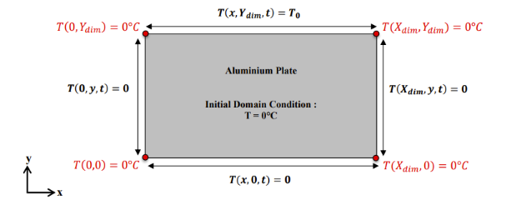
Figure 2:Shows the rectangular aluminium plate geometry used for the 2D transient heat conduction model.
In the MATLAB code theses boundaries are applied explicitly ensuring that they remain fixed throughout the simulation.

Analytical steady state solution
At thermal equilibrium, the transient term in the heat equation disappears and the temperature field satisfies the steady state Laplace equation with the boundary conditions mentioned earlier. The coursework provides a closed form analytical solution derived using the separation of variables. The solution is expressed as a Fourier sine series with exponential terms that satisfy the boundary conditions (Ma & Chang, 2004).
The analytical steady state temperature $T_{analytical}(x,y)$ depends on the plate dimensions and the boundary temperature $T_{0}$. This series is truncated after enough terms to achieve convergence (Ma & Chang, 2004).
This analytical solution provides a strict benchmark for assessing the accuracy of the EFDM results. Once numerical thermal equilibrium is reached, the converged numerical field is compared with $Tanalytical$ at every grid node and computes the maximum absolute error and root mean square error (Zhang et al., 2017).
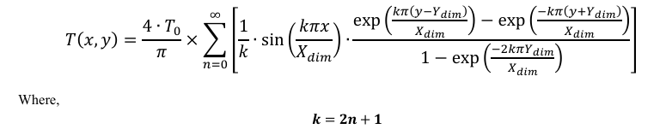
Figure 3:Steady state analytical solution used for testing the numerical model

Justification for the chosen conditions
The boundary conditions used are chosen because they correspond to the analytical solution in the coursework. Analytical solutions of 2D heat equations are available for a limited number of simple geometries and boundary conditions (Zhou et al., 2017). The use of matching conditions allows for node-by-node comparison of the numerical and analytical temperature fields providing a strong validation test of the EFDM as discussed in Chapter 6 (Shyla et al., 2018).

Code details and explanations

Definition of material properties and thermal diffusivity
The first line in the code clears the workspace to make it clean and clear. The first section of the script defines the properties of the aluminium plate and computes the thermal diffusivity as seen in Figure 3 below:
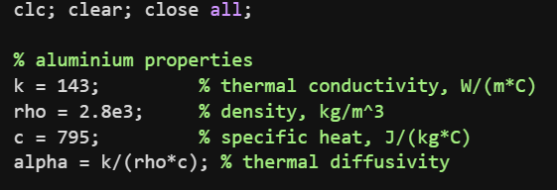
Figure 4: Shows the material properties of the aluminium plate.
These values match the ones given in the coursework brief and ensure there is consistency between the aluminium plate and the analytical solution. The thermal diffusivity $α=\frac{k}{ρc}$ controls how fast temperature disturbances propagate through the solid and appears in the Fourier number and the EFDM update equation.

Users input (geometry, grid spacing and stability check)
The next section of code shown in Figure 4 below, prompts the user to define the plate dimensions, grid spacing and time step:
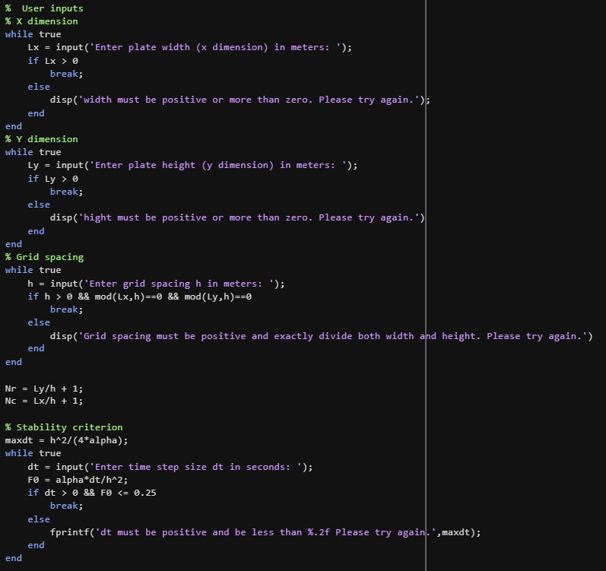
Figure 5: Shows code for the user inputs.
The code calculates the maximum time step and enters a loop where the user defines $dt$. For each proposed $dt$ the Fourier number $F0 = alpha×\frac{dt}{h^{2}}$ is computed and the inputted value is only accepted if $dt>0$and $F0<≡0.25$. This applies the von Neumann stability criterion for the 2D explicit model.

Initialisation and boundary conditions
Once the discretisation parameters are fixed the code as shown in Figure 5 below initialises the temperature field to zero and applies the boundary conditions in order to define the starting state of the model.
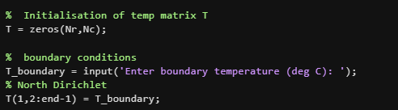
Figure 6: Shows initialisation of the temperature and application of boundary conditions.

Time marching loop and EFDM update
The code shows the time marching loop which advances the temperature field using the EFDM. Before entering the loop, the code sets a steady state flag and copies the initial field to $Tnew$and defines a tolerance of $tol=0.01$ which is used as the convergence threshold as shown in Figure 6 below. In the for loop the EFDM update equation is applied using the 5 point stencil. This approximates the temperature at each interior node from its neighbouring nodes.
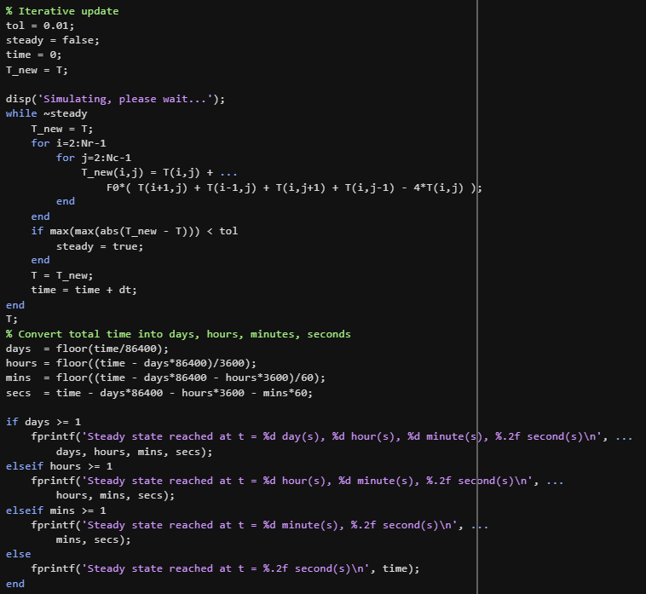
Figure 7: Shows the time marching loop and EFDM update.
The solution at time level $n+1$ is taken from the values at time level $n$. The convergence test is based on the maximum change between the fields. This is where steady state is identified once the temporal variation falls below the tolerance. At the end of the loop the code converts the total elapsed time into days, hours, minutes and seconds using the floor operation printing a message showing when steady state is reached.

Analytical solution and error calculation
After convergence, the code evaluates the analytical steady state solution on the same grid to validate the EFDM model as seen in Figure 7. The spatial coordinates are generated using $\left[X, y\right]=meshgrid\left(0:h:L_{x}, 0:h:L_{y}\right)$ and a matrix $Tanalytical=zeros\left(N_{r},N_{c}\right)$ is allocated. A for loop on the series index $n$ then computes each term of the analytical expression involving sine functions in the $x$ direction and exponential functions (approximations of hyper sine) in the $y$ direction and is collected into$Tanalytical$. The final matrix is scaled using $4×\frac{Tboundary}{pi}$. The truncation level of the Fourier series was determined through an accuracy test in which the number of terms were progressively increased and the result compares to T_boundary along the north boundary. Beyond 10000 terms, any further increases made negligible changes in the computation of T_boundary. 10000 terms were used as a balance between solution accuracy and computational cost.
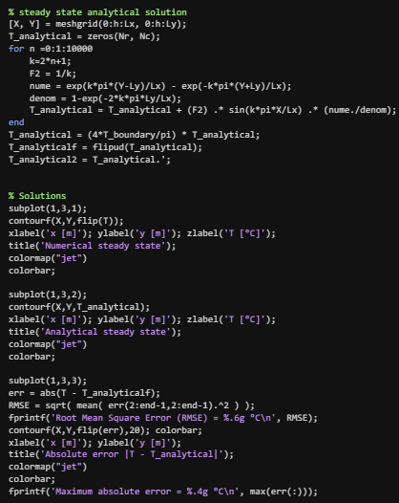
Figure 8: Shows the analytical solution and error calculation.
The maximum absolute error is recorded using $\max\left(err\left(:\right)\right)$. This code also plots the numerical steady state, analytical steady state and absolute error to give a visual representation of the aluminium plate. In the command window the following error metrics are printed: max(err,[],’all’) + RMSE (only the internal nodes).

Validation of the model
This chapter looks at the EFDM models accuracy by comparing its steady state temperature distribution with the analytical solution with the same boundary conditions. The plate dimensions used were 10m x10m. Two simulations were run one with a coarse mesh/grid spacing $(h)$ of 5m and the other of 1m. This was done to show the effects of grid spacing on the model accuracy and errors. The temperature was set to 50°C and a time step of 3600 seconds was used.

Comparison of steady state temperature fields
The EFDM simulation produces a steady state temperature field of $T_{num}\left(x,y\right)$ at convergence which is defined at every grid node of the aluminium plate. This field is plotted using a contour map where the isothermal points show the gradual rise in temperature from the cold interior towards the heated Dirichlet boundaries.
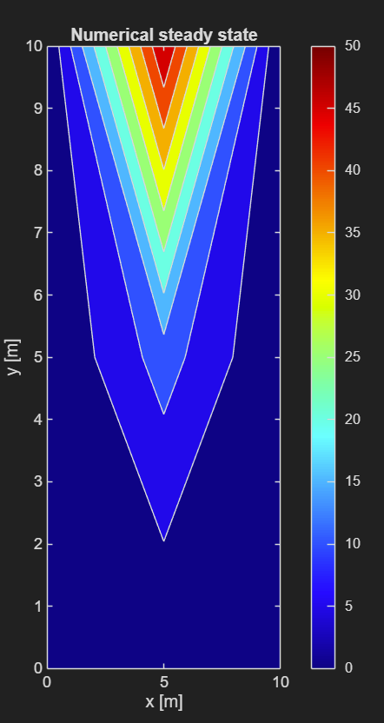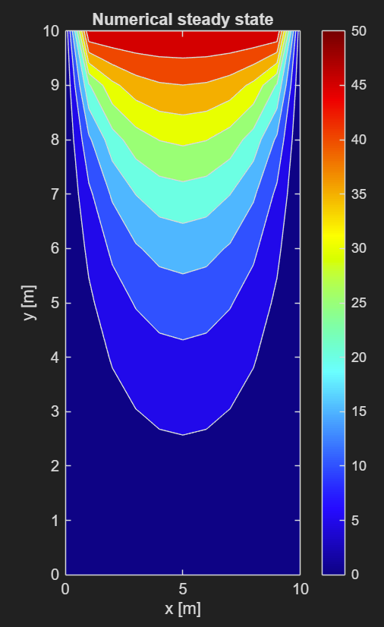
Figure 9:Shows steady state numerical temperature distribution coarse(left) fine(right).
The analytical steady state solution $Tanalytical\left(x,y\right)$ is evaluated from the series expression from the coursework on the same grid which is plotted on a second contour map. When these plots are compared the overall temperature levels near the hot boundary and curvature of isotherms in the interior are similar.
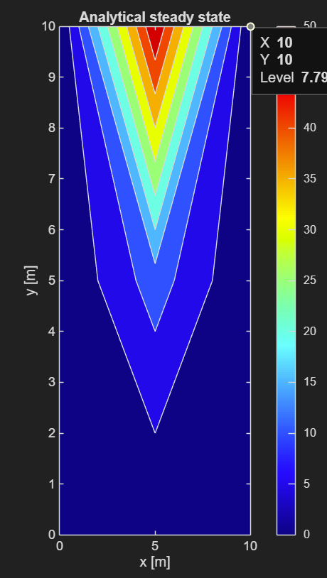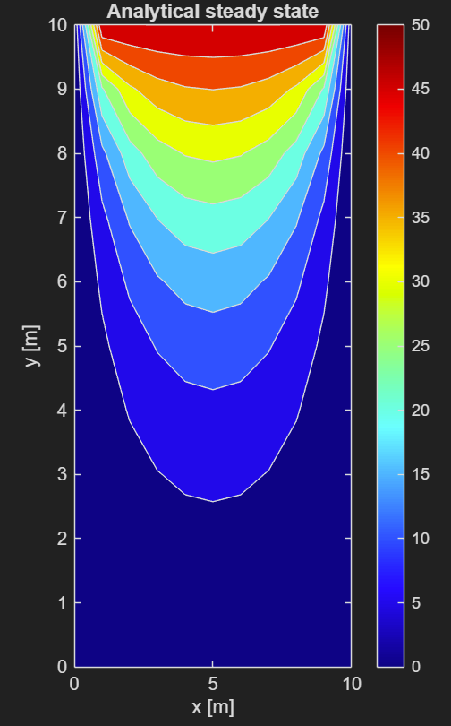
Figure 10: Shows steady state analytical temperature distribution coarse(left) fine(right).

Absolute error field
To show local differences between the numerical and analytical solutions an absolute error map is generated and plotted as the third contour figure as shown in Figure 12 below. In the code this is done by computing $err=abs\left(t-Tanalytical_fliped\right)$ where a vertical flip is applied to ensure consistency between the numerical and analytical groupings.
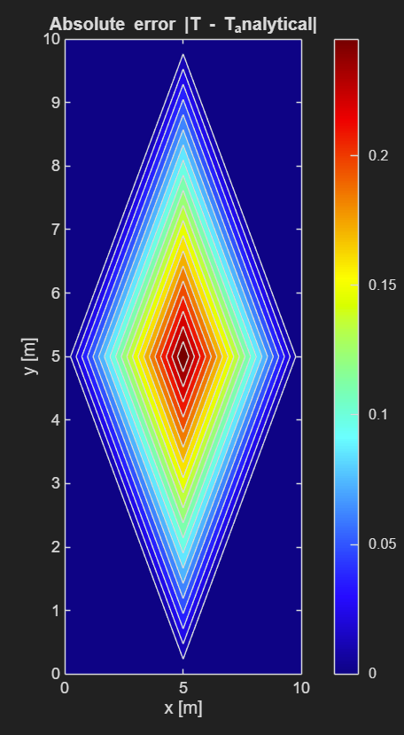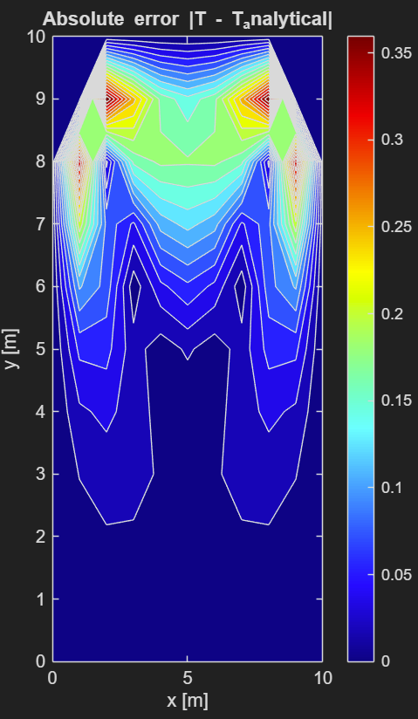
Figure 11:Shows absolute error at steady state coarse(left) fine(right).
The error field shows that differences are generally small across the field with a slightly larger error near the corners and regions of higher temperature where the truncation error from the finite difference discretisation is expected to be more noticeable.

Maximum absolute error and RMSE
To show the agreement between the numerical EFDM solution and the analytical steady state solution the maximum absolute error and root mean square error (RMSE) were evaluated. The maximum absolute error shows the largest difference between the numerical and analytical temperatures at any grid node. The RMSE gives the overall deviation across the entire computational domain. RMSE is calculated using: $\sqrt{\frac{1}{N}\sum_{i=1}^{N}{(T_{num,i}-T_{analytical,i})^{2}}}$ where $N$ is the total number of grid nodes, $T_{num,i}$ is the numerical temperature and $T_{analytical,i}$ is the analytical temperature.
For the coarse mesh the model gave an RMSE of 0.00861243℃ and a maximum absolute error of 0.02579℃. For the finer mesh, the RMSE was 0.0965008℃ with a maximum absolute error of 0.3774℃. In both cases the magnitude of the errors remains small relative to the boundary temperature. This shows agreement between the EFDM and analytical.

Discussion of agreement between numerical and analytical results
The visual comparison and error show a good agreement between the EFDM model and the analytical solution for the chosen discretisation parameters. The close match of the contour plots shows that the explicit scheme correctly captures the magnitude and spatial distribution of the steady state temperatures under the Dirichlet boundary conditions.
The remaining differences which are seen near the boundaries and areas with steep gradients can be linked to the truncation error from the second order spatial, first order temporal discretisation and the finite truncation of the analytical series.

Sensitivity analysis of key parameters

Effect of grid spacing
Figure 12 below shows monotonic convergence of the equilibrium time as grid spacing reduces. This shows the expected $O\left(h^{2}\right)$ truncation error reduction seen in second order central differencing. Finer grids require more iterations due to smaller temperature changes per step, but they achieve higher accuracy.
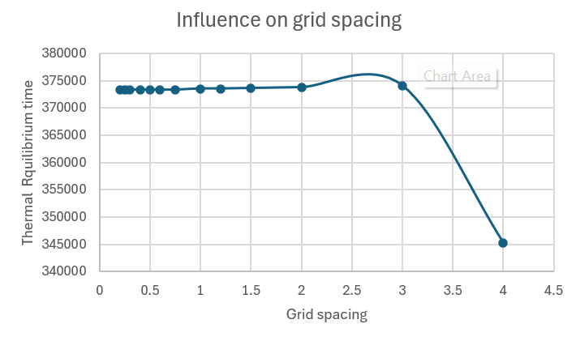
Figure 12: Shows influence on grid spacing.
Figure 13 below shows oscillations at very fine grids which is caused by discreate changes in the total node count. This also changes the number of iterations needed to satisfy the convergence tolerance (Pupeikis et al., 2012).

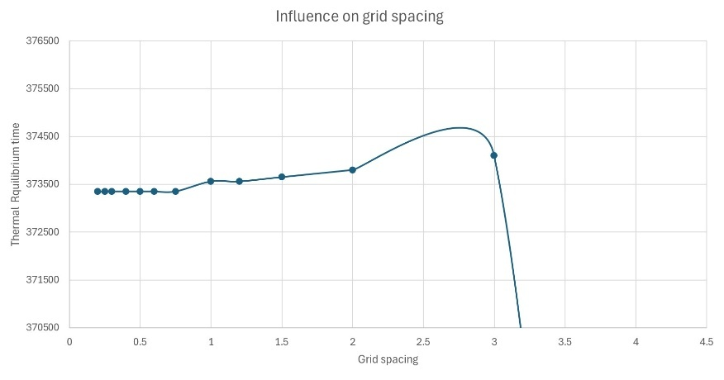
Oscillations to convergence
Figure 13:The influencing on grid spacing oscillations.

Effect of time step and Fourier number
Figure 14 shows non-monotonic behaviour of the truncation round off error duality. Large time steps $(∆t)$ increase first order temporal truncation error $O(∆t)$ while reducing the round off error accumulation. A small $∆t$ amplifies the round off errors through extreme iterations even though it reduces truncation error. Optimum accuracy is achieved at intermediate $∆t$ values near the $F_{0}=0.25$ stability boundary, which balances the numerical effects (Das et al., 2023).
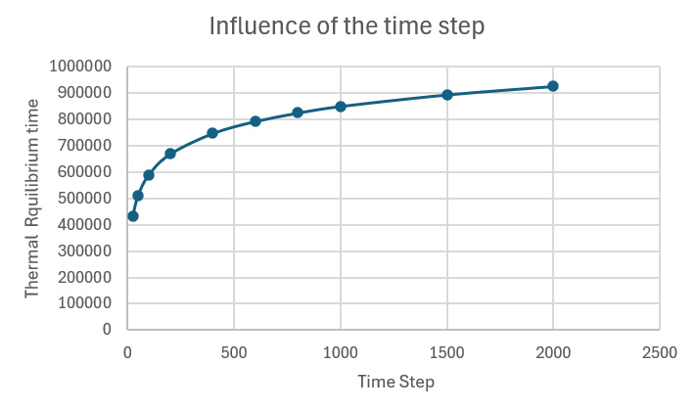
Figure 14: Influence of the time step.

Effect of thermal equilibrium tolerance
Figure 15 below shows that a stricter convergence criteria (CC) visibly increases the simulations run time as more iterations are needed to achieve smaller temperature changes between time steps. While the CC acts as a practical proxy for thermal equilibrium, it lacks a direct physical connection to the steady state conditions. Due to this the reported equilibrium time remains unreliable regardless of the CC value, showing the numerical convergence rather than the physical reality (Mou et al., 2017).
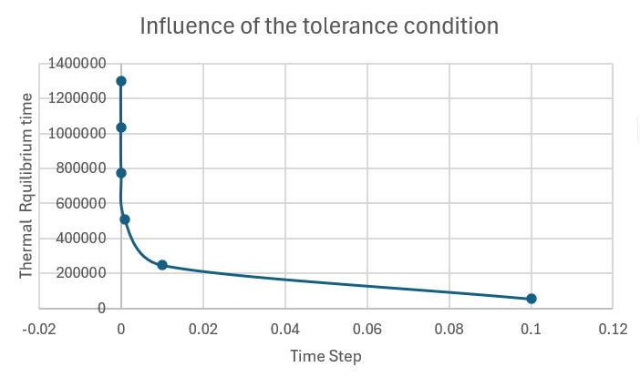
Figure 15: Influence of the tolerance condition.

Overall assessment of model robustness
The sensitivity analysis confirmed the EFDM’s reliability through predictable error trends across all parameters. Grid refinements consistently reduce the spatial truncation error, while time step changes navigate the truncation round off duality. Despite numerical limitations the model maintains stability and accuracy within the theoretical bounds. This validates its robustness for 2D transient heat conduction analysis.

Limitations of the numerical model

Method related limitations
Since the EFDM is first order in time and second order in space the truncation error reduces with $h^{2}$ and $∆t$ but is not eliminated. The sensitivity analysis in Chapter 7 showed that grid refinement and smaller time steps reduced the truncation errors but eventually produced significant round off errors (for the time step) by reducing gains when round off errors become dominant (Das et al., 2023). The finite difference formulation is based on a 5 point stencil which limits the analysis to structured geometries. Analytical solutions are not only limited to simple boundary conditions but basic geometrise too. While this is ideal for testing against rectangular plates along with Dirichlet boundary conditions it does not generalise easily to unstructured geometries or irregular boundaries. This means the validation done in this report cannot be assumed to hold for more complicated domains without reformulation of the numerical method (Das et al., 2023).

Limitations of the coding implementation
The equilibrium criterion is based on a fixed tolerance applied to the maximum change between successive time levels. This gives a stopping rule but defines steady state in numerical terms rather than physical. Loose tolerances can stop the simulation before true equilibrium is reached while strict tolerances increase run time with no benefits other than being purely mathematical (Mou et al., 2017).

Suggested improvements and future developments
This chapter looks at improvements that address the main limitations identified earlier by focusing on numerical methods, geometry handling and the treatment of thermal equilibrium. Implicit or Crank Nicolson models would help eliminate stability constraints and improve temporal accuracy which enhances the efficiency for fine grids despite needing a solution of liner systems at each time step (Dehghan, 2001).
These methods allow for accurate modelling of complex geometries and unstructured meshes (Wilson & Nickell, 1966). Enhanced temperature detection by combining temperature change measures with residual based checks better represents the physical steady state. An adaptive mesh refinement near steep gradients and dynamic time step adjustments based on local error estimates improves accuracy and computational cost (Rickman, 2024).

Conclusion
This report achieved its aims of creating a MATLAB model that solves the 2D transient heat equation for an aluminium plate using the EFDM. The objectives were met by deriving the EFDM formulation, applying the initial and boundary conditions, validating the numerical results against the analytical solution and assessing the effects of grid spacing, timestep and convergence tolerance.

References
Partial differential equations and boundary value problems(1999) Computers & Mathematics with Applications (1987), 37(3), pp. 133. Available at: https://doi.org/10.1016/S0898-1221(99)90393-0.
Accuracy Stability and Convergence.
Finite difference example 1D explicit heat equation.
Finite Difference Method.
Introduction to Numerical Methods in Heat Transfer.
Numerical Recipes-The Art of Scientific Computing 3rd Edition (Press et al).
Taylor series and FDM.
Two-Dimensional Conduction: Finite-Difference Equations and Solutions.
Articolo, G.A. 'CHAPTER 3 - the diffusion or heat partial differential equation', in Articolo, G.A. (ed.) Partial differential equations & boundary value problems with maple (second edition). Academic Press, pp. 161–215.
Ataie-Ashtiani, B., Lockington, D.A. and Volker, R.E. (1999) 'Truncation errors in finite difference models for solute transport equation with first-order reaction', Journal of Contaminant Hydrology, 35(4), pp. 409–428. Available at: https://doi.org/10.1016/S0169-7722(98)00106-5.
Beck, J.V., Wright, N.T., Haji-Sheikh, A., Cole, K.D. and Amos, D.E. (2008) Conduction in rectangular plates with boundary temperatures specified Elsevier BV.
Ben-Romdhane, M. (2025) Immersed finite element method for heat transfer analysis in multi-layered thermal protection systems SAGE Publications.
Buhlmann, S. (1977) 'Heat transfer calculations using finite difference equations. von D. R. croft und D. G. lihey. applied science publishers ltd., london 1977. 1. aufl., XI, 283 S., 102 abb., 30 tab., ln. $ 32.00', Chemie Ingenieur Technik, 49(11), pp. 922–923. Available at: https://doi.org/10.1002/cite.330491120.
Das, P., Islam, M.A., Mondal, D. and Nazim, M.S. (2023) Analytical and numerical (FEA) solution for steady-state heat transfer in generic FGM cylinder coated with two layers of isotropic material under convective-radiative boundary conditions Elsevier BV.
Dehghan, M. (2001) 'Crank–Nicolson finite difference method for two-dimensional diffusion with an integral condition', Applied Mathematics and Computation, 124(1), pp. 17–27. Available at: https://doi.org/10.1016/S0096-3003(00)00031-X.
Dixon, A. 'Chapter 7 - numerical methods for solving the “swing equation”', in Dixon, A. (ed.) Modern aspects of power system frequency stability and control. Academic Press, pp. 135–189.
Gloor, P. (1999) Partial Differential Equations and Boundary Value Problems with Maple V Taylor & Francis Ltd.
Huntul, M.J., Lesnic, D. and Johansson, B.T. Determination of an additive time-and space-dependent coefficient in the heat equation.
Ma, C. and Chang, S. (2004) 'Analytical exact solutions of heat conduction problems for anisotropic multi-layered media', International Journal of Heat and Mass Transfer, 47(8), pp. 1643–1655. Available at: https://doi.org/10.1016/j.ijheatmasstransfer.2003.10.022.
MEDHI, J. 'CHAPTER 4 - non-birth-and-death queueing systems: Markovian models', in MEDHI, J. (ed.) Stochastic models in queueing theory (second edition). Academic Press, pp. 165–219.
Mishra, S.C., Talukdar, P., Trimis, D. and Durst, F. (2005) 'Two-dimensional transient conduction and radiation heat transfer with temperature dependent thermal conductivity', International Communications in Heat and Mass Transfer, 32(3), pp. 305–314. Available at: https://doi.org/10.1016/j.icheatmasstransfer.2004.05.015.
Mou, S., Luan, Y., Ji, W., Zhang, J. and Tao, W. (2017) An example for the effect of round-off errors on numerical heat transfer Informa UK Limited.
Özışık, M.N. (2013) Boundary value problems of heat conduction. Dover Publications.
Pupeikis, D., Šeduikytė, L. and Bruzgevičius, P. (2012) The Impact of the Fourier Number on Calculation Accuracy of Transient Heat Transfer in Homogeneous Enclosures Kaunas University of Technology (KTU).
Pupeikis, D., Stankevičius, V. and Burlingis, A. (2010) THE EFFECT OF THE FOURIER NUMBER ON CALCULATION OF AN UNSTEADY HEAT TRANSFER OF BUILDING WALLS Vilnius Gediminas Technical University.
Rodriguez, A., Harris, C., Potluri, A., Estrada, N.L., Hernandez, A.M., Kumar, V., Aguirre Ortega, F.O. and Kumar, V.V. NUMERICAL AND ANALYTICAL MODELING OF HEAT TRANSFER IN CURRENT-CARRYING CONDUCTORS USING THE HEAT EQUATION IMPLEMENTED USING FINITE-JAX.
Shyla, M.V., Girija Bai, H., Prasanna Jeyanthi, M.M. and Professor, A. Finite Difference Solutions of Heat Conduction Problem with Dirichlet and Neumann Boundary Conditions.
Wilson, E.L. and Nickell, R.E. (1966) 'Application of the finite element method to heat conduction analysis', Nuclear Engineering and Design, 4(3), pp. 276–286. Available at: https://doi.org/10.1016/0029-5493(66)90051-3.
Zhang, H.H., Han, S.Y. and Fan, L.F. (2017) 'Modeling 2D transient heat conduction problems by the numerical manifold method on wachspress polygonal elements', Applied Mathematical Modelling, 48, pp. 607–620. Available at: https://doi.org/10.1016/j.apm.2017.03.043.
Zhou, Q., Oldenburg, C.M., Rutqvist, J. and Birkholzer, J.T. (2017) Revisiting the Fundamental Analytical Solutions of Heat and Mass Transfer: The Kernel of Multirate and Multidimensional Diffusion American Geophysical Union (AGU).
Zieniuk, E., Sawicki, D. and Boltuc, A. (2014) 'Parametric integral equations systems in 2D transient heat conduction analysis', International Journal of Heat and Mass Transfer, 78, pp. 571–587. Available at: https://doi.org/10.1016/j.ijheatmasstransfer.2014.07.016.

Appendix
clc; clear; close all;

% aluminium properties
k = 143; % thermal conductivity, W/(m*C)
rho = 2.8e3; % density, kg/m^3
c = 795; % specific heat, J/(kg*C)
alpha = k/(rho*c); % thermal diffusivity

% User inputs
% X dimension
while true
Lx = input('Enter plate width (x dimension) in meters: ');
if Lx > 0
break;
else
disp('width must be positive or more than zero. Please try again.');
end
end
% Y dimension
while true
Ly = input('Enter plate height (y dimension) in meters: ');
if Ly > 0
break;
else
disp('hight must be positive or more than zero. Please try again.')
end
end
% Grid spacing
while true
h = input('Enter grid spacing h in meters: ');
if h > 0 && mod(Lx,h)==0 && mod(Ly,h)==0
break;
else
disp('Grid spacing must be positive and exactly divide both width and height. Please try again.')
end
end

Nr = Ly/h + 1;
Nc = Lx/h + 1;

% Stability criterion
maxdt = h^2/(4*alpha);
while true
dt = input('Enter time step size dt in seconds: ');
F0 = alpha*dt/h^2;
if dt > 0 && F0 <= 0.25
break;
else
fprintf('dt must be positive and be less than %.2f Please try again.',maxdt);
end
end

% Initialisation of temp matrix T
T = zeros(Nr,Nc);

% boundary conditions
T_boundary = input('Enter boundary temperature (deg C): ');
% North Dirichlet
T(1,2:end-1) = T_boundary;

% Iterative update
tol = 0.001;
steady = false;
time = 0;
T_new = T;

disp('Simulating, please wait...');
while ~steady
T_new = T;
for i=2:Nr-1
for j=2:Nc-1
T_new(i,j) = T(i,j) + ...
F0*( T(i+1,j) + T(i-1,j) + T(i,j+1) + T(i,j-1) - 4*T(i,j) );
end
end
if max(max(abs(T_new - T))) < tol
steady = true;
end
T = T_new;
time = time + dt;
end
T;
% Convert total time into days, hours, minutes, seconds
days = floor(time/86400);
hours = floor((time - days*86400)/3600);
mins = floor((time - days*86400 - hours*3600)/60);
secs = time - days*86400 - hours*3600 - mins*60;

if days >= 1
fprintf('Steady state reached at t = %d day(s), %d hour(s), %d minute(s), %.2f second(s)\n', ...
days, hours, mins, secs);
elseif hours >= 1
fprintf('Steady state reached at t = %d hour(s), %d minute(s), %.2f second(s)\n', ...
hours, mins, secs);
elseif mins >= 1
fprintf('Steady state reached at t = %d minute(s), %.2f second(s)\n', ...
mins, secs);
else
fprintf('Steady state reached at t = %.2f second(s)\n', time);
end

% steady state analytical solution
[X, Y] = meshgrid(0:h:Lx, 0:h:Ly);
T_analytical = zeros(Nr, Nc);
for n =0:1:10000
k=2*n+1;
F2 = 1/k;
nume = exp(k*pi*(Y-Ly)/Lx) - exp(-k*pi*(Y+Ly)/Lx);
denom = 1-exp(-2*k*pi*Ly/Lx);
T_analytical = T_analytical + (F2) .* sin(k*pi*X/Lx) .* (nume./denom);
end
T_analytical = (4*T_boundary/pi) * T_analytical;
T_analyticalf = flipud(T_analytical);
T_analytical2 = T_analytical.';

% Solutions
subplot(1,3,1);
contourf(X,Y,flip(T));
xlabel('x [m]'); ylabel('y [m]'); zlabel('T [°C]');
title('Numerical steady state');
colormap("jet")
colorbar;

subplot(1,3,2);
contourf(X,Y,T_analytical);
xlabel('x [m]'); ylabel('y [m]'); zlabel('T [°C]');
title('Analytical steady state');
colormap("jet")
colorbar;

subplot(1,3,3);
err = abs(T - T_analyticalf);
RMSE = sqrt( mean( err(2:end-1,2:end-1).^2 ) );
fprintf('Root Mean Square Error (RMSE) = %.6g °C\n', RMSE);
contourf(X,Y,flip(err),20); colorbar;
xlabel('x [m]'); ylabel('y [m]');
title('Absolute error |T - T_analytical|');
colormap("jet")
colorbar;
fprintf('Maximum absolute error = %.4g °C\n', max(err(:)));

fprintf('\n Numerical Steady State Temperature Matrix (T_new) \n');
T_new
fprintf('\n Analytical Steady State Temperature Matrix (T_analyticalf) \n');
T_analyticalf
fprintf('\n Absolute Error Matrix (err) \n');
err

