Distinctiveness and Regeneration: Field Work Report
Jordan Hitchcock 1808395

Over the passed few weeks, as a class we have been learning about Llanelli and how it has gotten to where it is today. On 29th January 2019, guest lecturer Julie Hannam spoke to the class about ‘The Roots of Modern Llanelli’. Hannam is a very reliable source and a suitable guest lecturer, she achieved a BA(Hons) Social & Economic History and also has 16years experience of economic and community development in the former South Wales Coalfields. In a presentation titled ‘The Roots of Modern Llanelli’ Hannam went into the history of Llanelli before the industrial revolution as well as the growth and decline of the town.
Llanelli, “with a population of some 35,000 people is situated in the South Eastern corner of Carmarthenshire in South West Wales.” Llanelli Town Council (2018). Llanelli is an old town famously known for its steel, tinplate and coal production industries which began in the early 1700s. Before this period, the town of Llanelli was mainly “Arable land with large estates and smaller family farms” (J. Hannam,2019). With the invention of the steam engine and factories, the demand for coal greatly increased in order to fuel these furnaces and steam engines. Many people would travel from different parts of the UK to Llanelli, to make best of the opportunities that were available to make money and aid in the industrialisation of the town. But why Llanelli?
Llanelli was home to “low-lying coalfields rich in Bituminous coal” (J.Hannam,2019). Along with these coal fields, Llanelli is situated near to the sea and with an already established sea trade, not a lot of work was required in order to help ship this newly found coal out to other places in the UK and further. As a result of these conditions, there was increasing confidence in Llanelli and the potential the town had to be recognised as a key component of the strength of the industrial age. Investors would travel from all over looking to spend some of their money, and with these investors came people looking for jobs. The three key elements of setting up a successful industry were met, and soon Llanelli was going to become a key figure in the mining and exportation of coal industry across the world.
Tata Steel
On the 19th February 2019, Packaging Recycling Manager at Tata Steel: Nicola Jones, came into the class to give a presentation on Tata Steel and the work that they do in their Port Talbot and Llanelli factories. At the Port Talbot factory, limestone, coal and iron ore are all imported from across the world via ships which are then used to make the steel coils which are made in the factory. There is also a railway line which goes directly from the Tata Steel Port Talbot Factory to the Tata Steel Trostre Factory, this is called the Swansea District Line. “Port Talbot make the steel at 4mm thickness and send the coils via the Swansea District Line to the Trostre factory and it gets reduced in thickness, annealed (made more flexible and changed the grain structure) then it gets coated with either chrome or tin. This tin will then be sent to other companies which make drinks cans, aerosol cans and more.” (J.Price, 2019).
The Port Talbot and Trostre Steel works are interdependent, and are paramount in the production of steel produced by Tata. As a company, Tata are also aiming to become as sustainable as possible, “the work recycles as much heat as they can from the steel making process by heating the offices in the building with the steam waste” (N.Jones,2019). This is proof of Tata aiming to become more sustainable and being smarter with how they use their waste.
With regards to Llanelli, Tata have benefitted the community massively. Hundreds of people are employed at the Llanelli Factory with thousands more at the Port Talbot factory. The company brings jobs to people in the local area and therefore helping the local economy by giving more money into it.

Regeneration of Llanelli
Since the die down of the industrial age, Llanelli has become a quieter town with arguably ‘not a lot to offer’. As a result of this image, there have been many regeneration plans in Llanelli which have been aimed to increase the amount of people travelling to visit the town and with hopes of increasing tourism in the area. Some examples of these plans include Trostre Retail Park, Millenium Coastal Path, Pembrey Country Park, Park Howard Museum, Machynys Golf Course and also the Llanelli Wetland Centre. The Llanelli Wetland Centre is one of these regeneration plans that have worked. As a class, we visited the Wetlands Centre on February 19th, 2019 and spent the afternoon with an educational speaker, Sarah Rees who gave the class a talk on the history of the centre and the wetlands. “Work began on the Wetlands centre in 1984 and then it was finally finished in 1991.” (Rees, S. 2019). The Wetlands Centre was opened in 1991 by Sir David Attenborough, a massive and well known icon in the wildlife industry, and therefore being the perfect person to open the centre.

The centre was previously unused and the aim of the Wetlands Centre is to protect many of the animals that live there but also to increase awareness about the wildlife that are there and to let them live in a habitat that suits them. The educational speaker, Sarah Rees said that “last year there were 70,000 visitors against 24,000 in 2014”. This shows that the numbers are increasing dramatically and hopefully continue to do so. The Wetlands Centre is an excellent example of a regeneration plan that has been used in Llanelli and it is clearly working, these 70,000+ people are likely to spend money in local shops/ visit other local attractions and therefore boosting the local economy. By experiencing the local are they could be more likely to either re-visit or move to Llanelli permanently.

I am from Llanelli and have experienced first hand, a lot of changes within recent years that have been made in order to help regenerate the area. I think that Llanelli and surrounding areas have a lot to offer and as a town I feel that it will only get better. Below are some images that I took from our visit to the Llanelli Wetlands Centre where we were allowed to get up close with birds from all over the world.

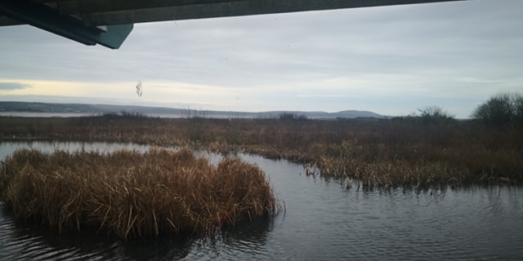
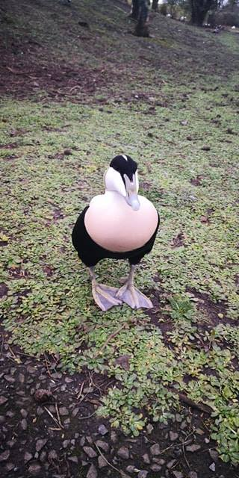

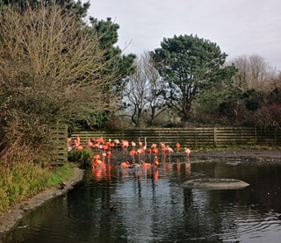

References
- About Llanelli Llanelli Town Council (2018) Website http://www.llanellitowncouncil.gov.uk/about-llanelli/ Accessed online on 14/03/2019 at 21:10
- Hannam, J. (2019). Guest Lecturer- The Roots of Modern Llanelli, January 29th, 2019.
- Price, J. (2019). 3rd Year Apprentice Mechanical Fitter at Tata Steel Trostre Spoke via phone call on March 15th , 2019.
- Jones, N. (2019) Guest Lecturer, Packaging Recycling Manager at Tata Steel, February 19th, 2019.
- Rees, S (2019) Educational Speaker at Llanelli Wetlands Centre, February 19th, 2019.

