Student Name: Ffion Price
Student Number: 1809701
Programme of Study: BA (Hons) Illustration

Module: ADAD4009

Word count: 1,500
Tutor's name: Scott L Smith

Curation, Space and Place – Curating a Metaphorical Exhibition

In today’s society, I believe an issue that is still heavily overlooked is mental illness. Many of us suffer with some form of mental illness, almost ALL of us have experienced some form of mental illness (within ourselves and people we care for), so why is the stigma and ignorance still at an all-time high? This is what I would like to explore within my exhibition and attempt to answer some of these questions. In 2019, mental health problems are still not recognised as being anywhere near as important as physical problems, and this could be due to the stigma around it. In a study performed last year, which explored mental illness stigma on social media, results showed that “mental health conditions were subject to more stigmatising and trivialising attitudes than physical health, but there was a large variation in prevalence between conditions.” (Robinson, Turk, Jilka, Cella, 2018) So I would like to focus on the more commonly ‘stereotyped’ conditions, such as depression, psychosis, bipolar disorder, obsessive compulsive disorder, and schizophrenia. My goal, through this exhibition, would be to educate people on mental illness, as studies show more education on the subject equates to less stigma (Rüsch et al., 2005).

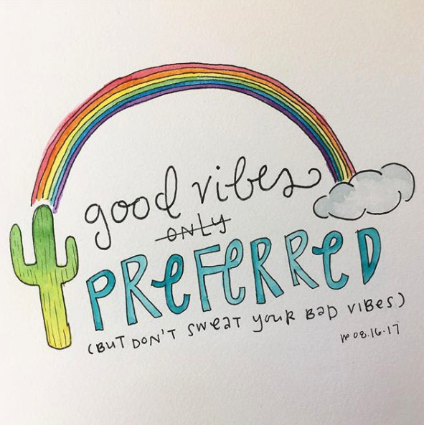
Figure 1 – Good Vibes Only (Press, 2017)
Mental illness has always been a sensitive subject, and it is my belief that through art we can educate and inform, whilst also creating an enjoyable and sometimes emotional experience for people. Therefore, each aspect of the exhibition must be carefully considered and perfectly executed. I wanted the location to be somewhere beautiful and uplifting, whilst also being practical in terms of weather and audience. I have chosen The Eden Project in Cornwall, as I believe that the beautiful botanics and greenery would be extremely soothing and create a great sensory experience whilst attending the exhibition. In an article about sensory deprivation, they claim that “adequate sensory stimulation may play a role in maintaining man's
normal psychological relationship to his environment” (Leiderman, Mendelson, Wexler, 1958). This is obviously extremely important in relation to my topic, as I want my audience to feel comfortable and understood in a place that feels almost like an escape from the real world. The art I would like to display in this exhibition is that of modern-day artists who portray mental illness as a normal thing in our current society and try their best to educate within their artwork. I feel that by using new, aesthetically pleasing artwork will help in winning over some of the less educated guests, by drawing them in with relatable, sometimes humorous illustrations and beautiful depictions of everyday life in our society. My audience is not targeted to any individual group, but I feel that those who attend will all be able to enjoy different elements of the exhibition, if not all.

I would like to include the work of Tori Press in my exhibition (see Figure 1) as her artwork is beautifully uplifting and, in my opinion, very inspiring to those who suffer from mental illness. I have followed her work for years and personally it has helped me many times when suffering with my own mental illness. Press uses watercolour to create soft, pretty artworks with a pop of boldness in the form of inspirational quotes or just directional advice. Her use of humour and light-heartedness is extremely refreshing and can easily bring a smile to someone’s face. Her artwork is widely known on the social media platform Instagram, and she is extremely popular at the moment, I rarely meet an art student or Instagram user who doesn’t follow and love her work. I believe that Press’s artwork will be a great addition to the exhibition as it will raise people’s spirits, make people laugh and possibly even give hope to those who need it, which is another of my aims in curating this exhibition. I want my audience to leave feeling as though they have gained something from the experience, be it knowledge, strength or positivity; all three are equally as important to me.
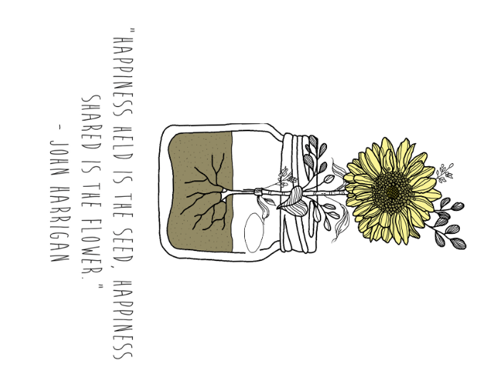
Figure 2 – Sunflower (Price, 2018)

As I said before, the environment is an extremely important factor in this exhibition, as the sensory impact of nature has a positive effect on mental health. Studies show that nature is an extremely helpful tool in relieving stress and improving general wellbeing in people. (Kaplan, Lewis, Leather et al., 1998). Personally, I believe that the life cycle of the flower is a great metaphor for the journey of recovery from mental health. The life stages of the flower mirror the steps we take in order to heal and get back to who we want to be. The idea of hosting the exhibit in a place filled with beautiful flowers, all at different stages of their life cycle, is very reflective upon the people that inspired this exhibition in the first place, as we are all in different stages of our recovery and no two people recover the same, just as no two flowers grow the same. I want to emphasise this within the exhibition by having lots of botanical artworks and creating inspirational quotes that relate to the location. I want to include soft, quiet music, to set the tone and further soothe the audience as they wander through the plant life, taking in the sights and scents and truly making the most of the sensory experience.

I would love to set out the exhibition so that none of the areas of mental illness are clearly defined. For example, I don’t want to label some as ‘depression’ and others as ‘bipolar disorder’, I want the viewers to be confused on which illness the artwork relates to, as mental illness usually isn’t a clear definition, and many people who suffer with it tend to suffer with more than one at the same time. This can often cause confusion and stigma, as said in a paper on mental health “Persons with mental illness often have to struggle with a double problem, the misunderstandings of society about these various mental disorders result in stigma.” (Rüsch, 2005). I will however make this clear to the audience beforehand, by making an informative speech about my intentions and ideas, much like I have done in this paper, and explaining my reasons behind the location and layout. I would love to incorporate many different forms of mental illness as the spectrum is so wide, and as well as the more discriminated illnesses I would like to involve the more common types, such as social anxiety, seasonal affective disorder, and all types of eating disorders. I understand that I wont be able to cover every single form of mental illness as there are so many, but I want to raise awareness to it as a whole and also provide information on helplines and ways people can find help for themselves or their loves ones.
Another illustrator I would love to display at the exhibition is Beth Evans. Beth creates very simple yet emotional art that is incredibly relatable for anyone suffering with mental illness. She is also extremely open and honest about her own mental illness, which is so empowering and important in spreading the word and ending the stigma of mental health. I would love to invite her to speak at the exhibition and share some of her own stories on her journey, to inspire and motivate those in the audience who feel that their mental health will stop them from achieving their dreams, as she is doing great things every day whilst fighting the same battle. Beth works predominantly in digital line drawings. As her work is so poignant in its message that it does not need to be extravagant or extremely detailed, she keeps it simple and it makes the art even more endearing and eye catching with its bold lines and lettering. She even has her own ‘character’ which is just a small creature, and illustrates portraits of herself when creating a more personal piece of art. I feel that Beth’s work would be an empowering addition to the exhibit.
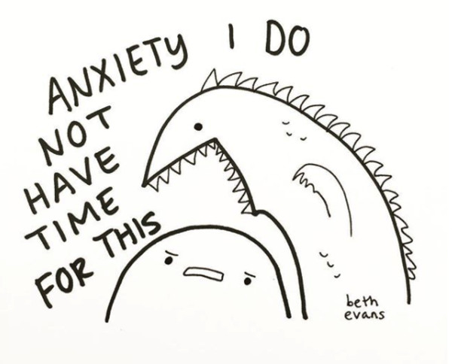
Figure 3 – Come on I have stuff to do (Evans, 2017)

In conclusion, I believe that the type of artwork I have chosen to present, and the combination of sounds, smells and visuals, will create an amazing experience for my audience. What I wanted more than anything was to create a safe space in which people can admire art, smell some flowers and be educated on a real issue, whilst still having a good time. As we all know, mental illness is one of the biggest causes of death in the UK, and almost every day we hear about someone either trying to or thinking of ending their life, so why is no one doing anything more about it? My hope is that this exhibition would raise awareness, as well as bringing joy to people and hopefully bringing them back from a dark place. Hopefully one day I can make this exhibition a reality.

Bibliography

- Robinson, P., Turk, D., Jilka, S. et al. (2019). Measuring attitudes towards mental health using social media: investigating stigma and trivialization. Social Psychiatry and Psychiatric Epidemiology, Volume 54, Issue 1, pp 51–58. available at: https://doi.org/10.1007/s00127-018-1571-5

- Nicolas Rüsch, Matthias C. Angermeyer, Patrick W. Corrigan (2005). Mental illness stigma: Concepts, consequences, and initiatives to reduce stigma. European Psychiatry, Volume 20, Issue 8. Pages 529-539. Available at: https://doi.org/10.1016/j.eurpsy.2005.04.004

- Press, Tori (2017). Good Vibes Only. Available at: https://www.instagram.com/p/BYJPT69n7L6/?taken-by=revelatori

- Leiderman H, Mendelson JH, Wexler D, Solomon P. (1958). Sensory Deprivation: Clinical Aspects. AMA Arch Intern Med. Pages 389-396. Available at: www.doi:10.1001/archinte.1958.00260140221032

- Price, Ffion (2018). Sunflower. Available at:

- C Maller, M Townsend, A Pryor, P Brown, L St Leger (2006). Healthy nature healthy people: ‘contact with nature’ as an upstream health promotion intervention for populations, Health Promotion International. Volume 21, Issue 1. Pages 45–54. Available at: https://doi.org/10.1093/heapro/dai032

- Evans, Beth (2017). Come on I have stuff to do. Available at: https://www.instagram.com/p/BYviJSwjeSQ/?taken-by=bethdrawsthings

