Usability Experience Design Assignment 1

Introduction

Usability Experience Design can be known for evaluating a variety of users and valuing their opinion of using a software, hardware or product you are developing. A book on “elements of experience” by Jesse James Garrett back in 2010 stated that, “With a clear sense of what we want and what our users want, we can figure out how to satisfy all those strategic objectives.” [1] This means that user experience has importance by the way there are many objectives to consider when building systems such as interface design, colour scheme, requirements involved in the system to engage users, data collection of applications and many more.The topics this assignment should cover is a comparison of Niantics two popular and unique games in the way that people have to physically go on a adventure and get out for playing the game, covering psychology and usability issues, social experiences and lessons company learned from creating both games.

Overview of Games

Ingress
Ingress has a familiaritiness of looking similar to an old 90’s augmented game where people can claim portals to improve the players attack, portal defence and energy drain for poweruping portals linked together. To successfully retrieve the portal, eight resonators are required to completely obtain portals.However, an opponent can retake the portal you achieved especially if they are a higher level as will have stronger weapons to attack.

Pokemon GO
Pokemon GO again a game created by the company Niantic is where people can go outdoors and travel to popular locations for instance Mumbles Lighthouse, popular parks and museums and so forth, these places known as Pokestops in the game. The objective is like the old Pokemon games is to capture, train and evolve.The statistic as stated by Wikipedia is “It was one of the most used and profitable mobile apps in 2016, having been downloaded more than 500 million times worldwide by the end of the year…..promoting physical activity.” [2] The overall aim has been known to capture Pokemons and increase the trainer level so the method of obtaining rare Pokemon becomes easier. For training Pokemon the trainer level needs to be level 5 and the necessity for training Pokemon as well as evolve is to defend the gyms captured similar to levelling up portals Ingress and to battle raid bosses also unlocking level 5, but tiers are more difficult if battle with weaker trained Pokemon. Lastly, evolve has been known to be an essential playing requirement Pokemon GO as stronger attacks Pokemon can use for defending gyms.

As both games contain good advantages such as physical activity promoting and social interactions, both games have known to cause psychological concerns, ethnic worries, privacy issues, usability concerns and user experience concerns. The next assignment part discusses these issues in detail applying appropriate referencing when necessary.

Psychology, Usability, and Copywriting concerns

Ingress

Psychology
Ingress has been known to have a positive psychological aspect more so due to the fact it is more of a basic game in comparison to the partner game Pokemon GO. A theory that suggests this is that “Ingress has broken down ethnic, sexual, financial, racial, and other barriers by bringing people together to focus on a common goal.” [3.1] Ingress has also been known to be more of an educational game by people discovering new appealing buildings or attractions they might wish to visit one day when acquiring portals. It is suggested Ingress has a more advantageous aspect of education by “portals provide the potential for other learning opportunities besides the historical aspect. For example, Anchorage, Alaska is home to portals that are part of an immense work of art. “ [3.2] This suggests that ingress psychologically will appeal to more retro game users as the location of portals have better places to distract people from continuously playing the game. However, could have a negative impact by gamers invading the privacy of historical landmarks such as if the landmark is a church, attendees might likely not want people attempting to fire weapons or obtain portals these areas especially if services are running as despite the weapons not real, it still becomes invasive of the areas privacy, although the portals are not as random as Pokemon GO.

Usability
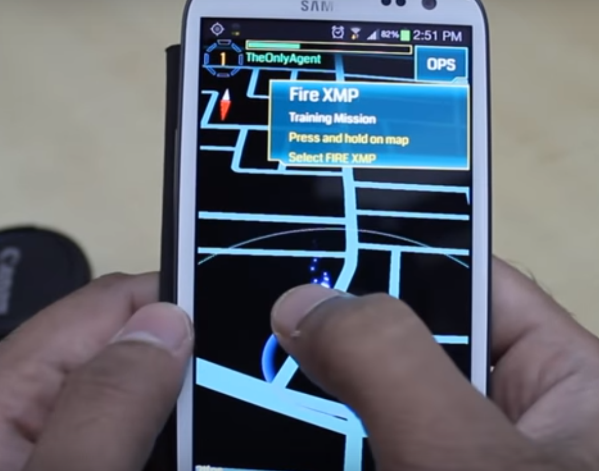
Ingress has been known to have more feasible usability features as it starts off by containing more in depth tutorial of how to play the game as shown in the below image.

A theory suggesting the game is less usable for new players is “All objects in Ingress are situated in the real world and players can only come into contact with them if they are physically near them.” [4] The big usability disadvantage question this could raise is if people are not nearby you within the same faction, it will be increasingly difficult for new players of the game to hack a portal especially if the opposing factions
Defending each surrounding portal well resulting in new players of the game quitting easy.

Design
Design principles should be essential to consider when creating any design as if the design is poor, the user feedback achieved will most likely be poor. A journal paper written by David Pinelle, Nelson Wong and Taseusz Stach on usability principles of game design, argues that “Failure to design usable game interfaces can interfere with the larger goal of creating a compelling experience for users.” [5] Ingress had suffered design complaints as 37% of their users felt that the design was very basic for what the company’s long term goal of attracting more people to play. However, for people in particular that suffer from colour blindness issues the design should appeal more so to them as Ingress contains very little colour and most of the game mechanics are blue shades resembling an easy game feel to basic users.

Pokemon GO

Psychology

Pokemon GO has been proven to be far more fan based in comparison with Ingress as the uniqueness of the game and user friendliness of the game is more appealing to larger target audience ranges. A theory that suggests this is statistics show that, “Pokémon GO is a mobile application game released by Niantic, Inc. on July 2016, and was explosively downloaded (over 500 million) in just 8 weeks.” [6.1] The growing and ongoing psychological issue is due to the sophisticatedness of the game and the portion of people that play this game how it has been known to contain a lot more ethical issues. For example the Niantic company has not now just received complaints of where Pokemons are located, but also about where gyms are stored and Pokestops and egg hatches.are and some Pokemon could be offensive to some users. A theory queried by this is that, “ Wagner-Greene et al9 . conducted a cross-sectional survey among 662 adult Pokémon GO players; their findings indicated that more than a quarter of the players reported that they were likely to play Pokémon GO while driving and biking and they would also sacrifice sleep.” [6.2] This suggests that due to the vast locations of finding Pokemon features that people could be less socially interactive with each other unlike Ingress as more arguments could happen especially if one person catches the rare Pokemon before anyone else within the PokeStop.

Usability
Usability of Pokemon GO has appealed to far more users unlike Ingress as there are many more features. For example with Pokemon Go you are rewarded for doing more in game features such as, increasing trainer level to catch rare Pokemon easier, training and evolving Pokemon to battle raid bosses some of which are too tough with low Combat Power level (CP), dueling versus other arena opponents and the higher up arena ladder achieved, the more likely a player can obtain an exclusive Pokemon but, the player must keep logging in daily to battle or lose rank. A theory suggesting Pokemon is easier to use for all individuals is that “The Pokémon GO phenomenon, therefore, can be analyzed primarily in two ways, both through the commodification of digital games and the appropriation of users as free labor. “ [7] Despite this being an easy to use freemium model, the games tutorial is vague unlike Ingress, plus the method in which Pokemon are caught can be sophisticated as you have to drag ball and flick screen at same time.

Conclusion
Having given a thorough overview of both applications, judging on users experience of Ingress the game would probably appeal to target audiences that rather little features in a game but, Ingress gives a happier feel to the whole community as it does not upset as many surrounding people because majority of portals are contained on relevant landmarks and Ingress has been known to be more of a team building game. However, if the users experience is purely play alone, then Pokemon GO would adhere to this audience. Primarily user experience is valuing a user or multiple users experience based upon several factors that are audience, ethical issues usability, design and psychological issues. Ultimately augmented reality games both have a risk of catering to the users requirements however, Ingress caters slightly better accessibility wise by making a more usable game despite the fact the game might not be as uplifting to users as Pokemon GO.

References

- https://s3.amazonaws.com/academia.edu.documents/40557986/The_Elements_of_User_Experience_-_Jesse_James_Garrett.pdf?AWSAccessKeyId=AKIAIWOWYYGZ2Y53UL3A&Expires=1548810759&Signature=WER4bXTSXTVEbAjuqP920TCLeYs%3D&response-content-disposition=inline%3B%20filename%3DThe_Elements_of_User_Experience_-_Jesse.pdf [1]
- https://en.wikipedia.org/wiki/Pok%C3%A9mon_Go [2]
- http://livre-rose.hyper-media.eu/wp-content/uploads/2014/03/AnEssayTheGoodTheBadAndTheUglyOfIngress.pdf [3]
- https://journals.sagepub.com/doi/pdf/10.1177/1555412015575833 [4]
- https://www.irit.fr/recherches/ICS/projects/twintide/upload/447.pdf [5]
- https://www.nature.com/articles/s41598-017-11176-2.pdf [6]
- https://journals.sagepub.com/doi/pdf/10.1177/2050157916677306 [7]

