3/24/2025
University of Wales Trinity Saint David
London campus
E-Portfolio Link: Home | Prestige Portfolio
Module Name: Learning In the Digital Era
Module Code: ACCA 4025

Student Name: ALPHUS NFORMI NGWANI
Student ID: 2517800
Group: 2

Lecturer’s Name: Koushik Modak

LDE Assignment 1
E-Portfolio
Table of Contents
Introduction 2
Main Body 2
Task 1: Essential Academic and Employment Skills for the future career Path 2
Task 1 (a): Report on Essential Academic and Employment Skills 2
Task 1 (b): Evaluation of Task 1 (a) based on Similarity report 2
Task 2: Collaborative Mind Map and Individual Poster 2
Mind Map (Collaborative) 2
Poster (Individual) 2
Task 3: Virtual Collaboration and RefWorks 2
Report on Virtual Collaboration 2
Step-by-step process of using RefWorks with visuals 2
Task 4: E-Portfolio Creation and Evaluation 2
Task 4 (a): E-Portfolio Creation 2
Task 4 (b): Illustrative Review of E-Portfolio tool Selection 2
Conclusion 2
References 2
Task 1 References: 2
Task 3 References: 2

Introduction

Main Body

Task 1: Essential Academic and Employment Skills for the future career Path

Task 1 (a): Report on Essential Academic and Employment Skills
The essential academic and employment skill is the main ability needed by a student or an employee to put in place for the growth of an institution or an industry. These essential skills include time management, critical thinking, communication, problem-solving, adaptability, self-motivation, academic writing, research, digital literacy teamwork, entrepreneurship, emotional intelligence [1].
Critical thinking is the ability of a student or an employee to reflect on their own idea of a particular information given to them. It is a very important and essential skill needed by people carrying out research or doing an assignment as the case with students. They are so many definitions about critical thinking but according to Beyer (1995) critical thinking means making clear reasoned judgements [2].
Time management [2] [3] [4] is also one of the most important skills that a student or an employee needs to put in place to be successful in their various institutions. For instance, as a student, you will have so many assignments to do and submit if you do not manage your time properly you will never submit these assignments on time so, time management is a very essential academic skill [3].

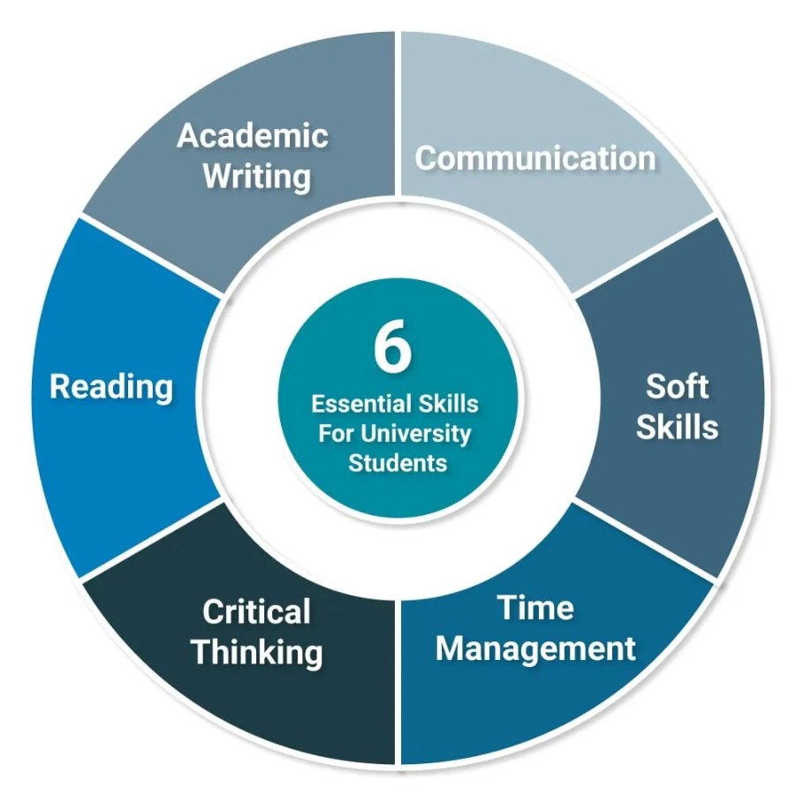 [4]
[4] | R. Needleman, What Are The 6 Essential Skills For University Students, London: UniAdmissions, 2025.

Communication is also a very essential skill for both a student and an employee as a student you must have the ability to communicate and interact with your lecturers and mates same as an employee with his or her colleagues [4].
Reading is also a very essential academic and employment skill as a student or an employee you must know how to read [5].

Task 1 (b): Evaluation of Task 1 (a) based on Similarity report
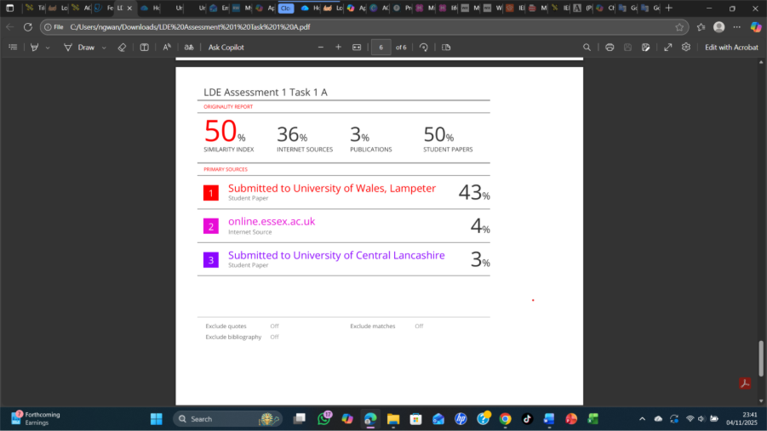
Similarity score: 50%
I will improve on my similarity score by reducing paraphrasing matches, summarizing and using my own words not quoting directly. I will also make sure that all quotes are correctly cited by using quotation marks and consistent reference style and I will also include bibliography or reference style at the end to properly credited my sources.
I will award myself 60-69% because I did the numerous research and read several articles by myself and came out with what I wrote so I deserve a pass mark.

Task 2: Collaborative Mind Map and Individual Poster

Mind Map (Collaborative)
The most essential thing about a well and organised and excellent team are communication, understanding, even trust, excellent leadership, great adaptability, and mature way of resolving problems. Concentrating on these portions create a strong attachment, improvement of massive outputs, promote an effective conducive place for the team.
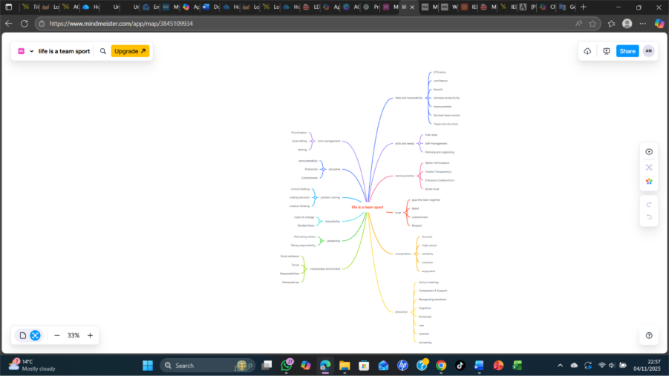 https://mm.tt/map/3845109934?t=JaHoBdrrhm
Task 2B
https://www.canva.com/design/DAG3aIRNQRw/SYgiYXltp2JDhcJt25E1EQ/edit?utm_content=DAG3aIRNQRw&utm_campaign=designshare&utm_medium=link2&utm_source=sharebutton
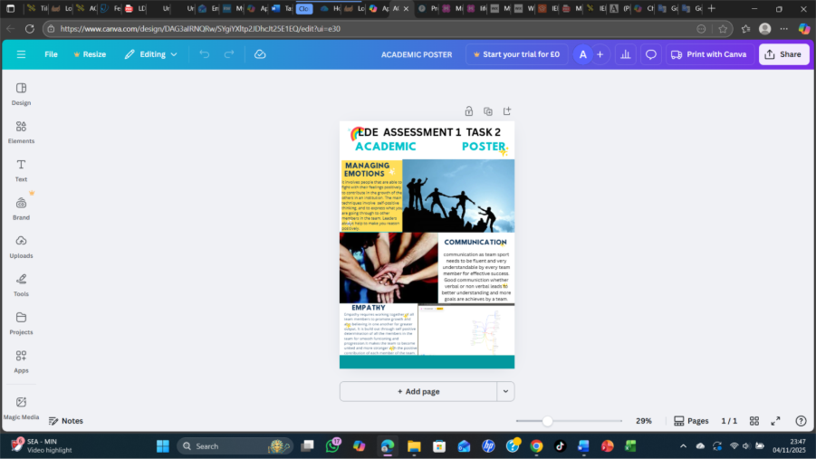 [5]
[5] | Unknown, Managing Emotions, Communication, and Empathy, London: unknown, 2025.

Poster (Individual)

Task 3: Virtual Collaboration and RefWorks
[5] It is the starting point where various people are coming together to know more about themselves deeply, sharing ideas to form a group to achieve goals. They are so many main reasons to come about while forming a team to make the team more powerful, well-structured and very effective. The key reasons of forming a team are as follows:
[6]: This is a very key point to consider or take into consideration while forming a team. It is very important to know the purpose of forming the team and to know the goals the team is going to acquire. To know the reason why the team is being formed and to take measures how to form a very strong team. To bring one common idea that is going to bind all the members together, accepting and coming out with a common goal.
To Select the right members: To create a good and competent team, you need to know the type of people you are choosing to form a team with base with what you want your team to give out as outputs. The members must be skilful, have good knowledge and well experienced to focus on what they are doing or the team they are building to yield good and promising outputs. To know also where they are coming from with their diverse ideas and their working styles, and to know that the members like to work together as a team or feel comfortable working with each. [7]
How to develop communication channels: means of communication is another important factor to consider while building a good and effective team. You need to make or create a means how the team members need to be sharing information between them and it can either be by creating meetings with the team members, creating various communicating platforms for members to be chatting through the platforms or still communicating with all the members through emails, make sure all the members are being informed with the message passed to them through the various means of communicating to them on time and also to give a good listening ears to all the members and constructive feedback. [8]

Report on Virtual Collaboration
To use RefWorks, you need to go online in any device and open a web browser like Microsoft edge or google chrome, open a new tap and type refworks.proquest.com and press enter.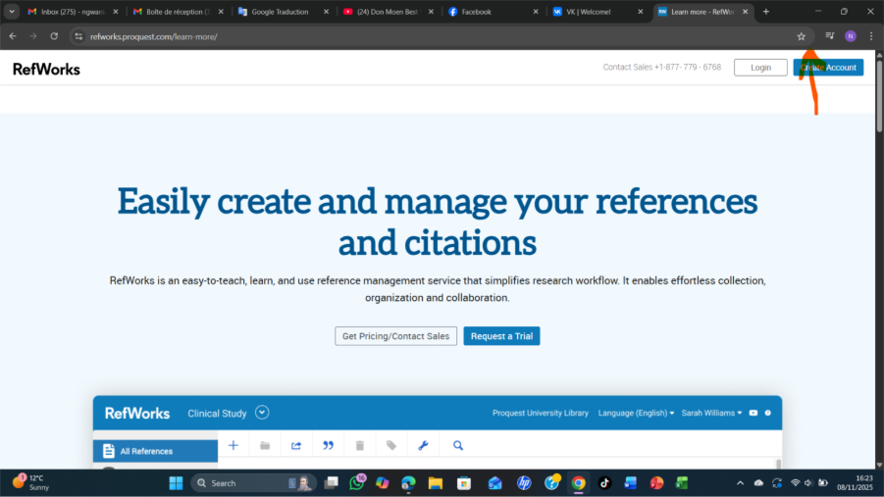
When you open the site on a browser you go to the top right corner and click on create an account.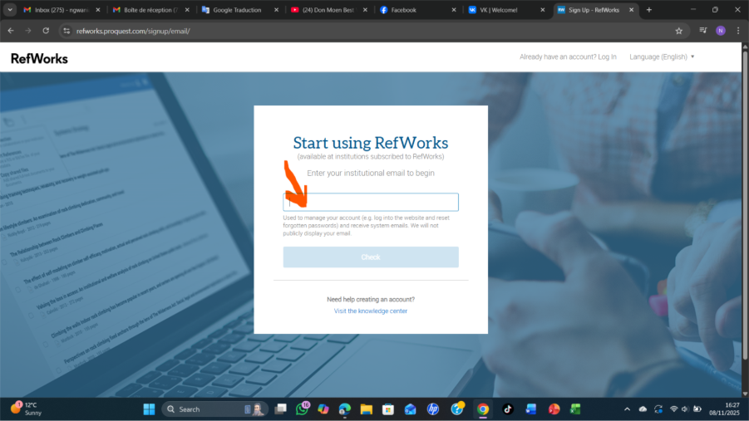
From here you enter your institutional email to begin.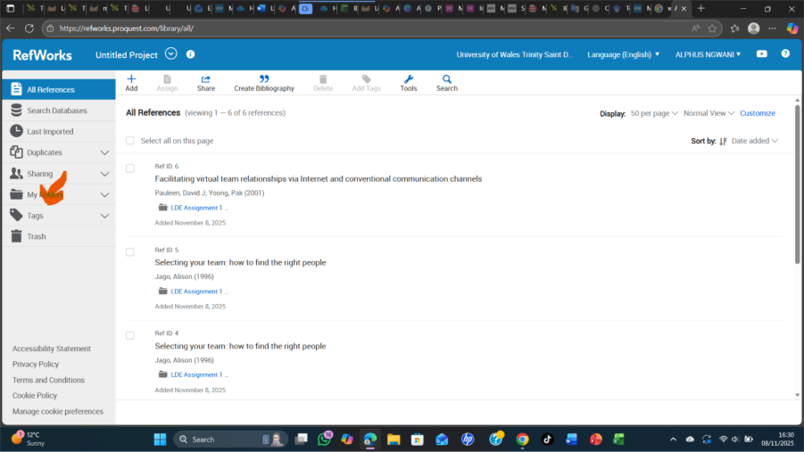
You will come to home page of RefWorks and from the home page you look to the left and select my folder and click on add folder.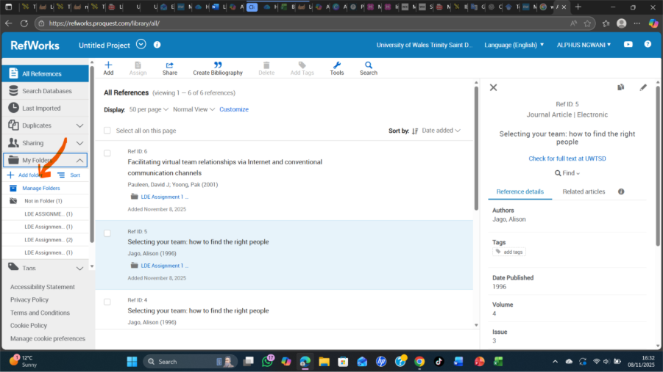

From here you type the name of the folder you want to create here for example LDE ASSIGNMENT 1 TASK 3A 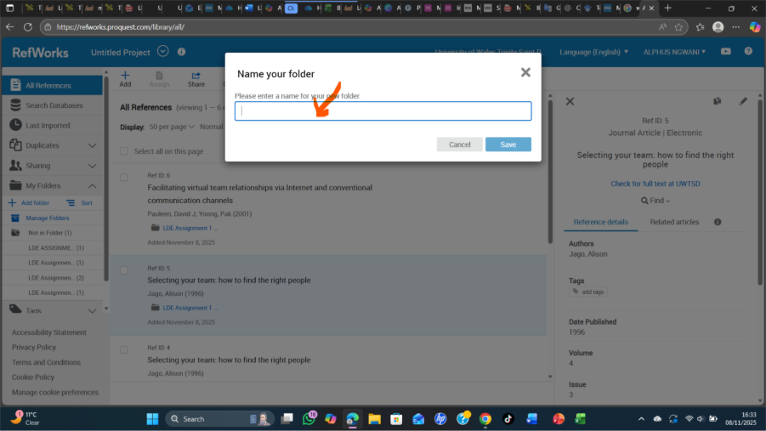
Click save and a new folder will be created in my folder with the name you entered go and check.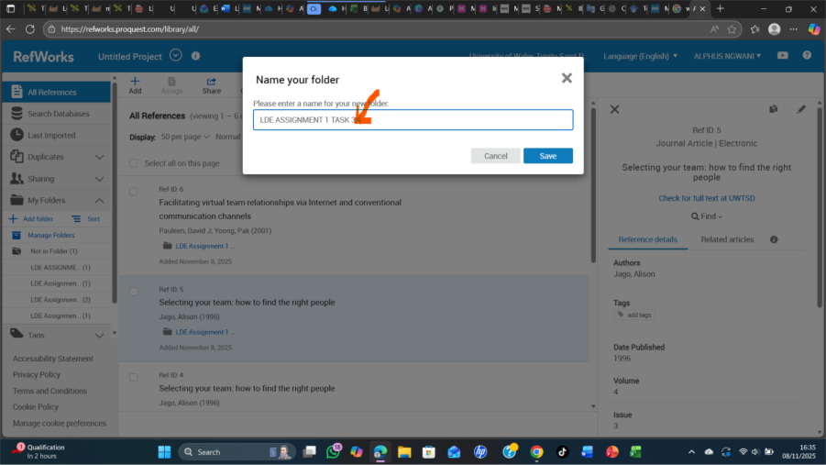
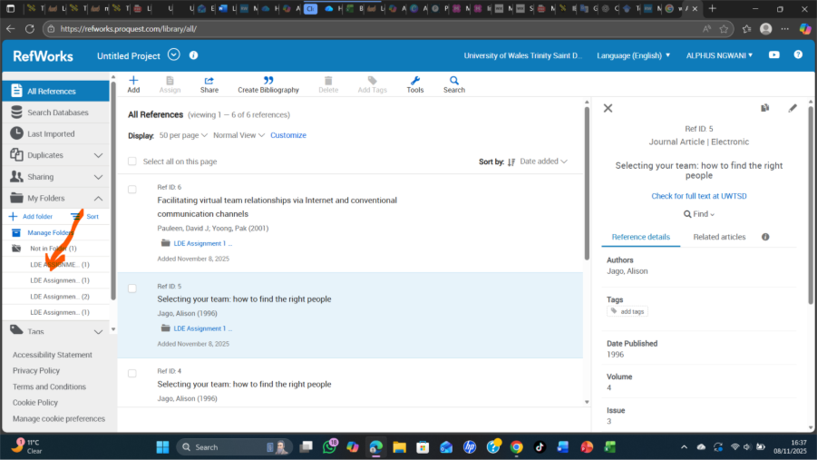
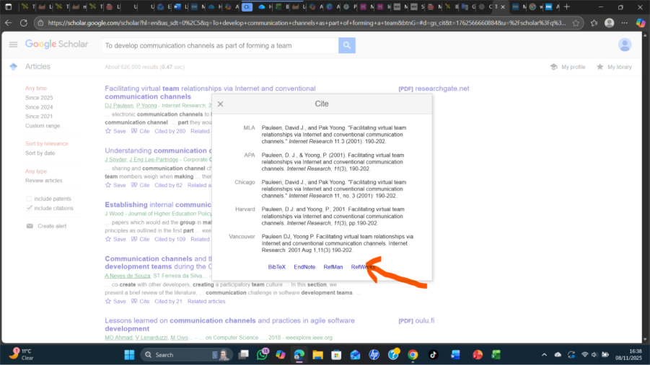
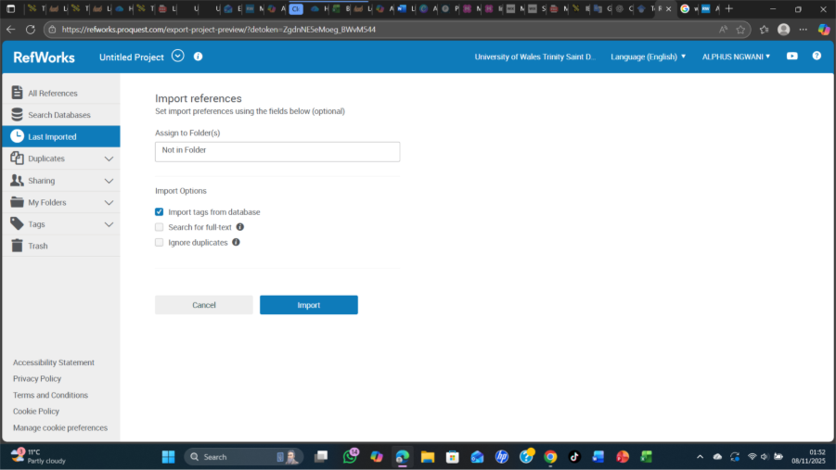
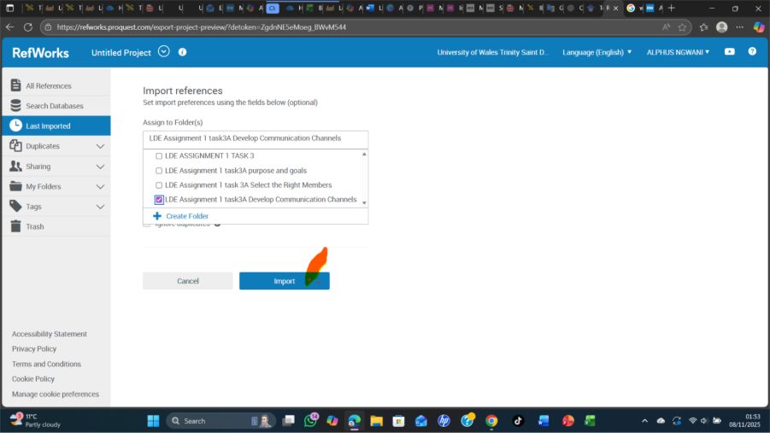
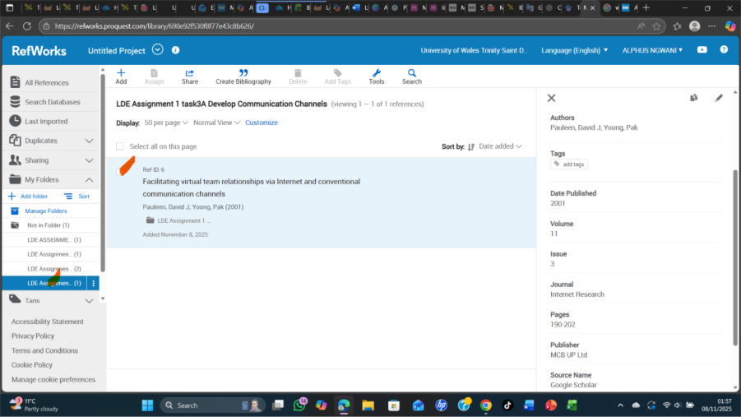

FORMING A TEAM

Step-by-step process of using RefWorks with visuals

Task 4: E-Portfolio Creation and Evaluation

Task 4 (a): E-Portfolio Creation
Create an account in wix or if you are having one sign in the wix account 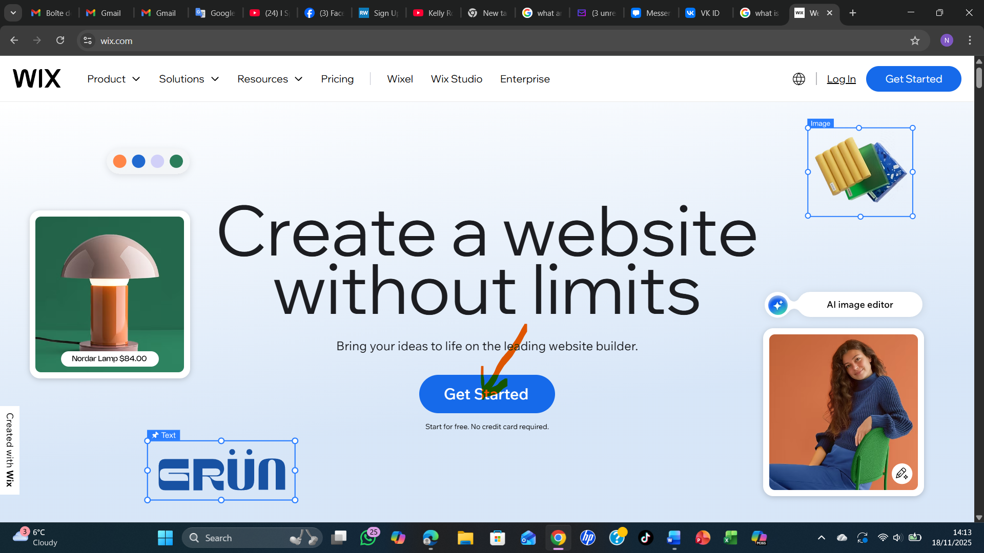 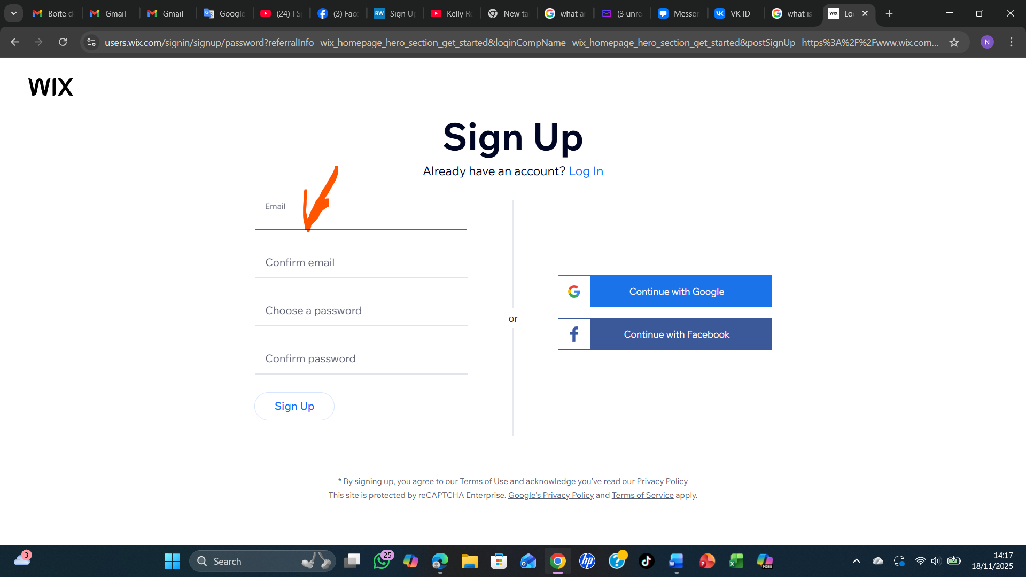 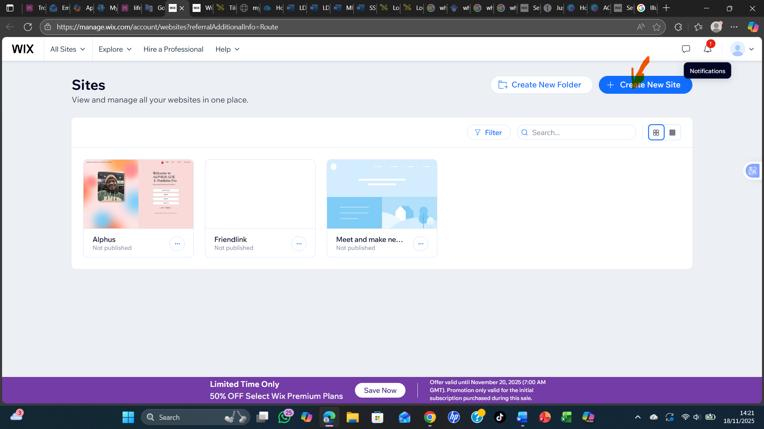 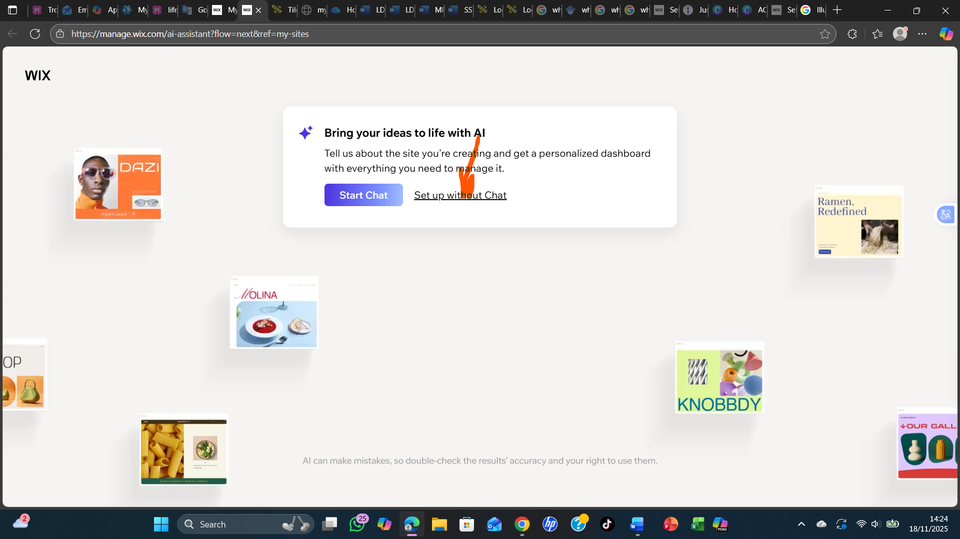 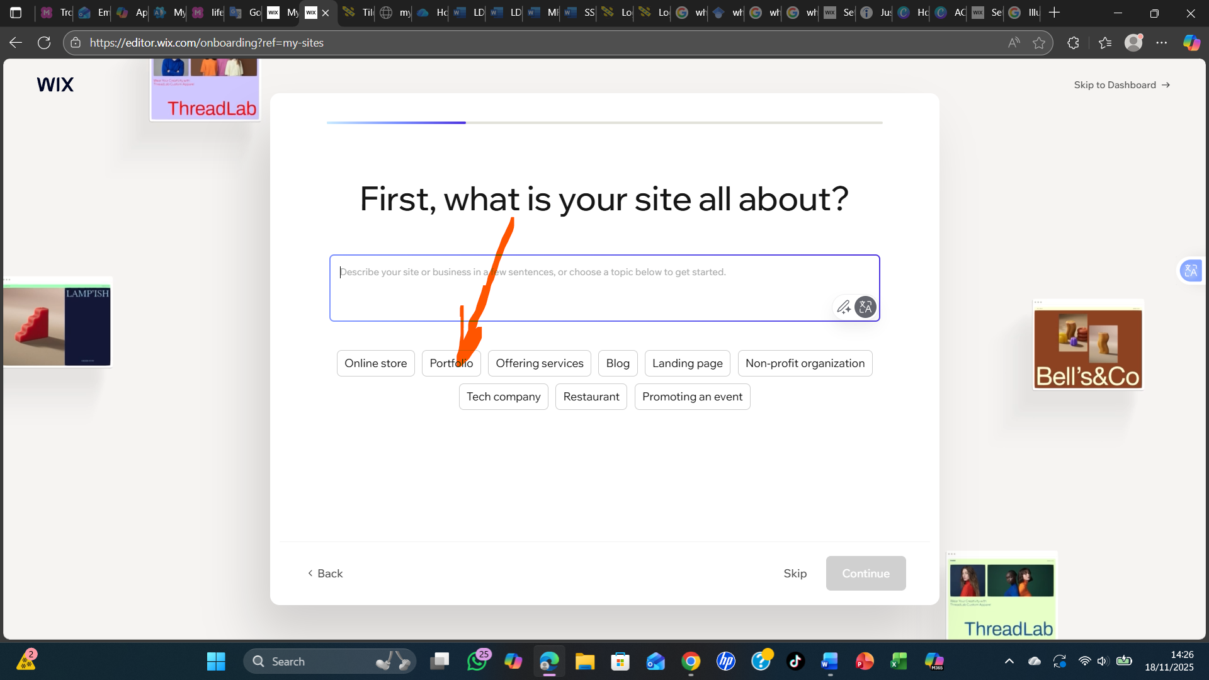 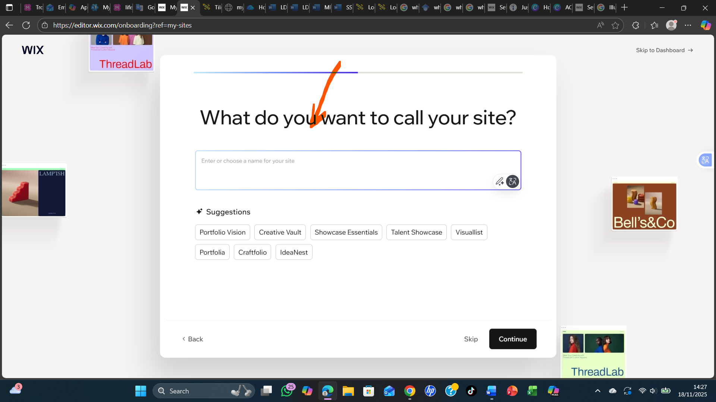 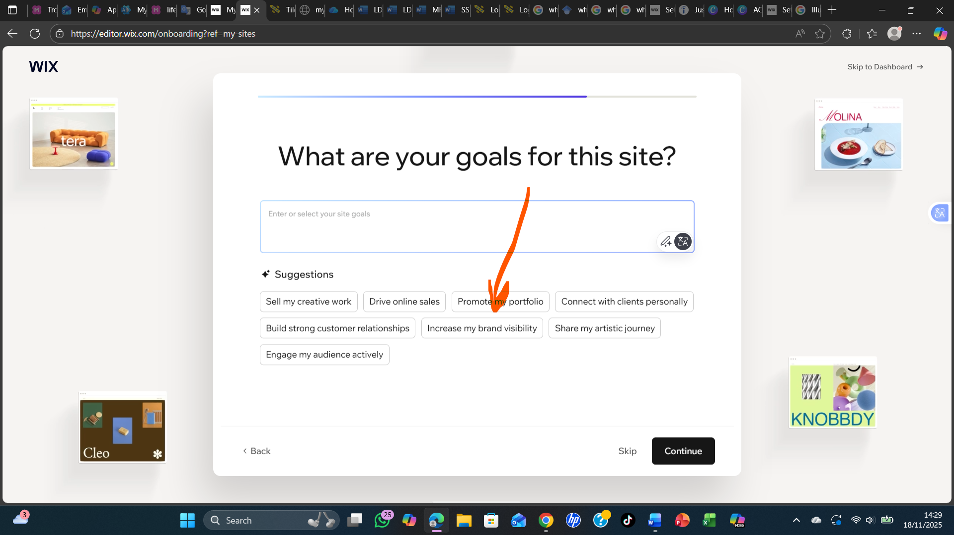 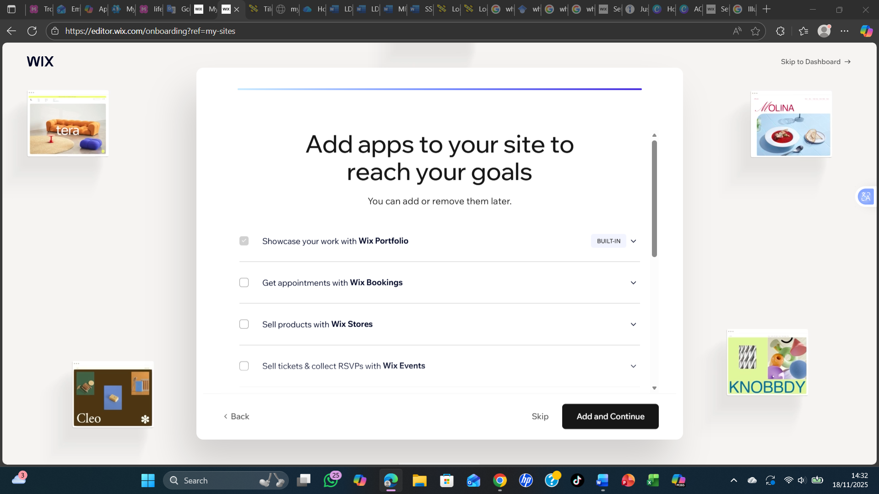 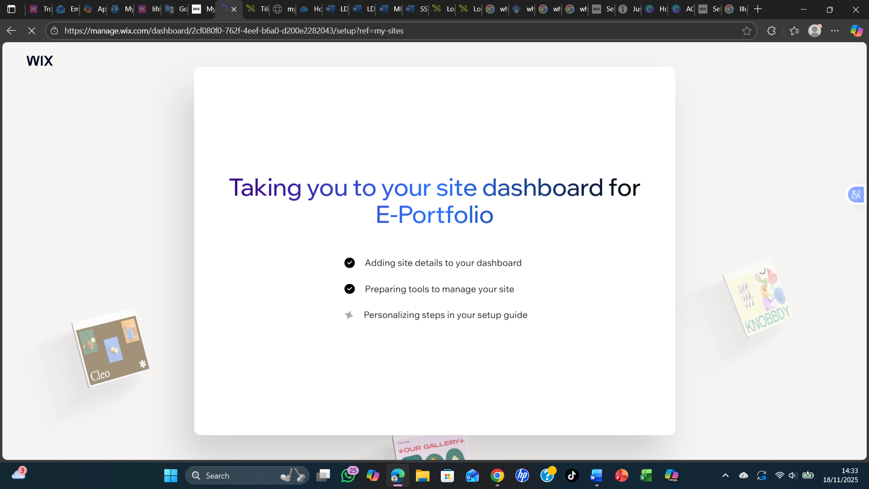 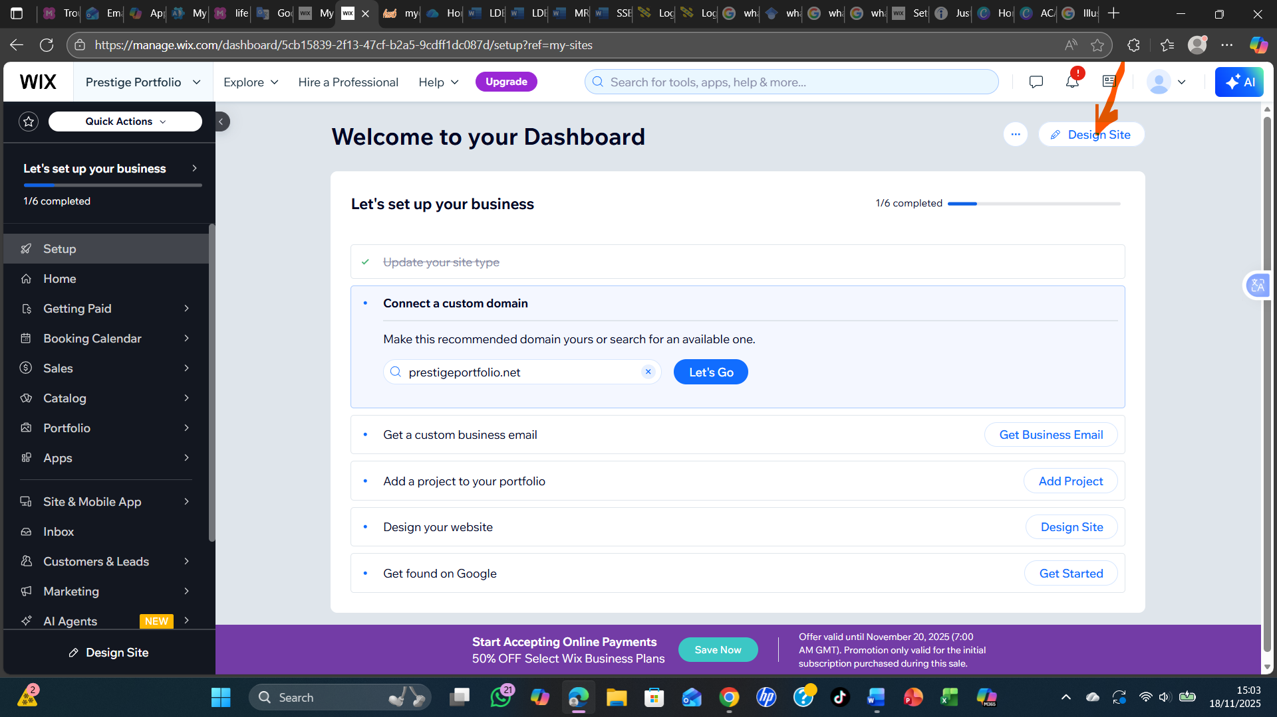 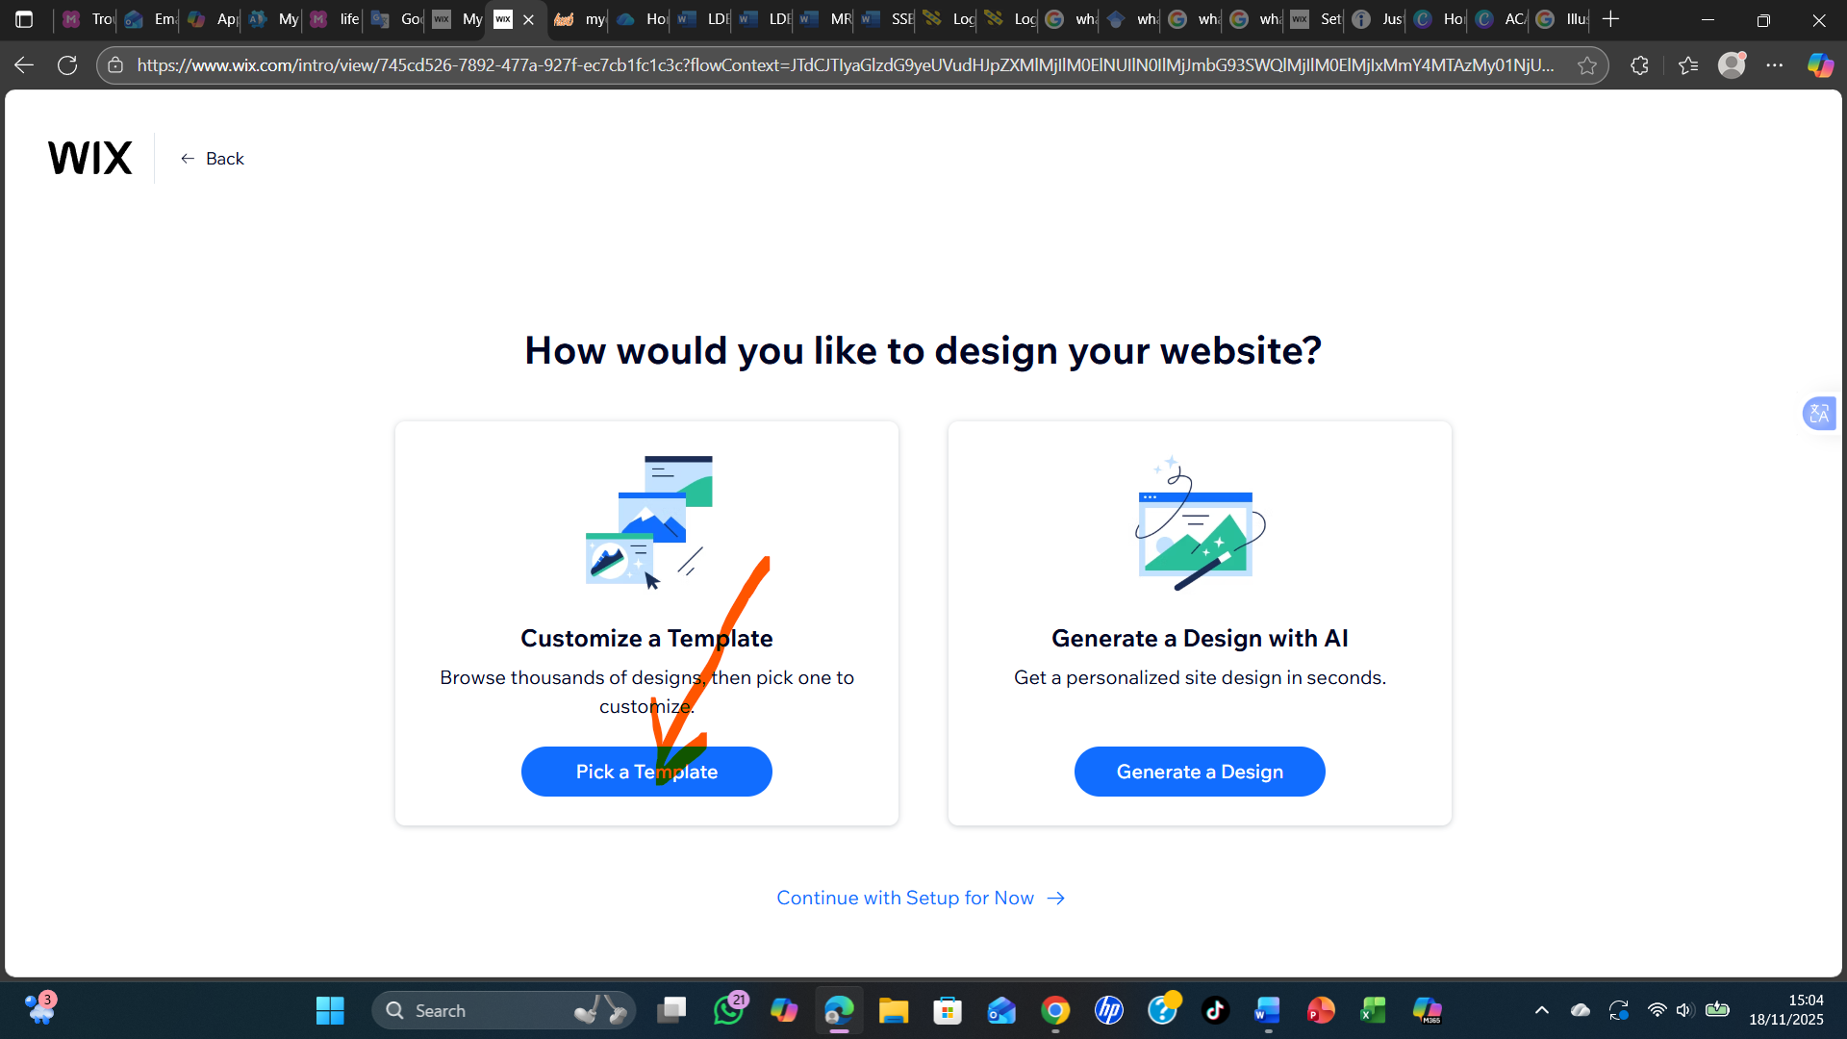 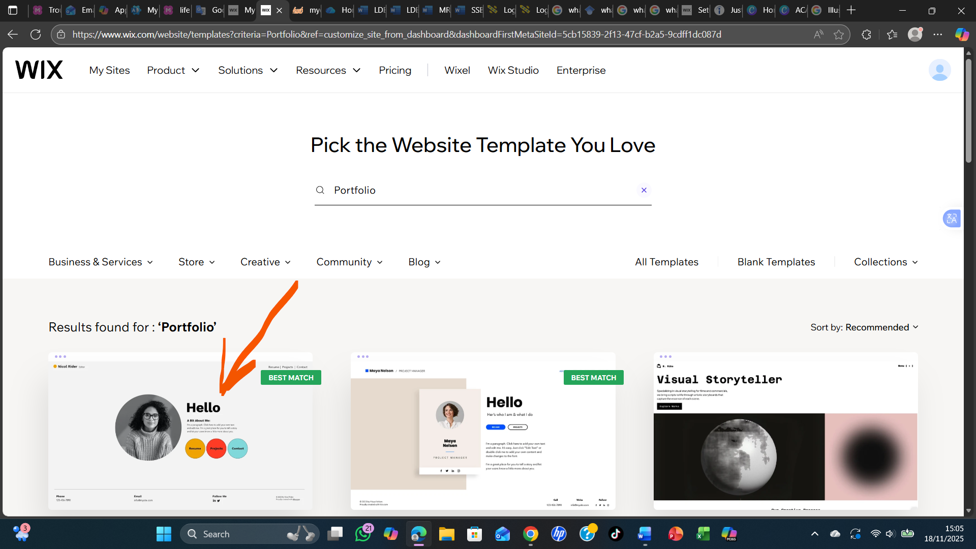 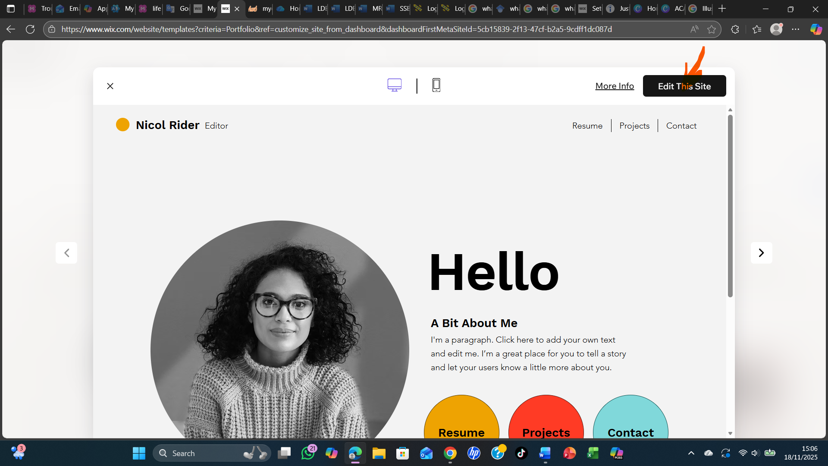 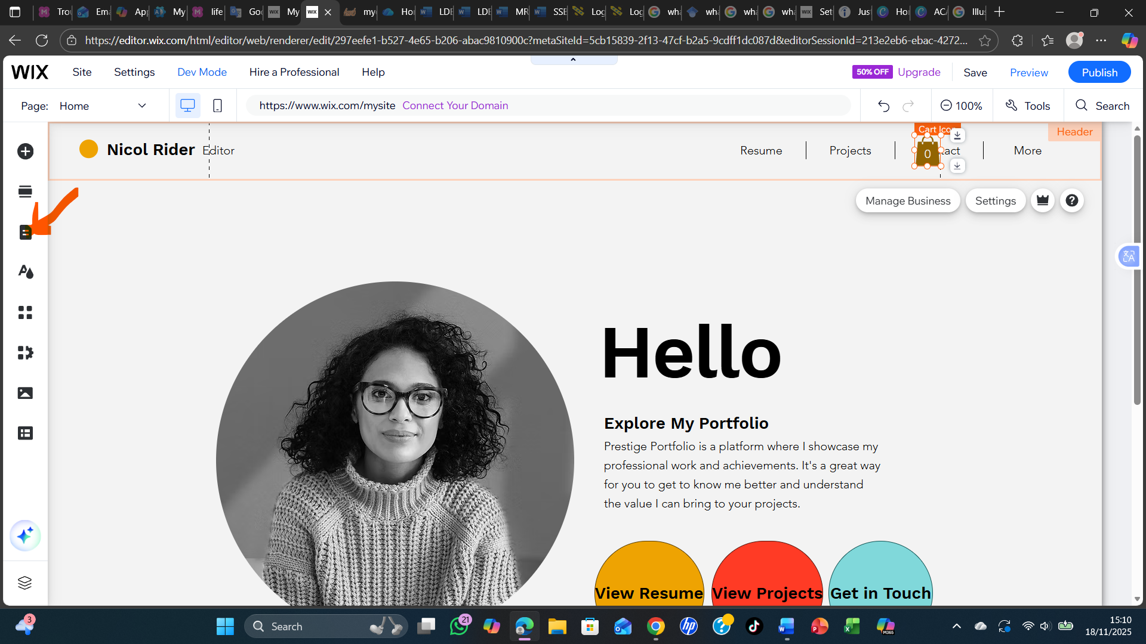 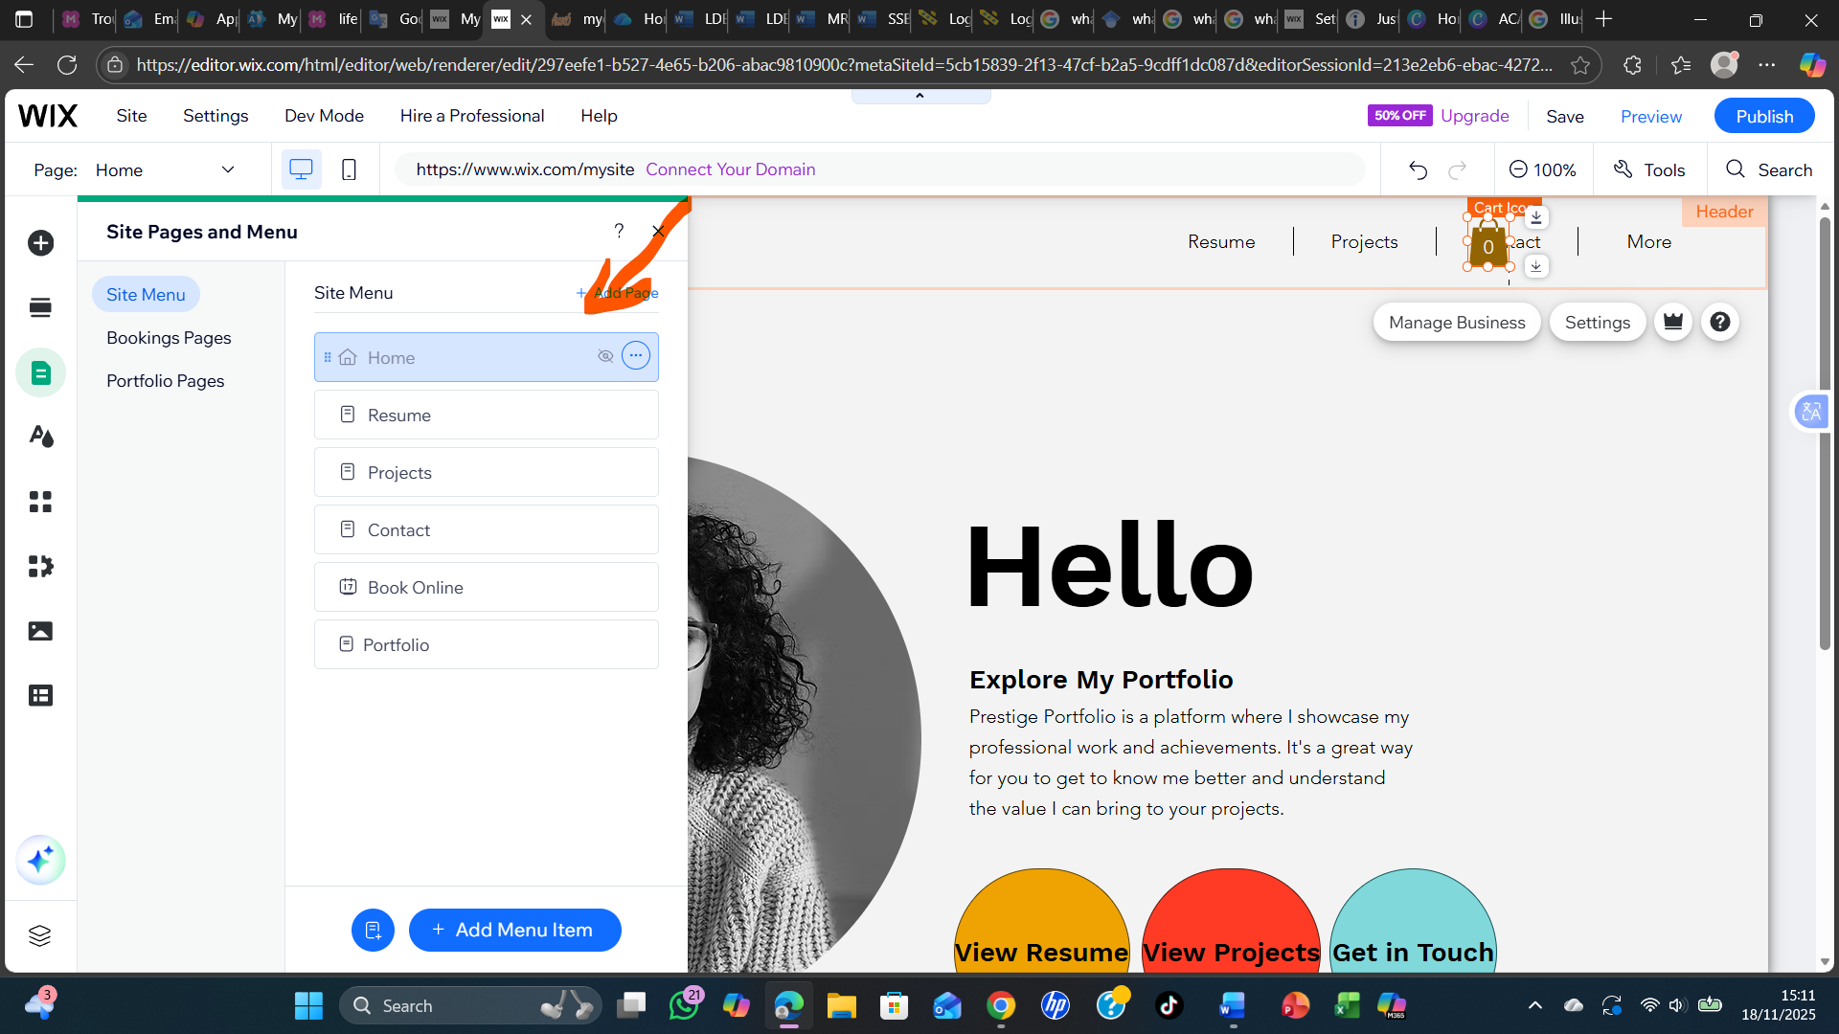 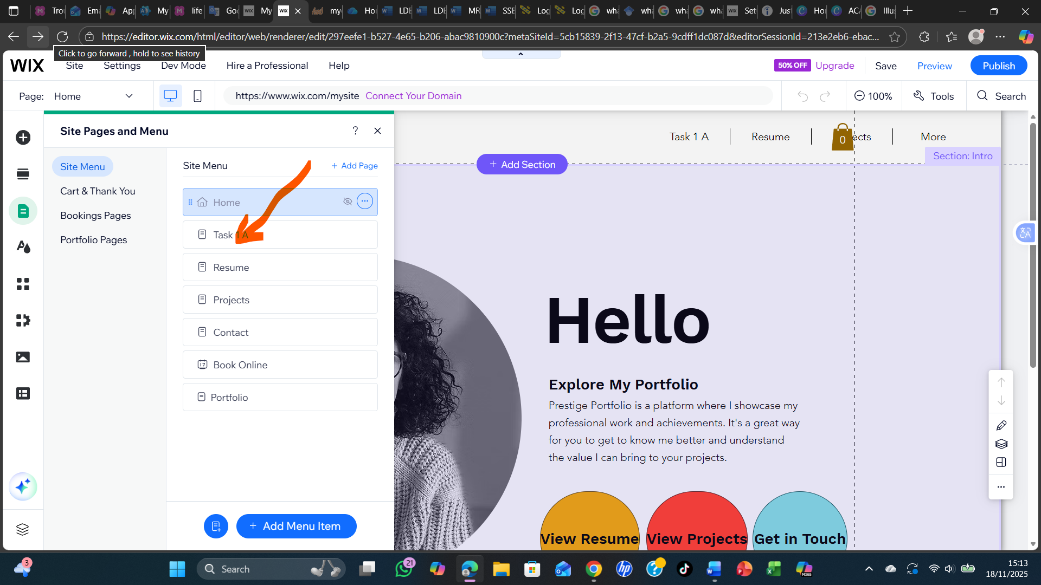 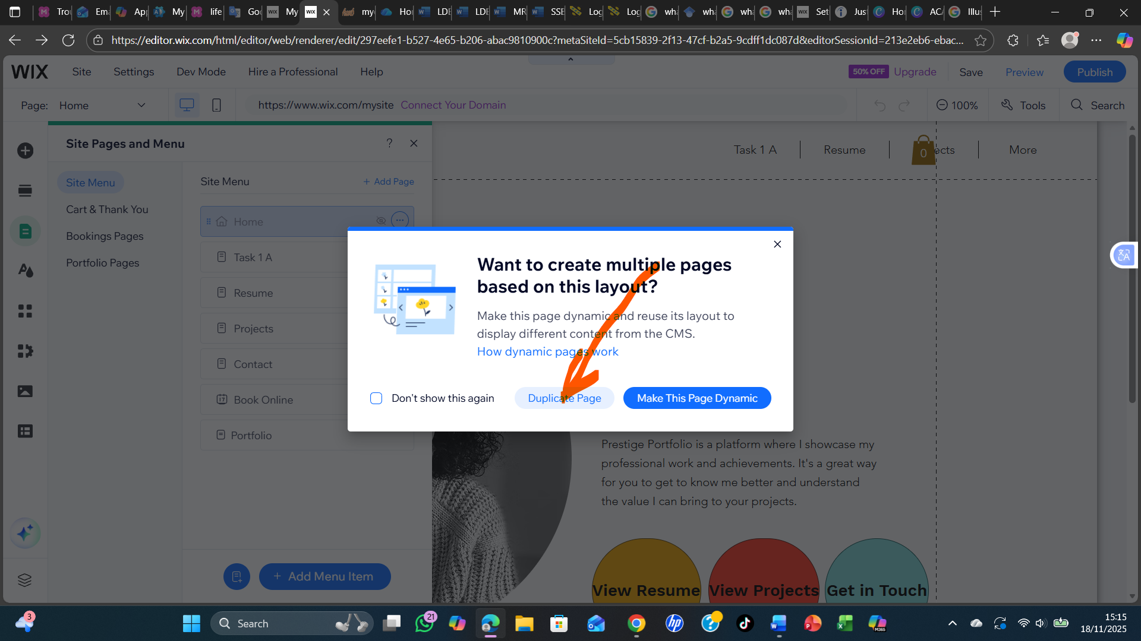 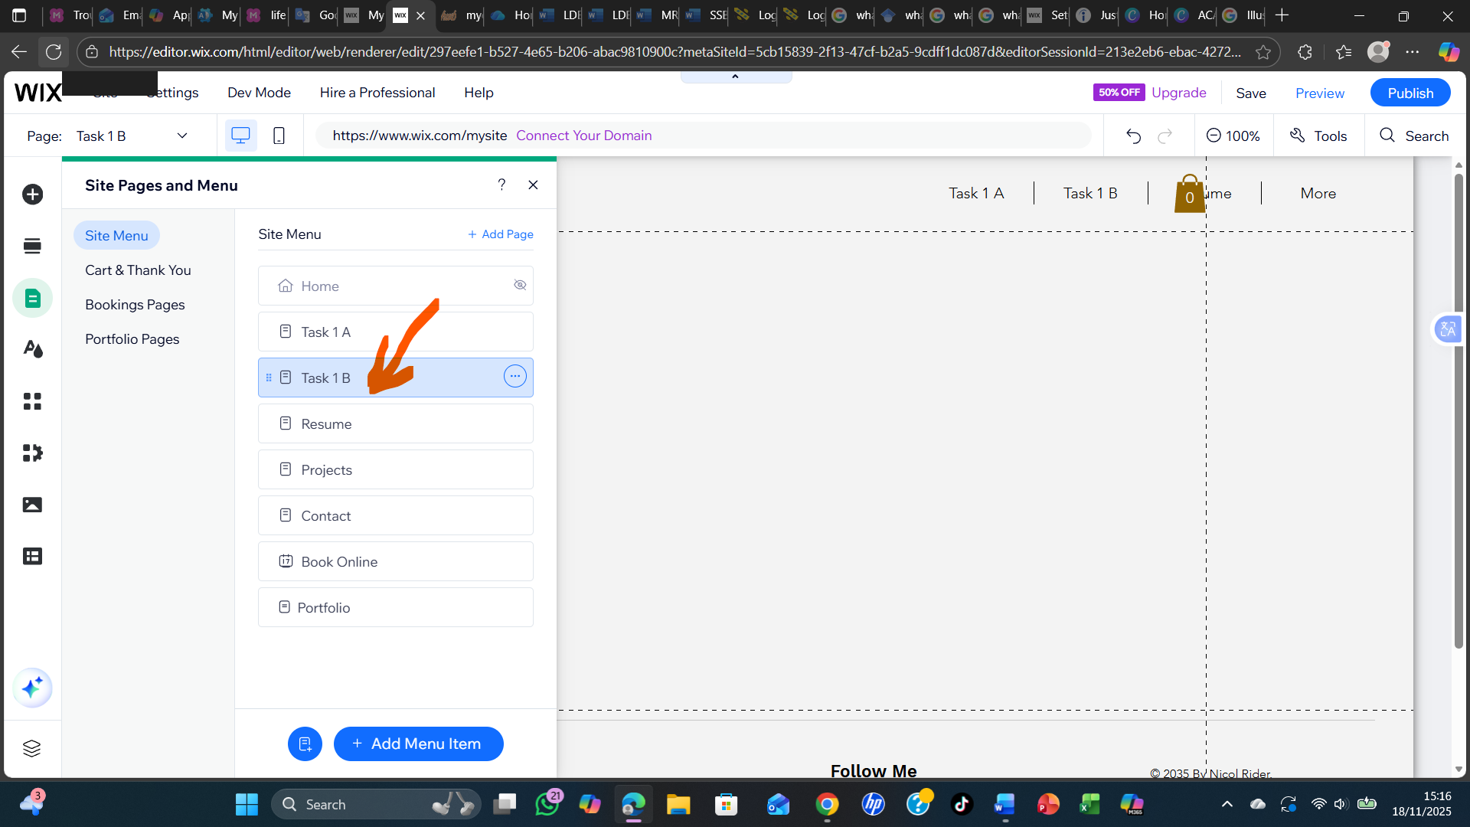 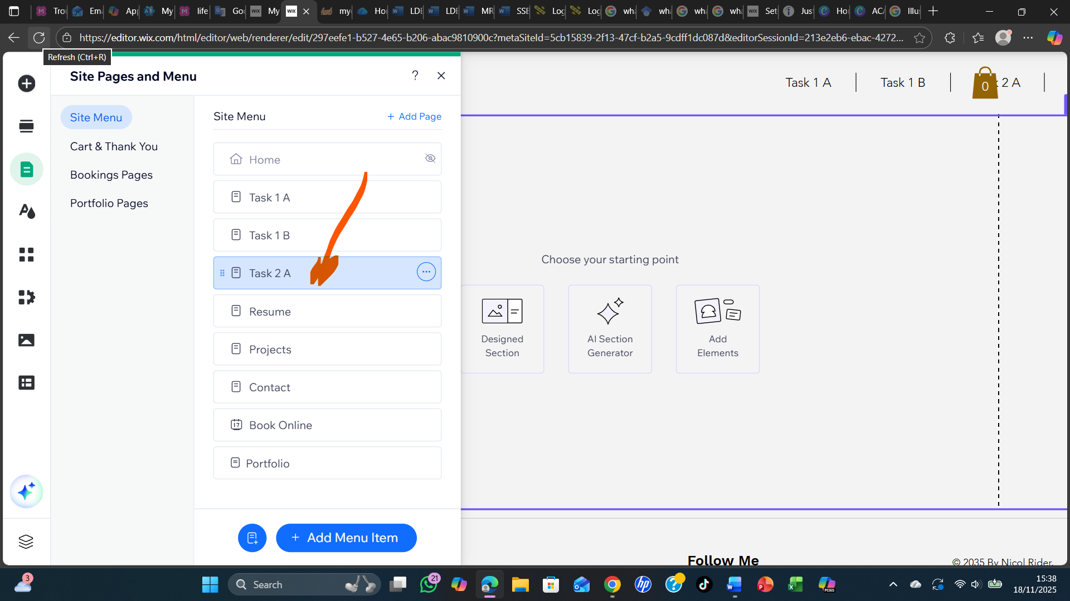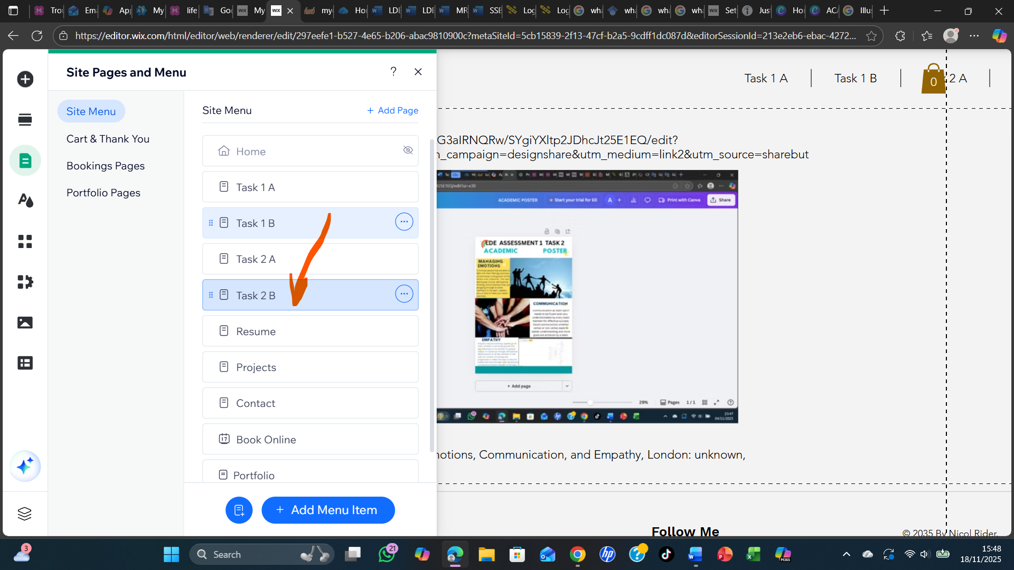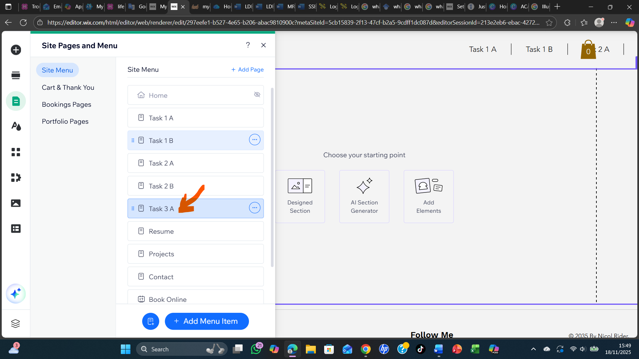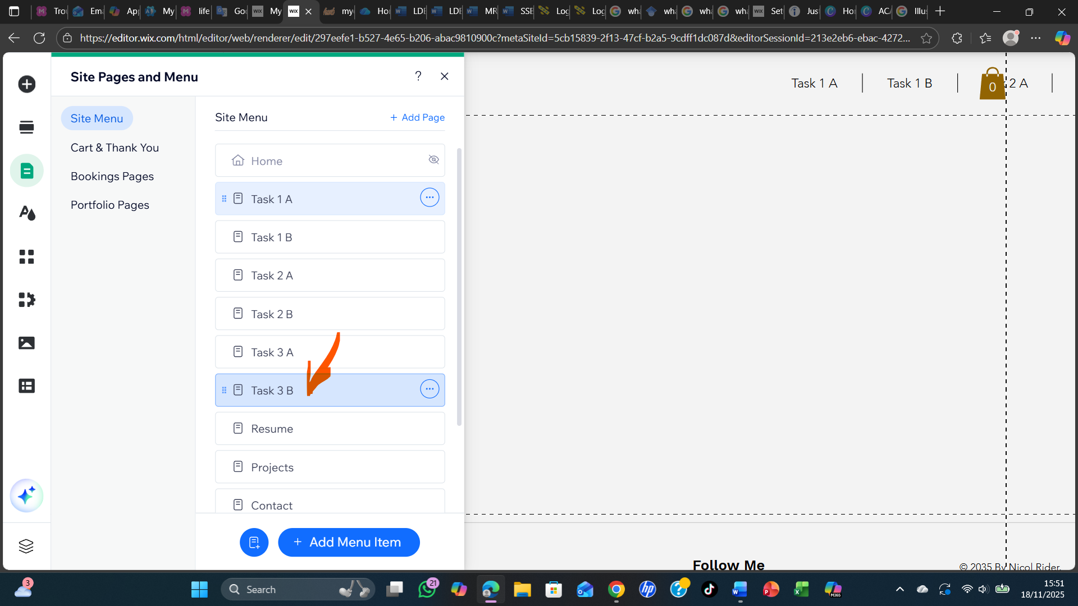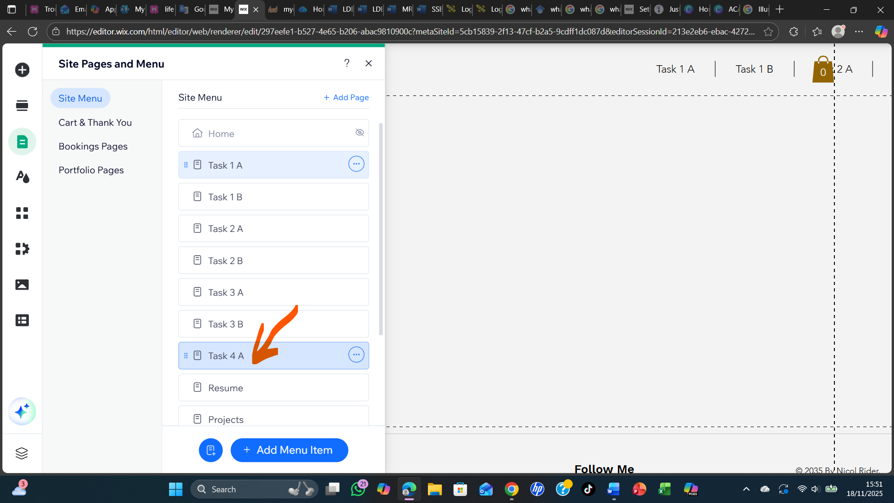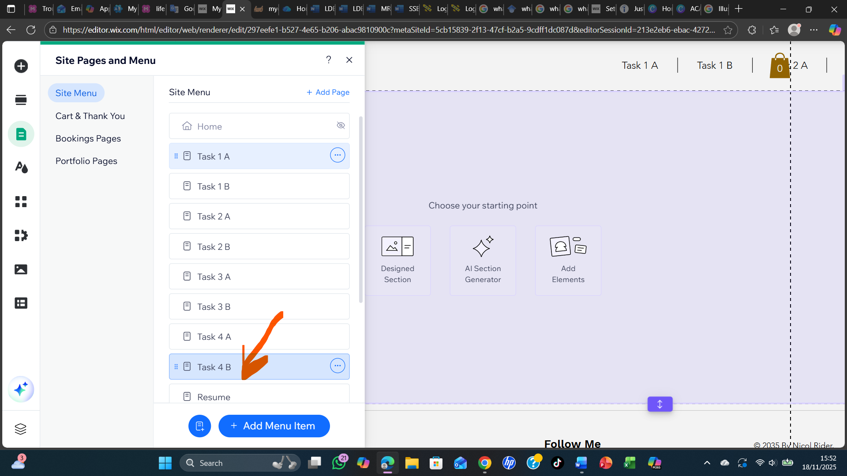

Task 4 (b): Illustrative Review of E-Portfolio tool Selection

I have used Wix in creating my e-portfolio because Wix is free I do not need to pay before using Wix, it is also very easy to assess, customise, lifelong access, and it is also data portable. Wix is user-friendly very easy to design, drag and drop editor, so many creative and customizable templates, it very has a very reliable hosting making it very easy to build a more advanced and beautiful online presence and it also has search engines optimisation applications.
I have also faced a lots of problems in using Wix to build my e-portfolio and i have face problems such as design flexibility limitations, template lock-in, you cannot change templates without starting over again to build the site, the capabilities to export are so minute making it so difficult to leave your portfolio to any platform. They are also some problems with the site speed most especially for very mighty or heavy sites, they are also very expensive as paid plans are available meaning you need to pay before you use some plans. Lack of the ability to export content.

Conclusion

References
Task 1 References:

[1] | W. E. Forum, “The Future of Jobs Report 2023,” World Economic Forum, Switzerland, 2023.
[2] | S. Cottrell, The Study Skills Handbook (5th ed.), London: Stella cottrell, 2019.
[3] | S. Cottrell, The Study Skills Handbook (5th ed.), London: Stella Cottrell, 2019.
[4] | S. Cottrell, The Study Skills Handbook (5th ed.), London: Stella Cottrell, 2019.
[5] | P. A. Facione, “Critical Thinking: What It Is and Why It Counts,” Peter A. Facione, Millbrae, California, 2011.

Task 3 References:
[5] | B. W. Tuckman, “Developmental Sequence in Small Groups,” Psychological Bulletin, vol. 63, no. 6, p. 384–399, 1965.
[6] | B. W. Tuckman, “Developmental sequence in small groups,” Psychological Bulletin, vol. 63, no. 6, p. 384–399, 1965.
[7] | S. P. &. J. T. A. Robbins, Organizational Behavior (18th ed.), Boston, MA: Pearson, 2019.
[8] | I. E. Team, “12 Ways to Improve Team Communication in the Workplace,” The Japanese Journal of Experimental Social Psychology, vol. 53, no. 1, p. 38–51, 2025.

