Hand rendered draft - block repeat tile
This example has been drafted as a collage in a block with a straight cut through, repeated out side by side as a straight block.
Draft: the first version of a design (not finished, but has the bones to become a finished outcome)

These pattern types can work well in a block repeat system, but are not limited to this method of repeat. Abstract, Check, Chevron, Ditsy, Floral, Geometric, Ogee, Scattered, Spot, Stripe, Trellis.

You can draft out a block repeat within the framework of a square or rectangle, something like this…

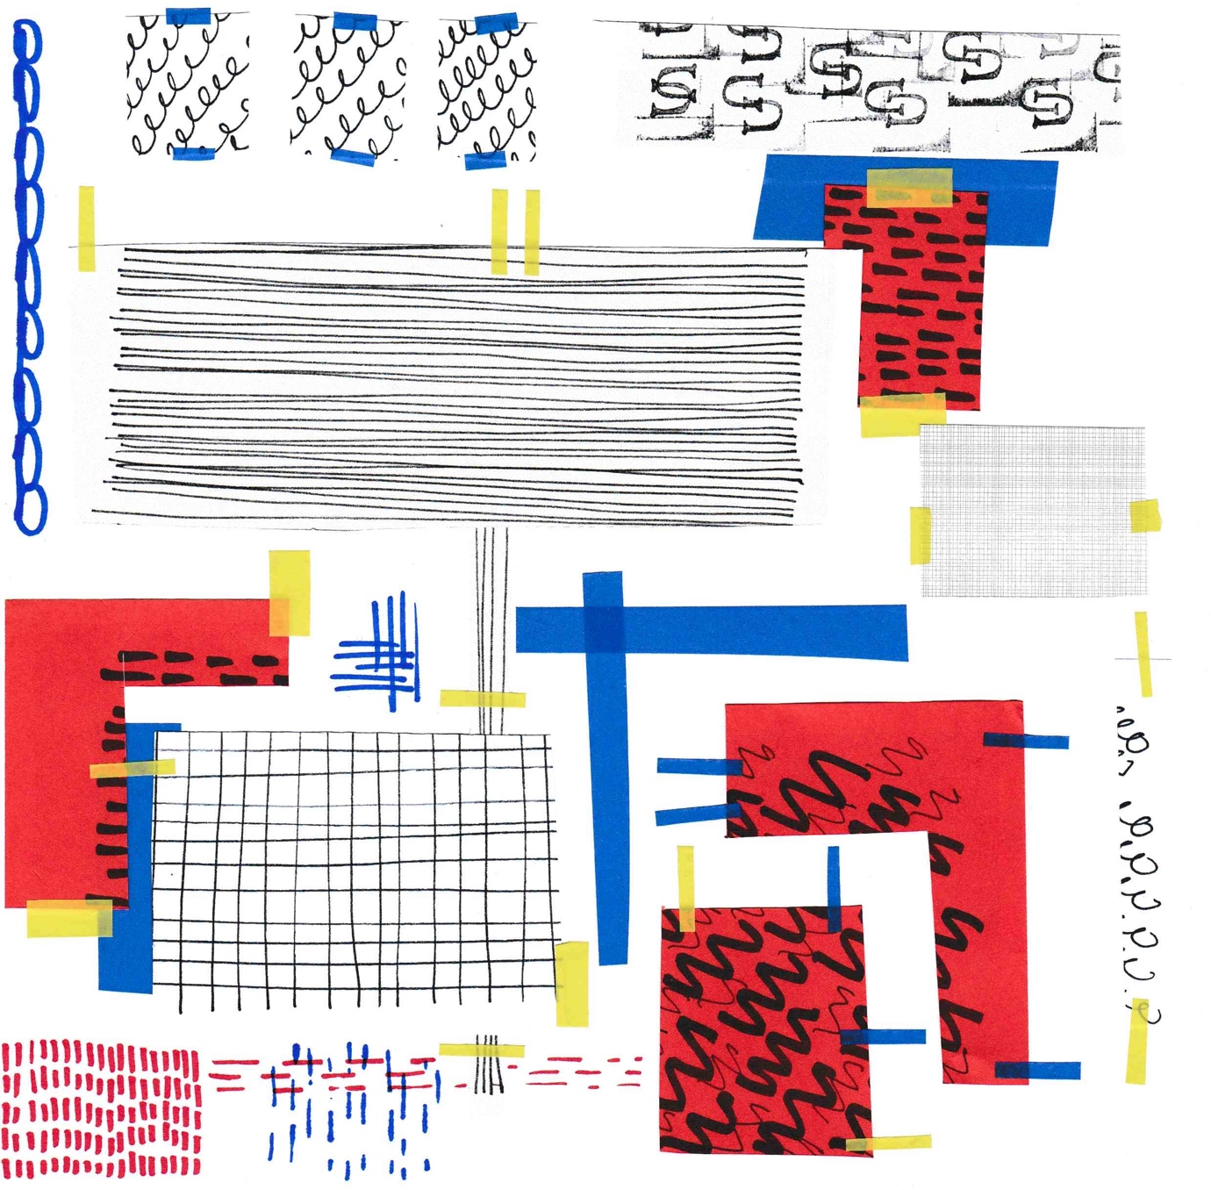

Hand rendered tile created with collaged paper and pen (uncut tile)

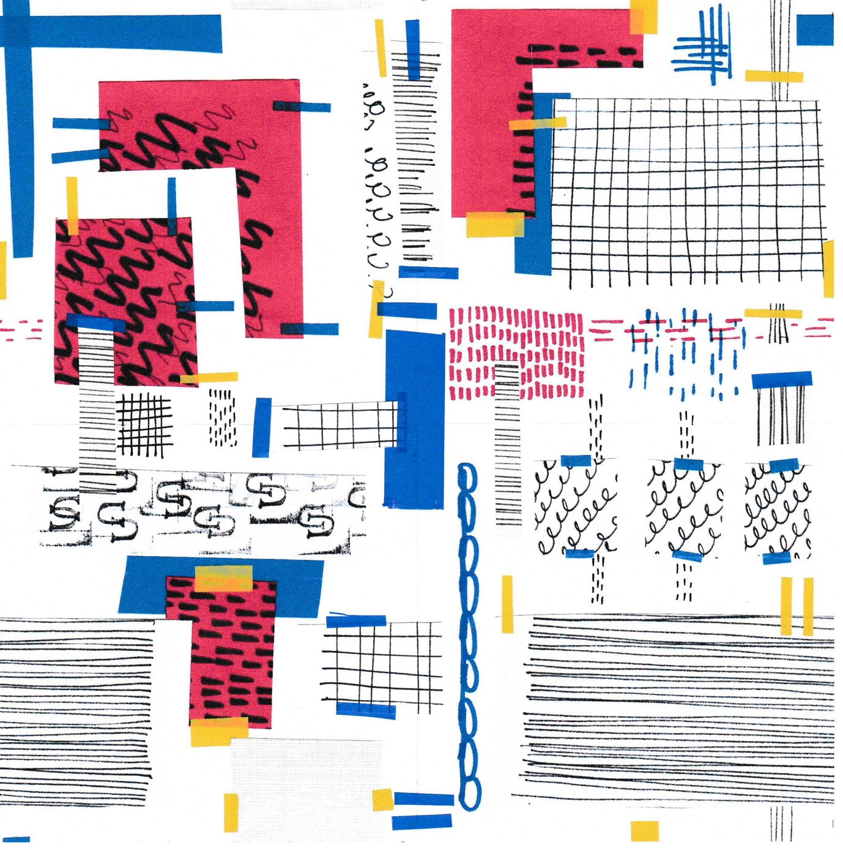

Hand rendered tile created with collaged paper and pen, tile has been cut in quarters, rearranged and more collage and pen work added to hide the seam
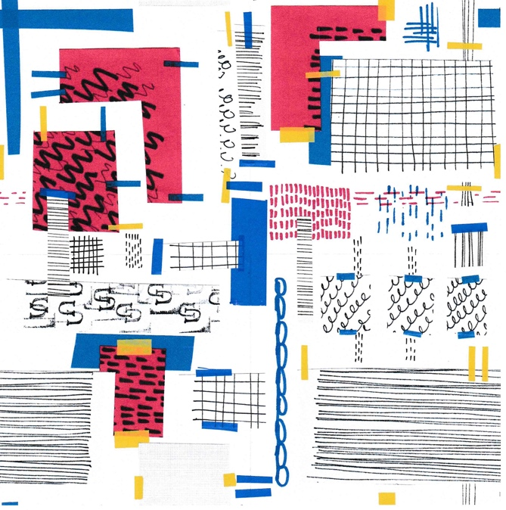
Hand rendered tile repeated out as a block repeat

