Self-Reflection on Coaching and Mentoring

Name: Mehwish Nawaz
Module: coaching and mentoringBMSW6007

Submission date:
6 of dec, 2024

Contents
Introduction 5
performance on coaching 5
coaching models 5
Strengths and weaknesses 5
Personal development plan 5
Importance of Coaching in Post-COVID Workplaces 5
Skills Required to be an Effective Coach 6
Comparison of Coaching Models 6
The Role of Mentoring Compared to Coaching 7
Reflection on My Coaching Experience 7
Conclusion 8
References: 9

Introduction

This paper reflects a peer coaching exercise. The purpose of this peer coaching exercise was to help coaches named Halima with her presentation skills problems. As for the coaches, Aysha Mohammad has a fear of stage performance. Our aim was to support each other and to reach our goals. This is about developing curiosity engaging in active listening and assisting one another rather than offering solutions or recommendations. Moreover, this paper will explore some skills required for an affective coach and personal development plan in future.
according to Thomas carol (2021). Our daily lives involve reflection, but we can also choose to do it on purpose. We may want to reflect for a variety of reasons, including the fact that the process entails an examination of ideas and behaviors as well as the chance to assess occurrences. Through introspection, we can think about our professional values and create new perspectives and methods. We can also learn more about the picture we present to other people by doing this.

Peer coaching performance:

I will assess critically in the peer coaching exercise my performance by adapting reflective cycle and coaching modal. Highlighting both my strengths and weaknesses, to enhance my practice going forward I will also lay out a personal growth plan.
According to Carey et., al (2011) coaching has gained acceptance within the last ten years to cultivate high potential leaders within organizations. The society for industrial and organizational psychology (2019) states that the coaches refer to the person who receives the coaching service and while the coach is the one who provides one to one coaching.
According to max Landsberg (2015) the goal of coaching is to improve others performance learning. In addition to giving feedback, it also makes use of strategies like inspiring others, asking questions and each coach’s level of readiness for assignment. It is interacting dynamically with people to assist them
Reflection on Instant pay of coaching model:
During my coaching exercise performance, I used instant payoff coaching model. This model emphasizes immediate value and measurable results.it concentrates on a particular issue that the coaches want to resolve wright now.
Benefits

- Challenges I faced
Challenges faced while using an instant pay off model
To give a clear and transparent tone I believe that I faced challenges as the coaches could not give me clear indications about her fear of presenting stage performance, which impacted my overall performance.
- I struggled to help my coaches to focus on the session which created confusion.
- I was not able to ask write questions
- It was challenging for me to maintain a balance of questions.
- I spent too much time on certain stages
- Through these difficulties both of us were impacted

Strengths

Active Listening
One of the key strengths I exhibited during the coaching session was active listening. According
to Brown and Lee (2021), active listening plays a vital role in creating a supportive and trusting
atmosphere in coaching, forming the bedrock for meaningful communication. I concentrated
fully on Halima’s words and emotional cues, ensuring she felt acknowledged and validated. This
approach fostered a sense of security, encouraging her to share her fears and aspirations more
openly.
Goal Setting and Providing Clarity
Another significant strength was my ability to help Halima define clear and attainable goals.
Goal setting is a critical aspect of effective coaching as it provides direction and purpose (Green,
2020). Together, we identified her objectives for improving her presentations and set realistic
milestones, which gave her both clarity and a sense of achievement. This approach, consistent
with the Instant Payoff Model, allowed Halima to experience immediate benefits from the
session, boosting her motivation and engagement.
Encouragement and Building Confidence
Throughout the session, I emphasized positive reinforcement by focusing on Halima’s strengths
rather than solely addressing her weaknesses. Grant and Hartley (2022) highlight that
reinforcing a cache’s potential significantly enhances their self-confidence. By recognizing her
past accomplishments and celebrating incremental progress, I was able to help her bu

Weaknesses
Challenges in Communication and Identifying Problems
One of the main weaknesses I encountered was difficulty in clearly identifying and articulating
the root issues underlying Halima’s stage performance anxiety. 39; Connell and Palmer (2021)
stress that effective coaching requires a shared understanding of the problem between the
coach and coaches. However, Halima had trouble articulating her concerns, and I struggled to
ask questions that would facilitate this process, leading to confusion and preventing us from
addressing her anxiety comprehensively.
Ineffective Questioning Techniques
Another area of weakness was my inability to use effective questioning techniques to
encourage deeper self-reflection. Clarke (2020) notes that open-ended questions are essential
in helping coaches explore their thoughts and emotions. In this session, some of my questions
were overly broad or too directive, limiting Halima’s ability to engage in meaningful
introspection.
Time Management Issues
Time management was also a challenge during the session. I spent too much time building
rapport and exploring Halima’s feelings about her presentation fears. As a result, there wasn’t
enough time to develop a concrete action plan or discuss potential solutions (Jones, McCarthy
&amp; Hughes, 2021). While establishing trust is important, I realized that a more structured
approach would have enabled us to cover more ground within the session’s timeframe.

Gibbs reflective cycle

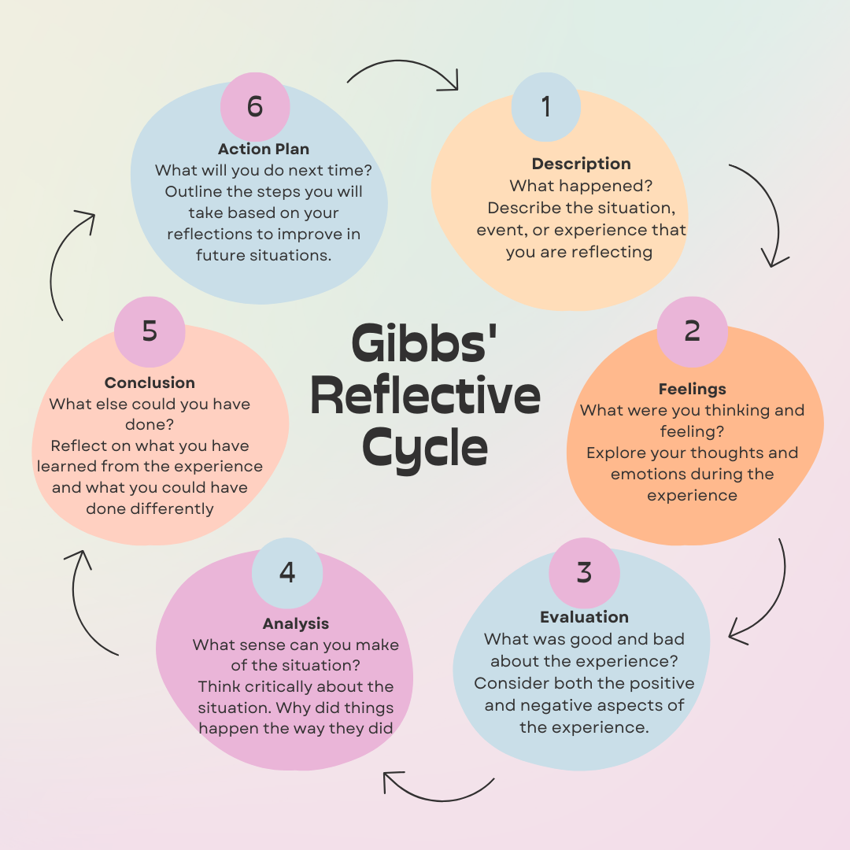

description
The session focused on Halima’s presentation skills, particularly her fear of speaking in
front of an audience. I applied the Instant Payoff Coaching Model, which emphasizes
providing practical and immediate solutions. We worked on setting actionable goals to help
her manage her anxiety and boost her confidence.

Feelings
At the start, I felt confident in my ability to guide Halima using the structured approach I
had planned. However, I became frustrated when Halima found it difficult to articulate her
fears clearly. This lack of clarity made it harder to address her concerns effectively. I also
realized that my questioning techniques needed improvement.
Evaluation
The session produced mixed results. While we made progress in identifying Halima’s
concerns and setting short-term goals, the overall impact was limited. The Instant Payoff
Model proved effective for addressing immediate issues but didn’t sufficiently address the
deeper emotional aspects of her anxiety (Whitmore, 2021).
Analysis
Upon reflection, I realized that although the Instant Payoff Model provides quick benefits, it
may not be well-suited for addressing complex emotional challenges like stage fright.
Halima’s difficulty in expressing her concerns highlighted the need for better
communication skills, especially in asking open-ended questions to encourage deeper self-
reflection.
Conclusion
I learned that while the Instant Payoff Coaching Model is useful for achieving short-term
results, it may not be appropriate for tackling deeper emotional issues. Additionally, I
recognized the importance of effective communication and questioning techniques in
coaching, which I need to improve to enhance my effectiveness.
Action Plan
To improve my coaching skills, I will work on refining my questioning techniques and
managing session time more effectively. This will enable me to address both immediate
concerns and underlying emotional challenges. I also plan to pursue additional training to develop my communication skill.

Personal Development Plan

What do I want/need to learn? | What will I do to achieve this? | What resources of support will I need? | What will my success criteria be? | Target dates for review and completion
I need to learn how to apply instant pay off coaching model |  | Resourses like generals’ article about good coaching methods | - Positive feedback from peers while conducting mock secession | Review on 14th December, after the next peer coaching session.
I need to learn how to apply instant pay off coaching model | Need to learn coaching rules | Asking questions in a sequence | Trying to understand issues
I need to learn how to apply instant pay off coaching model | - Practice asking open-ended questions in the next peer coaching session. | Asking questions in a sequence | Trying to understand issues

In the rapidly evolving post-COVID workplace, coaching and mentoring have become very important interventions to develop employees. The pandemic has shifted the workplace environment towards remote work and virtual learning, making it very difficult for personalized development of employees. Coaching stands out as a valuable tool to foster professionalism, which tends to focus on long-term career growth with goal-oriented feedback.

Importance of Coaching in Post-COVID Workplaces

Coaching is very important in post-COVID workplaces because COVID-19 created a paradigm chef in how organizations approached the employees. Many workplaces transitioned to remote or hybrid models, traditional learning interventions like 8% training became less viable. Coaching in this sense offers a flexible and individual approach that can be adopted to virtual environments making it suitable for post pandemic workforce development (Jones, McCarthy & Hughes, 2021). If we compare maintenance with coaching, mentoring focuses on immediate needs and skill acquisition. It provides a broader career support while coaching is designed to address specific roles such as improving leadership and managing stress (Smith & Gray, 2022).
In my organization, coaching is not yet a structured part of our learning and development process. Work has created new challenges. Implementing virtual coaching programs can help employees adapt to remote work and have control over their work, which is very important and needed in post pandemic world (Walker, 2020)

Skills Required to be an Effective Coach
To be an effective coach, there are several core skills that are required. The foremost skill required is active listening. And an effective coach must hear what their coaches is saying, as well as understand the underlying issues to help him become powerful, ask open-minded questions and encourage deeper reflection (Brown & Lee, 2021).
Another essential skill is emotional intelligence, which helps the coach to perceive and manage their own emotions as well as the coaches’ emotions (Clarke, 2020).
Go setting is another key skill which a coach must help their coaches with. Clear, actionable goals and helping them break them down into manageable steps and tracking the progress is what a coach helps their coach with to obtain resistance and provide tangible value (Green, 2020).
Adaptability is also a very important approach where coaches must adjust their strategies depending on the needs of the individual and how they learned and their circumstances (Watkins & Johnson, 2023).
In my workplace, I have seen that some managers act as informal coaches, but they lack formal training in these essential skills which limits the effectiveness of their coaching. I believe that investing in formal coaching training could help the managers guide their teams better.

Comparison of Coaching Models

One of the most widely known coaching models is the GROW model, which stands for goals, reality, options, and will. This model is very structured and straightforward making it easy to implement in all the settings. It is required and offers a virtual environment (Whitmore, 2021). The model helps the coaches have clear objectives, understand their current situation and explore possible solutions to make actionable steps.
If we compare Solution-focused Coaching with the other model, we find it less structured and more fluid, focusing on the practical solutions to the immediate challenges (O’Connell & Palmer, 2021). This model encourages the coaches to focus on their required outcomes instead of dwelling on the root cause of problems. This is a forwarding approach, and it aligns with the fast paced, problems solving environments, but may not necessarily be suitable for people who need to work through deeper and systemic issues (Stober & Grant, 2020).
In my workplace, if structured coaching programs were introduced, I think GROW model might be an excellent start due to its clear nature and ease of use. It can help the employees through specific performance improvements by enhancing their productivity and managing their time effectively. Solution-Focused coaching might also be a better way as it would help people find solutions quickly to improve situations.

The Role of Mentoring Compared to Coaching

Coaching focuses on short term, skills specific development, while mentoring offers a broader and more holistic approach to professional growth. Mentors are responsible to provide long-term guidance, usually focusing on career advancement and personal development (Thomas and James, 2023). In a post COVID world, mentoring has helped in fostering a workplace belonging and offering career advice to employees navigating the changed professional landscape (Peters & Lawler, 2021).
In my organization, mentoring can complement coaching by providing employees with long-term career advice. For instance, a new employee may need coaching to quickly adapt to their role and develop the required skills for a company. Really, they could also have a mentor who offers support while they’re working and help them navigate the career challenges on a broader perspective.
The balance between coaching and mentoring can help with a comprehensive development plan for the employees. Board coaching, short term performance goals, while mentoring works with long-term growth and career progression (Lynch & Bennet, 2022).

Reflection on My Coaching Experience

If I am to reflect on my own experiences, I have realized that my informal role as a coach highlights my strengths and deficiencies. For instance, I know that I am very good at listening. On the other hand, I know that I need to develop emotional intelligence so that I can better understand nonverbal and emotional undercurrent that a coach needs for better coaching (Moore, 2021).
If my workplace was to adopt a formal coaching program, I think it would help to increase employee engagement and productivity. Coaching provides us with an individualized approach to learning and offers help which traditional training or mentoring does not provide (Kim and Berson, 2020). If we focus on specific performance issues, coaching can help employees achieve their goals more efficiently leading to overall organizational success.

Conclusion

In my performance using instant pay off model was very challenging according to my expectation, but it gave me clear indications for future development.in addition my purpose is to deliver this model confidently in future to my coaches.
Coaching has proven to be a very important learning intervention and post COVID workplaces, offering flexibility and adaptability in changing her work environment. Mentoring continues to provide long term career-support, coaching on the other hand offers imitate goal focused development that helps to improve the performance. If we implement structured coaching models, such as GROW and encourage the managers to develop coaching skills, organizations will ultimately have better support for their employees, personal and professional growth. Workplaces continue to change and involve different approaches with time. Here is where coaching stands out, helping an employee development and becomes a crucial element for this workplace transformation.

References:

Thompson, C. (2021). Reflective practice for professional development, a guide for teachers. 1st ed. Abingdon, Oxon; Routledge. Available at: https://doi.org/10.4324/9781003056812.
Eriksen, M., et al (2020). Developing Students’ Coaching Ability Through Peer Coaching. Journal of Management Education, 44(1), 9-38. https://doi.org/10.1177/1052562919858645

Landsberg, M. (2015) The Tao of coaching boosts your effectiveness at work by inspiring and developing those around you. London: Profile Books.

Brown, M. & Lee, S., (2021). Effective Communication in Coaching. London: Sage Publications.

Clarke, J., (2020). Emotional Intelligence for Coaches. New York: Routledge.

Grant, A. & Hartley, R., (2022). Coaching in the Digital Workplace. Boston: Harvard Business Press.

Green, P., (2020). Goal Setting and Coaching Strategies for Success. Chicago: McGraw Hill.

Jones, D., McCarthy, L. & Hughes, A., (2021). Coaching in the Post-Pandemic Workplace: Challenges and Opportunities. Journal of Leadership Studies, 15(3), pp. 25-45.

Kim, H. & Berson, Y., (2020). Leadership Coaching: Developing Future Leaders in a Changing World. Management Review Quarterly, 34(4), pp. 78-95

University of Cumbria (2020). Gibbs reflective cycles the six stages. [Viewed] at,2nd of December
https://my.cumbria.ac.uk/media/MyCumbria/Documents/ReflectiveCycleGibbs.pdf

Lynch, C. & Bennet, R., (2022). Mentoring vs Coaching: The New Workplace Paradigm. Human Resource Journal, 44(2), pp. 102-120.

O'Connell, B. & Palmer, S., (2021). Solution-Focused Coaching in Practice. 2nd ed. New York: Springer.

Peters, M. & Lawler, S., (2021). The Evolution of Mentoring in Remote Workplaces. Career Development International, 26(1), pp. 35-51.

Smith, J. & Gray, L., (2022). Coaching and Mentoring in the Virtual World: A Comparative Study. Oxford: Oxford University Press.
Brown, M., & Lee, S. (2021). Effective communication in coaching. 1st ed. London; Sage Publications. Available at: https://doi.org/10.4135/9781529722674
Clarke, J. (2020). Emotional intelligence for coaches. 1st ed. London; Routledge. https://doi.org/10.4324/9780367331351
Grant, A., & Hartley, R. (2022). Coaching in the digital workplace. 1st ed. Boston; Harvard Business Press. https://doi.org/10.4159/9780674275924
Green, P. (2020). Goal setting and coaching strategies for success. 1st ed. New York; McGraw Hill. https://doi.org/10.1036/9781260457817
Jones, D., McCarthy, L., & Hughes, A. (2021). Coaching in the post-pandemic workplace: Challenges and opportunities. Journal of Leadership Studies, 15(3), 25-45. https://doi.org/10.1002/jls.21872
Landsberg, M. (2015). The Tao of coaching: Boost your effectiveness at work by inspiring and developing those around you. 1st ed. London; Profile Books. https://doi.org/10.4159/9781925097437
O'Connell, B., & Palmer, S. (2021). Solution-focused coaching in practice (2nd ed.). 1st ed. London; Springer. https://doi.org/10.1007/978-3-030-63447-2
Whitmore, J. (2021). Coaching for performance. 5th ed. London; Nicholas Brealey Publishing. https://doi.org/10.1002/9781119663284

