An Insensitive Munition Compliant Rapid Cratering Kit

Sam Parker

ACDA5022 – Work Based Group Project

Wales Institute for Science and Art
University of Wales Trinity Saint David



Contents
Introduction 2
Literature Review 3
Group Design Process 4
My Work 7
Small Scale Hazard Testing 7
Thermal 8
Mechanical 8
Stabiliser + Further Considerations 8
Small Scale Energetics Testing 9
Obsolescence 9
Group Communication 9
Josh Evans 9
Anna 10
Josh Ede 10
Stan 10
Presentation Feedback Discussion 11
Conclusion 12
References 12

Introduction
The task for this group assignment was to redesign the Rapid Cratering Kit (RCK) under a new set of specific requirements in the brief, which were as follows:
- IM Compliant
- Hot climate capability (all climate capability is desirable)
- Transportable on fixed and rotary wing aircraft
- Transportable by wheel and road transport
The next stage of the design process was to generate what we believed to be other important requirements according to the purpose of a rapid cratering kit, which is to enable forces to dig in at a defensive position, rapidly and safely. The final set of requirements can be seen in figures 1 and 2 below.
With these requirements in mind, the next stage of our design process was to research 5 different methods of reaching IM compliance. These were RDX / TNT in a new casing, TAW-EX in the current casing, a new fill in the current casing, a new fill and new casing, and a mixed-in-case shaped charge. Each member of the group was assigned one of these research areas, with mine being the mixed-in-case shaped charge. The next section will focus on my research into this possible design approach, and provide insight as to why it was not taken forward to use as the final design.

Literature Review
For the mixed-in-case shaped charge to be a feasible option for providing an IM munition, several prior conditions for its functionality would need to be met. These are the ability for the formulation to be produced using Resonant Acoustic Mixing, and that the formulation is capable of reaching IM compliance. There is a significant amount of research into using RAM to produce composite rocket propellant [1] [2], and The Falcon Project LTD offers production and manufacture capabilities for solid rocket motors, utilising RAM technology. With this knowledge, the next stage of the literature review process was to begin to investigate whether other types of energetic formulation could be produced using RAM, as the requirement for the RCK will need to utilise a secondary explosive, and not a propellant charge.
Polymer Bonded Explosives (PBX) are a type of energetic formulation in which the energetic component (e.g. RDX) is bound into a synthetic polymer network (e.g. hydroxy terminated polybutadiene, HTPB). The synthetic polymer tends to be an elastomer, yielding a more elastic final product, and hence yielding mechanical properties that are more resistant to higher stress / strain environments. The elasticity of this polymer also tends to increase its resistance to shock stimuli, which is a desirable property for IM compliance, and also allows formulations to be casted into a vessel before a curing process takes place. Claydon et al. have conducted a study ‘Determination and Optimisation of Resonant Acoustic Mixing (RAM) Efficiency in Polymer Bonded Explosive (PBX) Processing’, and concluded that utilising RAM for PBX formulations is a worthy area of future research, and a promising technology for the future [3]. Claydon has also published his PhD thesis, ‘Resonant Acoustic Mixing of Polymer Bonded explosives’ and pointed out several other significant benefits that RAM could provide. These are: enabling a higher solids loading (i.e. energetic content) and therefore higher performance of the formulation due to more efficient mixing of high viscosity mixtures, higher mechanical strength as a larger surface area to volume ratio is present due to a smaller particle size of solid being suitable for mixing, a safer material as the smaller particles will have fewer internal defects that could act as hotspots under certain stimuli. The higher solid content will also have other positive knock-on effects. For example, improving the aging properties of the material, as less plasticiser will be required, reducing the risk of plasticiser migration [4].
This research shows that PBXs have promise for being high explosive energetic formulations that are capable of being processed by RAM. It is also a possibility that the mixing vessel can form a part of the final charge, with a filed US patent showing this [5]. This possibility will significantly reduce waste generated, hence improving cost which is one of the requirements of our munition design. It also minimises environmental impacts and hazards for production staff, as excess energetic formulation will not need to be disposed of via burning, and mixing blades covered in energetic material will not need to be handled. This patent, alongside the previously discussed research show that a PBX, mixed-in-case shaped charge is a feasible possibility. The next stage was to understand if PBX formulations are capable of being IM compliant. If there was evidence that they were capable of fulfilling IM criteria, then the overall approach would be suitable for taking forward into the design choice process.
There has been research into using energetic binder systems in PBX formulations, as using inert binders, such as HTPB mentioned earlier reduces the energy output of the final formulation. Arthur Provatas has published research in this area and found energetic binders are suitable for use is missile systems with a high explosive payload. He also found that these energetic binders were likely to fulfil IM compliance, with the added benefit of the increased performance by not using inert binders [6]. Additionally, it has been demonstrated that cast PBX B2238 is a suitable replacement for use in small-calibre high performance insensitive munitions. The formulation did not explode when exposed to heat and impact stimuli, and performed well when exposed to fragmentation and shaped charges, thus allowing it be classified as an IM [7]. Finally, EURENCO France have demonstrated the capability to produce IM compliant 155 mm mortar shells at a production-scale rate by utilising PBX technology [8]. This research shows that PBX formulations can be IM compliant.
Now that it had been established that the approach was theoretically feasible, it was time to decide whether it is a sensible approach to solve the problem set in the group project. As this is still an emerging technology space, and there is no publicly available information on a mixed-in-case shaped charge specifically, it is impossible to state that the technology is readily available to produce the RCK. With this in mind, a significant amount of research would need to be done, based on the literature that has been discussed above to test and produce an RCK using mixed-in-case shaped charge approach. Even though the research presented shows a good indication that the technology is suitable, the fact that an immediate solution is not available means that there is a degree of risk, that makes the option uncertain. As the task was to design a new RCK, and not to design and research a project that could produce a novel way of manufacturing the RCK, it was decided during a group meeting session that it was not the most suitable approach. An improvement in this regard that could be made for future group projects of a similar nature would be to complete a rationalised comparison of the different researched design ideas, and see numerically, how each of them compare. This would give us a numerical reasoning on how our researched proposals meet the requirements that we have set, instead of deciding verbally during a group discussion.

Group Design Process
After discussion the decision was made to proceed by using the current casing / bag design, and instead implement a new IM compliant fill, in the form of Taw-Ex 2022 – a new, theoretical munition for which the data had been provided during the class brief. Reasoning for choosing this design approach was: guaranteed IM compliance, readily available for production, and easy to implement into the current charge design. Additionally, as the task was a hypothetical scenario for university coursework, and would not yield implementation into a real product, we decided that this approach would provide the greatest amount suitable discussion points for the project and report. Realistically, there are significantly easier ways of reaching IM compliance with the existing 60 : 40, RDX : TNT mix – for example by altering the packaging. This approach would require far less of the chemical / mechanical testing of a new formulation which will be discussed later in this report. Additionally, the turnaround time for delivering the product, and the cost of the work to produce it would also be lower, therefore making it a more viable option for a real-life project.
Once we had decided on our chosen solution, we conducted systems engineering workflow tasks to begin formalising our design process. Our first task was to provide a set of rationalised requirements, as seen in figure 1 below. This process was important as it provided numerical insight into our most important requirements for the design, from figure it is clear that the safety aspect, and the ability for the munition to produce a suitable crater were the most heavily weighted requirements.

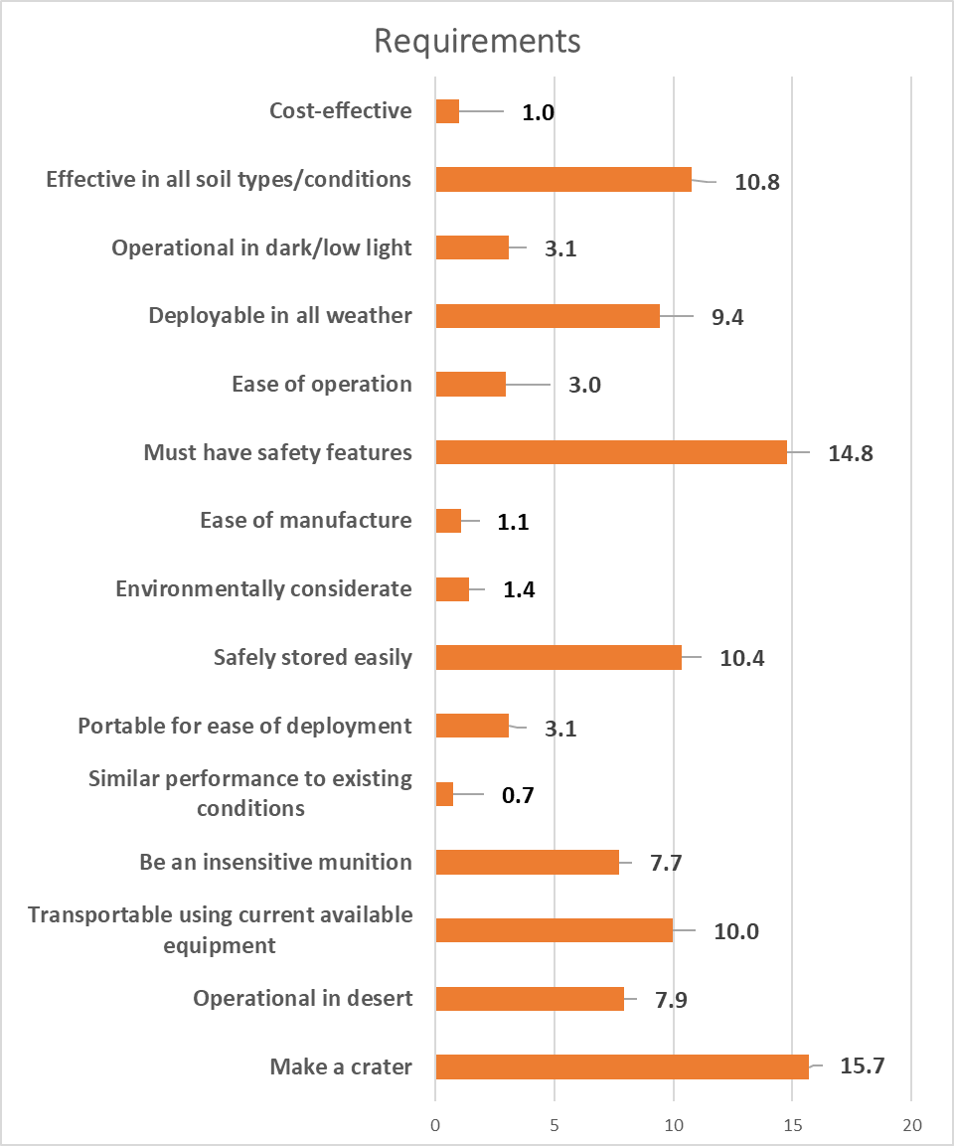
Figure 1 - Rationalised Requirements
Once the list of rationalised requirement was finalised, we formed Quality Function Deployment (QFD) one to compare our rationalised requirements, to how aspects of the design will meet the requirements. QFD 1 can be seen in figure 2 below. The rationalised requirements step performed prior feeds into QFD 1 via the importance column. This then allowed the group to see which column in the ‘how’ (functional requirements) section is the most important.
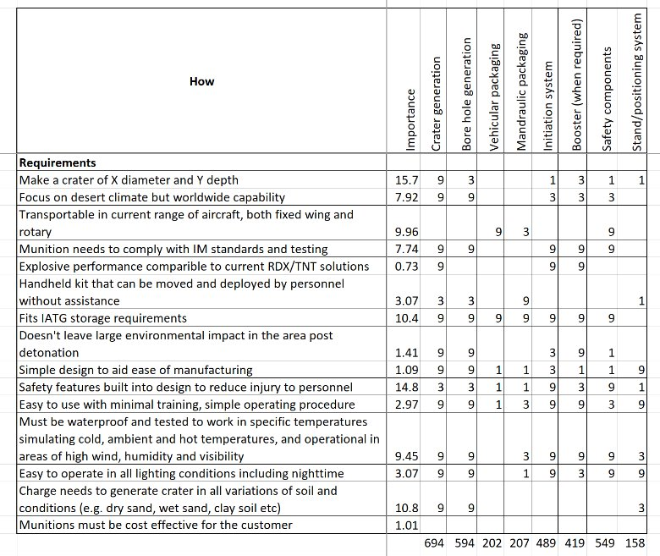
Figure 2 - Quality Function Deployment One
After QFD 1 was completed, we began to generate a list, as seen in figure 3 below. These were the features that we said would appear in the RCK, again rationalised to provide their relative importance. This could then be used in QFD 2, against the functional requirements from QFD 1 to yield our further priorities for the design of the RCK.
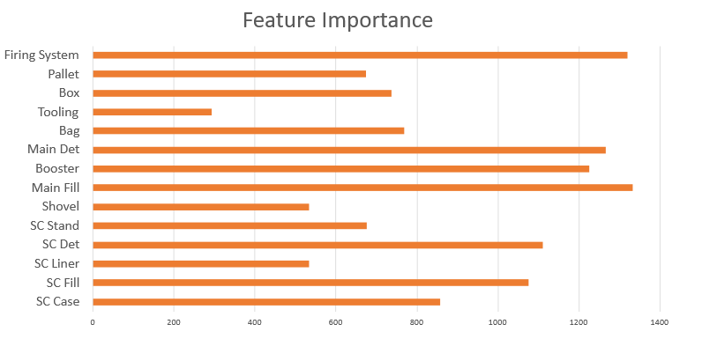
Figure 3 - Feature Importance
At this point, there are two more QFD processes that are available to continue following the systems engineering design approach. Due to lack of suitable knowledge, and limited time frames after the knowledge had been acquired the further stages of QFD were not carried out. For future design work, these extra steps could prove to be useful for our manufacturing process, and the associated controls in place for ensuring correct procedures are followed. Given that feedback from a ‘stakeholder’ presentation that was conducted prior to the generation of this report included manufacturing processes, it is likely that QFD 3 and QFD 4 will have alleviated some of these issues. This will be discussed further in later sections.
Now that as a group, we had reached the design point where the explosive fill of the RCK had been decided upon, and the relative importance of our key features was known, we were each assigned a specialist area. This assigned area would be how the rest of our time preparing our idea for the group project would progress. My role for the project was to provide a ‘lab scale’ testing regime for our chosen explosive, Taw Ex-2022. There was a datasheet on Taw Ex-2022 that was provided to us by the manufacturer. However, as this was a new munition we would need to perform our testing, to ensure that it is safe for use within the RCK. The next sections of the report will focus on the proposed testing that would need to be carried out on the explosive. It was important at all stages of the process to keep in contact with the other team members, as there is a significant amount of cross linkage between the different roles. Communication would be vital for ensuring that the final output of the project, meets the initial requirements. It is important to note that as there is no practical element to this project, that only a testing regime can be proposed. Figure 4 below shows the provided Taw Ex-2022 datasheet. Results from the qualification program proposed in this work should be similar.
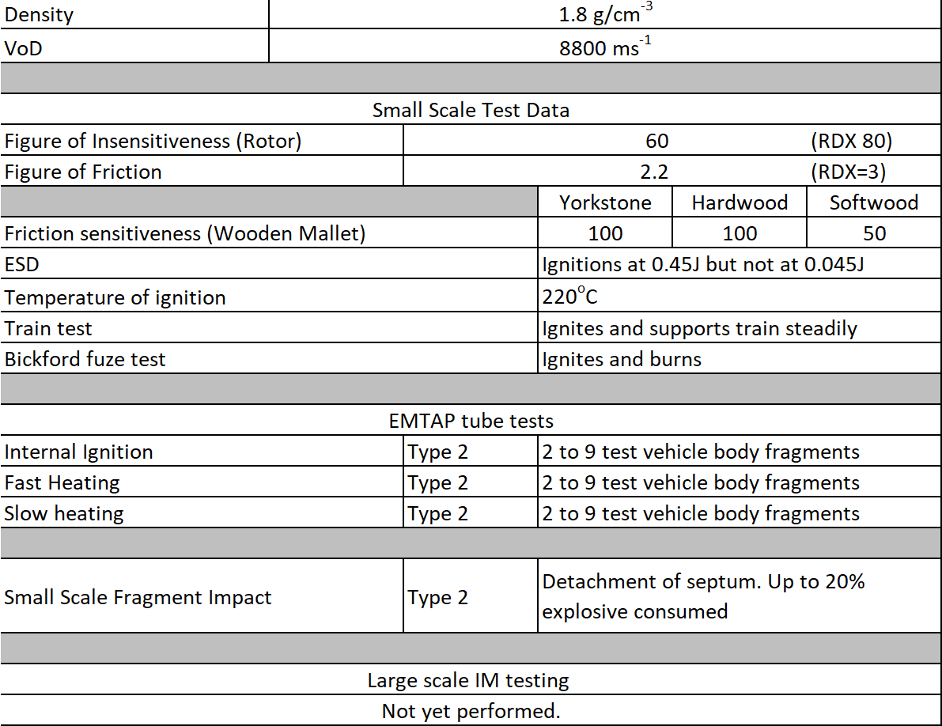
Figure 4 - Taw Ex-2022 Hazard Test Data

My Work
This section will briefly cover the testing that was proposed, without going into detail of how each test is performed, as this was covered during the appropriate section of the presentation. Each time a test is referenced, the appropriate STANAG can be read for detailed information on the method for carrying the test out. My role in looking after the lab-scale testing side of the project was to come up with a suitable testing regime that would ensure that our chosen energetic was capable of meeting the various safety, and performance metrics needed for a new UK munition.

Small Scale Hazard Testing
In the United Kingdom, the Energetic Testing and Assessment Policy (EMTAP) Committee provides the reference handbook used to assess the safety of energetic materials that are intended for use with UK service. In the manual, a brief description of each test is given, and it provides well-known results as an aide for test data interpretation [9]. The proposed tests can be found below, with their respective test number as they appear in the EMTAP manual.
- Rotter Impact ​(Test No. 1)
- Rotary Friction ​(Test No. 33)
- Temperature of Ignition (Test No. 3) ​
- Electric Spark Test ​(Test No. 6)
- Train Test​ (Test No. 5)
- Ease of Ignition / Bickford Fuze Test (Test No. 4)
It is important to note that there are numerous other tests listed in the manual. In the case that the material is not performing as expected, other tests (or multiple repeats of the same test) can be employed to ensure results are accurate.

Thermal
Compatibility testing forms a key part of any test regime for a new explosive formulation. STANAG 4147, Chemical Compatibility of Ammunition Components with Explosives [10]. This STANAG is currently classified by NATO, but it’s contents detail the type of testing that will need to be completed on a secondary high explosive, which is the specification for Taw Ex-2022. The tests below are the proposed set of tests that will be completed for the qualification of Taw Ex-2022.
- Vacuum Stability test (STANAG 4556 [11])​
- Differential Scanning Calorimetry (STANAG 4515 [12])​
- Heat Flow Calorimetry (STANAG 4582 [13], 4515)​
- Thermogravimetric Analysis (STANAG 4515)
Compatibility testing is a vital part of the munition whole design process. Each component within the RCK will undergo to discern whether it is compatible with the energetic part, Taw Ex-2022. There are different levels of testing in accordance with the proximity of the material to the energetic. For example, a material in direct contact with the explosive will need to undergo a more rigorous test. These different criteria are specified in the classified STANAG 4147, and so cannot be directly referenced here. Examples of the different things that will undergo the compatibility test include: the metal liner for the shaped charge, and internal coatings on the casing of the shaped charge, the material of the bag charge and any coatings on the outside of the casing. While a paint used on the outside of the shaped charge is not directly exposed to the energetic material, there is chance that during processing the materials could come into contact, or it could seep in via a joint. This therefore means that compatibility testing shall occur, to assess if there are safety concerns with using the paint.

Mechanical
Mechanical testing is a vital part of assessing the performance of an energetic material over its operational life. As one of the key requirements for this RCK was to be operable in hot conditions (e.g. desert), and preferably be able to operate in cold conditions (e.g. Ukraine in the winter). Mechanical testing judges how the energetic material will perform under maximum and minimum operating conditions. For example, a tensile JANNAF can be conditioned at a temperature below the minimum required operating temperature, to ensure that it is capable of performing at this minimum temperature. A material will only be cleared for service if it is capable of meeting the strict mechanical requirements to ensure it’s safety over the operating temperatures. Reasoning why tensile testing is important will be discussed in the ‘Feedback Review’ section.
- Dynamic Mechanical Thermal Analysis (STANAG 4540 [14])​
- Tensile Testing (STANAG 4506, [15])

Stabiliser + Further Considerations
As the energetic component of Taw Ex-2022 has not been specified, apart from saying it is a novel energetic molecule, it is a good design choice to include the use of a stabiliser to increase the shelf life of the formulation. AOP-48 is another NATO document that references how to perform compatibility testing based on the depletion of the stabiliser within the energetic composition, when it is exposed to a material. This is another test that would be carried out, if a stabiliser was used in our design.

Small Scale Energetics Testing
A number of small-scale energetics tests would be carried out, so that data for modelling purposes could be gathered. These smaller scale lab experiments would help to keep the overall cost of implementing the RCK down, as modelling data can be used to simulate larger scale trials which incur a significant cost. One of the tests that would be carried out would be the Velocity of Detonation (VoD) test, which is No. 47 in the EMTAP manual. Another test would be a small-scale detonation of our explosive formulation. Pressure transducers would capture the detonation pressure of the material, which would then be used by other members of the project team to complete their modelling experiments.

Obsolescence
Although obsolescence did not feature heavily in our design process, it is a key area that would need to be considered in our approach, or for any future iterations of the design. Taw Ex-2022 is said to use isocyanates, and a tin based catalyst which are increasingly facing risk of being subject action by the European Registration, Evaluation, Authorisation and Restriction of Chemicals (REACH) regulations. Diisocyanates and organotin catalysts are both hazardous to human health, and so are subject to restrictions on their use (e.g. limited their maximum concentrations). To avoid any issues in the future if the substances are completely banned, then suitable alternatives should be investigated. As these chemicals are used in a significant number of other industries, there has already been research into identifying potential alternate solutions. However, our own research into the alternatives would need to be carried out, as there is no guarantee that the technology is capable of being directly lifted from one area to another. Additionally, any new material that is used would have to undergo the compatibility testing regime that has been outlined previously.
WRITE OVERALL COMMENT ON HOW LAB TESTING FEEDS INTO DESIGN

Group Communication
Communication played a vital role in ensuring the correct elements of each individuals subject area were fed into other members of the group. This next section will cover my role in laboratory-scale testing fed into the other aspects of the project, broken down by communication with the individual in question.

Josh Evans
Josh took on the responsibility of the various safety aspects of the entire munition, and any other Safe Systems of Work (SSoW) that would require sign off. Clearly, both of the roles that we played in the project are closely linked, and there is significant crossover and communication required to ensure that the suitable aspects of each of our roles are integrated. For example, all results of the SSHT testing data that would be generated from my side of the project would need to be fed into Josh’s overall safety assessment of the munitions. Josh mentions performing drop tests as a large-scale trial that is required for a munition to reach UK service. The response that the RCK provides to this test is directly caused by the sensitivity of the explosive to impact stimuli. The Rotter Impact Test, as mentioned in the previous section, and discussed in the presentation will provide the necessary data that will help Josh to predict the outcomes of his large scale drop test. If the results from a Rotter Impact Test showed a Figure of Insensitiveness (FoI) of something low (e.g. 25, compared to the RDX standard of 80), then it would have been deemed that Taw EX-2022 was not suitable for use within the RCK. This safety critical information would’ve been fed to Josh, and allowed an informed decision to be made on the suitability of Taw Ex-2022, before any significant further investment into development is made. If the SSHT data showed that Taw Ex-2022 is suitable for use, then the large scale drop tests proposed by Josh, will inform as to whether the rest of the design does not compromise the sensitivity and safety of the overall design. Another key area of communication between myself and Josh would be generating, and signing risk assessments, method statements, and standard operating procedures for all energetic tests. While the EMTAP manual, and various STANAGs provide an outline of how the test should be carried out, any actual experimental work will require a full SSoW. Generating this SSoW will require review, and sign off from a safety perspective – which is Josh in this case.

Anna
As Anna was responsible for the manufacturing aspects of the RCK, communication between our two respective areas would be necessary for optimising the process, and ensuring that the correct methods are being used. For example, if after practical testing it was found that the inside of the shaped charge case required some sort of lining to better bond the explosive to the case, to avoid any cracks and gaps, which could negatively effect the sensitivity and effectiveness of the munition, then compatibility testing of this new bonding agent would need to be carried out. Additionally, any products that might be exposed to the energetic formulation during the manufacturing process will need to undergo the compatibility testing. An example of this could be a sealant that is used in securing a screw in some part of the shaped charge (e.g. the initiation system). This sealant would need to be compatibility tested, to control for any unwanted side reaction, and prevent degradation of the munition. A useful communication between myself and Anna that would ensure the efficient production of the RCK, would be for Anna to provide a complete list of all the different materials that would be involved in the manufacturing process, before production is due to begin. This would give the lab a list of materials that are subject to the testing regime that has been proposed.

Josh Ede
Josh was tasked with looking after the large-scale performance testing, disposal of our munition and the toxicity and environmental concerns with the munition post fire. It was through communication with Josh during the project that it was deemed necessary that the lab-scale testing side should carry out some small scale-scale energetics tests. It was quickly concluded that the data in the provided reference sheet, as seen in figure 4, does not provide all the information that we were happy to have for qualification into a UK munition. Josh requested that detonation pressure trials took place, that he could use for modelling purposes. He would use the results from small scale pressure trials, and incorporate the data into modelling purposes for investigations into how the RCK would behave in a simulated environment (e.g. different soil types). This use of modelling will greatly reduce the overall costs of development, as large-scale field trials incur significant costs compared to the use of modelling software.

Stan
Stan’s role within the project was the IM compliance of the RCK, and the UN testing regime for getting a new munition in UK service. There has been a significant degree of communication with respect to the IM compliance. This is because of the overlap between the IM standards, and the EMTAP manual. The EMTAP manual lists several of the tests that a munition needs to undergo to reach IM compliance, for example the shaped charge attack test (test No. 40). Whilst it has not been included in the regime that was proposed in the previous section, there was good communication between myself and Stan as to who’s remit the testing falls under. Ultimately it was decided that the discussion around the criteria for IM compliance, and the testing that it encompasses would fall under the overall IM compliance section, even though some form of testing would be required. If the actual trials were going to be carried out, then it is likely that both of our expertise in the area would be combined to perform the practical experiments. There also a number of official documents, for example STANAG 4439 [16], and AOP-39 [17] that cover IM compliance and testing which myself and Stan have discussed.

Presentation Feedback Discussion
It has been raised that there would be concerns with quality control for utilising a mixed-in-case shaped charge approach for producing the RCK. This is a fair consideration, that I believe could be mitigated with the appropriate controls in place. As none of the components of the formulation are naturally occurring (e.g. cellulose, nitrated to form nitrocellulose) it is possible to closely control the grade of the material that is being used within charge. Additional lab scale testing could be completed to investigate the purity and performance metrics of each component of the formulation. For example, the molecular weight of the polyol binder would need to be closely monitored, with a very tight set of tolerances set. If this style of approach was used for all of the components, then batch-to-batch variation of the energetic composition can be minimised. This will alleviate some of the quality control issues that arise from making a new batch of energetic mix for each charge.
Another point raised was whether the lab testing would need to be completed ourselves. The answer to this question depends on if the project team has access to suitable facilities to complete the work. It was the working assumption during the course of the project that the facilities, and suitable staff to carry out the tests would be available to the project team when required, as part of day-to-day operation. If it was the case that facilities were not readily available, then it would be more cost effective to outsource the work. However, if there was local capability to complete the testing regime, then it would be more cost effective to complete the testing in-house.
A valid point for clarification that was raised was where the biggest risk for munition compatibility lies. The answer for this is the polyol binder, as it is the reactive part of the mix. If an incorrect ratio of the crosslinking diisocyanates are used, if the cure is not left for long enough, or it is not at the correct temperature then reactive hydroxy sites will remain. This could cause significant compatibility issues, as these reactive sites would be capable of reacting with other material that they come into contact with. If the formulation was perfectly cross linked, and no hydroxy sites were exposed, the reactivity would be greatly diminished, and would likely be more compatible.
Feedback on graphical examples for compatibility, and diagrams for test equipment apparatus for use in presentation slides has been considered. A decision was made not to include them in this report however, as it is not a technical document, and instead is a reflective piece on my role within the project team, communication between the other colleagues, and what could be improved on in future projects.
The importance of carrying out tensile testing is another point that has been raised during questioning after the presentation. Whilst I would concede that this kind of test is not as important as in something, such as propellant – where a crack can lead to an increase in the burning surface area, which could have catastrophic consequences. A crack in a charge that is detonating can still cause performance issues, as a crack the whole way through can disrupt the detonation front of the material, and cause either a part, or total failure. Tensile testing is an important way of finding out how the mechanical properties of our formulation vary with the different temperature conditions set out in the requirements. Plasticised materials typically get more brittle, and less elastic at lower temperatures, and so testing our material at these temperatures will give us a better idea on how well it can perform across the temperature range. This is more relevant for the shaped charge, but for the bag charge, torsion testing could be carried out, as it would be more representative of the environment it sees.
Given that Taw Ex-2022 is made from: the energetic component, the binder system (HTPE), isocyanates for crosslinking, and a curing catalyst, it is essentially a PBX system. As the energetic has not been specified, it may be necessary to include a stabiliser to increase the pot-life of the formulation. However, feedback has stated that an HMX and RDX ratio has now been given, meaning that a stabiliser is not necessary as a nitramine does not undergo nitrate ester decomposition.

Conclusion
To conclude, communication between project team members has successfully integrated individual’s specialist areas, to produce a coherent idea for production of a RCK. Improvements that could be made for future projects of a similar nature would be to utilise more of the systems engineering tools that are available, for example QFD 3 and 4, and think more about how QFD 1 and 2 will affect the design, instead of just completing the task. This would alleviate some of issues that the project has faced, such as proposing an inaccurate manufacturing sequence. Future learning from a personal point-of-view would be to cover more aspects of actually developing the energetic formulation, so that more information into the performance, and how it will fit with the rest of the design process.

References

[1] | C. Wright, "Is ResonantAcousticMixing (RAM) a Game Changer for Manufacturing Solid Composite Rocket Propellants," Propellants, Explosives, Pyrotechnics, vol. 47, no. 1, 2022.
[2] | F. Rodriguez, J. Thomas and E. Petersen, "Comparison of Conventional and Resonant Acoustic Mixing of AP/HTPB Propellants," Catalyst (w%), vol. 30, 2021.
[3] | A. Claydon, N. Patil, S. Gaulter, G. Kister and P. Gill, "Claydon, Andrew J., et al. "Determination and optimisation of Resonant Acoustic Mixing (RAM) efficiency in Polymer Bonded eXplosive (PBX) processing," Chemical Engineering and Processing-Process Intensification, vol. 173, 2022.
[4] | A. Claydon, "Resonant Acoustic Mixing of Polymer Bonded Explosives," Doctoral Disseration, 2021.
[5] | M. McPhearson, "Propellant and explosives production method by use of resonant acoustic mix process". I.S Patent 12/251,694, 25 November 2010.
[6] | A. Provatas, "Formulation and Performance Studies of Poylmer Bonded Explosives (PBX) Containing Energetic Binder Systems," Defence Science and Technology, Edinburgh, South Australia, 2003.
[7] | K. Ralph, "Cast PBX B2238 for Small-Calibre High Performance Insensitive Munitions," Propllents, Explosives, Pyrotechnics, vol. 22, no. 2, pp. 65-70, 1997.
[8] | B. Nouguez, B. Mahe and P. Vignaud, "Cast PBX related technologies for IM shells and warheads," Sci. Technol. Energ. Mater, vol. 70, no. 5-6, pp. 135-139, 2009.
[9] | Defence Ordnance Safety Group, "Energetic Materials Testing and Assessment Policy Committee (EMTAP) Manual of Tests," Ministry of Defence, London, 2017.
[10] | North Atlantic Treaty Organization, "CHEMICAL COMPATIBILITY OF AMMUNITION COMPONENTS WITH EXPLOSVIES (STANAG 4147)," North Atlantic Treaty Organsiation.
[11] | North Atlantic Treaty Organisation, "Explosives: Vacuum Stability Test (STANAG 4556)," North Atlantic Treaty Organisation, Brussels, 1999.
[12] | North Atlantic Treaty Organisation, "Explosives: Thernak Analysis Using Differential Thermal Analysis (DTA), Differential Scanning Calorimetry (DSC), Heat Flow Calorimetry (HFC) and Thermogravimetric Analysis (TGA) (STANAG 4515)," NATO, Brussels, 2015.
[13] | North Atlantic Treaty Organisation, "Explsovies, Nitrocellulose Based Propellants, Stability Test Procedure and Requirements Using Heat Flow Calorimetry (STANAG 4582)," NATO, Brussels, 2007.
[14] | North Atlantic Treaty Organisation, "Explosives, Procedures For Dynamic Mechanical Thermal Analysis (DMTA) and Determination of Glass Transition Temperature," Brussels, 2002.
[15] | North Atlantic Treaty Organisation, "Explosive Materials, Physical / Mechanical Properties Uniaxial Tensile Test," NATO, Brussels, 2000.
[16] | North Atlantic Treaty Organisation, "Policy for Introduction, Assessment and Testing For Insensitive Munitions (MURAT)," NATO, Brussels, 1998.
[17] | North Atlantic Treaty Organisation, "Policy for Introduction and Assessment of Insensitive Munitions (IM)," NATO Standardisation Office, Brussels.

