COMPONENT 2: WRITTEN ASSESSMENT: PROBLEM ANALYSIS AND SOLUTION DEVELOPMENT
Table of Contents
1. Introduction 3
2. Problem Deconstruction 3
2.1 Understanding and Decomposing the Problem 3
2.2 Requirements and Priorities Using MoSCoW 4
2.3 Problem Constraints and Design Assumptions 5
3. Proposed Solution and Explanation 5
3.1 Proposed Scheduling Approach 5
3.2 Scheduling Flowchart and Logical Decision Process 6
3.3 Optimisation, Requirement Alignment and Critical Evaluation 8
4. Reflection and Justification 9
5. Conclusion 10
Reference List 11

1. Introduction
Coordinating group project meetings can be challenging for computing students because members often have different academic timetables, part-time employment and personal commitments. These conflicting needs can cause scheduling problems, slow down phases of collaboration and cause unequal workloads and the risk of not meeting the weekly project deadlines. Therefore, it is necessary to have a scheduling process in place to decide on the time of the meeting, based on the availability and needs of the members and the project. This report takes the following approach to break down the problem into a generic solution using problem decomposition, MoSCow prioritisation, constraint identification, scheduling optimisation and abstract thinking.

2. Problem Deconstruction

2.1 Understanding and Decomposing the Problem
Constraints such as the individual availability, existing commitments, meeting duration and the deadline of the project on the week are involved and must be satisfied to achieve a feasible meeting; hence, this can be considered as a multi-constraint scheduling problem. In the context of research on timetabling in universities, it is seen that student timetables, workload restrictions and institutional needs are linked together and can be a problem when manually timetabling [1]. So it is best to consider the problem of meeting co-ordination to be one of scheduling and not an informal decision on the meeting time. There are 4 decisions that are related, that make up the problem.
- (1) find out about the availability of each member;
- (2) determine possible common time slots;
- (3) remove slots which are not compatible with the constraints;
- (4) select the slot which is best available before the due date.
This decomposition can be used to make a problem more manageable by breaking it down into a sequence of logically related decisions related to the original problem. The constraint-programming research community is interested in the applicability of the modelling of complex real-life scheduling problems with explicit constraints and structured decision-making processes [2]. This structure also helps to design and evaluate the subsequent flowchart more easily.
Table 1: Key Variables and Constraints
Category | Key variables/constraints
Variables | Members, day/time, availability, duration, commitments, deadline, preferences
Hard constraints | Classes, employment, unavailable periods, insufficient duration, post-deadline slots
Soft constraints | Preferred times, preferred days, convenience

The variables contain information to consider evaluating candidate slots. The hard constraints are used to decide whether or not a slot is feasible, while the soft constraints are used to rank feasible slots. This makes it possible to systematically develop a generic scheduling solution that could be used for various student groups and has conflict reduction and timely completion of the project as its main concern.

2.2 Requirements and Priorities Using MoSCoW
A technique known as MoSCoW is one way to prioritise the need and categorise the requirements, so that the team can focus on getting important outcomes completed [3]. Prioritisation is important and the research confirmed that projects have to prioritise as not all the requirements could be fulfilled at the same time. The table below shows the applied to the scheduling solution.
Table 2: MoSCoW Analysis
Priority | Key requirement
Must | Identify availability of all required members
Must | Avoid timetable and commitment conflicts
Must | Schedule meetings before weekly deadlines
Should | Rank multiple feasible slots
Should | Consider member preferences
Could | Provide alternative meeting slots
Could | Send automatic reminders
Won’t | Automatically allocate project tasks

If the Must requirements are not included there is a risk that the solution will not work because one or more of these reasons are not addressed, availability is not included, conflict is not addressed or meeting after deadline is not addressed, which will be detrimental to the project. If requirements improve decision quality, but do not necessarily improve feasibility. Task allocation is NOT a part of scope and can requirements be added as convenience? This prioritisation is based on evidence that the importance of requirements can vary based on the criteria and the context of the project [4]. Hence, MoSCoW offers a starting point for balancing the essential scheduling functionality with optional enhancements.

2.3 Problem Constraints and Design Assumptions
The proposed scheduling solution is based on the assumption that members report their availability accurately and update the availability if there is any change. The times of the meeting are scheduled; the deadlines are known for the project and all the people who will participate in the project are well defined. These assumptions are necessary because if not, some incorrect or incomplete inputs may result in some inappropriate meeting recommendations. The only constraint is that the selected meetings have to meet all hard constraints, such as required classes, work obligations, length of time and the required one-week time limit. If there is no time available that satisfies all the hard constraints, then the system should find the next best time possible for which as many constraints as possible are met, or ask the members to reconsider a soft constraint, such as the preferred time or convenience.

3. Proposed Solution and Explanation

3.1 Proposed Scheduling Approach
The proposed solution uses a constraint-based, deadline-aware meeting scheduling process. This is suitable as an academic scheduling problem is a problem with several interacting restrictions in which feasible solutions have to meet hard constraints whilst optimising desirable conditions [5]. This takes place in the direction of the flow in Figure 1.
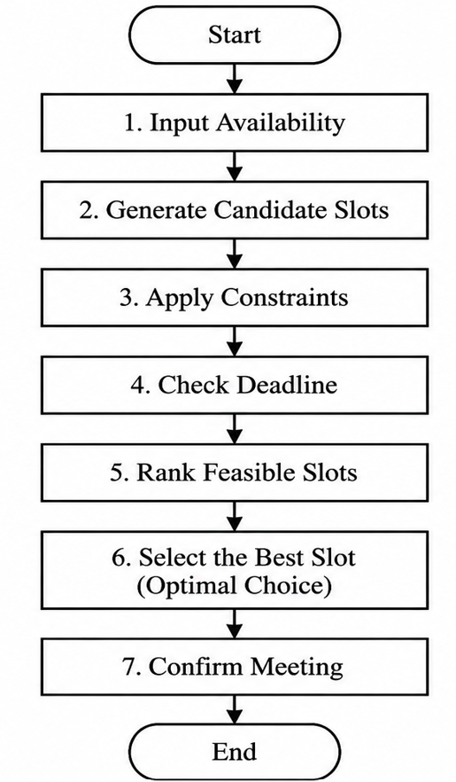
Figure 1: Process Flow
The system is initially given the availability of each member, members' current commitments, desired meeting length, and project deadline and optional preference (weekly). Next, the planning period(s) for the meeting times for the candidates are prepared. A filtering is performed for each candidate to remove periods that overlap classes, periods of work, unavailable periods or periods that are not enough meeting time. Similarly, in multi-agent scheduling, it is also observed that there exist hard constraints and soft ones that have to be obeyed in order to obtain feasible schedules [6].
The next step is a consideration of deadlines. Slots that are not submitted by the weekly deadline will not be accepted as they will not give a project time to be completed. Slots which are very close to the deadline may also be deprioritised as they allow less time for other tasks. If there are more than one option that can be undertaken, they are prioritised according to the availability of the members, the level of conflict, the suitability of the deadline and the preference.
What's more is that there needs to be ‘feasibility before preference'. If it is not a viable time due to a hard constraint, then do not select it if it is a highly preferred time. This produces a hierarchy of must be solutions which are feasible and 'should be' solutions which are the 'best of the feasible' solutions.

3.2 Scheduling Flowchart and Logical Decision Process
From the flowchart shown in figure 2, it can be observed that the proposed scheduling is a series of logical decisions. Members availability is taken into account, as well as the deadline for the project, the duration of the meeting is defined and finally the potential available time slots are made. It can be used in a structured scheduling since there are multiple constraints that must be fulfilled simultaneously in a timetable problem [7]. The candidates are then assessed in the following three decisions.
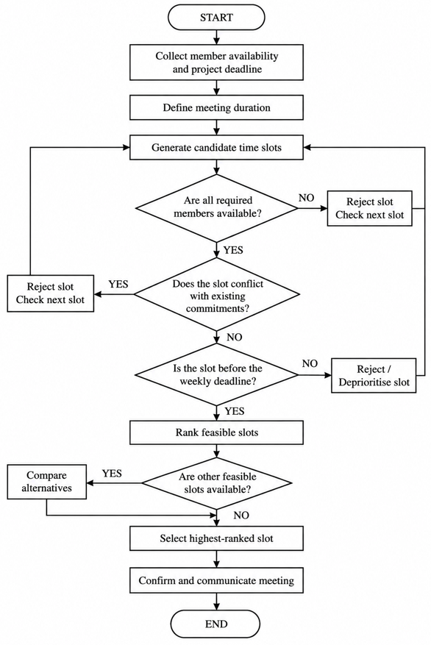
Figure 2: Proposed Group Meeting Scheduling Flowchart
Decision 1 – Availability
The first is one of availability of all the requisite members. If not, the slot is rejected, and the next candidates' slot is considered. This guarantees that a meeting is not chosen if key meeting participants are unavailable. It is important to take into account the availability of participants when designing research schedules so that feasible schedules can be developed [8].
Decision 2 – Conflict
Availability alone does not guarantee suitability. Existing academic and employment and private commitments of a candidate will also be screened. If a certain time frame relates to a number of meetings, the number of meetings is declined, otherwise it will limit their attendance at meetings and will make their purpose meaningless. Scheduling research has also recently focused on obtaining feasible schedules, rather than optimal ones, and this involves imposing constraints prior to optimisation.
Decision 3 – Deadline
Final feasibility check will determine if the meeting will occur prior to the weekly project deadline. The slot which comes after the deadline, is not accepted, and the too late slot might be deprioritised, due to the lack of time for project activities after the too late slot. This suggests that due-date should be taken into consideration while making scheduling decisions [8].
While there are still feasible slots they are ranked by conflict level, deadline suitability, availability and member preferences. Where there is more than one alternative, these alternatives are contrasted and the best one is chosen. It is therefore not only a “a free time” identification but it is an identification of the most appropriate feasible time in a systematic approach, first the mandatory constraints, then the preferences.

3.3 Optimisation, Requirement Alignment and Critical Evaluation
Several feasible alternatives might be left after infeasible slots have been eliminated. So it should yield a list of the nominees ranked rather than one selected at random. Extensive research in multi-objective scheduling has indicated that there are compromise solutions that take into account the priorities and balance the different objectives of the decision makers [9]. It is a fairly simple method of ranking.
- Satisfy all hard constraints.
- Provide sufficient time prior to the deadline.
- Minimize the number of "time tables" and commitment conflict situations.
- Accommodate member preferences.
This hierarchy provides that feasibility does not take precedence over preference. If a compulsory class is run by one member, for example a preferred evening class, then this should not be selected. This technique can then be considered a hybrid constraint satisfaction and preference-based optimisation technique.
Table 2: Assessment Requirements and Solution Responses
Assessment requirement | Solution response
Find suitable meeting times | Identifies common feasible availability
Minimise conflicts | Filters conflicting slots
Meet weekly deadlines | Incorporates deadline suitability
Provide a generic solution | Reuses the same decision logic for different groups

A first-available-slot approach would be easier and quicker, but could pick a technically possible, yet strategically wrong choice. It may not take into account better alternatives that may be available at another deadline or with less conflicts. Therefore, the proposed ranking method is more suitable because it has considered the feasible alternatives in a prioritized way and provided clear and justifiable scheduling decisions.

4. Reflection and Justification
The problem-solving method was appropriate because the problem of scheduling was a problem with many interrelated requirements which could not be satisfied by a single decision. The entire problem was broken down into subproblems regarding information gathering (availability information), identification of candidate meeting periods, introduction of constraints on meeting periods, evaluation of the feasibility of alternative meeting periods and selection of the final meeting period. This reduced the complexity of the problem, as it did not attempt to solve the whole scheduling problem at once, but one decision at a time. In order to create a generic solution, individual cases (classes, working and other personal engagements) were generalised using abstract thinking to variables and constraints. Thus various groups of students can be addressed by the proposed process without changing the logic of the process. Additionally, the MoSCoW prioritisation was used to differentiate between essential and desirable/optional functionality, which includes the availability, conflict avoidance, deadline compliance etc.
This is an important method as several constraints and competing objectives are often needed to be taken into consideration in scheduling problems [10]. These requirements are taken into account in the proposed process and alternatives that cannot be implemented before preferences are considered are filtered out. This provides a clear, repeatable, repeatable decision-making process and it's transparent to the users. Its systematic nature, generic nature and consideration of project deadlines and scheduling conflicts are the main advantages. However, there are some drawbacks to the solution. If the availability information is incorrect, this will result in incorrect recommendations and the meeting won't hold if a student changes their availability during the meeting. Also, all hard constraints can never be fulfilled and some groups will have to work on some soft constraints through negotiation. It may also be difficult to consistently express the subjective preferences, and scheduling may be more complex with larger groups [11].
There are some enhancements that could be made to the solution. Automated reminders can help minimize missed meetings, automated integration with electronic calendars can help to keep availability information up-to-date. In the event of changes of situation, real-time updates could also be helpful in the context of dynamic rescheduling. If the desired meeting is not available, then alternative-slot recommendations would help increase the level of flexibility.

5. Conclusion
The issue of arranging the meetings of the group projects of computing students with many academic, employment and personal responsibilities was discussed. A problem decomposition was done and this challenge was broken down to four subproblems: availability assessment, candidate-slot generation, constraint filtering and selection. The constraint-based scheduling method was proposed and elaborated to find the feasible meeting with the least of conflicts taking care of prioritization of the project deadlines weekly. This was communicated and implemented in a logical and explicit set of choices in the form of a flowchart. But the solution can only be determined based on the availability information and it may need negotiation if there is no completely feasible slot.

Reference List
[1] Mallari, C.B., San Juan, J.L. and Li, R., 2023. The university coursework timetabling problem: An optimization approach to synchronizing course calendars. Computers & Industrial Engineering, 184, p.109561. https://papers.ssrn.com/sol3/Delivery.cfm?abstractid=4276233
[2] Geibinger, T., Mischek, F. and Musliu, N., 2024. Investigating constraint programming and hybrid methods for real world industrial test laboratory scheduling. Journal of Scheduling, 27(6), pp.607-622. https://link.springer.com/content/pdf/10.1007/s10951-024-00821-0.pdf
[3] Alhenawi, E., Awawdeh, S., Khurma, R.A., García-Arenas, M., Castillo, P.A. and Hudaib, A., 2024. Choosing a suitable requirement prioritization method: a survey. arXiv preprint arXiv:2402.13149. https://arxiv.org/pdf/2402.13149
[4] Svensson, R.B. and Torkar, R., 2024. Not all requirements prioritization criteria are equal at all times: A quantitative analysis. Journal of Systems and Software, 209, p.111909. https://www.sciencedirect.com/science/article/pii/S0164121223003047
[5] Steiner, E., Pferschy, U. and Schaerf, A., 2025. Curriculum-based university course timetabling considering individual course of studies: E. Steiner et al. Central European Journal of Operations Research, 33(1), pp.277-314. https://link.springer.com/content/pdf/10.1007/s10100-024-00923-2.pdf
[6] Gaon, N., Schlosberg, Y.G. and Zivan, R., 2023. Scheduling operations in a large hospital by multiple agents. Engineering Applications of Artificial Intelligence, 126, p.107074. https://www.sciencedirect.com/science/article/pii/S0952197623012587
[7] Gu, X., Krish, M., Sohail, S., Thakur, S., Sabrina, F. and Fan, Z., 2025. From integer programming to machine learning: A technical review on solving university timetabling problems. Computation, 13(1), p.10. https://www.mdpi.com/2079-3197/13/1/10
[8] Kühn, R., Weiß, C., Ackermann, H. and Heydrich, S., 2024. Scheduling a single machine with multiple due dates per job. Journal of Scheduling, 27(6), pp.565-585. https://link.springer.com/content/pdf/10.1007/s10951-024-00825-w.pdf
[9] Zeiträg, Y. and Figueira, J.R., 2023. Automatically evolving preference-based dispatching rules for multi-objective job shop scheduling. Journal of Scheduling, 26(3), pp.289-314. https://link.springer.com/content/pdf/10.1007/s10951-023-00783-9.pdf
[10] Dunke, F. and Nickel, S., 2023. A matheuristic for customized multi-level multi-criteria university timetabling. Annals of Operations Research, 328(2), pp.1313-1348. https://link.springer.com/content/pdf/10.1007/s10479-023-05325-2.pdf
[11] Brouwer, R., Van Den Akker, M. and Hoogeveen, H., 2025. A hybrid local search algorithm for the continuous energy-constrained scheduling problem. Journal of Scheduling, 28(1), pp.65-84. https://link.springer.com/content/pdf/10.1007/s10951-024-00824-x.pdf

