THE ROLE OF REFLECTIVE PRACTICE AND CPD IN IMPROVING CARE QUALITY IN THE ADULT SOCIAL CARE SECTOR
BY FARZANA MUKHTAR
STUDENT ID: 2432703
MODULE NAME: PROFESSIONAL DEVELOPMENT WITHIN HEALTH AND SOCIAL CARE
MODULE CODE: LCHS4009
ASSIGNMENT TYPE: PERSONAL DEVELOPMENT PORTFOLIO
LECTURER: OLUBUKOLA ADEGBITE
UNIVERSITY OF WALES
SUBMISSION DATE: MARCH 28TH, 2026

Contents
Job advert 3
Task 1: Professional Curriculum Vitae 4
Key Skills 4
Employment History 5
Education and Qualifications 6
Interests 7
Task 2: Personal Statement 7
Task 3: SWOT Analysis and Personal Development Plan 8
3A. SWOT Analysis 8
3b. Personal Development Plan (PDP) 9
Task 4: Critical Reflection Using Gibbs’ Reflective Cycle 10
Introduction 10
Description 10
Feelings 10
Evaluation 10
Analysis 11
Conclusion 11
Action Plan 11
5.0 List of references 13

Job advert
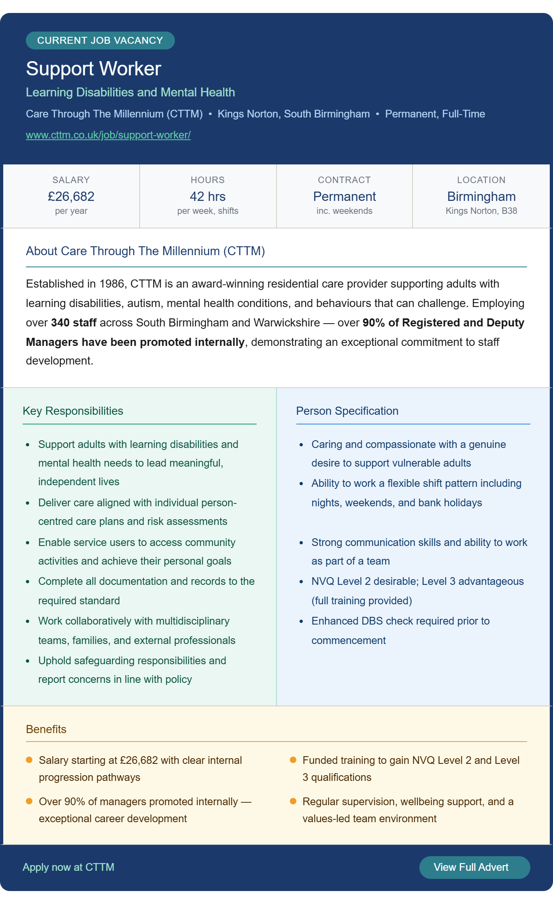
Job Advert Link: https://www.cttm.co.uk/job/support-worker/

Task 1: Professional Curriculum Vitae
FARZANA HAMEED
Health and Social Care Professional | Teaching Assistant | Support Worker
Email: farzana_@hotmail.co.uk
Tel: 07428 757095
Birmingham, West Midlands
Professional Profile
Professional in Health and Social Care committed to values and compassionate care-based practice; more than 15 years of experience in support work, teaching assistant, advocacy and administration. The concept of person-centred care indicates that my practice is based on the principles of the Care Act 2014 that focuses on the issues of dignity, wellbeing, and individual autonomy during the care delivery process (Department of Health and Social Care, 2014).
My strong experience involves assisting vulnerable adults and children in community, residential, and educational settings. I have been through my roles that there is a great need to safeguard the awareness, be a good communicator and develop trusting relationships with people who have a complex social or emotional experience. I am enrolled in a Certificate of Higher Education in Health and Social Care at the University of Wales Trinity Saint David to augment my academic understanding of professional ethics, patient care and health care models. Both in professional practice and in my academic work, I have acquired good interpersonal skills and the ability to be strong and dedicated to constant development as a professional.
I am now looking to secure a long-term position as a Support Worker in a progressive care organisation, and in the process, I will work on the enhancement of service-user wellbeing and ensure I am professionally growing.

Key Skills
Core Care Skills | Professional Skills | Personal Attributes
Person-Centred Care & Advocacy | Behaviour Management & De-escalation | Empathy & Compassion
Safeguarding Adults & Children | Record-Keeping & Administration | Emotional Intelligence
Risk Assessment & Reporting | Time Management & Prioritisation | Cultural Sensitivity
Effective Communication (Bilingual) | Reflective Practice & CPD | Resilience

Employment History
Position | Organisation | Location | Dates | Key Responsibilities
Teaching Assistant | Balfor Education | Birmingham | June 2024 – Present | Deliver individual and group learning support for pupils with SEN, SEMH and EAL needs. Support behaviour management strategies and promote inclusive learning environments. Maintain progress records and liaise with SENCOs and external professionals to coordinate support for pupils with complex needs.
Support Worker | Acorn Progression Project | Birmingham | Jan 2024 – June 2024 | Provided emotional support and advocacy to survivors of domestic abuse using person-centred and trauma-informed approaches. Conducted risk assessments, maintained confidential case records and worked collaboratively with housing services and legal professionals.
Teaching Assistant (Agency) | Pioneer People | Various Schools, Birmingham | June 2022 – Sept 2023 | Delivered classroom and one-to-one support across primary and secondary schools. Assisted pupils with autism, SEN and behavioural needs. Supported lesson preparation and monitored pupil progress.
Teaching Assistant | Ward End Community College | Birmingham | Sept 2011 – July 2012 | Supported pupils with additional learning needs in literacy and numeracy. Assisted teachers with classroom activities and maintained learning records.
Administrative Assistant | Ward End Community College | Birmingham | Sept 2006 – July 2011 | Managed reception duties, handled enquiries, processed documentation and maintained student records within a busy educational environment.
Retail Assistant | New Look | Birmingham | March 2006 – July 2006 | Provided customer service, handled cash transactions, managed stock replenishment and maintained store presentation standards.

Education and Qualifications
Institution | Qualification | Year
UWTSD | CertHE Health and Social Care | 2024–Present
Oplex Careers | CPD Teaching Assistant Level 3 | 2015–2016
University College Birmingham | NVQ Level 2 Children’s Care, Learning & Development | 2011–2012
Bournville College | NVQ Level 3 Business Administration | 2009–2010
JHP Training | Entry to Employment | 2005–2006
Matthew Boulton College | Key Skills Level 2 (Literacy & Numeracy) | 2004–2005

Interests
Community interaction, multicultural education, health policy and social care. I also like cooking and sharing different cultures with others, and this will assist me in associating with people of different backgrounds.
References available upon request

Task 2: Personal Statement
I am seeking the role of Support Worker at Care Through The Millennium (CTTM). The Care Act 2014 has a strong influence on my professional practice as it encourages the use of person-centred care and focuses on the core principles of service delivery, the person, dignity, wellbeing, and autonomy (Department of Health and Social Care, 2014).
Having over 15 years of experience in health, social care and educational contexts, I have gained excellent interpersonal skills and comprehend the intricate needs of the vulnerable parties. The most recent experience that I can find the most relevant is that I worked as a Support Worker at the Acorn Progression Project, which allowed me to work with the survivors of domestic abuse, offering emotional support and advocacy. This post demanded good communication, following the required safety protocol and the capability of upholding professional boundaries as well as assisting trauma victims.
I operated in a multi-agency setup to create an organisational support plan to ensure better outcomes for clients in collaboration with the help of housing services, legal professionals, and domestic abuse organisations. This experience empowered my skill to risk-evaluate, keep proper records of the case and provide a caring solution within the professional parameters.
I have also developed my communication and behaviour-management skills as a Teaching Assistant in various schools in Birmingham. Helping pupils with autism, SEN and behavioural difficulties meant a lot of patience, flexibility and a person-centred approach to communication. These are skills that can be directly applied to the adult care setting, in which the needs of individuals and relationships leading to trust must be comprehended.
I am still pursuing a Certificate of Higher Education in Health and Social Care at the University of Wales Trinity Saint David, which is reinforcing my knowledge of professional ethics, reflective practice, and modern paradigms of care. Skills for Care (2023) states that good care professionals are strong in values, communication skills and dedication toward continuous education. These attributes are displayed in my academic studies and experience.
One of my strengths I will bring to this position is the bilingual communication skill that can enable me to assist service users with diverse cultural backgrounds. During communications in a multicultural city like Birmingham, such a skill leads to the inclusion of individual people and assists in understanding that these people feel respected.
The reason why I am particularly interested in CTTM is that the organisation has a great investment in staff development and internal career advancement, where more than 90 per cent of managers have been promoted to join the organisation. This illustrates a positive organisational culture that appreciates job development and lifelong learning.
Given a chance to engage in CTTM, I will get with me compassion, professionalism and efforts towards the provision of high-quality care. I would also like to continue my practice by gaining an NVQ level 3 qualification, supervision and continued professional development, and bringing a positive contribution to a team focused on dignity, respect and person-centred care.

Task 3: SWOT Analysis and Personal Development Plan

3A. SWOT Analysis
A SWOT analysis is a reflective tool used to assess both internal strengths and weaknesses in comparison with external opportunities and threats to professional development (Price, 2022). Within health and social care practise reflective self-evaluation is vital in ensuring that there is professional competence and service user outcomes are improved (Reid and Westergaard, 2021).
The following SWOT analysis takes into account my readiness for the Support Worker job in CTTM, while identifying key areas and they can professionally grow.
Strengths | Weaknesses
Strong interpersonal and communication skills developed across care and education roles | No NVQ Level 3 Health and Social Care qualification yet
Compassion and empathy when supporting vulnerable individuals | Limited clinical knowledge, such as medication administration
Bilingual communication ability | Limited experience with digital care recording systems
Proven reliability across 15+ years of employment | Some anxiety during public speaking situations
Experience supporting individuals with complex needs | No formal supervisory experience
Opportunities | Threats
Currently studying CertHE Health and Social Care. | Competition for senior roles without a degree-level qualification
CTTM provides funded NVQ Level 2 and 3 training | High turnover rates in adult social care
High demand for care workers in the UK workforce | Changes in legislation require continuous CPD
Internal promotion opportunities within CTTM | Funding pressures affecting care sector training budgets
Skills for Care (2023) states that the adult social care workforce in England exceeds 1.6 million employees in the sector, but vacancy rates are still high, around 9.9%, proving the continued demand for qualified workers. This analysis has emphasised my strong interpersonal skills and practical experience of caring and highlighted the importance of gaining formal qualifications and technical competencies to aid further career progression in the long term.

3b. Personal Development Plan (PDP)
A Personal Development Plan will assist practitioners to achieve reflection and turn it into professional goals in the form of SMART (Cottrell, 2023). The SMART goals make sure that the goals are specific, measurable, achievable, realistic and time-bound.
The Experiential Learning Cycle by Kolb (1984) also stresses experience, reflection, and practical application as the means of professional development. The development goals that facilitate my advancement in the health and social care sector include the following.
Goal | Actions Required | Timeline | Measurement
Complete CertHE Health and Social Care with Merit or Distinction | Attend all lectures, complete assignments to a high academic standard and engage in independent reading | June 2026 | Module grades and tutor feedback
Achieve NVQ Level 3 Diploma in Health and Social Care | Enrol in employer-funded training and complete workplace competency assessments | December 2026 | NVQ certificate and assessor reports
Progress to Senior Support Worker or Team Leader | Gain experience, seek mentorship and complete leadership CPD | September 2027 | Promotion outcomes and supervisor feedback
Regular review during supervision sessions will ensure these goals remain achievable and aligned with professional development needs.

Task 4: Critical Reflection Using Gibbs’ Reflective Cycle

Introduction
This reflection will use Gibbs Reflective Cycle (1988) for my Component 1 presentation assessment of module LCHS4009. The model by Gibbs has gained popularity in health and social care education due to the fact that it facilitates reflection, which is organised and enhances meaningful professional learning (Bassot, 2023).

Description
The test involved a presentation on critical thinking in health and social care practise as an academic presentation. My presentation gave statistical data that proved the significance of critical thinking in a professional decision. I also presented within the given timeframe, and after that, my lecturer gave me some form of feedback orally.

Feelings
My anxiety and self-doubt occurred before the presentation. At the start of the presentation, I was nervous about my voice and spoke too fast. But upon moving to the second slide, I felt more at ease, and I started to concentrate on the explanation of the material clearly. At the conclusion of the presentation, I was relieved and proud of the accomplishment of the job.

Evaluation
In general, the presentation was successful. My lecturer made positive remarks regarding the use of statistics and the manner in which the slides were ordered, as well as observed that the work showed proper knowledge of the subject. The opening section was, however, not that fluent due to my nervousness at the beginning. Notwithstanding this, I regained confidence when the presentation went on, and my delivery was clear right until the end. This shows a strong character and capability of handling pressure when it comes to academic tests.

Analysis
One important thing that I learned during this experience is that the subject I was speaking on, critical thinking, was the main skill that I applied to create the presentation. To choose the right research evidence, to discuss statistical data, analytical thinking was needed, which, according to Falco-Pegueroles et al. (2021), is one of the key competencies of useful health and social care professionals.
Another concept that can be used to explain my initial anxiety is self-efficacy, which is an individual's belief in his or her capability to accomplish a task. With increased levels of self-efficacy, one finds that people become more confident and can perform better in difficult situations. As soon as I started concentrating on what I was saying and not being so concerned about the people who were listening, my confidence and delivery were improved.
According to Buhumaid et al. (2024), reflective models, including Gibbs cycle, are the models that are most beneficial in situations when they assist people in comprehending the reasons behind their performance. In this regard, the reflection indicates that my academic performance will improve due to a better approach to confidence and presentation practise.

Conclusion
This learning showed that I can perform well during times of pressure as long as I am focused on the task. My initial anxiety was helped by my preparation and level of understanding of the topic, as I was able to overcome it and finish the presentation successfully. It also supported the significance of evidence-based practise and critical thinking in health and social care (McCarthy et al., 2021).

Action Plan
To become a better and more confident academic in the future, I will:
  - Get more chances of giving presentations during my education.
  - Learn to breathe and relax to overcome anxiety.
  - Go on analysing academic and professional experiences with the help of the reflective model developed by Gibbs.
  - Cultivate a journal of reflection to keep track of my progress and learning requirements.
By doing so, I would like to enhance my communication abilities and build more confidence in doing academic work.

5.0 List of references
Amini, S., Ameri, F., Razi, S. and Haghdoost, A. (2025) 'Effect of narrative writing based on Gibbs' reflective model on the empathy and communication skills of nursing students', BMC Nursing, 24(1). Available at: https://pmc.ncbi.nlm.nih.gov/articles/PMC11697928/ Bassot, B. (2023). The Reflective Practice Guide. 2nd edn. London: Taylor and Francis.
Buhumaid, R., Otaki, F., Czabanowska, K., Stanley, A., Ezimokhai, M., Jackson, L. and Ho, S.B. (2024) 'Professionalism-training in undergraduate medical education in a multi-cultural, multi-ethnic setting: An exploration of reflective essays', BMC Medical Education, 24(1), p. 117. https://doi.org/10.1186/s12909-024-05103-z
Cottrell, S. (2023). The Study Skills Handbook. 5th edn. London: Bloomsbury Academic.
Department of Health and Social Care (2014). The Care Act 2014. London: HMSO. : https://www.legislation.gov.uk/ukpga/2014/23/contents
Falco-Pegueroles, A., Rodriguez-Martin, D., Ramos-Pozon, S. and Zuriguel-Perez, E. (2021) 'Critical thinking in nursing clinical practice, education and research: From attitudes to virtue', Nursing Philosophy, 22(1), e12332. https://doi.org/10.1111/nup.12332
Gibbs, G. (1988) Learning by Doing: A Guide to Teaching and Learning Methods. Oxford: Further Education Unit, Oxford Polytechnic.
Kolb, D.A. (1984). Experiential Learning: Experience as the Source of Learning and Development. Englewood Cliffs, NJ: Prentice Hall.
McCarthy, B., Bessell, N., Murphy, S. and Hartigan, I. (2021) 'Nursing and speech and language students' perspectives of reflection as a clinical learning strategy in undergraduate healthcare education: A qualitative study', Nurse Education in Practice, 57, p. 103251. https://doi.org/10.1016/j.nepr.2021.103251
Price, B. (2022). Studying Nursing Using Problem-Based and Enquiry-Based Learning. London: Macmillan Education.
Reid, B. and Westergaard, J. (2021) Personal Development and Professional Identity. London: Sage Publications.
Skills for Care (2023). The State of the Adult Social Care Sector and Workforce in England. Leeds: Skills for Care. https://www.skillsforcare.org.uk/Adult-Social-Care-Workforce-Data/Workforce-intelligence/publications/national-information/The-state-of-the-adult-social-care-sector-and-workforce-in-England.aspx
Thistlethwaite, J. and McKimm, J. (2023) Health Care Professionalism at a Glance. 2nd edn. Oxford: Wiley-Blackwell.

