
Applied Leadership and Management in the Workplace
Module Assignment Submission
Student Name: | Lisa Williams
Student Number: | 2309068
Module No: | BMSK6010
Module Title: | Inspiring Leadership

Statement of Confirmation of Authenticity
By the act of making this submission, the student declares that this is the work of the student named above. The work has not, in whole or in part, been knowingly presented elsewhere for assessment, or where assessment has been built on a previous assessment, this has been identified. Where materials have been used from other sources it has been properly acknowledged. If this statement is untrue, the student acknowledges that an assessment offence has been committed.
Attention is drawn to the plagiarism and unfair practice policies of both the University and of ILM.

Table of Contents
Introduction 3
Critically assess a recognised leadership model or theory in relation to its ability to impact on individual’s workplace performance. 3
Introduction to Leadership and Workplace Performance 3
Adair's Action-Centred Leadership Model 4
Situational Leadership Theory (Hersey and Blanchard) 6
Critical Comparison of the Two Leadership Theories 8
Evaluate own ability to use a range of leadership styles, in different situations and with and with different types of people, to fulfil the leadership role. 10
Introduction to Leadership Self-Evaluation 10
Evaluation of Leadership Perceptions and Vision 10
Leadership Skills 11
Leadership Strengths 11
Leadership Traits 11
Evaluation of Leadership Style Preferences 12
Situational Leadership Style Questionnaire 12
Conceptualising Leadership Questionnaire 13
Application of Leadership Styles in Practice 13
Assess your own ability to set direction, motivate, delegate, and empower others to bring about a workplace change. 14
Introduction to Leadership and Workplace Change 14
Ability to Establish a Vision and Set Direction 15
Ability to Motivate Others During Change 15
Ability to Delegate and Empower Others 16
Overall Evaluation of Leadership Effectiveness in Leading Change 16
References 17
Appendix A 20
Appendix B 21
Appendix C 22
Appendix D 23
Appendix E 24
Appendix F 25
Appendix G 26

Introduction
The successful implementation of workplace transformation, organisational success, and employee performance are all known to be significantly influenced by effective leadership. To retain employee engagement and accomplish organisational goals, leaders must modify their methods to suit the demands of individuals, teams, and organisations. This study evaluates the potential of two well-known leadership theories, Hersey and Blanchard's Situational Leadership Theory and Adair's Action-Centred Leadership Model to affect employee performance. Through a series of self-assessment questions, the report then looks at the individual's personal leadership qualities, examining leadership strengths, attributes, skills, styles, vision, and adaptability in various workplace scenarios. Lastly, the study evaluates the individual's ability to guide, inspire, assign, and empower others amid organisational change. The study seeks to discover leadership strengths, areas for improvement, and overall effectiveness in carrying out a leadership job within a modern organisational setting by fusing leadership theory with reflective practice and self-evaluation.

Critically assess a recognised leadership model or theory in relation to its ability to impact on individual’s workplace performance.

Introduction to Leadership and Workplace Performance
It is widely recognised that leadership plays a crucial role in shaping employee motivation, conduct, and organisational performance. According to (Northouse, 2021a), leadership is the process by which a person persuades a group of others to accomplish a common objective. Workplace performance, which is defined as the degree to which people successfully carry out their responsibilities and contribute to organisational goals, is greatly influenced by effective leadership (Padhi, 2010). Effective leaders provide clear direction, encourage engagement, and support employee growth, which eventually results in higher productivity and organisational success. This relationship between leadership and employee performance is well-established (Aggarwal, 2022). Managing workforce diversity, adapting to technological improvements, promoting employee health, and spearheading organisational transformation are just a few of the leadership issues complex and dynamic business world. Leaders must therefore take strategies that strike a balance between organisational demands and team and employee needs. This report critically assesses Hersey and Blanchard's Situational Leadership Theory and Adair's Action-Centred Leadership Model the influence of leadership on workplace performance. Although their presumptions about the efficacy and flexibility of leadership differ, both theories provide insightful viewpoints on how leadership actions the accomplishment of organisational goals.

Adair's Action-Centred Leadership Model
John Adair created the Action-Centred Leadership Model in 1973, which is one of the most influential behavioural leadership theories. According to the concept, successful leadership is attained by striking a balance between three interrelated areas of accountability: completing the task, creating, and sustaining the team, and personal growth (Adair, 1979a). The interconnectedness of these three components is sometimes depicted as overlapping circles, highlighting the need for leaders to handle all three areas Adair claims that while focusing just on individual requirements may lead to subpar team performance and the failure to meet organisational goals, an overemphasis on job completion may lower staff morale and engagement. Therefore, to achieve both organisational success and employee development, effective leadership necessitates a dynamic balance between all three components (Adair, 1979b). Because Adair's Action-Centred Leadership model offers a clear and useful framework for striking a balance between task completion, team needs, and individual growth, the individual concurs that it is effective. They have encountered this leadership style in the workplace, where managers have effectively shifted their attention between accomplishing goals, bolstering team performance, and attending to the needs of specific employees, leading to increased motivation and output.
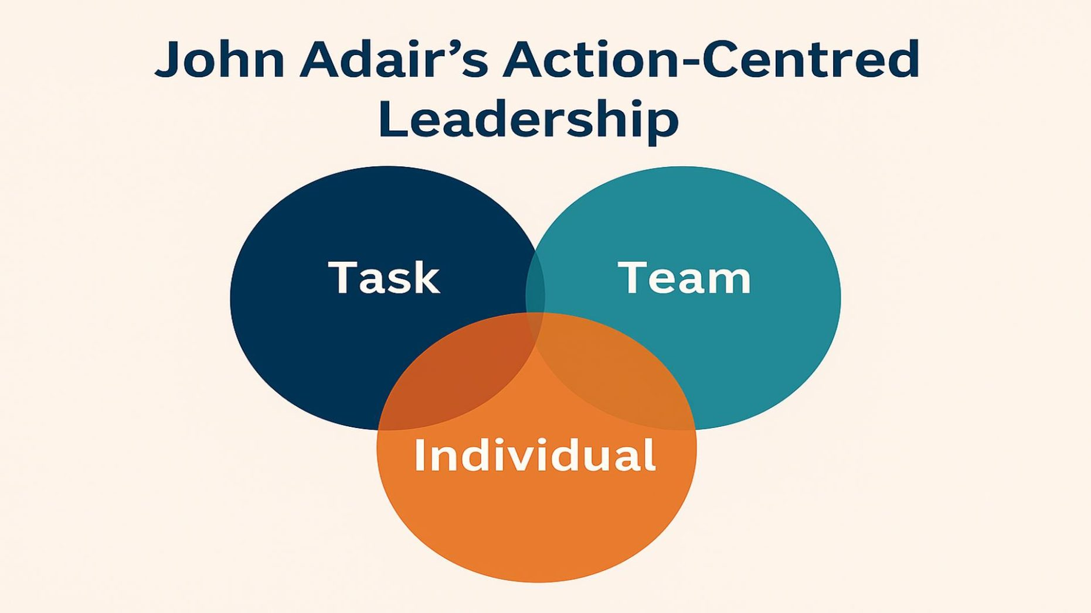(Humphries, 2025).

The model offers managers a useful foundation for enhancing team productivity and worker performance in the workplace. A project manager overseeing the deployment of a new digital system, for instance, can concentrate on the work by setting goals, due dates, and performance metrics. In addition to identifying individual needs through coaching, training, and performance reviews, the manager must simultaneously support the team by fostering cooperation, resolving conflict, and encouraging good communication. Employees are more likely to be engaged, motivated, and productive when these duties are balanced, which benefits organisational outcomes. According to research, workers exhibit greater levels of dedication, job happiness, and performance when leaders successfully combine task accomplishment with team cohesion and individual growth (Yukl & Gardner, 2020a).
Adair's model's simplicity and usefulness in a variety of organisational settings are two of its main advantages. ACL emphasises leadership functions that can be acquired and developed via experience and training, in contrast to trait-based approaches that contend that leadership effectiveness depends on innate qualities (Northouse, 2021b). The model also acknowledges that workers are people whose growth contributes to long-term corporate success rather than just tools for accomplishing organisational objectives. Additionally, its focus on striking a balance between conflicting priorities is still applicable in modern businesses that are marked by rapid change, hybrid working methods, and rising employee expectations for growth and well-being (Armstrong, 2011).
Effective leaders provide clear direction, encourage engagement, and support employee growth, which eventually results in higher productivity and organisational effectiveness. The relationship between leadership and employee performance is well-established (Yukl & Gardner, 2020b). Furthermore, in contrast to contingency theories, ACL offers little direction on how leaders should modify their actions in response to various circumstances or employee skill levels. As a result, although Adair's model provides a useful framework for comprehending leadership responsibilities, its efficacy might be increased when combined with more flexible methods like Situational Leadership Theory.

Situational Leadership Theory (Hersey and Blanchard)
Hersey and Blanchard (1969) created Situational Leadership Theory, which is predicated on the idea that there isn't a single ideal leadership approach for every circumstance. Rather, a leader's capacity to modify their strategy based on the skill, dedication, and growth requirements of each individual employee determines how effective their leadership is. Directing (high task, low relationship), coaching (high task, high relationship), supporting (low task, high relationship), and delegating (low task, low relationship) are the four leadership philosophies identified by the theory. Depending on the preparedness level of their followers—from those who need constant monitoring and direction to those who have the self-assurance and capacity to work independently—leaders are expected to modify their approach (Marchito et al., 2025). To enhance both individual and organisational success, this flexible approach acknowledges that employees change over time and that leadership actions should adapt accordingly. Situational Leadership Theory offers managers a useful framework for addressing the various requirements of workers in the workplace. A freshly hired employee, for instance, could need a directing style with precise instructions, organised guidance, and frequent oversight to guarantee duties are finished successfully. On the other hand, an experienced worker who is highly competent and self-assured might profit from a delegating approach that gives them more freedom and accountability. As a result, a team leader overseeing a varied workforce may use several leadership philosophies at once, modifying their strategy based on each person's aptitude and drive. In addition to increasing productivity and organisational performance, this flexibility can boost employee engagement, self-efficacy, and job happiness (Northouse, 2021c). Additionally, by giving workers the right amount of autonomy and support, managers may promote personal growth and a better sense of ownership over work results, both of which are important factors in performance and motivation (Yukl & Gardner, 2020c).
The flexibility and applicability of Situational Leadership Theory in a range of organisational circumstances is one of its main advantages. The notion recognises that employees have diverse developmental needs and that effective leaders must adapt accordingly, in contrast to traditional leadership approaches that promote a single favoured style (Northouse, 2021d). Because of its adaptability, the model is especially helpful in modern businesses with a diverse workforce, shifting job positions, and changing employee expectations. According to research, adaptive leadership behaviours can also have a good impact on employee commitment, motivation, and performance by making sure that guidance and assistance are tailored to everyone's needs (Thompson & Glasø, 2018). The theory also promotes the development of situational awareness, emotional intelligence, and communication skills—all of which are seen as critical leadership abilities in contemporary organisations (Goleman, 2000).
Situational Leadership Theory has drawn several criticisms in the scholarly literature despite its broad appeal. One drawback is that the theory's fundamental presumptions are not consistently supported by empirical data, especially when it comes to the connection between follower preparation and the efficacy of certain leadership philosophies (Northouse, 2021e). Critics contend that it might be challenging to quantify the developmental levels put forth by Hersey and Blanchard objectively, which makes it difficult for managers to correctly identify the needs of their workforce and choose the best approach (Yukl & Gardner, 2020d). Additionally, the theory pays little attention to broader organisational variables including culture, organisational structure, and external environmental forces in favour of concentrating mostly on leader-follower relationships. Therefore, even though Situational Leadership Theory provides a useful framework for comprehending employee growth and leadership flexibility, its efficacy may be limited when used in complex organisational situations where a variety of contextual circumstances affect performance. Because Hersey and Blanchard's Situational Leadership model acknowledges that leadership styles should be modified to fit employees' levels of competence and commitment, the individual concurs that it is effective. They have encountered this strategy in the workplace, where managers modified their degree of guidance and assistance based on each person's needs, leading to improved self-assurance, productivity, and staff growth.

Critical Comparison of the Two Leadership Theories
Although both Adair's Action-Centred Leadership Model and Hersey and Blanchard's Situational Leadership Theory aim to improve workplace performance through effective leadership behaviour, their conceptions and applications of leadership effectiveness are vastly different. (Adair, 1979c) argues that effective leadership is attained by striking a balance between work completion, team upkeep, and individual growth. He suggests that when these three areas are addressed concurrently, employee performance is maximised. (P Hersey, 1969), on the other hand, argues that a leader's performance depends on their capacity to modify their style in accordance with followers' degrees of competence and commitment. Although both theories stress the value of organisational performance and employee support, Adair's model takes a collective and organisational approach, whereas Situational Leadership emphasises individual employee growth and contextual flexibility.
The two theories' behavioural approaches to leadership are very similar. Both models imply that effective leadership behaviours can be acquired and developed over time, in contrast to trait theories, which contend that innate traits determine leadership effectiveness (Jabr, 2023a). Additionally, every theory recognises the connection between employee success and leadership by offering guidance, encouragement, and support. This is consistent with the findings of (Jenkins et al., 1998), who contend that leaders affect worker productivity by creating an environment at work that promotes commitment, engagement, and goal achievement. Despite these parallels, the theories' actual applications are very different. While Situational Leadership promotes modifying leadership actions in response to shifting conditions and staff readiness levels, Adair's model argues that leaders must constantly balance conflicting corporate priorities. As a result, Situational Leadership provides a more dynamic approach to leadership than Adair's comparatively static paradigm.
From an organisational standpoint, situational leadership seems especially pertinent in modern companies with varied workforces, fast technology progress, and changing employee expectations. Effective leaders, according to (Goleman, 2000b), exhibit emotional intelligence and behavioural flexibility, which allow them to react suitably to various circumstances and people. The principles of which encourage leaders to adapt their strategy in accordance with employee competence and confidence, are supported by this viewpoint. Additionally, research by and (Thompson & Glasø, 2015) indicates that by making sure that support is in line with each employee's unique developmental needs, adaptive leadership practices can have a good impact on employee motivation, engagement, and performance. However, the hypothesis criticism its lack of empirical support and the challenges leaders may face in effectively determining staff readiness levels (Graeff, 1997). The model's practical may be because of leadership decisions being made based on subjective assessments rather than objective measurements.
On the other hand, Adair's Action-Centred Leadership Model offers a methodical and useful framework that can be used in various organisational contexts. Its emphasis on striking a balance between task completion, team cohesiveness, and individual growth is its main strength, and it can improve workplace performance (Mullins & Rees, 2023). Additionally, the concept supports the current focus on worker wellbeing and engagement (Armstrong & Taylor, 2020a). Critics counter that it ignores outside variables that might have a significant impact on leadership effectiveness, like organisational culture, technological advancement, and unpredictability in the environment (John Storey, 2004). Because of this, the model could be less flexible in intricate and quickly evolving organisational settings.
In general, organisational context plays a crucial role in assessing the efficacy of any theory. While situational leadership is better suited to dynamic workplaces that demand adaptability and reactivity, Adair's model might be more suitable in organised settings where teamwork and operational efficiency are priority. (Avolio et al., 2009) suggests that contemporary leaders must increasingly modify their actions in response to shifting conditions and worker demands. Situational Leadership Theory is seen to be the most successful strategy because it fits with the individual's inclination to modify leadership styles to fit various individuals and circumstances, according to the evidence provided and the results of the individual's self-evaluation. This flexibility is especially important in modern organisations since it promotes employee growth, motivation, and performance.

Evaluate own ability to use a range of leadership styles, in different situations and with and with different types of people, to fulfil the leadership role.

Introduction to Leadership Self-Evaluation
Self-evaluation is a crucial component of leadership development since it allows people to examine their overall efficacy in carrying out a leadership job as well as their strengths and limitations. Because it promotes ongoing learning, better decision-making, and stronger interpersonal interactions, reflective leadership practice fosters increased self-awareness, which has been recognised as a crucial trait of good leaders (Armstrong & Taylor, 2020b). The individual answered several leadership questionnaires about conceptualising leadership, leadership vision, situational leadership style, leadership strengths, leadership traits, and leadership styles to evaluate their capacity for leadership. These tools enable a thorough assessment of leadership effectiveness by offering insight into an individual's leadership preferences, habits, and competencies. (Northouse, 2021f) believes that self-awareness allows leaders to identify how their actions affect other people and modify their strategy accordingly. Therefore, the results of the questionnaires will be utilised to critically assess the individual's capacity to implement various leadership styles in practice, pinpoint areas of leadership strength and growth, and gauge their efficacy in managing various individuals in a variety of workplace scenarios. This reflective approach promotes both enhanced organisational performance and individual leadership development (Armstrong & Taylor, 2023).

Evaluation of Leadership Perceptions and Vision
The results of the leadership self-assessment show that the individual has a solid grasp of leadership and a well-developed capacity for vision creation and communication. With a score of 42 out of 50 on the Leadership Vision Questionnaire, the individual's visioning skill falls into the extremely high category. According to (Northouse, 2022a), a leader's ability to create a compelling future vision that motivates and directs others toward common objectives is referred to as leadership vision. The findings of the assessment indicate that the individual is confident in their ability to communicate direction, establish future goals, and align others with organisational priorities. This result aligns with transformational leadership theory, which highlights the significance of developing and sharing a clear vision to inspire followers and foster dedication to corporate objectives (Bass & Riggio, 2006a). Please see appendix A for results.

Leadership Skills
The individual has a well-rounded leadership profile with specific strengths in conceptual thinking, interpersonal interactions, and helping others, according to the leadership capability assessments. Conceptual skills scored the highest on the Leadership Skills Questionnaire (27/30), followed by interpersonal skills (25/30) and administrative skills (23/30). Effective leaders need technical, human, and conceptual skills, with conceptual skills becoming more crucial in leadership roles, according to (Katz, 1955). The findings imply that the individual has excellent problem-solving, strategic thinking, and decision-making capabilities in addition to outstanding interpersonal and communication talents. These skills have aided the individual's capacity to lead teams, handle problems at work, and successfully convey organisational goals. Please see appendix B for results.

Leadership Strengths
The individual's greatest strength, according to the Leadership Strengths Questionnaire, was encouragement (27/30). High scores were also obtained in invention, mediation, implementation, and analytical thinking. These results imply that the individual takes a supportive leadership stance, inspiring others while encouraging cooperation and productive working relationships. These characteristics are consistent with modern leadership philosophies that prioritise teamwork, employee empowerment, and engagement (Northouse, 2022b). Please see appendix C for results.

Leadership Traits
Several important leadership traits were discovered by the Leadership Traits Questionnaire, including dependability, empathy, diligence, trustworthiness, and effective communication. These results are consistent with trait theory, which postulates that specific human traits influence effective leadership (Northouse, 2022c). The lower scores for self-assurance and confidence, however, point to areas for improvement. Even when the individual has excellent interpersonal skills and emotional intelligence, greater self-assurance while making choices or managing difficult circumstances may further improve leadership efficacy. Overall, the results indicate that a person's leadership potential is typified by strong people-focused abilities, effective communication, and strategic thinking, with confidence building serving as the main area for future development. Please see appendix D for results.

Evaluation of Leadership Style Preferences
According to the Leadership Styles Questionnaire, the individual's dominating style was democratic leadership (22/30), closely followed by authoritarian leadership (21/30), and laissez-faire leadership (14/30). These results imply that the individual appreciates teamwork, employee participation, and shared decision-making while also understanding the significance of giving guidance and structure when needed. Democratic leadership has been linked to increased levels of commitment, work satisfaction, and staff engagement because it promotes involvement and candid communication (Northouse, 2021g). Nonetheless, the comparatively high authoritarian score suggests the capacity to make firm choices and keep command when precise direction is required. Instead, then depending solely on one style of leadership, this shows some flexibility. Please see appendix E.

Situational Leadership Style Questionnaire
The Situational Leadership Self-Assessment further supports this adaptability, with the highest scores achieved in the Selling/Coaching and Participating/Facilitating styles (5 each), followed by Telling/Directing (2) and Delegating (0). Effective leaders modify their approach based on the skill and dedication of their followers, according to Hersey and Blanchard's Situational Leadership Theory (Hersey et al., 2013a). The findings imply that the individual prefers to assist, motivate, and involve staff members while offering direction as needed. This strategy's emphasis on staff engagement and development is one of its main advantages. The low propensity for delegation, however, can point to a need for improvement because giving highly skilled workers more freedom might boost output and enhance future leadership efficacy (Northouse, 2022d). Please see appendix F.

Conceptualising Leadership Questionnaire
According to the Conceptualising Leadership Questionnaire, the individual has the highest scores in Process Emphasis (20) and Relationship Emphasis (18), indicating that they predominantly see leadership as a process and relationship-based activity. Process leadership, according to (Northouse, 2022e), sees leadership as an interactive relationship in which followers and leaders collaborate to accomplish common objectives. When it comes to leading people, the individual's significant emphasis on connections also implies that they appreciate mutual influence, communication, and teamwork. When it comes to leading people, the individual's significant emphasis on connections also implies that they appreciate mutual influence, communication, and teamwork. Comparatively lower scores for Behaviour Emphasis (13) and Trait Emphasis (15) show less emphasis on the idea that personal traits or behaviours are the only factors that determine leadership. These results are consistent with modern leadership theories that prioritise collaboration, shared accountability, and engagement above leader centered strategies (Jabr, 2023b). As a result, the findings imply that the individual takes a people-focused approach to leadership, realising the value of fostering good connections and involving others in accomplishing organisational goals. Please see appendix G.

Application of Leadership Styles in Practice
In a particular case at work, the individual oversaw helping a recently hired team member who lacked the self-assurance and expertise to finish important tasks on their own. A coaching leadership approach was used to solve this, which included constant support, frequent feedback, and explicit instructions. According to Hersey and Blanchard's Situational Leadership Theory, this style was chosen because the employee showed great dedication but poor competence, making them appropriate for a leadership strategy that mixed guidance with support. The Leadership abilities and Leadership Strengths Questionnaires revealed the individual's positive leadership traits and excellent interpersonal abilities, which further validated the application of this strategy. By offering more direction, frequent check-ins, and chances to ask questions, leadership behaviour was tailored to the needs of the staff. The employee's expertise, confidence, and drive all greatly increased as a result, allowing them to work more independently. Although the strategy worked, critical analysis indicates that if it is sustained for an extended period, excessive support may impede the growth of autonomy. As a result, as the employee gained expertise, the leadership style would need to change.

In a second working scenario, the individual oversaw an experienced employee who was highly technically proficient but showed little dedication to a new organisational change project. The worker resisted adopting new procedures and regularly questioned judgements. To provide clear expectations, roles, and performance requirements, a directive leadership style was first used. However, the individual then adopted a democratic leadership style by including the employee in talks and promoting participation in decision-making after realising the employee's high level of ability. The Conceptualising Leadership and Leadership Styles Questionnaires revealed the individual's relationship-focused leadership beliefs and desire for democratic leadership, which had an impact on this strategy. Situational Leadership Theory states that changing leadership conduct to followers' preparedness and commitment levels is essential to effective leadership (Northouse, 2022f). The individual agrees that this approach works well. By recognising the employee's expertise whilst addressing their resistance through involvement and consultation, engagement improved and support for the change initiative increased. The outcome demonstrated the importance of adapting leadership styles to individual circumstances and highlighted the individual's ability to balance authority with collaboration to achieve positive workplace outcomes.

Assess your own ability to set direction, motivate, delegate, and empower others to bring about a workplace change.

Introduction to Leadership and Workplace Change
Implementing organisational change requires effective leadership because it gives direction, fosters commitment, and lessens resistance (Kotter, 1995). The results of the individual's questionnaire show strengths in leadership vision, interpersonal skills, and adaptability, which facilitate efficient communication and staff support during transition. These skills are consistent with Situational Leadership Theory, which promotes modifying leadership strategies to satisfy staff demands and enable the effective execution of change (Hersey et al., 2013b).

Ability to Establish a Vision and Set Direction
With a score of 42 out of 50 on the Leadership Vision Questionnaire, the individual has a good capacity to develop and convey a clear vision. Establishing direction is crucial for assisting staff in comprehending organisational objectives and their part in accomplishing them during times of workplace transition. According to transformational leadership theory, leaders who convey a compelling vision can boost motivation, inspire dedication, and motivate staff members to welcome change (Bass & Riggio, 2006b). The individual's excellent vision score indicates that they can successfully convey their goals and purpose, giving others concentration and clarity. All things considered, this is a major leadership strength that encourages employee involvement and helps organisational change be implemented successfully.

Ability to Motivate Others During Change
The answers of the individual's questionnaire show that they have a strong capacity to inspire others during changes at work. High encouragement (27/30) and interpersonal skills (25/30) scores indicate the capacity to foster good relationships, help, and sustain employee involvement. A preference for a democratic leadership style also shows a dedication to employee participation in decision-making, which may boost support for change projects. In prior work environments, the individual inspired workers by promoting involvement, paying attention to issues, and offering helpful criticism. This strategy is consistent with Herzberg's Two-Factor Theory, which emphasises involvement, accomplishment, and acknowledgement as important motivators (Herzberg, 1968). Overall, the results indicate that the individual's people-focused leadership style successfully encourages employee commitment, motivation, and engagement amid organisational transformation.

Ability to Delegate and Empower Others
The results of the Leadership Styles and Situational Leadership Questionnaires support the individual's ability to assign tasks and empower others. The high inclination toward a democratic leadership style suggests a readiness to promote responsibility ownership and employee participation in decision-making. Additionally, the Situational Leadership results showed a preference for participation and coaching approaches, indicating that the individual supports teamwork and staff development (Hersey et al., 2013c). These strategies help empower workers during workplace transition by boosting their engagement and dedication to accomplishing goals. Delegation, however, was also noted in the self-evaluation as an area for improvement because the individual expressed a reduced preference for assigning tasks to highly skilled workers. Overall, the results indicate that the individual successfully empowers others by involvement and support; yet, to enhance employee autonomy and performance throughout transition, it would be beneficial to further strengthen confidence in delegation.

Overall Evaluation of Leadership Effectiveness in Leading Change
Overall, the results indicate that the individual's excellent vision, communication, and interpersonal skills put them in a good position to lead a workplace transformation. Together with strong interpersonal and intellectual skills scores, the Leadership Vision Questionnaire score of 42/50 indicates a capacity to set goals, express them, and cultivate a good rapport with staff members. Additionally, the individual's inclination toward democratic, coaching, and participatory leadership styles indicates a flexible strategy that encourages employee commitment and participation during transition. Nonetheless, the self-evaluation noted that confidence and delegating needed more work. Leadership effectiveness could be further improved by giving skilled staff members more responsibility and boosting confidence while making tough decisions. However, since leadership flexibility is widely acknowledged as a crucial component of effective change management, the capacity to modify leadership styles to suit various individuals and circumstances is a considerable strength (Northouse, 2022g). Overall, the individual's leadership profile shows that they have a great deal of potential to support and lead organisational transformation.

References
Adair, J. E. (1979a). Action-centred leadership. Gower Publishing Company, Limited.
Adair, J. E. (1979b). Action-centred leadership. Gower Publishing Company, Limited.
Adair, J. E. (1979c). Action-centred leadership. Gower Publishing Company, Limited.
Aggarwal, J. (2022). Yukl, G. A., & gardner, W. L. (2020). leadership in organizations. pearson education, inc. Journal of Leadership Studies, 16(3). https://doi.org/10.1002/jls.21826
Armstrong, M. (2011). Armstrong’s handbook of strategic human resource management. Kogan Page. file:///C:/Users/willlis/Downloads/Armstrong%E2%80%99s%20handbook%20of%20human%20resource%20management%20practice%2011th%20edition3086%20(2).pdf
Armstrong, M., & Taylor, S. (2020a). Armstrong’s handbook of strategic human resource management (15th ed.). Kogan Page.
Armstrong, M., & Taylor, S. (2020b). Armstrong’s handbook of strategic human resource management (15th ed.). Kogan Page.
Armstrong, M., & Taylor, S. (2023). Armstrong’s handbook of human resource management practice (16th ed.). Kogan Page.
Avolio, B. J., Walumbwa, F. O., & Weber, T. J. (2009). Leadership: Current theories, research, and future directions. Annual Review of Psychology, 60(1), 421–449. https://doi.org/10.1146/annurev.psych.60.110707.163621
Bass, B. M., & Riggio, R. E. (2006a). Transformational leadership. Lawrence Erlbaum.
Bass, B. M., & Riggio, R. E. (2006b). Transformational leadership. Lawrence Erlbaum.
Goleman, D. (2000a). Leadership That gets results. https://www.wict.org/chicago-chapter/wp-content/uploads/sites/5/2020/05/Harvard_Business_Review.pdf#page=4
Goleman, D. (2000b). Leadership That gets results. https://www.wict.org/chicago-chapter/wp-content/uploads/sites/5/2020/05/Harvard_Business_Review.pdf#page=4
Graeff, C. L. (1997). Evolution of situational leadership theory: A critical review. The Leadership Quarterly, 8(2), 153–170. https://doi.org/10.1016/S1048-9843(97)90014-X
Hersey, P., Blanchard, K. H., & Johnson, D. E. (2013a). Management of organizational behavior : Leading human resources (10th ed.). Pearson. https://www.kenblanchardbooks.com/wp-content/uploads/2017/08/Management-of-Organizational-Behavior-Read-Sample0001.pdf
Hersey, P., Blanchard, K. H., & Johnson, D. E. (2013b). Management of organizational behavior : Leading human resources (10th ed.). Pearson. https://www.kenblanchardbooks.com/wp-content/uploads/2017/08/Management-of-Organizational-Behavior-Read-Sample0001.pdf
Hersey, P., Blanchard, K. H., & Johnson, D. E. (2013c). Management of organizational behavior : Leading human resources (10th ed.). Pearson. https://www.kenblanchardbooks.com/wp-content/uploads/2017/08/Management-of-Organizational-Behavior-Read-Sample0001.pdf
Herzberg, F. (1968). One more time: How do you motivate employees? Boston, Mass. Harvard Business Press C. https://eclass.uoa.gr/modules/document/file.php/PHILOSOPHY863/%CE%95%CE%BD%CE%B4%CE%B9%CE%B1%CF%86%CE%AD%CF%81%CE%BF%CE%BD%CF%84%CE%B1%20%CE%B5%CF%80%CE%B9%CF%83%CF%84%CE%B7%CE%BC%CE%BF%CE%BD%CE%B9%CE%BA%CE%AC%20%CE%AC%CF%81%CE%B8%CF%81%CE%B1-%CE%B5%CE%BA%CE%B8%CE%AD%CF%83%CE%B5%CE%B9%CF%82/%CE%95%CF%80%CE%B9%CF%83%CF%84%CE%B7%CE%BC%CE%BF%CE%BD%CE%B9%CE%BA%CE%AC%20%CE%86%CF%81%CE%B8%CF%81%CE%B1%20%CE%BA%CE%B1%CE%B9%20%CE%BC%CE%B5%CE%BB%CE%AD%CF%84%CE%B5%CF%82/Herzberg.pdf
Humphries, C. (2025, July 9). Understanding action centred leadership: A practical model for modern leaders. Voyager Executive Coaching. https://voyagercoaching.co.uk/understanding-action-centred-leadership-a-practical-model-for-modern-leaders/
Jabr, F. (2023a). John A. Long - Publications List. Publicationslist.org, 14(6). https://ore.exeter.ac.uk/articles/report/A_Review_of_Leadership_Theory_and_Competency_Frameworks/29685509?file=56687318
Jabr, F. (2023b). John A. long - publications list. Publicationslist.org, 14(6). https://ore.exeter.ac.uk/articles/report/A_Review_of_Leadership_Theory_and_Competency_Frameworks/29685509?file=56687318
Jenkins, W. E., Heyward, L. D., & Smith, T. I. J. (1998). Performance of domesticated striped bass morone saxatilis, palmetto bass and backcross hybrid striped bass (sunshine bass ? � striped bass ?) raised in a tank culture system. Journal of the World Aquaculture Society, 29(4), 505–509. https://doi.org/10.1111/j.1749-7345.1998.tb00677.x
John Storey. (2004). Leadership in organizations : Current issues and key trends. Routledge.
Katz, R. L. (1955). Skills of an effective administrator. Harvard Business Review Press.
Kotter, J. (1995). Leading Change. Competitive Intelligence Review, 8(2). https://web-docs.stern.nyu.edu/executive/Leading%20Change_Kotter.pdf
Marchito, A. D. P., García, A. G., & de, M. (2025). The hersey and blanchard’s situational leadership model revisited: Its role in sustainable organizational development. World, 6(2), 63–63. https://www.mdpi.com/2673-4060/6/2/63
Mullins, L. J., & Rees, G. (2023). Organisational behaviour in the workplace. Pearson.
Northouse, P. G. (2021a). Leadership : Theory and practice. SAGE Publications, Inc.
Northouse, P. G. (2021b). Leadership : Theory and practice. SAGE Publications, Inc.
Northouse, P. G. (2021c). Leadership : Theory and practice. SAGE Publications, Inc.
Northouse, P. G. (2021d). Leadership : Theory and practice. SAGE Publications, Inc.
Northouse, P. G. (2021e). Leadership : Theory and practice. SAGE Publications, Inc.
Northouse, P. G. (2021f). Leadership : Theory and practice. SAGE Publications, Inc.
Northouse, P. G. (2021g). Leadership: Theory and practice (9th ed.). Sage Publications.
Northouse, P. G. (2022a). Leadership: Theory and practice (9th ed.). Sage Publishing.
Northouse, P. G. (2022b). Leadership: Theory and practice (9th ed.). Sage Publishing.
Northouse, P. G. (2022c). Leadership: Theory and practice (9th ed.). Sage Publishing.
Northouse, P. G. (2022d). Leadership: Theory and practice (9th ed.). Sage Publishing.
Northouse, P. G. (2022e). Leadership: Theory and practice (9th ed.). Sage Publishing.
Northouse, P. G. (2022f). Leadership: Theory and practice (9th ed.). Sage Publishing.
Northouse, P. G. (2022g). Leadership: Theory and practice (9th ed.). Sage Publishing.
P Hersey. (1969). Management of organizational behavior : Utilizing human resources. Prentice Hall.
Padhi, N. (2010). Michal Armstrong, Armstrong’s Handbook of Human Resource Management Practice (11th Edition). United Kingdom: Kagan Publishing, 2009 (ISBN 9780742952421). Global Business Review, 11(2), 312–314. https://doi.org/10.1177/097215091001100213
Thompson, G., & Glasø, L. (2015). Situational leadership theory: A test from three perspectives. Leadership & Organization Development Journal, 36(5), 527–544. https://doi.org/10.1108/lodj-10-2013-0130
Thompson, G., & Glasø, L. (2018). Situational leadership theory: A test from a leader-follower congruence approach. Leadership & Organization Development Journal, 39(5), 574–591. Emerald. https://www.proquest.com/docview/2057456595/fulltextPDF?accountid=130472&sourcetype=Scholarly%20Journals
Yukl, G., & Gardner, W. (2020a). Leadership in organizations (9th ed.). Pearson Education Limited. https://onlinelibrary-wiley-com.uwtsd.idm.oclc.org/doi/epdf/10.1002/jls.21826
Yukl, G., & Gardner, W. (2020b). Leadership in organizations (9th ed.). Pearson Education Limited. https://onlinelibrary-wiley-com.uwtsd.idm.oclc.org/doi/epdf/10.1002/jls.21826
Yukl, G., & Gardner, W. (2020c). Leadership in organizations (9th ed.). Pearson Education Limited. https://onlinelibrary-wiley-com.uwtsd.idm.oclc.org/doi/epdf/10.1002/jls.21826
Yukl, G., & Gardner, W. (2020d). Leadership in organizations (9th ed.). Pearson Education Limited. https://onlinelibrary-wiley-com.uwtsd.idm.oclc.org/doi/epdf/10.1002/jls.21826

Appendix A
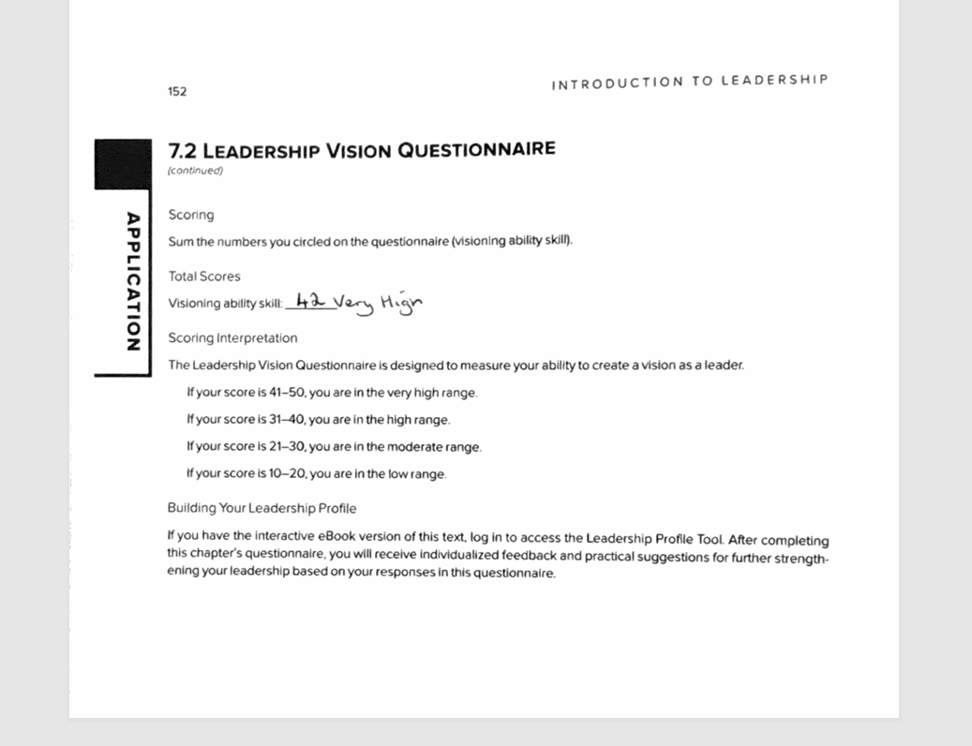

Appendix B
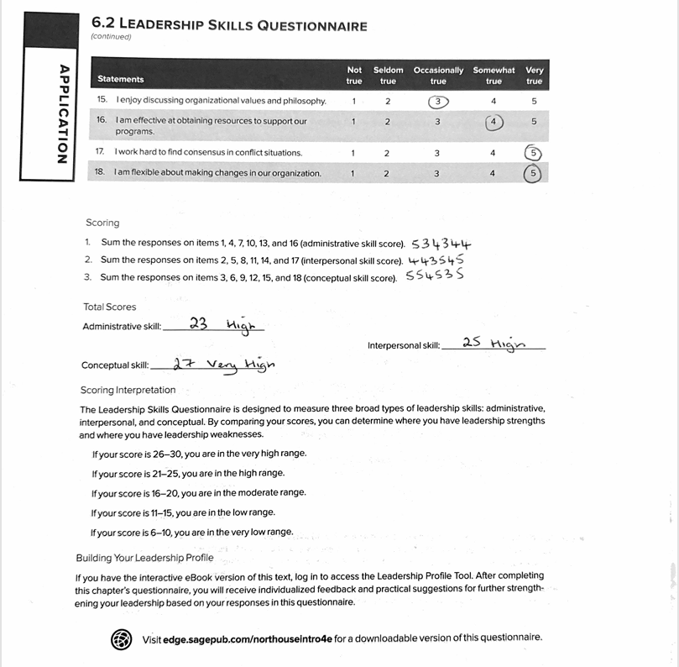

Appendix C
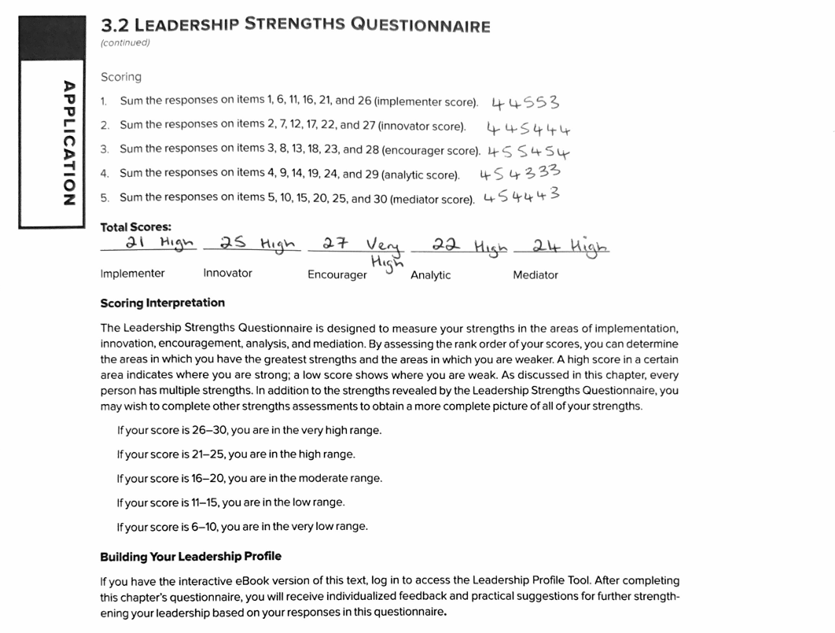

Appendix D
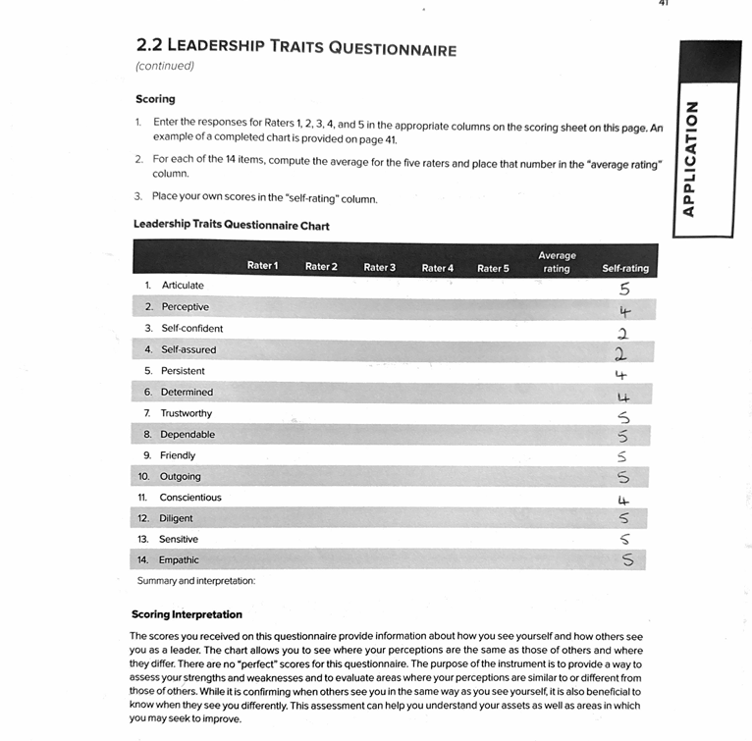

Appendix E
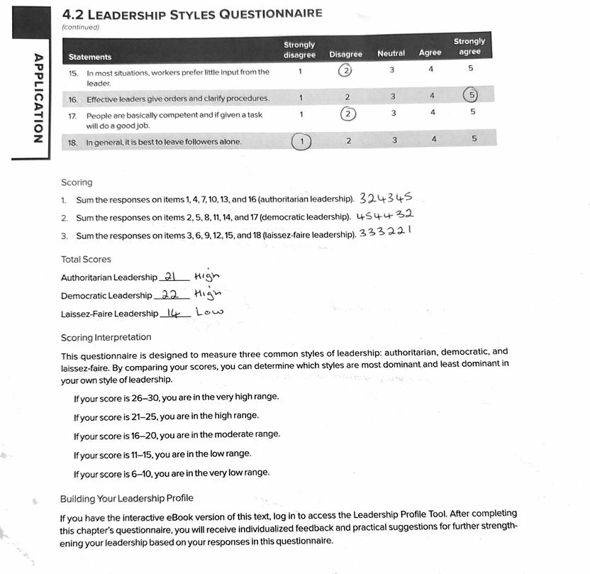

Appendix F
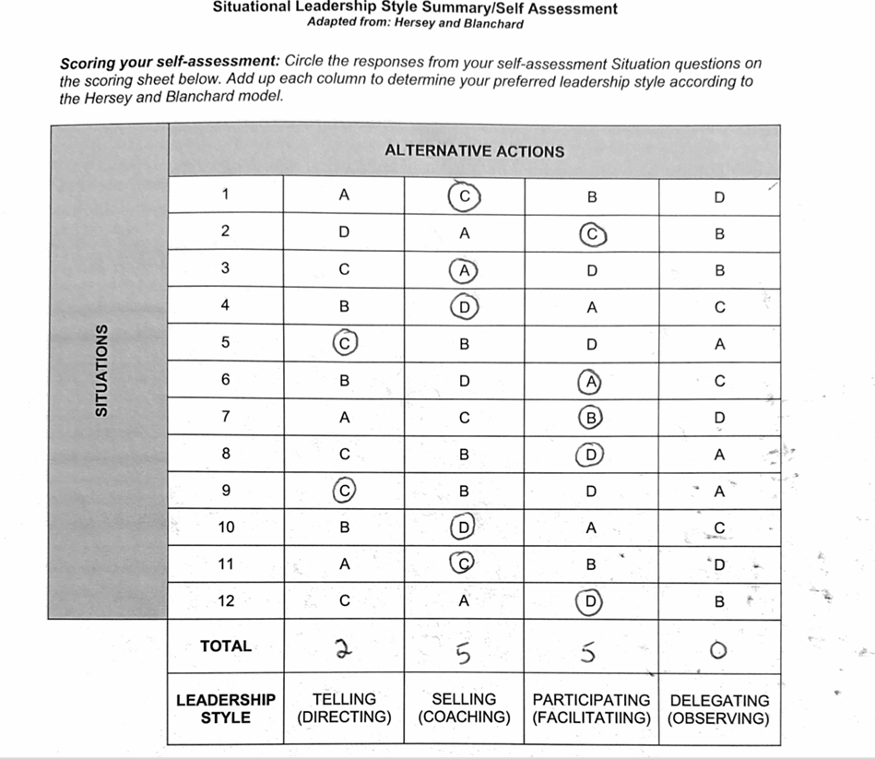

Appendix G


