

Marketing Management Assessment 2

Student Name: JOEL BINASH
Student ID: 2237045
Lecturer Name: TUSHARA BALENDRAN
Submission Date: 01/09/2023

Executive Summary
Marketing management is a popular business practice that includes several factors such as planning, execution of strategies and tracking them to accelerate business growth. Amazon was chosen in this report and a business overview was provided in the first part. In this report, the external business structure of Amazon has been described by using the PESTLE analysis. Porter's five forces analysis has also been discussed in the context of Amazon. The internal factors of Amazon were described with the help of a SWOT analysis in this report. An extended STP evaluation of Amazon has been detailed including the 7P marketing mix of the company. Along with that, the strategies of the Ansoff matrix and product life cycle model have been mentioned and explained. Some strategies have been recommended in the last part of this report, that will help Amazon to overcome the internal issues.

Table of Contents
Introduction 4
Question A 4
Overview of Organisation 4
PESTLE Analysis 5
Porter’s Five Forces 7
SWOT Analysis 7
Extended STP Analysis 9
Extended Marketing Mix 9
Question B 10
Ansoff Matrix 10
Product Life Cycle Model 11
Recommendations 11
Conclusion 12
Reference list 13

Introduction
Marketing management is a popular business practice that includes several factors such as planning, execution of strategies and tracking them to accelerate business growth. Marketing management is also related to innovation success and boosts customer base (Adams, Freitas and Fontana, 2019). A business overview of Amazon will be provided with a small description. Some external and internal factors will be outlined with the help of PESTLE and SWOT analysis respectively. The analysis of Porter's five forces will be detailed as the external environment analysis of the company. Moreover, the extended STP analysis and marketing mix will also be included in the report. Ansoff matrix and the model of product life cycle will be discussed in the context of the company. Along with that, some recommendations will be attached in the end to improve the business growth of the chosen organisation.

Question A

Overview of Organisation
Amazon is an e-commerce giant which has developed its business globally. Jeff Bezos is the founder of the company and its headquarter is situated in the United States. The company sells its products with the help of online transactions and Amazon is popular for its customer-centric approach (Amazon, 2023). It is the largest e-commerce company that has multiple varieties of products with huge revenue growth.
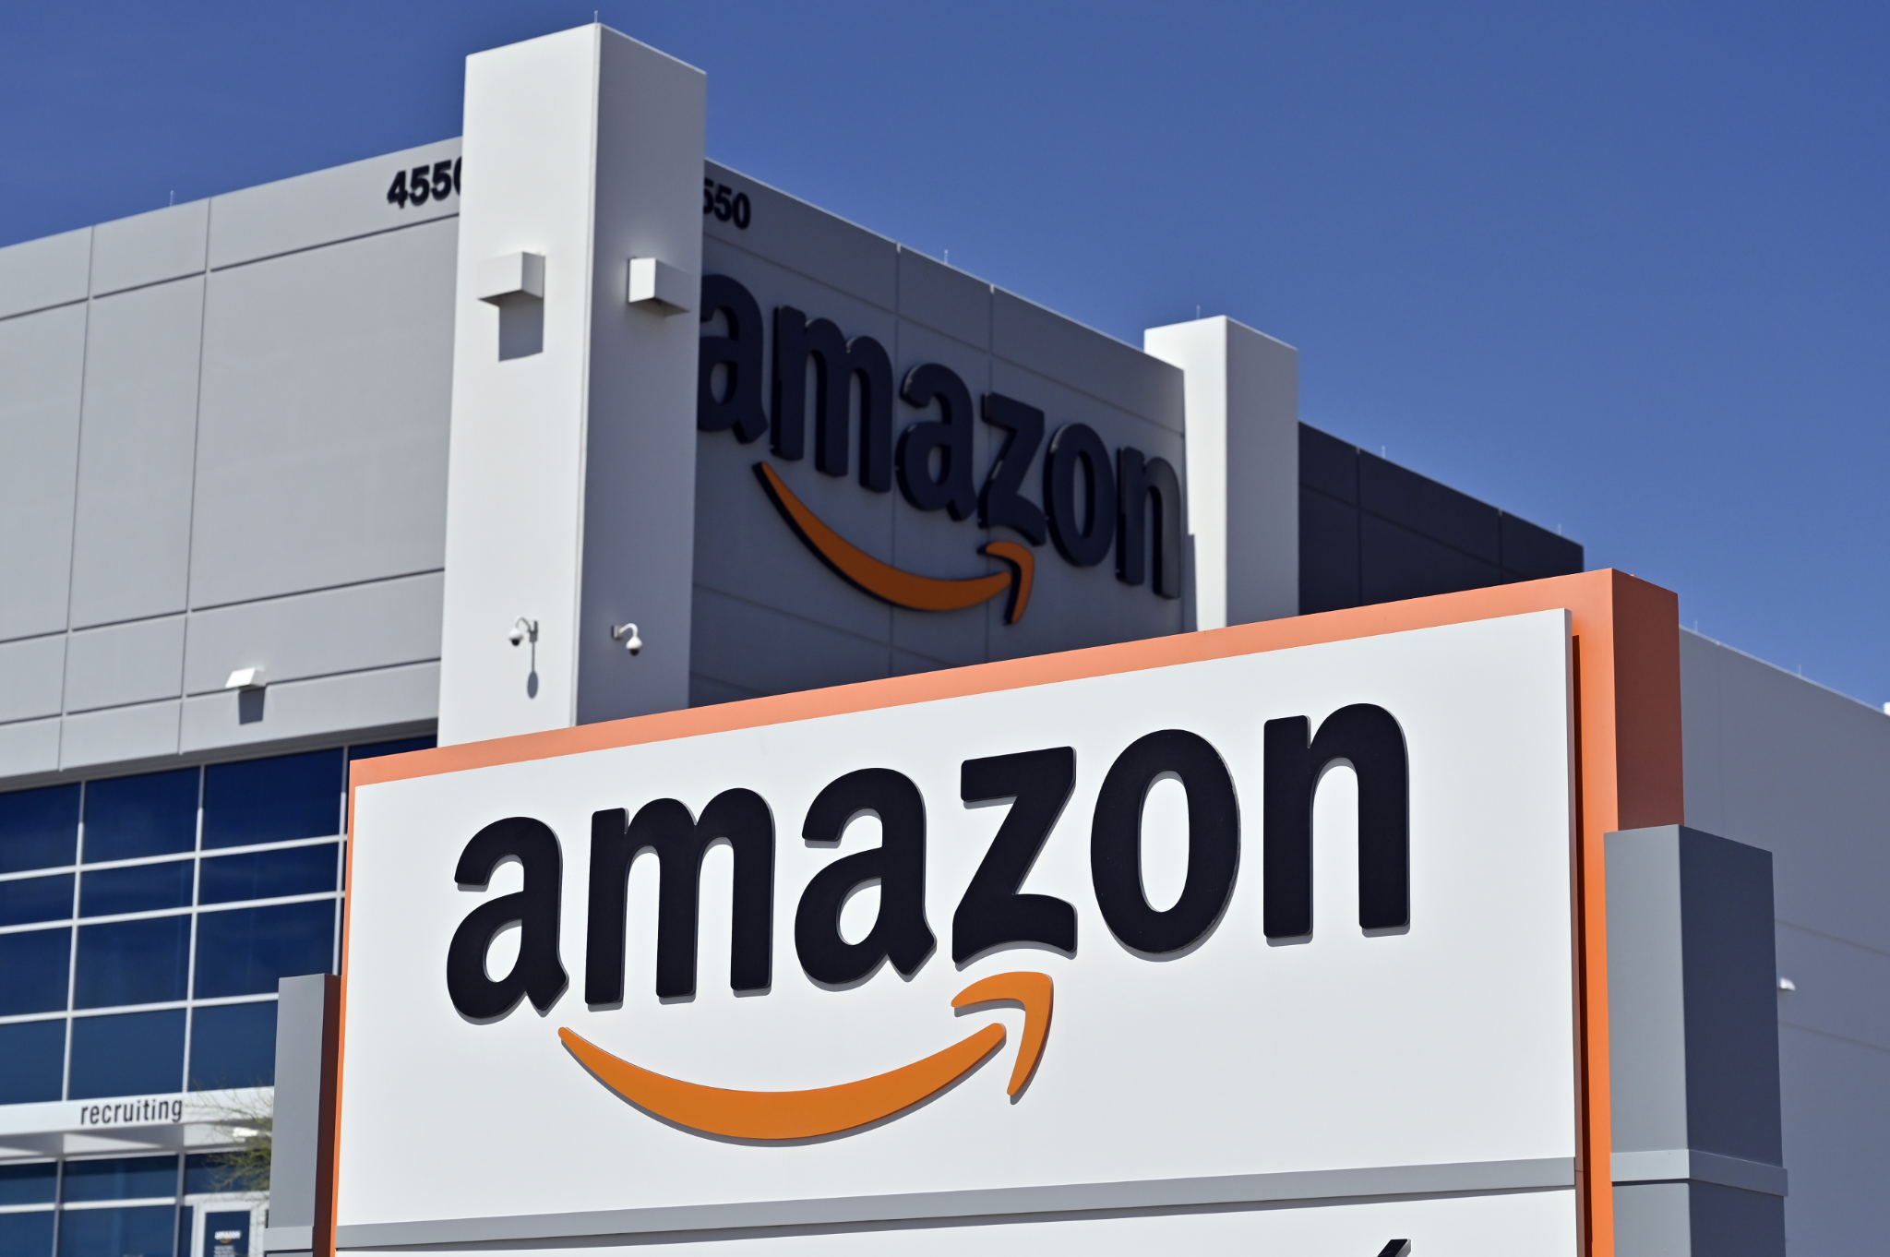
Figure 1: Amazon
(Source: TechCrunch, 2023)

PESTLE Analysis
In this part of the report, the external business structure of Amazon will be described by using the PESTLE analysis.
Political: Amazon is a US-based company and the political environment of the US is very stable. It is the 2nd largest democratic country in the world and the president is the head of the government. It is one of the most liberal democratic countries and the political stability of the US is the main strength for Amazon (Sandhya, 2023). Most foreign organisations first choose the US for expanding or starting their new business; therefore, it can be said that Amazon gets huge profits from the US to grow its business.
Economic: The US is also an advanced economy country and the nominal GDP of the US is also the largest in the world. In the US there are also many more successful companies, such as Facebook, Google, Microsoft and many more. The GDP of the US is 39.23 trillion US dollars in 2023. The manufacturing sector of the US is very advanced; therefore Amazon can produce their products under advanced technology (Dalirazar and Sabzi, 2023). The export business of the US is also very strong and this strong economic environment is favourable for any organisation’s growth including Amazon. On the other hand, labour prices are also very cheap in the US and that is also very profitable for Amazon’s business.
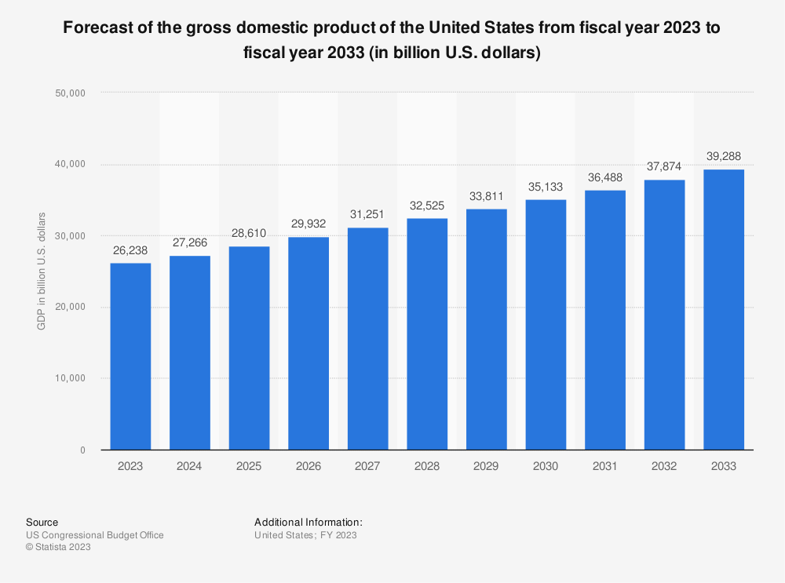
Figure 2: GDP of the US
(Source: Statista, 2019)
Social: The population rate of the US is very high, which helps Amazon to get a strong loyal consumer base from the US. The average population of the US is estimated to be 335 million up to the year 2023. The diverse social culture is favourable for Amazon to get a strong diverse workforce and diverse customer base (Beirão, 2022). The populations are highly educated, therefore, Amazon can easily get a skilled workforce at an affordable labour cost. That will help the company to balance the operational costs of their business.
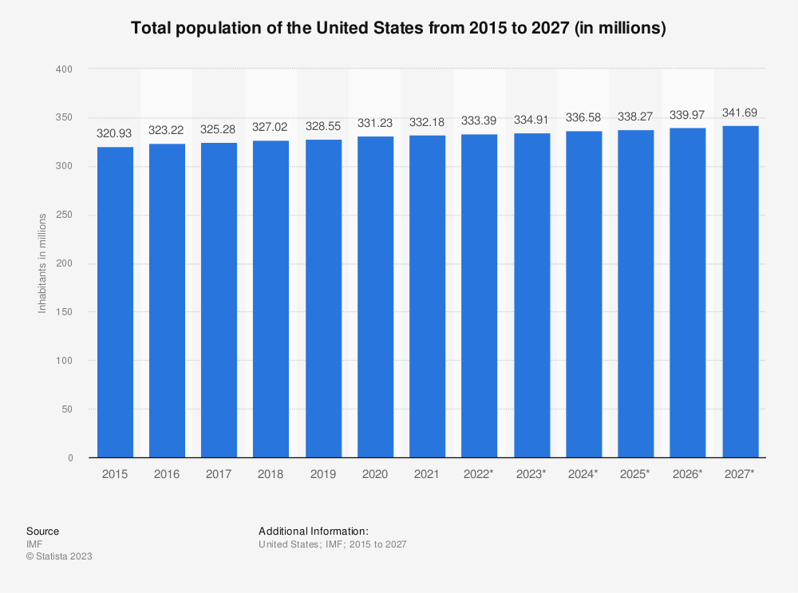
Figure 3: Increasing Population of the US
(Source: Statista, 2022)
Technological: The US is considered the international leader in technology and science. Amazon is already adopting high-quality technological advancements within their business and the telecommunication service in the US is also very strong (Beirão, 2022). Therefore, Amazon can easily manage their distribution network and can connect with the local population through advanced mobile network services.
Legal: The legal environment of the US is favourable for businesses including Amazon, every state has their different legal schemes. The business rules are highly strict which helps the companies to prevent corruption within the business (Sandhya, 2023). On the other hand, employee rights are highly protected and different employee laws are also implemented by the US government to protect the employees’ rights.
Environmental: The environment of the US is very healthy and the climate of the US is also very comfortable. Therefore, foreign business persons also choose the US to start their new business. This is also favourable for Amazon’s business, on the other hand, different sustainable laws are also adopted by Amazon, because of the government’s instructions, that are responsible for enhancing the operational cost of Amazon’s business.

Porter’s Five Forces
The threat of new entrants: The threat of new entrants for Amazon is low as the organisation has already built its brand image in the global business market. Therefore, it is hard to beat the organisation for the new business entrants.
The threat of new substitutes: The threat of new substitute products is very high for the company as other high street retailers sell similar types of products and services at a much-discounted rate.
Competitive rivalry: Amazon has several competitors such as Netflix, Walmart, eBay and many more (Alshmrani, 2021). They all are giant organisations and in this regard, it can be said that the competitive rivalry for the company is very high.
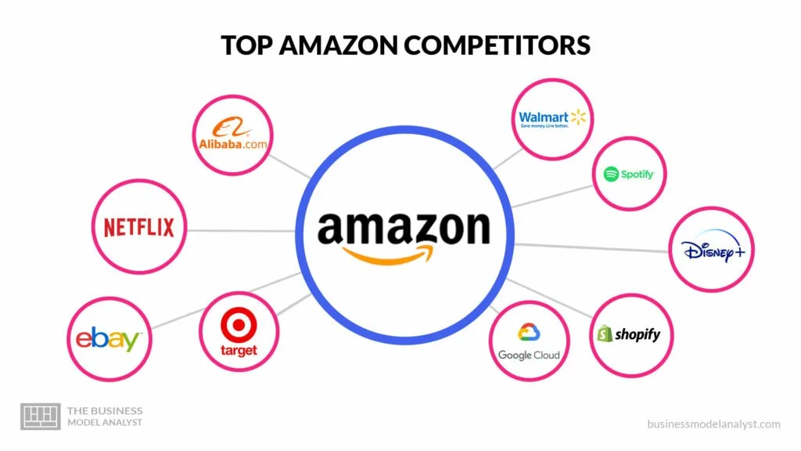
Figure 4: Competitors of Amazon
(Source: Pereira, 2023)
Buyer’s bargaining power: Buyer’s bargaining power is also high for the company as it depends on low switching costs as well as the availability of substitute products.
Supplier's bargaining power: Supplier's bargaining power is low for the company as global suppliers always want to work with large companies like Amazon.

SWOT Analysis
Strength: Amazon’s prime strength is its technical advancements in IT which have accelerated its e-commerce business growth. The company is way ahead of its competitors as it has paid attention to fulfilling the demands of the consumers. The company is popular for its customer-centric approach which has helped to increase its profit margin (Baboolal-Frank, 2021). The company is superior in distributing its products to the doorsteps of customers within a short period which has developed its business growth hugely.
Opportunity: The company will be scalable in the future and will be capable of capitalising on its products. Amazon will be successful in more globalisation and it will bring more profit to the company. According to a source, the net revenue of Amazon in 2022 was $514 billion and it is increasing day by day (Statista, 2023). This is an opportunity for Amazon to translate higher revenues.
Weakness: The free shipping strategy of Amazon can become a cause of danger in the future. It can affect its profit margin and the organisation might become incapable of optimising its costs (‌Altrad et al., 2021). The customer service in Amazon often mistreats its customers which is considered as it’s another weakness. The company has faced huge competition from other local competitors which are growing their online selling in e-commerce platforms.
Threat: The company can face difficulties while entering other places to expand its global market. The existing e-commerce competitors of these places can become a threat to Amazon as the company will face huge competition (Bloodstein, 2019). Also, the bad behaviours of customer service can affect its loyal customer base who can start purchasing products from other e-commerce companies. The loss of customers can affect the business growth of Amazon and it can face losses in its business.
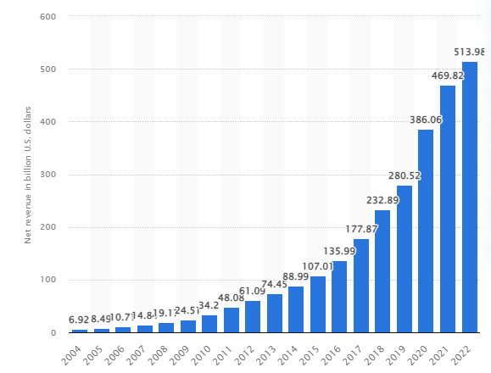
Figure 5: Amazon’s Net Sales Revenue in 2022
(Source: Statista, 2023)

Extended STP Analysis
STP analysis is mainly considered the process in which the focus on market segmentation, positioning as well and the target of a company can be known. Amazon operates its business in more than 100 countries all over the world and it mainly targets urban and rural areas of its market segmentation (Ramesh and Aravind, 2023). Along with that, the company is one of the most effective leaders in terms of the retail and streaming industry. Amazon mainly targets Gen Z for its streaming industry and it also focuses on attracting all types of customers for its retail industry. The company targets both customers and producers and it is noticed that 50% of the total consumers of the company are repeat buyers.
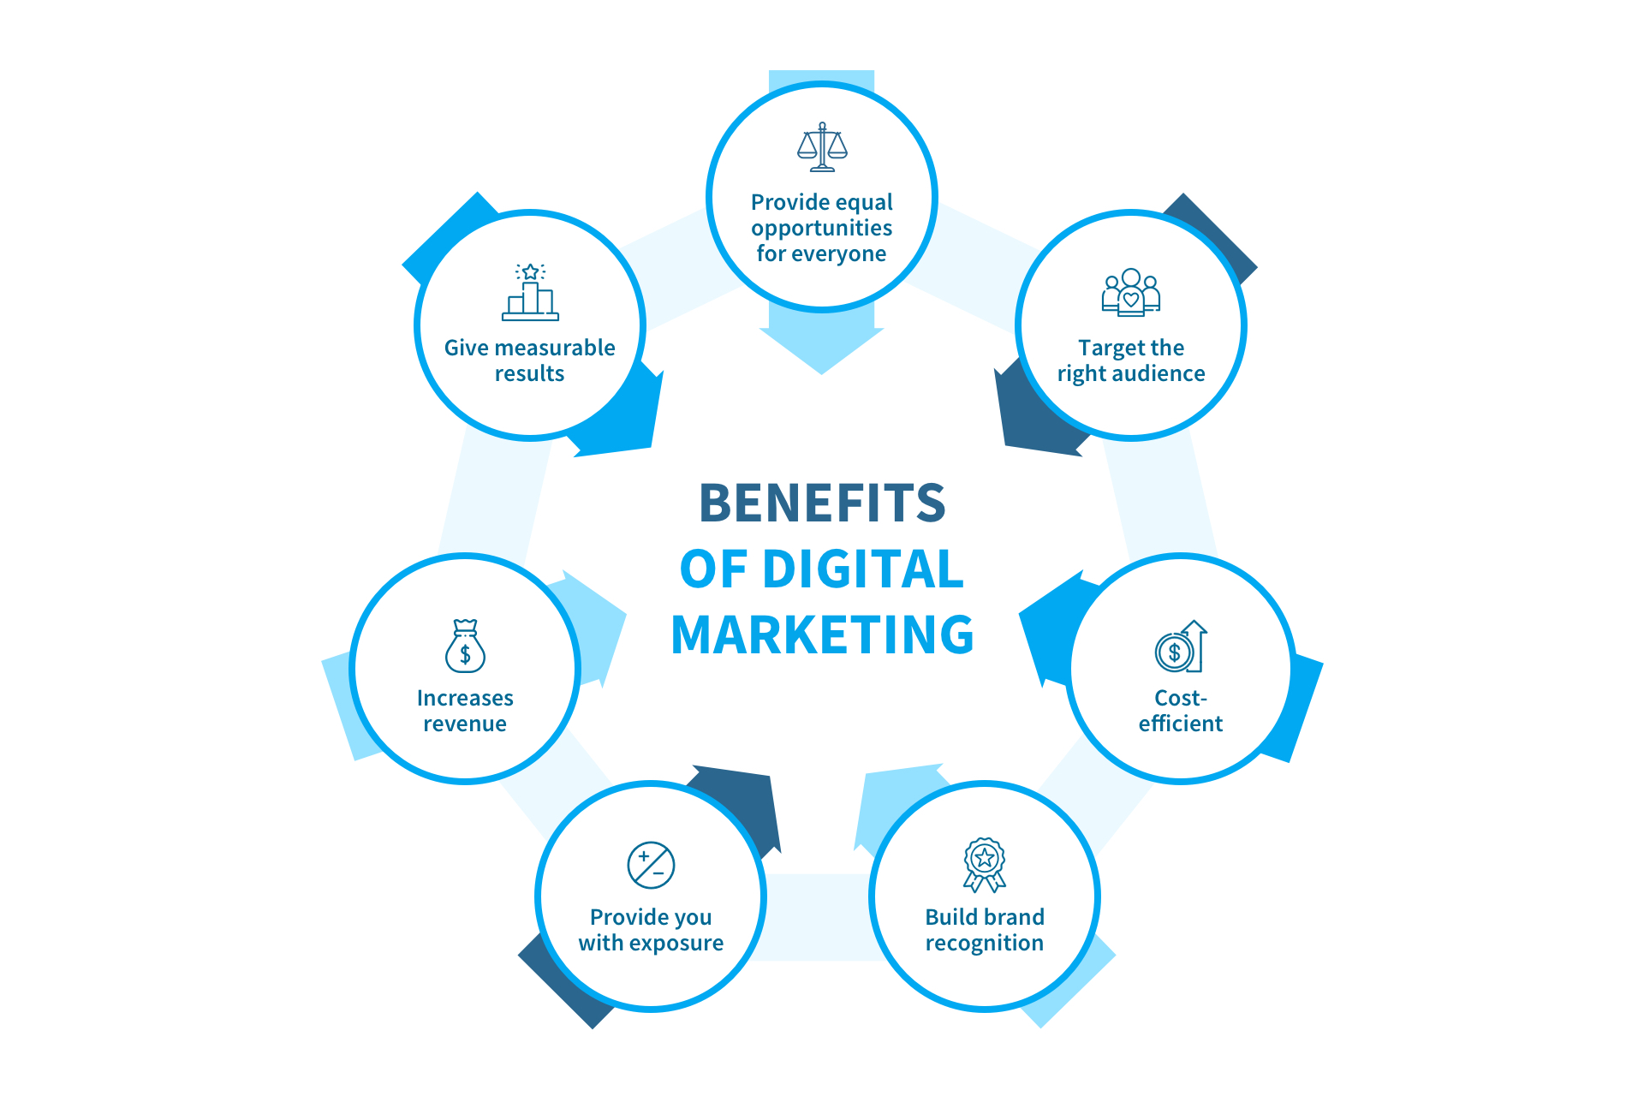
Figure 6: Benefits of Adopting Digital Marketing
(Source: Shah, 2022)

Extended Marketing Mix
Business organisations mainly follow the 4Ps marketing mix and in the case of Amazon, there are some extended marketing strategies available and it is called the 7Ps marketing mix. This marketing mix includes strategies regarding product, price, place, promotion, physical evidence, people and process. The company has strong product and service portfolios in terms of both sectors including retail and online streaming all over the world. Amazon also implements a less cost-effective strategy in marketing its products along with distributing them in several places in the global business market (Lee, 2023). The company promotes its products and services on several digital platforms like Facebook, Instagram and many more platforms. It also has a talented and strongly motivated workforce. Amazon has also applied different processes to reduce costs and optimise efficiency in its organisation. It also uses the strategy of physical evidence to create an effective shopping experience for customers and it is also a user-friendly website.
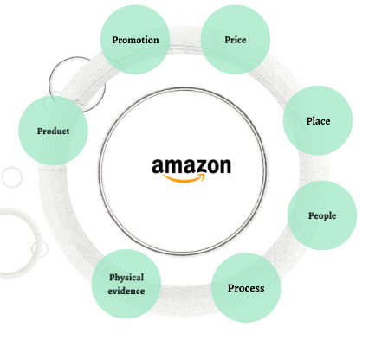
Figure 7: 7Ps Marketing Mix of Amazon
(Source: Prezi, 2023)

Question B

Ansoff Matrix
Market penetration: Amazon has attempted to sell its existing products in those markets that it already has entered. The company continuously promotes its products by creating simple yet attractive advertisements, and by providing discounts to its consumers.
Market development: In order to accomplish market development Amazon launches its existing products in new markets from different countries. The company benefits from this as it gets a new customer base from new markets.
Product development: Amazon has started selling new products in its already existing markets. The organisation follows third-party sellers for product development purposes and the product portfolio has been expanded over a long time. The website includes almost all products such as smartphones, dresses, household things, medicines and many more.
Diversification: Amazon sells its products in new markets with the help of the acquisition of new businesses. The organisation launched its cloud services to help out the customers (Sastry, Katvi and Tourani, 2019). Amazon launches new products in new markets to accomplish diversification procedures.
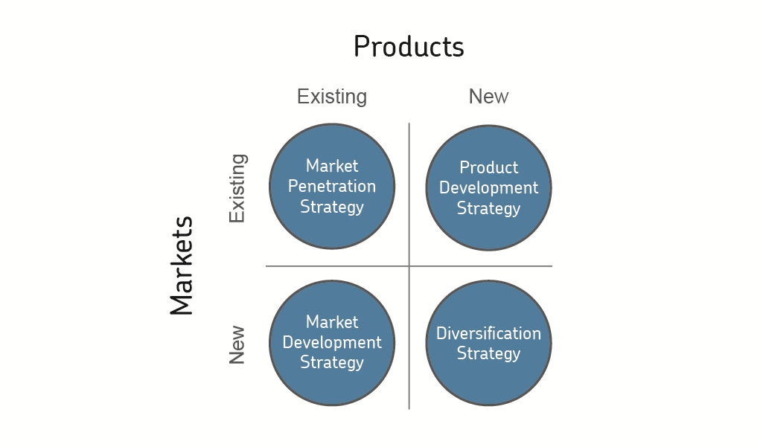
Figure 8: Ansoff Matrix
(Source: AQA, 2019)

Product Life Cycle Model
The product life cycle of Amazon includes the following steps. First, the development stage comes when the organisation develops the products which are not available for sale yet. The next segment is ‘launch’ where the products still have no availability in the market and the management makes several marketing strategies to promote the products on the market such as advertisements on digital media (Ali et al., 2020). After that, in the growth phase, the products are present in the market and sales are increased. Then the products become mature and, in this phase, steady sales are already accomplished. Lastly, the decline stage comes and the products lose their popularity as customers lose their interest in the products.
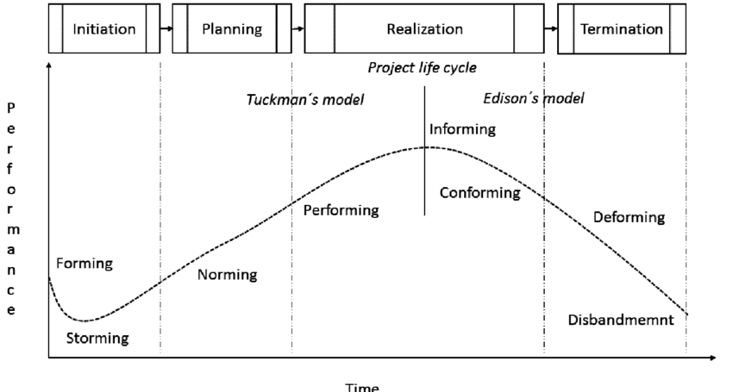
Figure 9: Project Life Cycle Model
(Source: Nekvapilová et al., 2016)

Recommendations
Some strategies will be recommended in this part, that will help Amazon to overcome the internal issues.
- Amazon is an American international e-commerce and retail-based technological organisation, the main issue of the company is overdependence on 3rd party distributors and sellers (Amiri and Vida, 2023). Therefore, internal corruption is affecting business revenue. The company has to adopt a digital and transparent distribution and supply chain process, that will prevent corruption and can make the distribution process smoother and transparent.
- Another issue of the company is data uncertainty and the customers were facing the data breaching issue within Amazon (Yang, 2022). The company has to strengthen their data security process and have to ensure customers that the personal information of the customers will never be misused by the company authority. The company has to adopt modern data security technology to secure the customer’s experiences.
- The limited loyal customer is another issue of the company and, to enhance and accelerate customer growth, the company has to modify their pricing strategies. Have to make the shipping charge affordable for any type of customer and need to provide attractive discounts and offers based on their products.
These recommended ways will help Amazon to overcome their current issues and by using these strategies the company will easily expand their sales growth.

Conclusion
Therefore, in conclusion, it can be stated that marketing management is a mandatory part of organisations which increases customer growth and business profitability. The report evaluated the marketing strategies of Amazon along with giving a small overview of the company in the first section. Some external factors were discussed by attaching a PESTLE analysis. Porter's five forces analysis was discussed as well in the context of Amazon. The fundamental drivers behind Amazon’s business growth are described in this report. SWOT analysis was mentioned to outline the organisation's strengths, opportunities, weaknesses and threats in the global market. The extended STP analysis and marketing mix were also described in the report. Ansoff matrix and the model of the product life cycle were mentioned in the context of the organisation. In the end, the role of marketing strategies in Amazon was identified and a few recommendations were provided for its further business development.

Reference list
Adams, P., Freitas, I.M.B. and Fontana, R., (2019). Strategic orientation, innovation performance and the moderating influence of marketing management. Journal of Business Research, 97, pp.129-140. Available at: https://e-tarjome.com/storage/panel/fileuploads/2019-04-08/1554704151_E11965-e-tarjome.pdf
Ali, M.M., Doumbouya, M.B., Louge, T., Rai, R. and Karray, M.H., (2020). An ontology-based approach to extract product's design features from online customers’ reviews. Computers in Industry, 116, p.103175. Available at: https://www.researchgate.net/profile/Hedi-Karray/publication/338528090_Ontology-based_approach_to_extract_product's_design_features_from_online_customers'_reviews/links/5e1999d1299bf10bc3a3678c/Ontology-based-approach-to-extract-products-design-features-from-online-customers-reviews.pdf
Alshmrani, H.M., (2021). An analytical view of amazon success in the worldwide. Life Science Journal, 18(6). Available at: http://www.lifesciencesite.com/lsj/lsj180621/10_37325lsj180621_71_90.pdf
‌Altrad, A., Pathmanathan, P.R., Al Moaiad, Y., Endara, Y.M., Aseh, K., El-Ebiary, Y.A.B., Farea, M.M., Latiff, N.A.A. and Saany, S.I.A., (2021, June). Amazon in Business to Customers and Overcoming Obstacles. In 2021 2nd International Conference on Smart Computing and Electronic Enterprise (ICSCEE) (pp. 175-179). IEEE. Available at: https://www.researchgate.net/profile/Yazeed-Al-Moaiad/publication/365180744_Amazon_in_Business_to_Customers_and_Overcoming_Obstacles_Syarilla_Iryani_Ahmad_Saany/links/636c688d37878b3e87997f96/Amazon-in-Business-to-Customers-and-Overcoming-Obstacles-Syarilla-Iryani-Ahmad-Saany.pdf
Amazon., (2023). Online Shopping site in India: Shop Online for Mobiles, Books, Watches, Shoes and More - Amazon. in. [online] Amazon.in. Available at: https://www.amazon.in/.
Amiri, S. and Vida, V., (2023). Analysis of marketing strategic issues at Amazon. SEA-Practical Application of Science, (31), pp.3-13. Available at: https://seaopenresearch.eu/Journals/articles/SPAS_31_1.pdf
AQA., (2019). Teaching guide: Ansoff matrix model. [online] Aqa.org.uk. Available at: https://www.aqa.org.uk/resources/business/as-and-a-level/business-7131-7132/teach/teaching-guide-ansoff-matrix-model.
Baboolal-Frank, R., (2021). Analysis of amazon: Customer centric approach. Available at: https://repository.up.ac.za/bitstream/handle/2263/86089/BaboolalFrank_Analysis_2021.pdf?sequence=1
Baboolal-Frank, R., (2021). Analysis of amazon: Customer centric approach. Available at: https://repository.up.ac.za/bitstream/handle/2263/86089/BaboolalFrank_Analysis_2021.pdf?sequence=1
Beirão, C.M.R.X., (2022). Amazon-s diversification strategies-a strategic analysis of allegro: keeping dominance of the polish e-commerce market in the face of amazon-s entry (Doctoral dissertation). Available at: https://run.unl.pt/bitstream/10362/148125/1/2021-22_fall_29238_constanca-beirao_.pdf
Bloodstein, B., (2019). Amazon and Platform Antitrust. Fordham L. Rev., 88, p.187. Available at: https://ir.lawnet.fordham.edu/cgi/viewcontent.cgi?article=5620&context=flr
Dalirazar, S. and Sabzi, Z., (2023). Strategic analysis of barriers and solutions to development of sustainable buildings using PESTLE technique. International Journal of Construction Management, 23(1), pp.167-181. Available at: https://www.researchgate.net/profile/Zahra-Sabzi/publication/347600549_Strategic_analysis_of_barriers_and_solutions_to_development_of_sustainable_buildings_using_PESTLE_technique/links/60d6bea8a6fdccb745e43a56/Strategic-analysis-of-barriers-and-solutions-to-development-of-sustainable-buildings-using-PESTLE-technique.pdf
Lee, C., (2023). The Nordics underdeveloped e-commerce food sector: how can e-commerce strategies be enhanced?. Available at: https://www.theseus.fi/bitstream/handle/10024/803397/Lee_Chaeeun.pdf?sequence=2
‌Nekvapilová, Ivana and Pitas, Jaromir., (2016). Factors Affecting Project Management in the Public Sector. International conference KNOWLEDGE-BASED ORGANIZATION. 22. 10.1515/kbo-2016-0037. Available at: https://www.researchgate.net/figure/Model-of-project-team-development-x-project-life-cycle-Development-of-the-project-team_fig1_305760870
Pereira, D., (2023). Top 10 Amazon Competitors & Alternatives in 2023. [online] The Business Model Analyst. Available at: https://businessmodelanalyst.com/amazon-competitors/.
Prezi., (2023). Available at: https://0901.static.prezi.com/preview/v2/fjfic2ntrzz2nv4k3mq6ek5vul6jc3sachvcdoaizecfr3dnitcq_3_0.png [Accessed 25 Aug. 2023].
Ramesh, M. and Aravind, A., (2023). A Study of Operation in E-Commerce Company with Reference to Amazon. New Research in E-commerce Business Management, 68, p.32. Available at: https://www.scripown.com/docs/EBOOK_20230413_084143.pdf#page=36
‌Sandhya, C., (2023). Competitive Digital Strategic Model of Amazon-A Case Study Analysis. International Journal of Case Studies in Business, IT and Education (IJCSBE), 7(2), pp.198-213. Available at: https://www.supublication.com/index.php/ijcsbe/article/download/34/30
Sastry, V.V.L.N., Katvi, S. and Tourani, P., (2019). AMAZON’S STRATEGIC ANALYSIS AND IT’S ENTERPRISE STRATEGY FOR THE CLOUD. Advance and Innovative Research, p.186. Available at: https://www.academia.edu/download/60692131/IJAIR_Volume_6__Issue_2_XXXXI_April_-_June_201920190924-49790-xqqzb1.pdf#page=195
Statista., (2019). U.S. Gross Domestic Product - forecast 2018-2029 | Statista. [online] Available at: https://www.statista.com/statistics/216985/forecast-of-us-gross-domestic-product/.
Statista., (2022). United States - Total Population 2024. [online] Statista. Available at: https://www.statista.com/statistics/263762/total-population-of-the-united-states/.
Statista., (2023). Annual Net Sales Revenue of Amazon from 2004 to 2022. [online] Statista. Available at: https://www.statista.com/statistics/266282/annual-net-revenue-of-amazoncom/.
TechCrunch., (2023). Amazon is Primed for online domination. [online] Available at: https://techcrunch.com/2022/04/21/amazon-is-primed-for-online-domination/.
Yang, Z., (2022). Amazon vs. Alibaba: Comparisons of Two E-commerce Giants based on SWOT Analysis. Highlights in Business, Economics and Management, 2, pp.497-503. Available at: https://drpress.org/ojs/index.php/HBEM/article/view/2409/2311

